 | 

Access Review
User Guide
Client Application Access Attestation - BPO Operations
Tuesday, June 9, 2026



Table of contents
1 Introduction 2
1.1 Key concepts at a glance 2
1.2 Who does what 2
2 Getting started 3
2.1 Opening the application 3
2.2 Signing in 3
2.3 The top bar and navigation 3
2.4 Switching between your views 4
3 Associate view - attesting your own access 4
3.1 Your dashboard 5
3.2 Reading the attestation table 5
3.3 Attesting a tool - step by step 6
3.4 Reporting a tool you should not have (a dispute) 6
3.5 Submitting your attestation 7
3.6 Dark mode 7
4 Manager view - tracking your team 8
4.1 Team overview 8
4.2 Inspecting a team member 9
4.3 Reopening a submitted attestation 10
4.4 Exporting disputes 10
5 Access management - granting and revoking 10
5.1 Granting new access 11
5.2 Managing existing access 12
6 Oversight dashboards - Admin, GFH, GFH Delegate, IFH 12
6.1 Dashboard anatomy 12
6.2 How the four oversight roles differ 13
6.2.1 GFH view (scoped, with setup rights) 13
6.2.2 GFH Delegate view (organisation-wide) 14
6.2.3 IFH view (scoped, view-only) 15
6.3 Drilling into a department 16
6.4 Notifications 17
6.5 Adding clients and tools (Admin / GFH / GFH Delegate) 18
7 User directory (Administrators) 18
7.1 Editing a user 19
8 Reference 20
8.1 Completion status thresholds 20
8.2 Role & permission matrix 20
8.3 Glossary 20
8.4 Troubleshooting & FAQ 21

1 Introduction
Access Review is Broadridge BPO’s web application for tool-access attestation. Periodically (each review cycle), every associate is asked to confirm which client applications and tools they still have access to, and which of those they actually used during the cycle. Managers track their team’s progress, reconcile any access disputes, and adjust who can use which tool. Oversight roles (GFH, GFH Delegate, IFH, and Admin) monitor completion across departments and export the exceptions that need follow-up. The result is an auditable record, each cycle, that access granted matches access needed — a core control for client data protection and regulatory compliance.

1.1 Key concepts at a glance
Cycle A defined attestation period with a start date, end date, and due date (for example, Q1 2026 Attestation, due 16 June 2026). The application always opens on the current cycle; you can switch cycles from the cycle picker. Client An external client whose applications your team supports (e.g. Barclays, Marex, Natixis). Client IDs are stored as text to preserve leading zeros. Tool A specific application or service used for a client (e.g. Trade Capture, Risk Engine, Compli- ance Portal). Attestation Your confirmation, per tool, of (a) whether you still have access and (b) whether you used it this cycle. Dispute A tool you flag as No access — you are telling the business that the system shows access you do not actually have (or no longer need). Disputes are surfaced to your manager and to oversight for reconciliation.

1.2 Who does what
Role | Primary task in Access Review
Associate | Attest your own tools each cycle (used / not used / no access) and submit.
Manager | Track direct reports completion; reconcile disputes; grant, time-box, or revoke access.
GFH (Global Functional Head) | Monitor completion for the departments you head; add clients/tools.
GFH Delegate | Same organisation-wide visibility as an administrator, minus user administration.
IFH (In-Country Functional Head) | Monitor completion for your departments - view only.
Admin | Organisation-wide oversight, client/tool setup, and the user directory.

Associate Attest your own tools each cycle (used / not used / no access) and submit.
Manager Track direct reports’ completion; reconcile disputes; grant, time-box, or revoke access.
GFH (Global Functional Head) Monitor completion for the department(s) you head; add clients/tools.
GFH Delegate Same organisation-wide visibility as an administrator (minus user administration).
IFH (In-Country Functional Head) Monitor completion for your department(s) — view only.
Admin Organisation-wide oversight, client/tool setup, and the user directory.
Roles are additive. A person can be an associate and a manager and an oversight role at the same time. The view you land on is your highest role, and you can switch between the views Accessyou areReviewentitled· User toGuide(see Section 2.3). 2 GETTING STARTED

2 Getting started

2.1 Opening the application
Open a web browser (Microsoft Edge or Google Chrome are recommended) and go to:
http://10.17.69.188/ClientAppAttestation/
Bookmark this address. The trailing slash matters — always open the URL exactly as shown.

2.2 Signing in
Access Review uses your Windows / company sign-in automatically. In normal use you will not see a login form — the application recognises your Windows account and takes you straight to your dashboard. If your identity cannot be verified (for example, you are not yet registered in the system, or you opened the site from an unsupported network), you will see the sign-in card in Figure
Click Try again; if it still fails, contact the dashboard administrator to confirm your account is set up.
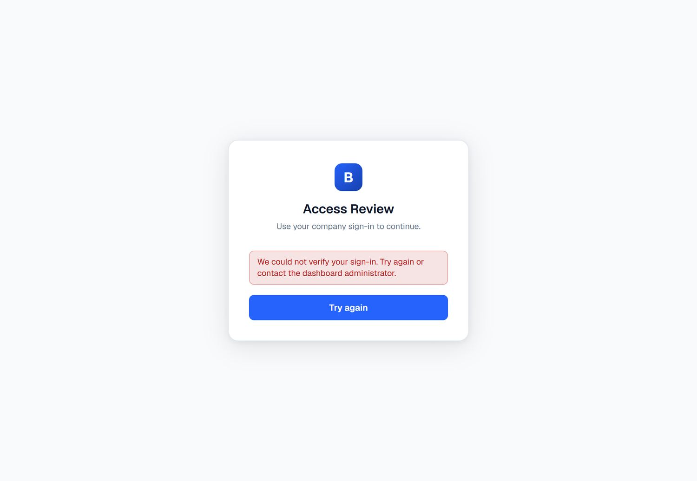
Figure 1 – The sign-in card. You normally bypass this automatically via Windows single sign-on; it only appears when your account could not be verified.

IMPORTANT
“We could not verify your sign-in” almost always means your Windows account is not yet mapped to a user record in Access Review, or your browser did not pass your Windows credentials. Try the site in Edge/Chrome on the corporate network first, then raise it with the administrator.

2.3 The top bar and navigation
Every screen shares a top bar (Figure 2). From left to right it contains:
- the Broadridge / Access Review brand mark;
- the Cycle picker — shows the current cycle, its due date, and days remaining; click it to switch to a past or future cycle;
- the view tabs (only shown if you have more than the associate role) — Associate view, Manager view, Access, and, for administrators, Admin Dashboard and Users;
- a Search box (filters the current screen);
- a Theme toggle (light / dark — see Section 3.6);
- your Profile menu (name, ID, and Sign out).
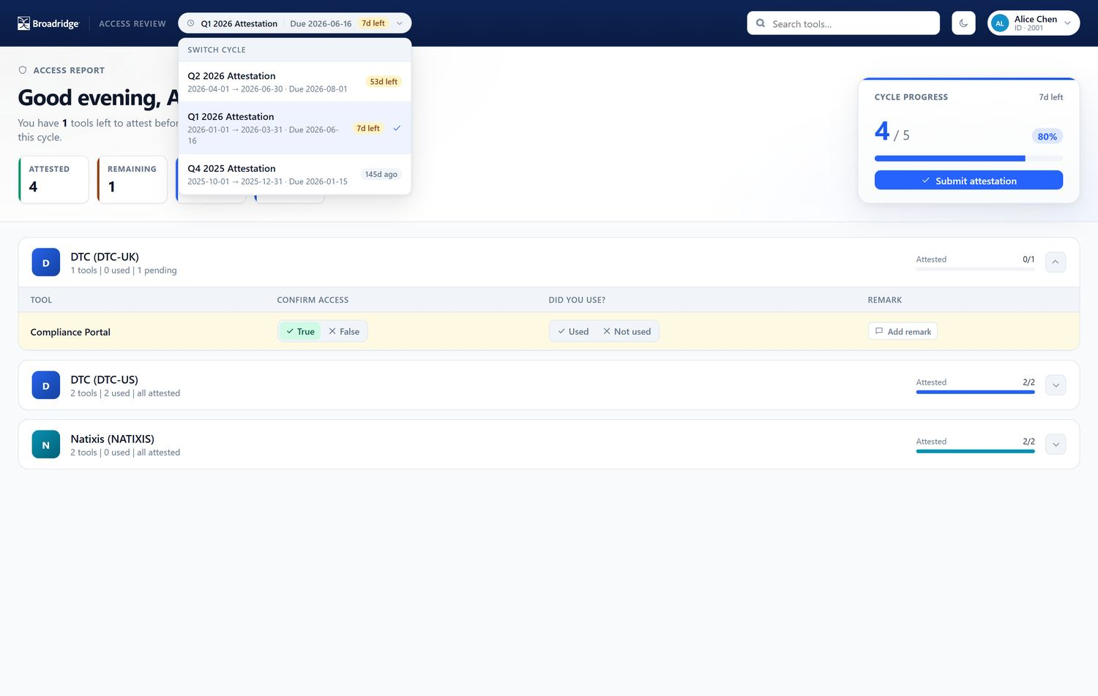
Figure 2 – The cycle picker open. Each cycle shows its date range and how many days remain until the due date; a tick marks the cycle you are currently viewing.

TIP
Switching cycles changes everything on the screen to that cycle’s data. If your numbers look unexpected, check which cycle is selected in the picker first.

2.4 Switching between your views
If you hold more than one role, use the view tabs in the top bar (or, on the oversight dashboard, the Associate View / Team View links in the left sidebar) to move between: the Associate view (your own attestations), the Manager view (your team), the Access screen (granting/revoking), the Admin Dashboard (oversight), and the Users directory (administrators only).

3 Associate view — attesting your own access
This is the part of Access Review that every user completes each cycle.

3.1 Your dashboard
On opening, the associate dashboard (Figure 3) greets you and summarises the cycle:
- Headline — how many tools you still have left to attest before the due date.
- KPI tiles — Attested, Remaining, Clients, and Days left.
- Cycle progress card — your overall completion (e.g. “4 / 5, 80%”) with the Submit attestation button.
- Client cards — one expandable card per client you have access to, each showing the tool count and how many are still pending.
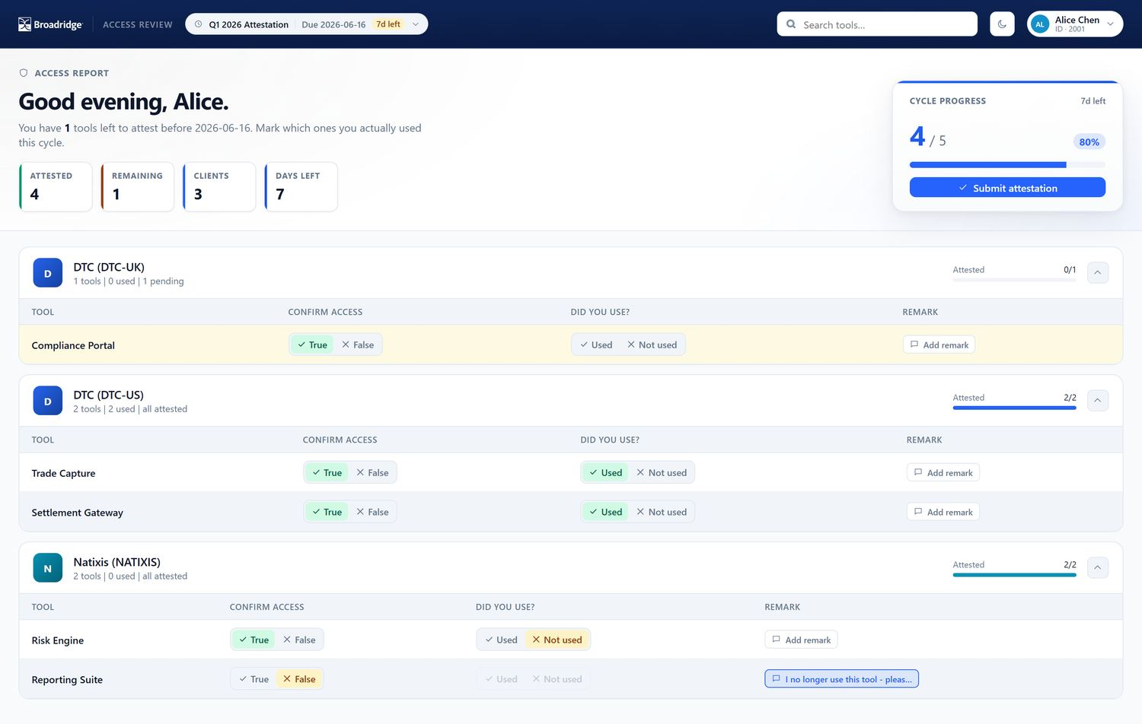
Figure 3 – The associate dashboard. The amber row is a tool still awaiting an answer; the last client shows one tool marked Not used and one flagged as a No access dispute (with a remark).

3.2 Reading the attestation table
Click a client card to expand it. Each tool is one row with four columns (Figure 4):
Tool The application name. Confirm Access True = “yes, I do have access to this tool”. False = “no, I do not have (or no longer need) this access” — this raises a dispute. Did you use? Used or Not used this cycle. This is disabled if you set Confirm Access to False (you cannot have “used” a tool you say you cannot access). Remark An optional free-text note — required when you flag No access.
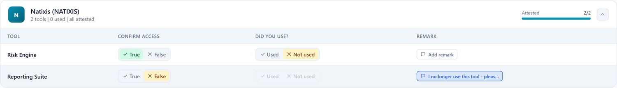
Figure 4 – A single client’s tool table. “Risk Engine” is confirmed but Not used; “Reporting Suite” is a No access dispute carrying a remark.

3.3 Attesting a tool — step by step
Expand the client card.
For each tool, set Confirm Access:
- Keep it True if you still have (and need) this access.
- Set it to False if you should not have this access. The Did you use? toggle then greys out, and you must add a remark explaining why (see Section 3.4).
For tools you confirmed access to, set Did you use? to Used or Not used.
(Optional) Add a Remark on any tool to give your manager or auditor context.
Your changes save automatically as you click — there is no separate “save” step. Rows you have not yet answered are highlighted amber and counted in Remaining.

3.4 Reporting a tool you should not have (a dispute)
When you set Confirm Access to False, click the Remark button on that row and explain the situation — for example, “I no longer use this tool, please remove my access.” (Figure 5). Remarks are limited to 500 characters and are visible to your manager and to audit.
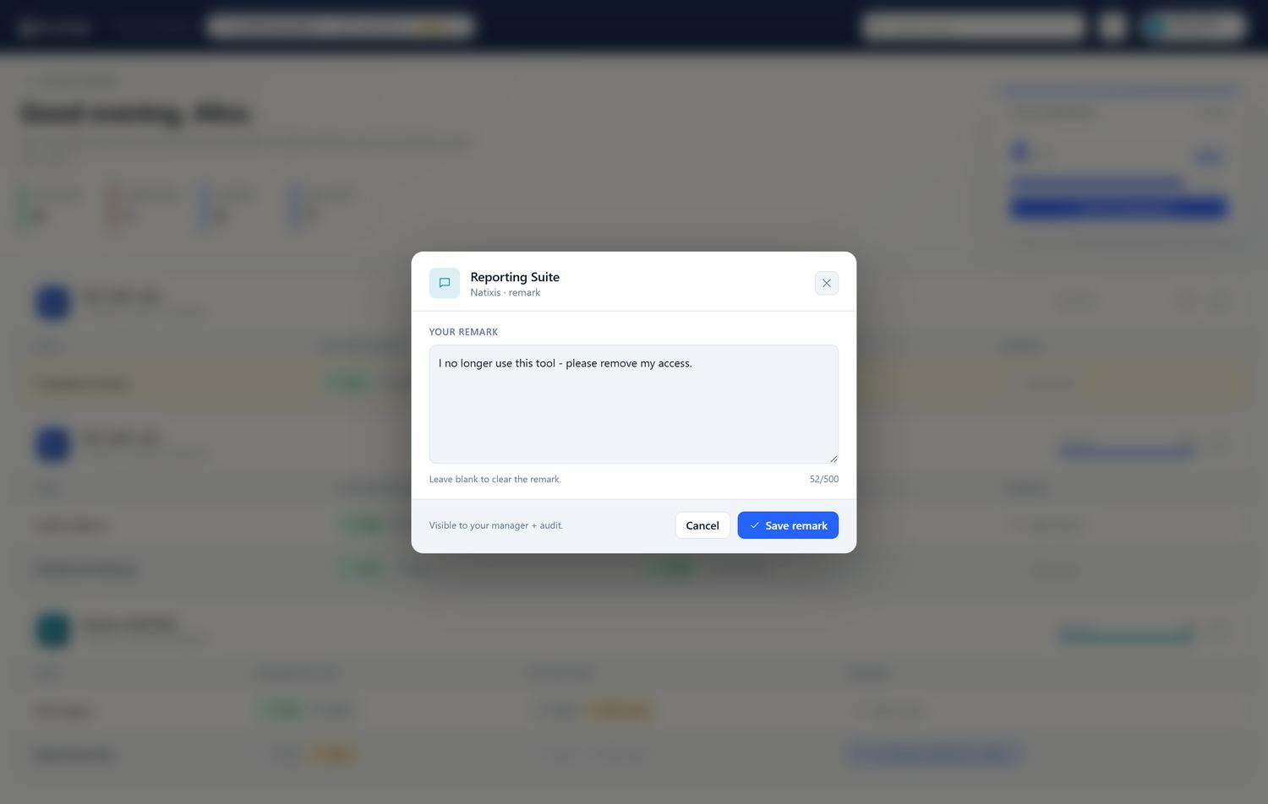
Figure 5 – The remark editor. Leave the box empty and save to clear an existing remark. A remark is mandatory for every tool you flag as No access.

IMPORTANT
You cannot submit until every tool you marked No access has a remark. The application tells you how many remarks are still missing.

3.5 Submitting your attestation
When every tool has an answer (and every dispute has a remark), click Submit attestation in the Cycle progress card. After submission:
- the attestation is locked — a green banner appears on each client and the toggles become read-only (Figure 6);
- the Submit button changes to Submitted;
- your manager sees your status flip to Submitted.
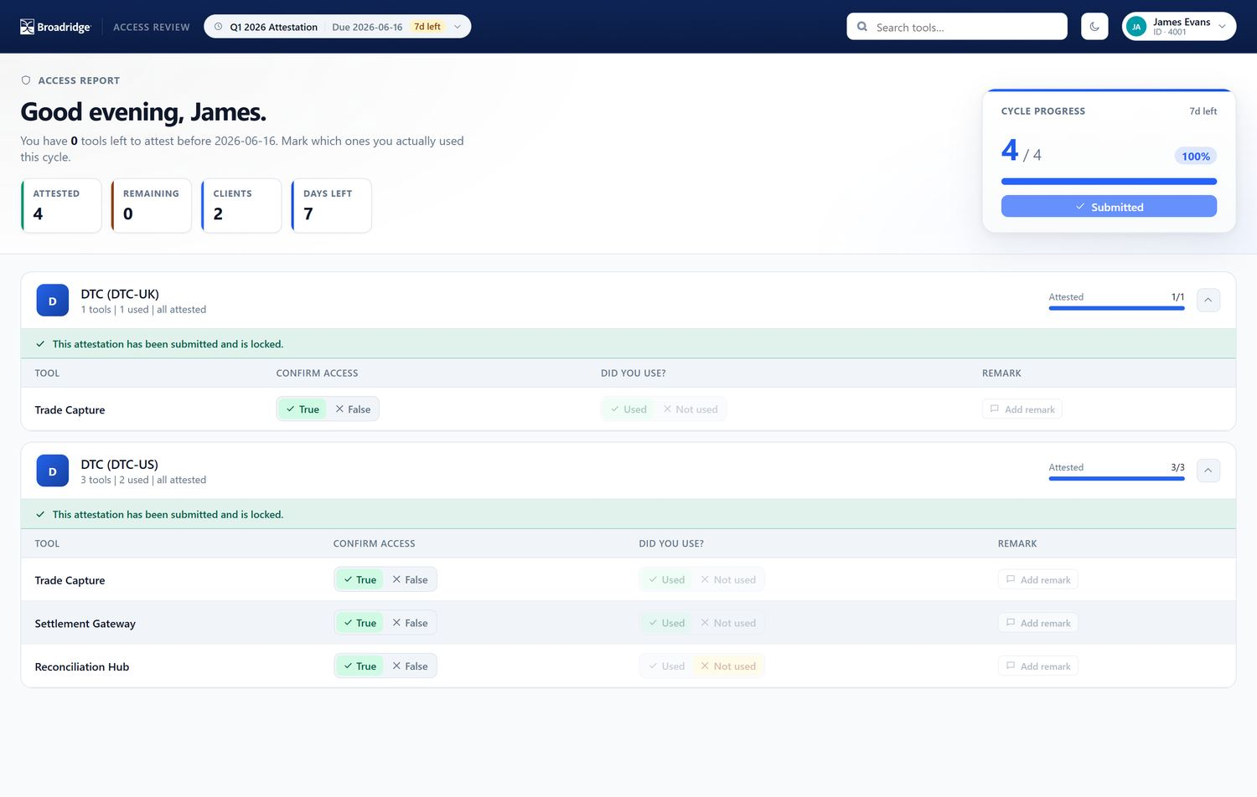
Figure 6 – A submitted, locked attestation. Everything is read-only and the “submitted and locked” banner is shown. Only a manager can reopen it.

NOTE
Made a mistake after submitting? Ask your manager to Reopen your attestation (Section 4.3); you can then edit and re-submit.

3.6 Dark mode
Use the sun/moon toggle in the top bar to switch between light and dark themes (Figure 7). The choice is purely visual and applies to every screen.
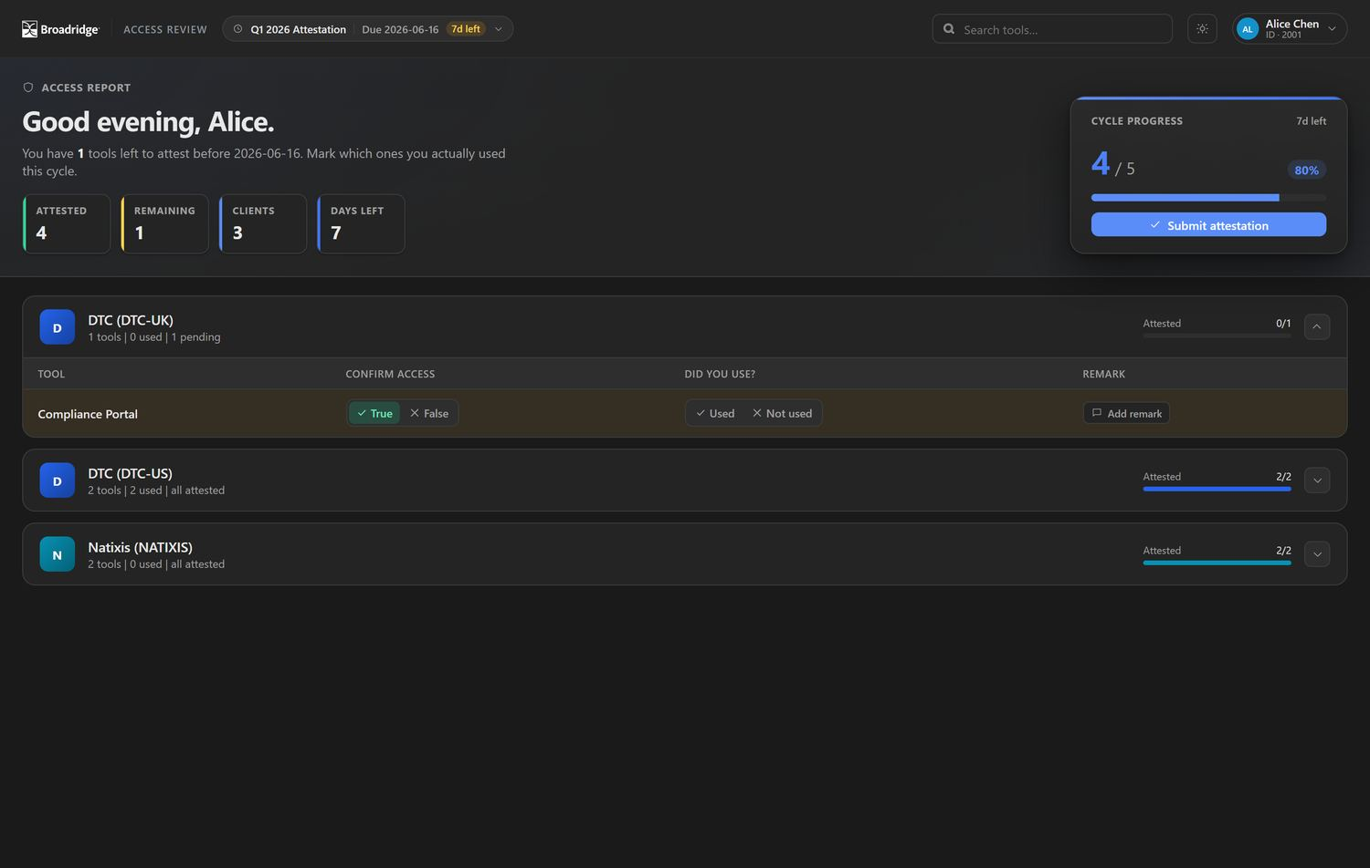
Figure 7 – The associate dashboard in dark mode.

4 Manager view — tracking your team
Managers see the Manager view by default. It answers one question: is my team done, and what needs my attention?

4.1 Team overview
The manager overview (Figure 8) shows:
- a red disputes banner when one or more reports have flagged access disputes this cycle, with an Export disputes button;
- summary tiles — Direct reports, Submitted, In progress, Not started;
- the Team completion table — every direct report with a progress bar, a tools count, and a status badge. Filter with Everyone / Not started / In progress / Submitted, or search by name or ID.
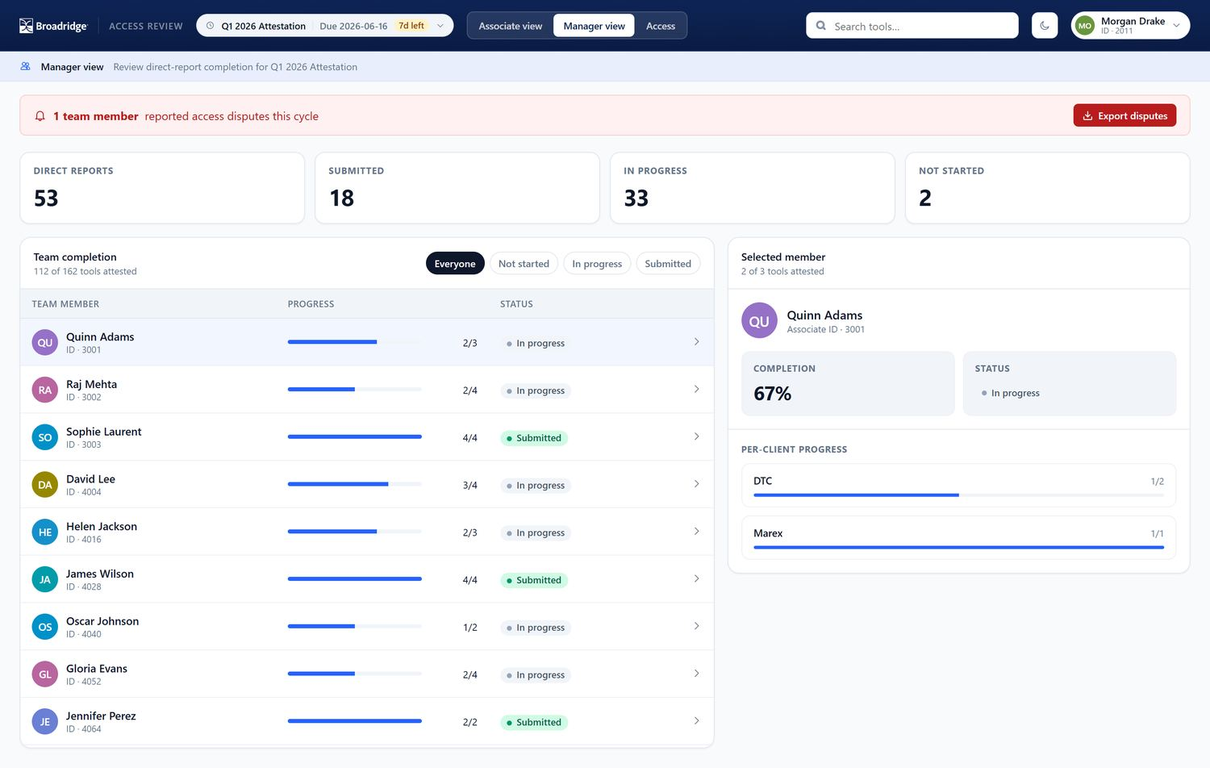
Figure 8 – The manager overview, with the access-disputes banner, status summary, and the filterable team table.

4.2 Inspecting a team member
Click any team member to open the Selected member panel (Figure 9). It shows their completion percentage and status, a per-client progress breakdown, and — if they reported any — an Access disputes list with the tool, client, and the associate’s remark.
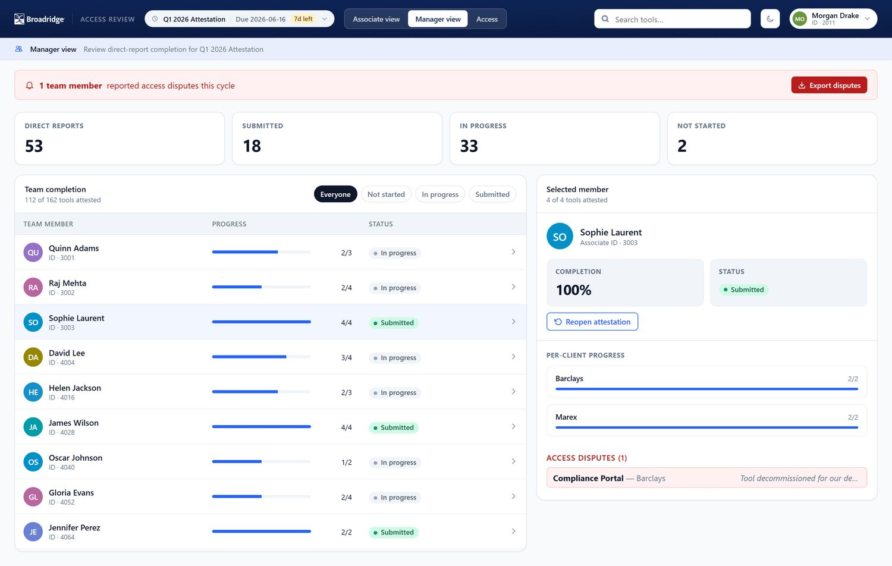
Figure 9 – Member detail. The selected associate is fully complete, but has one access dispute (“Compliance Portal — Barclays”) that the manager should reconcile.

4.3 Reopening a submitted attestation
If a report needs to correct an attestation they already submitted, select them and click Reopen attestation (visible only when their status is Submitted). Confirm the prompt; the attestation unlocks and the associate can edit and re-submit.

4.4 Exporting disputes
Click Export disputes (in the banner) to download a spreadsheet of every disputed tool across your team — associate, tool, client, the remark, and contact details — for reconciliation and access removal.

5 Access management — granting and revoking
The Access screen (Figure 10) lets managers control which tools each direct report can use. Pick a team member from the left list; their access appears on the right.
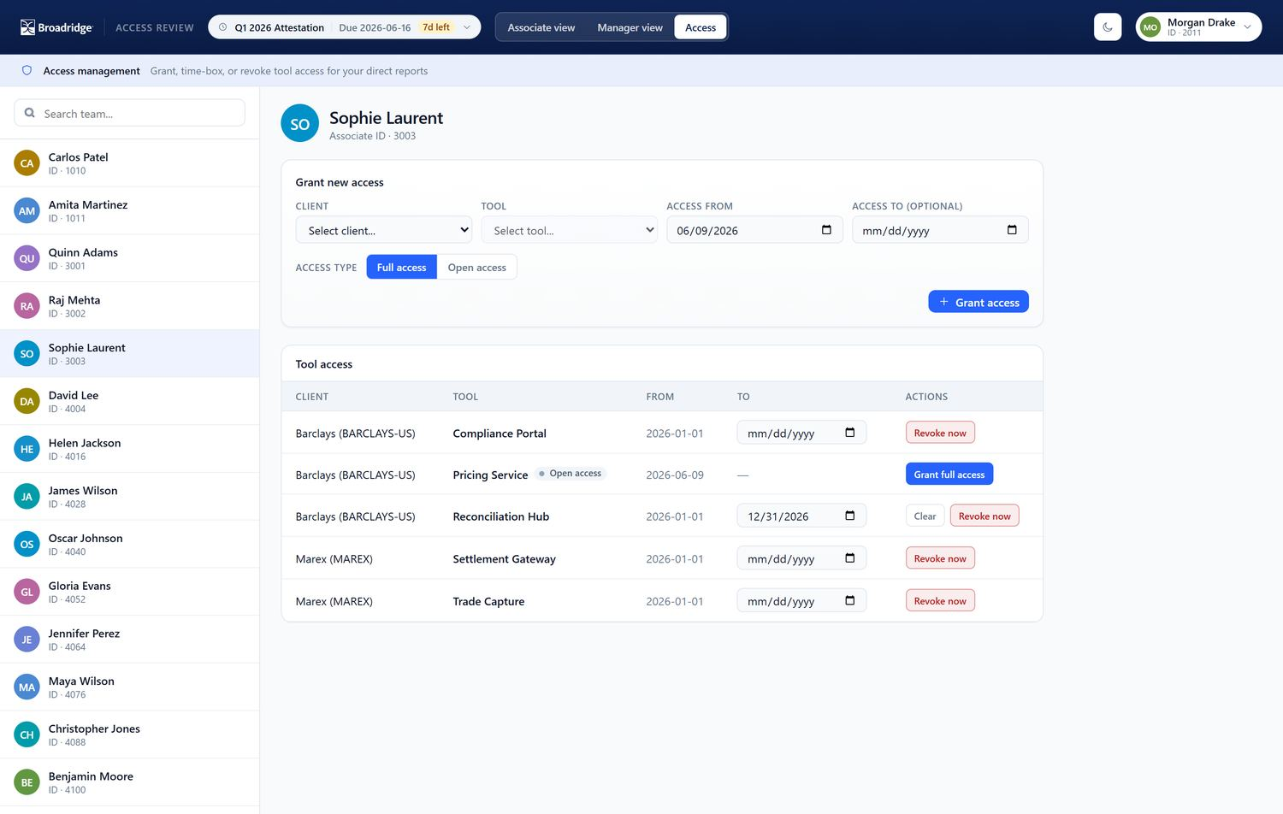
Figure 10 – Access management for a selected report: the Grant new access form on top, and the current Tool access table below (note the full-access rows, an Open access row, and a row with an end date).

5.1 Granting new access
In Grant new access:
Choose a Client, then a Tool. (You can only grant tools that belong to your department.)
Set Access from (defaults to today) and, optionally, Access to for time-boxed access. Leave Access to blank for open-ended access.
Choose the Access type (Figure 11):
- Full access — access is active immediately.
- Open access — a placeholder for access whose paperwork is still in process. It is marked pending until you later grant it fully. 4. Click Grant access.
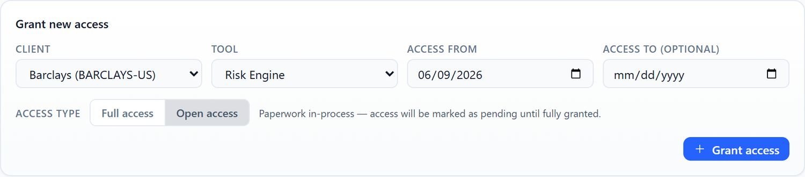
Figure 11 – The grant form with Open access selected — used when the access request is still being processed.

5.2 Managing existing access
In the Tool access table, each row offers:
- End date — edit the To date to time-box a full-access row; click Clear to make it open-ended again.
- Revoke now — ends access today (the row is closed out with today’s date).
- Grant full access — shown on Open access rows; promotes a pending placeholder to active, open-ended access.

IMPORTANT
Access scoping is enforced by department: a manager can only grant or change tools that belong to their own department. If a tool you expect is missing from the Tool list, it belongs to another department — ask that department’s GFH or an administrator to add it.

6 Oversight dashboards — Admin, GFH, GFH Delegate, IFH
Oversight roles open on the dashboard (Figure 12). All four roles share the same layout; they differ in how much they can see and what they can do.
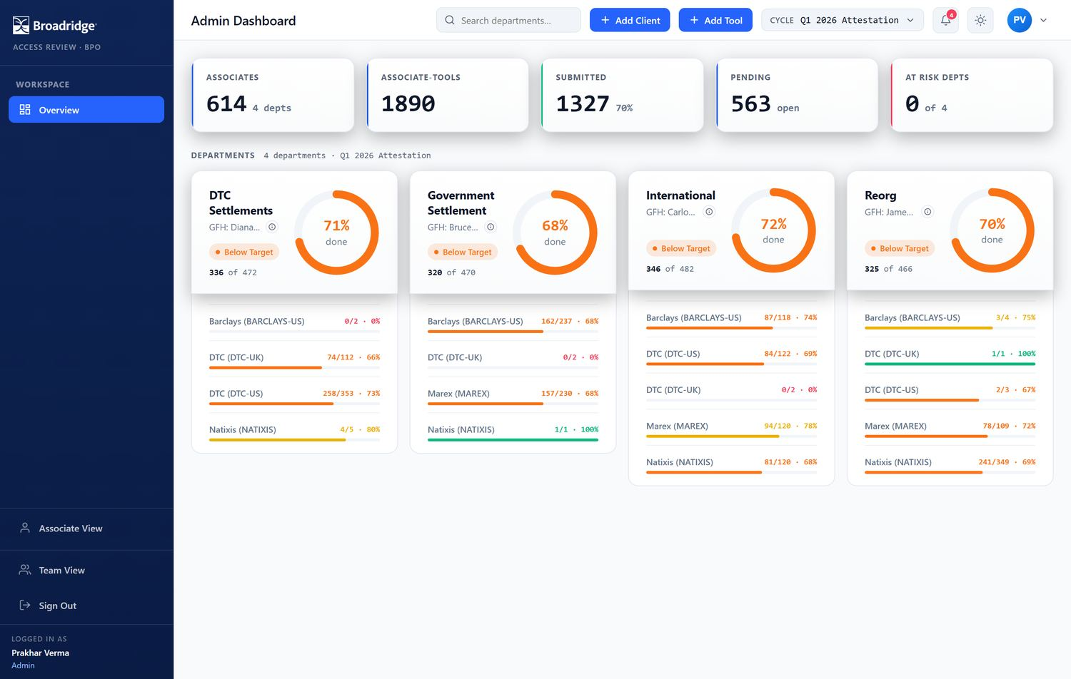
Figure 12 – The Admin Dashboard: an organisation-wide KPI band, then one card per department with a completion donut and a per-client breakdown.

6.1 Dashboard anatomy
- KPI band — associates, associate-tool combinations, submitted, pending, and the number of at-risk departments in scope.
- Department cards — each shows the responsible GFH, a completion donut, a status badge, the submitted/total count, and a per-client completion breakdown. The card colour and status follow the completion thresholds in Section 8.1.
- Search — filter the visible departments.
- Cycle picker, notifications, theme, profile — as on every screen. The notifications bell (Figure 17) flags departments that are behind as the due date approaches.

6.2 How the four oversight roles differ
Admin GFH Delegate GFH IFH
Departments visible All All Own department(s) Own department(s)
Title shown “Admin Dashboard” “Admin Dashboard” “Name — GFH View” “Name — IFH View”
Add Client / Add Tool Yes Yes Yes —
User directory (Users tab) Yes — — —
Drill-down & exports Yes Yes Yes Yes

ADMIN & OVERSIGHT ROLES
In plain terms: Admin can do everything, including managing user records. GFH Delegate sees the whole organisation and can add clients/tools, but cannot administer users. A GFH (Global Functional Head) manages the department(s) they head and can add clients/tools there. An IFH (In-Country Functional Head) monitors their department(s) but cannot add clients or tools — it is a view-only oversight role.

6.2.1 GFH view (scoped, with setup rights)
A GFH sees only the department(s) they head and the title reads “Name — GFH View” (Figure 13). The Add Client and Add Tool buttons are available.
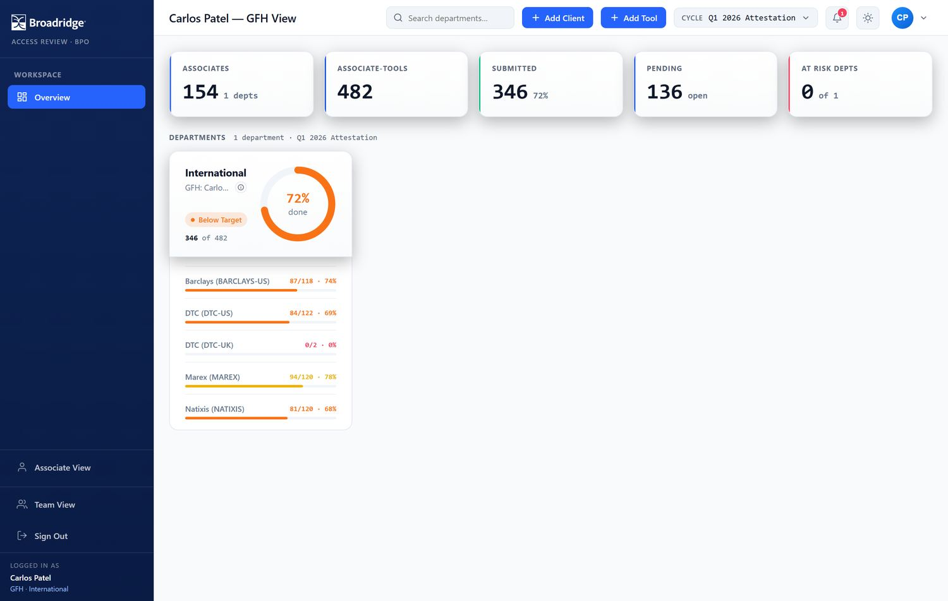
Figure 13 – A GFH dashboard scoped to a single department (“International”), retaining the Add Client / Add Tool buttons.

6.2.2 GFH Delegate view (organisation-wide)
A GFH Delegate has the same organisation-wide reach as an administrator and keeps the Add Client/Add Tool buttons, but has no access to the user directory. The dashboard is titled “Admin Dashboard”; the role badge in the sidebar reads “GFHDelegate” (Figure 14).
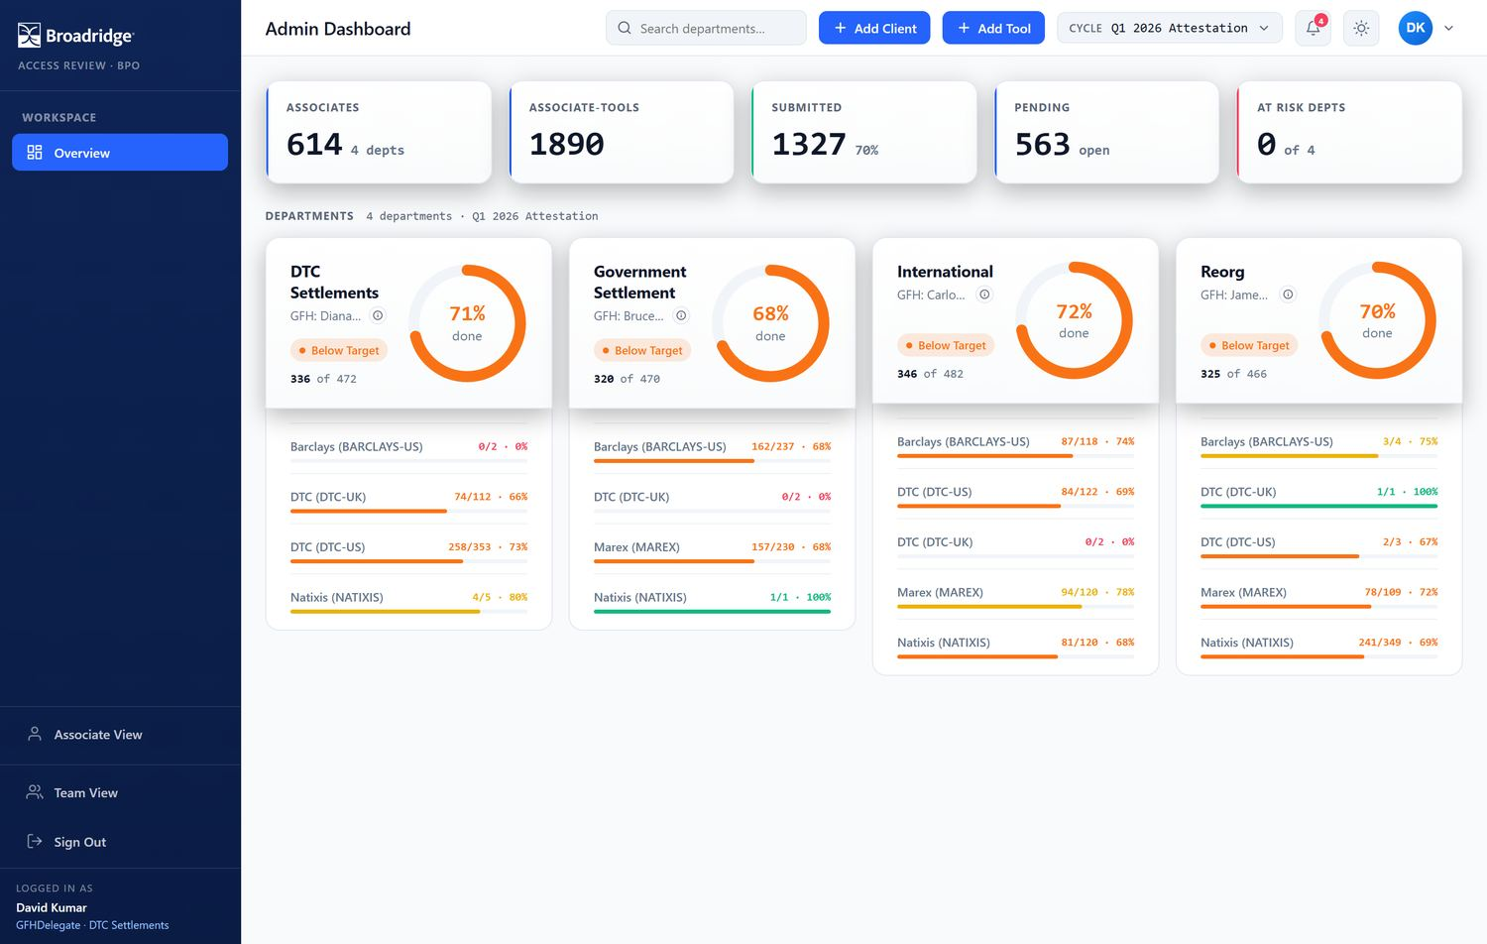
Figure 14 – A GFH Delegate sees every department, like an administrator. The sidebar role badge (lower left) distinguishes the delegate from a full administrator.

6.2.3 IFH view (scoped, view-only)
An IFH sees only their department(s), titled “Name — IFH View”, and has no Add Client/Add Tool buttons (Figure 15).
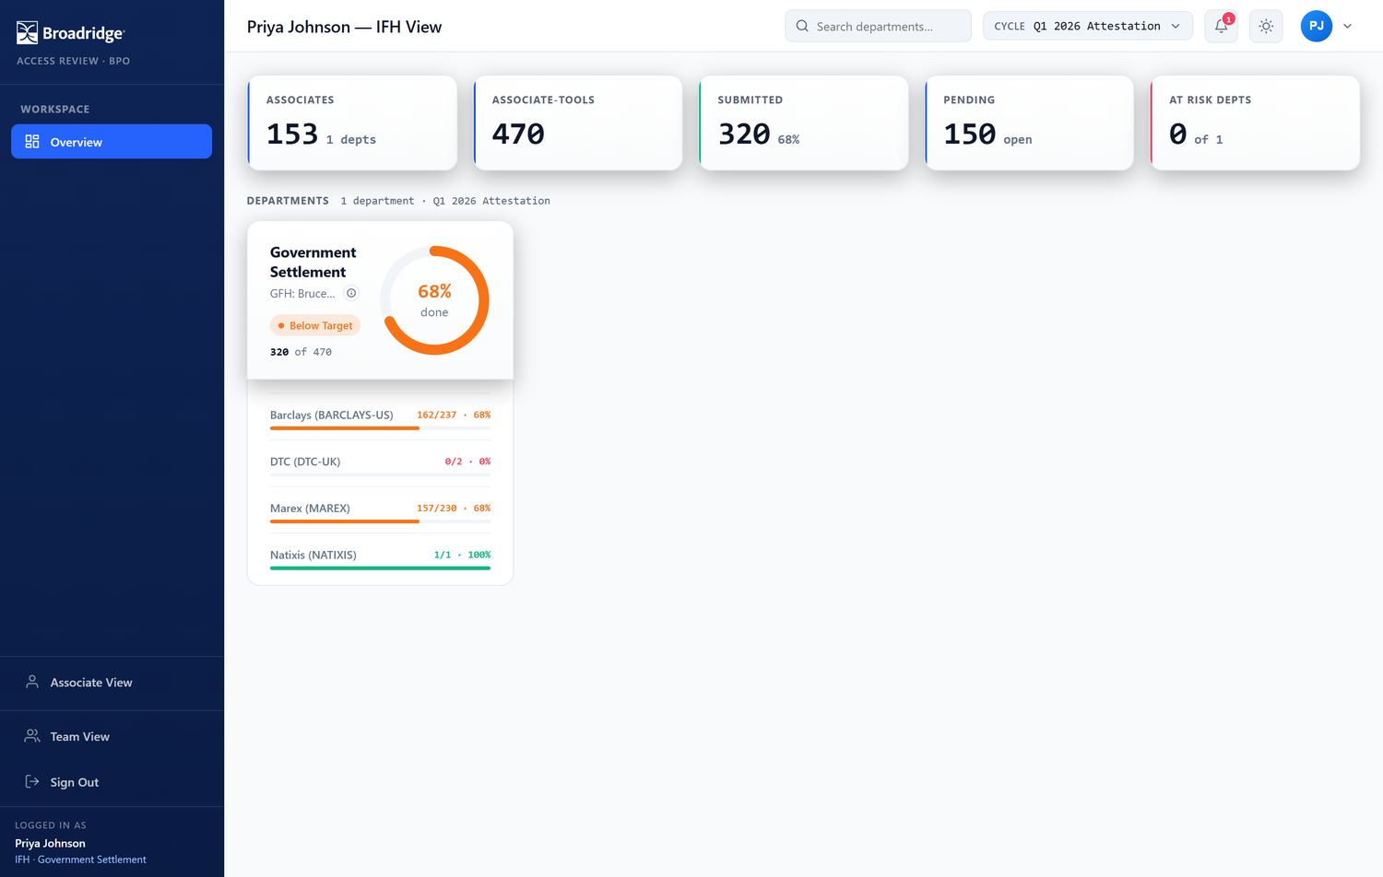
Figure 15 – An IFH dashboard — scoped like a GFH, but without client/tool setup buttons.

6.3 Drilling into a department
Click a department card to drill in (Figure 16). You get:
- a breadcrumb (All Departments) to go back, and a Filter by client row;
- a department header with the completion breakdown bar and donut;
- an Exception Exports card — download Incomplete submissions (associates who have not finished) and Access disputes (tools reported as No access);
- a Managers grid — each manager’s completion. Click a manager to drill further into their associates.
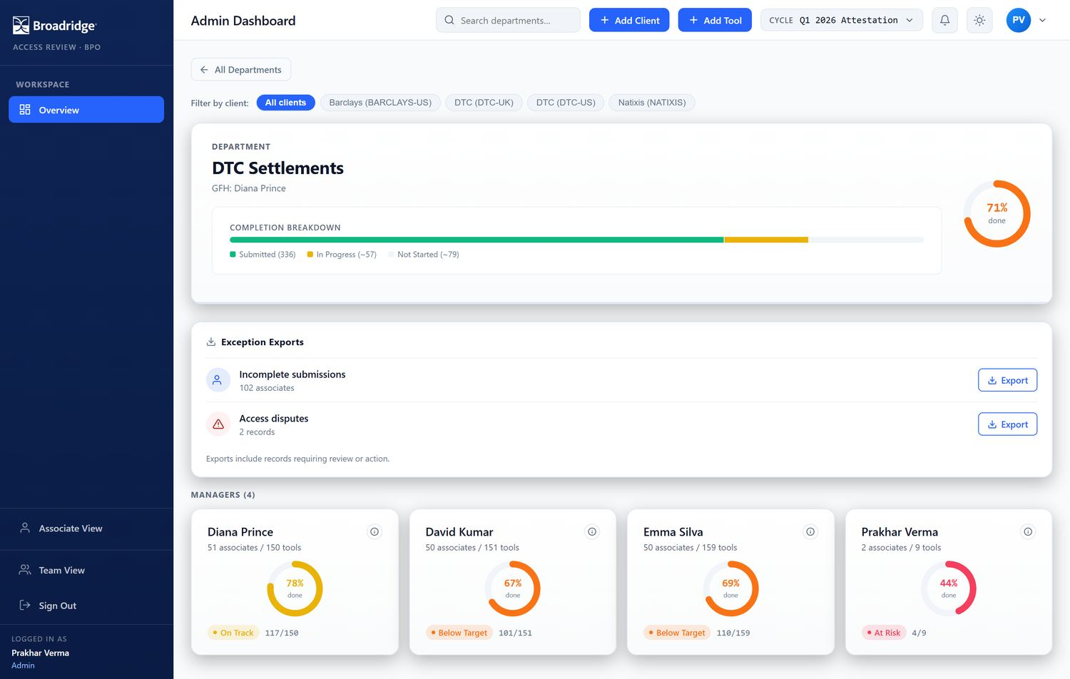
Figure 16 – Department drill-down: completion breakdown, the Exception Exports card, and the managers grid.

6.4 Notifications
The bell in the top bar opens the notifications panel (Figure 17), which highlights departments falling behind as the due date nears, plus a cycle reminder. Use Mark all read to clear the badge.
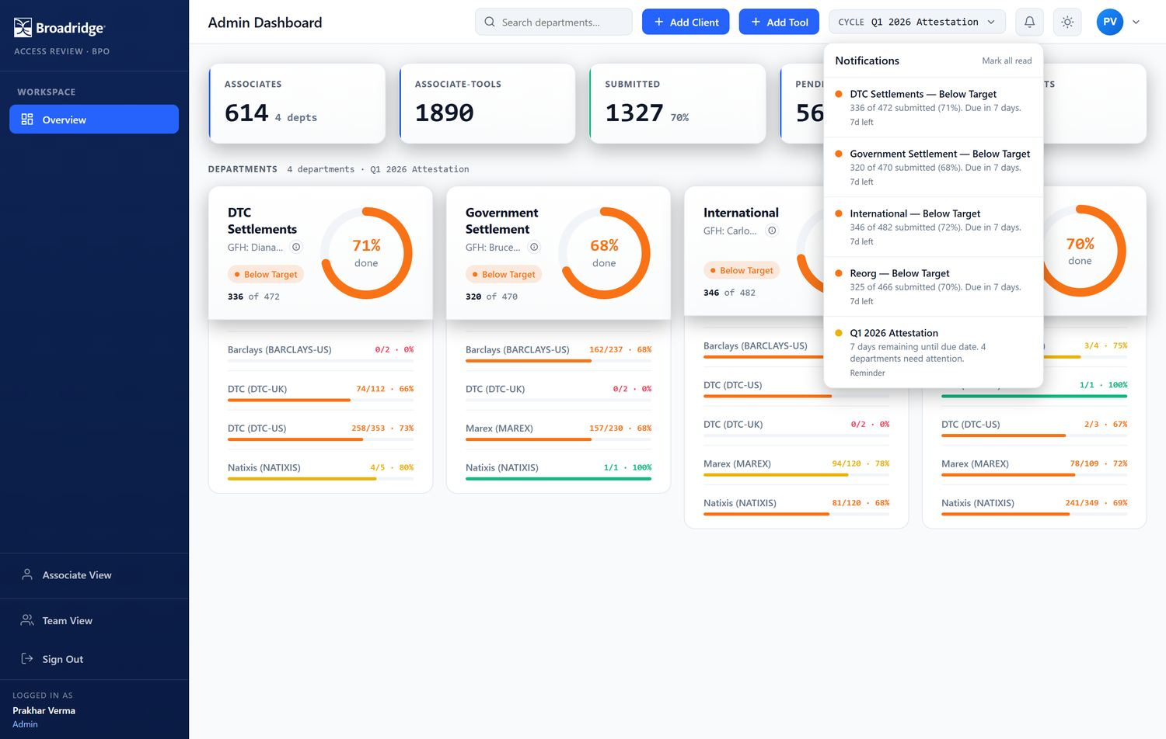
Figure 17 – The notifications panel.

6.5 Adding clients and tools (Admin / GFH / GFH Delegate)
Add a client. Click Add Client, enter a Client ID (text — leading zeros are preserved, e.g. “0039”) and a Client Name, then Add Client (Figure 18).
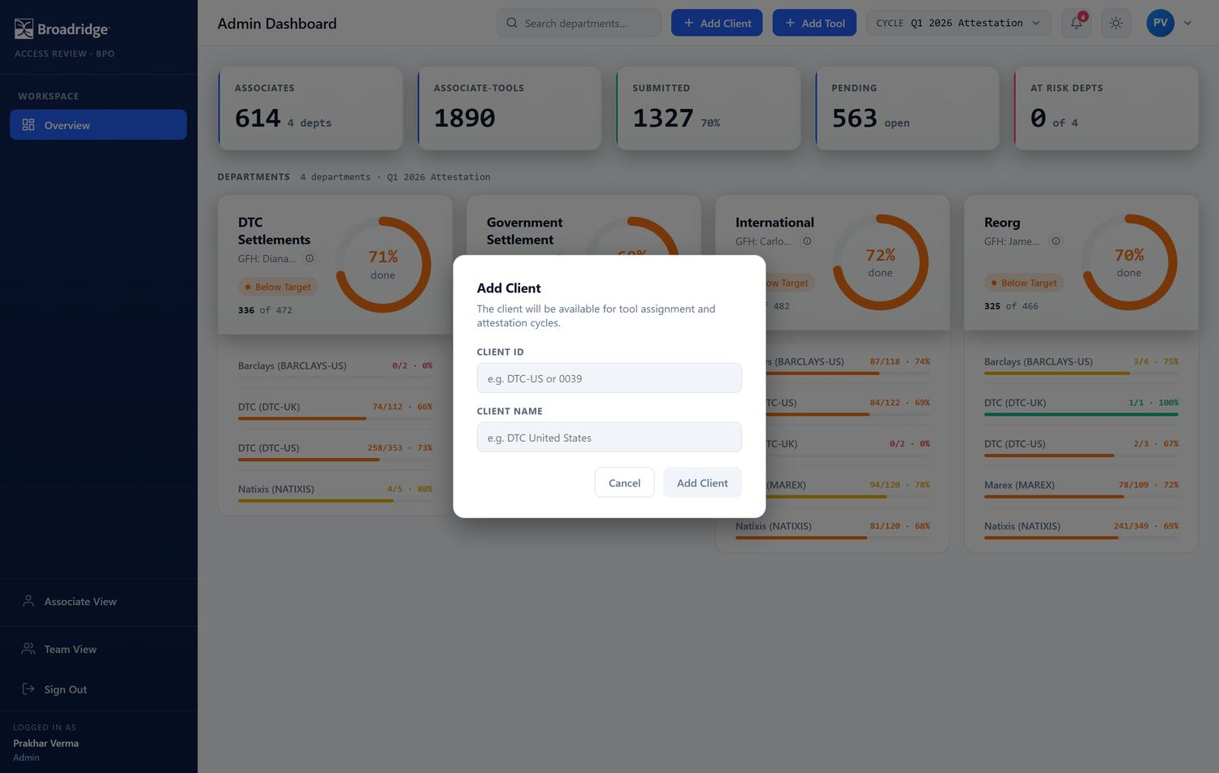
Figure 18 – The Add Client dialog.
Add a tool. Click Add Tool, choose the Client and the Department the tool belongs to, type the Tool Name, then Add Tool (Figure 19). The tool then becomes available for managers in that department to assign.
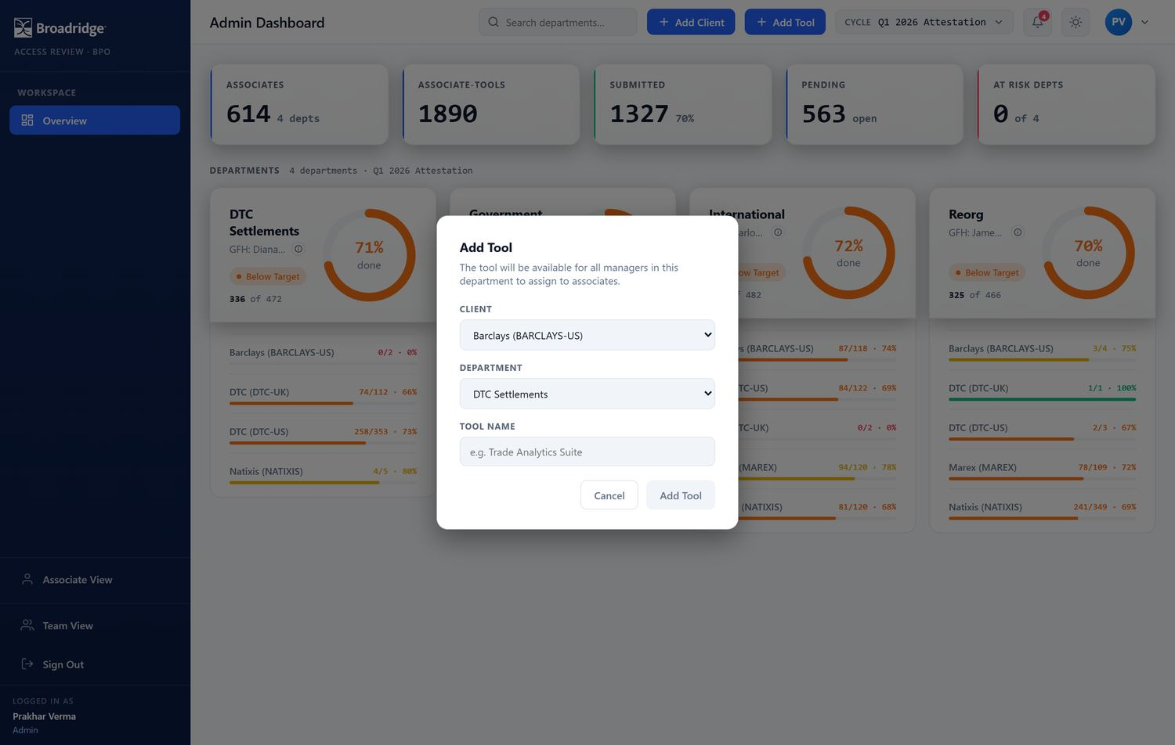
Figure 19 – The Add Tool dialog. The department determines which managers can later grant the tool.

7 User directory (Administrators)
Administrators can open the Users tab for a read-only directory of everyone in the system (Figure 20): associate ID, full name, user name, department, and manager. Use the search box to filter by name, ID, user name, department, or manager.
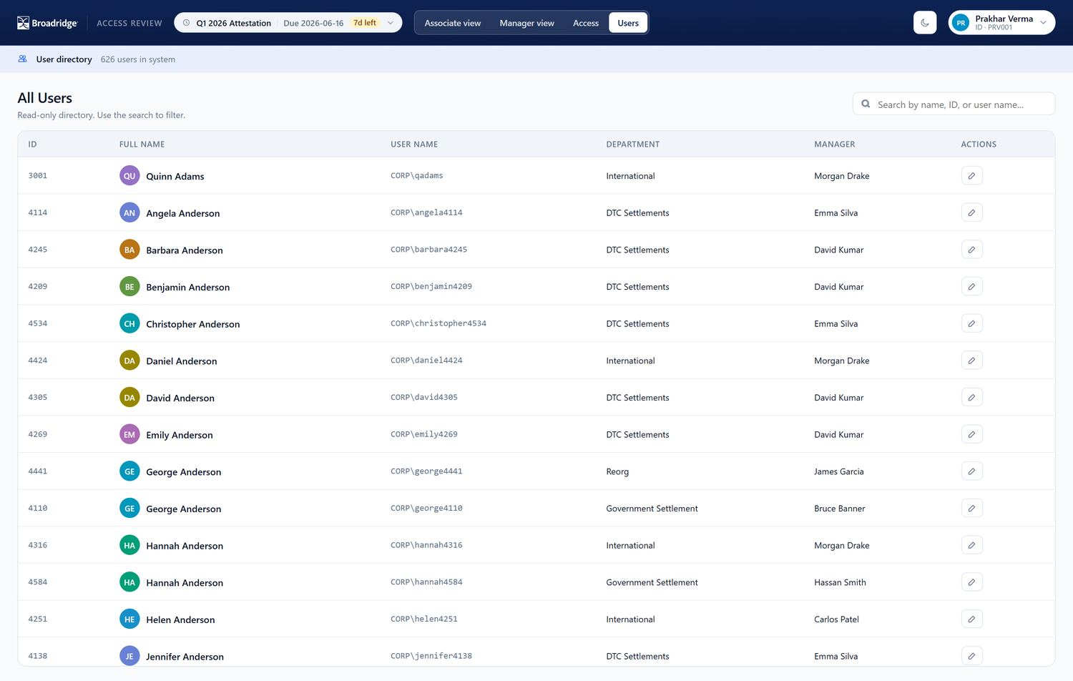
Figure 20 – The user directory. The edit (pencil) action in the last column is available to administrators only.

7.1 Editing a user
Click the pencil icon on a row to open Edit User (Figure 21). You can update the first/last name, user name, department, manager, and e-mail address, then Save.
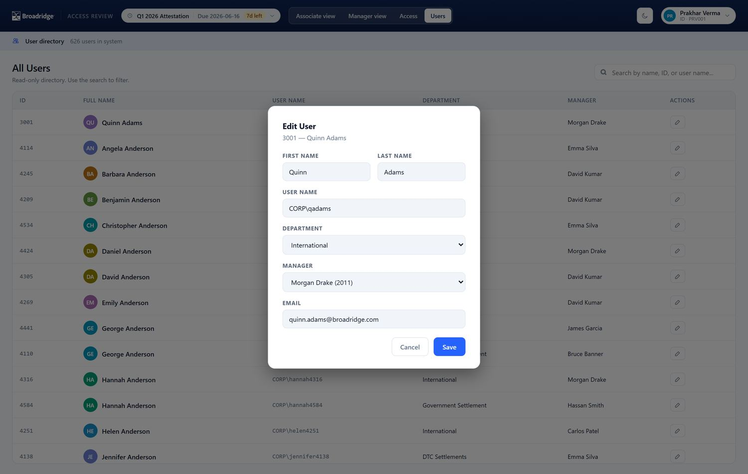
Figure 21 – The Edit User dialog.

IMPORTANT
Changing a user’s Manager immediately moves them into that manager’s team for tracking and access management. Changing the Department affects which tools can be granted to them.

8 Reference

8.1 Completion status thresholds
Department and manager completion is colour-coded by percentage:
Status | Completion
At Risk | below 50%
Below Target | 50% - 74%
On Track | 75% - 89%
Completed | 90% and above

At Risk below 50%
Below Target 50% – 74%
On Track 75% – 89%
Completed 90% and above
Associate / team-member status is reported as Not started (nothing answered), In progress (some answered), or Submitted (all answered / locked).

8.2 Role & permission matrix
Capability | Assoc. | Mgr | IFH | GFH | Admin/Del.
Attest own tools | Yes | Yes | Yes | Yes | Yes
Track a team | - | Yes | - | - | -
Grant / revoke access | - | Yes | - | - | -
Reopen a submission | - | Yes | - | - | -
Department oversight dashboard | - | - | Yes | Yes | Yes
Add clients / tools | - | - | - | Yes | Yes
Org-wide visibility | - | - | - | - | Yes
Edit the user directory | - | - | - | - | Admin only

Attest own tools ✓ ✓ ✓ ✓ ✓ Track a team — ✓ — — — Grant / revoke access — ✓ — — — Reopen a submission — ✓ — — — Department oversight dashboard — — ✓ ✓ ✓ Add clients / tools — — — ✓ ✓ Org-wide visibility — — — — ✓
Edit the user directory — — — — Admin only
Mgr capabilities also apply to any oversight user who happens to manage a team. “Admin/Del.” = Admin and GFH Delegate; only a full Admin can edit the user directory, and only a full Admin sees the whole organisation and the user directory.

8.3 Glossary
Attestation A user’s per-tool confirmation of access and usage for a cycle. Cycle A dated attestation period with a due date. Client An external client supported by the BPO operation. Tool An application/service used for a client. Dispute / No access A tool the user states they should not have; requires a remark.
Full access Active access to a tool. Open access A pending access placeholder (paperwork in process), not yet active. GFH Global Functional Head — owns oversight (and setup) for a department. GFH Delegate An organisation-wide delegate of the GFH function, without user administration. IFH In-Country Functional Head — view-only department oversight. Admin Full administrator: org-wide oversight, setup, and user administration.

8.4 Troubleshooting & FAQ
“We could not verify your sign-in.” Your Windows account is not yet linked to an Access Review user, or your browser did not pass your corporate credentials. Use Edge/Chrome on the corporate network and click Try again; if it persists, contact the administrator. The page loads but shows no data / 404s. Make sure you opened the exact URL http://10.17.69.188/ClientAppAttestation/ (including the trailing slash). I can’t click Submit. Every tool must have an answer, and every No access tool must have a remark. The app shows how many items still need attention. My attestation is locked. You have already submitted. Ask your manager to Reopen it, then edit and re-submit. A tool I need to grant isn’t in the list. Tools are scoped to a department. Ask that department’s GFH or an administrator to add it. My numbers look wrong. Check the cycle picker — you may be viewing a different cycle.
— End of guide — For access or account issues, contact your Access Review administrator.

