Game Design Document
Fill up the Following document

- Write the title of your project.
The lost Treasure of Mars

- What is the goal of the game?
The goal of the game is to find the treasure

- Write a brief story of your game?
Kuro is a shape shifting martian who found the location of the lost treasure of mars and he has set out on a journey to find it. But unlike otherss of his species he can only transform into 3 forms:
red form, blue form, yellow form. He has travelled to earth to find the treasure and must solve multiple puzzles to find to.

- Which are the playing characters of this game?
- Playing characters are the ones which respond to the user based on the input from the user
- Cars, monkeys, dinos, wizards etc, are the playing characters in the game.
Number | Character Name | What can this character do?
1 | Kuro | Run, jump, change color.
2
3
4
5
6
7
8

- Which are the Non Playing Characters of this game?
- Non Playing characters are the ones which don't have an action or a behaviour when the user interacts with the game.
- Hurdles, stones, bananas, coins, etc are non playing characters in the game.
Number | Character Name | What can this character do?
1 | levers | Turn platforms nuetral
2 | platforms | Help to get to higher places
3
4
5
6
7
8

Draw your imagination of this game. What does this game look like?
- Draw the game either on your computer or on paper,
- Add images of scenes of the game to show each of the playing and non-playing characters at least once.

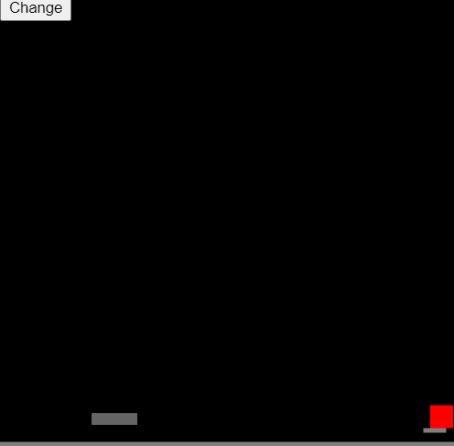

How do you plan to make your game engaging?

By adding puzzles.

