Kubernetes Core Flow

(kubectl, kubelet, scheduling, failure handling)

🧩 1. kubectl vs kubelet
Component | Role
kubectl | CLI → sends commands to API Server
kubelet | Node agent → executes Pods on node
👉
- kubectl = control interface (YOU)
- kubelet = execution engine (SYSTEM)

🧠 2. Node–Kubelet Mapping
- 1 Node = 1 kubelet
- Runs on every node (worker + control-plane)
- Without kubelet → node is useless

🔁 3. How Pod Actually Gets Created

Flow (VERY IMPORTANT)
kubectl → API Server → Scheduler → kubelet → container runtime

Key Insight
- API server does NOT call kubelet
- System is pull-based
👉 kubelet:
- Watches API server
- Picks only Pods where:
nodeName = its own node

⚙️ 4. What kubelet does internally
- Detect assigned Pod
- Validate PodSpec
- Pull image (container runtime)
- Create & start container
- Setup networking (CNI)
- Report status
- Maintain loop (self-healing)
👉 Ensures:
Desired state = Actual state

🆔 5. How kubelets are distinguished
- Each kubelet = Node identity
- Node has:
  - Name (unique)
  - UID
- kubelet only processes its own node’s Pods

💀 6. What if kubelet dies?

Causes
- Crash / bug
- OOM kill
- Manual stop
- Node failure

Timeline
Time | Event
0s | kubelet stops
~40s | Node → NotReady
~5 min | Pods evicted

Important Reality
- Containers may still run ❗
- But cluster stops trusting them

🔁 7. What Kubernetes does after failure
👉 Kubernetes DOES NOT create new node
Instead:
Node fails
↓
Pods marked lost
↓
Scheduler picks other nodes
↓
kubelet there starts new Pods

🔑 Key Principle
Kubernetes moves workloads, not infrastructure

⚖️ 8. Pod Termination Types
Type | Meaning | Safety
Deletion | Normal graceful stop | Medium
Eviction | Policy-controlled (PDB safe) | High
Force Delete | Immediate kill | Low ⚠️

🧠 9. Critical Concepts (Exam Gold)
- Kubernetes is declarative + pull-based
- kubelet watches, not called
- Node failure → Pods recreated elsewhere
- kubelet death ≠ container death
- Eviction = safe deletion with constraints

🔥 Final Mental Model
YOU (kubectl)
↓
API Server (desired state)
↓
Scheduler (assign node)
↓
kubelet (executes)
↓
Containers (running app)

🧩 One-line Summary
Kubernetes doesn’t fix nodes — it replaces Pods on healthy nodes

If you want, I can convert this into:
- 📊 Mind map (like your Docker one)
- 🧠 Memory tricks for exam
- 🎯 10 MCQs based on this
Just tell me.

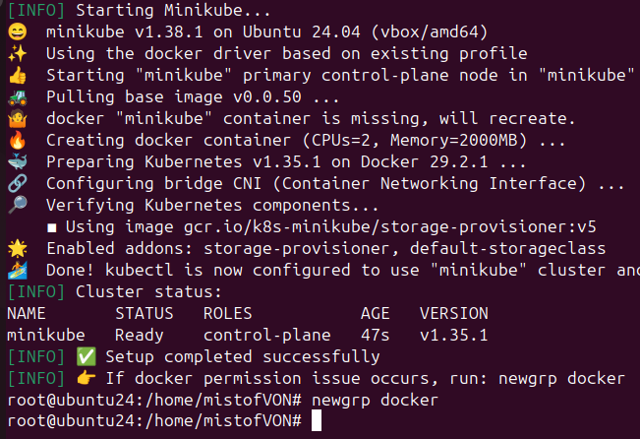
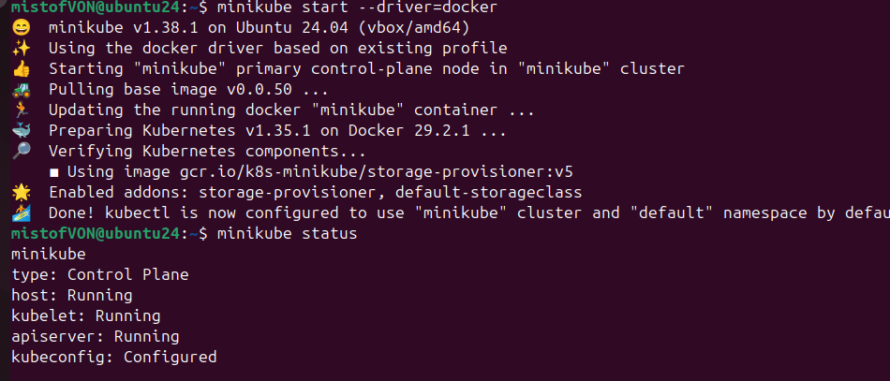

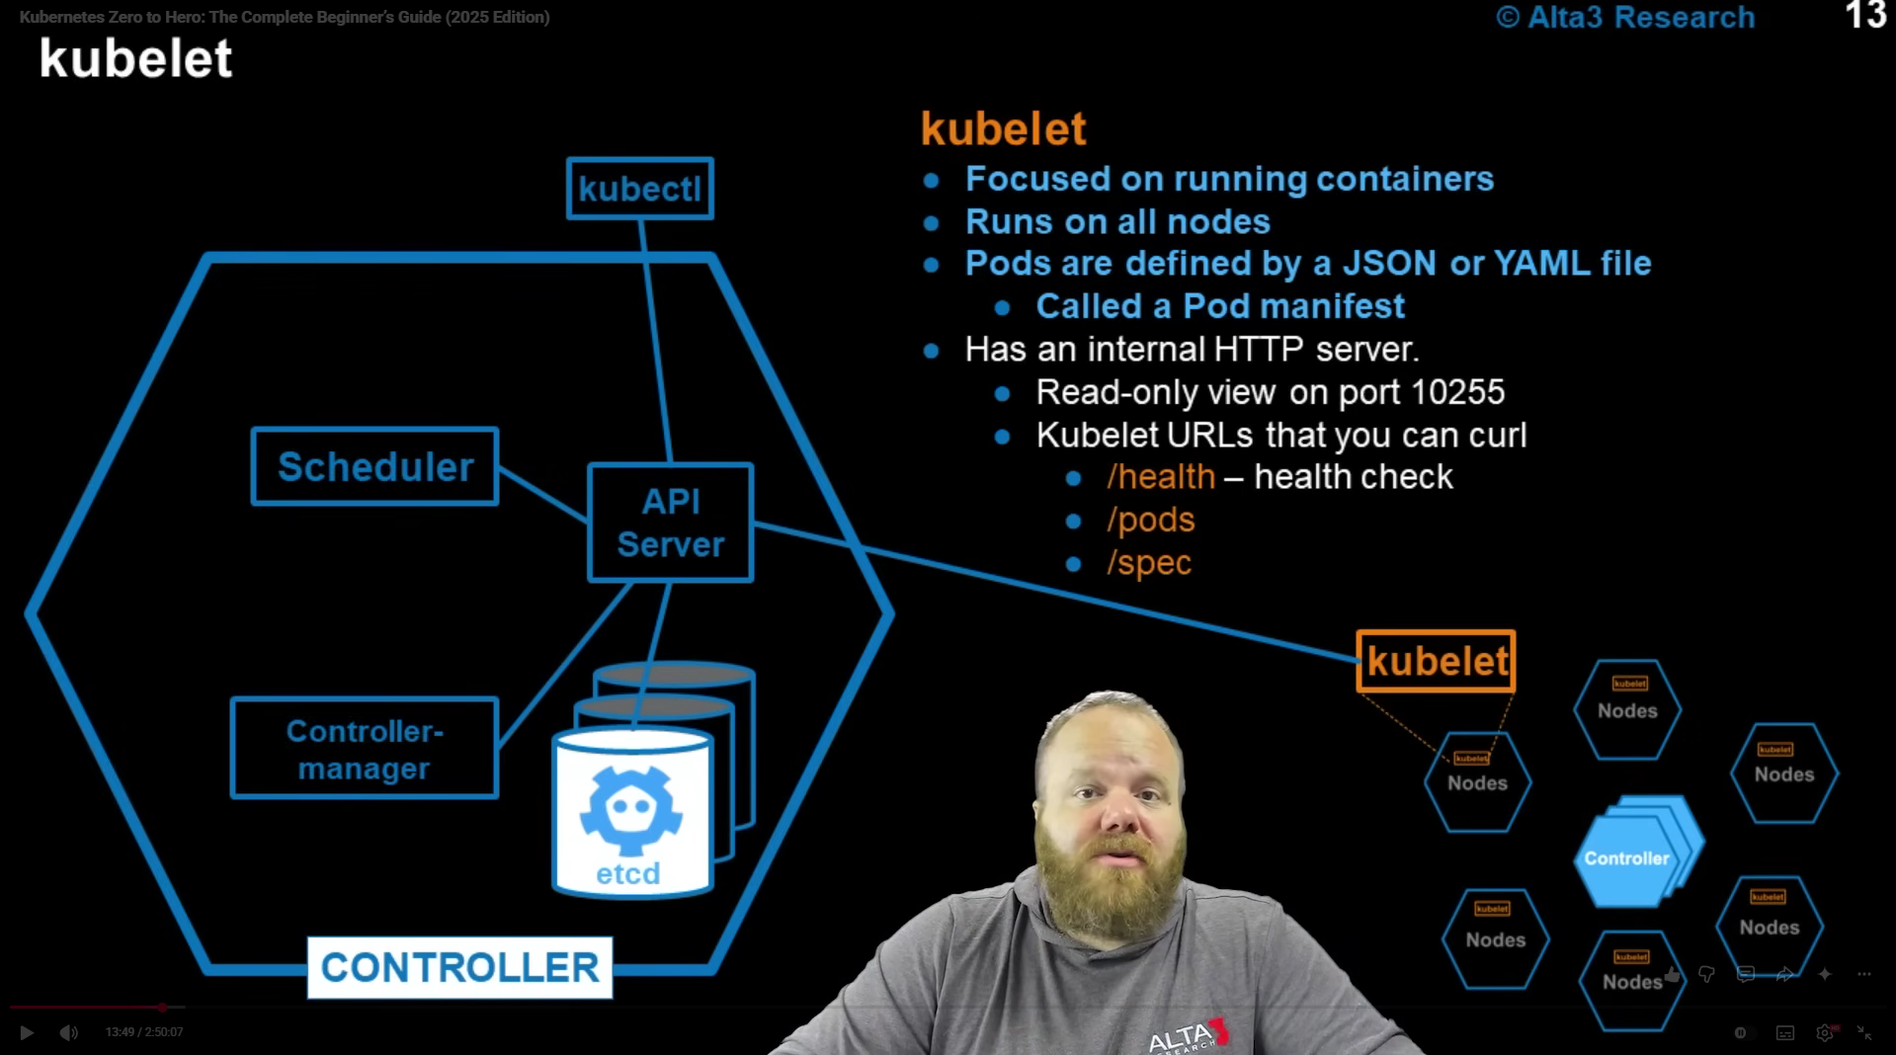
Control Plane Components
🔹 API Server
- Main entry point of Kubernetes (like a gatekeeper)
- Receives all requests from kubectl
- Stores and retrieves cluster data from etcd
🔹 Scheduler
- Decides which node should run a Pod
- Checks CPU, memory, constraints
- Assigns Pod → specific node
🔹 Controller Manager
- Ensures desired state = actual state
- Watches cluster and fixes issues (like restarting Pods)
- Examples: ReplicaSet, Node controller
🔹 etcd
- Database of Kubernetes
- Stores all cluster data (Pods, nodes, configs)
- If etcd is lost → cluster state is lost

🧑‍💻 Client
🔹 kubectl
- Command-line tool used by users
- Sends commands to API Server
- Used to create, delete, debug resources
⚙️ Node Component
🔹 kubelet
- Runs on every node (agent of that node)
- Watches API Server for assigned Pods
- Creates and manages containers
🔧 kubelet internal features (from image)
- Reads Pod manifest (YAML/JSON)
- Talks to container runtime (Docker/containerd)
- Has internal endpoints:
  - /health → check status
  - /pods → running pods
  - /spec → node info
🧠 Simple Flow (connect everything)
kubectl → API Server → Scheduler → kubelet → Containers
🔑 Final Understanding
- Control Plane = brain (decision making)
- kubelet = worker (execution)
- kubectl = user interface

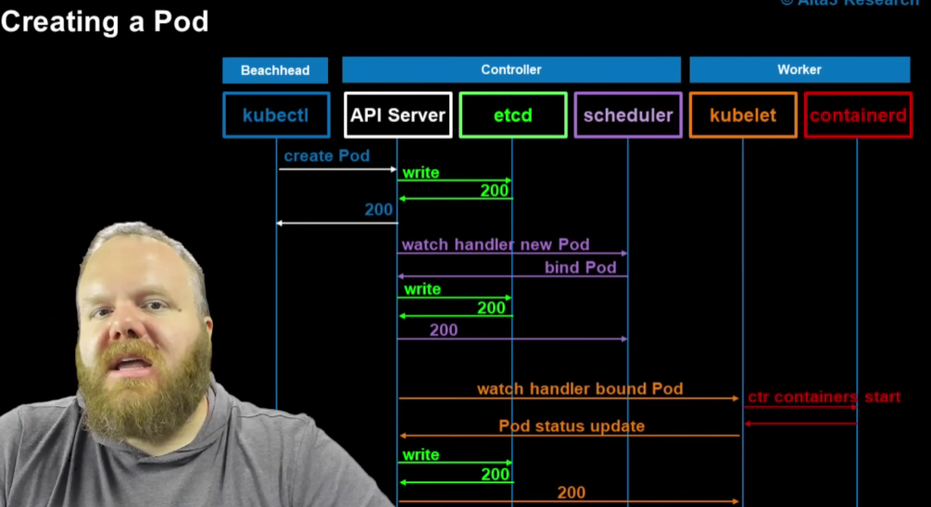
🧠 Big Idea
Kubernetes works like a pipeline:
kubectl → API Server → Scheduler → kubelet → container runtime
🔁 Step-by-Step (Simple)
1️⃣ You create a Pod
- You run:
kubectl apply -f pod.yaml
- kubectl sends request to API Server
👉 “I want this Pod”
2️⃣ API Server stores it
- API Server saves Pod info in etcd (database)
- Pod is created but not assigned to any node yet
👉 Pod = “pending”
3️⃣ Scheduler decides where to run
- Scheduler sees new Pod
- Chooses best node
- Assigns:
nodeName: node-1
👉 “Run this Pod on this node”
4️⃣ kubelet picks it up
- kubelet (on that node) is watching API Server
- Sees Pod assigned to itself
👉 “This is my job”
5️⃣ kubelet starts the container
- Talks to container runtime (containerd)
- Steps:
  - Pull image
  - Create container
  - Start container
👉 Your app starts running
6️⃣ Status is updated
- kubelet sends status back:
status: Running
- API Server updates etcd
👉 Now cluster knows Pod is running
🔄 Visual Flow (Easy Memory)
kubectl → API Server → etcd
↓
Scheduler
↓
kubelet
↓
containerd
↓
Pod Running
🔑 Important Insights
- API Server = central brain
- Scheduler = decision maker
- kubelet = executor
- containerd = actually runs containers
🧩 One-line Summary
You request a Pod → Kubernetes decides where → kubelet runs it → container starts
CREATE A YMAL FILE
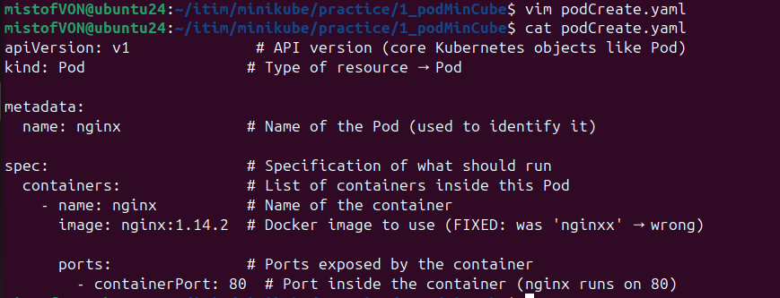

apiVersion: v1 # API version (core Kubernetes objects like Pod)
kind: Pod # Type of resource → Pod
metadata:
name: nginx # Name of the Pod (used to identify it)
spec: # Specification of what should run
containers: # List of containers inside this Pod
- name: nginx # Name of the container
image: nginx:1.14.2 # Docker image to use (FIXED: was 'nginxx' → wrong)
ports: # Ports exposed by the container
- containerPort: 80 # Port inside the container (nginx runs on 80)

DRY RUN THEN APPLY

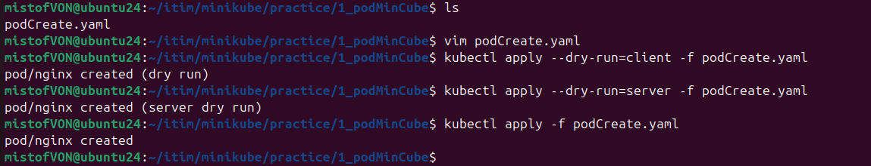
Feature | create | apply
Creates resource | ✅ Yes | ✅ Yes
Updates resource | ❌ No | ✅ Yes
Repeatable | ❌ No | ✅ Yes
Style | Imperative | Declarative
Best for | Quick creation | Real deployments / CI/CD

- create → “Create it once”
- apply → “Create OR update it repeatedly (declarative)”
⚙️ 1. kubectl create
📌 Behavior
- Creates a resource only if it doesn’t exist
- Fails if the object already exists
⚙️ 2. kubectl apply
📌 Behavior
- Creates resource if not present
- Updates it if already exists

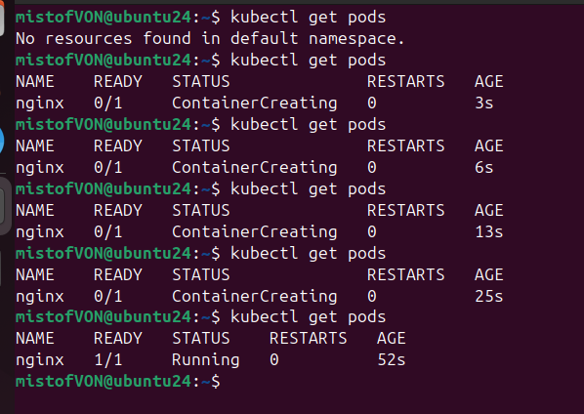

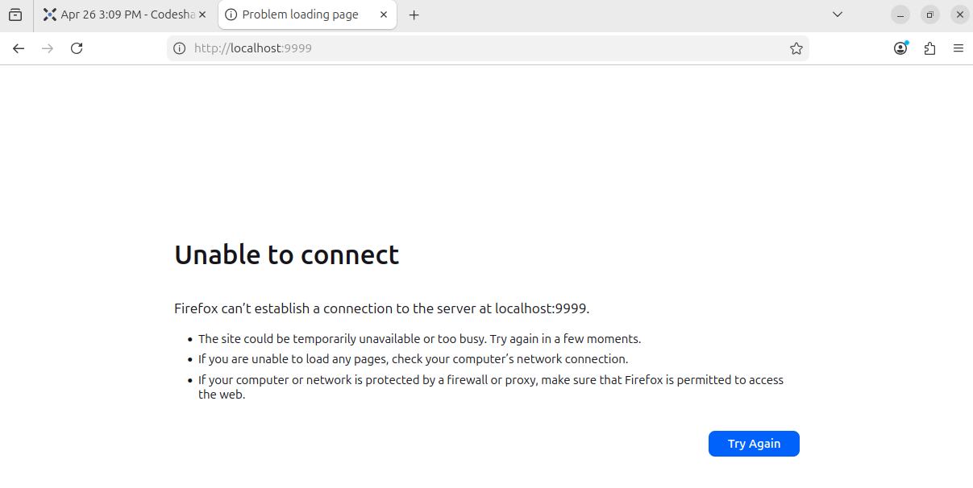

PORT FORWARDING
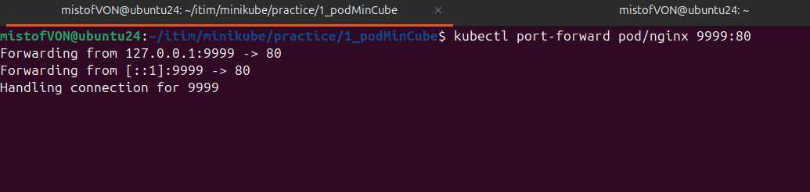
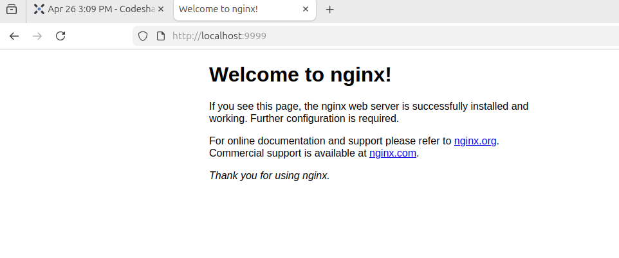

Describe Pod

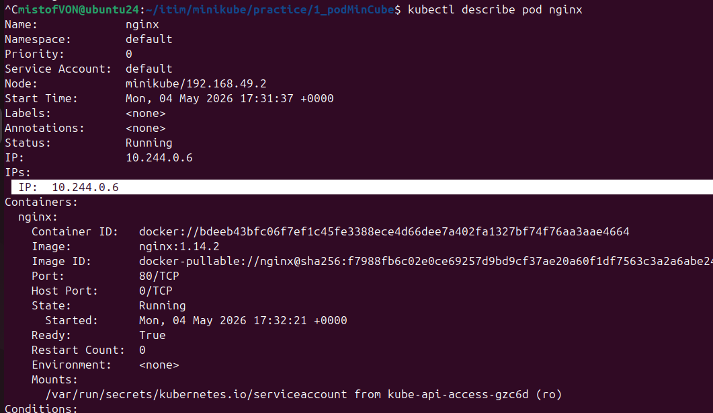
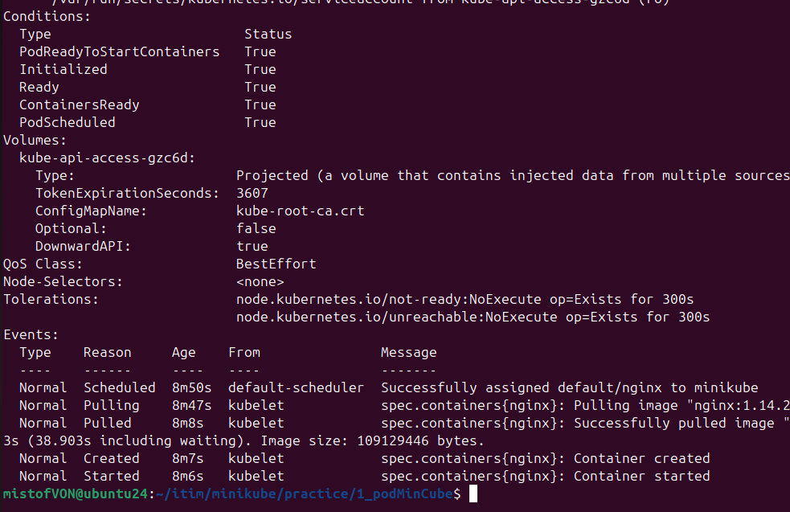

DELETE POD
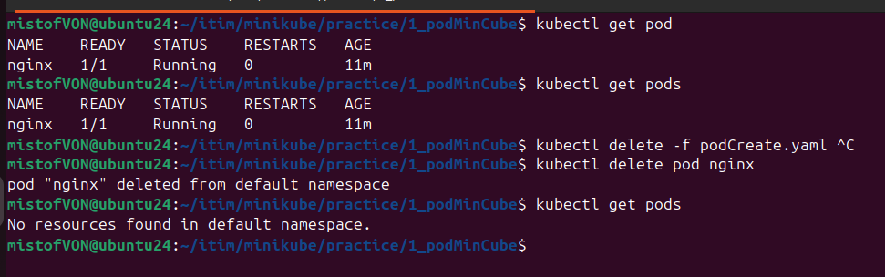

NAMESPACE

What is a Pod Namespace in Kubernetes?
Namespace = a logical partition inside a cluster to organize and isolate resources (like Pods, Services, etc.)

🧠 Simple Understanding
Think of a namespace like a folder
Inside it, you keep related Pods and resources
Cluster
├── namespace: dev
│ ├── pod1
│ ├── pod2
│
├── namespace: prod
├── podA
├── podB

apiVersion: v1
kind: Pod
metadata:
name: nginx
namespace: dev # ← namespace defined here
spec:
containers:
- name: nginx
image: nginx
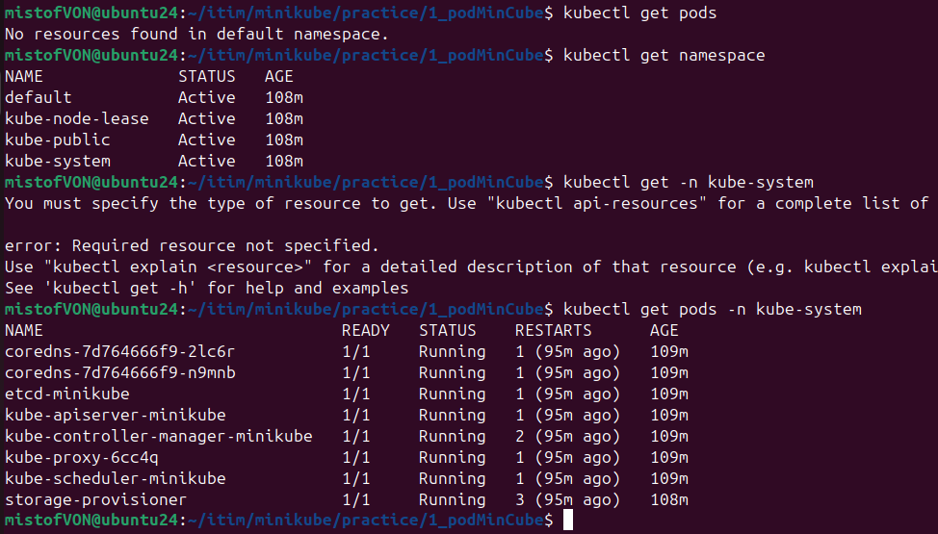

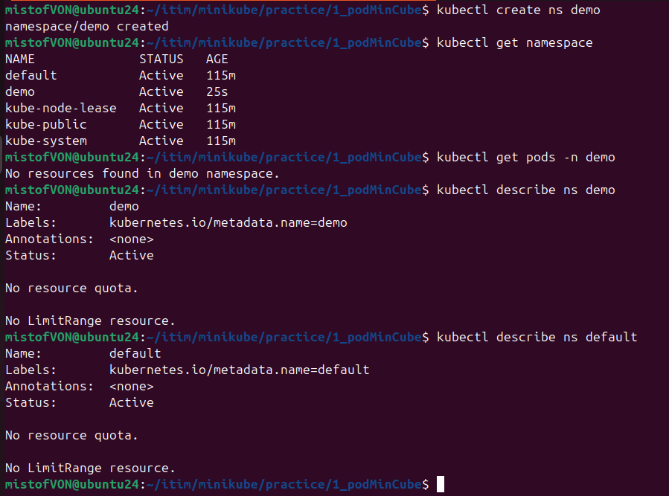

Merix

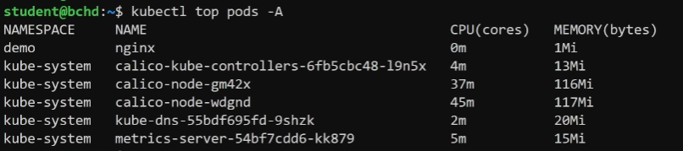

RESOURCES
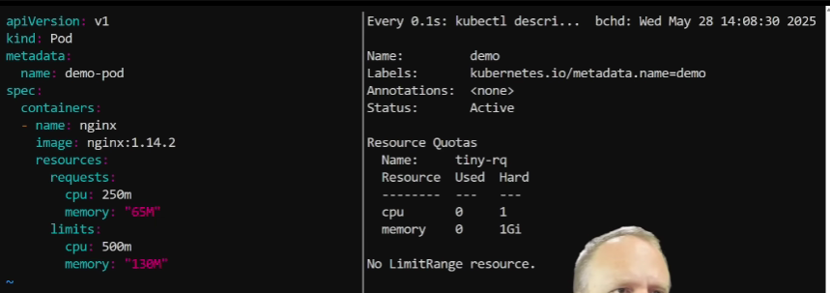
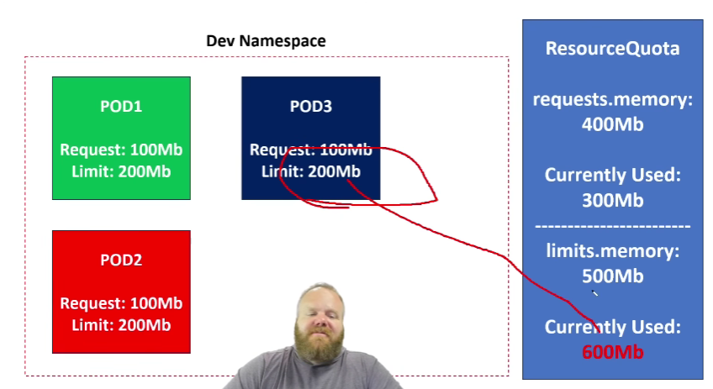

REDINESS PROB

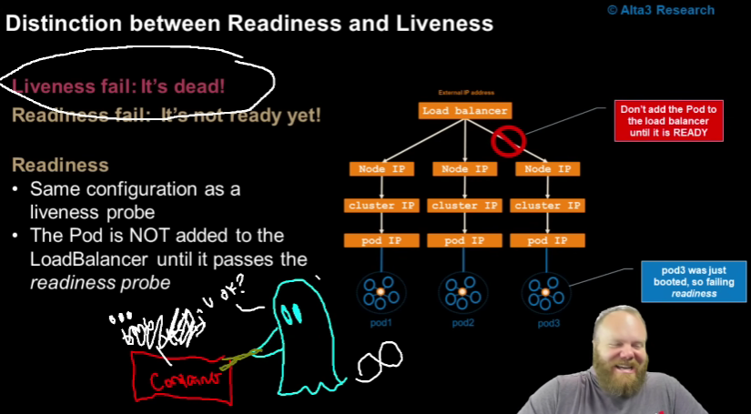

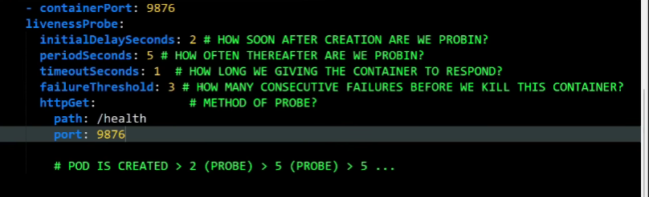

RUN POD PORTFORWADING EXEC
kubectl run = fast, temporary Pod creation
kubectl apply = structured, repeatable, and update-friendly deployment method
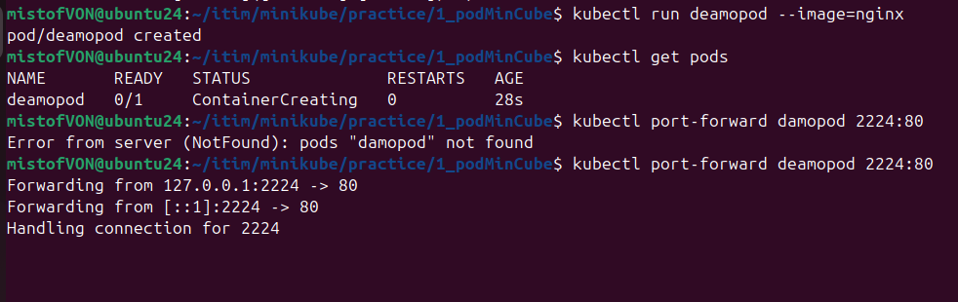

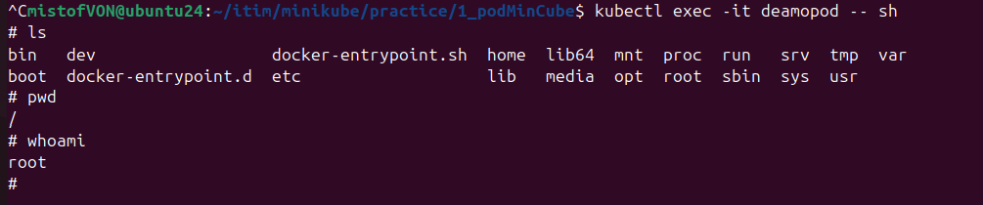

Labls
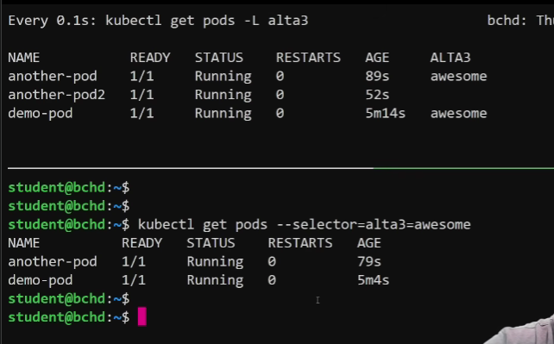

DEployent
Deployment ensures your application is always running by automatically creating, replacing, and updating Pods to match the desired state.

kubectl create deployment nginx-deploy --image=nginx
kubectl scale deployment nginx-deploy --replicas=3

kubectl create deployment nginx-deploy --image=nginx --replicas=3
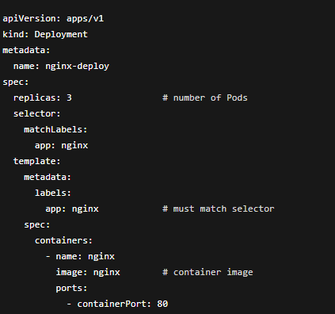

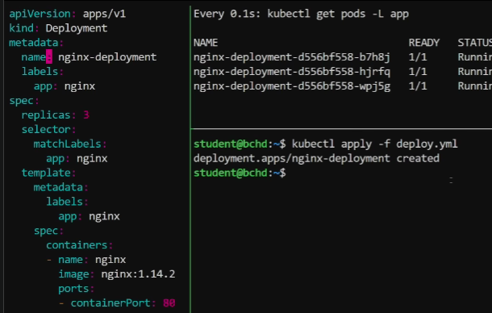

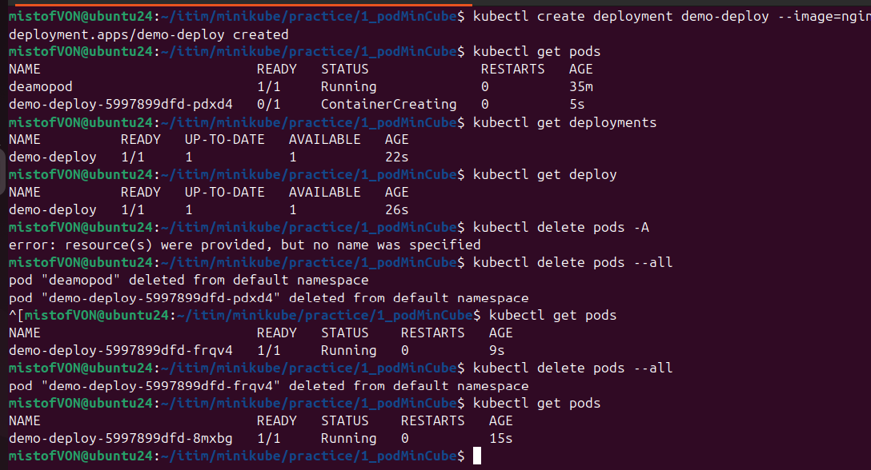

Delete deployment

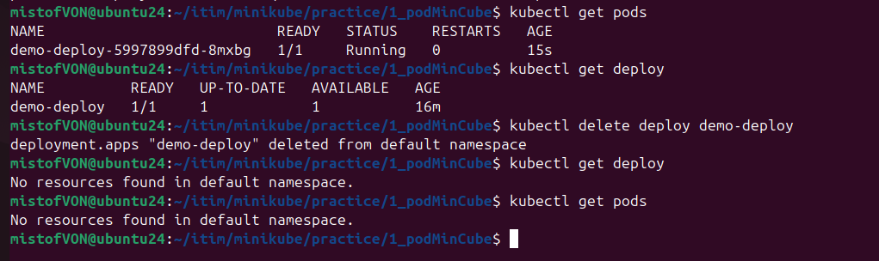

Scaling = changing how many Pod instances (replicas) run your application
- Scale up → increase Pods (handle more load)
- Scale down → decrease Pods (save resources)

🔁 Why scaling matters
- Handle traffic spikes (more users → more Pods)
- Improve availability (multiple replicas)
- Optimise cost (reduce replicas when idle)
- Scale up
kubectl scale deployment nginx-deploy --replicas=5
- Scale down
kubectl scale deployment nginx-deploy --replicas=2

