“Metrics from hell?” — yeah, that’s exactly what Docker fixes
Without Docker, teams get stuck in environment inconsistency metrics hell:
- “Works on my machine” bugs
- Different OS / library versions → unpredictable failures
- Deployment success rate drops
- Debug time increases (huge hidden cost)
- Scaling becomes messy (manual + error-prone)
Docker standardizes runtime → same app, same behavior everywhere
➡️ Result: stable deployments, fewer surprises, measurable reliability.

Why do you need Docker?
- Consistency → same environment across dev, test, prod
- Isolation → apps don’t conflict (no dependency clashes)
- Portability → run anywhere (laptop, server, cloud)
- Fast deployment → ship as container, not setup steps
- Scalability → spin multiple instances easily
- Efficiency → lighter than VMs (shares OS kernel)

In one line
Docker removes environment-related uncertainty and makes software predictable to build, ship, and run.
If you want, I can connect this directly to your Docker Swarm issue you were facing — that’s where this really clicks.

Docker
1. Problem Before Docker
- Applications behaved differently across environments
- Challenges faced:
  - Compatibility issues
  - Difficult to build and ship applications
  - Changing one component affected others
  - Hard to modify underlying OS when needed
- Needed a solution that:
  - Ensures compatibility
  - Allows independent modification of components
  - Works across different systems

2. Introduction to Docker
- Docker solved these problems by:
  - Allowing each component to run in separate containers
  - Each container has:
    - Its own dependencies
    - Its own libraries
- All containers run:
  - On the same VM
  - On the same OS
  - But inside isolated environments

3. Key Advantage
- Build Docker configuration once
- Developers can run using:
- docker run
- Works irrespective of underlying OS
- Only requirement:
  - Docker must be installed on the system

4. What are Containers?
- Containers are completely isolated environments
- Each container can have:
  - Its own processes/services
  - Its own network interfaces
  - Its own mounts (file systems)
- Analogy:
  - Like separate machines (e.g., washing machines)
  - But all share the same OS kernel

5. Important Note About Containers
- Containers are not new
  - Exist for ~10 years
- Types of containers:
  - LXC (Linux Containers)
  - LXD
  - Others (low-level implementations)
- Docker uses LXC-based concepts

6. Why Docker is Important
- Setting up containers manually is:
  - Complex
  - Low-level
- Docker provides:
  - High-level tools
  - Easy-to-use interface
  - Powerful functionalities
- Makes container usage simple for developers
7. Operating System Basics (Required for Docker Understanding)
Operating System Components
Every OS consists of:
- OS Kernel
- Software Layer
OS Kernel
- Responsible for:
  - Interacting with hardware
- Example:
  - Linux kernel
Software Layer
- Defines the OS distribution differences:
  - Ubuntu
  - Fedora
  - SUSE
  - CentOS
- Includes:
  - User interfaces
  - Drivers
  - Additional software

8. Key Insight
- OS distributions differ not because of kernel
- They differ because of the software layer above the kernel

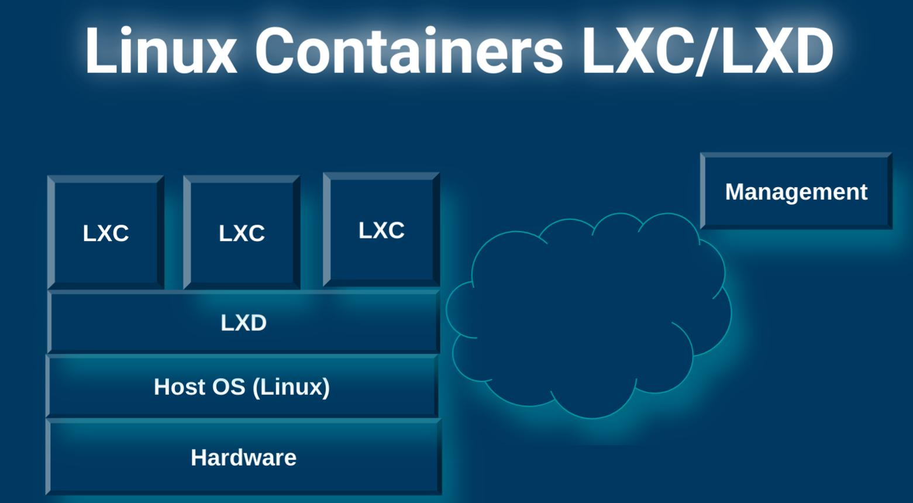

Docker Commands – Ultra Short Revision
Run & Pull
- docker run <image> → run container
- Pulls from Docker Hub if not present
- docker pull <image> → download only

List Containers
- docker ps → running containers
- docker ps -a → all containers

Stop & Remove
- docker stop <id/name> → stop container
- docker rm <id/name> → delete container
- docker rmi <image> → delete image (no containers using it)

Images
- docker images → list images

Container Behavior
- Runs a process, not full OS
- Stops when process ends
- Example:
  - docker run ubuntu → exits immediately
  - docker run ubuntu sleep 5 → runs 5 sec

Execute Inside Container
- docker exec <id> <cmd> → run command inside container

Modes
- Default → foreground (blocks terminal)
- -d → detached (background)

Attach
- docker attach <id> → reconnect to container

Core Idea
A container lives only while its process runs.

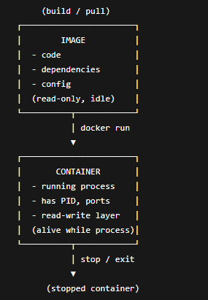
Image = what to run
Container = running instance of it
No docker run → no container exists

Image ≈ ISO / VM template (blueprint)
Container ≈ Running VM instance (but lighter)

⚠️ But one important correction
A container is NOT a full VM.
Difference:
- VM → runs full OS
- Container → runs just a process on the host OS
Containers start faster because they reuse the host OS kernel and only launch a process, while VMs must boot an entire operating system from scratch.
• VM startup = powering ON a laptop
• Container startup = opening Chrome

IMAGE
operations = download, tag, build, push, delete, inspect

Operations you can perform on Docker Images
🔽 1. Pull (download from Docker Hub)
docker pull nginx
- Gets image from registry → local system
- Like downloading a file
If you type just nginx, Docker assumes:
docker.io/library/nginx:latest
- Registry: docker.io (Docker Hub)
- Namespace: library (official images)
- Repo: nginx
- Tag: latest
- You can be explicit:
- docker pull docker.io/library/nginx:1.25
docker pull ghcr.io/nginx/nginx:latest
docker pull registry.k8s.io/pause:3.9
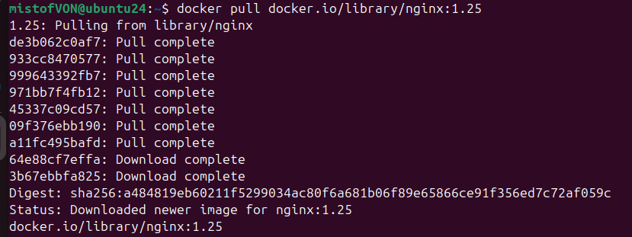

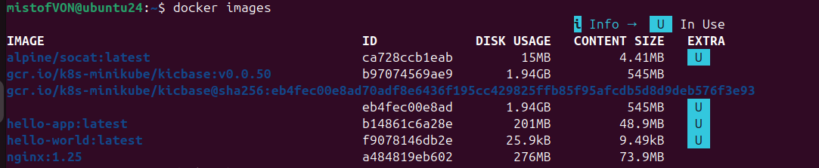

Verify where it came from
docker image inspect nginx --format '{{.RepoTags}} {{.RepoDigests}}'
- RepoTags → human tags (nginx:latest)
- RepoDigests → immutable content address (e.g. nginx@sha256:...)

2) How does the image actually come? (layers + registry API)
What happens internally
- Docker CLI → talks to dockerd
- dockerd → contacts registry API
- Downloads:
  - manifest (what layers exist)
  - layers (blobs) = compressed filesystem chunks
- Stores them locally (content-addressed by SHA256)
🔍 Verify the layers you got
docker history nginx
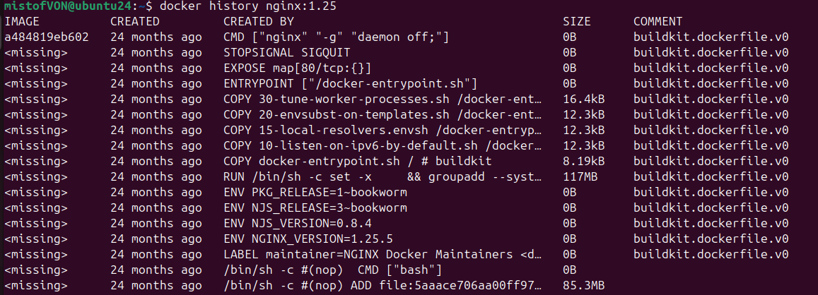
- Shows each layer (size + command)
docker image inspect nginx --format '{{json .RootFS.Layers}}' | jq
- Exact layer digests

3) Where are images stored on your machine?
On Linux (default)
/var/lib/docker/
├── image/
├── overlay2/ # filesystem layers
└── containers/
🔍 Verify disk usage
docker system df
docker system df -v

🔍 Explore a layer (advanced)
docker inspect nginx --format '{{.GraphDriver.Data.UpperDir}}'

2. List images
docker images
- Shows:
  - Repository
  - Tag
  - Image ID
  - Size

3. Tag (rename / version it)
docker tag nginx my-nginx:v1
- Creates a new name or version
- Useful before pushing to your repo
👉 Think:
Same image, different label

4. Build (create your own image)
docker build -t myapp:v1 .
- Uses Dockerfile
- Converts your app → image

5. Push (upload to registry)
docker push my-nginx:v1
- Upload to:
  - Docker Hub
  - Private registry

6. Remove image
docker rmi nginx
- Deletes image from local system
⚠️ Only if no containers are using it

7. Inspect image (deep info)
docker inspect nginx
- Gives:
  - Layers
  - Metadata
  - Config

8. History (layer breakdown)
docker history nginx
- Shows how image was built layer-by-layer

9. Clean unused images
docker image prune
- Removes unused images

Real Flow (how it's actually used)
pull → run → modify → build → tag → push

