Practical: LVM Configuration (Comprehensive)
Can use any available disk (like /dev/sda, /dev/sdb) instead of /dev/nvme0n1, depending on your system’s device naming.
Question
You are given a disk /dev/sdb with free space. Perform the following tasks:
Physical Volume (PV)
- Create two partitions on /dev/sdb:
  - /dev/sdb1 → 4GB
  - /dev/sdb2 → 4GB
- Initialise both partitions as Physical Volumes
- Verify PV creation
Volume Group (VG)
- Create a Volume Group named vgdata using both PVs
- Verify VG details
- Display:
  - Total size
  - Free space
  - Physical Extent (PE) size (default)
- Create another Volume Group vgcustom with custom PE size (e.g., 16MB)
Logical Volumes (LV)
- Create a Logical Volume lvsize of 2GB in vgdata (size-based)
- Create a Logical Volume lvext using Logical Extents (e.g., percentage of free space)
- Create a Logical Volume lvcustom in vgcustom using extents
Formatting (Different File Systems)
- Format:
  - lvsize → XFS
  - lvext → xfs
  - lvnext → xfs
Mounting
Temporary:
- Mount:
  - lvsize → /mnt/data1
  - lvnext → /mnt/data2
Permanent:
- Mount lvnext → /mnt/backup using UUID in /etc/fstab
Verification
- Verify:
  - Physical Volumes
  - Volume Groups
  - Logical Volumes
  - Filesystem types
  - Mounted filesystems
LVM Management (Resize Operations)
- Extend lvsize by 1GB
- Resize the filesystem accordingly
- Reduce lvext by 500MB (after unmounting)
- Resize the filesystem safely before reduction
Cleanup (WITHOUT reboot)
- Unmount all logical volumes
- Remove entries from /etc/fstab
- Remove Logical Volumes
- Remove Volume Groups
- Remove Physical Volumes
- Delete partitions
- Apply changes

------------------------command------------------------------

# ===============================
# STEP 1: Create partitions (4GB + 4GB + extra for custom VG)
# ===============================
fdisk /dev/sdb
# n → p → 1 → Enter → +4G
# n → p → 2 → Enter → +4G
# n → p → 3 → Enter → +2G
# t → 1 → 8e
# t → 2 → 8e
# t → 3 → 8e
# w

partprobe
lsblk

# ===============================
# STEP 2: Create Physical Volumes
# ===============================
pvcreate /dev/sdb1 /dev/sdb2 /dev/sdb3

# Verify
pvs
pvdisplay

# ===============================
# STEP 3: Create Volume Groups
# ===============================
vgcreate vgdata /dev/sdb1 /dev/sdb2
vgcreate -s 16M vgcustom /dev/sdb3

# Verify
vgs
vgdisplay

# ===============================
# STEP 4: Create Logical Volumes
# ===============================
lvcreate -L 2G -n lvsize vgdata
lvcreate -l 50%FREE -n lvext vgdata
lvcreate -l 100%FREE -n lvnext vgcustom

# Verify
lvs
lvdisplay

# ===============================
# STEP 5: Format Filesystems (all xfs as per your work)
# ===============================
mkfs.xfs /dev/vgdata/lvsize
mkfs.xfs /dev/vgdata/lvext
mkfs.xfs /dev/vgcustom/lvnext

# ===============================
# STEP 6: Mount (Temporary)
# ===============================
mkdir -p /mnt/data1 /mnt/data2 /mnt/backup

mount /dev/vgdata/lvsize /mnt/data1
mount /dev/vgcustom/lvnext /mnt/data2

# ===============================
# STEP 7: Permanent Mount
# ===============================
blkid

vi /etc/fstab
# Add:
# UUID=xxxx /mnt/backup xfs defaults 0 0

systemctl daemon-reload
mount -a

# ===============================
# STEP 8: Verification
# ===============================
pvs
vgs
lvs
lsblk -f
df -h

# ===============================
# STEP 9: Extend LV
# ===============================
lvextend -L +1G /dev/vgdata/lvsize
xfs_growfs /mnt/data1

# ===============================
# STEP 10: Reduce LV (correct safe method)
# ===============================
umount /dev/vgdata/lvext
lvreduce -L 1.5G /dev/vgdata/lvext
mkfs.xfs -f /dev/vgdata/lvext
mount /dev/vgdata/lvext /mnt/data2

# ===============================
# STEP 11: Cleanup (WITHOUT reboot)
# ===============================
umount /mnt/data1
umount /mnt/data2
umount /mnt/backup

vi /etc/fstab
# remove added entry

lvremove /dev/vgdata/lvsize -y
lvremove /dev/vgdata/lvext -y
lvremove /dev/vgcustom/lvnext -y

vgremove vgdata
vgremove vgcustom

pvremove /dev/sdb1 /dev/sdb2 /dev/sdb3

fdisk /dev/sdb
# d → delete all → w

partprobe

lsblk
-------------------------x-----------------------------------------
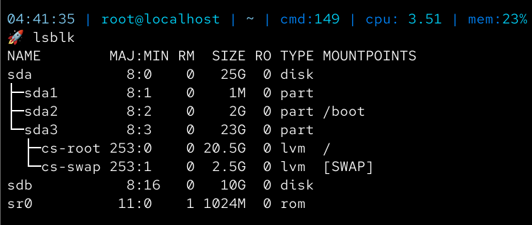

Physical Volume (PV)
- Create two partitions on /dev/sdb:
  - /dev/sdb1 → 4GB
  - /dev/sdb2 → 4GB
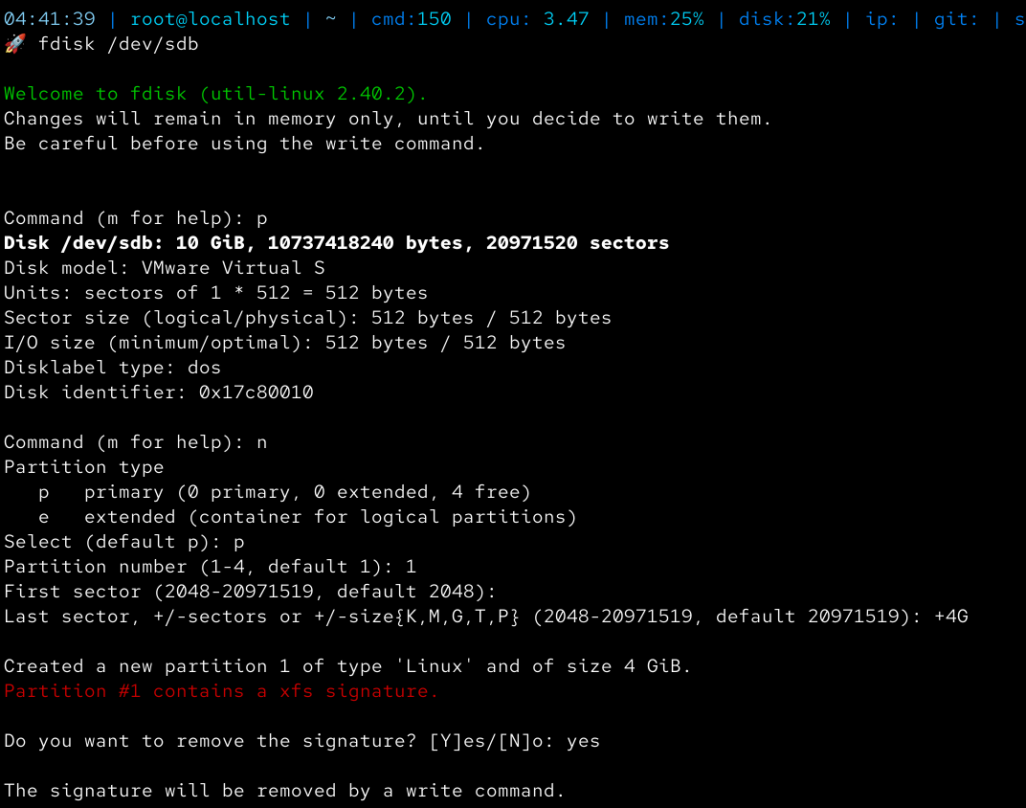

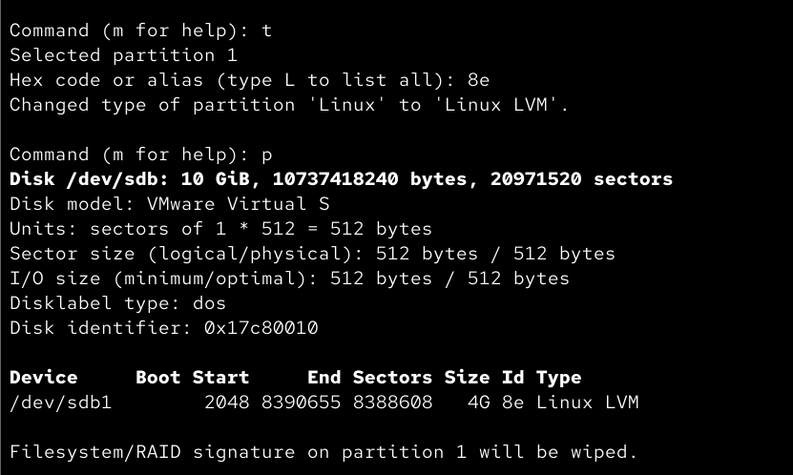

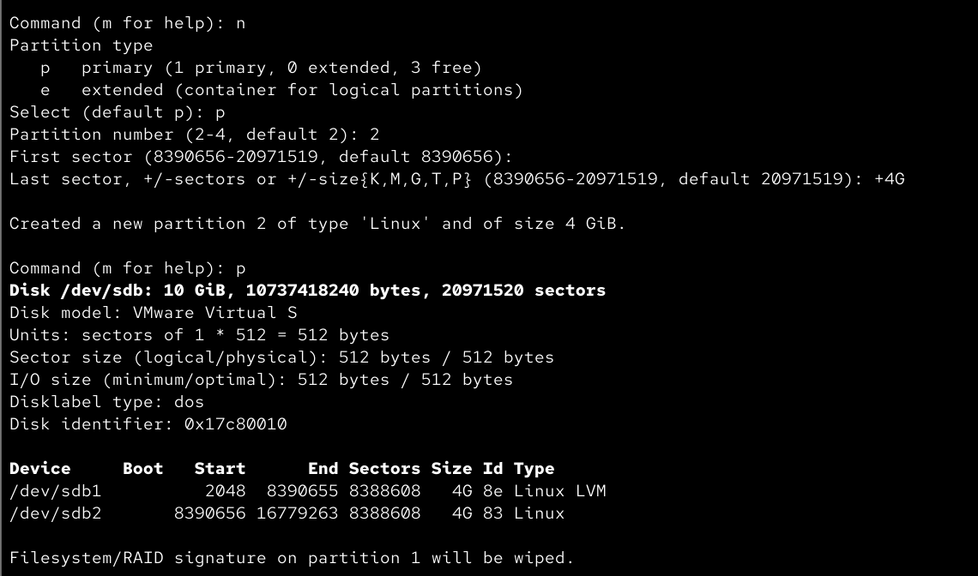

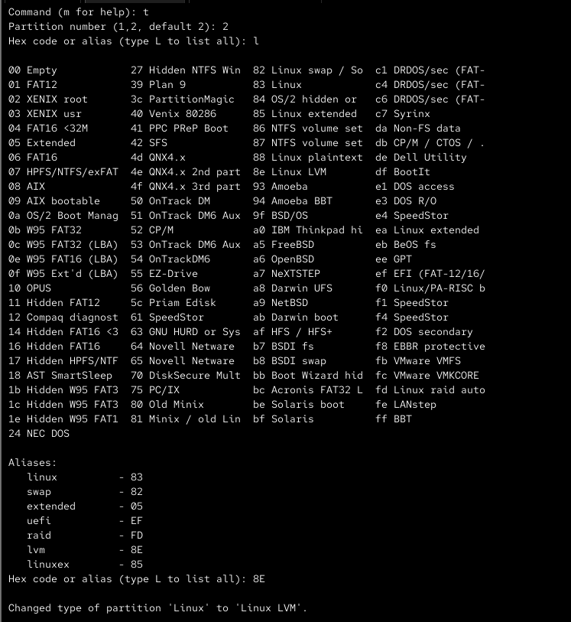

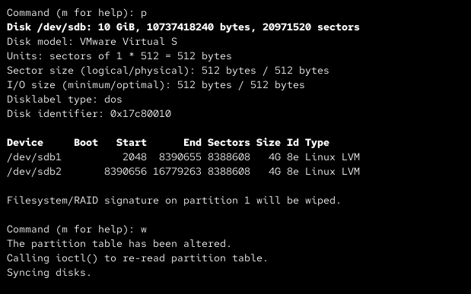

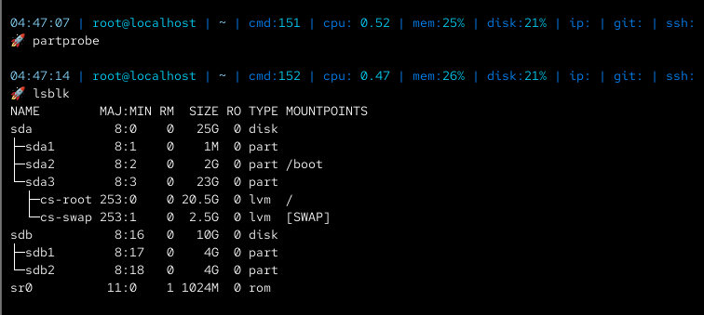

- Initialise both partitions as Physical Volumes
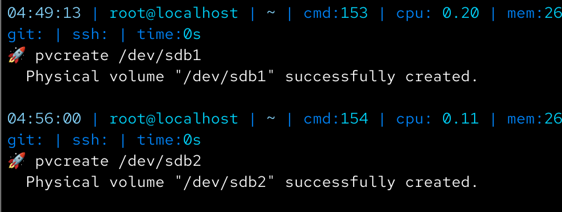

- Verify PV creation
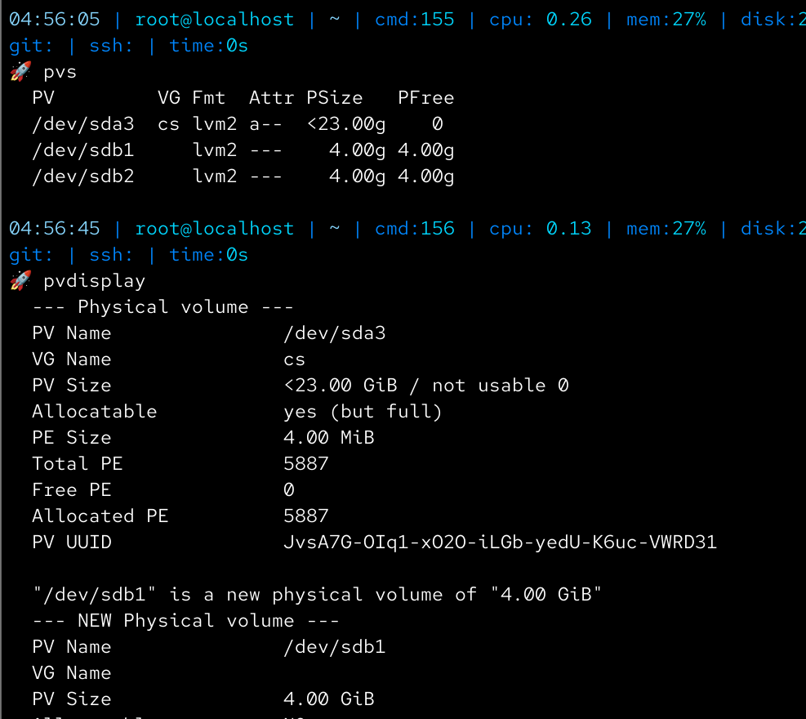
Volume Group (VG)
- Create a Volume Group named vgdata using both PVs
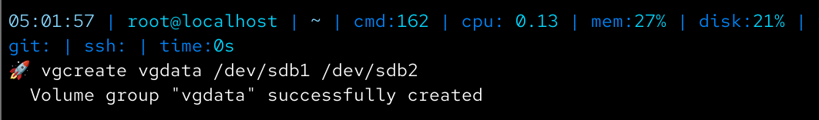
- Verify VG details
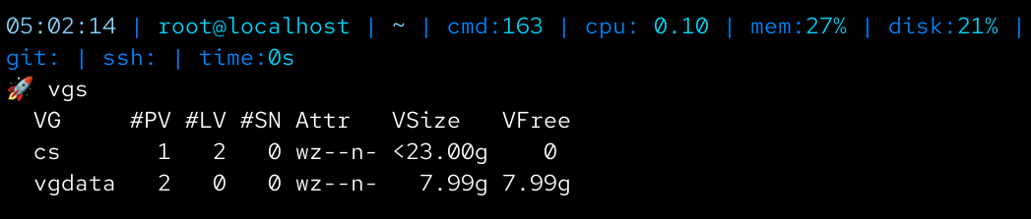
- Display:
  - Total size
  - Free space
  - Physical Extent (PE) size (default)
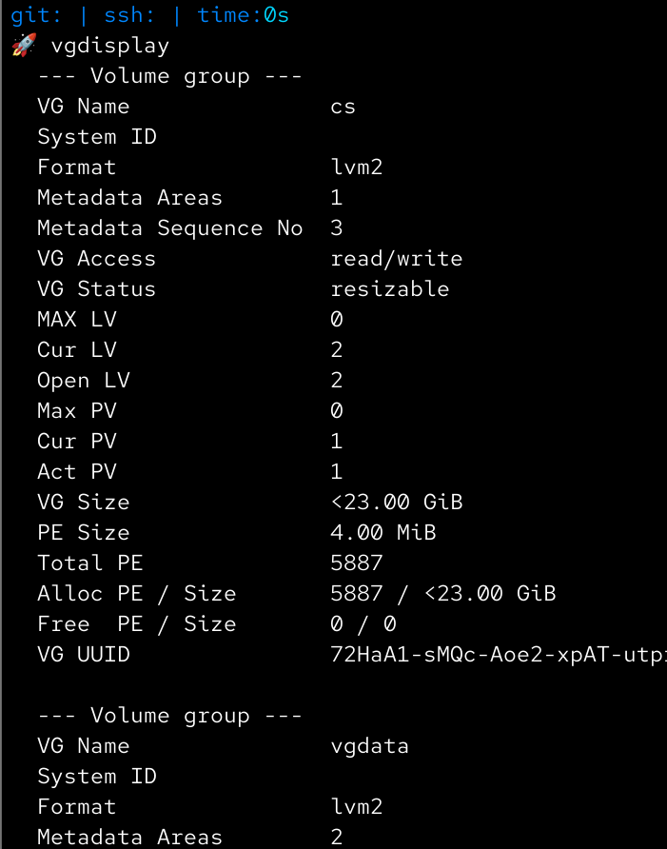
- Create another Volume Group vgcustom with custom PE size (e.g., 16MB)
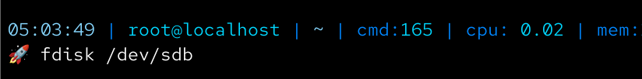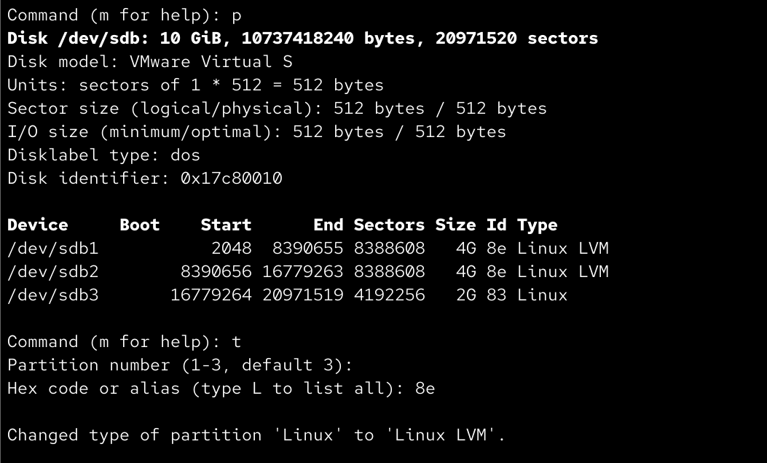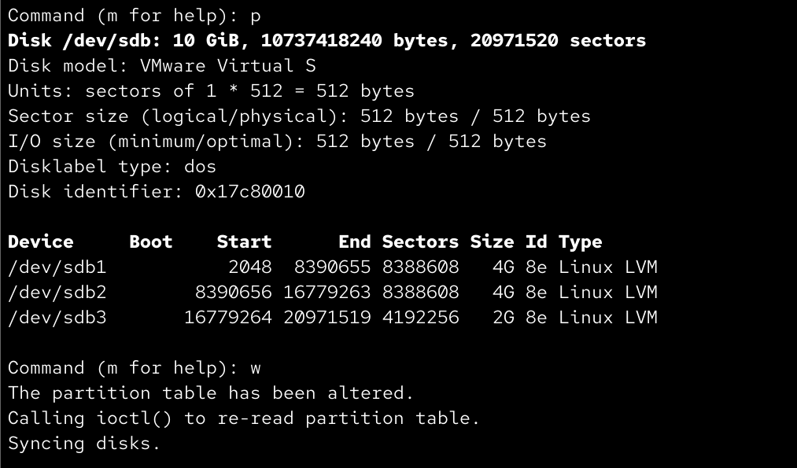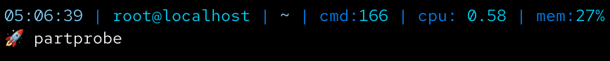
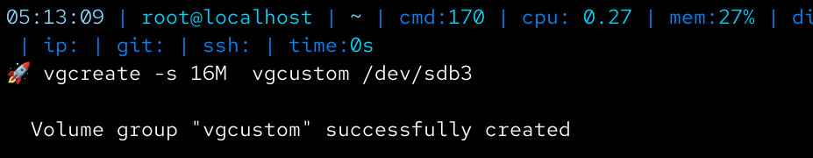
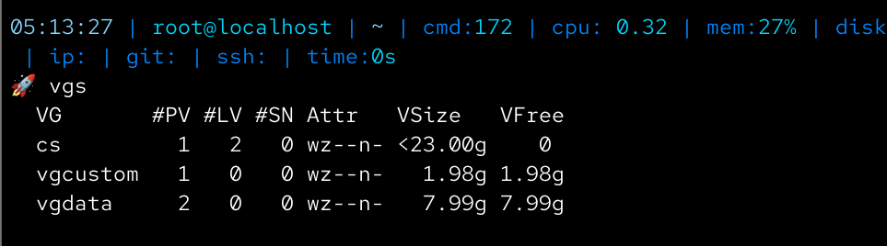

Logical Volumes (LV)
- Create a Logical Volume lvsize of 2GB in vgdata (size-based)
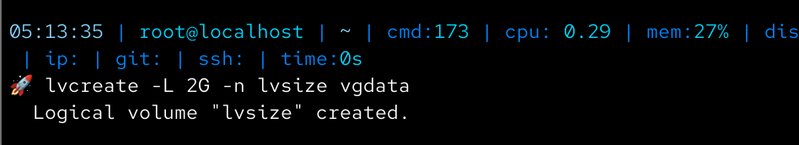
- Create a Logical Volume lvext using Logical Extents (e.g., percentage of free space)
- Create a Logical Volume lvcustom in vgcustom using extents
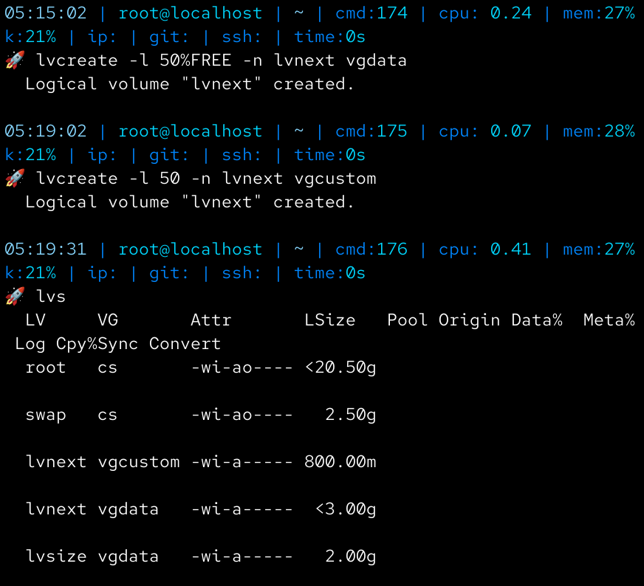

Formatting (Different File Systems)
- Format:
  - lvsize → XFS
  - lvext → xfs
  - lvcustom → xfs
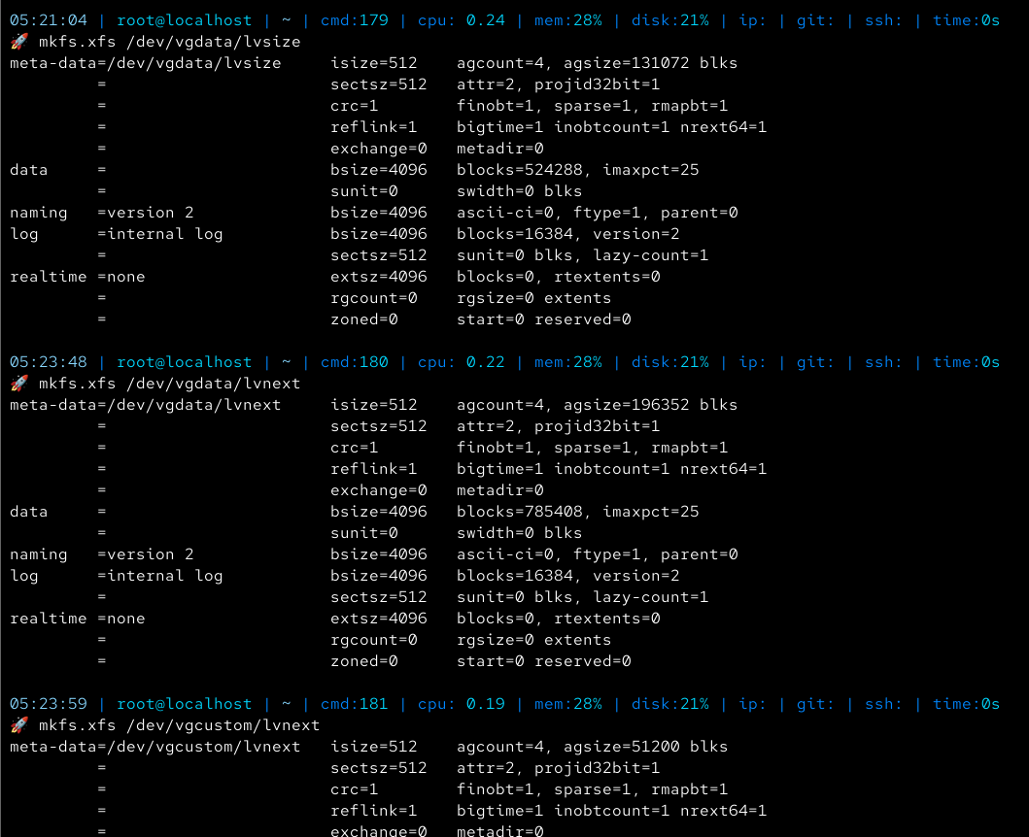

Mounting
Temporary:
- Mount:
  - lvsize → /mnt/data1
  - lvext → /mnt/data2
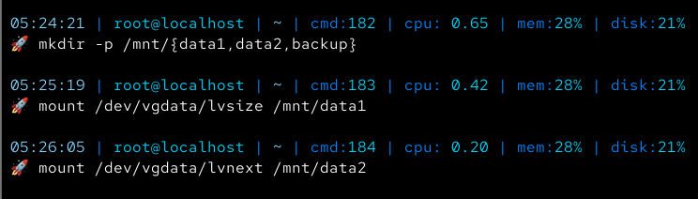
Permanent:
- Mount lvnext → /mnt/backup using UUID in /etc/fstab
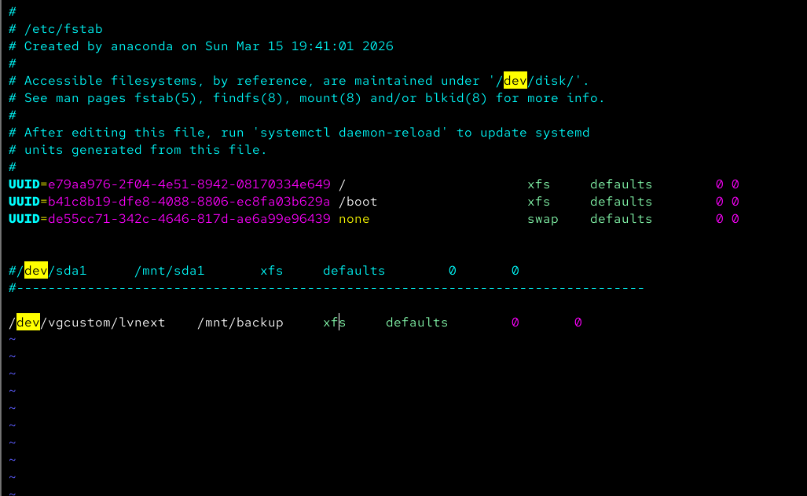

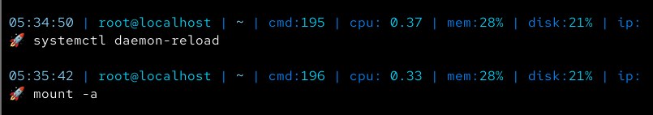
Verification
- Verify:
  - Physical Volumes
  - Volume Groups
  - Logical Volumes
  - Filesystem types
  - Mounted filesystems
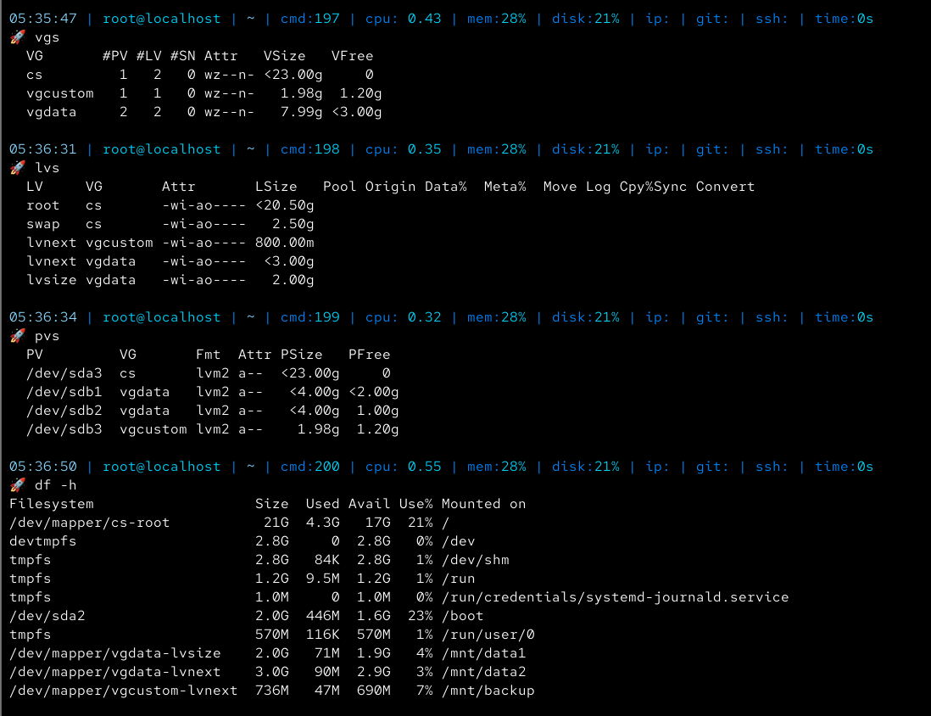

LVM Management (Resize Operations)
- Extend lvsize by 1GB
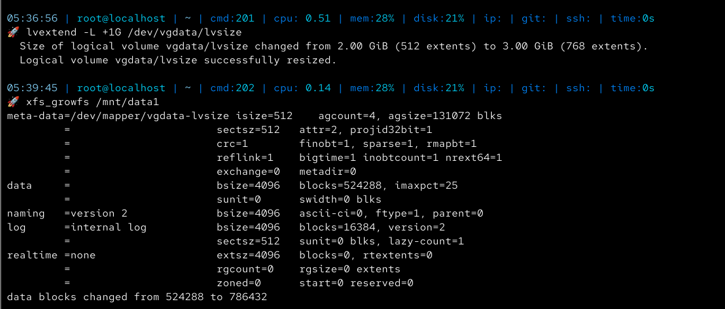
- Resize the filesystem accordingly
- Reduce lvext by 500MB (after unmounting)
- Resize the filesystem safely before reduction
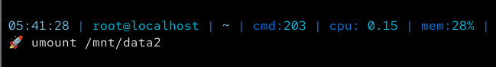
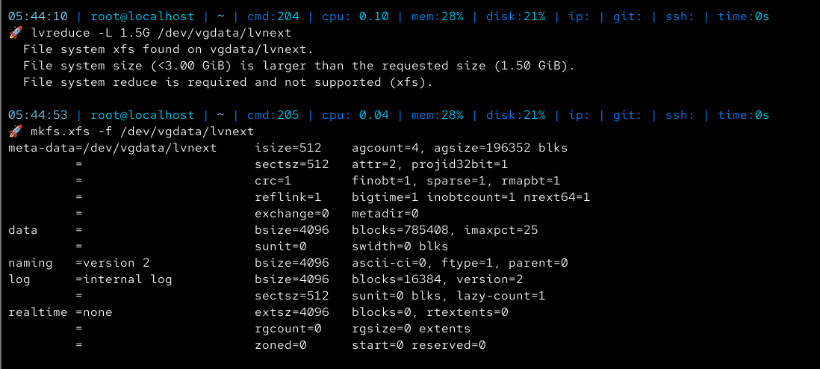
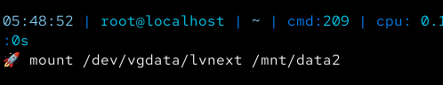

Cleanup (WITHOUT reboot)
- Unmount all logical volumes
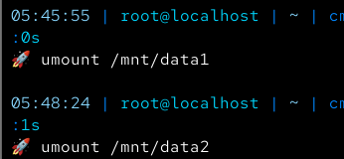
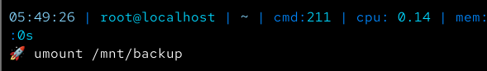
- Remove entries from /etc/fstab
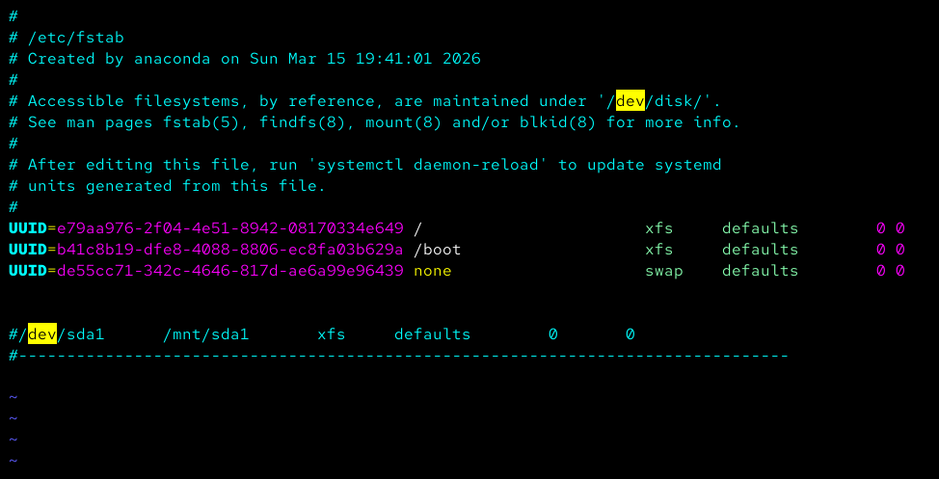
- Remove Logical Volumes
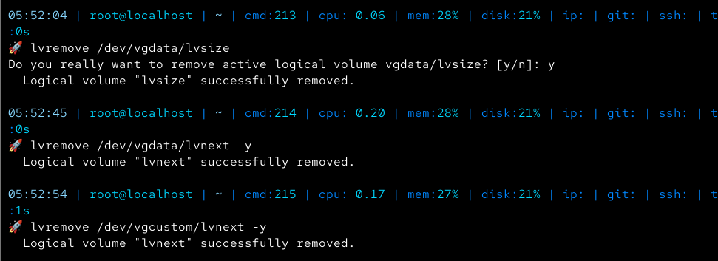

- Remove Volume Groups
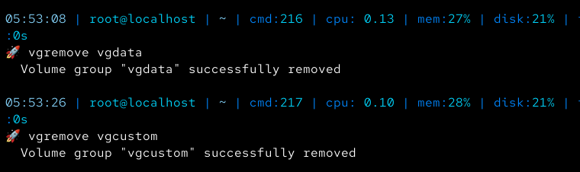
- Remove Physical Volumes
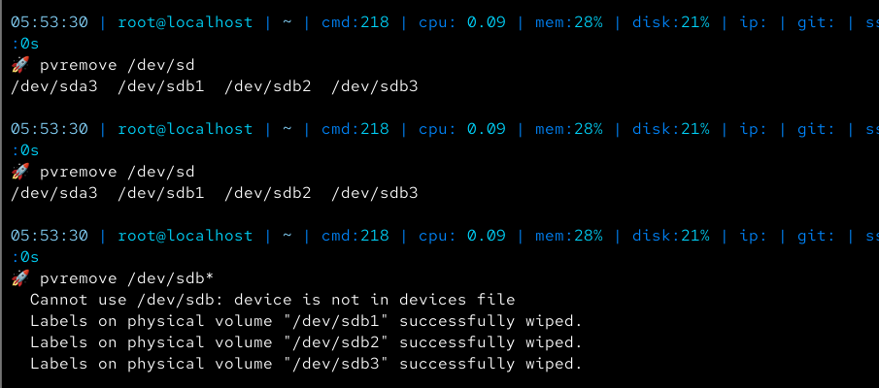

- Delete partitions
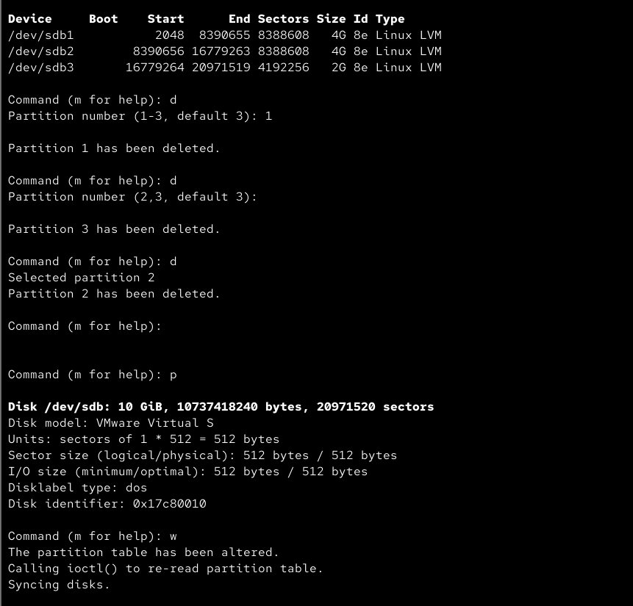
- Apply changes
