Practical Question: Primary Partition
Question
You can use any available disk (like /dev/sda, /dev/sdb) instead of /dev/nvme0n1, depending on your system’s device naming.
You are given a disk /dev/nvme0n1 with free space available.
Perform the following tasks:
Create a primary partition of size 2GB
Format it using the XFS filesystem
Mount it temporarily on the directory /data1
Verify that the partition is mounted
Make the mount permanent using /etc/fstab
Then delete the partition completely, ensuring:
It is unmounted
Removed from /etc/fstab
Deleted from the partition table
Changes applied without reboot
-----------------------Commands--------------------
lsblk
fdisk /dev/sda → n p 1 +2G w
partprobe
mkfs.xfs /dev/sda1
mkdir /data1
mount /dev/sda1 /data1
blkid → add to /etc/fstab
mount -a
umount /data1
remove fstab entry
fdisk /dev/sda → d 1 w
partprobe
lsblk
-----------------------------------------------------------
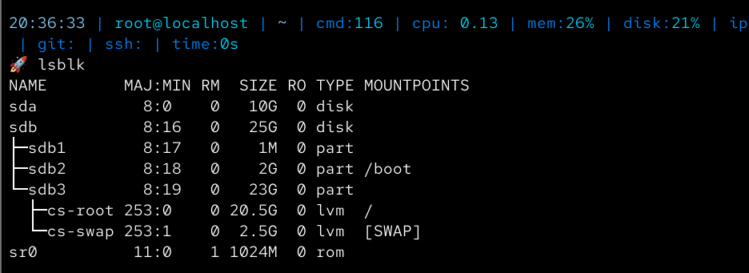
Perform the following tasks:
Create a primary partition of size 2GB
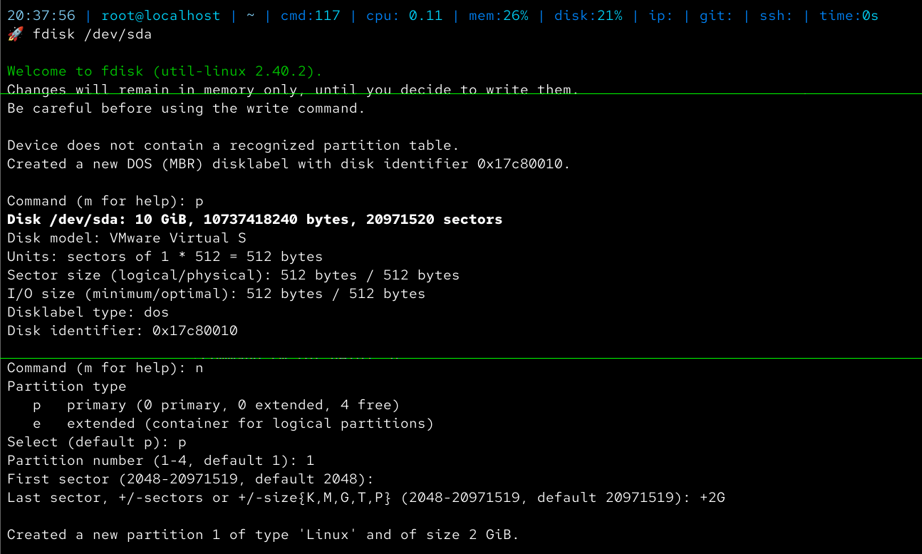
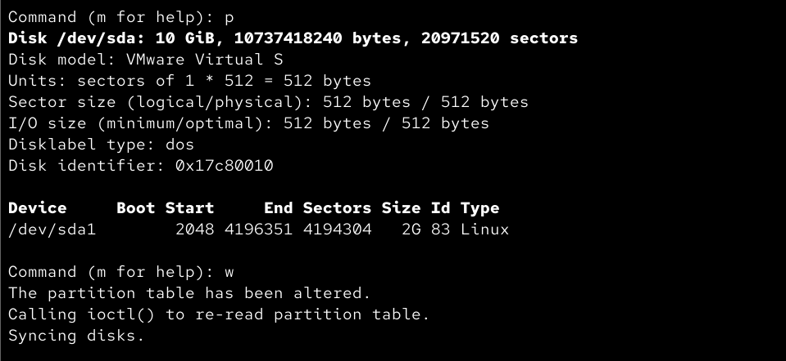
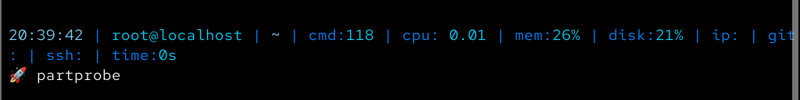

Format it using XFS filesystem
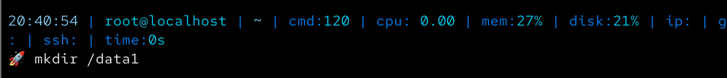
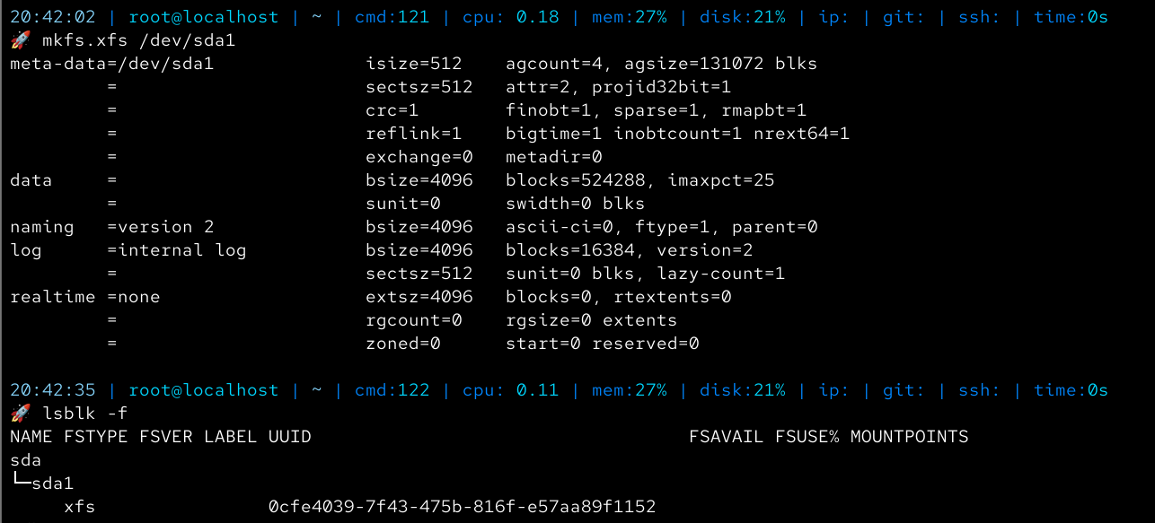

Mount it temporarily on directory /data1
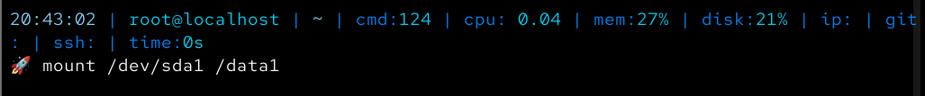
Verify that the partition is mounted
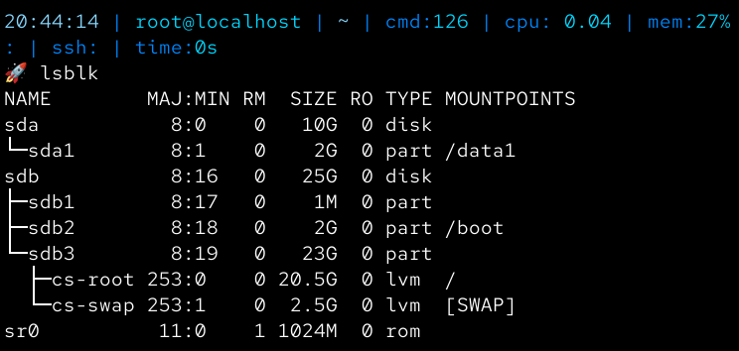
(To delete prttn from this point forward use following commands-
umount /data1
remove fstab entry
fdisk /dev/sda → d 1 w
partprobe
lsblk)

Make the mount permanent using /etc/fstab
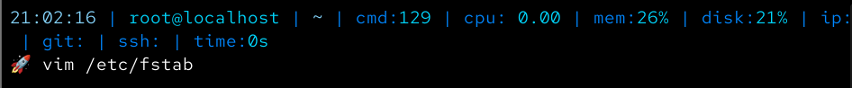
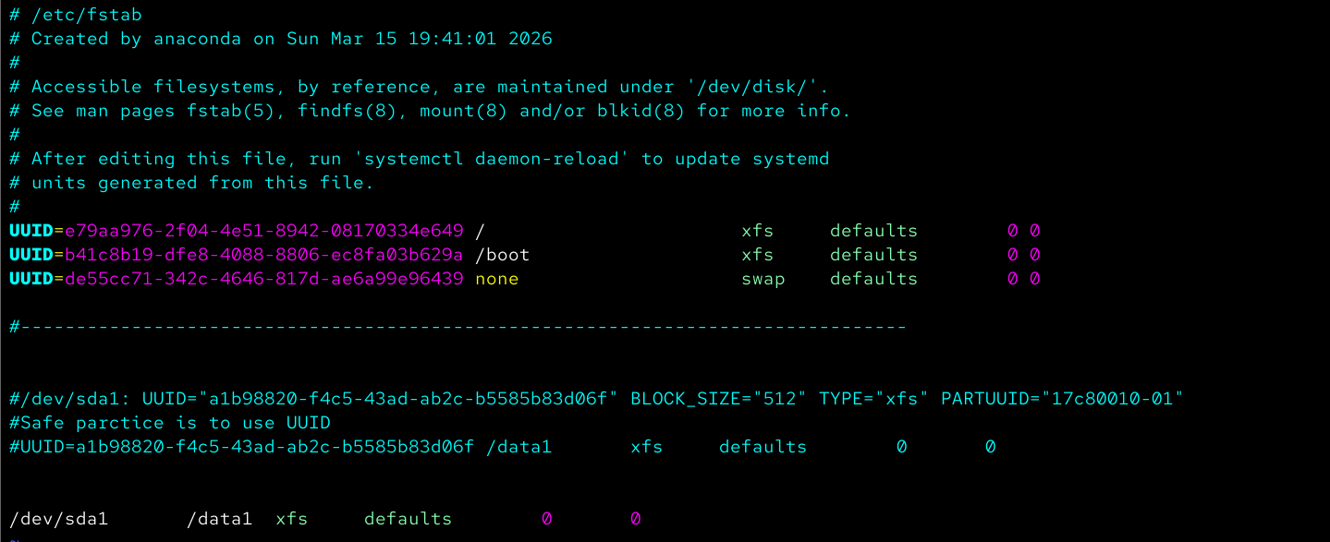
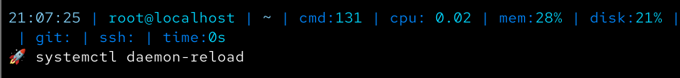
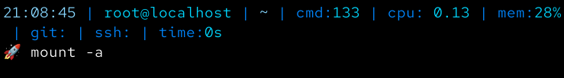

Then delete the partition completely, ensuring:
It is unmounted
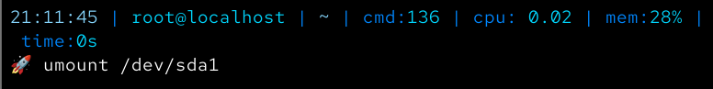

Removed from /etc/fstab
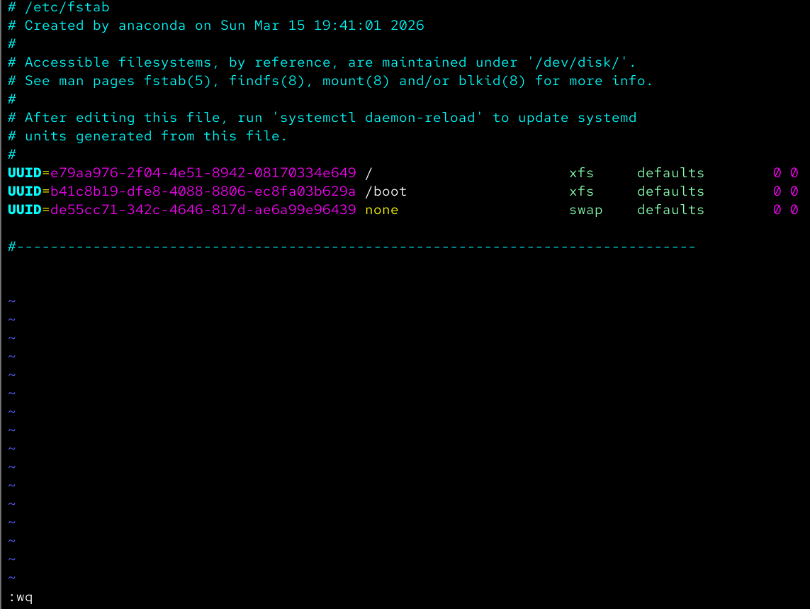
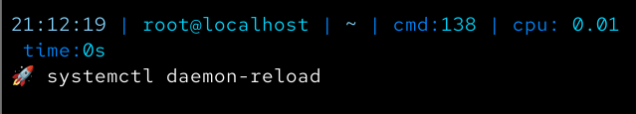
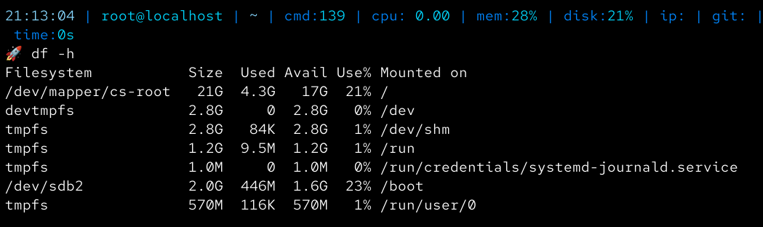

Deleted from the partition table
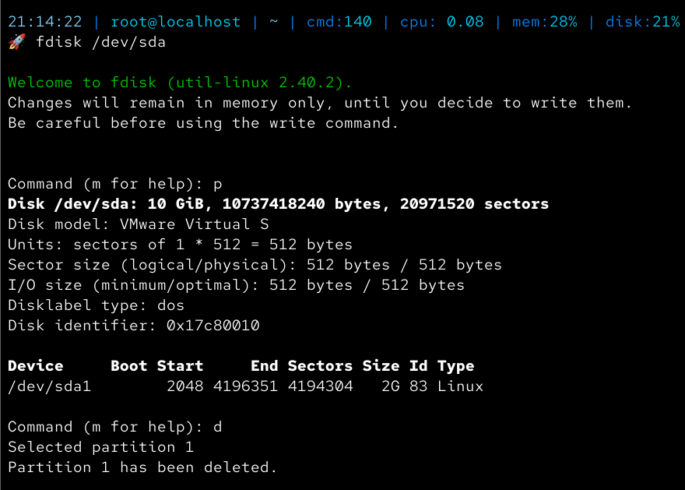

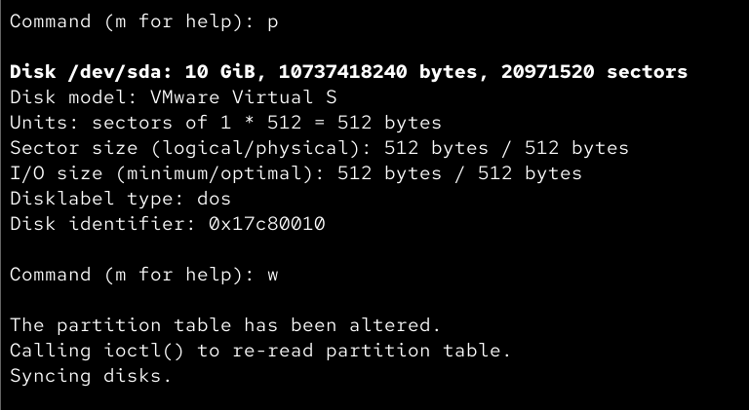

Changes applied without reboot
