A swap partition can be created either as a primary or logical partition inside an extended partition, depending on partition availability.
Practical: Swap Partition Configuration
Question
Can use any available disk (like /dev/sda, /dev/sdb) instead of /dev/nvme0n1, depending on your system’s device naming.
You are given a disk /dev/sdb with free space. Perform the following tasks:
Partitioning
- Create a primary partition of size 2GB on /dev/sdb
- Change its type to Linux Swap
Swap Configuration
- Initialize the partition as swap space
- Activate the swap partition
- Verify that swap is active
Temporary vs Permanent
Temporary:
- Activate swap immediately
Permanent:
- Configure swap in /etc/fstab using UUID
Verification
- Verify swap usage
Advanced Tasks (Not neccesary)
- Set swap priority manually
- Create an additional swap file (1GB) and activate it
- Verify both swap partition and swap file are active
Cleanup (WITHOUT reboot)
- Disable swap
- Remove swap entry from /etc/fstab
- Disable and delete swap file
- Delete partition
- Apply changes

-------------------commands------------------------------------
# ===============================
# STEP 1: Verify disk
# ===============================
lsblk

# ===============================
# STEP 2: Create swap partition (2GB)
# ===============================
fdisk /dev/sdb
# n → p → 1 → Enter → +2G
# t → 82 (Linux swap)
# w

# Apply changes
partprobe

# Verify
lsblk

# ===============================
# STEP 3: Initialize + Activate Swap
# ===============================
mkswap /dev/sdb1
swapon /dev/sdb1

# Verify
swapon --show
free -h

# ===============================
# STEP 4: Permanent Configuration
# ===============================
blkid

vi /etc/fstab
# Add:
# UUID=xxxx none swap defaults 0 0

systemctl daemon-reload
swapon -a

# Verify
swapon --show
free -h
cat /proc/swaps

# ===============================
# STEP 5: (Optional) Advanced Tasks
# ===============================
# Set priority
swapon -p 10 /dev/sdb1

# Create swap file (1GB)
fallocate -l 1G /swapfile
chmod 600 /swapfile
mkswap /swapfile
swapon /swapfile

# Verify both
swapon --show
free -h

# ===============================
# STEP 6: Cleanup (WITHOUT reboot)
# ===============================
# Disable swap partition
swapoff /dev/sdb1

# Remove fstab entry
vi /etc/fstab

# Disable and remove swap file
swapoff /swapfile
rm /swapfile

# Delete partition
fdisk /dev/sdb
# d → 1 → w

# Apply changes
partprobe

# Final verify
Lsblk

-----------------------x-----------------------------

Partitioning
- Create a primary partition of size 2GB on /dev/sdb
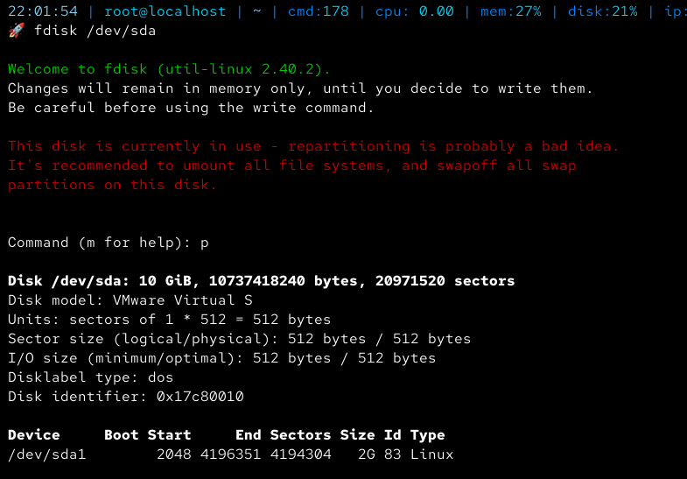
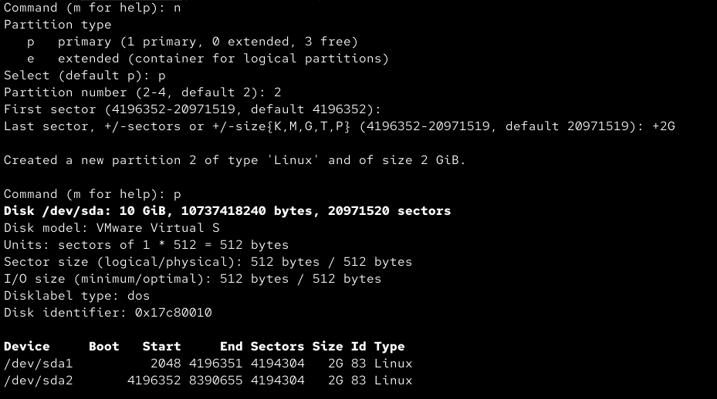

- Change its type to Linux Swap
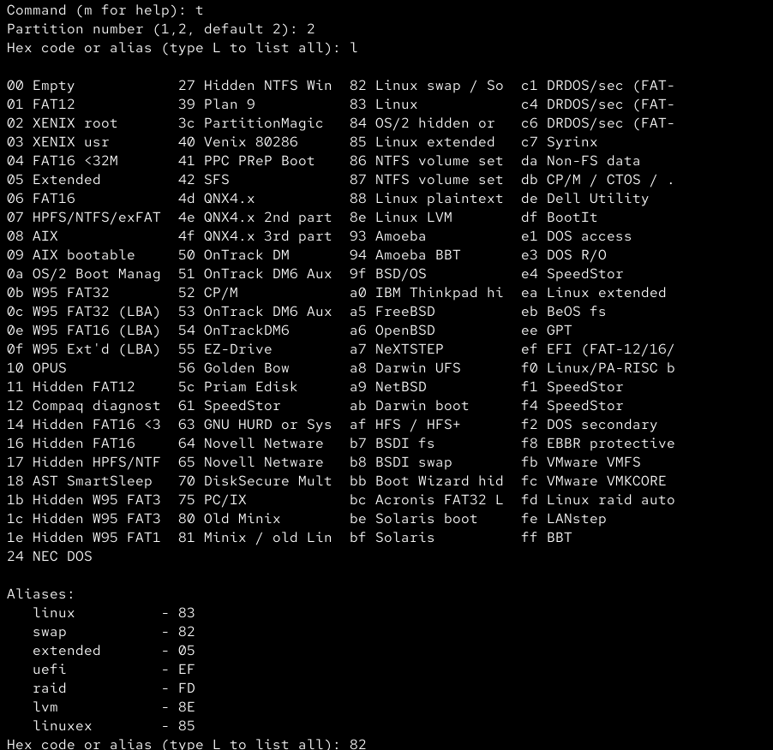
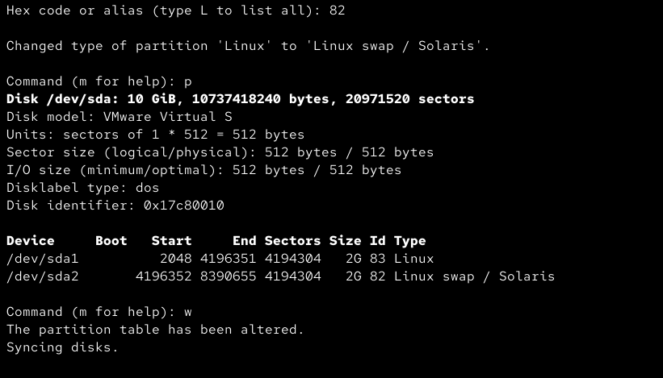

Swap Configuration
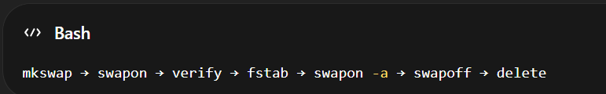
- Initialise the partition as swap space
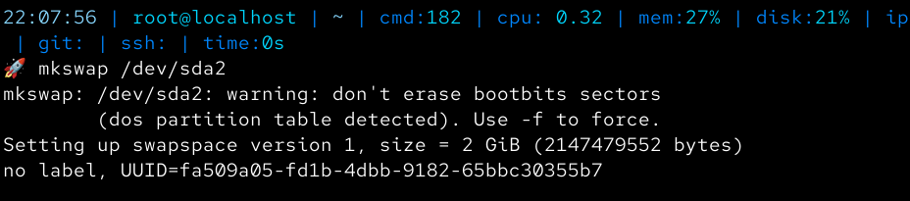
- Activate the swap partition
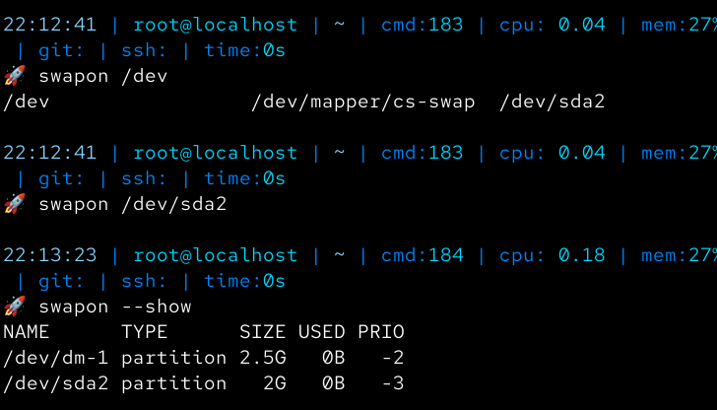
- Verify that swap is active
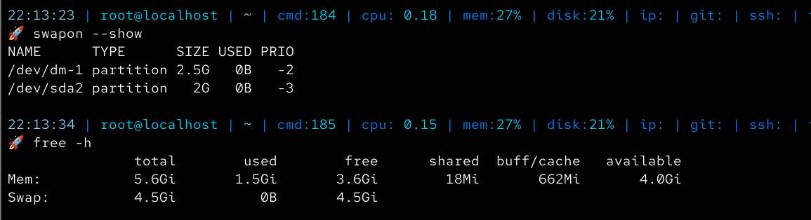
Temporary vs Permanent
Temporary:
- Activate swap immediately


Permanent:
- Configure swap in /etc/fstab using UUID
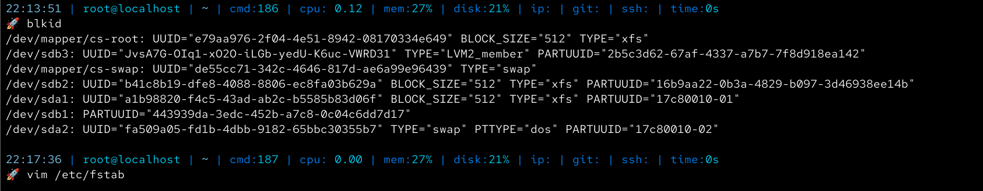
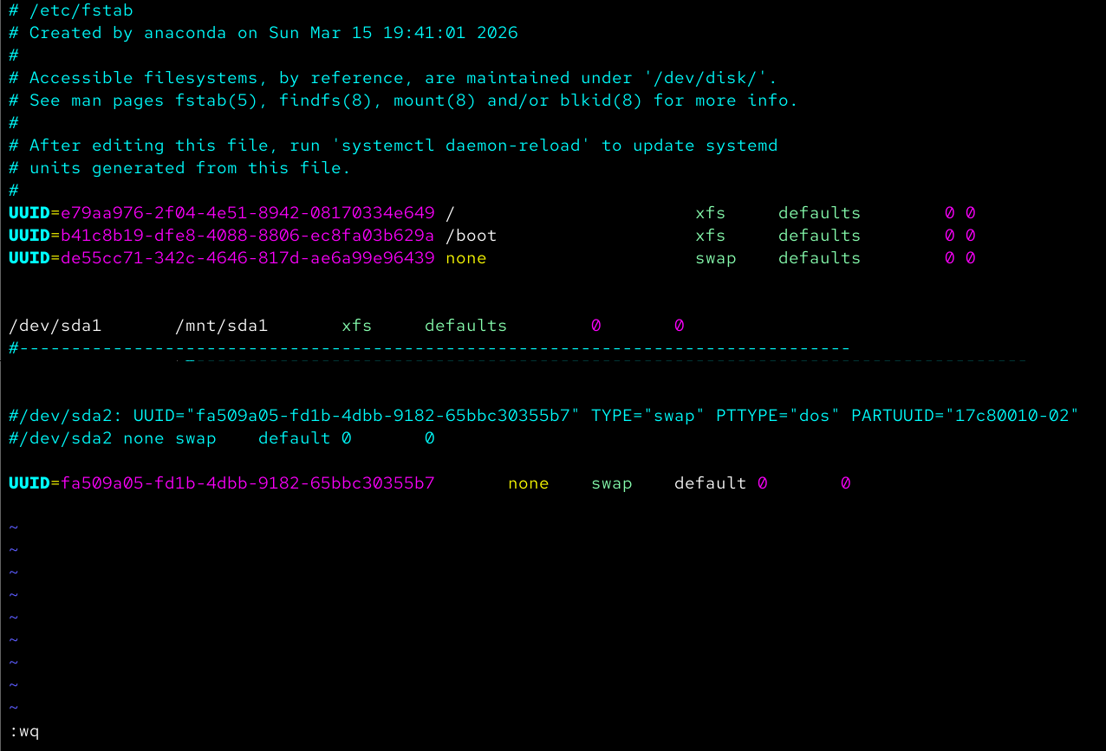
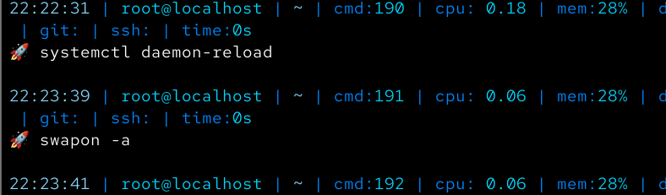

Verification
- Verify swap usage
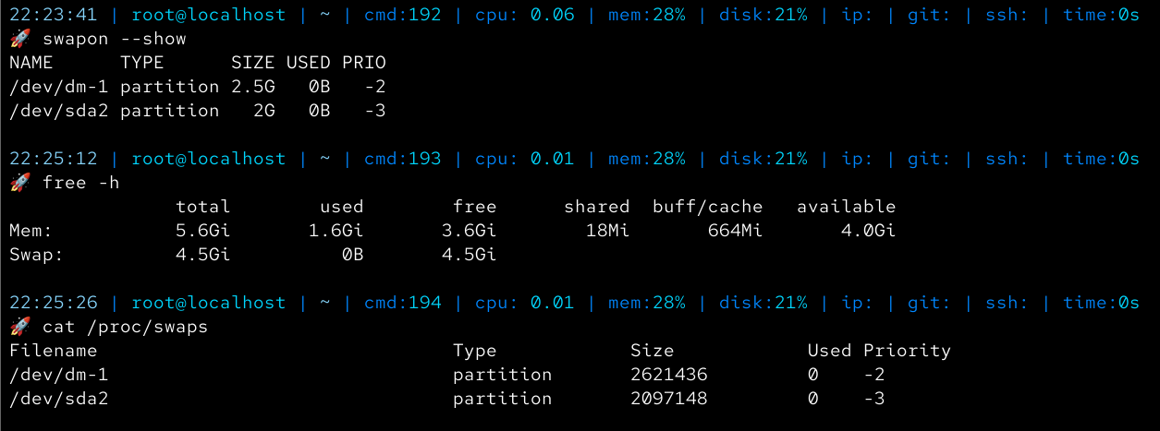

Advanced Tasks|(not teached)
- Set swap priority manually
- Create an additional swap file (1GB) and activate it
- Verify both swap partition and swap file are active
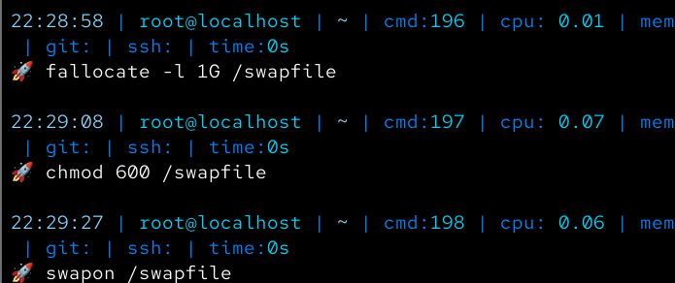

Cleanup (WITHOUT reboot)
- Disable swap
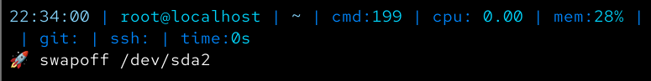

- Remove swap entry from /etc/fstab
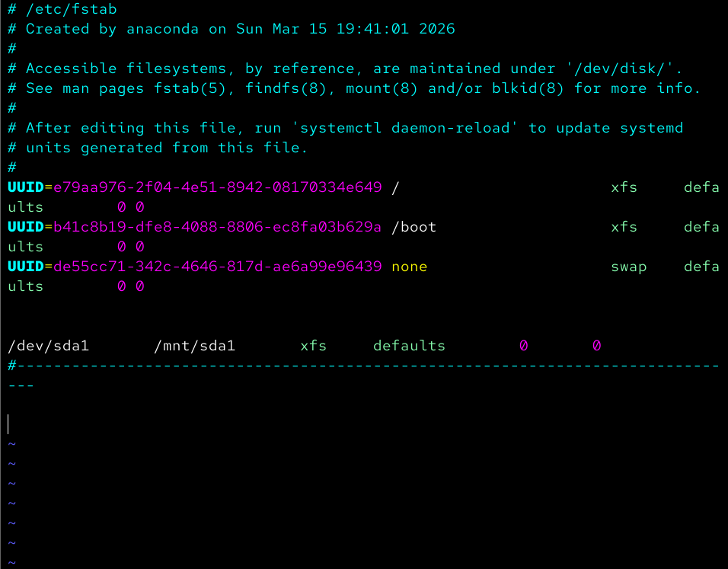
- Disable and delete the swap file
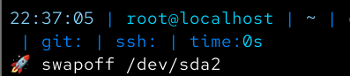
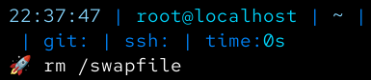

- Delete partition
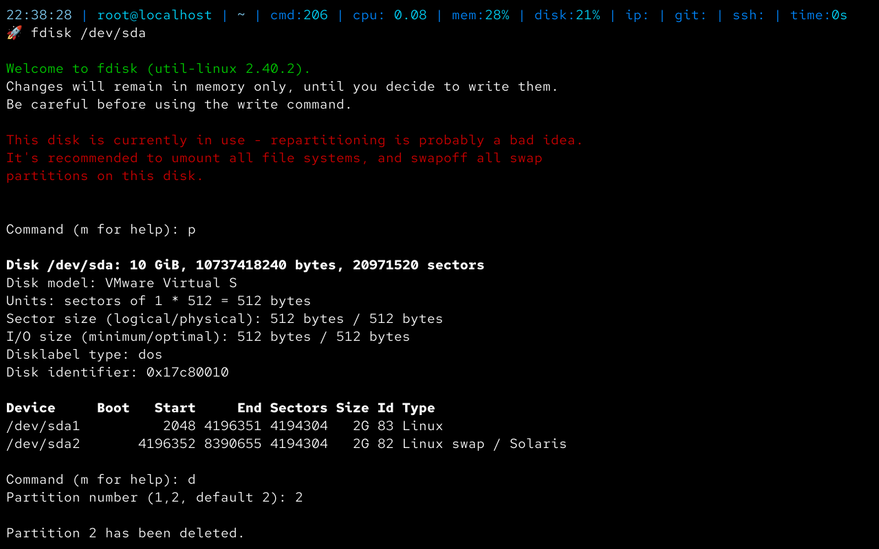
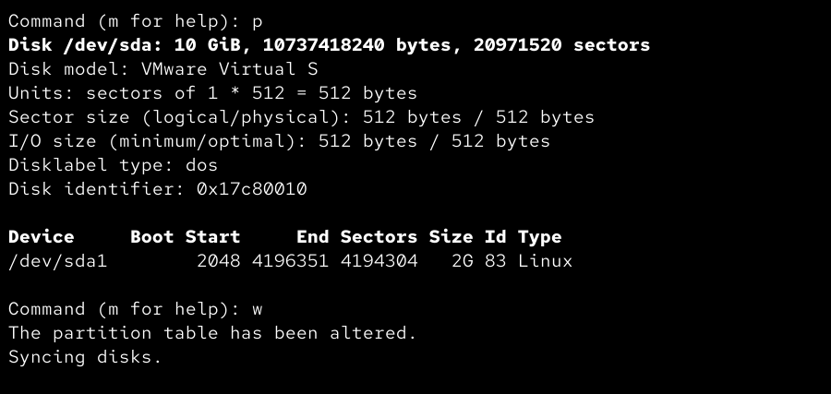
- Apply changes
