You are assigned to configure a Windows Server to act as a centralized network infrastructure server for an organization.
Requirements:
- Install and configure Domain Name System (DNS):
  - Create a Forward Lookup Zone: corp.local
  - Add A records:
    - fileserver.corp.local
    - client1.corp.local
  - Ensure name resolution using nslookup
- Configure Dynamic Host Configuration Protocol (DHCP):
  - Create a scope:
    - Network: 192.168.220.0/24
    - Range: 192.168.220.100 – 192.168.220.200
  - Set:
    - Default Gateway: 192.168.220.1
    - DNS Server: Server IP
  - Verify client receives IP dynamically
- Configure Distributed File System (DFS):
  - Create a shared folder: D:\Data
  - Configure DFS Namespace:
    - Namespace name: \\corp.local\shared
  - Add folder target pointing to D:\Data
  - Verify access from client using namespace path

You are assigned to configure a Windows Server to act as a centralized network infrastructure server for an organization.
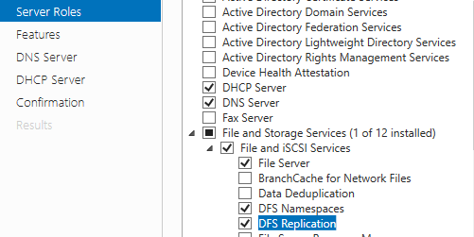
Requirements:
- Install and configure Domain Name System (DNS):
  - Create a Forward Lookup Zone: corp.local
  - Add A records:
    - fileserver.corp.local
    - client1.corp.local (IM NOT CREATING DIFF CLIENT)
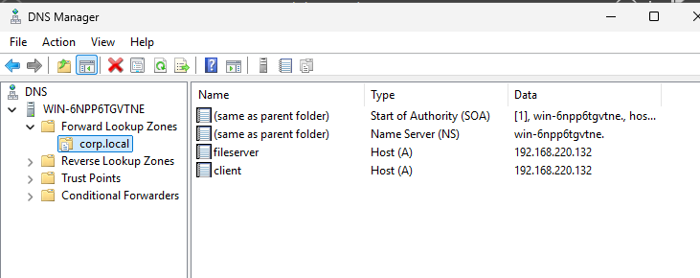

  - Ensure name resolution using nslookup
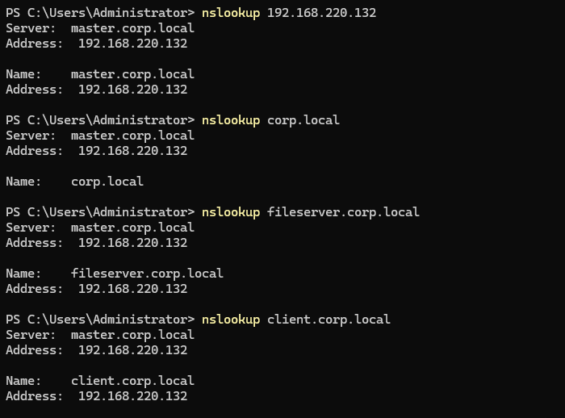
- Configure Dynamic Host Configuration Protocol (DHCP):
  - Create a scope:
    - Network: 192.168.220.0/24
    - Range: 192.168.220.100 – 192.168.220.200
  - Set:
    - Default Gateway: 192.168.220.2
    - DNS Server: Server IP
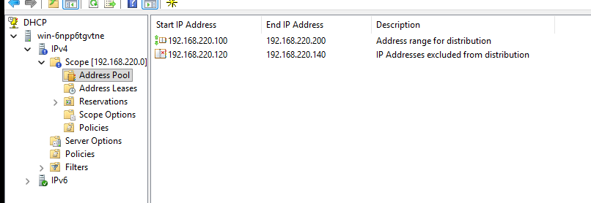
  - Verify client receives IP dynamically
- Configure Distributed File System (DFS):
  - Create a shared folder: C:\Data
  - Configure DFS Namespace:
    - Namespace name: \\corp.local\shared
  - Add folder target pointing to C:\Data
  - Verify access from client using namespace path
