Q2 Web + Deployment Infrastructure (IIS + WDS)
Question
You are required to configure a Windows Server to host multiple websites and deploy operating systems over the network.

Part A: Configure Internet Information Services (IIS)
- Install IIS Web Server
- Configure:
  - Default Website (Dedicated)
    - Path: C:\inetpub\wwwroot
    - Port: 80
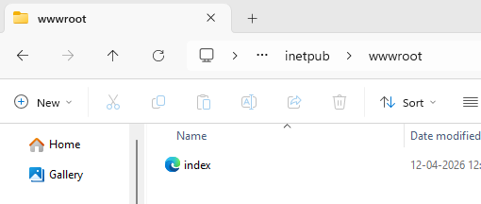
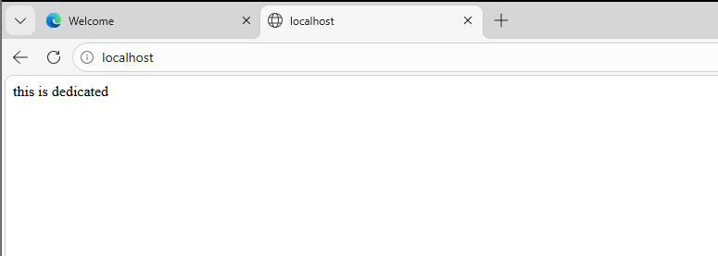

  - Virtual Directory
    - Name: test
    - Path: C:\VirtualData
    - Access via: http://server/test
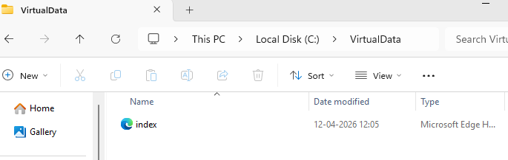
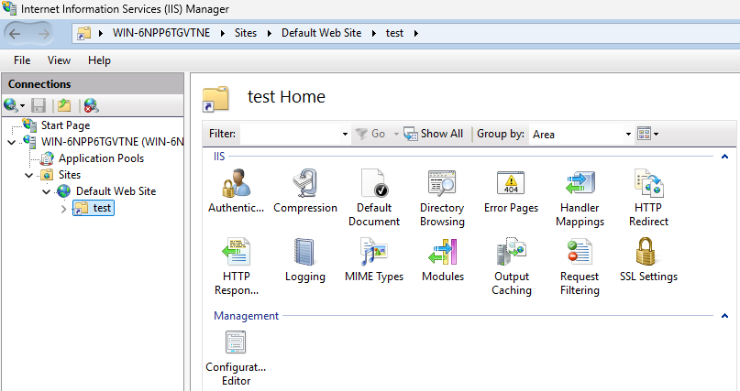
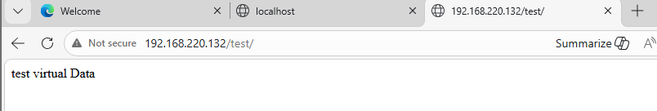

  - New Website on Different Port
    - Site name: AppSite
    - Port: 8080
    - Path: C:\AppSite
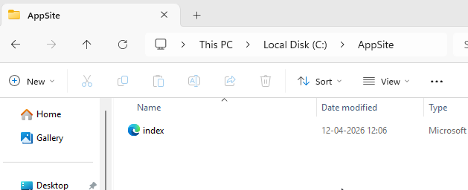

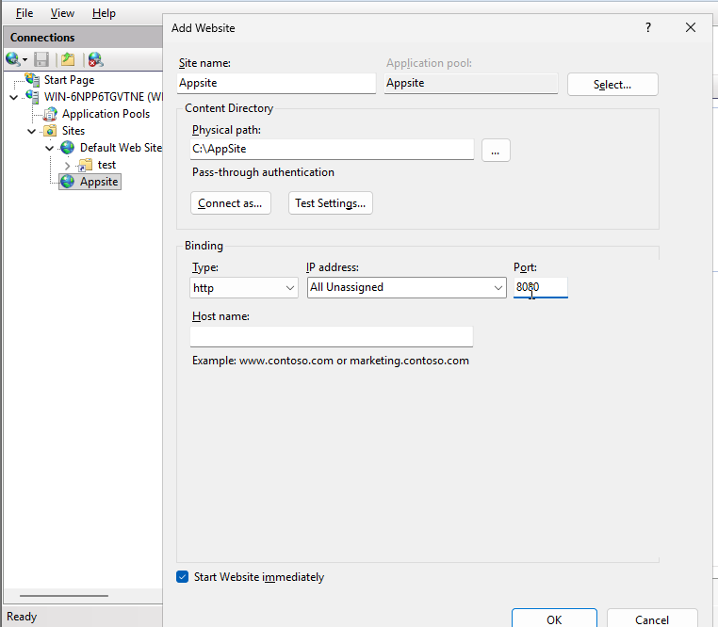

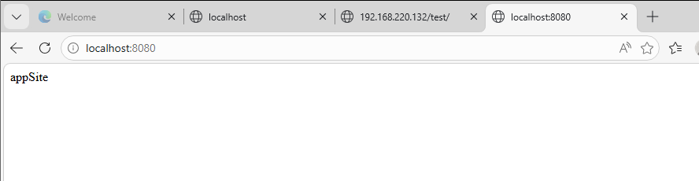
- Enable Basic Authentication:
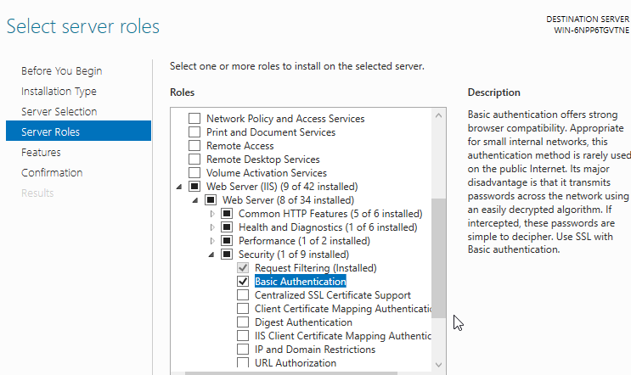
  - Apply on AppSite
  - Disable Anonymous Authentication
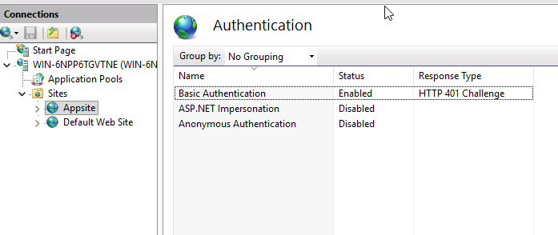
  - Test login via browser
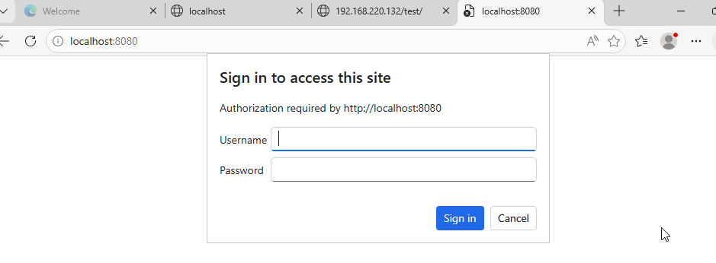

Part B: Configure Windows Deployment Services (WDS)
- Install WDS role
- Configure WDS:
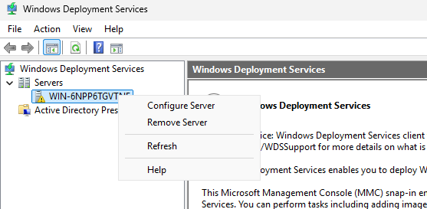
  - Integrated with Active Directory (if available)
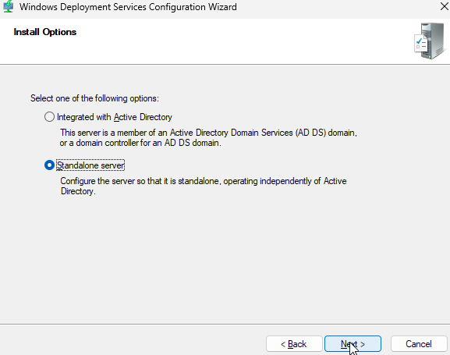
  - Set remote install folder: C:\RemoteInstall
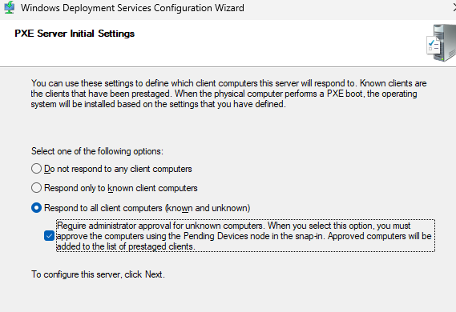
- Add Images:
  - Boot Image (from Windows ISO)
  - Install Image

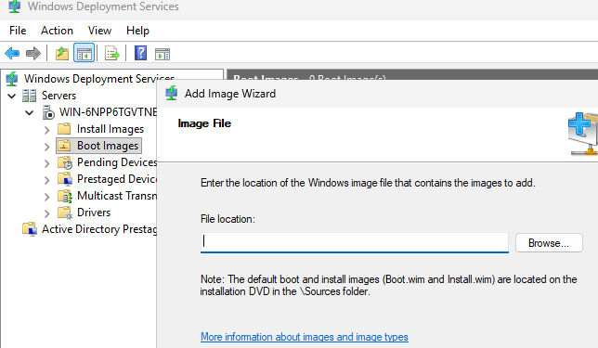
- Configure PXE boot:
  - Allow known and unknown clients
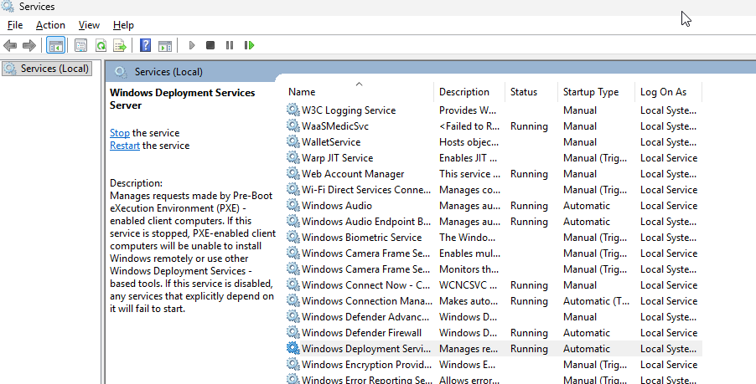
- Test deployment:
  - Boot a client using network (PXE)
  - Verify OS deployment screen appears

Expected Outcome:
- Multiple IIS sites accessible (port 80, 8080, virtual directory)
- Authentication enforced on selected site
- WDS successfully deploys OS via PXE boot

