Confusion and Diffusion
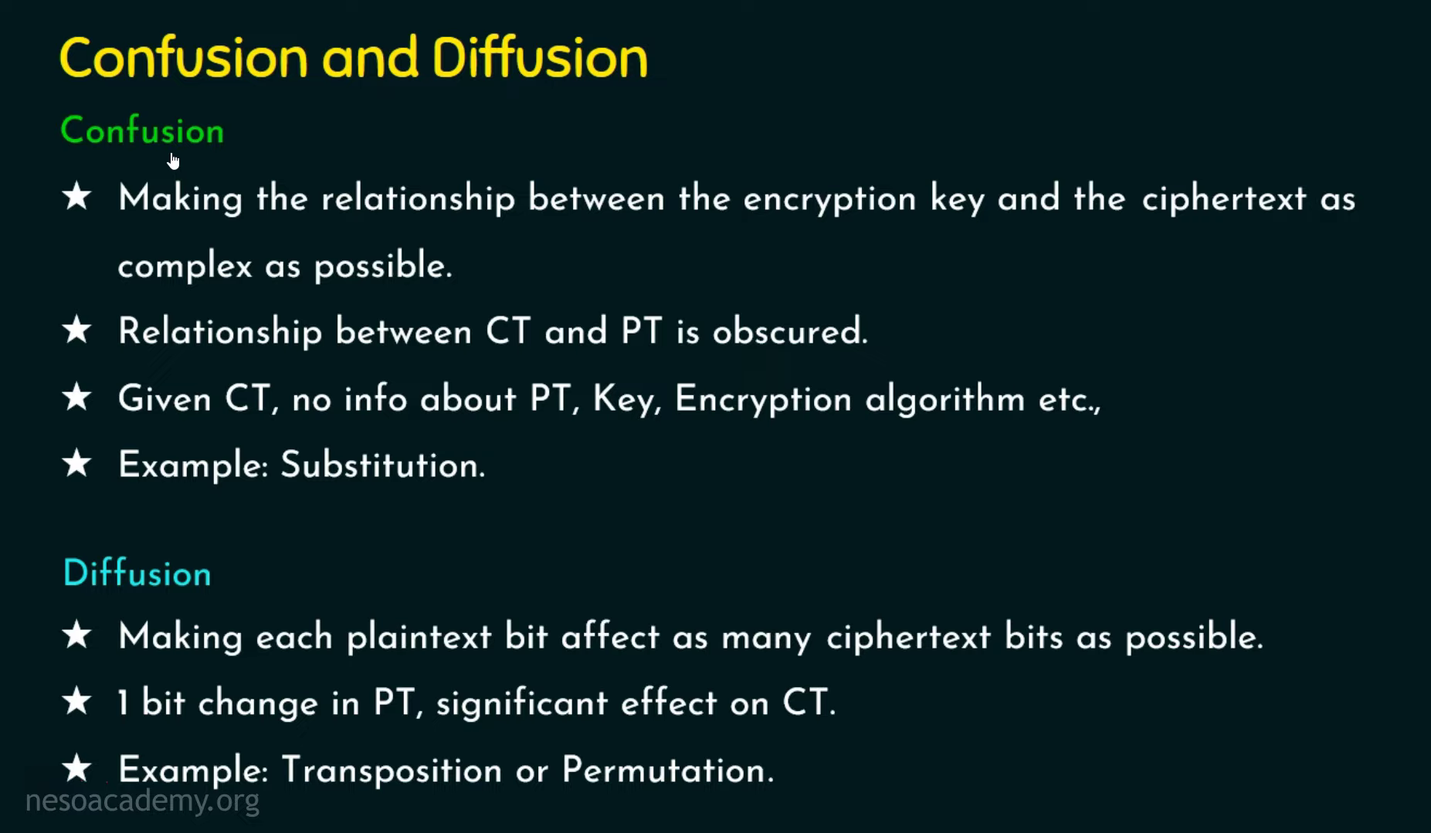
very important principles in cryptography introduced by Claude Shannon:
Confusion and Diffusion
These are techniques used to make encrypted data hard to break.

1. Confusion
Meaning
Confusion hides the relationship between:
- Plaintext (PT)
- Ciphertext (CT)
- Encryption Key
The attacker should not understand how the key affects the ciphertext.

Simple Idea
If someone sees encrypted text:
HELLO → X7A91
they should NOT be able to figure out:
- the key
- the encryption pattern
- original message

Goal of Confusion
Make encryption look:
- random
- unpredictable
- complex

Achieved Using
Mostly through:
- Substitution
- S-Boxes in AES
- nonlinear transformations

Example
Caesar Cipher
A → D
B → E
C → F
Characters are substituted.

In Modern Encryption
AES uses:
- substitution boxes (S-Boxes)
- nonlinear mathematical mappings
This creates strong confusion.

2. Diffusion
Meaning
Diffusion spreads plaintext information across the ciphertext.
A tiny change in plaintext should change MANY ciphertext bits.

Simple Idea
If:
HELLO
changes to:
HELLo
then ciphertext should completely change.

Goal of Diffusion
Hide statistical patterns in plaintext.
Attackers should not see:
- repeated letters
- common words
- frequency patterns

Achieved Using
Mostly through:
- permutation
- transposition
- mixing operations

Example
Plaintext
AAAAAAAA
Without diffusion:
BBBBBBBB
Pattern still visible.
With diffusion:
X9P2L7Q1
Pattern disappears.

Avalanche Effect (Important)
Diffusion creates the:
Avalanche Effect
Small input change → huge ciphertext change.
Example:
Input 1:
HELLO
Cipher:
8A91F2
Input 2:
HELLo
Cipher:
F71BC9
Huge difference from one small change.
Real World Mapping
Concept | Mainly Achieved By
Confusion | Substitution
Diffusion | Permutation / Transposition

In AES
AES uses BOTH:
AES Step | Purpose
SubBytes | Confusion
ShiftRows | Diffusion
MixColumns | Diffusion
AddRoundKey | Key Mixing

Easy Analogy
Confusion
Like scrambling words with complex code rules.
Diffusion
Like dropping ink into water — it spreads everywhere.

One-Line Definitions
Confusion
Makes the relationship between key and the ciphertext complex.
Diffusion
Spreads plaintext influence across ciphertext.

Stream cipher & Block cipher
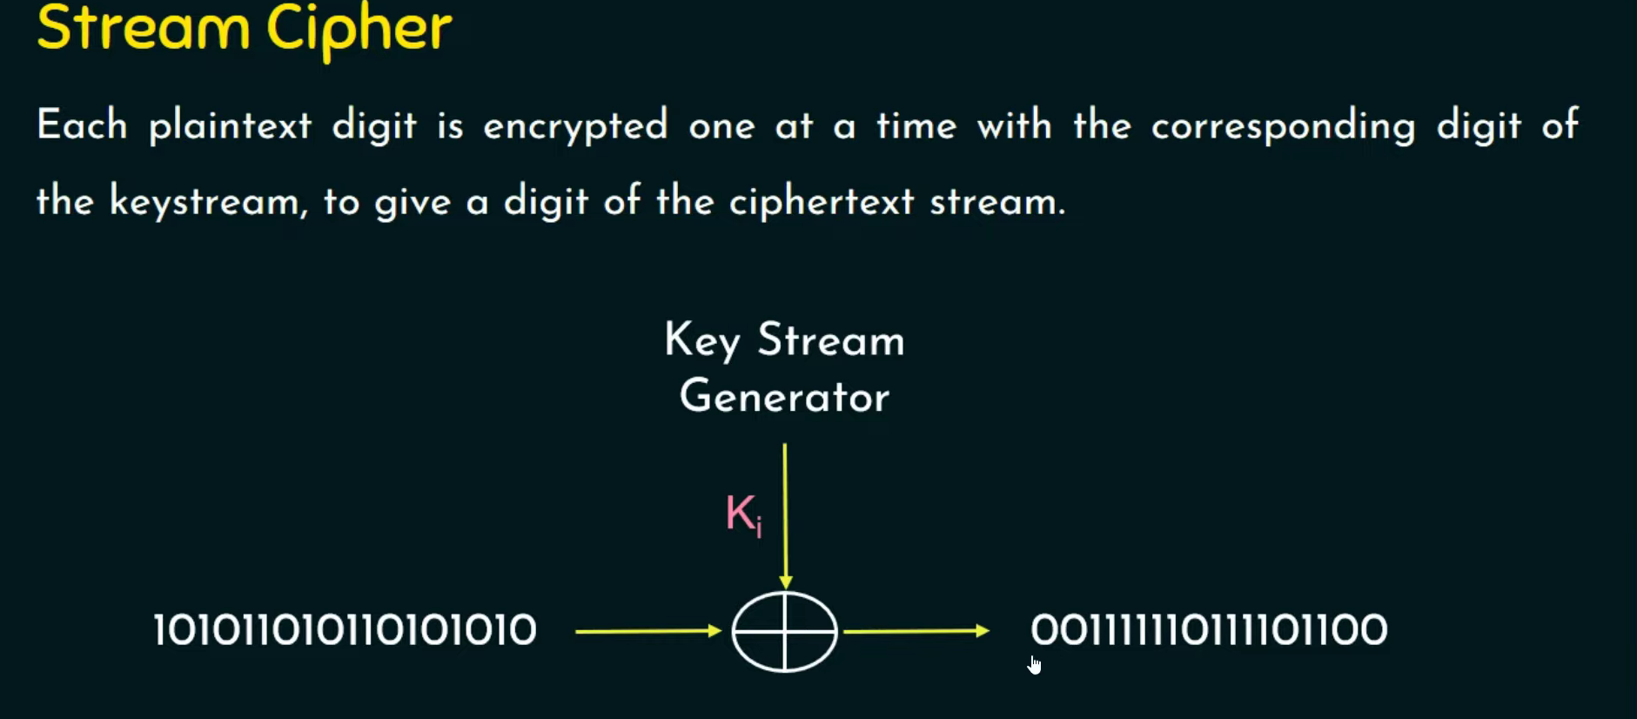
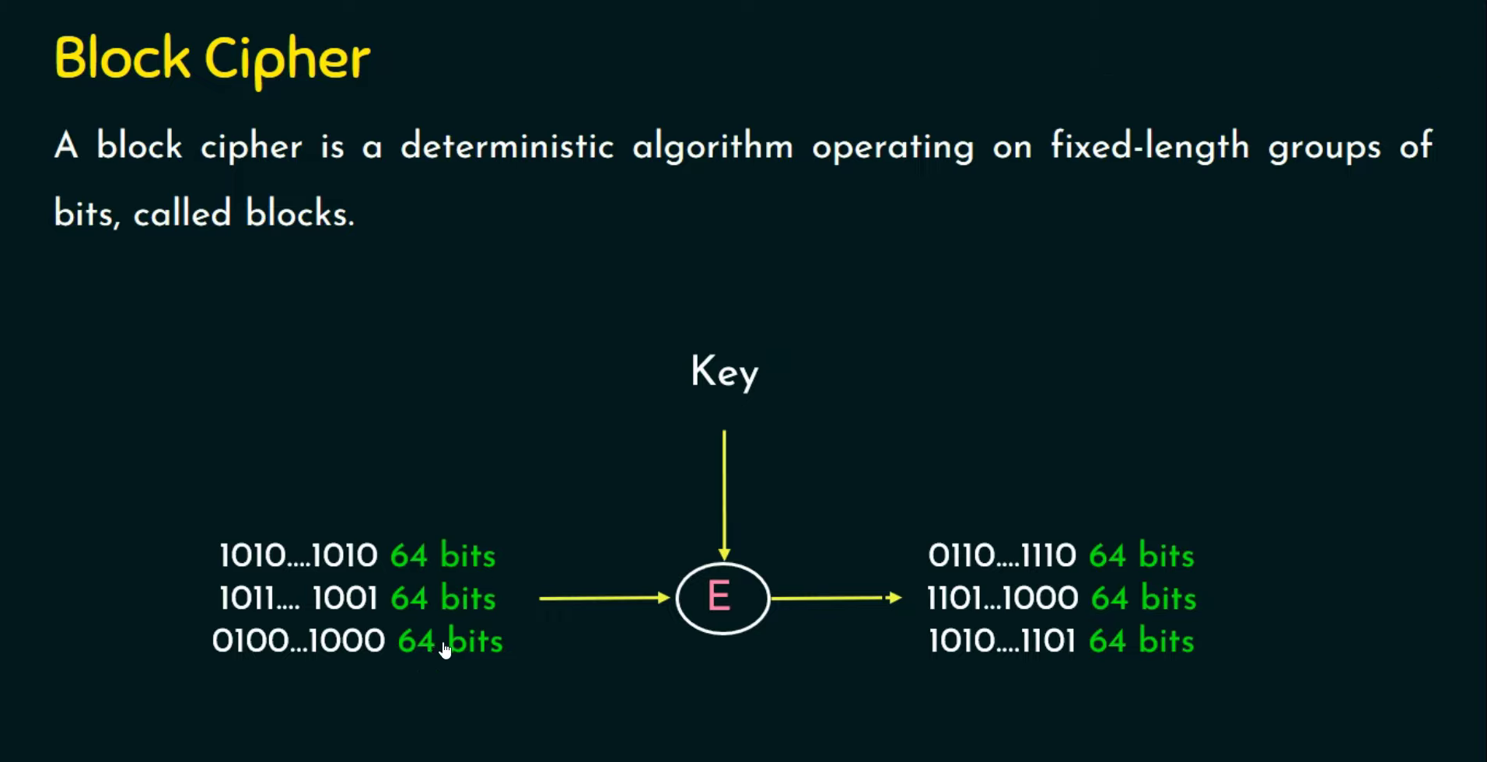

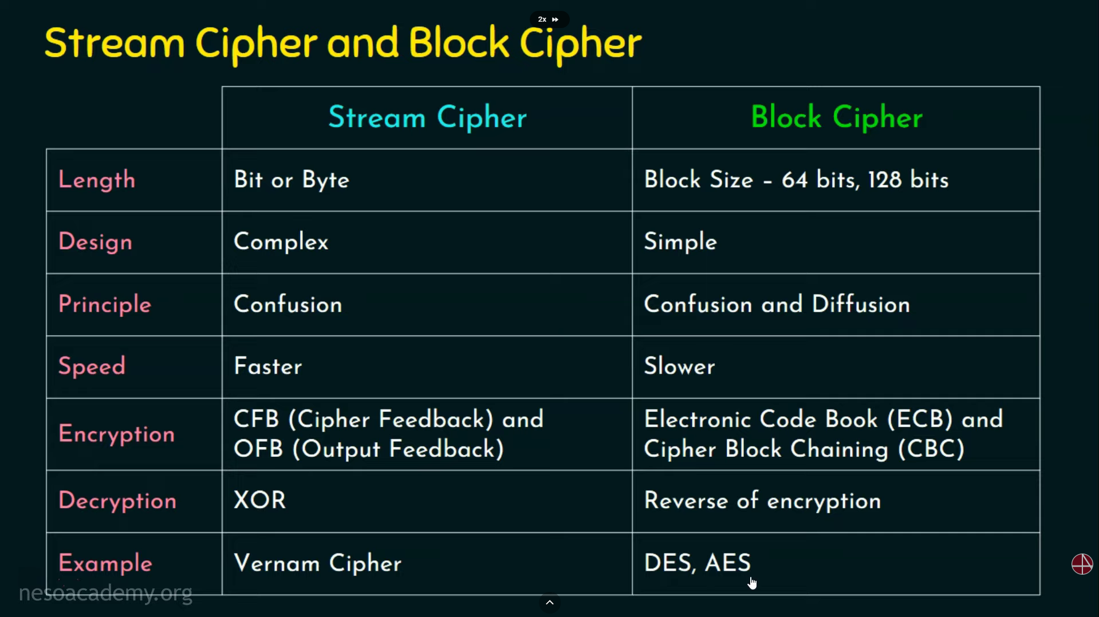

Stream Cypher vs Block Cipher
Stream Cipher
Encrypts data:
- bit-by-bit or byte-by-byte
Working
Ciphertext = Plaintext XOR Keystream
Uses a keystream generator and XOR operation.
Features
- Faster
- Low memory usage
- Low latency
- Mainly uses confusion
- Small error propagation
Examples
- RC4
- ChaCha20
- Salsa20
- Vernam Cipher
Best For
- Voice calls
- Streaming
- WiFi
- VPNs

Block Cipher
Encrypts data in:
- fixed-size blocks (64-bit / 128-bit)
Working
[Plaintext Block] → Multiple Encryption Rounds → Ciphertext Block
Uses:
- substitution
- permutation
- diffusion
- key mixing
Features
- Slower
- Stronger security
- Uses confusion + diffusion
- Larger error propagation
Examples
- AES
- DES
- 3DES
- Blowfish
Best For
- File encryption
- Disk encryption
- HTTPS
- Storage security

Why Stream Cipher is Faster
Stream Cipher
Uses:
- simple XOR operations
- continuous processing
- fewer computations
Generate Keystream → XOR → Output
Very lightweight.

Block Cipher
Uses:
- multiple rounds
- substitutions
- permutations
- matrix operations
Example AES:
- 10/12/14 rounds
Block → Round 1 → Round 2 → ... → Ciphertext
More processing = slower speed.

Quick Comparison
Feature | Stream Cipher | Block Cipher
Unit | Bit/Byte | Block
Speed | Faster | Slower
Complexity | Low | High
Security | Good | Stronger
Memory | Low | Higher
Principle | Confusion | Confusion + Diffusion
Error Effect | Small | Larger

Easy Analogy
Stream Cipher
Writing continuously with a pen
Block Cipher
Processing full pages with many checks

Feistel Structure

