Project Structure

tailscale-chat-demo/
├── .env # Tailscale auth key
├── .env.example # Template
├── .gitignore
├── docker-compose.yml # OpenClaw + Tailscale containers
├── backend/
│ ├── main.py # Auth server (FastAPI)
│ └── requirements.txt
└── client/
├── main.py # Simulates mobile app users
└── requirements.txt

- Problem
- Clairify needs a chat feature where users talk to an AI assistant (OpenClaw). The core challenges are:
  - Per-user sessions— each user needs an independent conversation
  - Backend bottleneck — if every message passes through the backend, it becomes a single point of failure and a performance bottleneck
  - Network separation — OpenClaw may run on a completely different network than the backend
  - Security — chat traffic must be encrypted and private
  - Scalability — the solution must handle growing user counts

Solution Overview
- The backend only authenticates users. After authentication, users connect directly to OpenClaw through a secure Tailscale tunnel. The backend has zero involvement in the actual chat.
- AUTHENTICATION (one-time):
User → Backend → "You're verified. Here's where OpenClaw is."
- CHAT (ongoing):
User ←──── direct connection ────→ OpenClaw
Backend is completely uninvolved.

Architecture
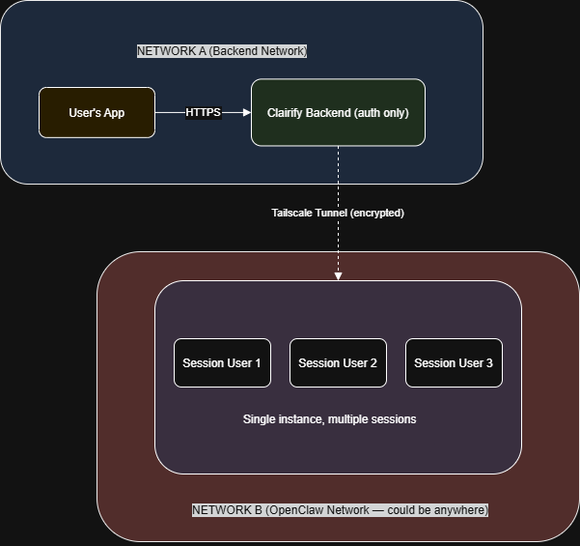

How It Works
- Step 1: User Opens Chat
The user taps "Chat" in the Clairify app. The app sends a login
request to the backend.

- Step 2: Backend Authenticates
The backend verifies the user's identity. It then looks up
OpenClaw's address on the Tailscale network and returns it
to the user.

- Step 3: Backend Steps Out
The backend's job is done. It does not participate in any
further communication.

- Step 4: Direct Chat
The user's app connects directly to OpenClaw through the
Tailscale tunnel. Messages flow back and forth without
touching the backend.
- Timeline:
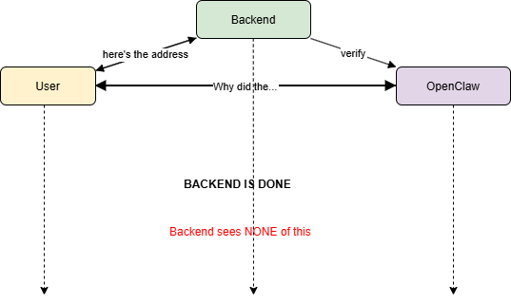

Why This Design
- Problem: Backend as Middleman
  - User ──► Backend ──► OpenClaw
User ◄── Backend ◄── OpenClaw

  - Every message doubles the load on Backend.
1,000 users = 2,000 message hops through Backend.
Backend becomes slow. Users wait. Bad experience.

- Solution: Backend as Gatekeeper Only
  - User ──► Backend (once)
User ◄── Backend (once)
  - Then:
  - User ◄═══════════► OpenClaw (direct, unlimited)

1,000 users = 1,000 auth requests (one-time) +
1,000 direct connections to OpenClaw.
Backend stays fast. Users get instant responses.

What is Tailscale
- Tailscale creates a private, encrypted tunnel between services on different networks. It eliminates the need for public IP addresses, port forwarding, or firewall configuration.
S.N. | Without Tailscale | With Tailscale
1 | Services need public IPs | Private IPs (100.x.x.x)
2 | Must configure firewalls | No firewall changes
3 | Must manage TLS certificates | Encryption is automatic
4 | Complex networking setup | Install and connect

- Analogy
  - Without Tailscale**: Sending mail through the postal system. You need an address, stamps, envelopes, and anyone can see the envelope.
  - With Tailscale**: A private phone line directly between two offices. Just pick up and talk. No one else can listen.

Alternatives Considered
S.N. | Solution | Verdict | Reason
1 | REST API (Backend relays all messages) | Rejected | Backend becomes bottleneck
2 | Message Queue (RabbitMQ) | Rejected | Adds infrastructure, not real-time
3 | WebSocket through Backend | Rejected | Backend still in the middle
4 | gRPC | Viable | Good for server-to-server, not client-facing
5 | Direct connection + Tailscale | Chosen | Backend steps out, low latency, encrypted

Scalability
S.N. | Users | What Happens
1 | 1–100 | Single OpenClaw instance handles all sessions
2 | 100–1,000 | Same instance, monitor resource usage
3 | 1,000–10,000 | Add more OpenClaw instances, load balance
4 | 10,000+ | Kubernetes orchestration, auto-scaling

- The architecture does not change. Only the number of OpenClaw instances and the orchestration layer scales.

Security
S.N. | Layer | Protection
1 | User → Backend | HTTPS
2 | Backend | OpenClaw | Tailscale (WireGuard encryption)
3 | User → OpenClaw | Tailscale (WireGuard encryption)
4 | OpenClaw | Not exposed to public internet
5 | Session tokens | One-time, per-user, expire on disconnect

- OpenClaw has zero public exposure. It is only reachable through the Tailscale network. Even if someone knows the IP, they cannot connect without being on the same Tailscale network.

