Game Design Document

Fill up the Following document

1. Write the title of your project.

Bob’s Adventures

1. What is the goal of the game?

You have to travel across all three worlds to recollect all the materials that have been stolen by the evil Wigglesworth, so that you can build yourself a wonderful castle at the end. Then whoever has the most elegant and expensive castle, will rank at the top.

1. Write a brief story of your game?

You have just received your materials that you bought from online and are ready to build a magnificent castle for yourself. Meanwhile, an evil villain named Wigglesworth is sitting in his rotting castle, and thinking about repairs. Then, he hears about all the materials that Bob has bought, and being an evil villain, decides to take them. Bob really wants to get his materials back as he spent a fortune on them. Now he must travel across three lands to face Wigglesworth and get his materials back along the way.

1. Which are the playing characters of this game?

* Playing characters are the ones which respond to the user based on the input from the user
* Cars, monkeys, dinos, wizards etc., are the playing characters in the game.

|  |  |  |
| --- | --- | --- |
| Number | Character Name | What can this character do? |
| 1 | Bob | Is the main character |
| 2 | Wigglesworth | Is the antagonist |

1. Which are the Non-Playing Characters of this game?

* Non-Playing characters are the ones which don't have an action or a behavior when the user interacts with the game.
* Hurdles, stones, bananas, coins, etc. are non-playing characters in the game.

|  |  |  |
| --- | --- | --- |
| Number | Character Name | What can this character do? |
| 1 | Wombats | An enemy on platformer levels |
| 2 | Material | Used by Bob to build things |
| 3 | Danny | One of Wigglesworth’s servants |

Draw your imagination of this game. What does this game look like?

* Draw the game either on your computer or on paper,
* Add images of scenes of the game to show each of the playing and non-playing characters at least once.

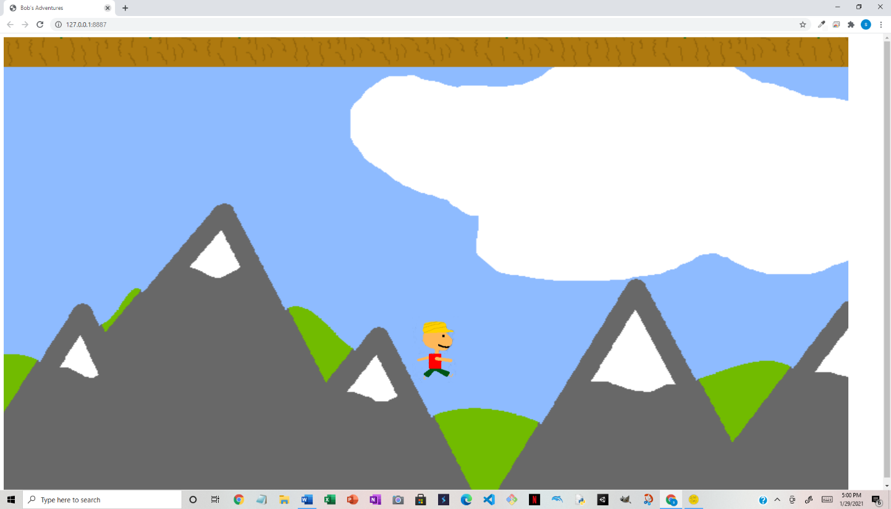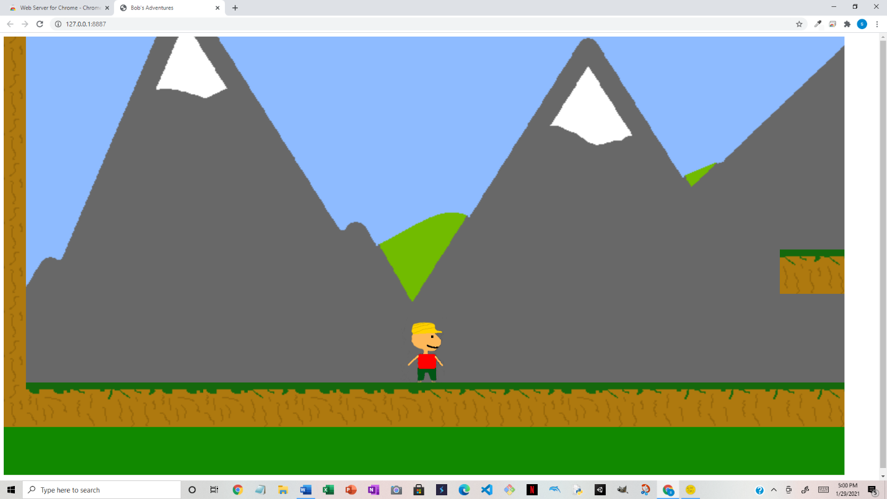

How do you plan to make your game engaging?

I will add a way to take a picture of your castle and post it, so that others can see it. I will also make objectives to work towards, and mini-missions to earn more material.