**Geetansh Rathore**

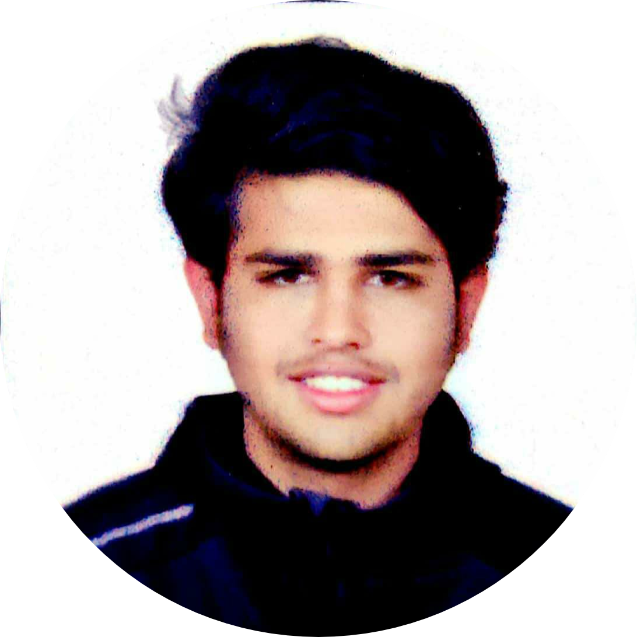

**rathore.geetansh12@gmail.com | +917339751224**

|  |  |  |  |  |
| --- | --- | --- | --- | --- |
| Degree/Specialization | College/University | Location | Year | Percentage/CGPA |
| Post-Graduation | - | - | - | - |
| Graduation | Birla Institute Of Technology | Jaipur | 2021 | 7.4 |
| 12th Std | The Daly College | Indore | 2018 | 74.5% |
| 10th Std | The Daly College | Indore | 2016 | 6.4 |

* Completed SQL database Management system
* Completed C programming
* Completed Relational Algebra
* Currently Studying cyber forensics,
* Completed network Security
* Completed java

**My Work**

* **Intershala student program (isp)** - A 70-day transformational program aimed at building the leaders of tomorrow. It helped me to improve my communication skills and leadership qualities I gave talks about the program to other students and that helped me gain confidence.

**My Tech Lab**

* **C** is the base of all the languages. I studied c in my first semester
* **Java** it is a great language as its a OOP which means a computer programming model that organizes software design around data, or objects.
* **SQL** it is a database query language to format and show desired data. I studied SQL in the 3 semester
* **HTML/CSS** these are the building block of a web site as they will decide how your site is going to look.
* **Bootstrap5** I have studied the library of bootstrap by twitter.
* **JAVA SCRIPT (js)** it is also one of the powerful languages that is used to give functionality to the web site the js uses interpreter to translate the code.
* **JQUERY** it is also a framework for java script basically as programmers we don’t want to repeat cod so j query helps us to minimize our code and saves us with unnecessary repetition of code.
* **Node.js** it is used to do the server side development and with express framework it makes programming the sever very easy and responsive.

**Badges I’ve Earned**

* participated at IPSC Soccer competition – 2017,2018
* won the best goalkeeper award at Kasliwal championship, 2016
* Finished second in Kasliwal championship,2016
* Won Kasliwal championship, 2017
* Participated at IPSC cricket competition- 2016,2017

**My Certificate courses**

* online certificate course on full stack web development by Angela Yu on udemy.

**Social welfare activities**

* worked as a volunteer of Anganwadi program – helping disabled people with providing them the proper hygiene knowledge, meals, cleaning parks and repainting the parks slides and swings.

**My vision.**

During the years of my graduation, I felt like I should acquire some practical knowledge about the field I’m going to step into. I personally want to test my knowledge, skills and caliber to work in the corporate sector. I am excited to be trained by the professionals of your organisation and get a gist of work culture in big organisations such as yours. During these years I have tirelessly worked on my communication and teamwork skills which are the most important part of a job. I am full of enthusiasm and energy that I’ll deploy for the all-round growth of your organisation. It is a great opportunity for me to work for such a prestigious organisation as yours.