AI WEATHERWISE
Deliver intelligent weather forecasts and insights
PHASE 1
PROJECT ARCHITECTURE
Epic 1: MVC pattern, technical architecture, ER diagram, features, roles and user flow
Technology: Node.js, Express.js, MongoDB, Google Gemini AI.
CONTENTS
1 Introduction to this phase
2 The problem we set out to solve
3 The MVC pattern
4 Technical architecture
5 Entity-relationship design
6 Features of AI WeatherWise
7 Roles and responsibilities
8 User flow
9 Security in the architecture
10 Design decisions and trade-offs
11 Phase review and summary
A Appendix: key terms and viva questions

1. Introduction to this phase
Every project starts with a plan, and in AI WeatherWise the plan lives in Phase 1. Before we created a folder or typed a single line of JavaScript, we sat down and decided how the system should be organised. What are the main parts? How do they talk to each other? What data do we need to store? Who is going to use it, and what is each person allowed to do? This document records the answers to those questions.
AI WeatherWise is a backend service. It does not have a web page or a mobile screen of its own. Instead, it offers a set of REST APIs that any client, such as Postman today or a React or Android app tomorrow, can call. A user can register, log in, save the cities they care about, read the current weather for a city and ask an AI model for advice based on that weather. Behind those few actions there is quite a lot of planning, and that is what this phase covers.

1.1 Objectives of Phase 1
By the end of this phase the team wanted to have the following things settled on paper:
- A clear separation of responsibilities using the Model-View-Controller (MVC) pattern.
- A technical architecture showing the client, the Express server, the middleware, the database and the two outside services (the weather provider and Google Gemini).
- An entity-relationship (ER) design for the data we need to keep: users and their favorite locations.
- A list of features the first version must deliver.
- The roles in the system and what each role is responsible for.
- A step-by-step user flow that shows how a person moves through the application.

1.2 Where this phase fits in the project
The project is divided into five phases, and each one builds on the one before it. Phase 1 is the only phase where we do not run any code. That might sound like a small thing, but it saves a lot of time later. A bad decision made in the first week, such as storing passwords in plain text or mixing database code into the routes, can take days to undo once the code is written.
Phase | Epic | What it delivers
1 | Project Architecture | The design: MVC, architecture, ER diagram, features, roles, user flow
2 | Project Setup and Configuration | Project folder, dependencies, folder structure, environment variables
3 | Backend Development | Server, routes, controllers, middleware and services
4 | Database Development | MongoDB connection, schemas and models
5 | Project Execution | Running the project and testing every API with output screenshots

1.3 Technology choices in one glance
We chose the MERN-style backend stack minus the front end: Node.js for the runtime, Express.js for the web framework, MongoDB for the database and Mongoose to talk to MongoDB from JavaScript. Two additional services give the project its character. A weather provider supplies live conditions, and Google Gemini turns those numbers into a short piece of advice in plain language.
Technology | Why we picked it
Node.js | Runs JavaScript on the server. One language for everything, and a huge package ecosystem through npm.
Express.js | A small, flexible framework for routes and middleware. Easy to learn and easy to read.
MongoDB | Stores data as JSON-like documents. Our user and location data fits this shape naturally.
Mongoose | Adds schemas, validation and helper methods on top of MongoDB.
JSON Web Tokens | Lets the server recognise a logged-in user without keeping a session in memory.
bcrypt | Hashes passwords so they are never stored as readable text.
Google Gemini | Writes natural language weather summaries and recommendations.
Postman | Used to send test requests and check responses.

2. The problem we set out to solve
A good way to understand why a system exists is to follow one person who needs it. We used a simple case study built around a traveller named Alex.

2.1 Background
Alex travels often and moves between cities for work and for fun. Every time Alex lands somewhere new, the same routine begins. Open a weather app, type the city, read a few numbers, then wonder what they actually mean. Is 34 degrees with 79 percent humidity something to worry about? Should Alex carry a jacket? Is it a good evening for a walk by the lake?

2.2 The problems Alex faces
- Tracking many places is awkward. Alex wants to keep an eye on five or six cities at once, but most apps make that clumsy.
- The numbers are not advice. Temperature, humidity and wind speed are facts. What Alex wants to know is what to wear and what to do.
- Raw data is tiring to read. A sentence such as "hot and humid, stay hydrated" is faster to understand than a table of values.
- Preferences do not travel. If Alex changes phones or laptops, the saved cities should still be there, protected by a proper login.

2.3 How AI WeatherWise answers these problems
AI WeatherWise is a central service. Alex registers once, logs in, and saves favorite cities to a personal list stored in the database. When Alex asks for the weather of a city, the server fetches live data. When Alex wants advice, the server sends the weather details to Google Gemini and returns a short recommendation. Because everything is stored on the server and protected by a token, the same list is available from any device.

2.4 Who uses the system
User type | How they use AI WeatherWise
Registered user | Keeps a list of favorite cities, checks live weather and asks for AI summaries and recommendations.
Admin / developer | Watches the health of the API, manages user accounts and checks that the weather and AI integrations still work.
Public weather user | Reads the public weather endpoint to see current conditions without creating an account.

2.5 The outcome we are aiming for
If the project works the way we planned, people spend less time interpreting numbers and more time acting on them. Data stays consistent because Mongoose schemas check everything before it is saved, and the advice comes in a form a normal person can use straight away.

3. The MVC pattern
MVC stands for Model, View and Controller. It is one of the oldest and most widely used ways of organising an application. The idea is simple: split the code into three areas, each with one clear job, so that a change in one area does not break the others.
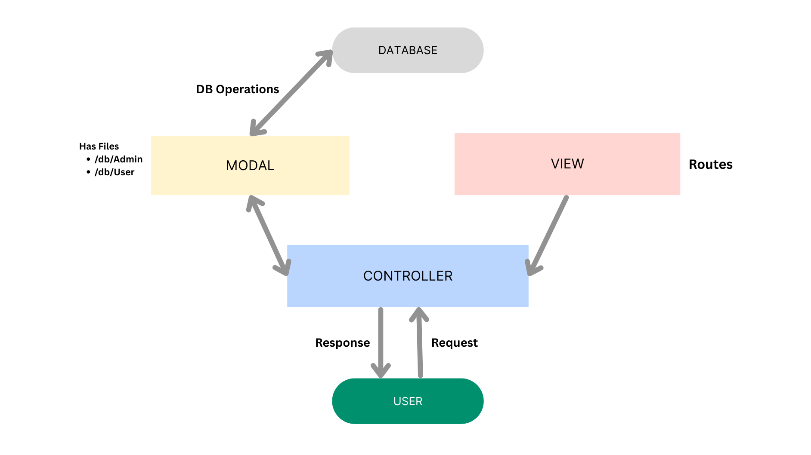
Figure 3.1: MVC structure used in AI WeatherWise

3.1 The Model layer
The model is the blueprint for our data. In AI WeatherWise there are two models, User and Location. Each one is a Mongoose schema that lists the fields a document may have, the type of each field, which fields are required and what the default values are. For example, the User model says an email must be present, must be unique, and must look like a real email address. If a request tries to save a user without those things, the model rejects it before anything reaches the database.
The model layer knows nothing about HTTP, routes or JSON responses. It only cares about data. That is what makes it easy to test and easy to reuse.

3.2 The Controller layer
The controller is where the actual work happens. A controller function receives the request, reads the input, checks that it makes sense, calls the model or a service, and then decides what to send back. In our project the controllers are split by topic: one for authentication, one for locations, one for weather and one for the AI features.
Think of a controller as a careful office clerk. It does not store the files itself (that is the model's job) and it does not decide which desk a visitor goes to (that is the router's job). It takes the request, does what is needed and hands back a result.

3.3 The View layer
In a classic website the view is the HTML page the user sees. AI WeatherWise has no pages, so there is no HTML view. The role of the view is played by the routing layer and the JSON responses it produces. A route connects a URL and an HTTP method to a controller function. When the front end is added later, it will simply consume the JSON that these routes return.

3.4 Why we used MVC
- Readability. Anyone opening the project can guess where to look. Database code lives in models, request handling in controllers, URL mapping in routes.
- Teamwork. Different members can work on different layers without constantly editing the same file.
- Easier fixes. If the weather provider changes, only the weather service changes. The routes and models stay as they are.
- Room to grow. Adding a new feature means adding a new model, controller and route file rather than rewriting existing ones.

3.5 How a request travels through MVC
Take a request to save a favorite city as an example. The route receives the call and passes it through the authentication middleware. The location controller reads the city and country from the body, attaches the logged-in user's id and asks the Location model to save the document. The model validates the fields and writes to MongoDB. The controller then returns a JSON message saying the city was saved. Each layer did its own part and nothing more.

4. Technical architecture
The MVC pattern describes how the code is organised. The technical architecture goes one step further and shows every piece involved when the system is running, including the pieces that are not ours, such as MongoDB and the Gemini service.
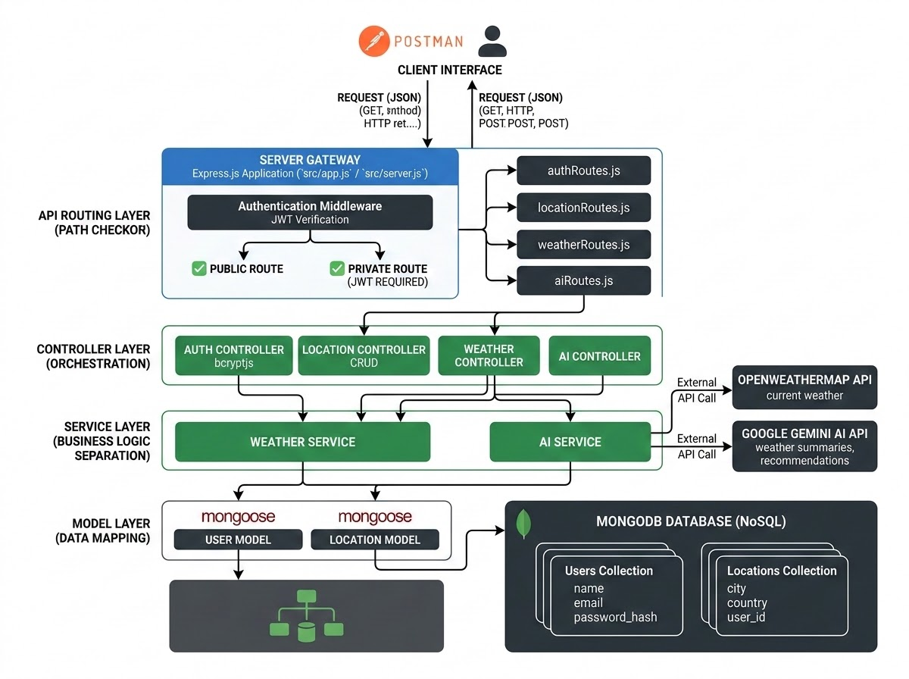
Figure 4.1: Technical architecture of AI WeatherWise

4.1 The main components

Client or interface
The client is anything that can send an HTTP request. During development we use Postman. Later it could be a React web app, a mobile app or another server. The client only needs to know the URL of an endpoint and the format of the request and response.

Express server gateway
The Express server is the front door of the system. It listens on a network port, reads incoming requests, understands the HTTP method (GET, POST, PUT or DELETE), parses JSON bodies and sets CORS headers so approved web clients can call it. It also decides which route should handle each request.

Middleware
Middleware are small functions that run between the request arriving and the controller running. We use them for JSON parsing, CORS, input sanitization, authentication and error handling. The authentication middleware reads the token from the request header, checks that it is genuine and not expired, and only then lets the request carry on to the controller.

Controllers and services
Controllers handle each request. Services hold the code that talks to the outside world. Keeping this code in a separate services folder means a controller does not need to know how the weather provider formats its response or how the Gemini SDK is called.

Database interface layer
Mongoose sits between our code and MongoDB. We write JavaScript such as "find the locations that belong to this user" and Mongoose turns it into a proper MongoDB query. It also applies schema rules and indexes.

Weather provider
A weather API supplies live temperature, humidity, wind speed and conditions for a city. If the provider key is missing or the call fails, AI WeatherWise has a fallback mode that returns sample data so the rest of the API keeps working. In our test run the weather response carried a flag called isMock to show that fallback data was used.

Google Gemini AI
The AI service receives the city, temperature, humidity and condition, and returns a short recommendation. The system is built so the same fallback idea applies here. Without an API key, a simple rule-based message is returned instead of an error.

4.2 Component summary
Component | Responsibility | Talks to
Client (Postman) | Sends requests, shows responses | Express server
Express server | Routing, JSON parsing, CORS | Middleware, routes
Auth middleware | Verifies the token | Controllers
Controllers | Request logic and responses | Models, services
Services | Weather and AI calls | External APIs
Mongoose models | Schemas and validation | MongoDB
MongoDB | Stores users and locations | Mongoose

4.3 A closer look at one request
To see the architecture in motion, follow a request for the weather in Bangalore. The client sends a GET request to the weather endpoint with the city name in the URL. Express matches the route. The weather controller reads the city, asks the weather service for live data and gets the numbers back. The controller wraps them in a JSON object with a success flag and returns it with status 200. If the provider could not be reached, the service supplies fallback numbers and the response is marked so the caller knows.
Design note: The architecture is stateless. The server does not remember anyone between requests. Everything it needs to know about the caller arrives inside the token, which is why the same service can later run on several machines without extra work.

5. Entity-relationship design
An ER diagram shows the things we store (entities), the details about each (attributes) and how the things relate to each other. AI WeatherWise keeps its data model small on purpose. There are two entities.
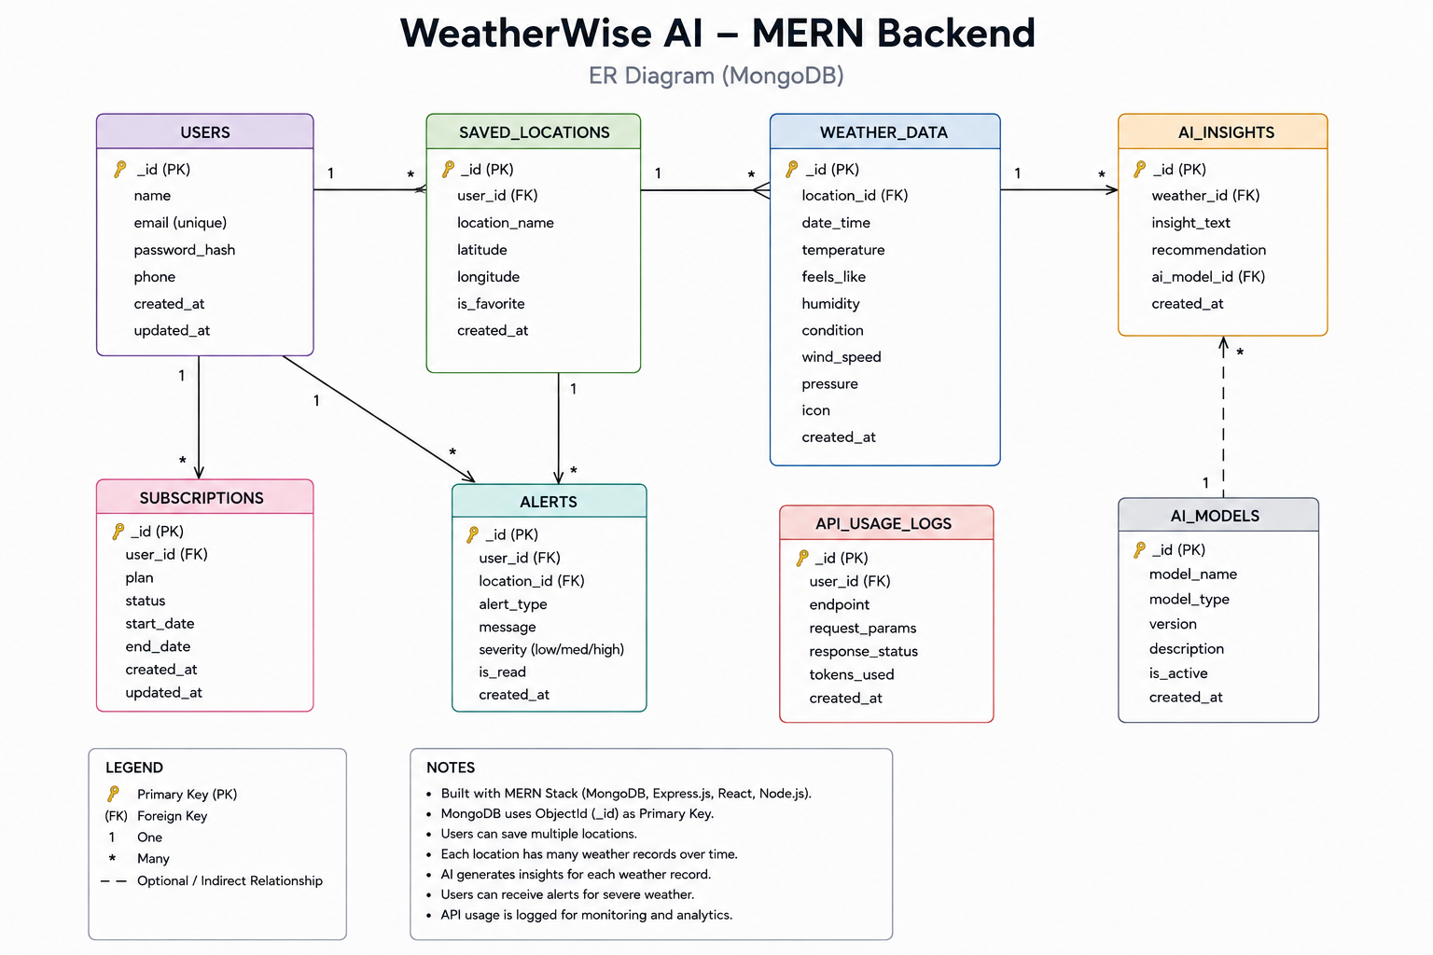
Figure 5.1: ER diagram of AI WeatherWise

5.1 The User entity
A user is a person who has registered in the system. We store only what we need to identify them and let them log in.
Field | Type | Notes
_id | ObjectId | Primary key created by MongoDB
name | String | Required, extra spaces trimmed
email | String | Required, unique, stored in lower case, must match an email pattern
password | String | Required, at least 6 characters, stored as a bcrypt hash
createdAt, updatedAt | Date | Added automatically by Mongoose timestamps

5.2 The Location entity
A location is a city that a user has saved as a favorite.
Field | Type | Notes
_id | ObjectId | Primary key created by MongoDB
user | ObjectId | Reference to the User who owns this location, required
city | String | Required, trimmed
country | String | Required, trimmed
createdAt, updatedAt | Date | Added automatically by Mongoose timestamps

5.3 The relationship
One user can have many locations, but each location belongs to exactly one user. This is a one-to-many relationship. In MongoDB it is stored by keeping the owner's id inside each location document. That is the same idea as a foreign key in a relational database, except MongoDB does not enforce it by itself. Mongoose helps with the "ref" setting, and our own code makes sure the id is always present.

5.4 Preventing duplicate favorites
It would be annoying if a user could save Chennai, India ten times. To stop this, the Location schema has a compound unique index on user, city and country. The database itself refuses a second copy of the same combination for the same user, so even if two requests arrive at the same moment, only one is saved. Two different users can still save the same city without any problem.

5.5 Why only two entities
Weather readings change every few minutes and are easy to fetch again, so we decided not to store them. Saving them would make the database bigger and the data stale very quickly. The AI recommendations are generated on request for the same reason. Keeping the stored data small also keeps the system simple to explain, test and maintain.

6. Features of AI WeatherWise
The feature list was written from the problems in the case study. Each feature exists because a real need pointed to it.

6.1 Secure registration and login
A new user sends a name, email and password. The server checks the input, hashes the password with bcrypt and saves the user. In reply it returns the user's basic details and a JSON Web Token. When the user logs in later with the same email and password, the server compares the password with the stored hash and, if it matches, issues a fresh token. The token is then sent with every protected request.

6.2 Role-aware route protection
Routes that deal with personal data are protected by the authentication middleware. Requests without a valid token are stopped before they reach a controller. The design also leaves room for stricter admin-only routes, such as user management, by checking the role carried by the token.

6.3 Favorite locations
Logged-in users can add a city to their list, view the list, update an entry and delete it. These are the four CRUD operations: create, read, update and delete. The list always belongs to the person who is logged in, so nobody can see or change another user's cities.

6.4 Real-time weather
Any caller can request the current weather for a city. The response contains the city, temperature, humidity, wind speed and a short condition such as "Windy". This endpoint is public, so it can be used without an account.

6.5 AI-generated recommendations
The caller sends a city and the weather values. The server asks Gemini for a short, practical suggestion and returns it. In one of our tests the input was 34 degrees, 79 percent humidity and a windy condition for Bangalore, and the answer advised staying hydrated and wearing light cotton clothes.

6.6 Fallback mode
External services fail sometimes. Keys expire, networks drop and free plans run out. Instead of returning an error, AI WeatherWise falls back to sample data and rule-based advice. This keeps development and demos smooth, and the isMock flag tells the caller when it happened.

6.7 Input sanitization and error handling
User input is never trusted. Request bodies are cleaned to remove characters that could be used for cross-site scripting or for NoSQL injection, where an attacker sends an object such as a query operator instead of a plain string. All errors are passed to one central error handler that returns a consistent JSON message and a sensible status code.

6.8 Feature summary
Feature | Who uses it | Needs login
Register and login | Everyone | No
Favorite locations (CRUD) | Registered user | Yes
Current weather | Everyone | No
AI recommendation | Registered user / client app | As configured
User management | Admin | Yes (admin)

7. Roles and responsibilities
A system with accounts needs clear rules about who can do what. AI WeatherWise recognises two main roles, and a third group of visitors who do not log in at all.

7.1 Admin
The admin looks after the health of the platform rather than the day-to-day use of it. The responsibilities are:
- Creating, deleting or suspending user accounts when needed.
- Watching the API health and system logs to notice slow responses or repeated errors.
- Keeping an eye on the database, for example checking that indexes exist and that no stray test data is left behind.
- Confirming that the weather and AI integrations still respond after any key or provider change.

7.2 Registered user
The registered user is the person the product is built for. Their responsibilities are:
- Building and maintaining a list of favorite locations.
- Requesting real-time weather data for those places.
- Asking the AI service for summaries and activity or clothing suggestions.
- Looking after their own credentials and keeping their profile details up to date.

7.3 Public visitor
A visitor without an account can still call the public weather endpoint. They cannot save locations or use anything tied to a personal profile.

7.4 Permission overview
Action | Visitor | User | Admin
Register / log in | Yes | Yes | Yes
View current weather | Yes | Yes | Yes
Manage own favorite cities | No | Yes | Yes
Request AI recommendation | Per setup | Yes | Yes
Manage other users | No | No | Yes
View system health | No | No | Yes

7.5 Team responsibilities in the Kanban board
Apart from the system roles, the people building the project also divided the work. The Kanban board lists five epics and sixteen stories. Each story was given to a team member and carried a priority of Easy, Medium or Hard. Architecture stories such as MVC pattern, technical architecture, ER diagram, features, roles and responsibilities and user flow were all rated Medium. Backend structure was the one story marked Hard, because it decides how everything else is arranged. Steps for project execution and output screenshots were rated Easy. Every story passed through a Review column before being treated as finished.

8. User flow
The user flow describes the path a normal person takes through the system from the first request to the last. It is useful because it shows whether the features we listed actually fit together.
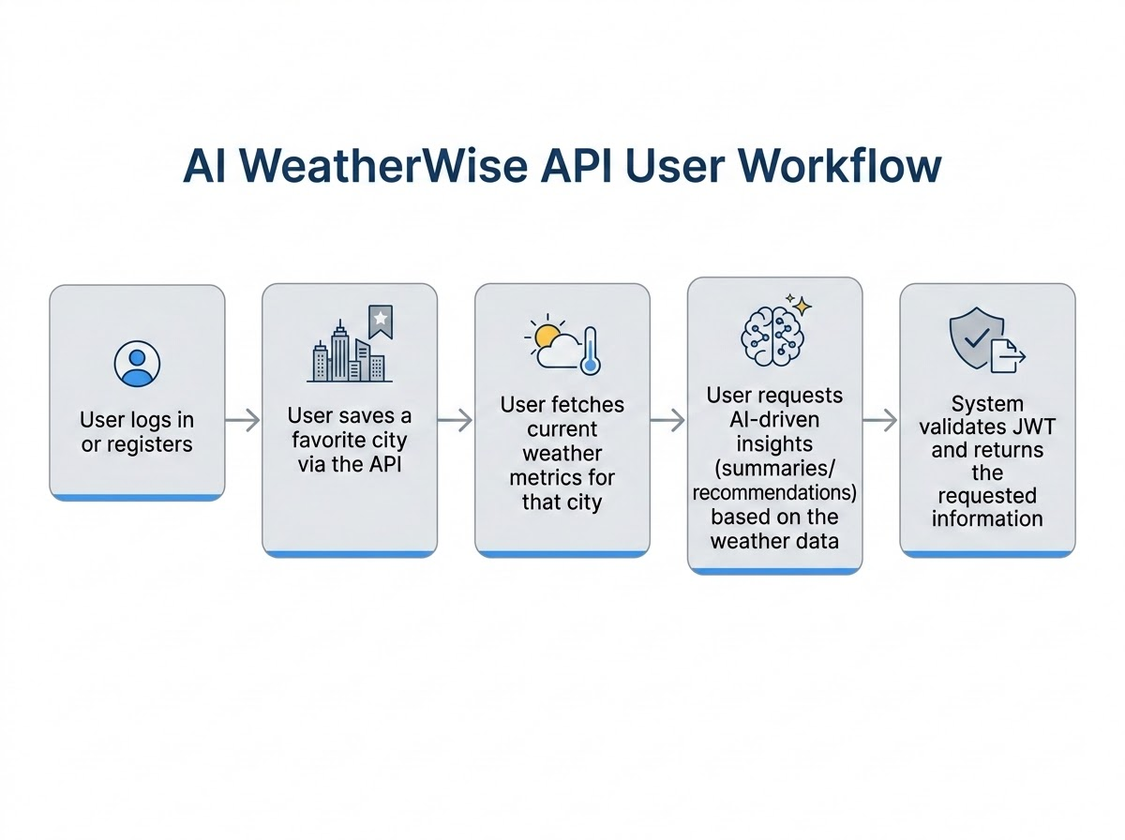
Figure 8.1: User flow of AI WeatherWise

8.1 The five steps
- Register or log in. The user creates an account or signs in. The server returns a token.
- Save a favorite city. The user sends the city and country along with the token. The server stores it under that user.
- Fetch current weather. The user asks for the weather of a city and receives temperature, humidity, wind speed and condition.
- Ask for AI insights. The weather values are passed to Gemini and a short recommendation comes back.
- Token validation. On every protected call the server checks the token first and only returns data when it is valid.

8.2 Walking through Alex's day
Alex lands in Bangalore. Using a client app, Alex registers with a name, email and password and gets a token back. Alex saves Bangalore and two other cities. A moment later Alex asks for the weather in Bangalore and sees 34 degrees, 79 percent humidity and wind. Alex then asks for a recommendation and is told to stay hydrated and wear light cotton clothes. The next morning Alex logs in from a different phone, and the same three cities are waiting.

8.3 What happens when something goes wrong
Situation | What the system does
Wrong password at login | Returns an error message without saying whether the email or the password was wrong
Token missing or expired | Rejects the request with an unauthorized status
Same city saved twice | The unique index blocks it and the user gets a clear message
Weather provider unreachable | Falls back to sample data and sets the isMock flag
Gemini key missing | Returns a simple rule-based recommendation
Invalid email at registration | Validation fails before anything is saved

9. Security in the architecture
Security is not something we added at the end. It shaped several of the decisions above. This chapter gathers them in one place.

9.1 Password protection
Passwords are never stored as typed. They are hashed with bcrypt, which adds a random salt and is deliberately slow, making large-scale guessing expensive. Even someone who gets a copy of the database cannot read the original passwords.

9.2 Token-based authentication
After login the server signs a JSON Web Token with a secret that only the server knows. The token carries the user's id and an expiry time. Because it is signed, nobody can change its contents without the server noticing. The secret is kept in an environment variable and is never written into the source code.

9.3 Input cleaning
Incoming data is cleaned before use. This protects against script injection and against NoSQL operator injection. The schema validation then adds a second layer by rejecting wrong types and missing fields.

9.4 Keeping secrets out of the code
Database addresses, the token secret and the Gemini key are read from a .env file. The file is listed in .gitignore so it is never uploaded to a public repository.

9.5 Controlled error messages
The error handler returns short, safe messages. It does not leak stack traces, file paths or database details to the caller, since those can help an attacker.

9.6 Security checklist
Measure | Threat addressed | Status
bcrypt password hashing | Stolen database | Planned in design
JWT with secret in .env | Forged sessions | Planned in design
Input sanitization | XSS, NoSQL injection | Planned in design
Schema validation | Bad or missing data | Planned in design
Central error handler | Information leaks | Planned in design
.gitignore for .env | Leaked secrets | Planned in design

10. Design decisions and trade-offs
Every design involves choices, and it helps to write down why we made them. Someone reading this later, perhaps the team itself in six months, can then judge whether the reasons still hold.

10.1 MongoDB instead of a relational database
Our data is small and document-shaped. A user and a list of their locations fit naturally as documents. MongoDB also lets us add fields later without a migration step. The trade-off is that the database does not enforce relationships on its own, so our code and indexes carry that responsibility.

10.2 Tokens instead of server sessions
With tokens the server stores nothing per user, which keeps it simple and ready to scale. The trade-off is that a token cannot easily be cancelled before it expires, so we keep the lifetime reasonable.

10.3 Not storing weather data
Weather changes quickly. Storing it would give us old data and extra storage. The trade-off is that every weather request depends on the provider, which is why the fallback mode matters.

10.4 A fallback mode for outside services
Making the system work without keys helps in development, demos and exams. The trade-off is that a caller might mistake sample data for real data, so the response carries a clear flag.

10.5 A headless backend
We kept the project to the API only. It allows any front end to be added later and lets us test everything in Postman. The trade-off is that non-technical users cannot try it until a front end exists.

10.6 Limits we accept in version one
- No weather history or charts.
- No password reset by email.
- No refresh tokens; users log in again when a token expires.
- Only two collections, so no analytics.

11. Phase review and summary

11.1 Review checklist
Item | Result
MVC pattern explained and agreed | Done
Technical architecture diagram prepared | Done
ER diagram with User and Location entities | Done
Feature list written from the case study | Done
Roles and responsibilities defined | Done
User flow drawn and walked through | Done
Security approach recorded | Done
Stories passed review on the Kanban board | Done

11.2 What we learned
Planning first made the later phases easier to talk about. When a teammate asked where a piece of code should go, the answer was already in the MVC diagram. When someone asked whether a new field was needed, the ER diagram showed what was stored and why. Most of all, writing the case study about Alex kept the team focused on real needs instead of adding features for their own sake.

11.3 Summary
Phase 1 gave AI WeatherWise a solid foundation. The system is organised using MVC, runs on an Express server with middleware for security, stores users and favorite locations in MongoDB, and uses outside services for weather and AI advice with a fallback when they are not available. The roles are clear and the user flow shows how every feature fits together.
Phase 2 takes this design and turns it into a working project folder with the right tools, packages and configuration.

Appendix: key terms and viva questions
This appendix gathers the important words from this phase in one place and lists questions that are likely to come up in a review or viva, together with short answers.

A.1 Key terms
Term | Meaning
MVC | Model-View-Controller, a way of splitting code into data, logic and interface layers
REST API | A set of web addresses that clients call using HTTP methods and that reply with data, usually JSON
Endpoint | One address plus one method that does a specific job
Middleware | A function that runs between the request and the controller
ER diagram | A drawing of the entities we store and how they relate
Entity | A thing we keep data about, such as User
One-to-many | One record on one side linked to several on the other
JWT | JSON Web Token, a signed proof of login
Hashing | Turning a password into a fixed text that cannot be reversed
Stateless | The server remembers nothing between requests
Fallback mode | Sample answers returned when an outside service is unavailable

A.2 Review questions and short answers
Q1. Why did the team choose MVC?
To keep data, logic and routing separate so each can change without breaking the others.
Q2. What plays the role of the View in this project?
The routing layer and its JSON responses, since there are no HTML pages.
Q3. How many entities does the ER diagram have, and how are they related?
Two, User and Location, in a one-to-many relationship.
Q4. Why is weather data not stored?
It changes constantly and is cheap to fetch again, so storing it would only create stale data.
Q5. What does the isMock flag tell a client?
That the answer came from fallback sample data.
Q6. Name two security measures planned in the architecture.
Password hashing with bcrypt and token-based authentication with a secret kept in .env.

A.3 How to use this document
Read the chapters in order the first time. When revising, go straight to the review table near the end of the document and the questions above. If you are presenting the project, keep the figures open on screen while you explain, because each picture was chosen to show one idea clearly.

