AI WEATHERWISE
Deliver intelligent weather forecasts and insights
PHASE 4
DATABASE DEVELOPMENT
Epic 4: configuring MongoDB, creating the database connection, schemas and models

Technology: Node.js, Express.js, MongoDB, Google Gemini AI
CONTENTS
1 Introduction to this phase
2 MongoDB and Mongoose basics
3 Configuring MongoDB
4 Creating the database connection
5 Schemas and models in Mongoose
6 The User schema
7 The Location schema
8 Relationships between collections
9 Data integrity and validation
10 Working with the data
11 Looking inside the database
12 Performance, backup and security
13 Troubleshooting database problems
14 Phase review and summary
A Appendix: key terms and viva questions

1. Introduction to this phase
An application without a database forgets everything the moment it stops. For AI WeatherWise, the database is what remembers who the users are and which cities they have saved. This phase explains how we set that memory up: how MongoDB was prepared, how the Node.js server connects to it, and how the User and Location data is described with Mongoose schemas.
On the Kanban board, this is the Database Development epic. It has three stories: Configure MongoDB, Create Database Connection and Create Schema and Models. All three were rated Medium. They follow each other naturally, so this document follows the same order.

1.1 Goals
- Get a working MongoDB database that the project can reach.
- Connect to it once, cleanly, before the server accepts requests.
- Describe the stored data with schemas so that mistakes are caught early.
- Prevent duplicate favorite locations for the same user.
- Make the data easy to inspect and easy to back up.

1.2 What is stored
Only two kinds of data are stored: users and their favorite locations. Weather readings and AI recommendations are produced fresh for each request, so they are not saved. This keeps the database small and the design easy to reason about.
Collection | Holds | Related to
users | Registered accounts with a hashed password | Owns many locations
locations | Favorite cities saved by users | Belongs to one user

2. MongoDB and Mongoose basics
Before looking at our own setup, it helps to be clear about a few ideas. If you have used spreadsheets or SQL tables, MongoDB will feel familiar in some ways and different in others.

2.1 What MongoDB is
MongoDB is a document database. Instead of rows in tables, it stores documents, which look like JSON objects. Documents of a similar kind live together in a collection, and collections live inside a database. A single MongoDB server can host many databases.
SQL idea | MongoDB idea | In AI WeatherWise
Database | Database | weatherwise
Table | Collection | users, locations
Row | Document | One user, one saved city
Column | Field | name, email, city, country
Primary key | _id | ObjectId created automatically

2.2 A document looks like this
{
"_id": "6a4391c99e4426c279d7e4fb",
"name": "John Doe",
"email": "john@mail.com",
"password": "<bcrypt hash>"
}

This is the shape of the user we created while testing the register endpoint. The identifier is generated by MongoDB, and the password is shown only as a hash, never as the typed text.

2.3 ObjectId
Every document has an _id. If we do not supply one, MongoDB creates an ObjectId, a 12-byte value that is unique across the database and roughly increases over time. It is usually shown as a 24-character text of letters and digits. We never have to invent identifiers ourselves.

2.4 Why MongoDB suits this project
- The data is naturally document-shaped.
- New fields can be added later without a migration.
- The JSON-like format matches the JSON that our API sends and receives.
- It is easy to run locally, and free in the cloud for small projects.

2.5 What Mongoose adds
MongoDB itself does not force a document to have any particular fields. That freedom is useful but dangerous, because a typo such as emial instead of email would quietly be saved. Mongoose is a library that sits on top and adds structure. With Mongoose we define a schema that lists the fields and rules, create a model from it, and then use that model to read and write data. It also provides validation, default values, helper methods, hooks that run before or after saving and a tidy way to describe relationships.
Mongoose term | Meaning
Schema | A description of the fields in a document and the rules they must follow
Model | A tool made from a schema that lets us create and query documents
Document | One saved record, an instance of a model
Validator | A rule such as required, minlength or match
Index | A structure that speeds up searches or enforces uniqueness
Timestamps | Automatic createdAt and updatedAt fields

3. Configuring MongoDB
The first story of the epic is to make a database available and to prepare the project to use it.

3.1 Installing Mongoose
Mongoose is the one package the project needs for this. In the project directory, the command is:
npm install mongoose

It was already included in the long install command from Phase 2, so running it again simply confirms it is present. After it finishes, mongoose is listed under dependencies in package.json.

3.2 Choosing where the database runs
Option | Good for | Things to remember
Local MongoDB | Quick testing on one computer, no internet needed | The database exists only on that machine
MongoDB Atlas (cloud) | Sharing between team members, access from anywhere | Needs an account, a database user and an allowed IP address

3.3 Option A: local MongoDB
- Download and install MongoDB Community Server and, if offered, MongoDB Compass, a graphical tool.
- Make sure the MongoDB service is running. On Windows it normally starts as a service after installation.
- The default address is mongodb://127.0.0.1:27017. Add a database name to the end, such as /weatherwise.
- Put the full address in the .env file as MONGO_URI.
MONGO_URI=mongodb://127.0.0.1:27017/weatherwise

3.4 Option B: MongoDB Atlas
- Create a free account and a free shared cluster.
- Create a database user with a username and password.
- Allow your IP address in the network access list. For classroom testing some teams allow all addresses, which is convenient but not recommended for anything real.
- Choose the connect option for applications, copy the connection string and replace the placeholders with your user name and password.
- Add the string to .env as MONGO_URI.
Watch out: If the password contains special characters such as @ or #, they must be URL-encoded in the connection string. Otherwise the string breaks in the middle and the error message can be confusing.

3.5 Database name
We named the database weatherwise. The name is part of the connection string. If you leave it out, MongoDB uses a database called test, which is easy to forget and hard to find later. Giving it a proper name means all our collections end up in one expected place.

3.6 A quick check that MongoDB is alive
Before writing code, make sure the database answers. With Compass, click Connect and see if a list of databases appears. With the shell, run the following command.
mongosh "mongodb://127.0.0.1:27017"

If the prompt appears, the server is accepting connections. If it fails with a connection refused message, the service is not running or the port is wrong.

4. Creating the database connection
The second story is the connection itself. In AI WeatherWise, it lives in one small file, src/config/db.js, and it has a single purpose: make sure the backend can talk to MongoDB before any request is processed.
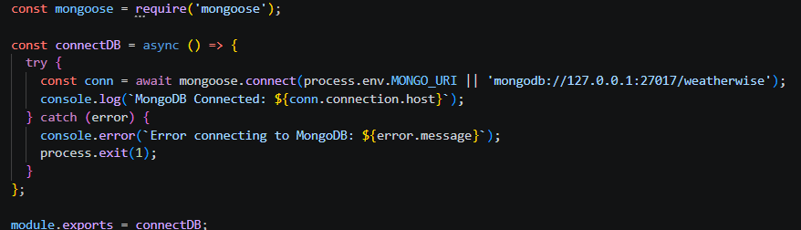
Figure 4.1: Database connection module (db.js)

4.1 Reading the code
The file imports mongoose and defines an async function called connectDB. Inside it, a try block waits for mongoose.connect with the address taken from process.env.MONGO_URI. If that variable is not set, the code falls back to mongodb://127.0.0.1:27017/weatherwise, a local database with our chosen name. That fallback makes it easy for a teammate to run the project right after installing MongoDB, even before creating a .env file.
When the connection succeeds, the function prints "MongoDB Connected:" followed by the host name. That line is the proof that the connection is alive. When it fails, the catch block prints "Error connecting to MongoDB:" together with the error message and calls process.exit(1) to stop the program. The function is exported with module.exports so the server file can use it.

4.2 Why a function and not top-level code
By wrapping the connection in a function that returns a promise, server.js gets control over when it happens and what happens next. It calls connectDB, waits for it to succeed and only then starts listening. If we had used top-level code, the server would start without knowing whether the database was ready.

4.3 Why stop the process on failure
A backend that cannot reach its database is not useful. It can neither register users nor save locations, and it may give the impression of working. Exiting immediately with a clear message is more honest. Tools such as process managers and hosting platforms can then notice the exit and restart the service, or alert someone.

4.4 Connection options
Recent versions of Mongoose choose good defaults, so we do not need to pass the old option flags that older tutorials show. If needed, a few options can still be added to the second argument of connect:
Option | Purpose
serverSelectionTimeoutMS | How long to wait for a server before giving up
maxPoolSize | Maximum number of simultaneous connections kept open
dbName | Choose the database name separately from the string

4.5 Connection events
Mongoose emits events such as connected, disconnected and error on its connection object. They can be used to log what happens if the database goes away after the server has started. We kept the first version simple, but this is a natural extension for the future.

4.6 How it fits with server.js
The two files cooperate. db.js knows how to connect and server.js knows when. The result in the terminal on a healthy start is a pair of messages: the first confirming the MongoDB host and the second reporting the server's port.

5. Schemas and models in Mongoose
The third story is where the shape of our data is written down. We did this in two files, one for each entity, inside src/models.

5.1 Anatomy of a schema
A schema is an object that maps each field name to a description. The description says the type, whether it is required, the default value, validators and a few helpful switches like trim and lowercase. The schema also accepts a second argument for options such as timestamps.
Setting | Effect
type | The kind of value: String, Number, Date, ObjectId and so on
required | The field must be present; the second value is the error message
unique | Creates a unique index so no two documents share the value
trim | Removes spaces from both ends of a string before saving
lowercase | Converts a string to lower case before saving
minlength | Minimum number of characters, with an error message
match | The value must fit a regular expression pattern
ref | Names the model that an ObjectId points to
default | Value used when none is supplied

5.2 From schema to model
After the schema is written, mongoose.model turns it into a model. The first argument is the model name, such as User, and Mongoose automatically uses its lower-case plural, users, as the collection name. The model is then exported so controllers can use it.

5.3 Why we validate in two places
Controllers do check the input, and the schema checks it again. This looks repetitive but it protects us from different mistakes. The controller's check is about the request. The schema's check is about the stored data and applies wherever the model is used, even in scripts or future code that skips a controller. Data is safest when the last gate in front of the database is strict.

5.4 Custom messages
Every required field in our schemas has its own message, such as "Please provide a name" or "Please provide an email". When validation fails, those exact messages are what the central error handler shows to the client, which makes API responses friendlier and removes the need to write separate messages in the controller.

6. The User schema
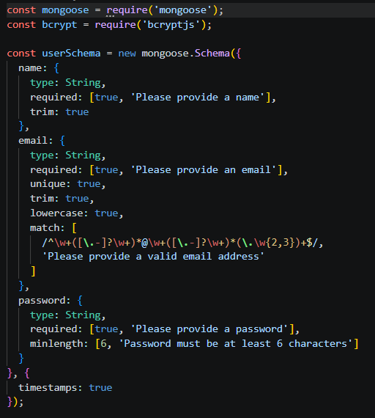
Figure 6.1: User schema (User.js)
The User model describes a registered account. It imports mongoose and also bcryptjs, which is used for hashing the password.

6.1 Field by field
Field | Rules | Message when invalid
name | String, required, trimmed | Please provide a name
email | String, required, unique, trimmed, lowercased, must match an email pattern | Please provide an email / Please provide a valid email address
password | String, required, minimum length 6 | Please provide a password / Password must be at least 6 characters

6.2 The email field
Email has the most rules. Required means it cannot be missing. Unique makes MongoDB reject a second account with the same address. Trim and lowercase make sure that " John@Mail.com " and "john@mail.com" are treated as the same person, which prevents accidental duplicates. Finally the match setting checks the text against a regular expression, so a value like "johnmail" is turned away before it reaches the database.

6.3 The password field
The password is required and must have at least six characters. This rule is checked on the plain text before it is hashed. After hashing, the stored value is much longer, but the check has already happened. The password is kept as a bcrypt hash, so even a person with access to the database cannot read the original text.

6.4 Timestamps
The second argument of the schema sets timestamps to true. Mongoose then adds createdAt and updatedAt to every document and keeps them up to date. They answer practical questions such as when an account was created, without us writing any code for it.

6.5 Where the role fits
The architecture in Phase 1 describes an Admin role and a Registered User role. In the current schema there is no separate role field, so every account is a regular user. Adding a role field with a default value, for example "user", is a small change to the schema, and the authentication middleware can then check it for admin-only actions. We kept version one minimal and left this as an extension.

6.6 What a stored user looks like
A user document in the collection has an id, the name, the email, the hashed password, and the two timestamps. When the API returns a user, for example after registration, it sends only the id, the name and the email along with a token. The password hash never leaves the server.

7. The Location schema
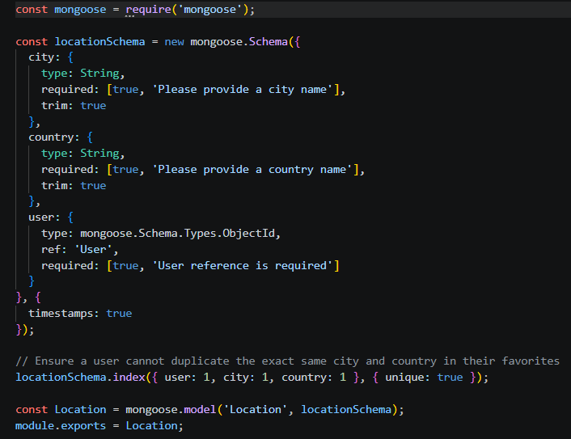
Figure 7.1: Location schema (Location.js)
The Location model describes one saved favorite city and who it belongs to.

7.1 Field by field
Field | Rules | Message when invalid
city | String, required, trimmed | Please provide a city name
country | String, required, trimmed | Please provide a country name
user | ObjectId referencing User, required | User reference is required

7.2 The user reference
The user field is the link between the two collections. Its type is mongoose.Schema.Types.ObjectId and its ref is "User". It holds the _id of the user who owns the location. Every location must have one, so no orphan locations can exist without an owner.

7.3 The compound unique index
Below the schema, the file declares an index on user, city and country with the unique option. A comment in the code explains the intention: a user cannot save the same city and country twice. The index covers the three fields together, so it is the combination that must be unique.
User | City | Country | Allowed?
Alex | Bangalore | India | Yes, first time
Alex | Bangalore | India | No, duplicate
Alex | Bangalore | Canada | Yes, different country
Sam | Bangalore | India | Yes, different user

Because the rule is enforced by the database itself, it holds even when two requests arrive at nearly the same moment. A check in code alone could miss that situation.

7.4 Timestamps
Like the User schema, this one enables timestamps. That gives us createdAt and updatedAt on each location, which can later be used for sorting favorites by when they were added.

7.5 Why city and country are separate
There is more than one Bangalore, Cambridge and Springfield in the world. Keeping the country as a separate field removes the ambiguity and also lets us build searches or groupings by country later.

8. Relationships between collections

8.1 One user, many locations
A user can have many locations, and each location has one user. This one-to-many link is implemented by storing the user's _id inside each location. The alternative would be to store an array of locations inside the user document. We chose the first approach because the list of locations can grow, individual locations are updated and deleted often, and we frequently want to look up locations on their own.

8.2 Referencing and populating
A reference only stores an id. If we want the actual user details together with a location, Mongoose offers populate, which fetches the referenced document and swaps it in. We rarely need this in AI WeatherWise because the user is already known from the token. It remains available for admin tools.

8.3 Referential integrity
MongoDB does not check that the referenced user exists, the way a relational database with foreign keys would. We handle this in application code. A location is always created from the id in the verified token, so it will point to a real user. If an admin ever removes a user, the related locations should be removed too, and the code that deletes users is responsible for that clean-up.

8.4 Querying by owner
Every query for locations includes the user id, for example "find all locations where user equals this id". The unique index starts with user, so MongoDB can also use it to answer this query efficiently. One index does two jobs.

9. Data integrity and validation
Good data does not happen by accident. In this project, it is protected at several levels, working like a series of gates.
Gate | Where | What it stops
Sanitization | Express middleware | Scripts and operator injection in input
Controller checks | Controllers | Missing fields, wrong request shape
Schema validation | Mongoose models | Wrong types, bad email, short password
Unique indexes | MongoDB | Duplicate emails and duplicate favorites

9.1 Normalising data on the way in
Trim and lowercase are small features with a big effect. Email addresses are compared by their lowercase form, and extra spaces around city names are removed. This means data stays tidy without the user having to care.

9.2 Handling validation errors
When a rule fails, Mongoose throws a ValidationError that lists the failing fields and their messages. When an index rule fails, MongoDB reports a duplicate key error with the code 11000. The central error handler recognises both and returns a clear message and a suitable status code instead of a general server error.

9.3 Examples
Request | Result
Register with email "johnmail" | Rejected: Please provide a valid email address
Register with a 4-character password | Rejected: Password must be at least 6 characters
Register twice with the same email | Rejected: duplicate key on email
Save a location without a country | Rejected: Please provide a country name
Save Bangalore, India twice for one user | Rejected: duplicate key on the compound index

9.4 Sensitive data
The only truly sensitive field in the database is the password, and it is stored as a hash. No other personal data, such as phone numbers or addresses, is collected. Keeping the collected data small is itself a security measure.

10. Working with the data
Controllers talk to the database through the models. The common operations all have a Mongoose method, and understanding them makes the controllers easy to read.

10.1 CRUD with Mongoose
Operation | Typical Mongoose method | Where we use it
Create | Model.create(data) | Registering a user, adding a location
Read one | Model.findOne(filter) / findById(id) | Login by email, token user lookup
Read many | Model.find(filter) | Listing a user's locations
Update | Model.findByIdAndUpdate(id, data) | Editing a saved location
Delete | Model.findByIdAndDelete(id) | Removing a favorite city

10.2 An example from our test data
While testing the register endpoint, we sent a name of John Doe, an email of john@mail.com and a password of 123456. The server created a user document and responded with status 201 and the new id. When we called login with the same email and password, it found that document by email, compared the hash and returned status 200 with a token.

10.3 Why we compare hashes at login
The server never decrypts the stored password, because a hash cannot be reversed. It hashes what the user typed, using the salt stored inside the original hash, and checks whether the results match. bcryptjs provides a compare function for exactly this.

10.4 Choosing what to return
It is good practice to return only what the client needs. When registering, we send back the id, the name and the email, together with a token. Using a projection or building the response object by hand keeps the hash out.

10.5 Async operations
Every database call returns a promise, so the controller uses await. If the awaited call fails, the controller's catch block forwards the error. A common beginner mistake is forgetting await. The code then continues with a pending promise, and nothing appears to be saved.

11. Looking inside the database
It is helpful to see the data with your own eyes. We used two tools.

11.1 MongoDB Compass
Compass is a desktop application with a visual interface. After connecting with the same connection string, you can open the weatherwise database, browse the users and locations collections, filter documents with simple queries and view the indexes that Mongoose created. Seeing the unique index on the locations collection confirms that the compound rule is really in place.

11.2 The mongosh shell
For quick checks, the shell is faster. A few commands cover most needs:
use weatherwise
show collections
db.users.find().pretty()
db.locations.countDocuments()
db.locations.getIndexes()

11.3 Things to look for
- The password field of every user should look like a long hash starting with a recognisable prefix, not like readable text.
- Every location should have a user value that matches an existing user's _id.
- Email addresses should all be in lower case.
- The indexes list should include the unique email index and the compound index on locations.

11.4 Cleaning up test data
While developing, we registered many test users like John Doe. Before the final demonstration we dropped the test documents so that the database started clean. Mixing test data with real data is a common cause of confusing demo results.

12. Performance, backup and security

12.1 Indexes
Indexes are what keep queries fast as data grows. We rely on three: the default one on _id, the unique one on email and the compound one on locations. For the amount of data in this project, that is more than enough. If the weather history were stored later, an index on date would be the next addition.

12.2 Connection reuse
Mongoose opens a pool of connections once and reuses it for all requests. We connect only once in the whole program, which is why the connection code is called from the server start-up and not from each controller.

12.3 Backup
Data that matters should exist in more than one place. For a local database, the mongodump tool exports a backup, and mongorestore brings it back. Atlas can take scheduled backups on paid plans. For this project the data is small and mostly test data, but the habit is worth learning.
mongodump --uri="mongodb://127.0.0.1:27017/weatherwise" --out=backup
mongorestore --uri="mongodb://127.0.0.1:27017" backup

12.4 Security checklist
Practice | Why
Keep MONGO_URI in .env only | Credentials never reach the repository
Use a dedicated database user with limited rights | A leak affects as little as possible
Restrict network access on Atlas | Only known machines can connect
Hash passwords with bcrypt | A copy of the data does not reveal passwords
Keep MongoDB updated | Known issues get fixed
Do not expose a local MongoDB to the internet | It has no password by default

13. Troubleshooting database problems
Here are the problems we ran into, or expected to run into, and what to do about them.
Message or symptom | Likely cause | Fix
ECONNREFUSED 127.0.0.1:27017 | Local MongoDB is not running | Start the MongoDB service
Authentication failed | Wrong user or password in the string | Check credentials and encode special characters
Server selection timed out | IP not allowed on Atlas or no internet | Add the address to the access list
MONGO_URI undefined, local database used | .env missing or dotenv loaded late | Check the file location and load dotenv first
E11000 duplicate key error | A unique rule was broken | Use a different email or avoid saving the same city twice
ValidationError | A field breaks a schema rule | Read the message and fix the request
Collection not found | Model name or database name mismatch | Check the string and the model name
Data saved to a database named test | No database name in the string | Add /weatherwise to the end

13.1 A useful debugging order
- Is MongoDB running and reachable? Test with Compass or mongosh.
- Is MONGO_URI what you expect? Print only the host part, never the password.
- Did the terminal show "MongoDB Connected"? If not, read the error from the catch block.
- Is the request valid for the schema? Check the field names and rules.
- Look at the data in Compass to see what was actually saved.

13.2 Lesson
Almost every database problem we saw was a configuration mistake and not a code mistake. A wrong string, a service that was not started or a missing .env file explained most of them. Checking the basics first saves a lot of time.

14. Phase review and summary

14.1 Review
Story / item | Status
Configure MongoDB: Mongoose installed, database available | Done
MONGO_URI stored in .env | Done
Create Database Connection: db.js with try, catch and exit on failure | Done
Server starts only after the connection succeeds | Done
Create Schema and Models: User and Location | Done
Unique compound index on user, city and country | Done
Timestamps on both models | Done
Data checked in Compass or mongosh | Done
Stories passed review | Done

14.2 Lessons learned
- Connect once, at start-up, and fail loudly when it does not work.
- Put rules in the schema so that every part of the system shares them.
- Let the database enforce uniqueness, since code alone can be raced.
- Store as little data as the product needs.

14.3 Summary
Phase 4 gave AI WeatherWise its memory. MongoDB holds two collections, users and locations, which are described by Mongoose schemas with clear validation messages, timestamps and a compound unique index that stops duplicate favorites. The connection is created once through db.js and the server waits for it before it opens the port. With the database ready, the project can finally be run and tested from end to end, which is what Phase 5 shows.

Appendix: key terms and viva questions
This appendix gathers the important words from this phase in one place and lists questions that are likely to come up in a review or viva, together with short answers.

A.1 Key terms
Term | Meaning
MongoDB | A document database that stores JSON-like records
Collection | A group of similar documents, like a table
Document | One record, like a row
ObjectId | The unique identifier MongoDB gives each document
Mongoose | A library that adds schemas and validation to MongoDB
Schema | A description of fields and rules
Model | A tool built from a schema for reading and writing data
Index | A structure that speeds up queries or enforces uniqueness
Compound index | An index over several fields together
Timestamps | Automatic createdAt and updatedAt fields
Atlas | MongoDB's cloud service

A.2 Review questions and short answers
Q1. Why is the connection wrapped in an async function?
So server.js can wait for it and decide what happens next.
Q2. What does the compound unique index on the Location schema prevent?
The same user saving the same city and country twice.
Q3. Why does the email field use trim and lowercase?
So the same address typed in different ways is treated as one account.
Q4. How are users and locations linked?
Each location stores the _id of its owner in the user field.
Q5. Does MongoDB check that a referenced user exists?
No, the application code has to make sure of that.
Q6. What happens if MONGO_URI is not set?
The code falls back to a local database named weatherwise.

A.3 How to use this document
Read the chapters in order the first time. When revising, go straight to the review table near the end of the document and the questions above. If you are presenting the project, keep the figures open on screen while you explain, because each picture was chosen to show one idea clearly.

