AI WEATHERWISE
Deliver intelligent weather forecasts and insights
PHASE 5
PROJECT EXECUTION
Epic 5: running the backend, testing every API and recording the output

Technology: Node.js, Express.js, MongoDB, Google Gemini AI
CONTENTS
1 Introduction to this phase
2 Before you run the project
3 Steps for project execution
4 Setting up the testing tool
5 Testing the Register API
6 Testing the Login API
7 Testing the Weather API
8 Testing the Recommendation API
9 Summary of test results
10 Testing error situations
11 Demo videos and source code
12 Troubleshooting while running
13 Limitations and future scope
14 Conclusion
A Appendix: key terms and viva questions

1. Introduction to this phase
This is the phase where everything comes together. The design from Phase 1, the project from Phase 2, the backend code from Phase 3 and the database from Phase 4 are now run as one working system, and we prove that it works by calling its APIs and saving the results as screenshots.
On the Kanban board, this epic has two stories: Steps for Project Execution and Output Screenshots. Both were rated Easy, because after four careful phases the system mostly just works. That does not make the phase less important. It is the part that an evaluator, a teacher or a future employer will look at first, so it should be clear enough for someone who has never seen the project to repeat it.

1.1 Aims
- Give exact steps to install, configure and start the backend.
- Show what a healthy start looks like in the terminal.
- Test the four main APIs and record the requests and responses.
- Explain every result, including the status codes, times and sizes.
- Point to the demo videos and the code for anyone who wants to see more.

1.2 What was tested
API | Method | Address | Result
Register | POST | /api/auth/register | 201 Created
Login | POST | /api/auth/login | 200 OK
Weather | GET | /api/weather/bangalore | 200 OK
Recommendation | POST | /api/ai/weather-recommendation | 200 OK

2. Before you run the project
A few things must be true before the first start. Going through this list takes two minutes and removes most of the usual problems.

2.1 Checklist
Requirement | How to check
Node.js 16 or above and npm 8 or above | node -v and npm -v in the terminal
MongoDB is running | Open Compass or run mongosh and connect
Project folder opened in Visual Studio Code | The Explorer shows package.json and src
.env file exists with four variables | PORT, MONGO_URI, JWT_SECRET, GEMINI_API_KEY
Postman or Thunder Client installed | Open the tool and import the collection
Internet access (for live weather and Gemini) | Not essential, because fallback mode works offline

2.2 About the environment file
The server reads its settings from the .env file. For the screenshots in this document, the server was running on port 5001, so the PORT line in that machine's .env contained 5001. If your file says 5000 or has no PORT at all, the server uses 5000, and the test addresses must use that number instead.

2.3 Running without external keys
A great feature of this project is that it can be run and tested without a weather key and without a Gemini key. Both services fall back to sample answers. If the weather response contains isMock set to true, you are looking at sample data. This is exactly what appears in our Weather API screenshot, which means the test was done in fallback mode.
Good to know: Fallback mode is not an error. It is deliberate behaviour that lets the whole system be demonstrated on any computer, even one with no internet.

3. Steps for project execution
The backend runs locally using Node.js. Follow the steps in order.

3.1 Step 1: open the project
Open Visual Studio Code, choose File and then Open Folder, and pick the AI Weatherwise project folder. Open the integrated terminal from the Terminal menu. Confirm that the path shown ends with the project folder name.

3.2 Step 2: install the dependencies
If you received the project without the node_modules folder, you must install the packages first. This reads package.json and downloads everything that is listed.
npm install

Wait until the command finishes and the prompt returns. A few warnings are normal. Red error lines are not.

3.3 Step 3: configure the environment
Create the .env file in the project root as explained in Phase 2, and enter your own values.
PORT=5000
MONGO_URI=your_mongodb_connection_string
JWT_SECRET=your_jwt_secret
GEMINI_API_KEY=your_gemini_api_key

3.4 Step 4: make sure MongoDB is ready
For a local database, check that the MongoDB service is running. For Atlas, check that your IP address is allowed. The server will not start without the database, because it waits for the connection before listening.

3.5 Step 5: start the server
npm start

During development, we use the nodemon script so that the server restarts when files change:
npm run dev

3.6 Step 6: read the terminal
After a successful start, you should see two messages. The first line shows that MongoDB is connected and gives the host. The second line says the server is running on the chosen port, and adds a hint to press Ctrl and C to stop it. When you see both, the backend is ready for requests.
What you see | What it means
MongoDB Connected: <host> | The database connection worked
Server running on port <number> | Express is listening for requests
Press Ctrl+C to terminate. | Reminder on how to stop the server
Database connection failed. Express server aborted: ... | The database was not reachable; the server exited on purpose

3.7 Stopping the server
Press Ctrl and C in the terminal. The prompt returns and the port is released. If you start it again immediately and get an "address already in use" error, the old process is still running somewhere, so check for another terminal window.

3.8 Summary of commands
Command | Purpose
npm install | Download all dependencies
npm start | Run the server normally
npm run dev | Run with automatic restart on file changes
Ctrl + C | Stop the server

4. Setting up the testing tool
We use Postman for testing, though Thunder Client inside Visual Studio Code works equally well. Both let you pick a method, enter an address, add headers and a body and look at the response.

4.1 Importing the collection
- Open Postman and choose Import.
- Select postman_collection.json from the project folder.
- The requests for register, login, weather and recommendation appear in a new collection.
- Check that the address in each request uses the same port as your server.

4.2 What to set on each request
Part | Setting
Method | POST for register, login and recommendation; GET for weather
URL | http://localhost:<port>/api/... as in the table in chapter 1
Body type | raw, with the type set to JSON, for the POST requests
Header | Content-Type: application/json (Postman adds it automatically for raw JSON)
Authorization | Bearer token, only for the protected routes

4.3 Reading a Postman response
Below the request, Postman shows the response. Three pieces of information are worth a look. The status tells you whether the call succeeded. The time tells you how fast it was, in milliseconds. The size tells you how many bytes were returned. The body is the JSON itself, and the Pretty view formats it for easy reading.

4.4 Using the token
Both register and login return a token. For protected routes such as the favorite locations, copy the token into the Authorization tab as a Bearer token. In Postman, you can store it in a collection variable so that every request picks it up automatically.

5. Testing the Register API
Registration is the entry point for every user, so it is the first thing we tested.
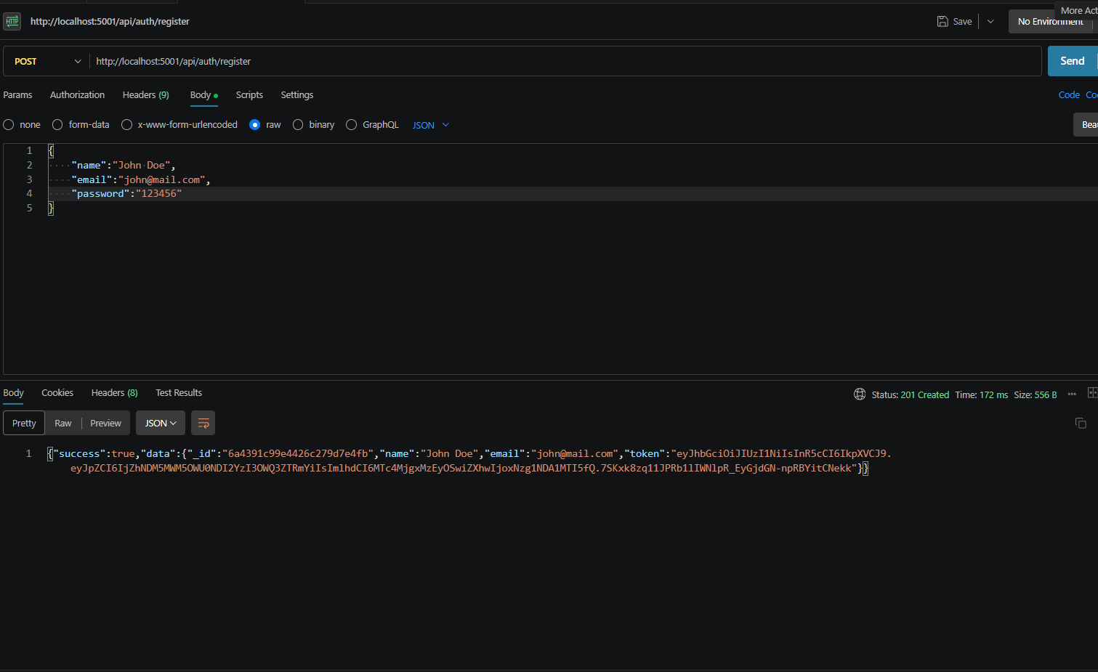
Figure 5.1: Register API test in Postman

5.1 The request
Part | Value
Method and URL | POST http://localhost:5001/api/auth/register
Body type | raw, JSON
name | John Doe
email | john@mail.com
password | 123456

5.2 The response
Part | Value
Status | 201 Created
Time | 172 ms
Size | 556 bytes
success | true
data | The new _id, the name, the email and a token

5.3 What this tells us
- Status 201 means a new resource was created, which is correct for registration.
- The response contains an _id. That is the identifier MongoDB generated, which proves that the document was saved.
- The password does not appear anywhere in the response. It was hashed and stored, and never sent back.
- A token is returned, so the user can start making protected calls right away without logging in a second time.
- 172 milliseconds is a little slower than the other calls. That is expected, because hashing the password with bcrypt is deliberately slow work.

5.4 Try it yourself
Send the same request twice. The first call returns 201. The second call should be rejected, because an account with that email already exists. The email field in the User schema is unique, so the database refuses the duplicate.

6. Testing the Login API
After registering, a user needs to be able to come back later. The login test proves that the stored account can be found and the password verified.
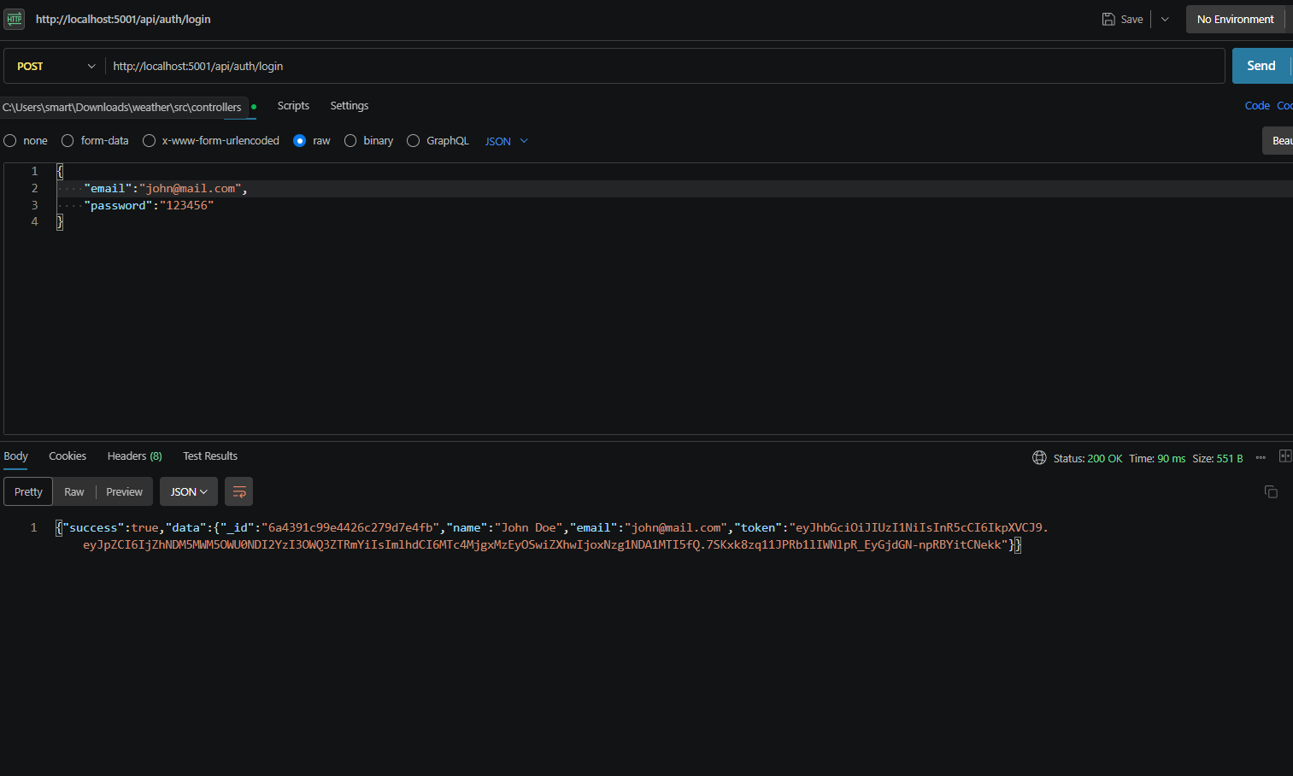
Figure 6.1: Login API test in Postman

6.1 The request
Part | Value
Method and URL | POST http://localhost:5001/api/auth/login
Body type | raw, JSON
email | john@mail.com
password | 123456

6.2 The response
Part | Value
Status | 200 OK
Time | 90 ms
Size | 551 bytes
success | true
data | The same _id and name as registration, the email and a token

6.3 What this tells us
- The _id in the login response is the same one we received at registration. This proves the system found the stored user rather than creating a new one.
- Status 200 is right for a successful read or login, because nothing new was created.
- The call took 90 ms, faster than the register call. Hashing at registration and comparing at login both take effort, but registration also writes to the database.
- A fresh token is returned. Tokens from different logins are different because they carry their own issue time.

6.4 What the user does with the token
The token is the user's proof of identity from now on. Clients keep it, for example in memory or in secure storage, and send it with each protected request in the Authorization header. When it expires, the client simply logs in again.

7. Testing the Weather API
The weather endpoint is the core data feature. We asked for the weather in Bangalore.
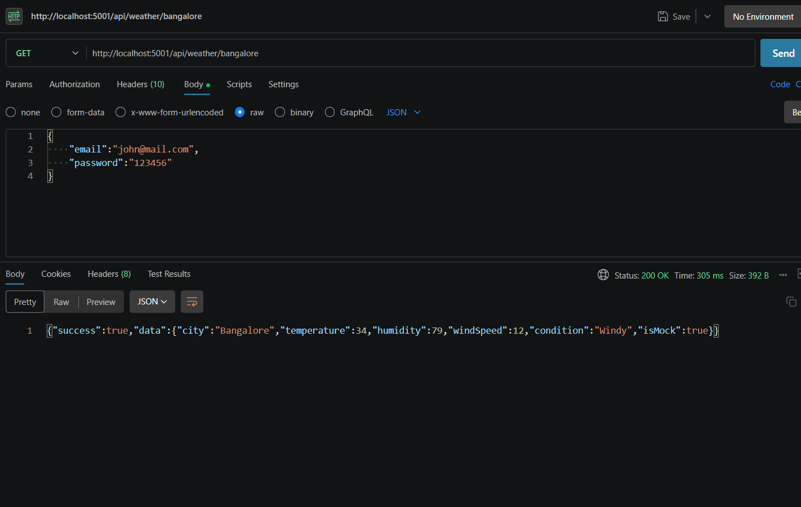
Figure 7.1: Weather API test in Postman

7.1 The request
Part | Value
Method and URL | GET http://localhost:5001/api/weather/bangalore
URL parameter | The city name, bangalore, is part of the address

The screenshot also shows a JSON body with an email and a password left over from the previous login request. A GET request does not use a body, and the endpoint is public, so those values are simply ignored. It is a harmless leftover from copying the previous request in Postman, and it also shows that the weather endpoint works without any login.

7.2 The response
Part | Value
Status | 200 OK
Time | 305 ms
Size | 392 bytes
city | Bangalore
temperature | 34
humidity | 79
windSpeed | 12
condition | Windy
isMock | true

7.3 What this tells us
- The response has the clean structure we designed: success, then a data object with the city and the four weather values.
- The city is returned with a capital letter even though the address used lower case, so the service tidies the name.
- The flag isMock: true shows that fallback data was used. This test was done without a live weather key, or with the provider unavailable. The point of the test was to check the behaviour of the API, and it passed.
- 305 ms is the time for the whole round trip, including the fallback logic.

7.4 With a live provider
When a valid weather key is available and the network works, the same call returns real values and isMock is false or absent. The structure of the response stays the same. That is the benefit of reshaping the provider's answer inside the service.

8. Testing the Recommendation API
The last of the four tests is the one that gives the project its name. The AI endpoint turns the weather values into advice a person can act on.
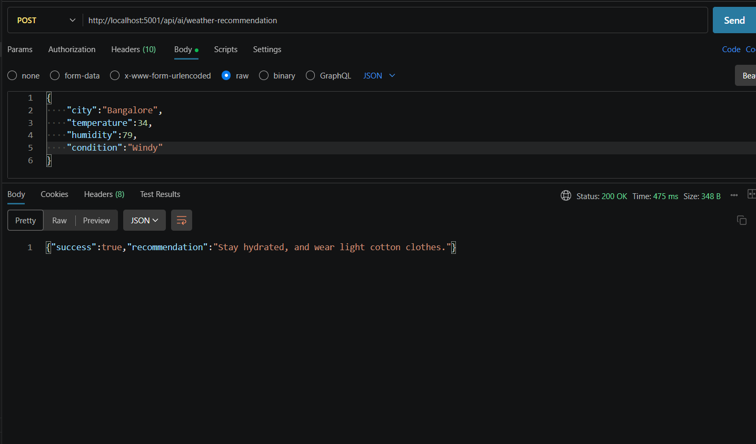
Figure 8.1: Recommendation API test in Postman

8.1 The request
Part | Value
Method and URL | POST http://localhost:5001/api/ai/weather-recommendation
Body type | raw, JSON
city | Bangalore
temperature | 34
humidity | 79
condition | Windy

The values are the same as those returned by the Weather API in the previous test. That is how a real client would use the two endpoints together: first get the weather, then send it for advice.

8.2 The response
Part | Value
Status | 200 OK
Time | 475 ms
Size | 348 bytes
success | true
recommendation | Stay hydrated, and wear light cotton clothes.

8.3 What this tells us
- The advice fits the numbers. At 34 degrees with high humidity, hydration and light clothing are sensible suggestions.
- The response is short and plain, not a block of raw data. That was one of the problems Alex faced in the case study.
- At 475 ms this is the slowest of the four calls, and that makes sense, because it involves the AI step or the fallback logic.
- The response shape is simple: a success flag and a recommendation text.

8.4 How the answer is produced
The controller passes the city and the weather values to the AI service. With a Gemini key, the service asks the model for brief advice. Without one, or if the call fails, the service returns a built-in suggestion based on the temperature and condition. Either way, the client receives the same kind of response.

9. Summary of test results
Putting the four tests side by side gives a quick picture of the system's behaviour.
API | Status | Time | Size | Notes
Register | 201 Created | 172 ms | 556 B | New user, token returned
Login | 200 OK | 90 ms | 551 B | Existing user found, token returned
Weather | 200 OK | 305 ms | 392 B | Fallback data, isMock true
Recommendation | 200 OK | 475 ms | 348 B | Short advice returned

9.1 Reading the numbers
All four tests succeeded with the expected status codes. Every response came back in under half a second on a normal development laptop. The two responses that include a token are a little over 550 bytes, mostly because a token is a long piece of text. The other two are smaller than 400 bytes.

9.2 Test cases written as a table
No. | Test case | Expected result | Outcome
1 | Register with valid name, email and password | 201 and a token | Passed
2 | Login with the registered email and password | 200 and a token | Passed
3 | Get weather for Bangalore | 200 and weather values | Passed
4 | Ask for a recommendation with weather values | 200 and a recommendation | Passed

9.3 Does the system meet the goals?
Goal from Phase 1 | Evidence
Secure registration and login | Test 1 and 2: token issued, no password in the response
Real-time weather in a clear format | Test 3: structured weather object
Natural language advice | Test 4: plain recommendation text
Keep working without external keys | Test 3: isMock flag shows the fallback worked

10. Testing error situations
Good testing is not only about the happy path. The following checks are part of our test plan. They describe the behaviour the system is designed to show, and each one can be tried in Postman in a few seconds. Repeat them whenever the code changes.

10.1 Input errors
What to send | Expected response | Reason
Register with an invalid email like johnmail | 400 with a message about the email | Schema pattern check
Register with a password of 3 characters | 400 with a message about the length | Minimum length rule
Register with no name | 400 with "Please provide a name" | Required field
Register the same email again | Error about a duplicate | Unique email index
Login with a wrong password | 401 with a general message | Hash comparison fails
Login with an unknown email | 401 with the same general message | No account found

10.2 Authorization errors
What to send | Expected response | Reason
Location request with no token | 401 | Middleware stops it
Location request with a random text as token | 401 | Signature check fails
Location request with an expired token | 401 | Expiry check fails

10.3 Route and method errors
- A request to an address that does not exist should return 404 in the same JSON format.
- A POST body with broken JSON, such as a missing quote, should return 400 and not crash the server.
- A weather request for a city that the provider does not know should be handled gracefully, either with fallback data or a clear message.

10.4 Service failures
To check fallback mode, remove or blank the weather or Gemini key in the .env file, restart the server and repeat the weather and recommendation tests. They should still return 200 with sample data and a rule-based message. That is how our screenshot for the Weather API was produced.

10.5 After every change
Run the whole collection again. If everything that passed before still passes, the change is safe. This habit is what makes a small team able to change code without fear.

11. Demo videos and source code
Screenshots show a single moment. Videos show the whole flow. Along with this document, we recorded two videos and shared the code.

11.1 Links
- API testing video (API testing.mp4)
- Backend demo video (Backend demo.mp4)
- Source code (Drive folder)

11.2 What each resource shows
Resource | Content
API testing video | The four API tests being run in Postman, with the responses explained
Backend demo video | The server starting, the database connecting and the API working end to end
Source code folder | The complete project, ready to be installed with npm install

11.3 Using the Kanban board as evidence
The project was managed on a Kanban board with five epics, sixteen stories and a progress indicator that read 90 percent in our last screenshot. The board also holds the links to the GitHub repository and the demo. Each story went through Review before being accepted, and the board gives a record of who worked on which part.

12. Troubleshooting while running
These are the problems most likely to appear when running or testing the project, with their usual causes.
Symptom | Cause | What to do
Server exits straight away | MongoDB not reachable | Start MongoDB or check MONGO_URI
Cannot GET /api/... in the response | Wrong path or method | Compare with the endpoint table
Connection refused in Postman | Server not running or wrong port | Check the terminal and the port number
400 Bad Request on a POST | Body is not JSON or the type is not set | Choose raw and JSON in Postman
401 on a protected route | Missing or invalid token | Log in again and add the Bearer token
Same response after changing code | Server not restarted | Use npm run dev or restart manually
isMock is true when you want live data | No weather key or provider error | Add a valid key to .env and restart
Recommendation looks generic | Gemini key missing, fallback used | Add GEMINI_API_KEY and restart
EADDRINUSE on start | Port already in use | Stop the other process or change PORT

12.1 Where to look first
- The terminal where the server runs. It usually names the problem.
- The status code in Postman. It narrows down the kind of problem.
- The request itself. Is the method, address, header and body correct?
- The .env file. A great many problems start here.
- The database, with Compass, to see what was really saved.

12.2 Protect your keys while showing the project
When recording a demo or sharing screenshots, make sure the .env file and any real keys are not visible. Tokens in screenshots expire, but keys do not, so treat those with care.

13. Limitations and future scope

13.1 Current limitations
- There is no front end yet, so the system is tested through API tools only.
- The weather test in this document used fallback data, so live accuracy depends on the provider and the key.
- Tokens cannot be cancelled before they expire.
- No automated test suite exists, so testing is manual through Postman.
- There is no password reset and no email verification.
- The Gemini free quota limits how often the AI endpoint can be used.

13.2 Future improvements
Improvement | Benefit
React or mobile front end | Lets ordinary users use the system without Postman
Weather forecasts and history | Adds planning value for travellers
Automated tests with Jest and Supertest | Faster and safer changes
Rate limiting | Protects login and AI endpoints from abuse
Caching of weather results | Fewer provider calls and quicker responses
Role field and admin tools | Makes the admin role in the design fully real
Refresh tokens and password reset | Better security and user comfort
Deployment to a cloud host | Makes the API reachable from anywhere
API documentation with Swagger | Easier for other developers to adopt

13.3 A natural next step
The next piece of work with the most value is a simple front end that lets a person register, save cities and read recommendations in a friendly screen. The backend already supports every call it needs.

14. Conclusion

14.1 What was achieved
AI WeatherWise started as a case study about a traveller named Alex who wanted simple weather advice and a safe place to keep favorite cities. Over five phases, we turned that story into a working backend. We planned the system with MVC and a technical architecture, prepared the project and its tools, wrote a modular Express backend with token-based security, built the MongoDB layer with validated schemas and finally ran everything and proved it with real requests and responses.

14.2 Final review of the phase
Item | Status
Steps to install, configure and run written down | Done
Server starts and connects to MongoDB | Done
Register API tested: 201 Created | Done
Login API tested: 200 OK | Done
Weather API tested: 200 OK, fallback shown with isMock | Done
Recommendation API tested: 200 OK | Done
Output screenshots captured and explained | Done
Demo videos and code shared | Done
Stories passed review | Done

14.3 Closing note
The most useful thing the team took from this project is the habit of working in phases. Each phase had a clear purpose, a short list of stories and a review before moving on. When something broke, we usually knew which phase to look at. That habit will be useful in every project to come, long after the details of this particular weather service are forgotten.

Appendix: key terms and viva questions
This appendix gathers the important words from this phase in one place and lists questions that are likely to come up in a review or viva, together with short answers.

A.1 Key terms
Term | Meaning
Postman | A tool for sending test requests to an API
Status code | A number that summarises the result of a request
201 Created | A new resource was made
200 OK | The request succeeded
Payload | The data sent in a request or response
JSON | A text format for structured data
isMock | A flag that shows fallback data was used
Latency | The time a request takes, here in milliseconds
Test case | A described input with an expected result
Regression | An old feature that breaks after a new change
Collection (Postman) | A saved group of requests

A.2 Review questions and short answers
Q1. What status does registration return and why?
201 Created, because a new user is created.
Q2. Why was the register call slower than login?
It hashes the password and writes a new document.
Q3. What does isMock true in the weather response mean?
Fallback sample data was returned and not live weather.
Q4. Why is the password never in a response?
It is stored only as a hash and is never sent back.
Q5. How do you run the project?
Run npm install, set up .env, make sure MongoDB is running, then npm start.
Q6. Why rerun the Postman collection after every change?
To catch features that stopped working because of the change.

A.3 How to use this document
Read the chapters in order the first time. When revising, go straight to the review table near the end of the document and the questions above. If you are presenting the project, keep the figures open on screen while you explain, because each picture was chosen to show one idea clearly.

