Week-01-Overview of C, Constants, Variables and Data Types

--Coding-C-Language Features-Optional.
ROLL NO: 241801299
NAME: THEPPAN SANJAY R
Q1) 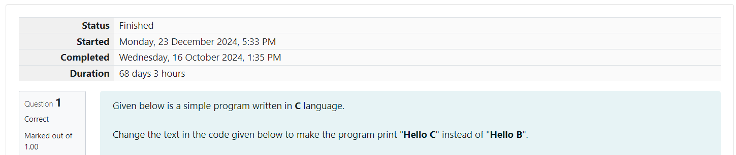
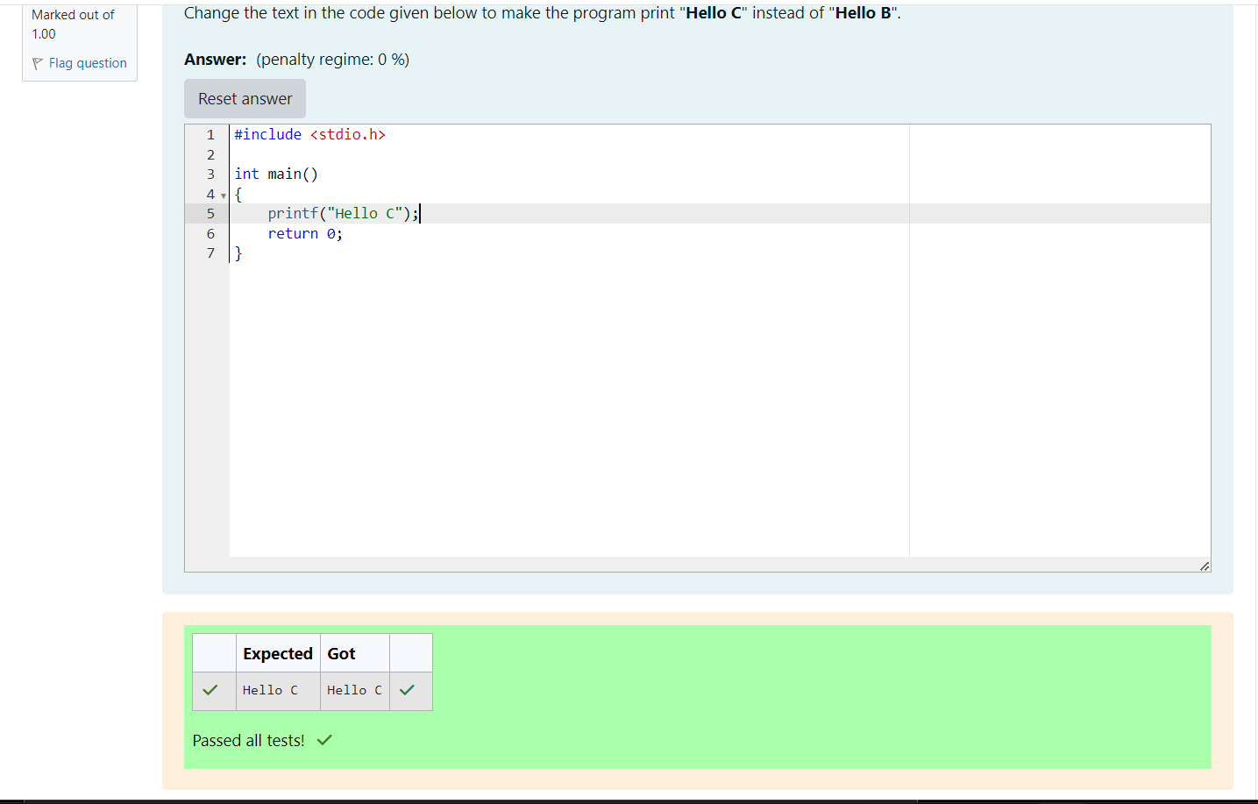

--Coding-C-Language Features-Optional.
ROLL NO: 241801299
NAME: THEPPAN SANJAY R
Q2)
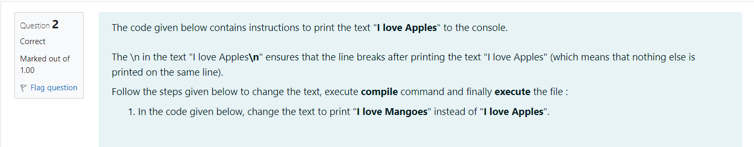
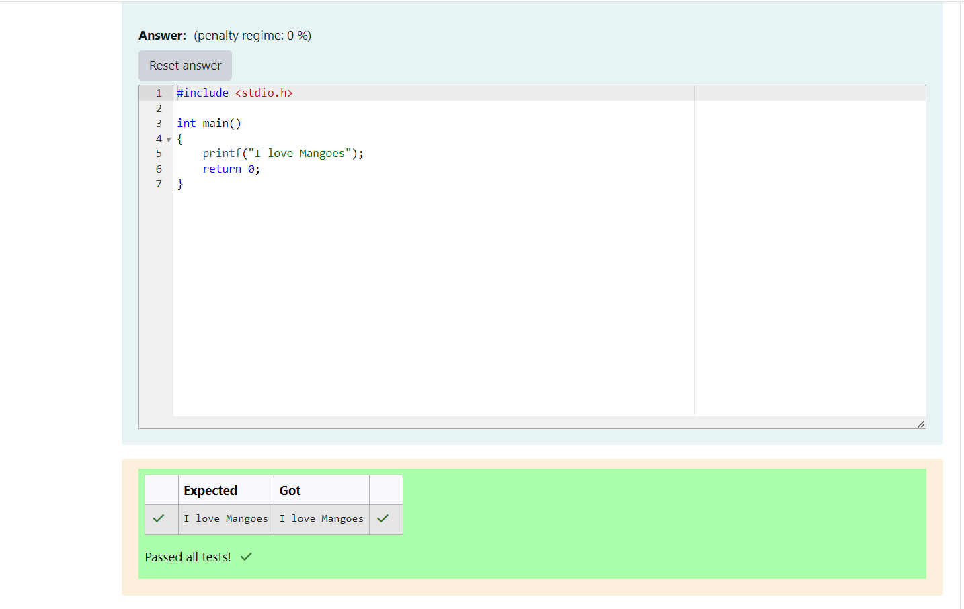

Week-01-01-Practice Session-Coding
ROLL NO: 241801299
NAME: THEPPAN SANJAY R
Q1)
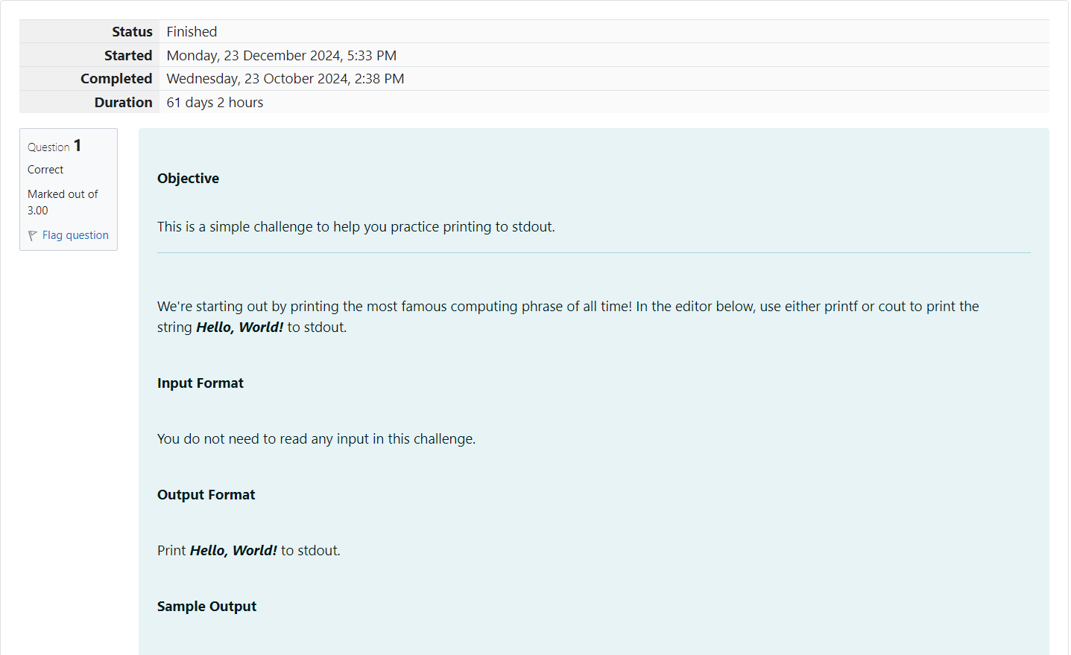
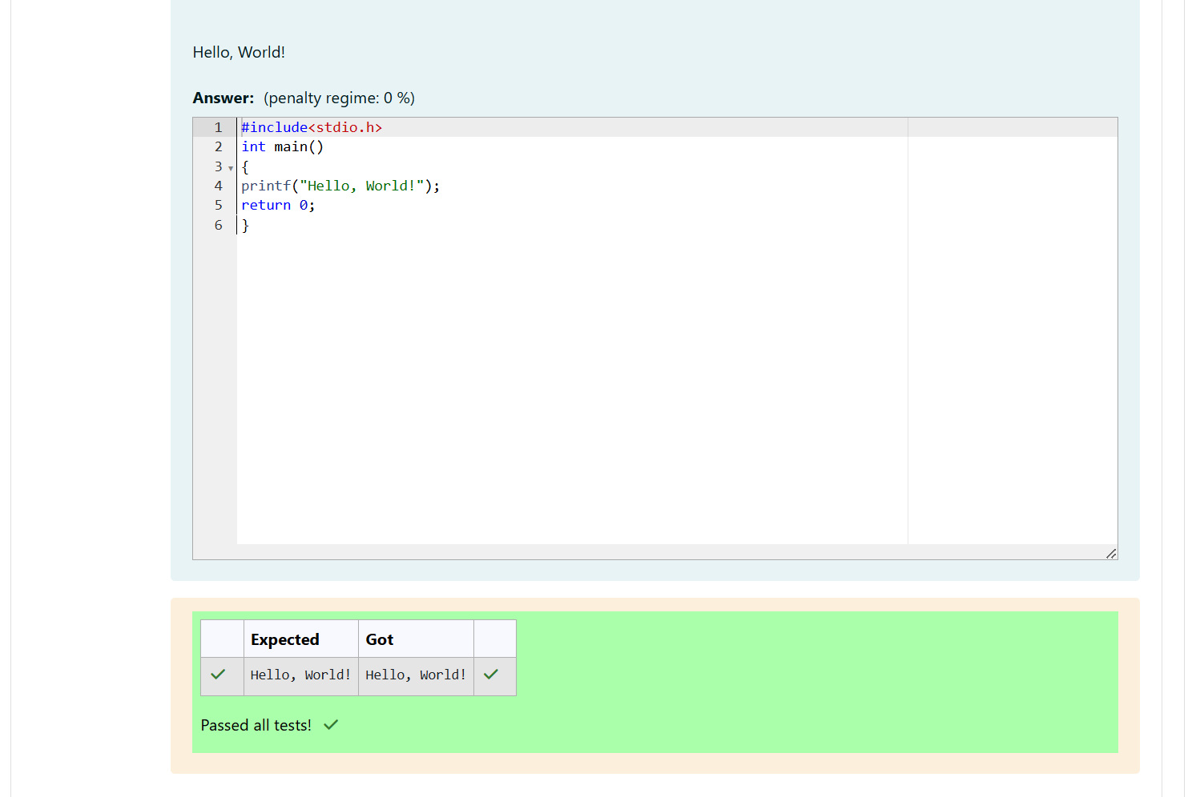
Q2)
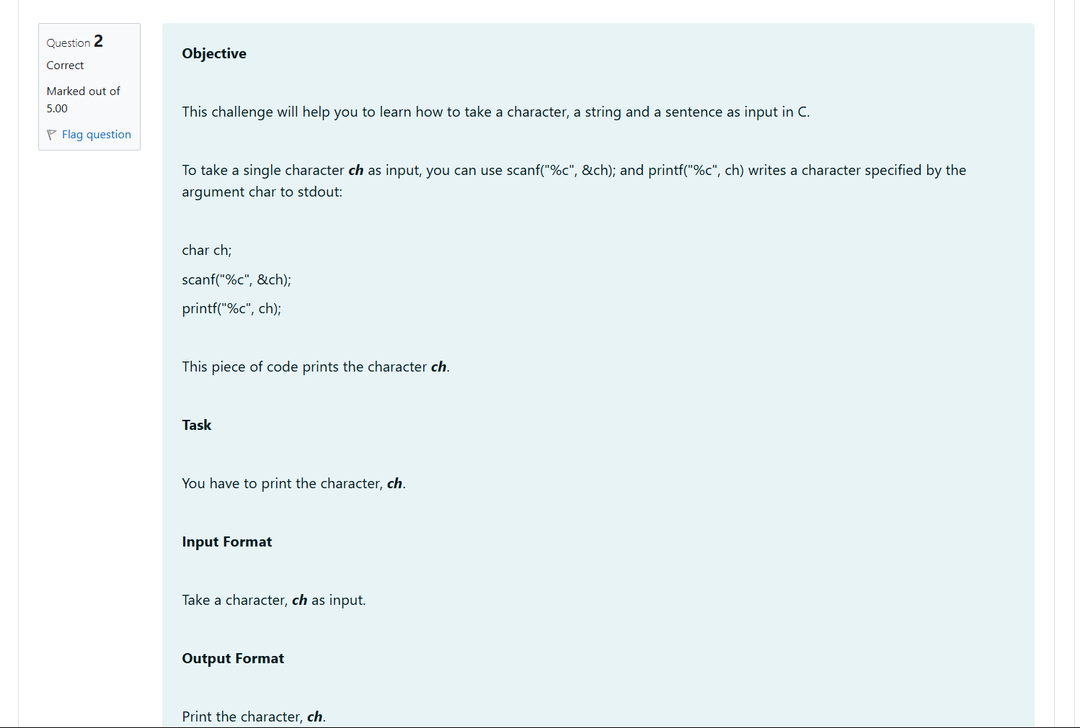
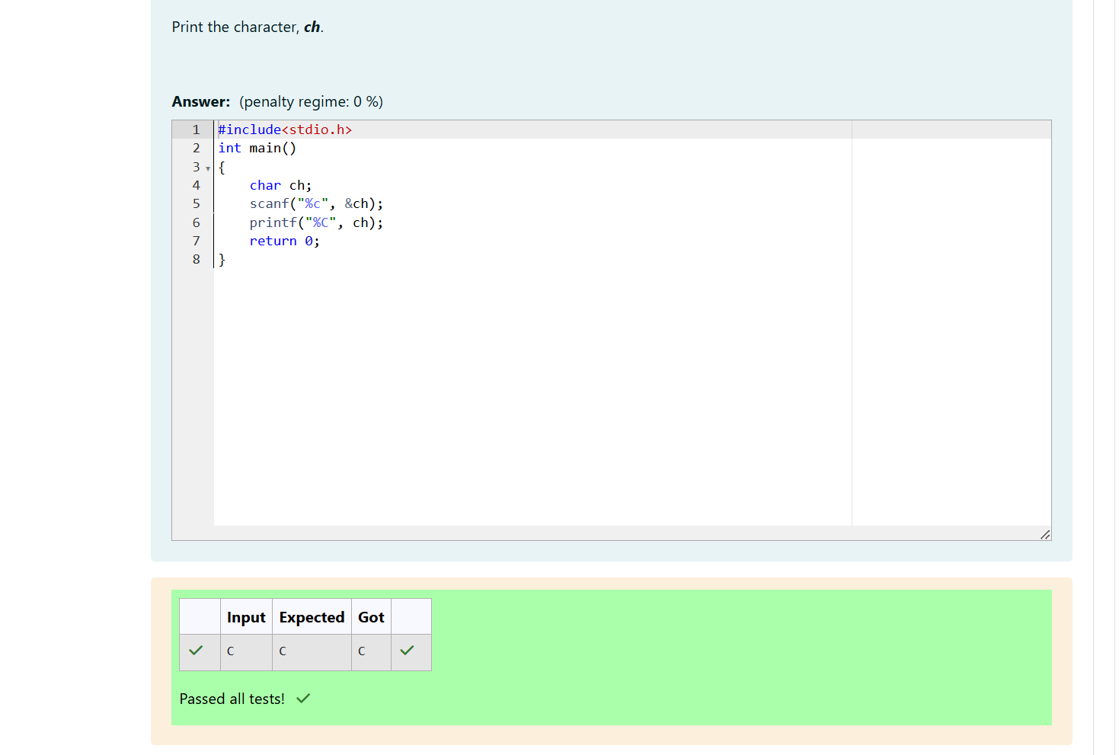

Q3)
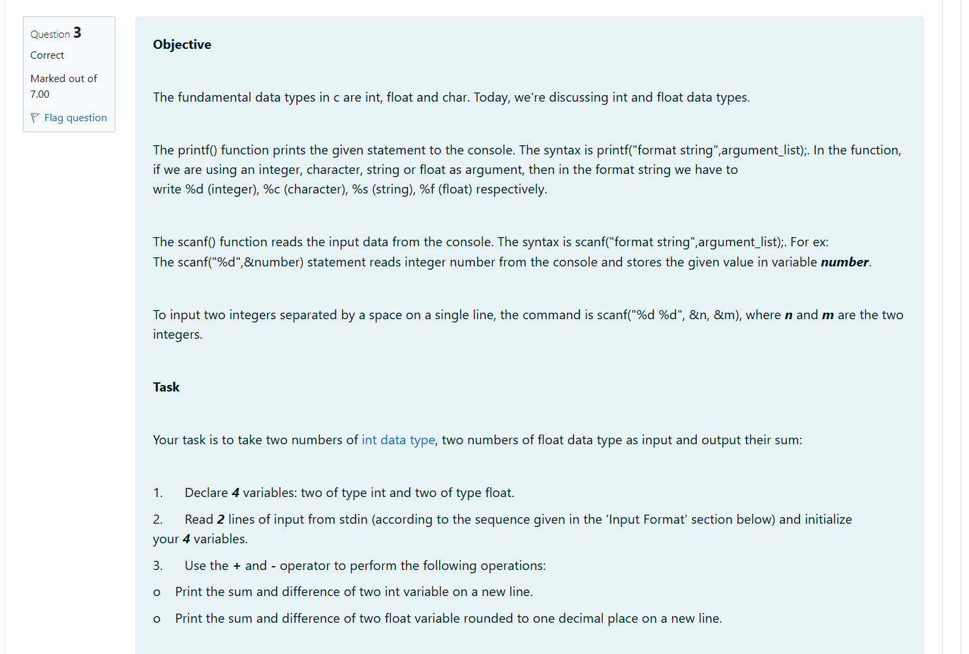
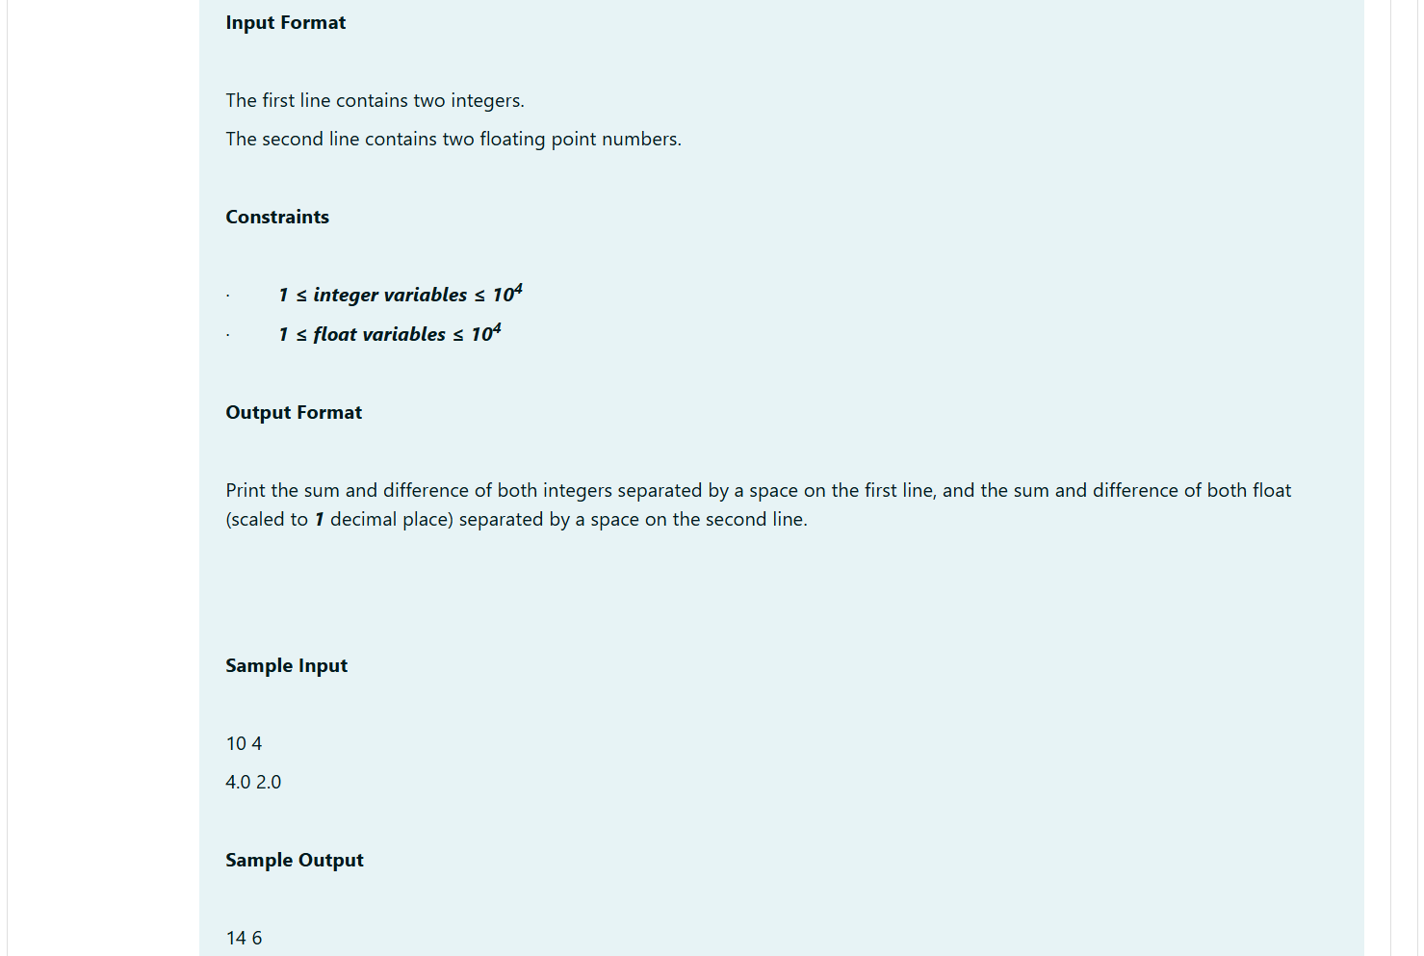
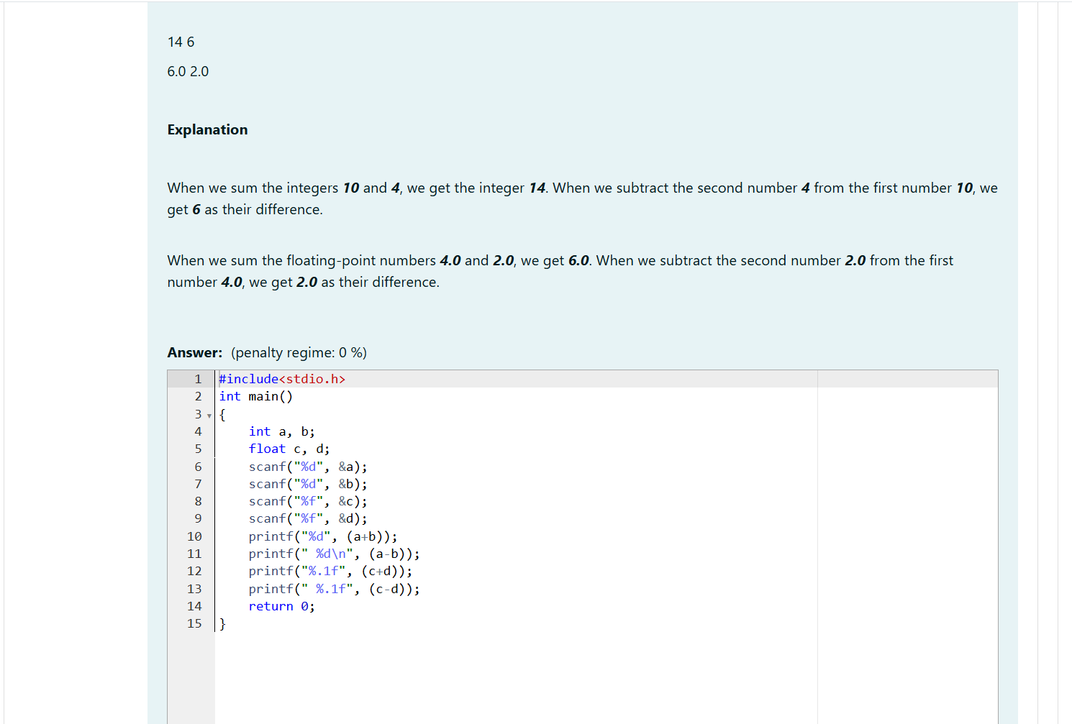
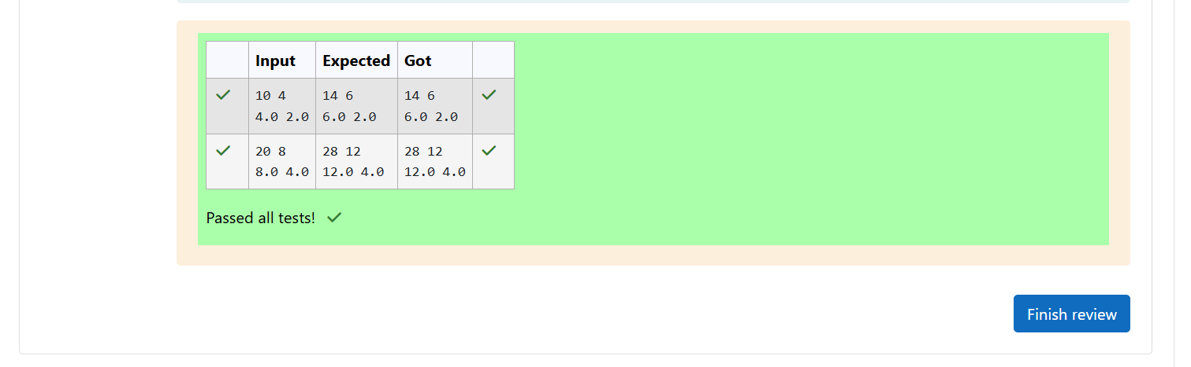

Week-01-02-Practice Session-Coding
ROLL NO: 241801299
NAME: THEPPAN SANJAY R
Q1)
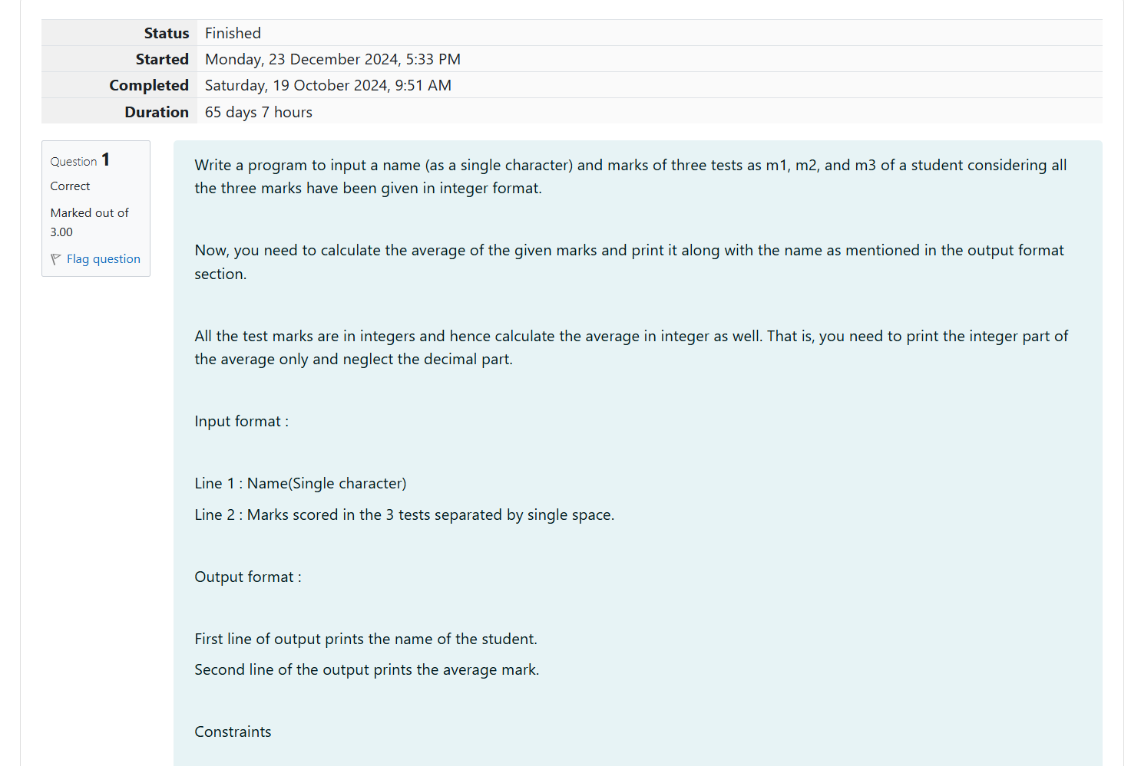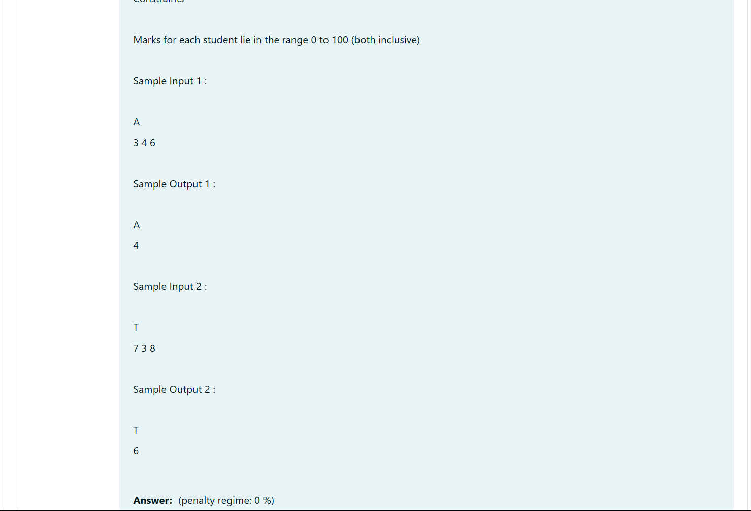
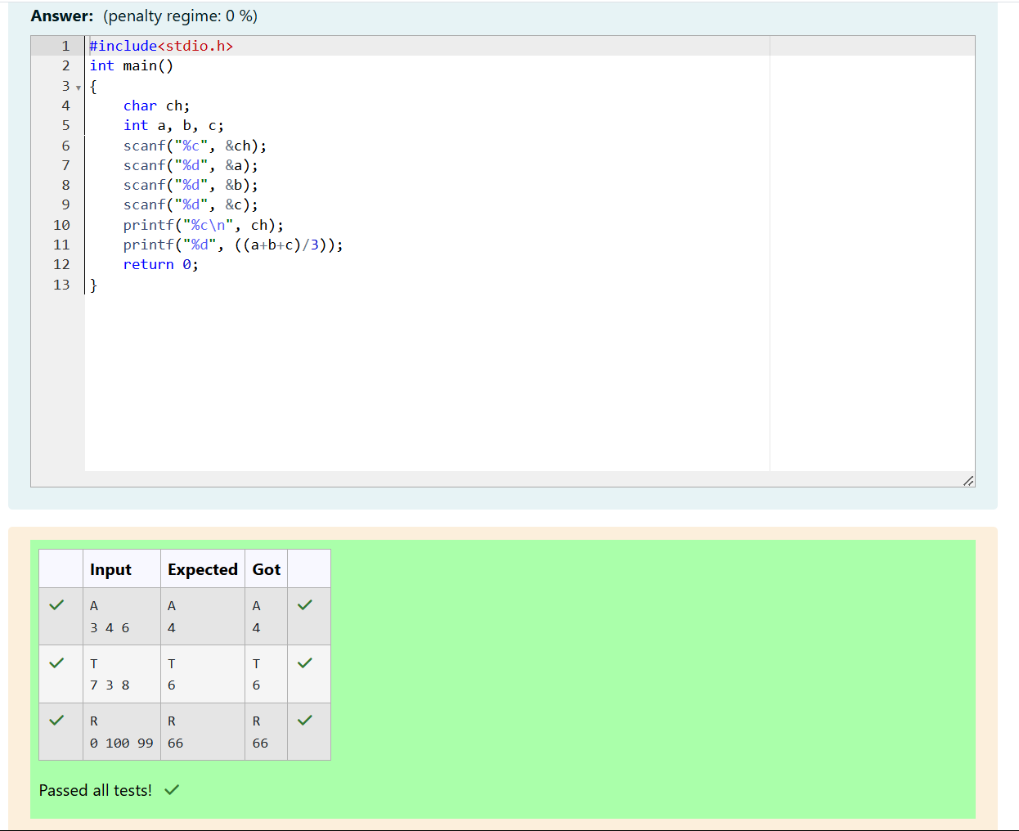

Q2)
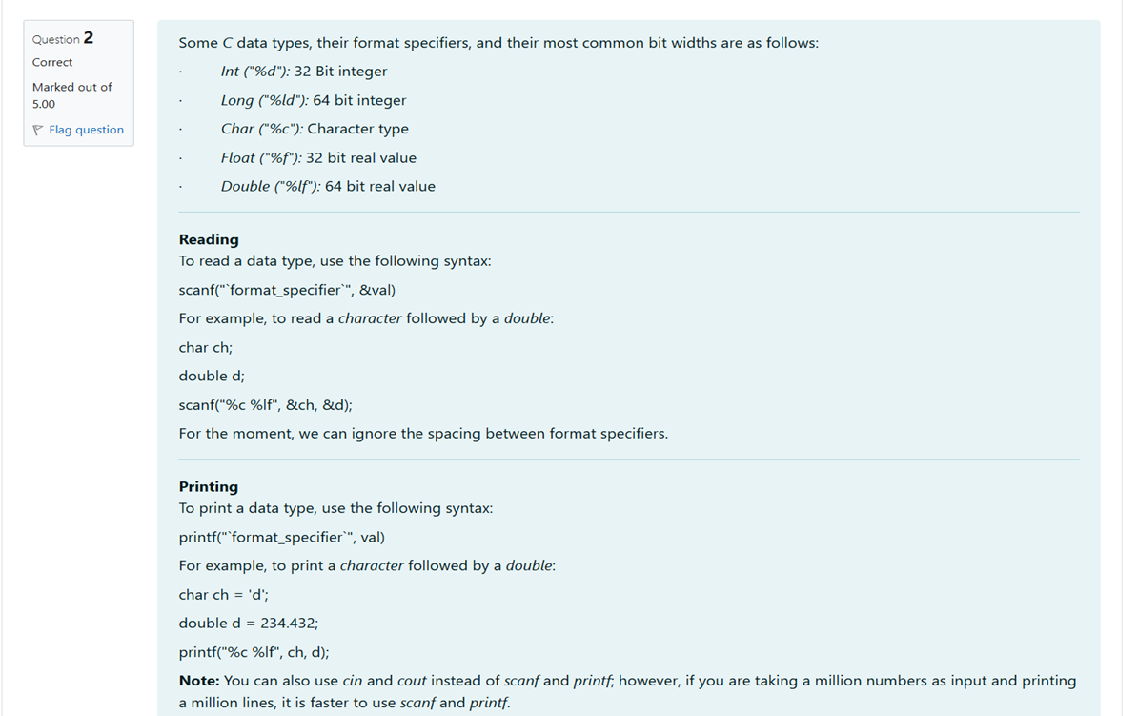

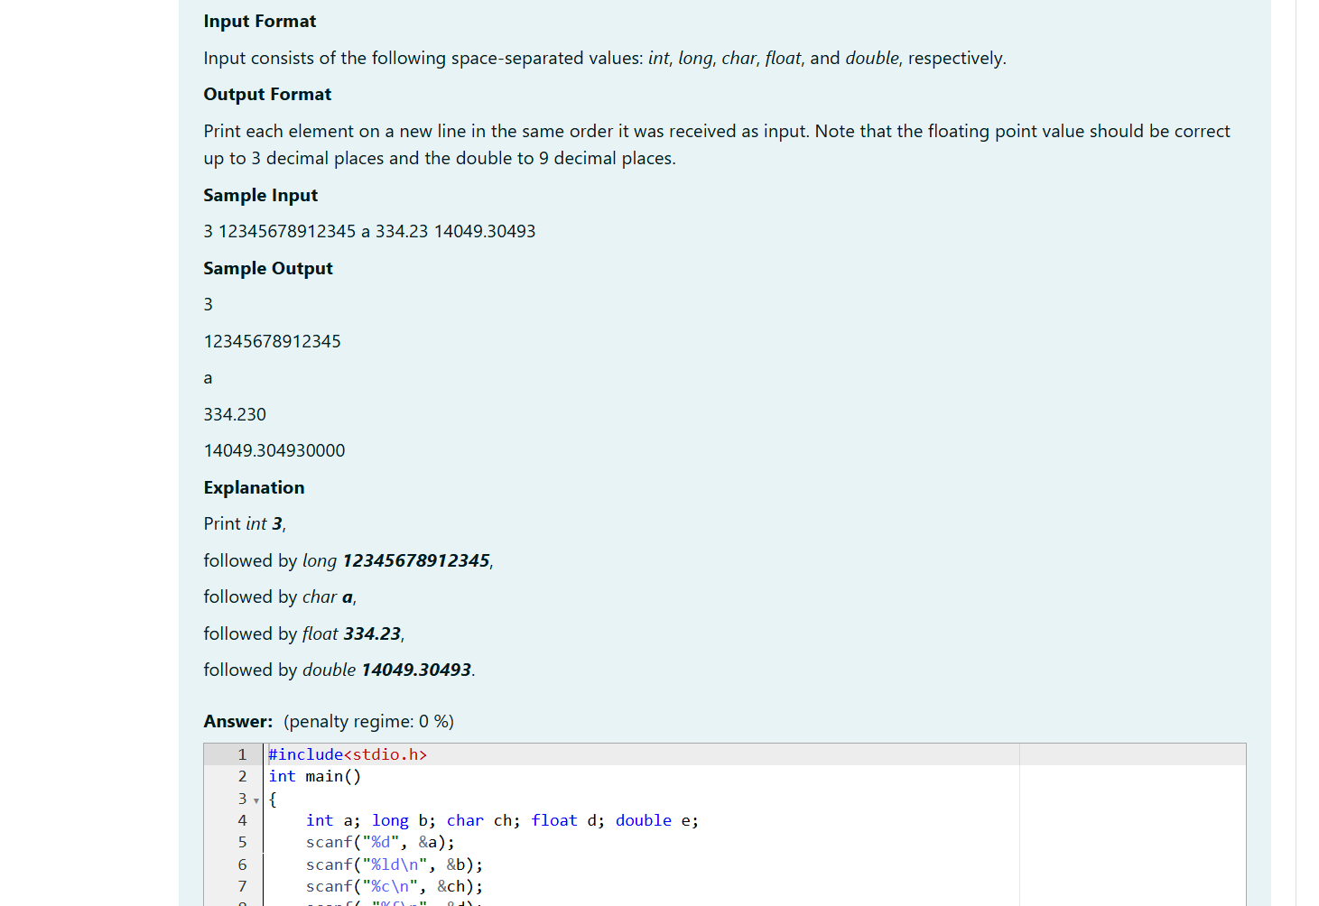
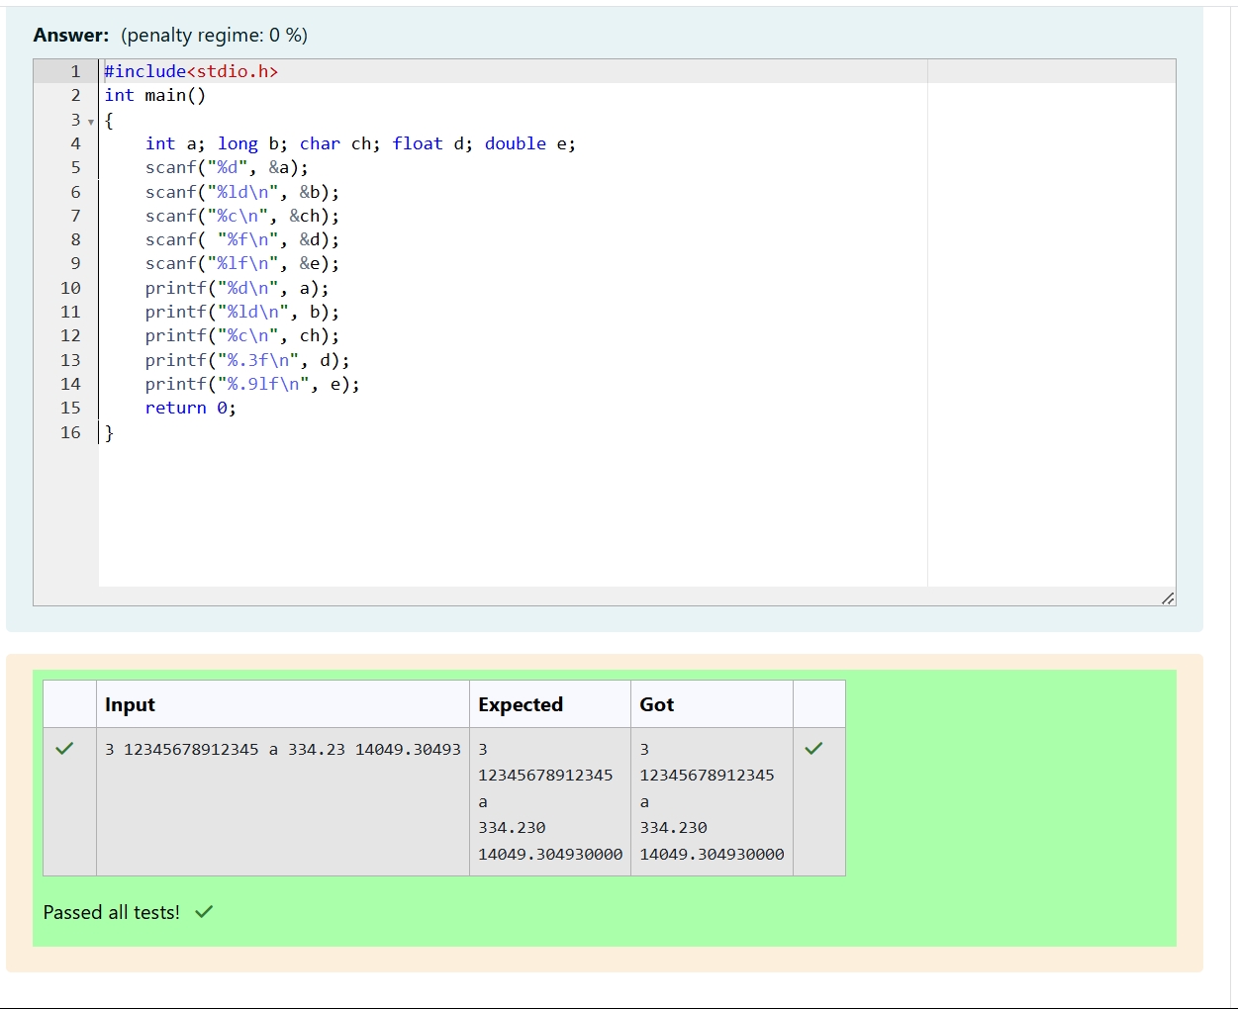
Q3)