# Sales and Profitability Analysis Report

This report presents an analysis of sales and profitability data across various product categories and states based on the provided Walmart.

## 1. Sales by Category

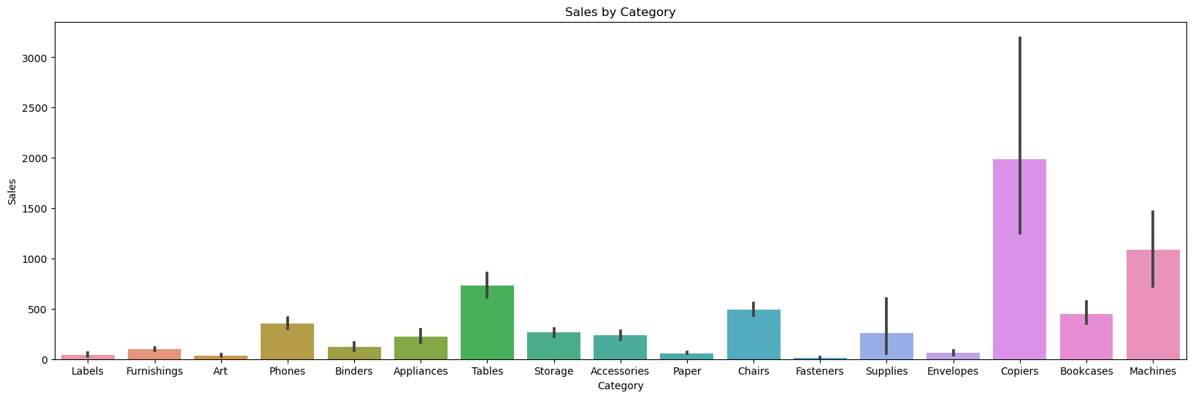

The bar chart titled "Sales by Category" reveals the sales volume or units sold for each product category. The top-performing categories in terms of sales are:

- Machines

- Bookcases

- Copiers

- Envelopes

- Supplies

These categories exhibit the highest sales figures compared to others. Conversely, categories such as:

- Labels

- Furnishings

- Art

- Phones

- Binders

- Appliances

- Tables

- Storage

have relatively lower sales volumes.

## 2. Distribution of Sales

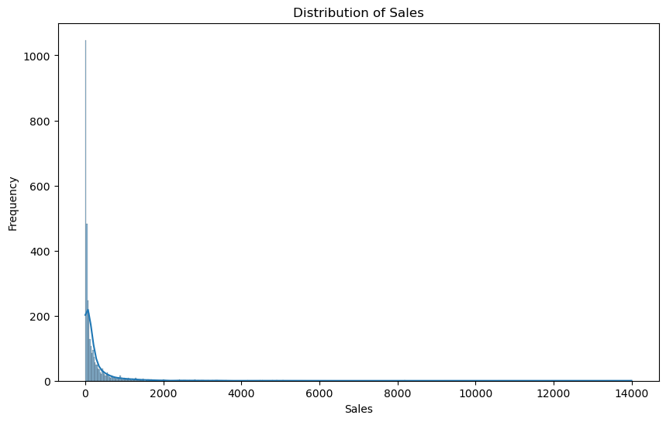

The histogram "Distribution of Sales" illustrates the frequency distribution of sales values across different ranges. The distribution is heavily skewed to the right, indicating that most sales transactions fall within the lower value ranges. A smaller number of high-value sales contribute significantly to the overall sales figures. This skewed pattern is common in sales data, where a few large transactions or customers account for a substantial portion of the sales.

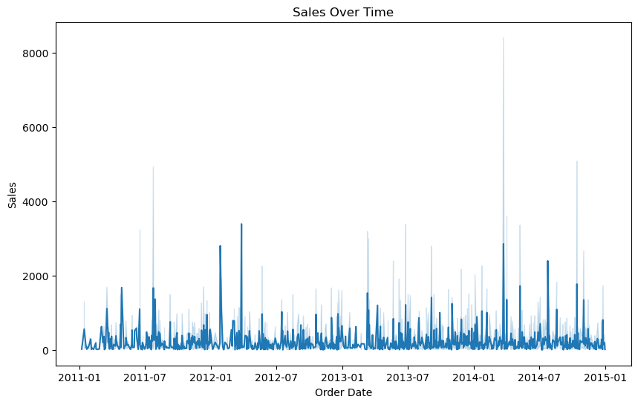

## 3. Sales by State

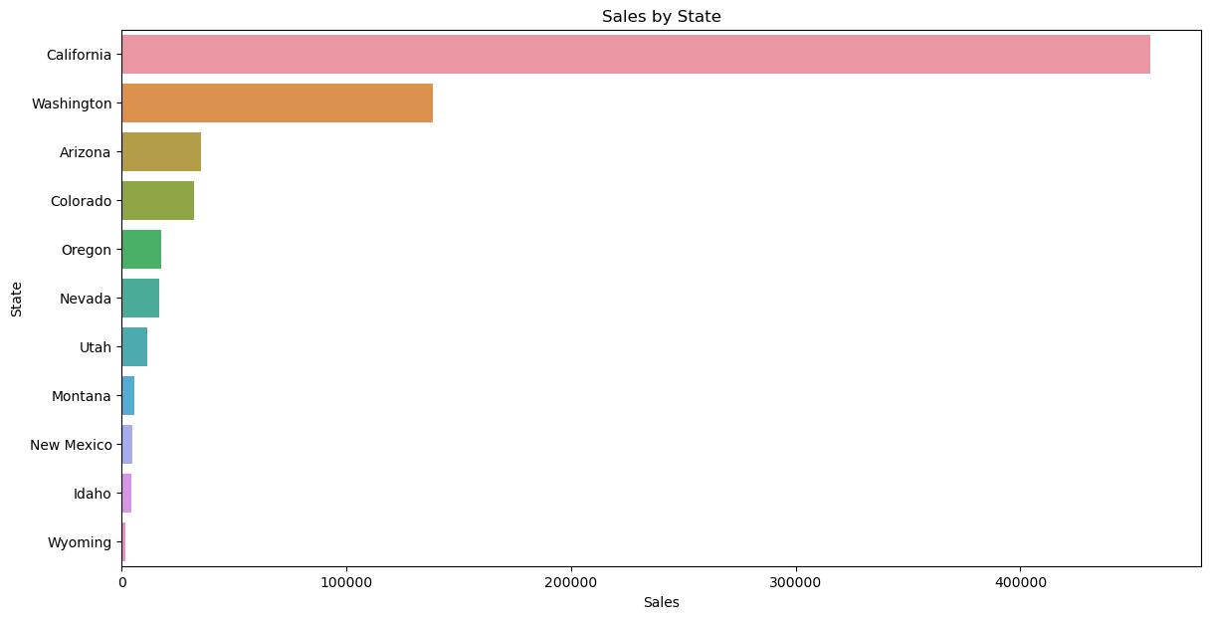

The bar plot titled "Sales by State" highlights the sales performance across different states. California emerges as the top-performing state, generating the highest sales figures compared to other states. This information is crucial for understanding regional market dynamics and identifying areas with strong sales performance.

## 4. Sales vs. Profit by Category

The scatter plot "Sales vs. Profit by Category" examines the relationship between sales and profitability for each product category. Key insights from this visualization include:

- **Positive Correlation**: There is a positive correlation between sales and profit, indicating that higher sales generally lead to higher profits.

- **Clustering**: Most categories cluster towards the lower-left region, suggesting relatively lower sales and profit values for the majority of product categories.

- **Outliers**: A few categories stand out as outliers with significantly higher sales and profit values, likely representing the top-performing or most profitable product lines.

- **Negative Profitability**: Some data points fall below the x-axis, indicating negative profitability for certain categories despite generating sales.

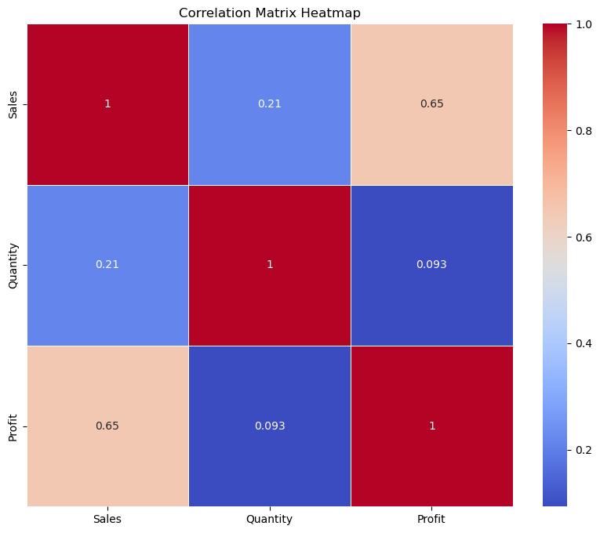

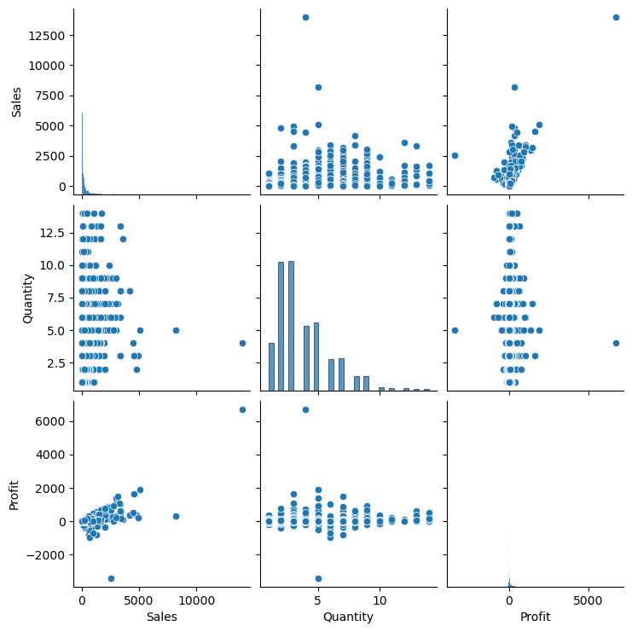

## 5. Profit Over Time

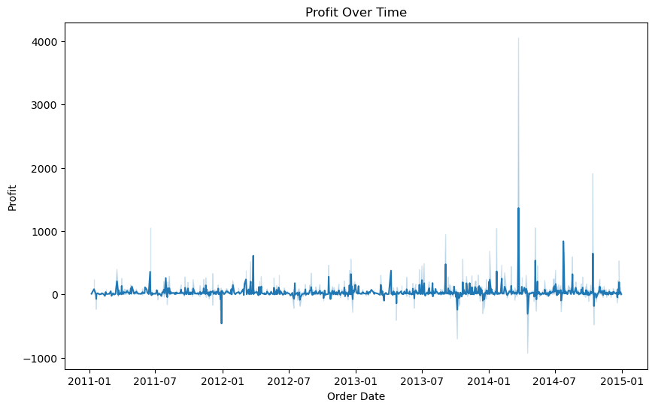

The line graph "Profit Over Time" displays the profit figures over the period from early 2011 to early 2015. The graph exhibits a cyclical pattern with recurring peaks and valleys, suggesting fluctuations in profitability over time. The peaks likely correspond to periods of higher profitability, while the valleys represent lower or potentially negative profitability.

## 6.Profit by Category

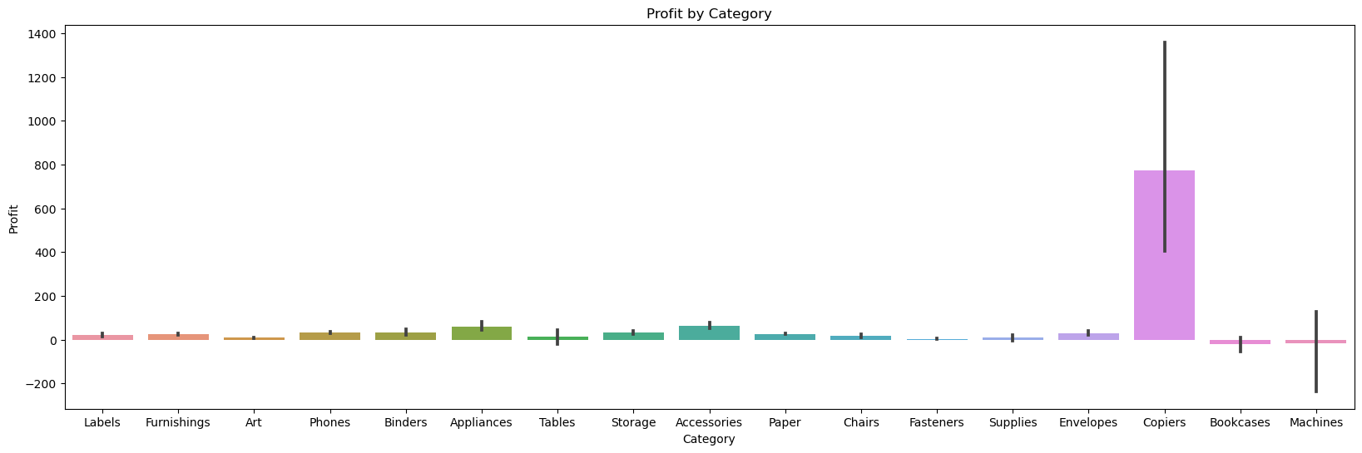

The bar plot titled "Profit by Category" indicates the profitability of each product category. The Copiers category stands out as the highest profit generator, significantly outperforming other categories. This suggests that despite the potential higher costs associated with copiers, their sales margins are substantial enough to yield the highest profit. Identifying such high-profit categories is crucial for strategic planning, as it highlights the products that contribute most significantly to the company's bottom line. Focusing on and possibly expanding the product lines within these high-profit categories could be a key strategy for enhancing overall profitability.

## Summary

This analysis provides valuable insights into the sales performance, profitability, and revenue distribution across different product categories and states. The visualizations help identify top-performing and underperforming categories and regions, guiding strategic decisions regarding:

- **Resource Allocation**: Directing resources towards high-performing categories and states.

- **Cost Optimization**: Reducing costs in low-performing categories.

- **Product Line Adjustments**: Adjusting or discontinuing underperforming product lines to maximize profitability.

By leveraging these insights, businesses can make informed decisions to enhance overall profitability and drive sustainable growth.