Getting Stylish

Joseph R. Bishop

ITEC 6020

Walden University

Creation & Perfection

Creating and perfecting a website that takes advantage of a style sheet that conforms to XHTML standards comes with some upfront time investment, but pays off. Ultimately, the individually pages will have far fewer lines of code and therefore more efficient creation and rendering. With some minor changes, the top few lines of every page can be exactly the same. There was one problem that kept occurring here, which had to do with the validation: each time the declarations appear as below, the w3c validator automatically assumes that <head> is already open for some reason, so it does not need to appear in the code. Similarly, <title> and </title> need to appear before closing out </head>, so deviation from either of those rules resulted in easily recognizable and fixable errors (Sebesta, 2015):

<!DOCTYPE html>

<html lang="en">

<meta charset="utf-8"/>

<link rel="stylesheet" href="style.css">

<title> Education Detail </title> </head>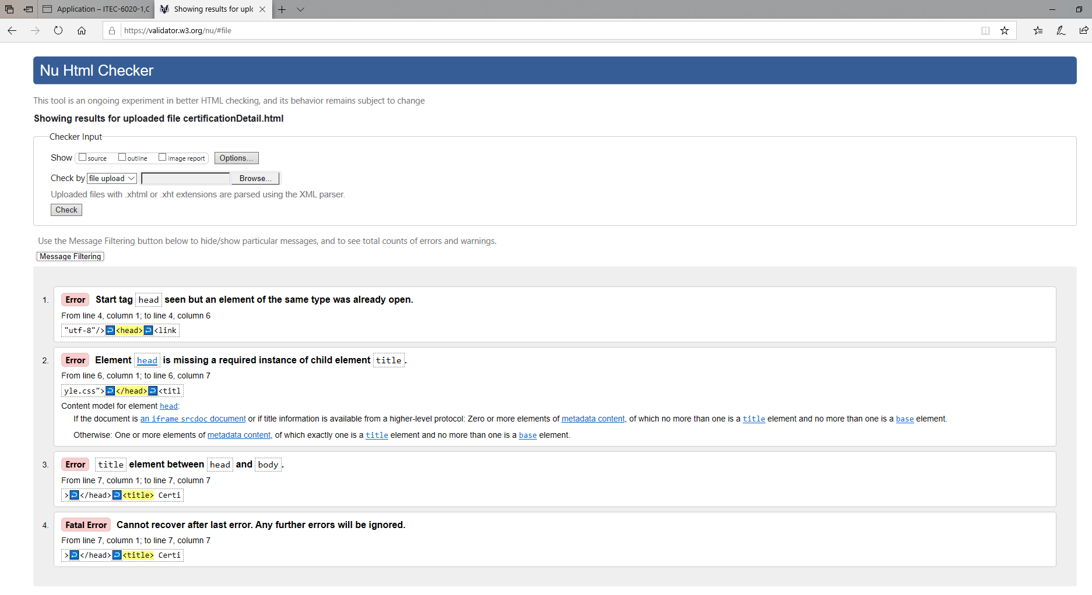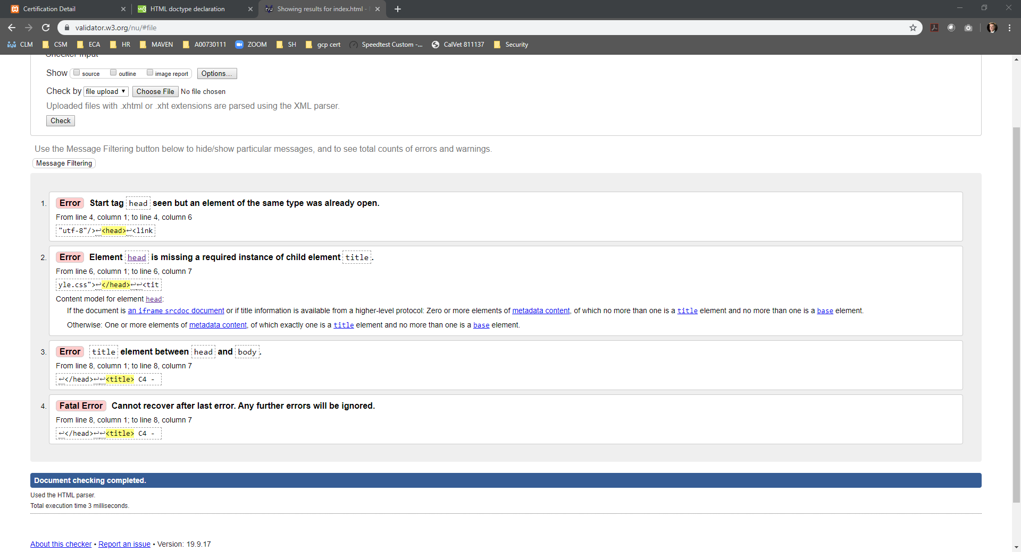

Screenshots of Each Page

Education Catalog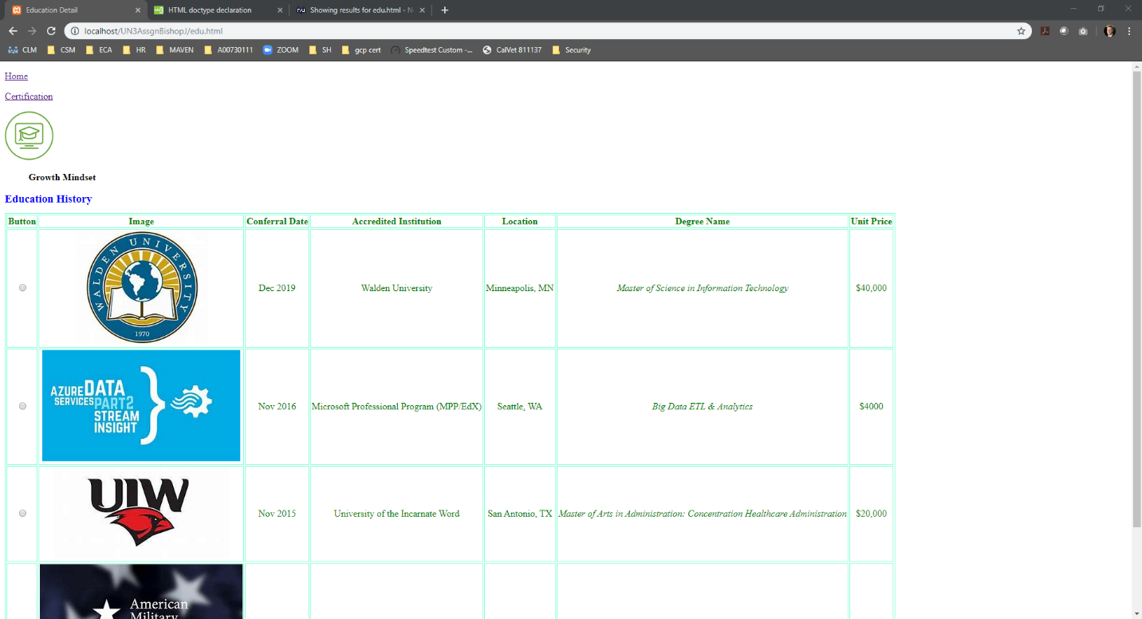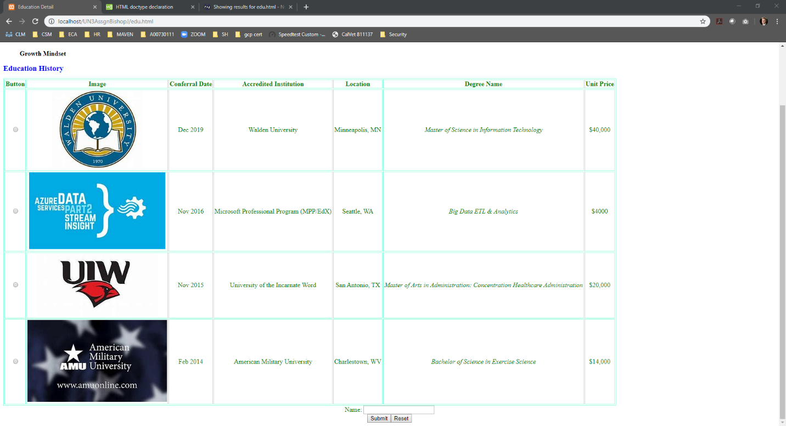

“Home” or Index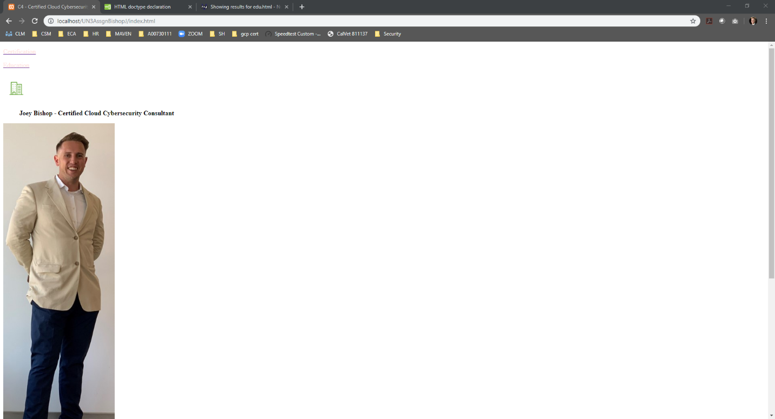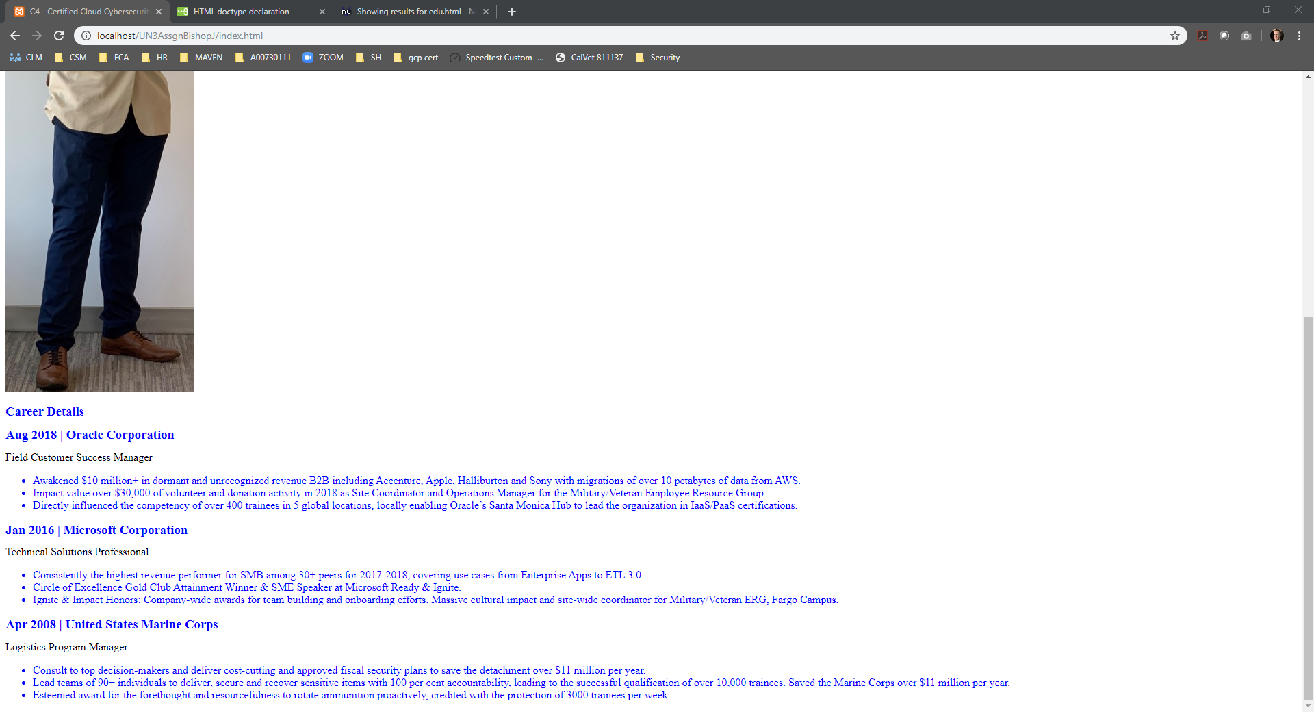

Certification List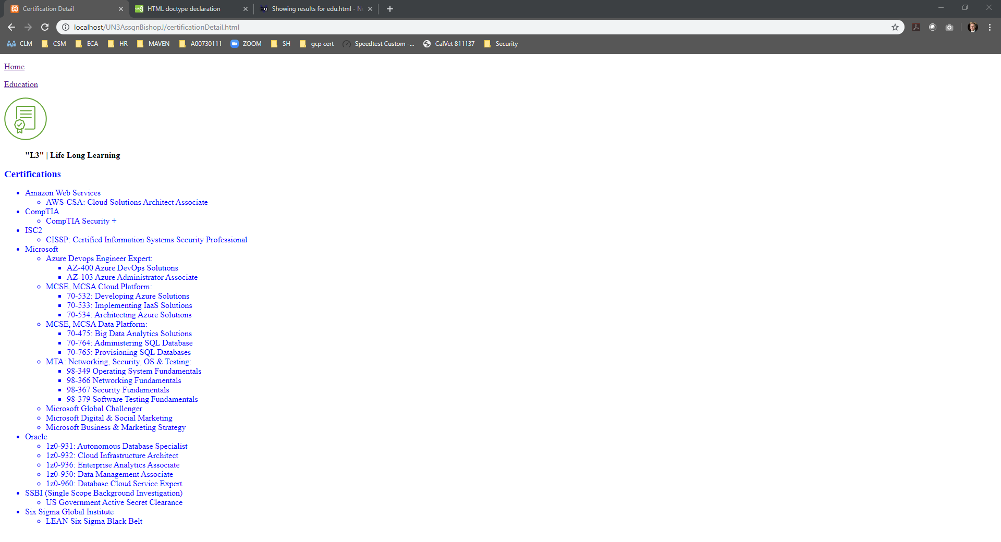

W3C Validation

Index

Education Catalog

Certification List

Reference

Sebesta, R.W. (2015). *Programming the World Wide Web* (8th ed.). Upper Saddle River, NJ: Pearson.