ASSIGNMENT 8

1. Height of Binary Tree After Subtree

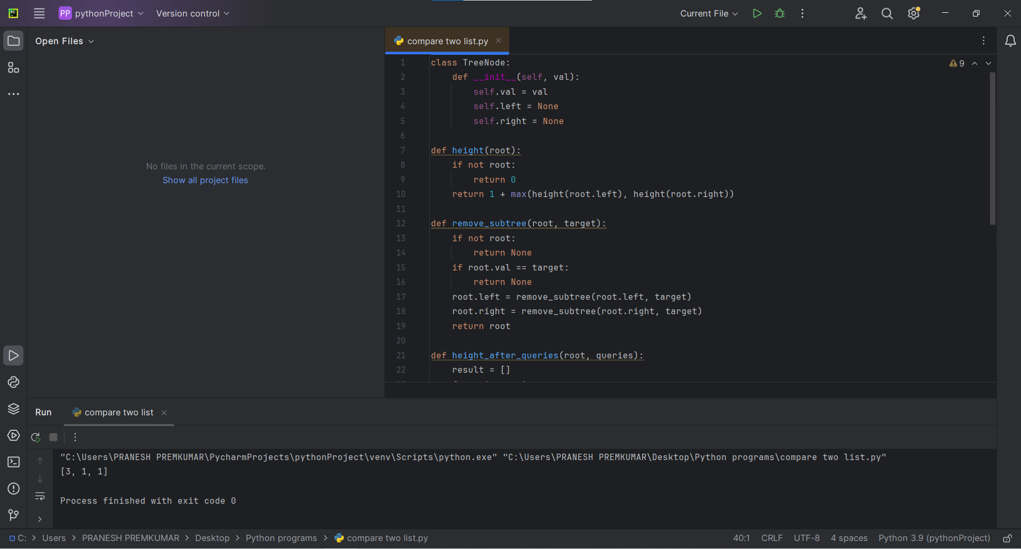

2. Sort Array by Moving Items to Empty Space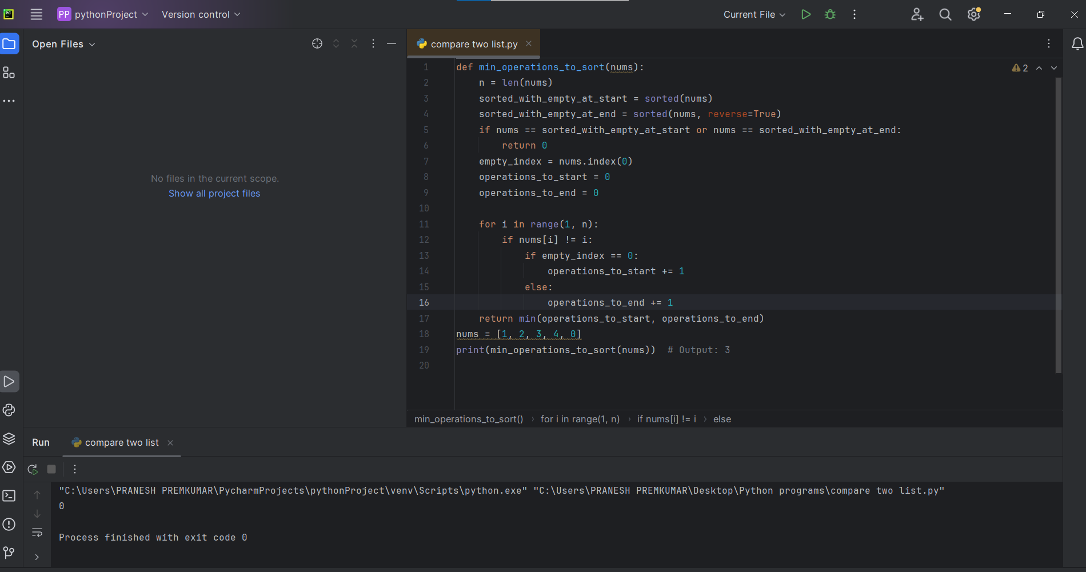

3. Apply Operations to an Array

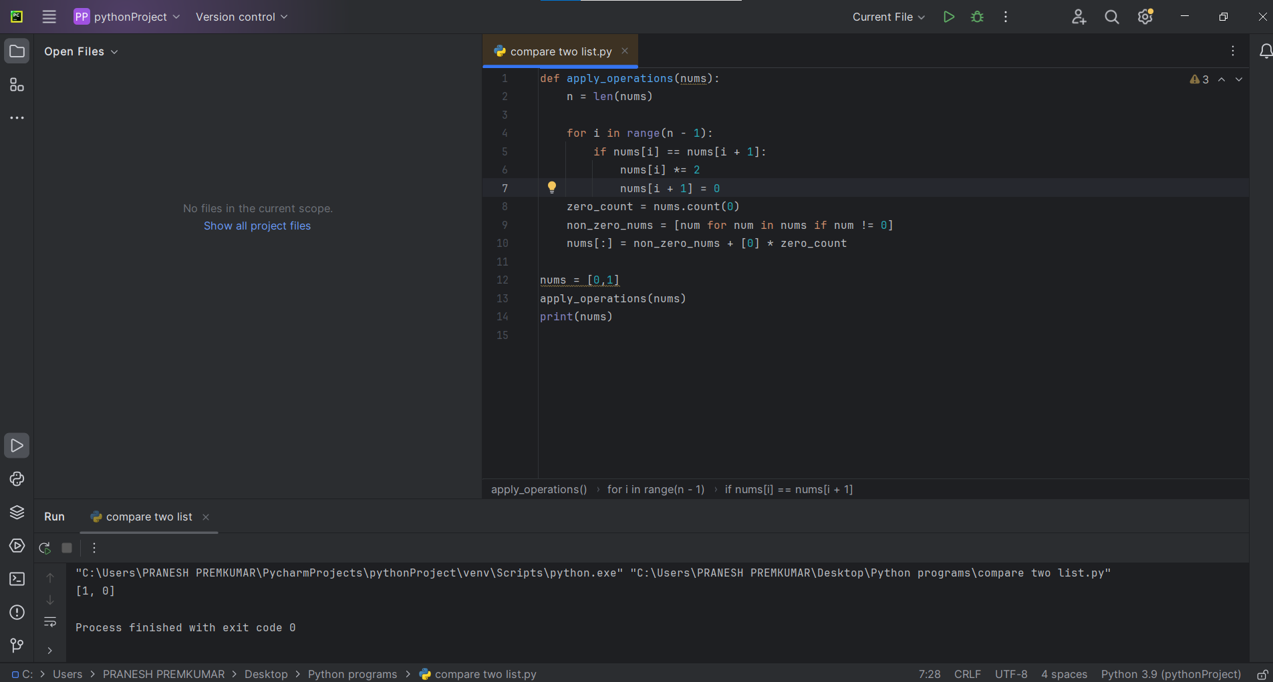

4. . Maximum Sum of Distinct Subarrays With Length K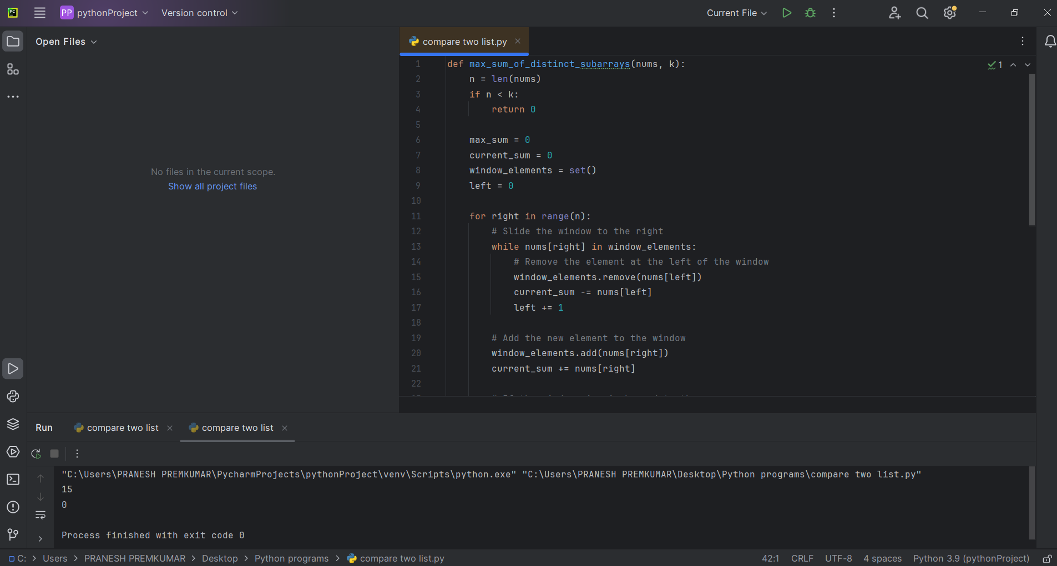

5. Total Cost to Hire K Workers

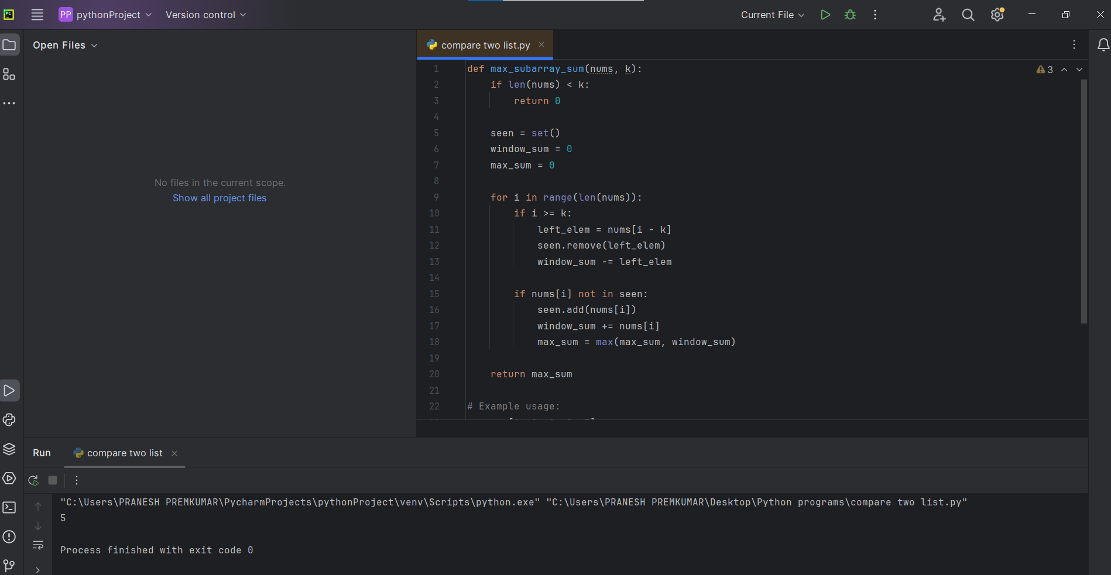

6. Minimum Total Distance Travelled

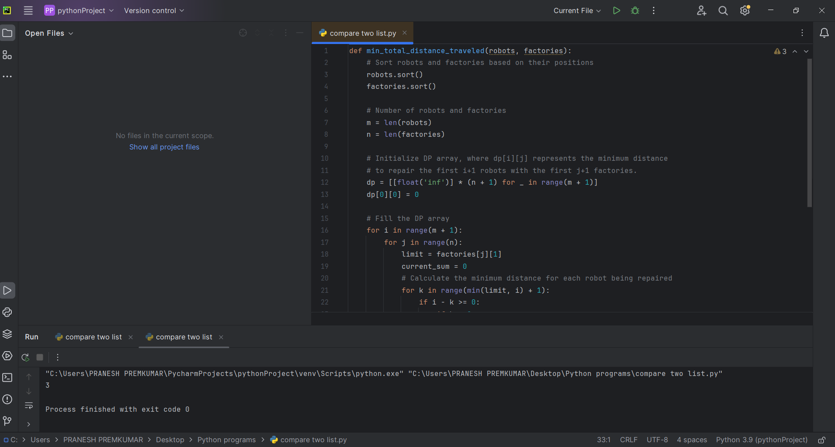

7. . Minimum Subarrays in a Valid Split

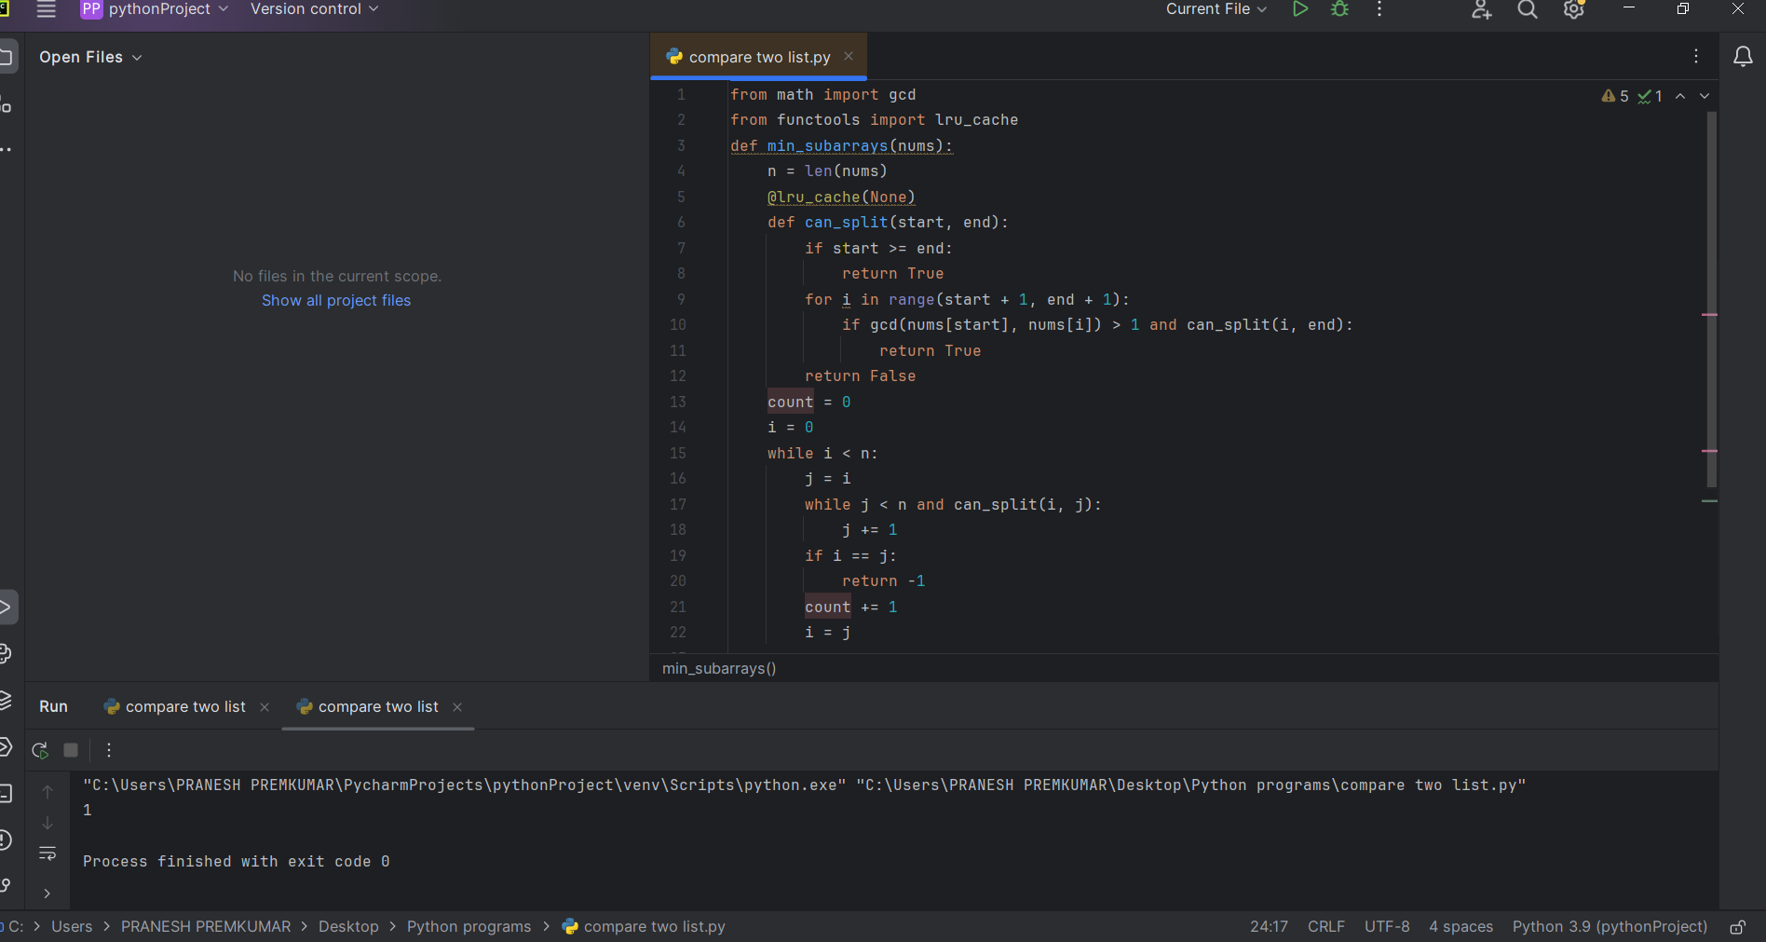

8. Number of Distinct Averages

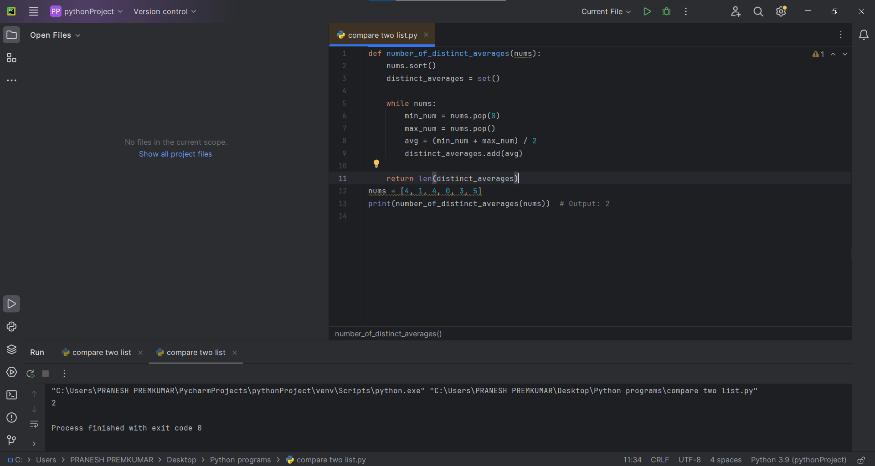

9. Count Ways To Build Good Strings

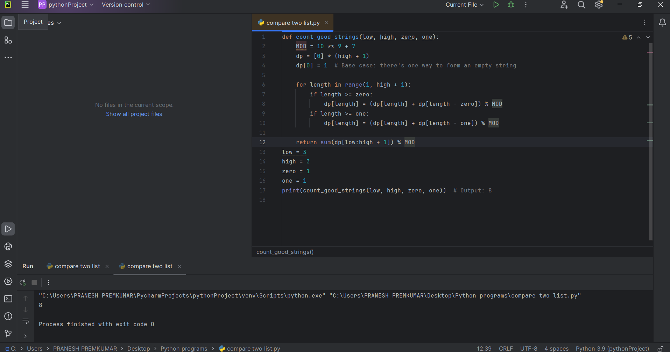

10. Most Profitable Path in a Tree

