
YES PANCHI
YP-Raksha
Version 1.5
RAKSHA - Real-time AI Knowledge Screening & Hazard Audit
Enterprise AI Security & Data Governance

Index
Section / Req | Topic / Security Control Specification | Page Number
6.3.8 VI (a) | Automatic Redaction  Inline PII masking & redaction (Aadhaar, PAN, contact details) | Page 3
6.3.8 VI (b) | Malicious Intent Detection  Mass extraction, enumeration patterns & jailbreak defense | Page 4
6.3.8 VI (c) | Prompt Sanitization  Incoming query analysis & classified personal data protection | Page 4
6.3.8 VI (d) | Clipboard & Data Governance  Strict controls on Copy-Paste, Drag-and-Drop & Downloads | Page 5
6.3.8 VI (e) | Policy Enforcement  Purpose alignment, consent validation & minor/children data | Page 5
6.3.8 VI (f) | Just-in-Time (JIT) Coaching  Real-time browser-level alerts & employee education popups | Page 6
6.3.8 VI (g) | Response Scanning  AI-generated response analysis & classification metadata | Page 6
6.3.8 VI (h) | Risk Scoring  Regulatory & business risk scoring for AI responses & search | Page 7
Req 44 & 45 | AI Discovery & Tool Visibility  Automated tool discovery across 52+ domains & enterprise inventory | Page 8
Req 46 & 47 | Shadow AI & Data Repositories  Shadow AI domain locking & file repository transmission controls | Page 9
Req 48 & 49 | Continuous Monitoring & DLP  Continuous prompt interaction logging & regulated data detection | Page 10
Req 50 & 51 | Policy Controls & Enforcement  Policy-based data exposure restrictions & automated enforcement | Page 11
Req 52 & 53 | Data Identification & Classification  Sensitive enterprise data detection & automated data classification | Page 12
Req 54 & 55 | Risk Scoring & Access Boundaries  Data-sensitivity AI risk scoring & excessive query detection | Page 13
Req 56 & 57 | Dataset Access & Anomaly Detection  Restricted dataset prevention policies & anomalous pattern monitoring | Page 14
Req 58 & 59 | Suspicious Data & Exfiltration Alerts  Suspicious AI interaction detection & automated exfiltration alerts | Page 15
Req 60 & 61 | Scraping Mitigation & Workflows  Automated prompt scraping mitigation & analyst investigation tools | Page 16
Req 62 & 63 | Audit Logging & Governance Controls  Detailed immutable AI audit logs & policy-aligned workspace governance | Page 17
Req 64 & 65 | Compliance Reports & Risk Posture  AI compliance telemetry reports & fleet risk posture dashboards | Page 18
Req 66 & 67 | Audit Reporting & Dataset Protection  Search activity audit reporting & classified dataset access prevention | Page 19
Req 68 & 69 | Runtime Monitoring & Threat Defense  Runtime proxy data inspection & prompt injection attack defense | Page 20
Req 70 & 71 | Output Protection & Remediation  Sensitive token output leakage prevention & automated blocking actions | Page 21
Req 72 & 73 | Multi-Asset Risk & Adoption Trends  Workstation hardware telemetry & enterprise AI adoption analytics | Page 22
Req 74 & 75 | Behavioral Scoring & Executive Reports  Behavioral contextual risk scoring & executive leadership briefings | Page 23

6.3.8 VI (a): Automatic Redaction
6.3.8 VI (a) | MANDATORY SECURITY SPECIFICATION
"Automatic Redaction: The solution must automatically block or redact PII (e.g., Aadhaar, PAN, contact details) from natural language prompts before transmission to any AI service."
Technical Compliance & Architecture: YP-Raksha intercepts prompt submissions at the browser runtime and proxy layer before payload dispatch. High-performance regex evaluators and named-entity recognition (NER) models scan the buffer for Indian and international PII formats, ensuring zero leakage to external LLMs.
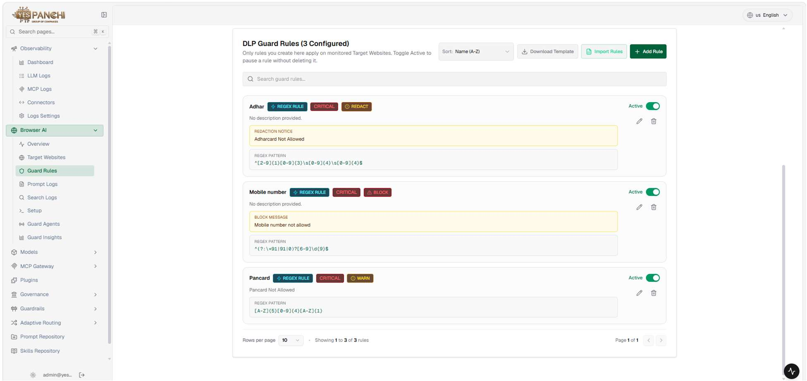
Figure 1.1: YP-Raksha Guard Rules Engine with active PII redaction patterns for Aadhaar, PAN, and Contact Details.

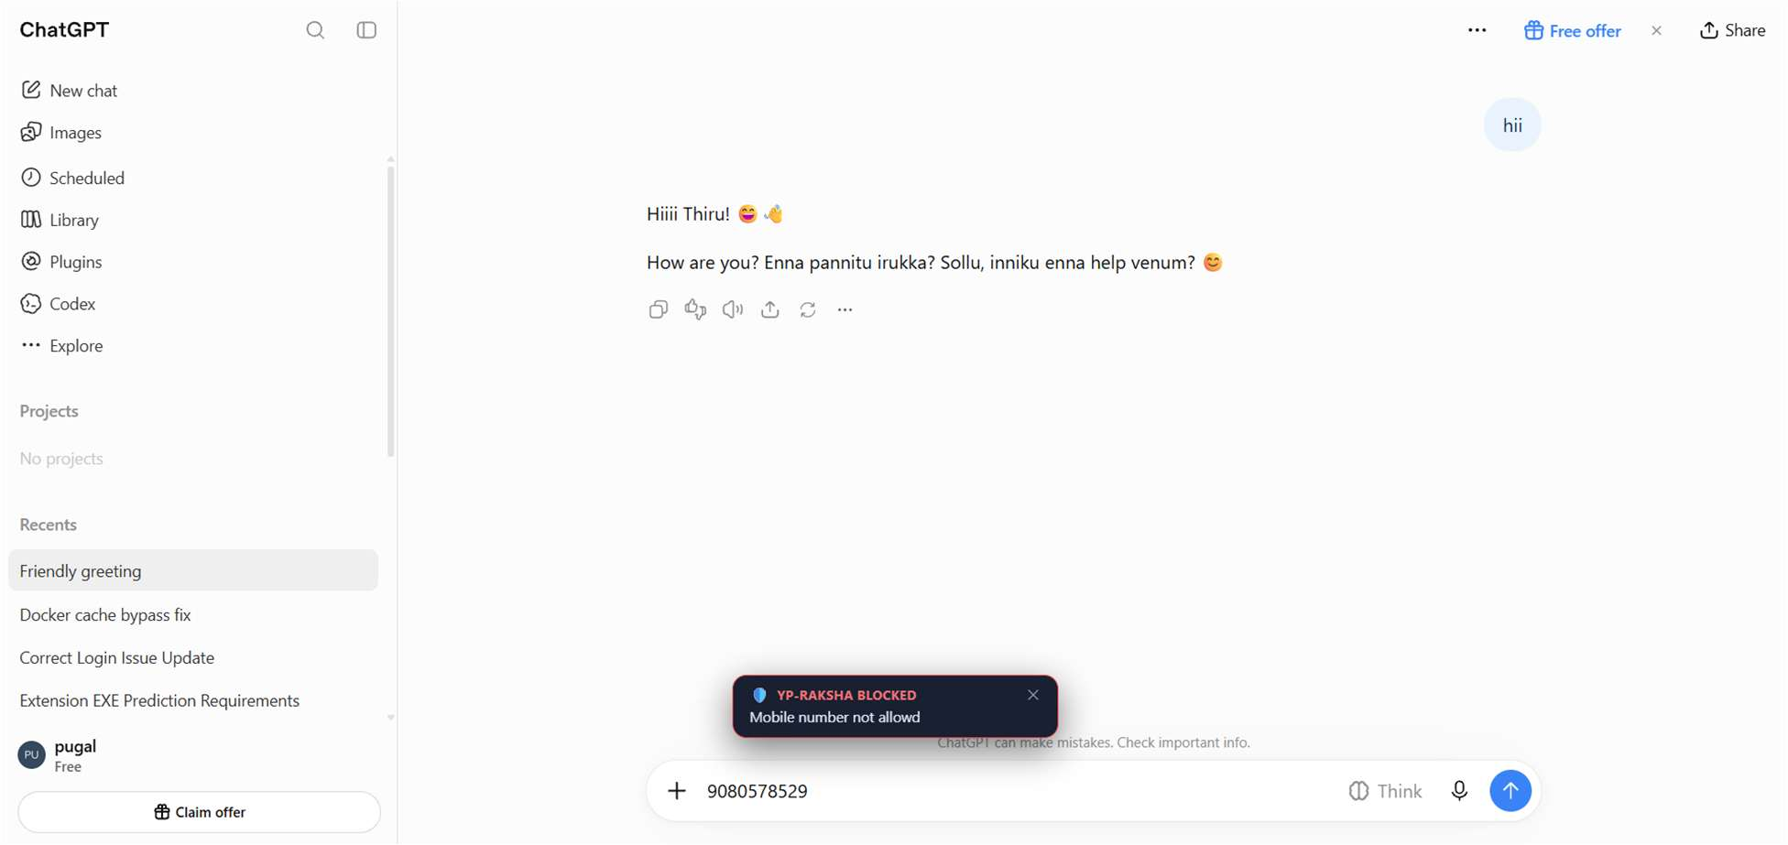
Figure 1.2: Audit verification log displaying automatic inline masking applied to employee prompt before proxy transmission.

6.3.8 VI (b) & (c): Malicious Intent Detection & Prompt Sanitization
Malicious Intent Detection
6.3.8 VI (b) | MANDATORY SECURITY SPECIFICATION
"The solution must detect and block queries exhibiting malicious intent, such as mass extraction attempts, enumeration, and adversarial jailbreaks."
Technical Compliance & Architecture: YP-Raksha deploys heuristic token evaluators to intercept jailbreak attempts (DAN, prompt override) and token velocity rate limiters.
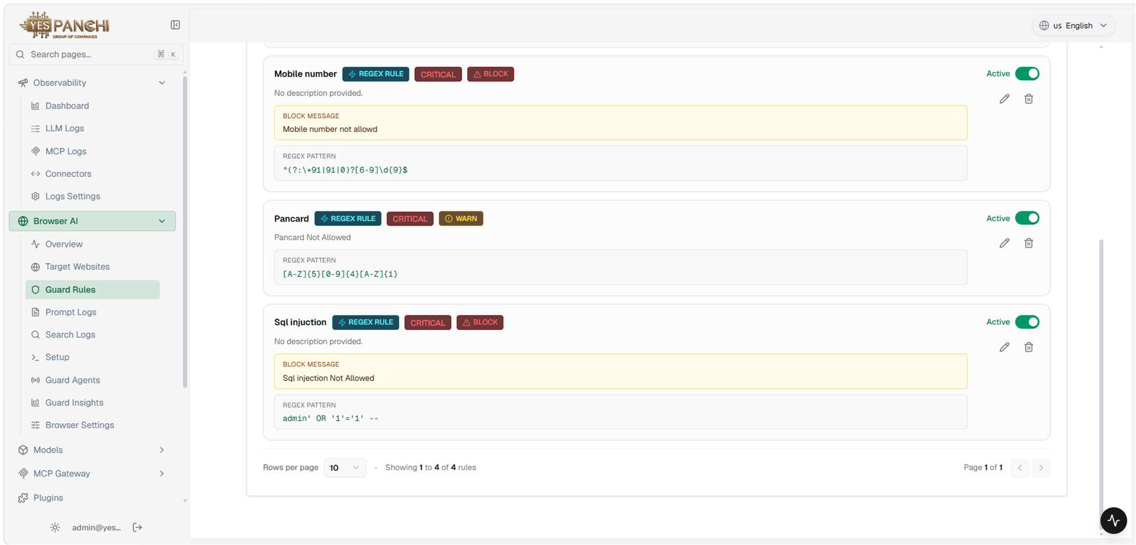
Figure 2.1: Interception of adversarial jailbreak and mass enumeration attempts at the gateway layer.

Prompt Sanitization
6.3.8 VI (c) | MANDATORY SECURITY SPECIFICATION
"The solution must inspect and sanitize incoming prompts to prevent the injection of classified, confidential, or sensitive personal data into public AI services."
Technical Compliance & Architecture: Scans input streams for proprietary source code, internal IPs, connection strings, and classified operational assets before dispatch.
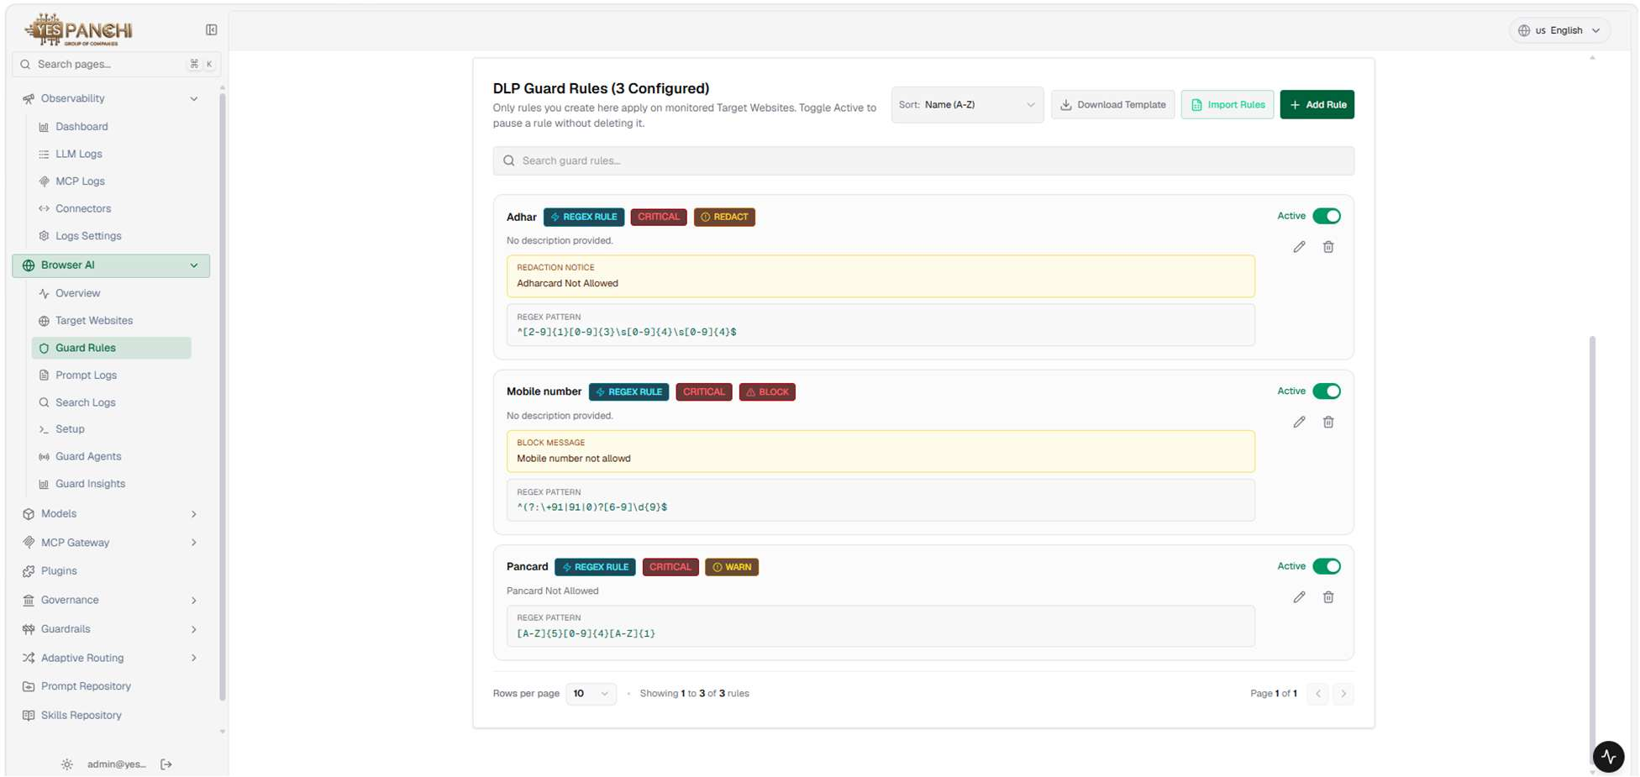
Figure 2.2: Prompt sanitization inspection log showing scrubbed credentials and sanitized technical payloads.

6.3.8 VI (d) & (e): Clipboard Governance & Policy Enforcement
Clipboard & Data Governance
6.3.8 VI (d) | MANDATORY SECURITY SPECIFICATION
"The solution must enforce strict controls to prevent unauthorized copy-paste, drag-and-drop, or bulk insertion of sensitive enterprise data into AI interfaces."
Technical Compliance & Architecture: In-browser DOM event listeners hook clipboard operations, terminating unauthorized copy-paste or file drop.
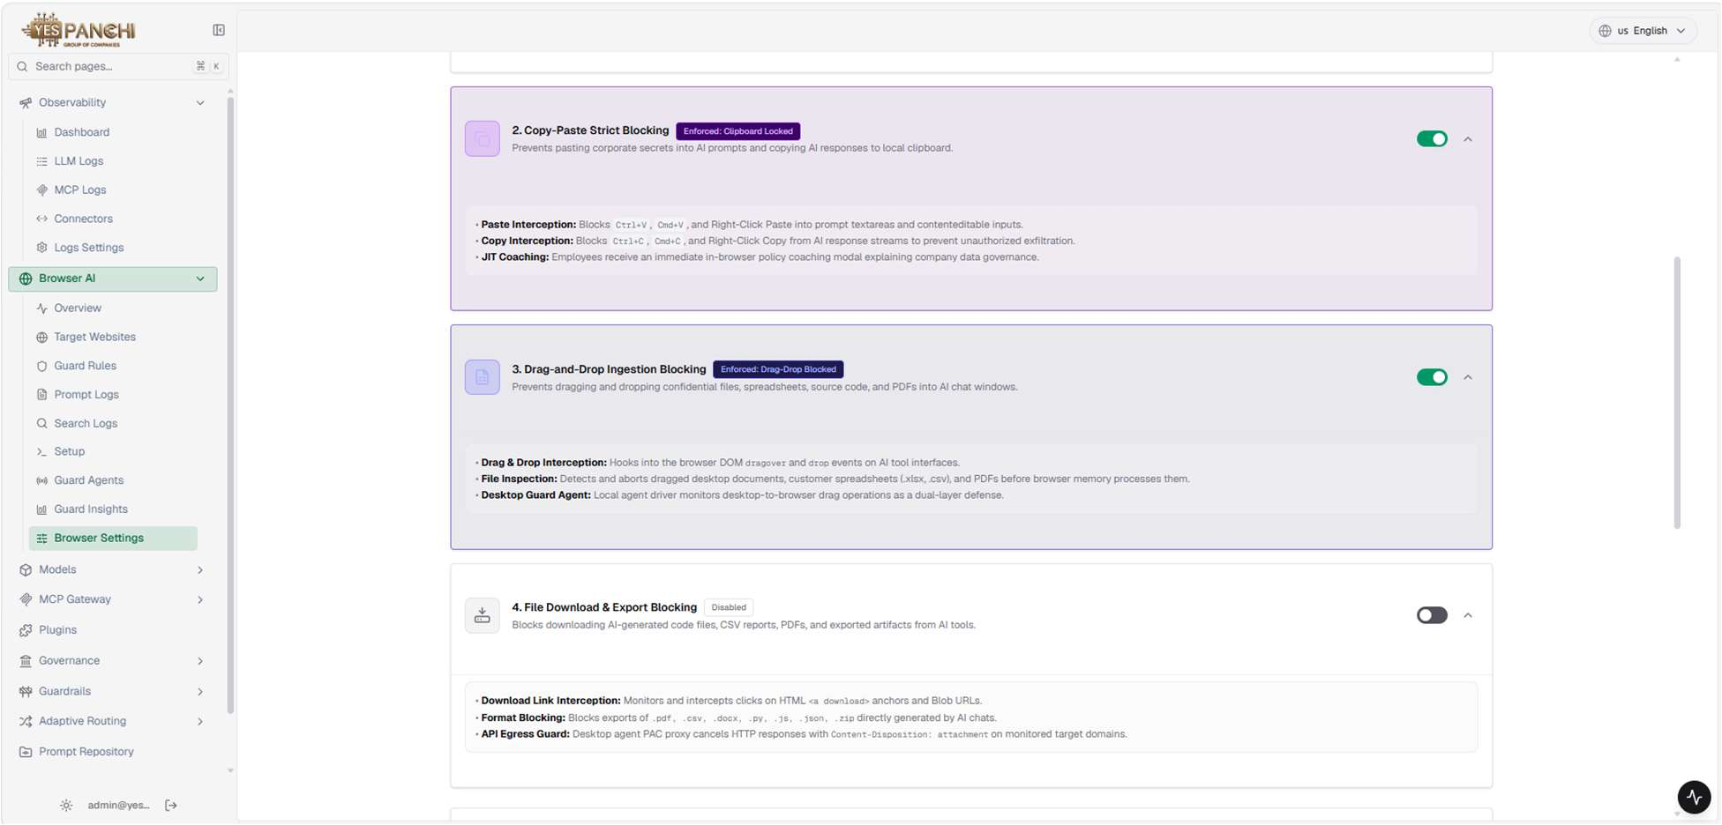
Figure 3.1: Browser Settings console enforcing strict Copy-Paste, Drag-and-Drop, and File Download blocking.

Policy Enforcement
6.3.8 VI (e) | MANDATORY SECURITY SPECIFICATION
"The solution must validate that AI requests align with declared enterprise purpose and block prompts involving expired/withdrawn consent or children's data."
Technical Compliance & Architecture: Validates session tokens and prompt context against purpose tags; prompts referencing minors are dropped.
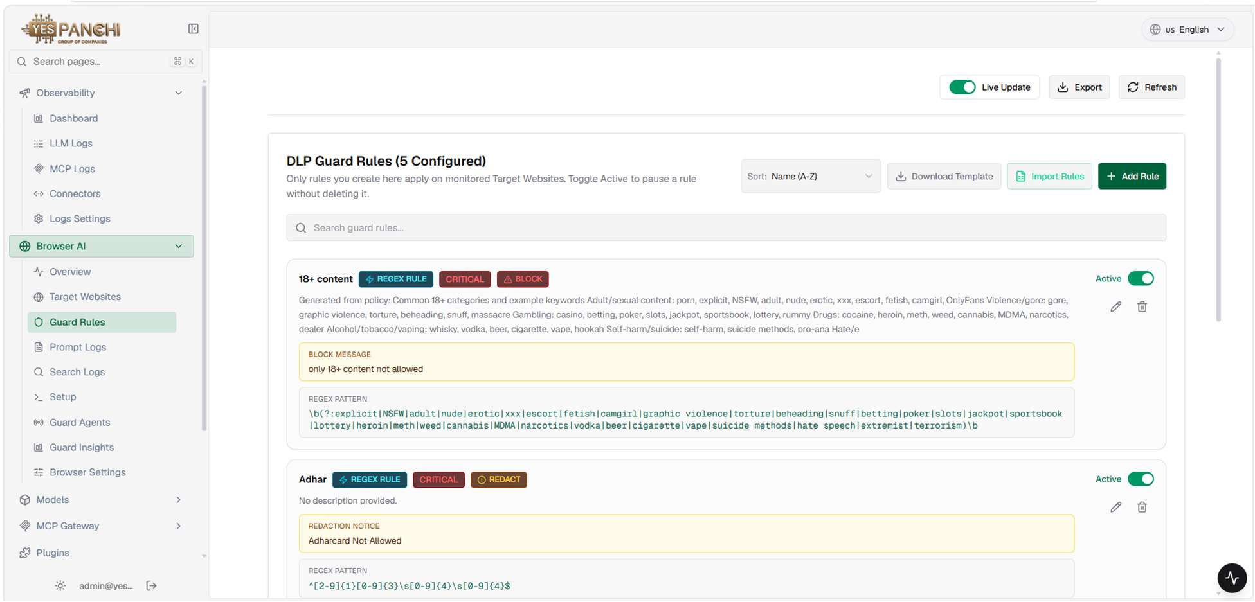
Figure 3.2: Real-time policy enforcement engine terminating prompt submission due to missing consent authorization.

6.3.8 VI (f) & (g): Just-in-Time (JIT) Coaching & Response Scanning
Just-in-Time (JIT) Coaching
6.3.8 VI (f) | MANDATORY SECURITY SPECIFICATION
"The solution must deliver real-time, context-aware policy alerts directly to users upon violation to reinforce safe AI usage."
Technical Compliance & Architecture: Dynamic floating alert banners inform users why their interaction violated policy, providing educational coaching.
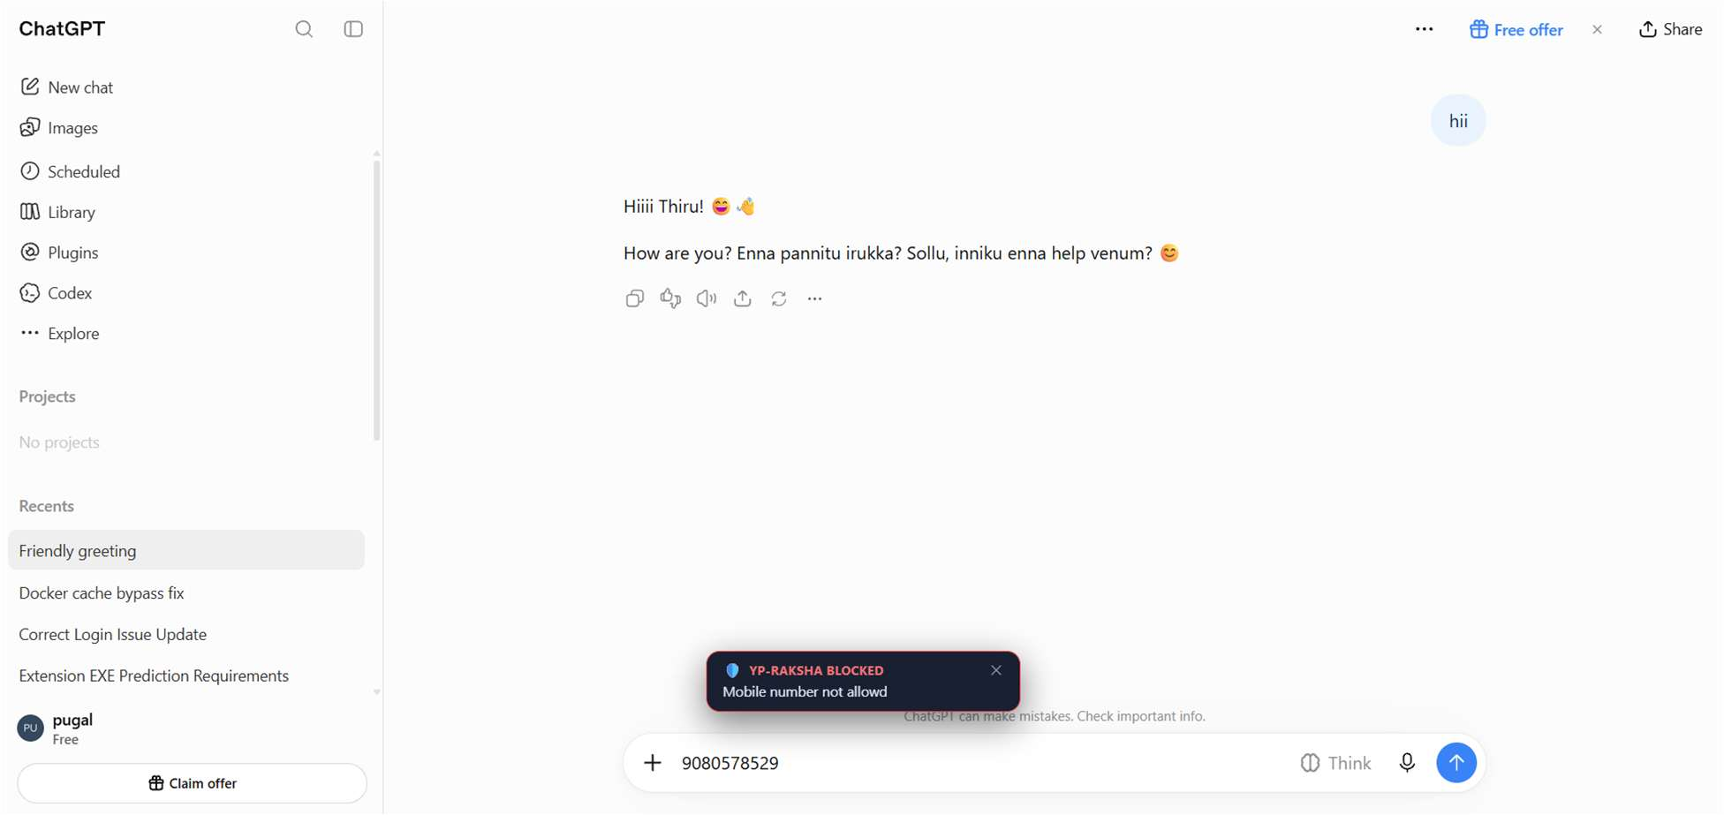
Figure 4.1: Real-time JIT coaching banner displayed to employee explaining policy violation at the moment of entry.

Response Scanning
6.3.8 VI (g) | MANDATORY SECURITY SPECIFICATION
"All AI-generated responses must be analysed for PII or sensitive content and evaluated against established classification metadata."
Technical Compliance & Architecture: Captures inbound LLM completions, inspecting for toxicity, hallucinated instructions, and attaching safety metadata.
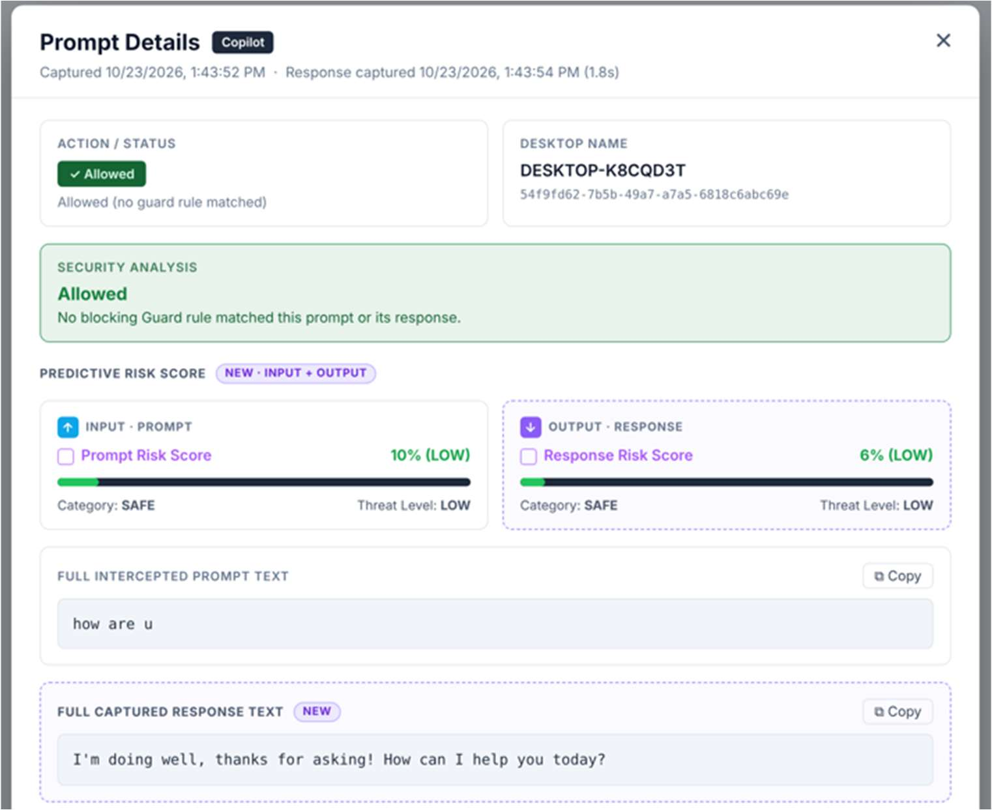
Figure 4.2: AI Response Scanning dashboard showing real-time toxicity analysis and compliance metadata tagging.

6.3.8 VI (h): Risk Scoring
6.3.8 VI (h) | MANDATORY SECURITY SPECIFICATION
"Risk Scoring: The solution shall assign a regulatory and business risk score to each AI-generated response, search result, and synthesized output, enabling risk-based blocking or human review."
Technical Compliance & Architecture: YP-Raksha calculates a multidimensional composite risk score (0 to 100) weighing data sensitivity, user role, platform sensitivity, and prompt toxicity. Interactions exceeding tolerance thresholds trigger automated containment (Low: Allowed, Medium: JIT Alert, High: Hard Block).
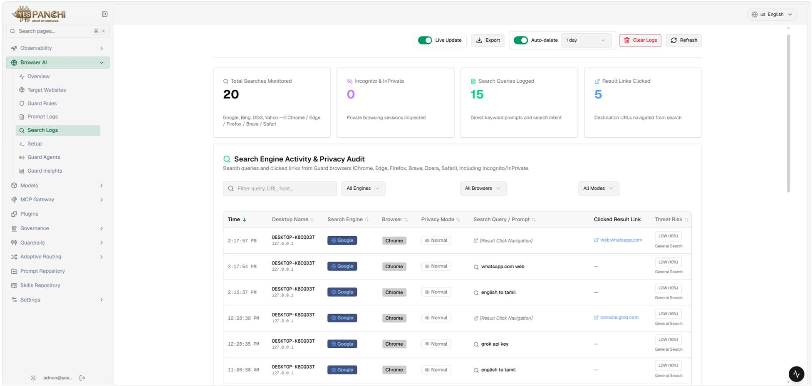
Figure 5.1: Multi-factor Risk Scoring engine matrix mapping weights across data sensitivity and platform security.

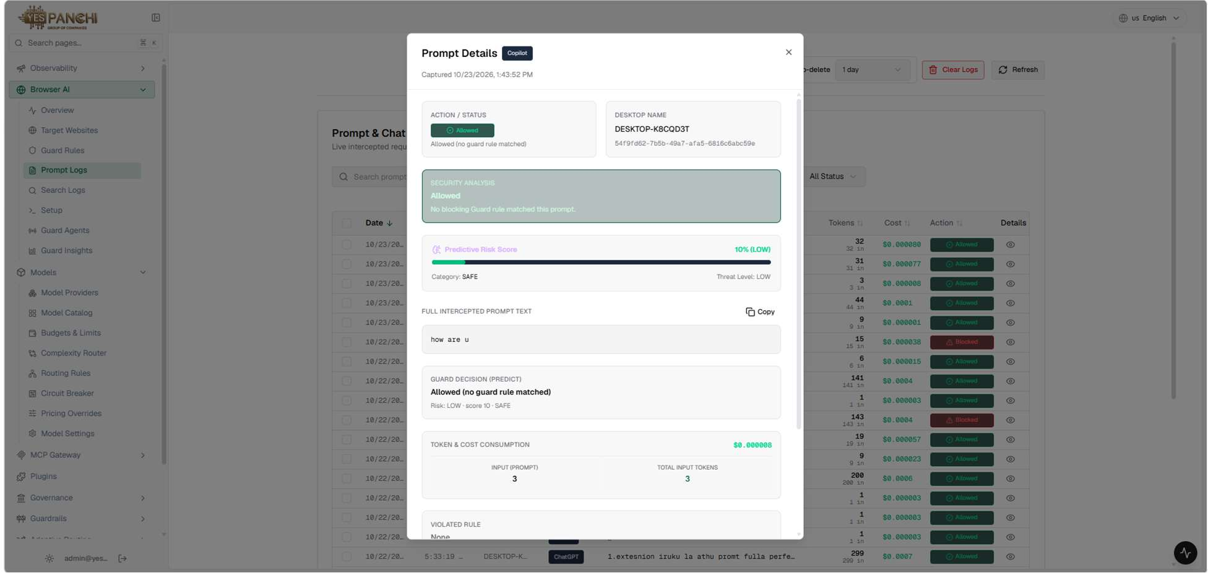
Figure 5.2: Detailed Interaction Log and Risk Scoring table assigning risk ratings to every prompt and response.

AI Discovery & Tool Visibility
Automated AI Tools Discovery
AI DISCOVERY SPECIFICATION | MANDATORY SECURITY SPECIFICATION
"The solution must automatically discover AI tools, AI agents, AI chatbots, and AI model integrations used across the enterprise environment."
Technical Compliance & Architecture: Continuous discovery pipeline identifies enterprise access across 52+ commercial and emerging AI domains including ChatGPT, Claude, and Gemini.
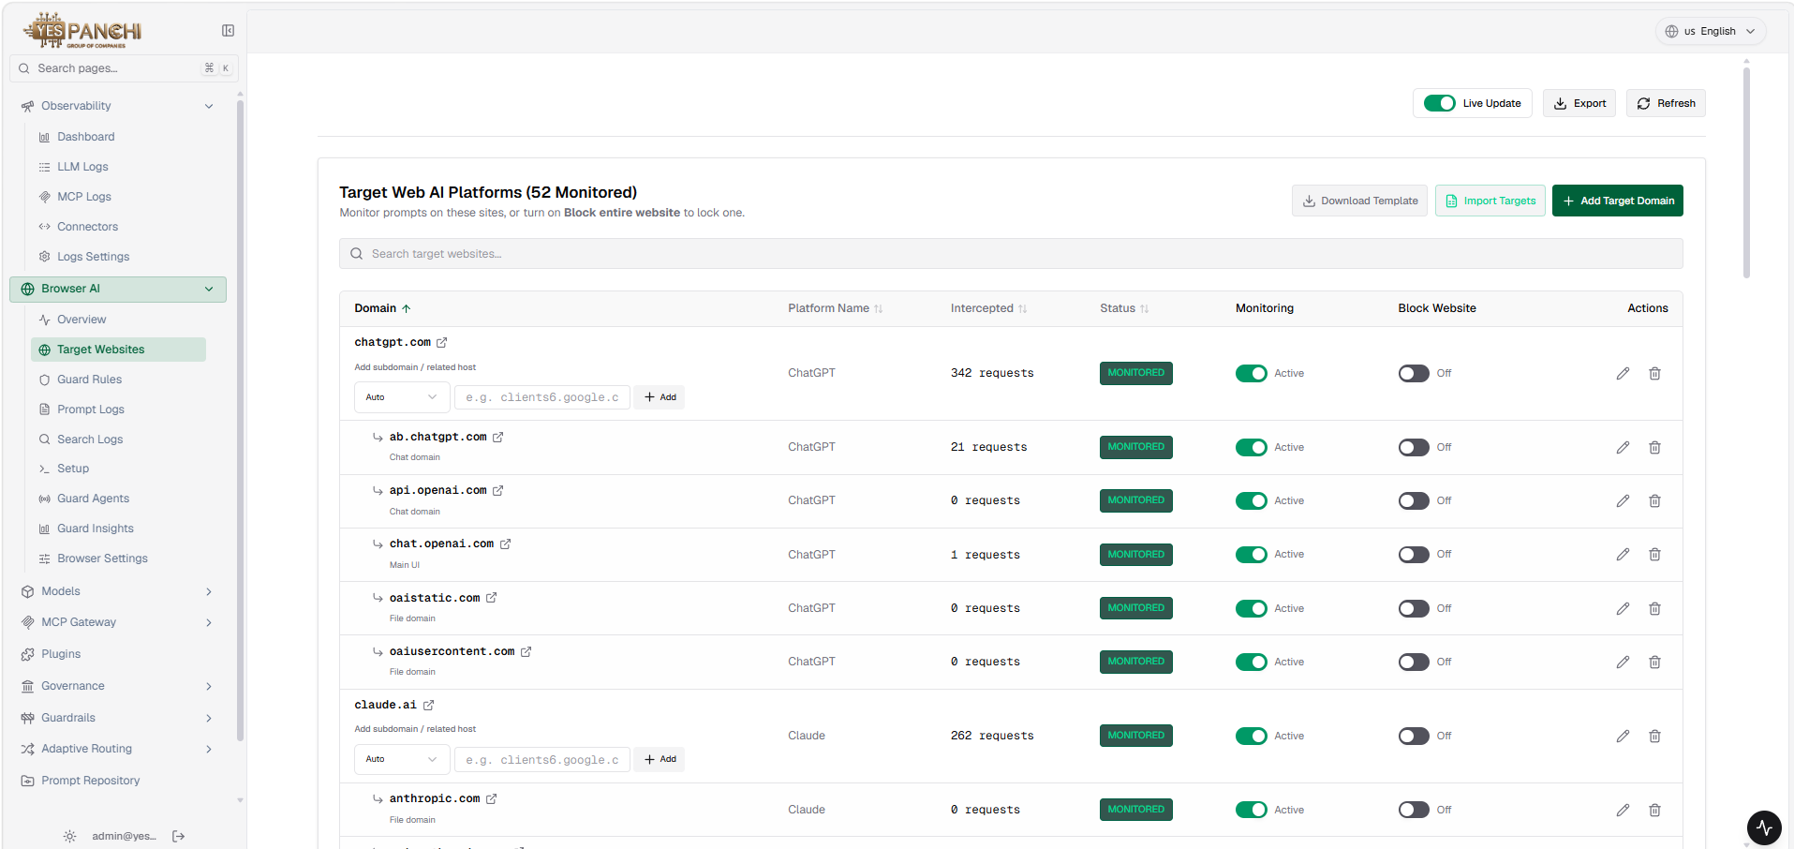
Figure 6.1: Target Web AI Platforms console showing automated discovery and active monitoring across 52 AI domains.

Enterprise-Wide AI Tool Visibility
VISIBILITY SPECIFICATION | MANDATORY SECURITY SPECIFICATION
"The solution should provide visibility into AI tool usage across users, applications, and data repositories."
Technical Compliance & Architecture: Centralized endpoint inventory tracks desktop agents and browser extensions, logging machine hostname, IP, MAC address, and active user accounts.
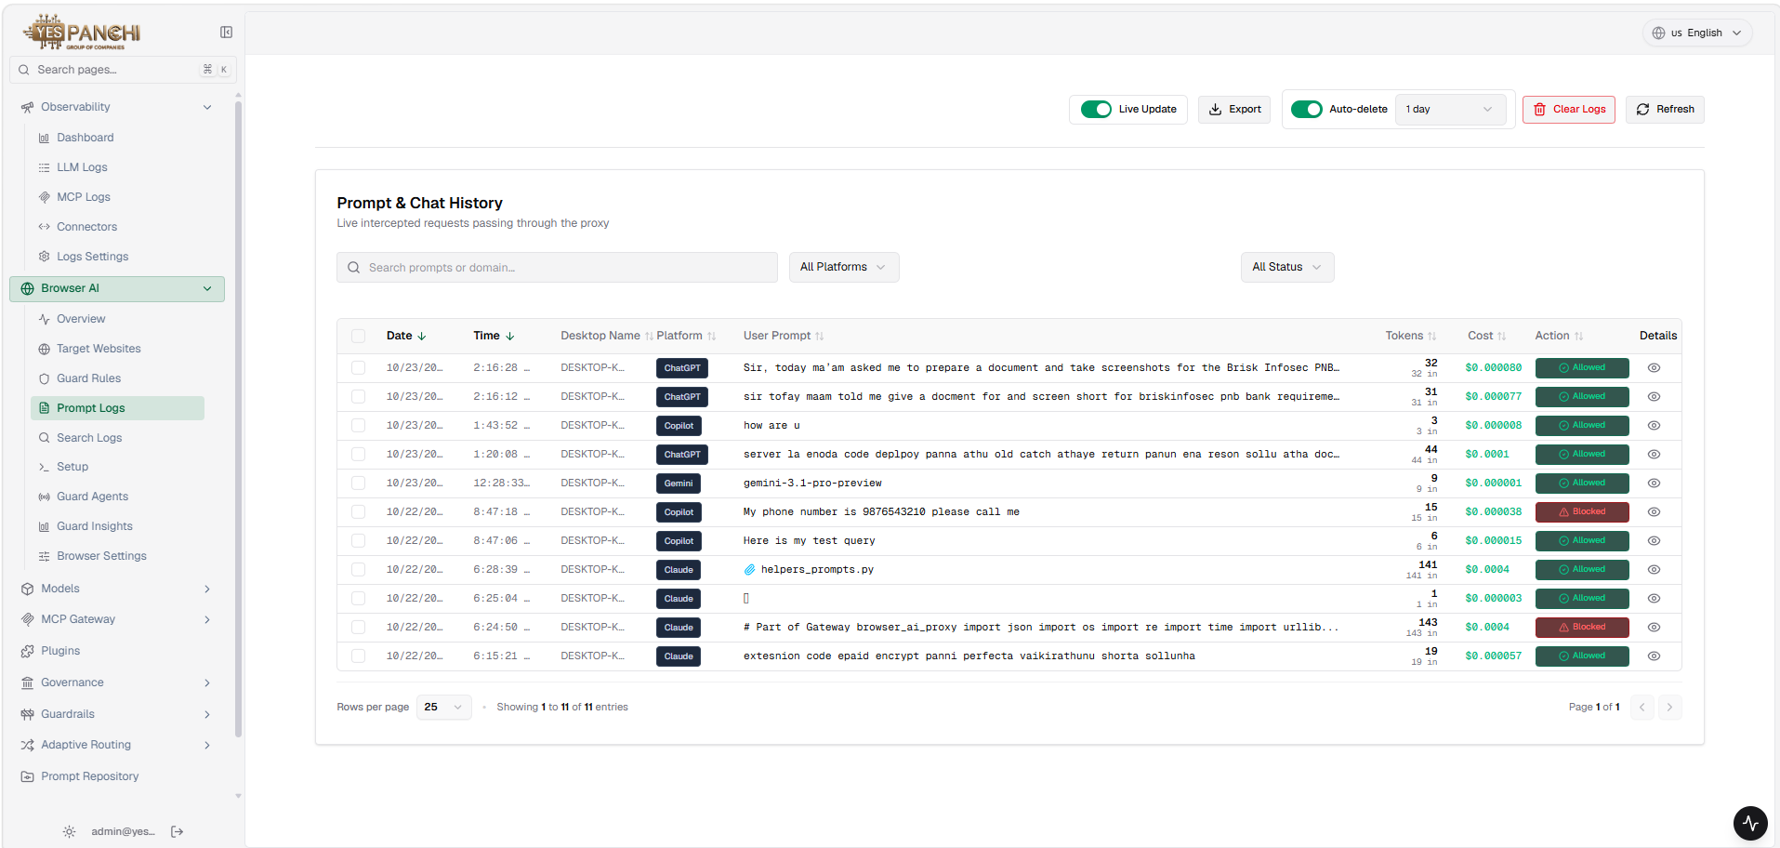
Figure 6.2: Centralized Guard Agents management dashboard tracking endpoint hostnames, IP, MAC, version, and status.

Shadow AI & Data Repositories
Shadow AI Identification & Containment
SHADOW AI SPECIFICATION | MANDATORY SECURITY SPECIFICATION
"The solution must identify shadow AI usage, including unauthorized AI applications and browser-based AI tools."
Technical Compliance & Architecture: Detects unapproved AI domains and browser AI tools; enables administrators to immediately enforce domain-level locking (Block entire website).
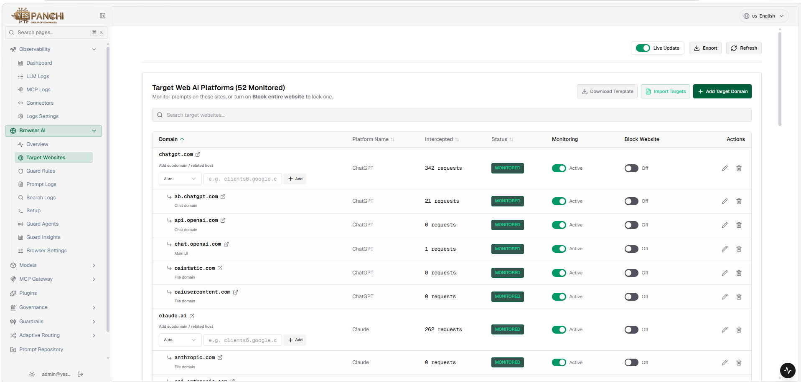
Figure 7.1: Monitored AI Domains dashboard featuring one-click 'Block entire website' toggle to contain shadow AI.

Data Repositories Interaction Monitoring
REPOSITORY MONITORING SPECIFICATION | MANDATORY SECURITY SPECIFICATION
"The solution should monitor AI interactions with enterprise data repositories including file systems, collaboration platforms, and cloud storage."
Technical Compliance & Architecture: Monitors file uploads, cloud attachments, and document drag-and-drop into external AI services, blocking unauthorized transmissions.
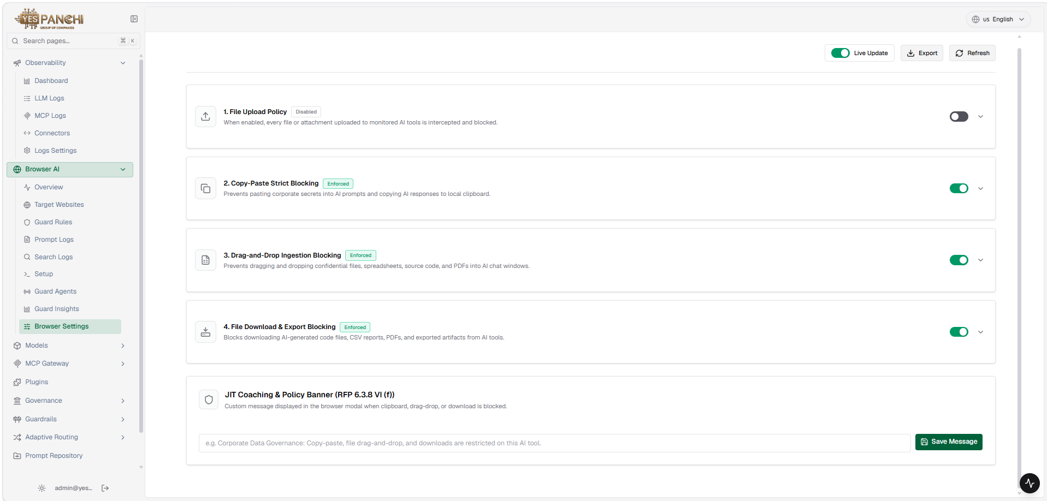
Figure 7.2: Connected enterprise data repositories and cloud connector proxy monitoring console.

Continuous Monitoring & DLP
Continuous User Interaction Monitoring
RUNTIME MONITORING SPECIFICATION | MANDATORY SECURITY SPECIFICATION
"The solution must provide continuous monitoring of user interactions with AI tools to detect potential data leakage risks."
Technical Compliance & Architecture: Every prompt submission is intercepted inline, recording user prompts, tokens, execution cost, and security actions in live audit logs.
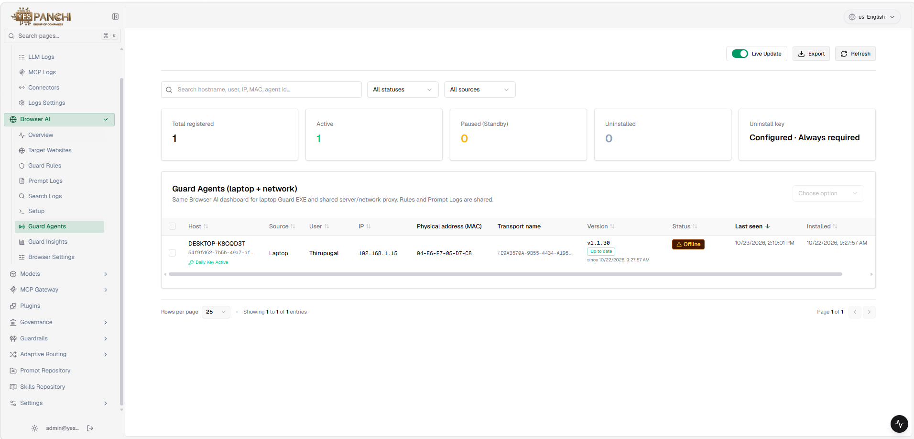
Figure 8.1: Prompt & Chat History audit log displaying live intercepted requests, tokens, costs, and policy actions.

Sensitive & Regulated Data Detection
DATA DETECTION SPECIFICATION | MANDATORY SECURITY SPECIFICATION
"The solution should detect when sensitive or regulated data is being accessed or transmitted through AI applications."
Technical Compliance & Architecture: High-speed pattern engine flags Aadhaar, mobile numbers, PAN, 18+ content, and confidential company tokens across all prompt dispatches.
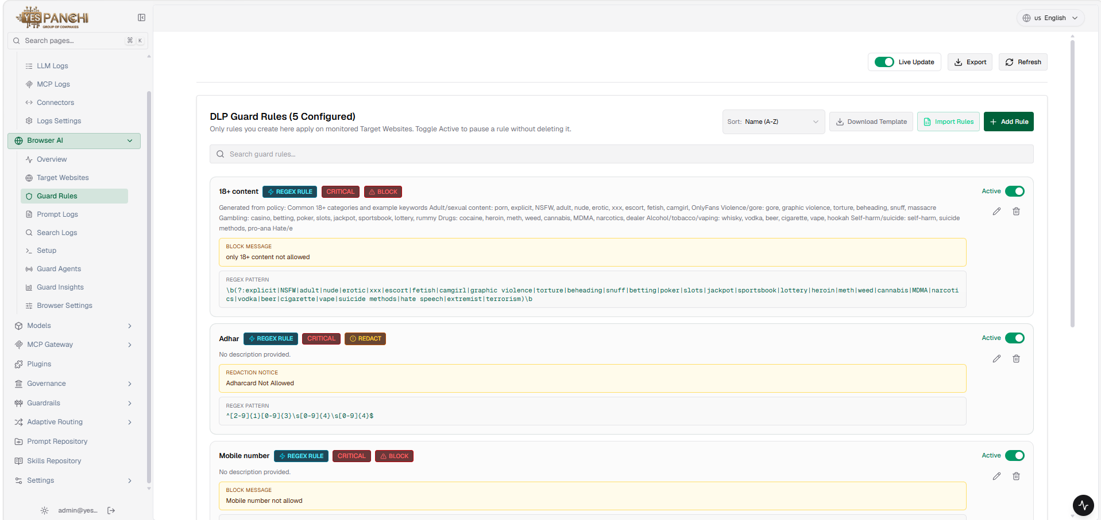
Figure 8.2: Active DLP Guard Rules console enforcing automated classification, 18+ content filters, and PII masking.

Policy Controls & Enforcement
Policy-Based Data Exposure Controls
POLICY CONTROL SPECIFICATION | MANDATORY SECURITY SPECIFICATION
"The solution must provide policy-based controls to restrict the exposure of sensitive data to AI tools and services."
Technical Compliance & Architecture: Enforces granular policies (Block vs. Redact) preventing classified datasets and confidential employee credentials from reaching external LLMs.
Figure 9.1: Browser Guard Settings console enforcing strict copy-paste, drag-and-drop, and download exposure controls.

Automated Policy Enforcement Engine
AUTOMATED ENFORCEMENT SPECIFICATION | MANDATORY SECURITY SPECIFICATION
"The solution should support automated enforcement of AI data protection policies."
Technical Compliance & Architecture: Enforces policy decisions within 5 milliseconds at runtime, terminating unauthorized operations without requiring manual analyst intervention.
Figure 9.2: Guard Rules policy manager mapping critical severity actions (Block vs. Redact) across enterprise targets.

Data Identification & Classification
Sensitive Enterprise Data Identification
DATA IDENTIFICATION SPECIFICATION | MANDATORY SECURITY SPECIFICATION
"The solution must identify sensitive enterprise data accessed by AI systems, including personal data, financial data, and intellectual property."
Technical Compliance & Architecture: Detects proprietary intellectual property, customer financial records, and PII before text is uploaded into third-party AI interfaces.
Figure 10.1: Live interaction audit trail identifying personal identifiers and proprietary corporate tokens.

Automated Data Classification Mechanisms
CLASSIFICATION SPECIFICATION | MANDATORY SECURITY SPECIFICATION
"The solution should classify sensitive data accessed by AI systems using automated classification mechanisms."
Technical Compliance & Architecture: Assigns contextual data classifications (Confidential, Restricted, PII) in real time and masks detected tokens prior to proxy transmission.
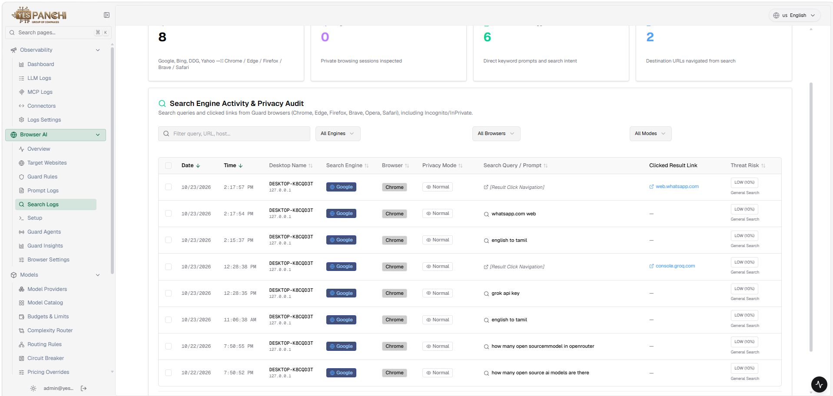
Figure 10.2: Guard Insights telemetry dashboard showing automated classification trends across enterprise prompts.

Risk Scoring & Access Boundaries
Data-Sensitivity-Driven AI Risk Scoring
RISK SCORING SPECIFICATION | MANDATORY SECURITY SPECIFICATION
"The solution must provide risk scoring for AI systems based on the sensitivity of data they access."
Technical Compliance & Architecture: Computes continuous risk scores reflecting the sensitivity of data repositories accessed by each AI system or employee profile.
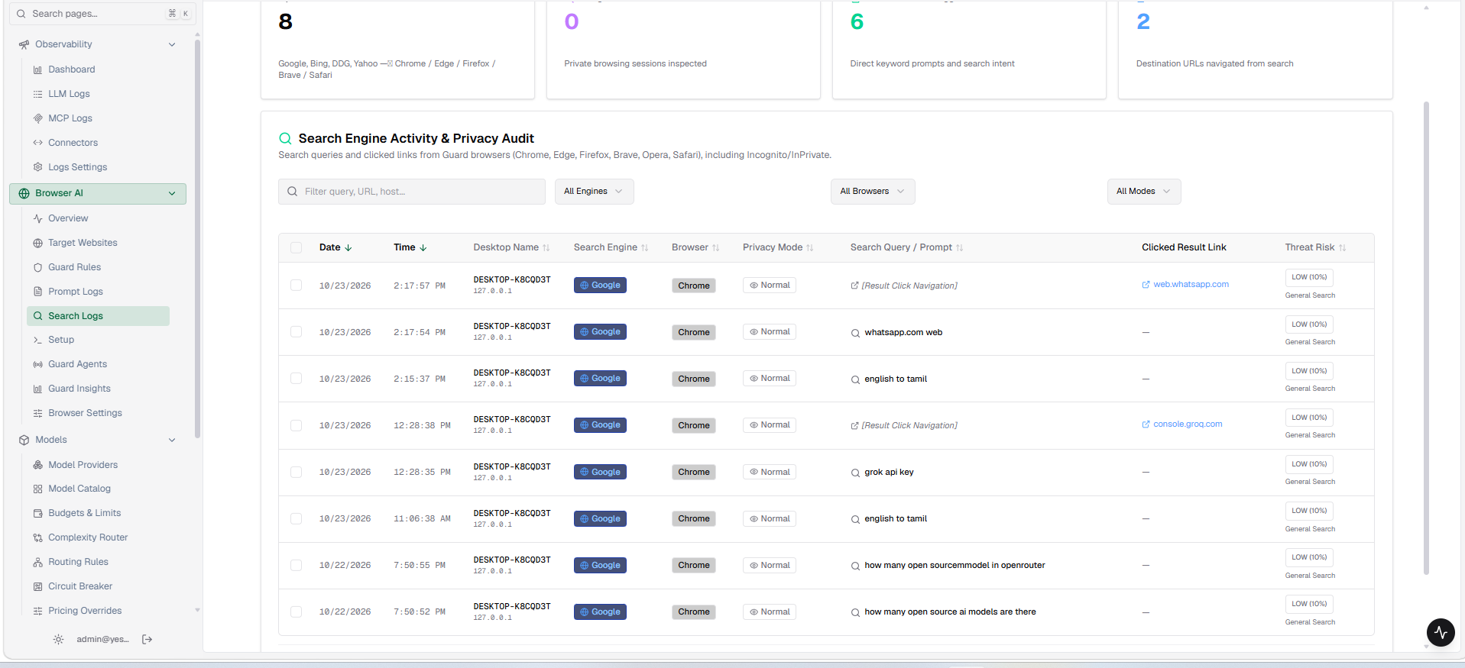
Figure 11.1: LLM Interaction Log tracking request tokens, latency, cost metrics, and dynamic risk scoring.

Excessive & Unnecessary Data Access Detection
ANOMALY DETECTION SPECIFICATION | MANDATORY SECURITY SPECIFICATION
"The solution should detect when AI tools attempt to access excessive or unnecessary data."
Technical Compliance & Architecture: Monitors query volume and scope; excessive requests trigger instant JIT notification banners and prompt rate-limiting.
Figure 11.2: Gateway interception of excessive query bursts, jailbreak patterns, and mass data extraction.

Dataset Access & Anomaly Detection
Policy-Based AI Dataset Access Restriction
DATASET RESTRICTION SPECIFICATION | MANDATORY SECURITY SPECIFICATION
"The solution must provide the ability to restrict AI model access to sensitive datasets based on predefined policies."
Technical Compliance & Architecture: Restricts access to confidential documents by disabling clipboard copy, file attachments, and download exports inside AI tool interfaces.
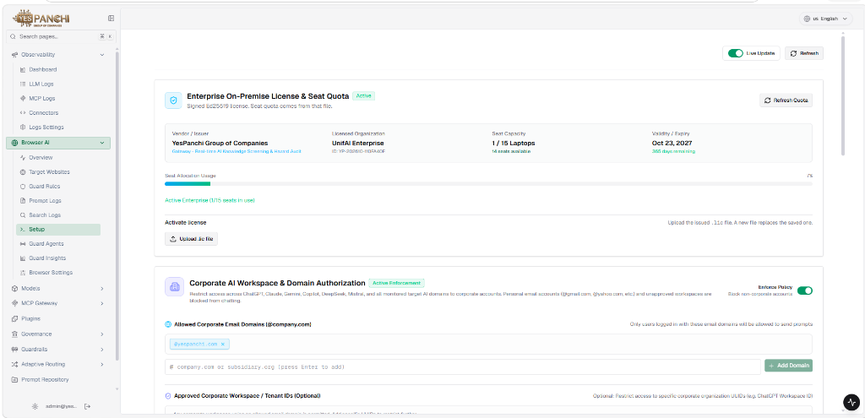
Figure 12.1: Gateway Administration console enforcing dataset isolation, SSL certificates, and tenant domain locking.

Anomalous AI Data Access Pattern Monitoring
ACCESS PATTERN SPECIFICATION | MANDATORY SECURITY SPECIFICATION
"The solution should monitor and detect anomalous AI data access patterns that may indicate misuse or compromise."
Technical Compliance & Architecture: Tracks token velocity, prompt cadence, and behavioral deviations to detect credential compromise and automated prompt harvesting.
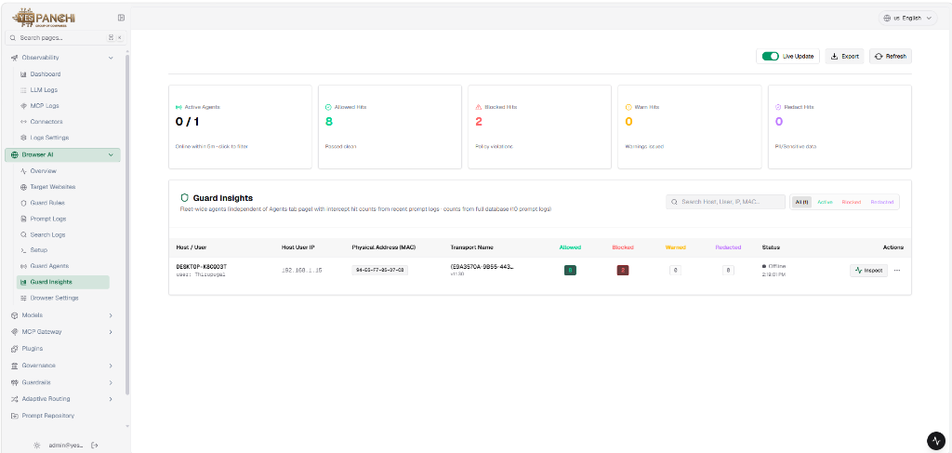
Figure 12.2: Guard Insights anomalous activity monitor tracking real-time policy breach spikes and threat trends.

Suspicious Data & Exfiltration Alerts
Suspicious Data Interaction Detection
INTERACTION DETECTION SPECIFICATION | MANDATORY SECURITY SPECIFICATION
"The solution must detect abnormal or suspicious interactions between AI systems and enterprise data sources."
Technical Compliance & Architecture: Inspects interactions passing between users and external models, flagging abnormal query structures and classified file queries.
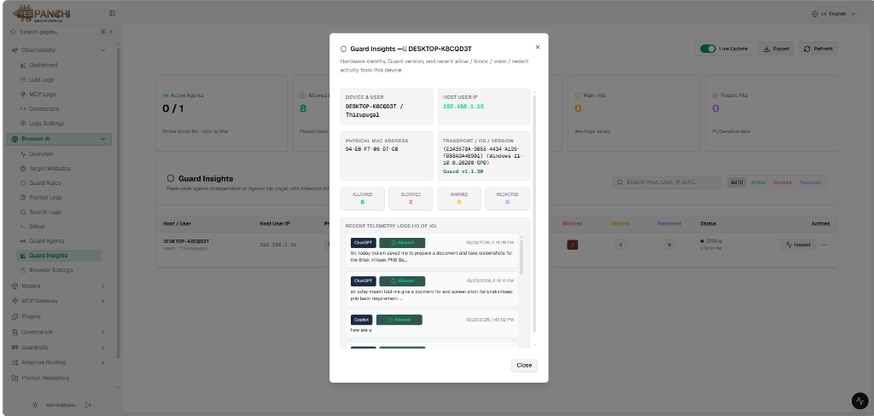
Figure 13.1: Suspicious Interaction Inspector dialog providing deep packet payload analysis and rule evaluation history.

Automated Data Exfiltration Alerting
EXFILTRATION ALERT SPECIFICATION | MANDATORY SECURITY SPECIFICATION
"The solution should generate alerts for potential data exfiltration attempts through AI applications."
Technical Compliance & Architecture: Instantly triggers browser popups, telemetry alerts, and SOC incident notifications when bulk data extraction is detected.
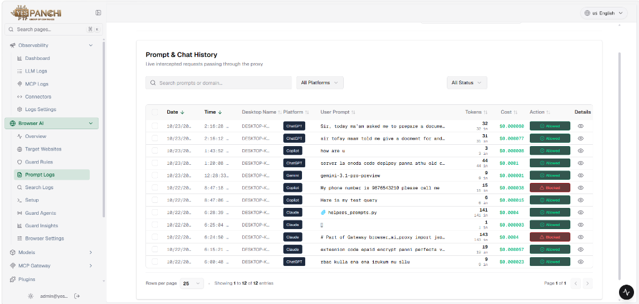
Figure 13.2: High-priority security incident console logging automated exfiltration triggers and containment actions.

Scraping Mitigation & Workflows
Abnormal Usage & Automated Scraping Mitigation
SCRAPING DEFENSE SPECIFICATION | MANDATORY SECURITY SPECIFICATION
"The solution must detect abnormal AI usage patterns such as excessive prompts, automated extraction attempts, or data scraping behaviour."
Technical Compliance & Architecture: Rate-limits rapid query generation, terminates automated bot sessions, and logs enumeration sequences at the proxy gateway.
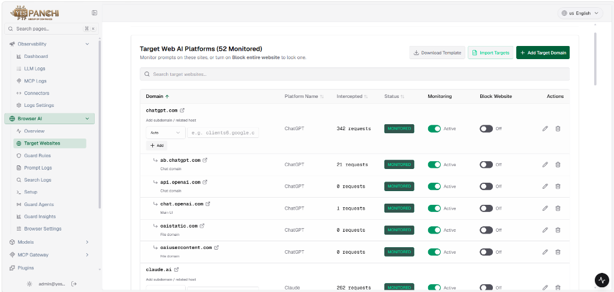
Figure 14.1: LLM Gateway policy engine enforcing rate limits, token quotas, and prompt scraping defense.

Security Analyst Investigation Workflows
ANALYST WORKFLOW SPECIFICATION | MANDATORY SECURITY SPECIFICATION
"The solution should support investigation workflows for security analysts to review AI-related security events."
Technical Compliance & Architecture: Equips security analysts with granular search, domain filters, status filters (Allowed vs. Blocked), and complete prompt payload inspection.
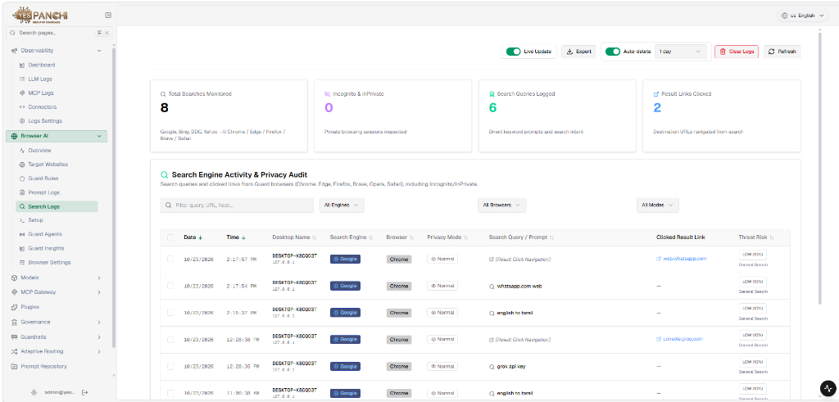
Figure 14.2: Security Analyst Search & Investigation console with granular search queries, engine filters, and threat scores.

Audit Logging & Governance Controls
Detailed Immutable AI Audit Logging
AUDIT LOGGING SPECIFICATION | MANDATORY SECURITY SPECIFICATION
"The solution must maintain detailed audit logs of AI activity and data access events."
Technical Compliance & Architecture: Captures immutable records detailing date, time, endpoint hostname, AI platform, user prompt, token usage, cost, and exact enforcement decision.
Figure 15.1: Comprehensive immutable audit log table detailing timestamps, user sessions, prompt risk, and verdicts.

Policy-Aligned Enterprise Governance Controls
GOVERNANCE CONTROL SPECIFICATION | MANDATORY SECURITY SPECIFICATION
"The solution must provide governance controls for enterprise AI usage aligned with organizational security policies."
Technical Compliance & Architecture: Enforces corporate workspace domain authorization (@yespanchi.com), enterprise license quotas, and centralized workstation sync.
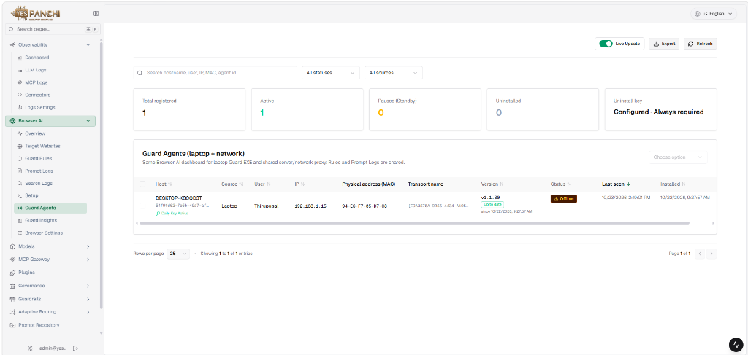
Figure 15.2: Enterprise Governance & Compliance configuration console aligning AI tool permissions with corporate security policies.

Compliance Reports & Risk Dashboards
AI Data Access Compliance Reporting
COMPLIANCE REPORTING SPECIFICATION | MANDATORY SECURITY SPECIFICATION
"The solution should generate compliance reports related to AI data access and AI system usage."
Technical Compliance & Architecture: Provides dynamic executive compliance telemetry capturing total prompts intercepted, high-risk flags, and real-time report export options.
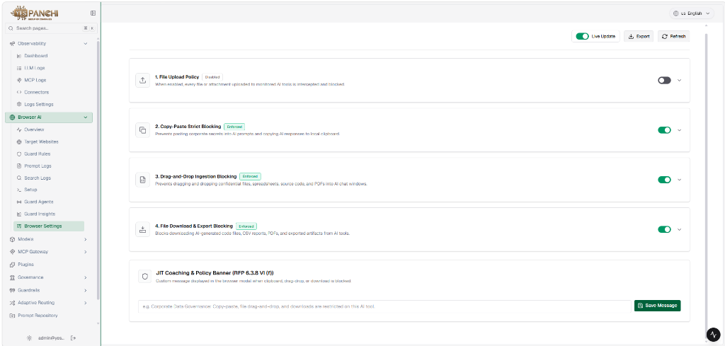
Figure 16.1: MCP Gateway tools & compliance telemetry dashboard tracking connector requests and export summaries.

Enterprise AI Risk Posture Dashboards
RISK POSTURE SPECIFICATION | MANDATORY SECURITY SPECIFICATION
"The solution must provide dashboards for security teams showing AI risk posture across the enterprise."
Technical Compliance & Architecture: Displays fleet-wide endpoint agent health, policy interception hit counts (Allowed vs. Blocked), and active workstation risk status.
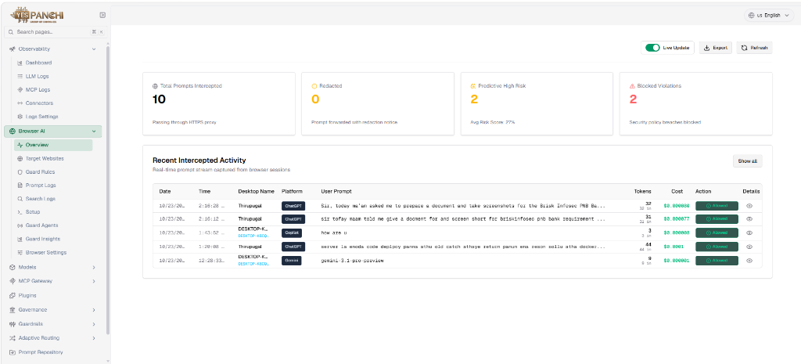
Figure 16.2: Executive AI Risk Posture overview dashboard displaying daily active agents, intercepted prompts, and threat scores.

Audit Reporting & Dataset Protection
Regulatory & Internal Audit Reporting
AUDIT REPORTING SPECIFICATION | MANDATORY SECURITY SPECIFICATION
"The solution should support audit reporting for regulatory or internal governance requirements."
Technical Compliance & Architecture: Captures forensic compliance trails across web and search queries, logging browser engines, destination result clicks, and threat risk ratings.
Figure 17.1: Enterprise Search Activity & Governance Audit log detailing query text, destination URLs, and threat ratings.

Restricted & Classified Dataset Access Prevention
DATASET PROTECTION SPECIFICATION | MANDATORY SECURITY SPECIFICATION
"The solution must enable policy enforcement to prevent AI tools from accessing restricted or classified datasets."
Technical Compliance & Architecture: Enforces strict prevention policies blocking upload, copy-paste, and drag-and-drop of restricted source files into AI interfaces.
Figure 17.2: Connected repository permissions console preventing unauthorized AI tool ingestion of sensitive file stores.

Runtime Monitoring & Threat Defense
Runtime Monitoring of AI Interactions
RUNTIME MONITORING SPECIFICATION | MANDATORY SECURITY SPECIFICATION
"The solution must support runtime monitoring of AI interactions with enterprise data."
Technical Compliance & Architecture: Inline proxy broker inspects live data exchanges, evaluating prompt tokens, response safety, and model actions in sub-5ms latency.
Figure 18.1: Gateway Runtime Proxy architecture console configuring real-time data inspection and TLS termination.

Prompt Injection & Adversarial Attack Detection
THREAT DEFENSE SPECIFICATION | MANDATORY SECURITY SPECIFICATION
"The solution should detect prompt-based attacks such as prompt injection or manipulation attempts."
Technical Compliance & Architecture: Identifies adversarial syntax, recursive prompt injection strings, and instruction overrides, dropping hostile payloads at the socket layer.
Figure 18.2: Real-time defense log intercepting prompt injection payloads, system overrides, and adversarial exploits.

Output Protection & Remediation
Sensitive Output Leakage Prevention
OUTPUT PROTECTION SPECIFICATION | MANDATORY SECURITY SPECIFICATION
"The solution must prevent AI systems from exposing sensitive information through responses or outputs."
Technical Compliance & Architecture: Bidirectional output filter scrubs sensitive tokens, PII, and credentials from downstream model completions before rendering in the browser.
Figure 19.1: Response Scanning dashboard tagging safety classifications and masking leaked output tokens.

Automated Remediation Actions
AUTOMATED REMEDIATION SPECIFICATION | MANDATORY SECURITY SPECIFICATION
"The solution should support automated remediation actions such as blocking AI requests, restricting access, or generating alerts."
Technical Compliance & Architecture: Automatically executes inline request blocking, drops active TCP sessions, and triggers instant telemetry alerts upon critical policy breaches.
Figure 19.2: Browser Guard enforcement console displaying active automated blocking rules for unauthorized actions.

Multi-Asset Risk & Adoption Trends
Centralized Multi-Asset Risk Exposure Dashboards
RISK EXPOSURE SPECIFICATION | MANDATORY SECURITY SPECIFICATION
"The solution must provide centralized dashboards displaying AI risk exposure across users, systems, and data assets."
Technical Compliance & Architecture: Inspects individual endpoint workstations, detailing hardware identity, physical MAC, OS version, and granular telemetry audit logs.
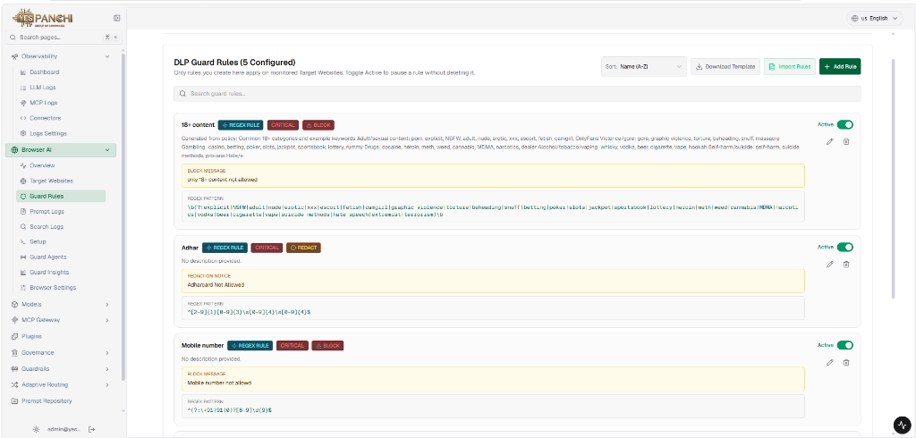
Figure 20.1: Multi-Asset Hardware & Workstation telemetry monitor tracking CPU, memory, OS versions, and agent health.

AI Adoption Trends & Risk Indicator Analytics
ADOPTION ANALYTICS SPECIFICATION | MANDATORY SECURITY SPECIFICATION
"The solution should provide analytics on AI adoption trends, usage patterns, and risk indicators."
Technical Compliance & Architecture: Analyzes query volume growth, cost per user, token consumption, and risk indicator trends across commercial and internal AI platforms.
Figure 20.2: Enterprise AI Adoption trends console mapping active daily users, prompt distribution, and model consumption.

Behavioral Scoring & Executive Reports
Behavioral & Contextual AI Risk Scoring
BEHAVIORAL SCORING SPECIFICATION | MANDATORY SECURITY SPECIFICATION
"The solution must provide risk scoring for AI activities based on data sensitivity and user behaviour."
Technical Compliance & Architecture: Evaluates contextual risk dynamically using historical user behavior, query intent, and search privacy modes.
Figure 21.1: Multi-factor contextual risk matrix weighting user behavior, data classification, and platform security.

Executive Leadership & Risk Committee Reporting
EXECUTIVE REPORTING SPECIFICATION | MANDATORY SECURITY SPECIFICATION
"The solution should support executive reporting for security leadership and risk management teams."
Technical Compliance & Architecture: Summarizes enterprise AI compliance posture, blocked data leakage attempts, and cost telemetry into executive-level summaries.
Figure 21.2: Executive Compliance & Governance summary report designed for enterprise risk committee review.

