
PRODUCT REFERENCE

YP-Raksha Gateway and Browser AI Guard Product Datasheet
Capabilities, interfaces, platform support, data handling and prerequisites
Document information
Version 1.0 | source-derived planning pack
Prepared 24 October 2026
Audience Enterprise architecture, security and operations teams
Release status Validate against the selected product release before procurement or production use
Product capability and sizing statements are labelled by evidence and assumption. Confirm release-specific support and commercial terms with the product owner.

Contents and document index
Section page numbers include the cover page. Headings are listed in reading order.
Product summary 3
Product composition 3
Product architecture 4
Common deployment use cases 5
Capability overview 5
Interfaces and request types 6
Gateway routes 6
Request families 6
Authentication patterns 6
Provider and integration coverage 6
Data and persistence 7
Security and deployment model 7
Platform support matrix 7
Capacity and service level statement 8
Deployment prerequisites 8
Product boundaries and confirmation register 8
Product workflows and service behavior 9
Application inference flow 9
Browser AI Guard policy flow 10
Administration and policy publication flow 11
Product capability and operational detail 11
Deployment profiles and environment separation 12
Data handling and trust boundaries 12
Capacity and sizing interpretation 12
Release acceptance and operating checklist 13
References 13

Product: YP-Raksha Gateway and Browser AI Guard
Audience: enterprise architecture, information security, infrastructure, application and procurement teams
Document status: product capability reference based on the current repository; release-specific support and commercial terms require confirmation
Related documents: Technical Documentation; On-Premises Deployment Architecture for DC, DR and UAT

Product summary
YP-Raksha is a self-hostable platform for governing application-to-model traffic and browser-based use of AI services. The YP-Raksha Gateway sits between approved applications and configured model endpoints. It provides a common API surface, authentication, policy enforcement, provider selection, usage controls and operational records. Browser AI Guard steers selected browser traffic through a local endpoint proxy or an optional internal shared proxy, evaluates configured rules and reports policy events to the Gateway.
The platform can be deployed in bank-controlled infrastructure. Residency is an architecture and operations outcome: provider, telemetry, email, update, licensing and support paths must use internal destinations or be disabled, and network egress must be enforced at the bank boundary. See the companion architecture document for the 120,000-endpoint reference design and verification process.

Product composition
Component | Function | Deployment and responsibility
YP-Raksha Gateway | Serves the administration UI, management APIs, inference APIs, integrations, policy and observability routes | Container or Kubernetes deployment on bank-operated Linux infrastructure; production ingress, persistence, secrets and HA are platform-owner responsibilities
Gateway core | Normalizes requests, selects configured provider/model routes, invokes provider adapters and returns model results | Runs within Gateway process; model execution is remote to a configured provider endpoint, including a bank-hosted endpoint in a sovereign design
Browser AI Guard endpoint agent | Provides local proxy/PAC steering, policy evaluation, health/heartbeat and event/configuration exchange | Packaged endpoint agent exists for Windows and macOS; deploy through the bank endpoint-management system and validate release-specific OS versions
Optional shared Guard proxy | Provides centrally managed proxy-mode inspection for selected network/browser traffic | Separate internal service; deployment, identity mapping, throughput and HA require independent validation
ConfigStore | Stores configuration, workspace identities, roles, virtual keys, provider/model configuration and related settings | Relational database layer; PostgreSQL is the recommended production planning baseline in this pack
LogsStore | Stores and aggregates inference, MCP, audit and Browser AI records | Relational database layer; define payload capture, access, retention, archival and backup before production
Optional supporting services | Cache, vector store, metrics/tracing, object store, email and connectors | Choose bank-operated equivalents for a no-egress environment; enable only the services needed by the approved design

Product architecture
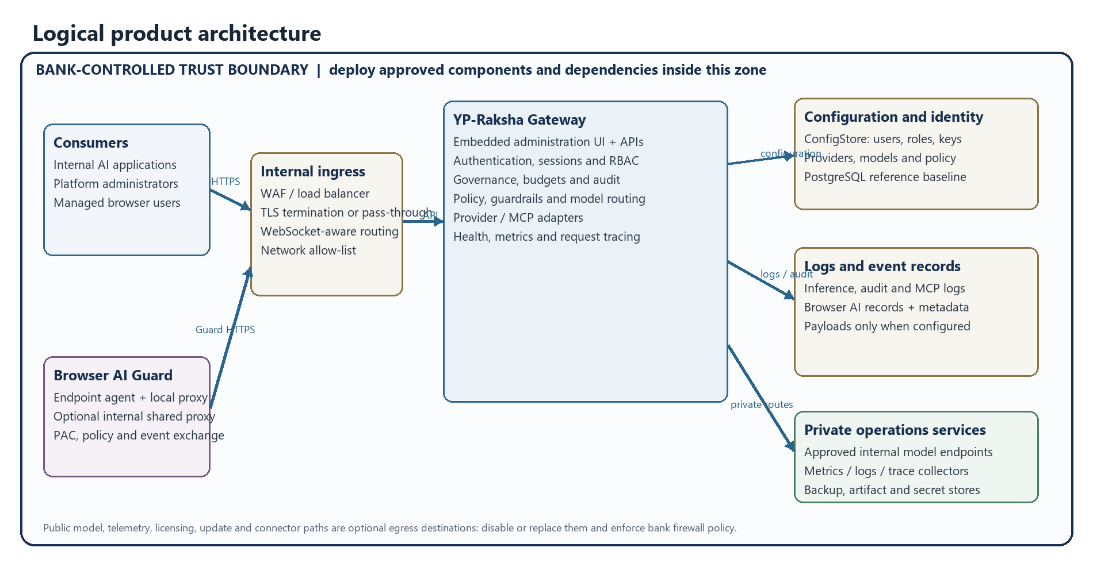
Figure 1. Logical YP-Raksha architecture. Optional services and destinations depend on configuration; the bank must enforce the residency boundary.
The figure shows the product boundary and principal runtime dependencies. The Gateway process hosts the embedded administration UI, management APIs, inference routes and optional integrations. It mediates approved application traffic; it is not itself a model runtime. Model execution occurs at the configured provider endpoint. For a bank-only deployment, that endpoint and every enabled persistence, telemetry, update and support dependency must be bank-operated or disabled.
Architecture layer | Components and responsibility | Bank deployment control
Consumers and endpoints | Internal AI clients, administrators, managed browsers and Guard agents | Endpoint identity, browser policies, certificates, permitted destinations
Edge access | Internal WAF/load balancer and TLS path | TLS policy, trusted proxy list, WebSocket support, request limits and network allow-list
Gateway runtime | Embedded UI, API routing, sessions, authentication, RBAC, policy, budgets, provider selection and adapters | Approved image, replica count, secrets, runtime configuration and network policy
Model services | Configured provider or self-hosted model endpoint | Provider selection, model approval, locality, credentials, capacity and egress policy
Configuration and logs | ConfigStore, LogsStore, attachment storage and optional cache/vector services | HA database, encryption, retention, storage capacity, backup and restore
Guard control plane | Agent heartbeat, target/rule/config retrieval, PAC generation and event ingestion | Fleet secret, package/update process, endpoint rollout and retention
Operations | Internal metrics, logs, trace collection, alerting, DNS, NTP, secrets and artifact mirrors | Internal destination allow-list, access control and evidence of no-egress enforcement

An implementation deployment can run multiple Gateway replicas behind an internal ingress, but production availability depends on shared state, compatible secrets, durable storage and database service design. The application cluster feature must not be treated as cross-site database replication or a complete DR mechanism.

Common deployment use cases
- Governed internal AI access: internal applications authenticate to the Gateway with virtual keys and use approved private model endpoints.
- Model consolidation: applications use a shared gateway API while the platform team configures one or more provider adapters and routing rules.
- Usage administration: platform owners assign keys to users, teams, customers or business units and apply configured budgets, rate limits and access profiles.
- Browser AI policy: endpoint or shared-proxy traffic to configured AI destinations is evaluated against browser guard rules and policy settings.
- Operational review: administrators review Gateway, audit, MCP and Browser AI records and monitor internal health and metrics endpoints.
- MCP tool governance: where enabled, administrators manage MCP connections, tool groups, sessions and related credentials.
These are functional patterns, not a statement that every provider implements every endpoint or that every browser/VDI combination is certified.

Capability overview
Capability area | Product function | Configuration or scope note
Model API gateway | OpenAI-compatible inference routes and provider-specific pass-through routes | Request/response feature coverage depends on the selected provider adapter and model
Provider adapters | Adapter packages cover commercial, cloud and self-hosted provider families | Credentials and outbound destinations are configured by administrators; use private endpoints for strict residency
Model selection | Configured models, provider key selection, routing rules, fallback and circuit-breaker components | Routing behavior and fallback targets must be reviewed against data classification and locality requirements
Identity and access | Users, teams, customers/business units, virtual keys, system roles and custom RBAC | Resource-level operations and section grants are enforced in the application; integrate bank identity/SCIM where configured
Usage governance | Budgets, rate limits, access profiles and audit records | Limits are configuration-driven; confirm enforcement scope in release acceptance tests
Gateway guardrails | Optional guardrail plugin and policy integrations on inference traffic | Enabled checks, failure behavior and third-party/model dependencies must be documented per deployment
Browser AI Guard | Target websites, rule management, endpoint fleet, policy configuration and event/log views | Rule actions are BLOCK, REDACT or WARN; unmatched traffic follows configured policy behavior
Prompt and skills repositories | Managed prompt/skill content and related workspace functionality | Access scope follows configured role and workspace grants
MCP Gateway | MCP clients/servers, tool groups, sessions and OAuth-related flows | Optional feature; each remote MCP destination is an egress path and must be approved or disabled
Observability | Health endpoint, Prometheus metrics, application logs, audit/log views and optional tracing/connectors | Keep scrape targets and exporters internal for a sovereign deployment
Deployment packaging | Docker/Compose examples and Kubernetes Helm charts | Examples contain defaults intended for development/evaluation; replace public endpoints and sample credentials before bank use

Interfaces and request types

Gateway routes
Route family | Typical purpose
/v1/* | Inference and related API operations
/api/* | Administration, governance, configuration, reporting and Browser AI control plane
/openai/*, /anthropic/*, /genai/*, /bedrock/*, /cohere/*, /cursor/*, /litellm/*, /langchain/*, /pydanticai/* | Provider/client-compatible pass-through integration surfaces present in the server
/ws, /v1/realtime | WebSocket and realtime transports where supported by the selected route/provider
/health | Service health check
/metrics | Metrics endpoint; restrict to internal scrapers
/pprof | Development profiling route; do not expose in production

Routes are examples from the implementation surface, not a promise that every operation is enabled for every tenant or provider. See the technical manual and release API definitions for exact request schemas.

Request families
Provider code includes adapter implementations for combinations of chat/completions, text completions, responses, embeddings, reranking, image generation, speech, transcription, OCR, video, batch, file, container and realtime operations. The provider capability matrix is not uniform. Validate each application’s required operation, streaming behavior, upload limits, model parameters, error mapping and cancellation behavior with its selected provider before production.

Authentication patterns
- Inference clients use a Gateway virtual key or an administrator-configured provider key through supported request authentication headers.
- Administrators use dashboard sessions and role-based authorization.
- Browser Guard agents use the configured fleet secret and agent identity path, separate from an interactive dashboard session.
- Service-to-service identity, SSO/SCIM, TLS termination and key rotation depend on the bank deployment configuration.

Provider and integration coverage
The repository contains provider adapter packages for: Anthropic, Azure, Amazon Bedrock, Bedrock Mantle, Cerebras, Cohere, DeepSeek, ElevenLabs, Fireworks, Gemini, Groq, Hugging Face, Mistral, Nebius, Ollama, OpenAI, generic OpenAI-compatible endpoints, OpenCode, OpenRouter, Parasail, Perplexity, Replicate, Runware, Runway, SGL, Vertex, vLLM and xAI.
Adapter presence indicates an implementation path; it does not imply feature parity, a current commercial certification, a vendor support agreement, or that all request families are implemented. In a bank deployment, configure only internal/private destinations if data must remain within the bank and India. Review per-provider capabilities and network destinations for the exact release.

Data and persistence
Record family | Examples | Design treatment
Configuration and identity | Users, roles, workspace objects, virtual keys, providers, models, routing and settings | Restrict write access to administrators; back up consistently with secrets and encryption-key recovery procedures
Inference records | Request metadata, usage and, depending on settings, request/response content | Treat as sensitive; decide payload logging, redaction, retention and deletion before rollout
Browser AI records | Agent inventory/heartbeat, detected events, policy verdicts, search and event details | Treat captured prompts or content as sensitive; constrain field access and retention
MCP records | Tool/server configuration, sessions and logs | Treat tool input/output and credentials as sensitive; approve remote MCP destinations individually
Audit records | Mutating management actions and actor/context metadata | Retain under bank policy and ensure audit storage is included in backup and review controls
Metrics and traces | Operational service and request measurements; traces when configured | May contain identifiers or attributes; inspect configuration and keep collectors/exporters internal
Attachments and packages | Files or Guard distribution artifacts where used | Restrict object-store access; use internal encrypted storage and verify backup/retention behavior

The code supports PostgreSQL, MySQL and SQLite storage drivers in the relevant layers. This reference architecture selects PostgreSQL for production planning. A specific enterprise support or certification matrix for database versions must be confirmed for the release.

Security and deployment model
The Gateway is commonly placed behind an internal load balancer or WAF, with the application process separated from user and database networks. Use TLS for client-to-ingress and service/database links according to bank standards, trusted proxy allow-lists when forwarding headers, least privilege for management roles, strong secrets, encrypted storage, key rotation and audited administrative changes.
The application includes session-cookie controls, authentication throttles, RBAC checks, audit middleware, optional database-secret encryption and Guard fleet authentication controls. These are components of a control set; they do not by themselves establish a bank security certification or guarantee a particular regulatory posture. Review the exact release, threat model, configuration and operational evidence with bank security owners.
A zero-egress design requires the bank to disable external providers/exporters/connectors, configure private services, use internal DNS/NTP/IAM/SMTP and image/package mirrors, and block all unapproved outbound traffic at the network layer. See the deployment architecture for flows and verification steps.

Platform support matrix
The table separates implementation/package evidence from formal version certification. Exact release builds must be checked before procurement or rollout.
Area | Evidence and current statement | Validation required
Gateway host | Container and Helm deployment paths are present for Linux-based infrastructure | Match the bank Kubernetes/container platform, OS, ingress, database and storage versions to the product release
Browser Guard on Windows | Windows executable and installer build paths exist | Confirm Windows editions/builds, endpoint-management deployment, certificate installation and update behavior
Browser Guard on macOS | macOS application/package build paths exist | Confirm exact macOS releases, signing/notarization, permissions and certificate deployment
Browser Guard on Linux | A Linux endpoint installer is not documented in the repository | Do not include Linux endpoints in the supported Guard-agent population without separate release evidence
Chrome and Edge | PAC/system proxy and OS certificate trust are used by the design | Candidate browsers only; test exact enterprise versions, policy and update channel
Firefox | No versioned certification matrix is documented | Candidate only; validate PAC and browser-specific CA trust distribution
Safari | No versioned certification matrix is documented | Candidate only on macOS; validate system proxy and CA behavior
VDI | No named VDI vendor certification matrix is documented | Citrix, VMware Horizon, Azure Virtual Desktop and other VDI targets require UAT for persistent/non-persistent identity, agent lifecycle, proxy and certificate handling

Do not describe the browser or VDI candidates as certified until the relevant version-level test evidence and support statement exist.

Capacity and service level statement
This pack contains a planning envelope for 120,000 managed endpoints, derived from explicit endpoint activity, event-rate and inference-rate assumptions. It is not a product maximum, measured benchmark, performance guarantee or service-level commitment. Private model CPU/GPU capacity is not included in Gateway sizing. Payload capture, streaming, large uploads, retention, provider latency, database I/O and Guard heartbeat/event behavior can change required resources.
Commercial licensing, support hours, warranty, SLA, release lifecycle, security certification and product-version entitlements are not established by the repository material used here. Obtain these terms separately from the product owner before procurement.

Deployment prerequisites
- Bank-operated container/Kubernetes platform and internal image/Helm repository for production deployment.
- Production database topology, storage, backup and restore plan; PostgreSQL is the reference planning choice.
- Internal DNS, NTP, certificate authority, secrets management, identity and optional SMTP relay.
- Private model service(s) reachable from the Gateway over approved internal routes.
- Internal log, metrics and tracing collectors if enabled; endpoint agents must reach the internal Gateway ingress.
- Endpoint-management method for installing Guard packages and distributing proxy/certificate configuration.
- Firewall and DNS policy that blocks direct access to unapproved public AI, telemetry and package destinations.
- Separate UAT identities, secrets, database and synthetic or masked test data.

Product boundaries and confirmation register
The following points must be settled for the selected release and bank design; this document does not invent them:
Item | Current status in source material | Required evidence/decision
Browser/VDI version certification | No complete versioned matrix found | Product-owner compatibility statement plus bank UAT results
Certified endpoint maximum or benchmark | No independently measured result included | Agreed workload profile and signed load-test report
Database version certification | Drivers are present; version certification not stated | Product support matrix and bank DBA approval
Linux endpoint Guard package | Not documented | Product-owner confirmation before including in endpoint count
Cross-site automatic DR guarantee | Not implied by application cluster support | Bank-operated database/infra design and exercised DR evidence
Offline licence activation/update | Not confirmed by repository evidence | Product-owner confirmation and successful disconnected UAT
Commercial SLA, support and certification | Not included in source files | Contract and release documentation

Product workflows and service behavior

Application inference flow
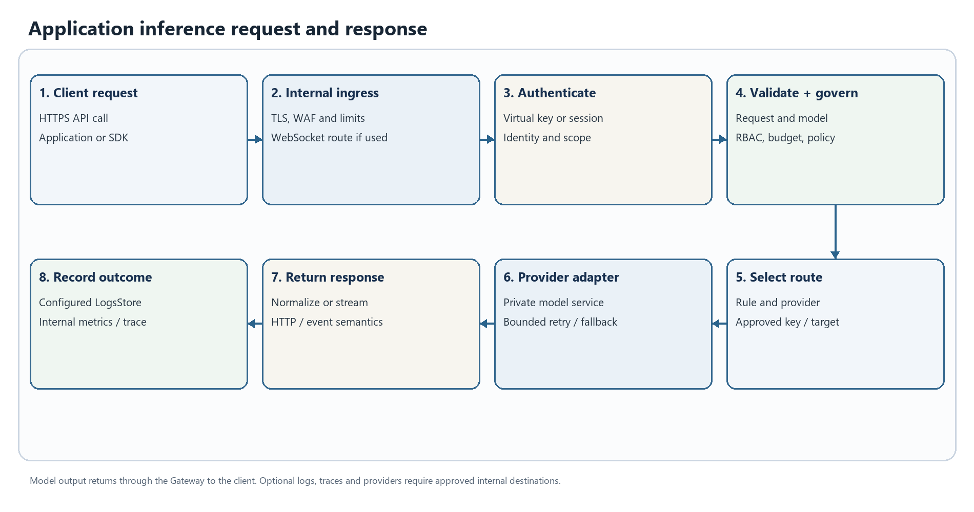
Figure 2. Application inference request and response. This is a logical workflow; enabled stages depend on deployment configuration.
The Gateway authenticates the client, applies configured access/governance checks, resolves an approved model route, invokes the adapter and returns the normalized response. Provider/model-specific operations, retry support and streaming behavior vary; validate the required API surface against the selected release and private endpoint.

Browser AI Guard policy flow
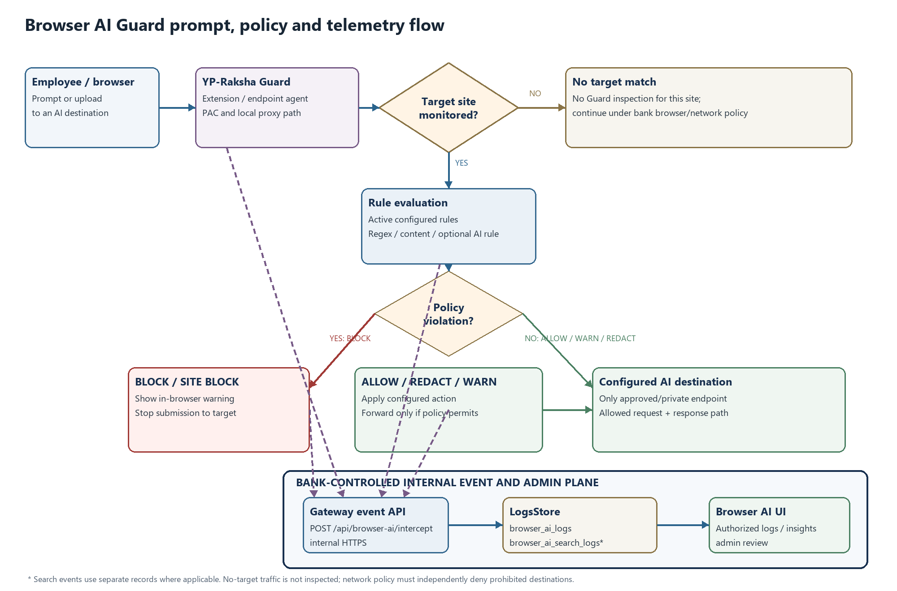
Figure 3. Browser AI Guard request, verdict and internal event flow. Exact behavior depends on configured rules and the validated release.
A browser request is steered by endpoint PAC/proxy policy, checked against configured targets and rules, then allowed, redacted, warned, blocked or site-blocked according to policy. Configured regex rules can encode approved sensitive-term/pattern checks for DLP-style policy; the reviewed source does not establish a separate certified DLP engine. Allowed traffic proceeds to its configured destination. Policy events are submitted to the internal Gateway and appear in the Browser AI UI for authorized roles. A no-egress bank design must also prevent direct browser access to prohibited public AI destinations.

Administration and policy publication flow
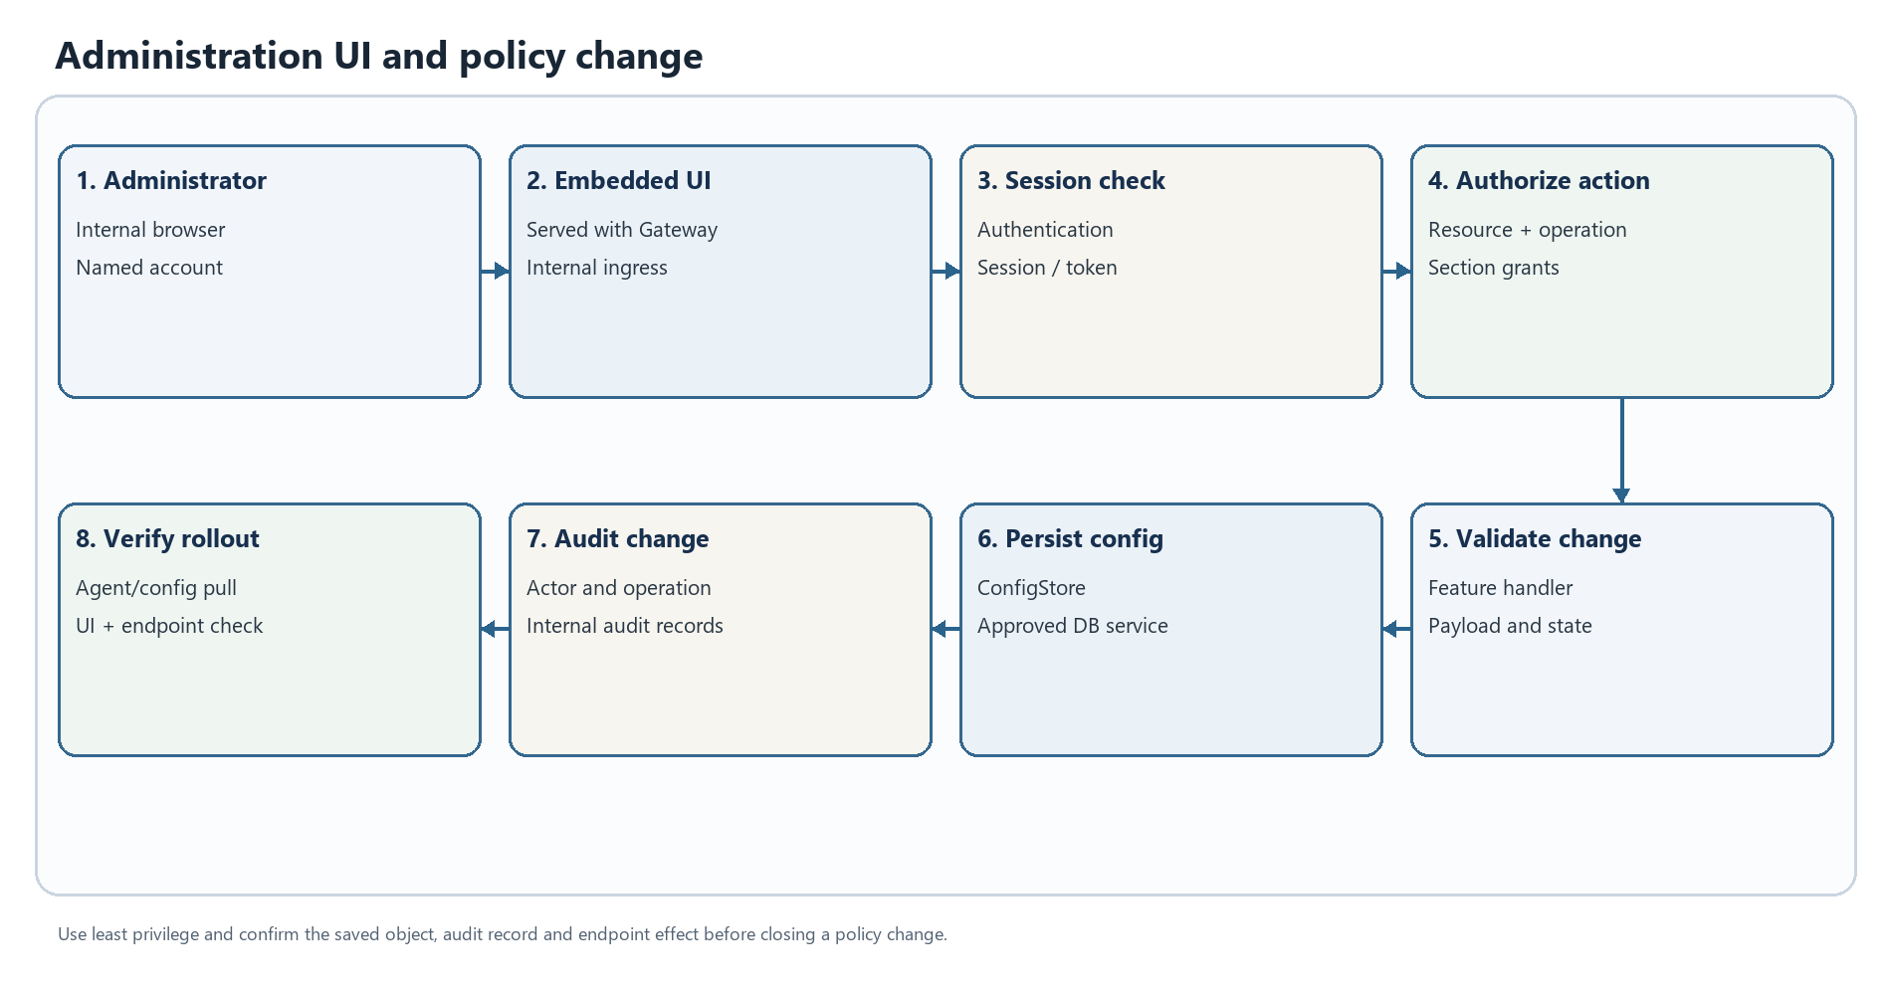
Figure 4. Administration UI and policy change. This is a logical workflow; enabled stages depend on deployment configuration.
The embedded UI calls management APIs protected by session authentication, audit middleware, resource/operation permissions and section grants. A valid policy/configuration change is saved to ConfigStore; Guard agents obtain applicable fleet settings and rules from the internal control plane. Validate propagation, audit visibility and endpoint behavior after each approved change.

Product capability and operational detail
Product area | Main workflow | Administrative outputs | Key dependencies and checks
Inference Gateway | Application request → authentication → model/provider resolution → policy/routing → adapter → response | Usage/log records, provider and model selections, configured governance result | Private model endpoint, credentials, route, TLS, quotas and operation support
Identity and governance | User/team/business-unit and virtual-key setup → role/scope assignment → budget/rate enforcement | Audit records, key lifecycle and access status | Identity source, least-privilege RBAC, secrets and configured usage limits
Browser AI Guard | Browser request → endpoint/shared proxy → target/rule evaluation → verdict → response/event | Agent fleet status, policy logs, search events and setup/package state | PAC, CA trust, proxy address, fleet secret, endpoint health and log store
MCP Gateway (optional) | Client selects permitted tool → Gateway authenticates → MCP server/tool → result | Tool group, session and MCP usage/error records | Approved server URL, transport, credentials, tool scope and egress allow-list
Administration UI | Admin session → management API → validation/authorization → configuration update | Dashboard views, configuration and audit events | Internal ingress, session settings, database health and role grants
Operations/observability | Scraper/collector queries health and metrics; configured logs/traces are sent internally | Health state, metrics, logs and traces | Internal collector, token/access control, retention and no-egress route

Deployment profiles and environment separation
Profile | Purpose | Required isolation
Development | Feature work and local integration using Compose or local services | Synthetic data and non-production credentials; no bank data
UAT | Release qualification, endpoint/browser/VDI testing, load and recovery exercises | Separate database, secrets, administrators, model endpoint and telemetry; synthetic or masked data
DC production | Primary service for approved users/applications and Guard endpoints | Bank-controlled ingress, HA database, durable storage, internal private models and default-deny egress
DR production | Recovery service and replicated data for site incident | Bank-operated replication, secrets/certificates, internal model path, tested capacity and explicit cutover runbook

Compose and chart examples are not a complete bank production configuration. The exact release image, image digest, chart version, database versions, browser support and security sign-off must be recorded before production use.

Data handling and trust boundaries
Data category | Processing/storage location | Control expected in a bank deployment
Inference prompts and responses | Gateway memory; payload logs only if configured; configured model endpoint | Select bank-private endpoint; minimize or disable raw payload storage; TLS and access control
Browser prompt/upload events | Guard proxy/agent during evaluation; event metadata/content may be posted to LogsStore | Define captured fields, role access, retention, deletion and attachment handling
Credentials and tokens | Secret inputs, session state and encrypted database fields where configured | Use secret manager, stable encryption key, least privilege and rotation/recovery
Identity and policy configuration | ConfigStore | Database TLS, HA, backup, admin audit and environment separation
Metrics, logs and traces | Gateway and internal collectors when enabled | Keep collectors internal, inspect labels/content and restrict scrape/export access
Updates and packages | Internal artifact repositories and endpoint-management channels | Verify source, signature/digest and release approval; deny public runtime pulls
Backups and DR copies | Bank-operated backup/object storage and DR site | Encryption, India residency, separate access, retention and restore testing

The intended no-egress state is established by the bank’s network rules and verified destination inventory. Application settings alone cannot prove that prompts, logs, telemetry or backups stay inside the bank or India.

Capacity and sizing interpretation
For the 120,000-endpoint deployment reference, the accompanying architecture uses an explicit planning case: 10% busy-period activity, one Guard event per active endpoint every 180 seconds, one inference request per active user every 120 seconds, and approximately 2× headroom. This yields planning targets around 150 Guard events/second and 200 inference requests/second. These figures are assumptions for qualification, not a measured throughput result or product limit. Model/GPU capacity, response length, streaming concurrency, payload capture, attachments, DB retention and provider latency are sized separately.

Release acceptance and operating checklist
- Confirm exact Gateway, Guard, chart and database versions with product owner/support evidence.
- Test required model/provider operations and representative streaming/error behavior against the private endpoints.
- Confirm Windows/macOS package builds and every browser/VDI version in the bank acceptance matrix; do not treat candidate platforms as certified by this document.
- Verify Guard PAC selection, CA trust, target/rule match, allow/redact/warn/block behavior and public-AI bypass denial.
- Confirm roles, virtual keys, budgets, API session security, audit events and admin separation.
- Set payload capture, retention, attachment handling, data deletion, backup and restore policies.
- Validate DC/DR failover and failback with measured RPO/RTO; these are bank infrastructure objectives, not product guarantees.
- Capture firewall/DNS/egress evidence showing external model, telemetry, analytics, mail, update and package paths are denied or explicitly approved.
- Publish incident contacts, request/agent correlation fields, retry rules, escalation process and rollback version.

References
- Technical Documentation
- On-Premises Deployment Architecture
- Server and Deployment Documentation
- Administrator Guide
- Repository source architecture note

