**Lab worksheet 1: Introduction to Program Components**

Q1.

Code:

|  |
| --- |
| ***package Q_01;***  ***import javax.swing.*;***  ***public class Q_01 {***  ***public static void main(String[] args) {***  ***JFrame myWindow;***  ***myWindow = new JFrame();***  ***myWindow.setSize(800, 600);***  ***myWindow.setTitle("Welcome to Java.");***  ***myWindow.setVisible(true);***  ***}*** |

Output:

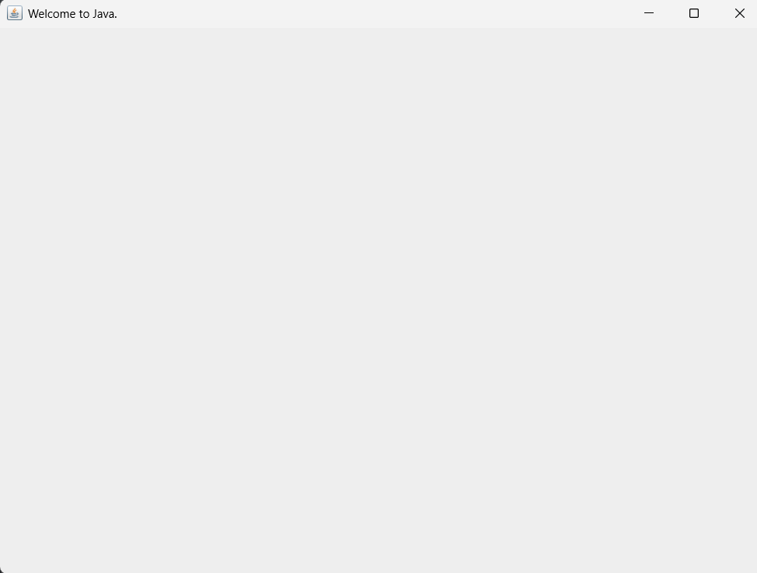

Q2.

Code:

|  |
| --- |
| ***package Q_02; import javax.swing.*; import java.util.*;  public class Q_02 {  public static void main(String[] args) {  Scanner scanner = new Scanner(System.in);  String firstname , lastname , fullname;  System.out.println("Enter your firstname : ");  firstname = scanner.next();  System.out.println("Enter your lastname : ");  lastname = scanner.next();  fullname = firstname + " " + lastname +"." ;   JFrame myWindow;  myWindow = new JFrame();  myWindow.setSize(800,600);  myWindow.setTitle(fullname);  myWindow.setVisible(true);  } }*** |

Output:

Q3.

Code:

|  |
| --- |
| ***package Q_03; import java.util.Scanner;  public class Q_03 {  public static void main(String[] args) {   Scanner scanner = new Scanner(System.in);  String firstname, lastname,middlename , fullname;  char middle_name_initial;  System.out.println("Enter your firstname : ");  firstname = scanner.next();   System.out.println("Enter your middlename : ");  middlename = scanner.next();  middle_name_initial = middlename.charAt(0);   System.out.println("Enter your lastname : ");  lastname = scanner.next();   fullname = firstname+" "+ middle_name_initial +". "+ lastname +"." ;  System.out.println(fullname);   } }*** |

Output:

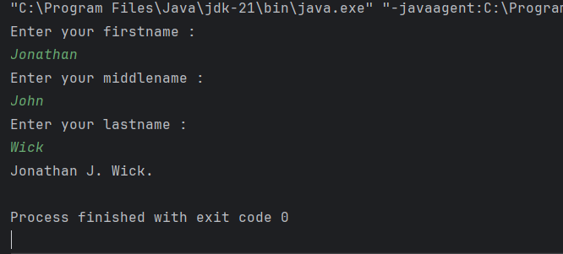

Q4.

Code:

|  |
| --- |
| ***package Q_04; import java.text.SimpleDateFormat; import java.util.*;  public class Q_04 {  public static void main(String[] args) {  Date today;  SimpleDateFormat sdf;  today = new Date( );  sdf = new SimpleDateFormat("dd MMM yyyy.");  System.out.println(sdf.format(today)); }  }*** |

Output:

Q5.

Code:

|  |
| --- |
| ***package Q_05; import java.text.SimpleDateFormat; import java.util.*;  public class Q_05 {  public static void main(String[] args) {  Date today;  SimpleDateFormat sdf;  today = new Date( );  sdf = new SimpleDateFormat("EEEE, MMM dd,yyyy");  System.out.println(sdf.format(today)); } }*** |

Output:

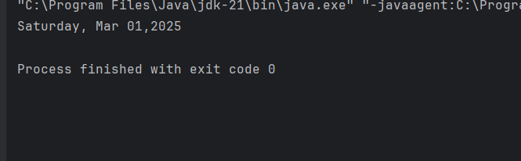

Q6.

Code:

|  |
| --- |
| ***package Q_06; import javax.swing.*; import java.util.*;  public class Q_06 {  public static void main(String[] args) {  Scanner scanner = new Scanner(System.in);   //Obtaining information from the user  // W for Width  // H for Height  int W ,H ;  String title;  System.out.println("Enter the title of the window :");  title = scanner.nextLine();  System.out.println("Enter the width :");  W = scanner.nextInt();  System.out.println("Enter the height :");  H = scanner.nextInt();   //window  JFrame myWindow;  myWindow = new JFrame();  myWindow.setSize(W,H);  myWindow.setTitle(title);  myWindow.setVisible(true);  } }*** |

Output:

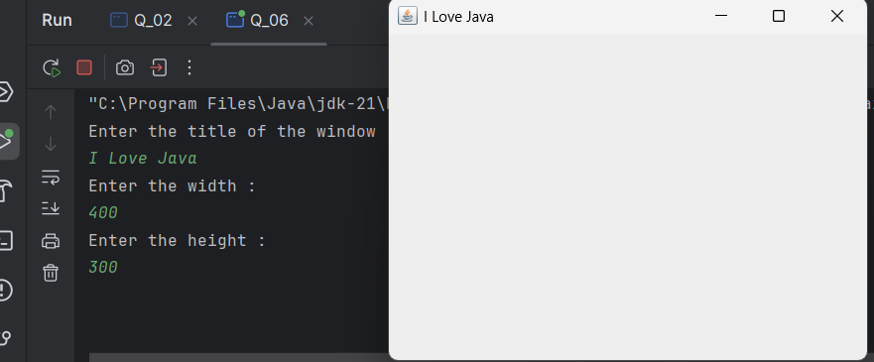

Q7.

Code:

|  |
| --- |
| ***package Q_07; import java.text.SimpleDateFormat; import java.util.*; import javax.swing.*;  public class Q_07 {  public static void main(String[] args) {  Date today;  SimpleDateFormat sdf;  today = new Date( );  sdf = new SimpleDateFormat("hh:mm:ss a.");   JFrame myWindow;  myWindow = new JFrame();  myWindow.setSize(500,400);  myWindow.setTitle(sdf.format(today));  myWindow.setVisible(true);  } }*** |

Output:

Q8.

Code:

|  |
| --- |
| ***package Q_08; import java.util.Scanner;  public class Q_08 {  public static void main(String[] args) {   Scanner scanner= new Scanner(System.in);  System.out.println(" Enter a string that contains a single exclamation mark:");  String word= scanner.nextLine();   int index = word.indexOf('!');   System.out.println(word.substring(0, index));  System.out.println(word.substring(index+2));  } }*** |

Output:

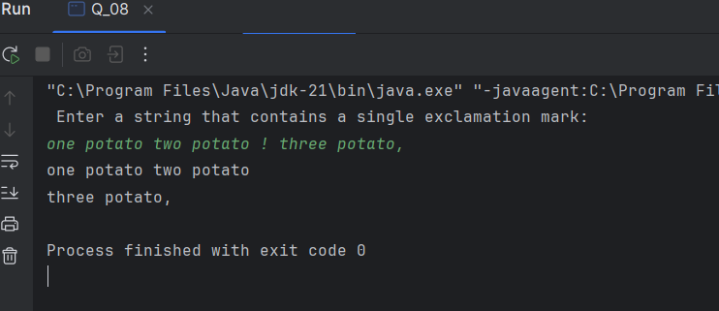

Q9.

Code:

|  |
| --- |
| ***package Q_09; import java.util.*;  public class Q_09 {  public static void main(String[] args) {  Scanner scanner = new Scanner(System.in);  System.out.println("Enter the string : ");  String text = scanner.nextLine();  int length = text.length();   System.out.println(length);  System.out.println(text.charAt(0));  System.out.println(text.charAt(length-1));   } }*** |

Output:

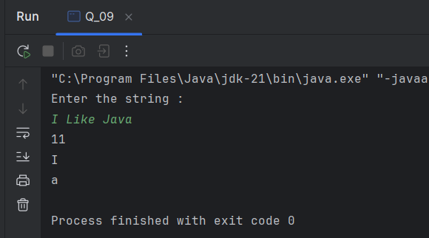

Q10.

Code:

|  |
| --- |
| ***package Q_10; import java.util.Scanner;  public class Q_10 {  public static void main(String[] args) {  Scanner scanner =new Scanner(System.in);  System.out.println("Enter the odd length Word: ");  String text = scanner.nextLine();   int length = text.length();  char middle_letter;  middle_letter = text.charAt((length / 2));  System.out.println(middle_letter);    }  }*** |

Output:

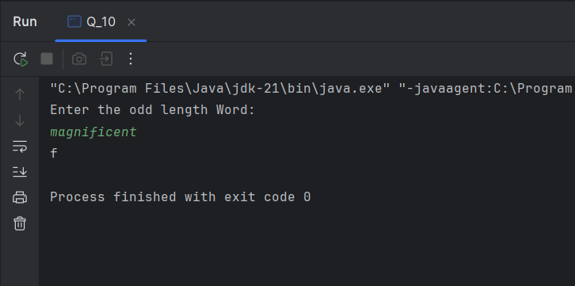

Q11.

Code:

|  |
| --- |
| ***package Q_11; import java.util.*;   public class Q_11 {  public static void main(String[] args) {  Scanner scanner = new Scanner(System.in);  System.out.println("Enter the full name (order - first middle last) with spaces :");  String text = scanner.nextLine();    String[] parts = text.split(" ");  String firstname = parts[0];  String middlename = parts[1];  String lastname = parts[2];   System.out.println(lastname +","+" "+firstname+" "+middlename.charAt(0)+".");   } }*** |

Output:

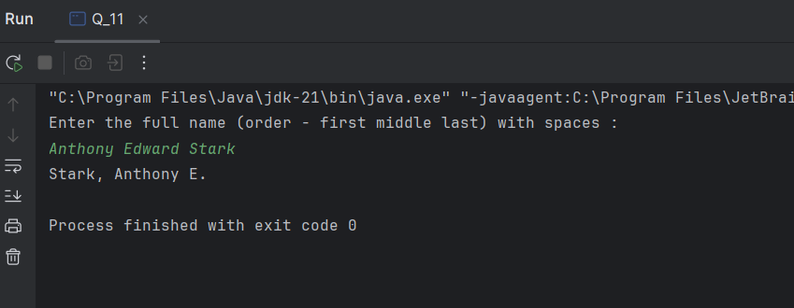

Q12.

Code:

|  |
| --- |
| ***package Q_12; import javax.swing.*;  public class Q_12 {  public static void main(String[] args) {  JFrame myWindow;  myWindow = new JFrame();  myWindow.setSize(300,200);  myWindow.setLocation(100,50);  myWindow.setTitle("My First Frame");  myWindow.setVisible(true);   } }*** |

Output:

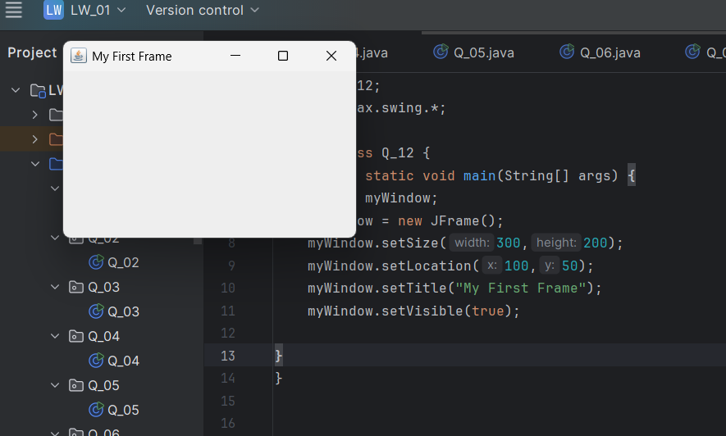

Q13 (Extra Question).

Code:

|  |
| --- |
| ***package Q_13; import javax.swing.*;  public class SampleWindow {  public static void main(String[] args) {  JFrame myWindow;  myWindow = new JFrame();  myWindow.setSize(500, 250);  myWindow.setTitle("UOK");  myWindow.setVisible(true);  try {Thread.sleep(500);} catch(Exception e) { }  myWindow.setVisible(false);  try {Thread.sleep(500);} catch(Exception e) { }  myWindow.setVisible(true);  }  }*** |

Output:

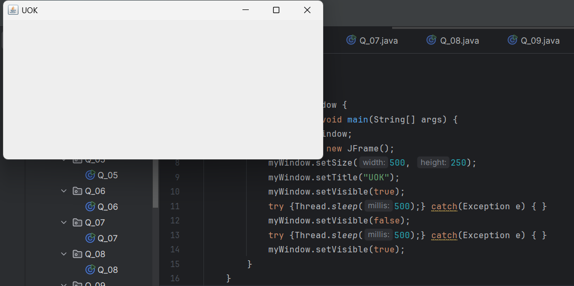

**how it works.**

This program creates a window with the title "UOK" and a size of width 500 and height 250 pixels. It first shows the window, then hides it after 500 milliseconds, and shows it again after another 500 milliseconds. The {Thread.sleep(millis:500);} method pauses the program to create this blinking effect.