Q1.

Code:

|  |
| --- |
| ***package Q_01;  public class Q_01 {  public static void main(String[] args) {  // Define the variables  // r for radius  double A = 10.0,B=20.0,C=30.0,X=10.0,Y=5.0,r=7,PI=3.14;   // a. The square root of B^2 + 4AC  double outputA = Math.sqrt(Math.pow(B, 2)+4*A*C);  System.out.println("The square root of B^2+4AC is: " +outputA);   // b. The square root of X + 4Y^3  double outputB = Math.sqrt(X+(4*Math.pow(Y, 3)));  System.out.println("The square root of X+4Y^3 is: " + outputB);   // c. The cube root of the product of X and Y  double outputC = Math.cbrt(X*Y);  System.out.println("The cube root of the product of X and Y is: " + outputC);   // d. The area of a circle  double area = PI*r*r;  System.out.println("The area of the circle is: " + area);  }  }*** |

Output:

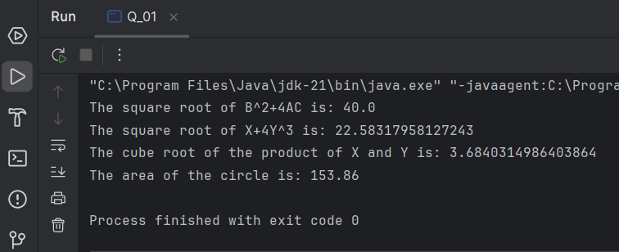

Q2.

Code:

|  |
| --- |
| ***package Q_02; import java.util.Scanner;  public class Q_02 {  public static void main(String[] args) {  Scanner scanner = new Scanner(System.in);   System.out.print("Enter the length in centimeters: ");  double length = scanner.nextDouble();  // 1 inch = 2.54cm  // Convert centimeters to inches  double inches = length /2.54;   // Convert inches to feet and remaining inches  int feet = (int) (inches/12);  int totalInches = (int) inches%12;   System.out.println(feet + " feet and " + totalInches + " inches.");    }  }*** |

Output:

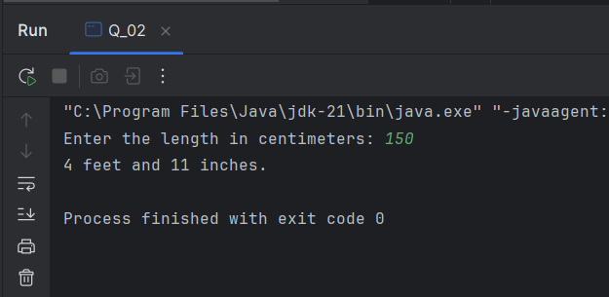

Q3.

Code:

|  |
| --- |
| ***package Q_03; import java.util.Scanner;  public class Q_03 {  public static void main(String[] args) {   Scanner scanner = new Scanner(System.in);  System.out.print("Enter the temperature in degrees Celsius: ");  double celsius = scanner.nextDouble();   // Convert Celsius to Fahrenheit using the formula  double fahrenheit = (1.8 * celsius) + 32;   System.out.println(fahrenheit + " degrees Fahrenheit.");   }  }*** |

Output:

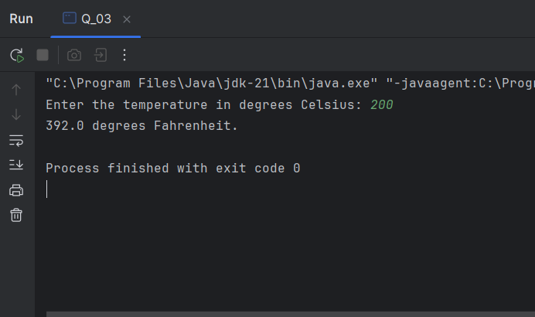

Q4.

Code:

|  |
| --- |
| ***package Q_04; import java.util.Scanner;  public class Q_04 {  public static void main(String[] args) {  Scanner scanner = new Scanner(System.in);  System.out.print("Enter the body weight in pounds: ");  double bodyWeight = scanner.nextDouble();   // Calculate number of calories needs in one day  double calories = bodyWeight * 19;  System.out.println(calories + " calories");   }  }*** |

Output:

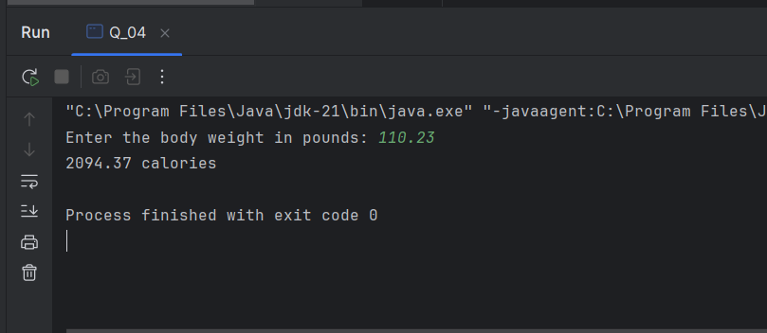

Q5.

Code:

|  |
| --- |
| ***package Q_05; import java.util.Scanner;  public class Q_05 {  public static void main(String[] args) {  Scanner scanner= new Scanner(System.in);   System.out.print("Enter the temperature in degrees Fahrenheit :");  double temp =scanner.nextDouble();   // Convert degrees Fahrenheit to degrees Celsius using the formula  double celsius = (5.0/9.0)*(temp- 32);   System.out.println(celsius+ " degrees celsius.");   } }*** |

Output:

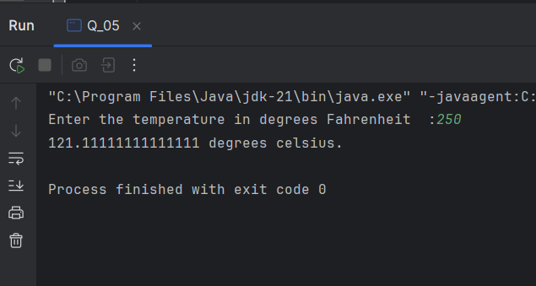

Q6.

Code:

|  |
| --- |
| ***package Q_06;  import java.util.Calendar; import java.util.GregorianCalendar; import java.util.Scanner;  public class Q_06 {  public static void main(String[] args) {  Scanner scanner = new Scanner(System.in);  System.out.print("Enter year of born: ");  int birthYear = scanner.nextInt();    GregorianCalendar cal = new GregorianCalendar();  int currentYear = cal.get(Calendar.YEAR);  int Age = currentYear - birthYear;  System.out.println("You were born in " + birthYear + " and will be (are) " + Age + " this year.");*** |

Output:

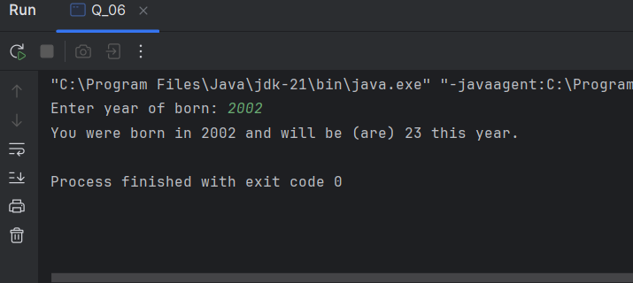

Q7.

Code:

|  |
| --- |
| ***package Q_07;  import java.text.DecimalFormat; import java.util.Scanner;  public class Q_07 {  public static void main(String[] args) {  Scanner scanner = new Scanner(System.in);   System.out.print("Enter weight in kilograms: ");  int weight = scanner.nextInt();  System.out.print("Enter height in centimeters: ");  int height = scanner.nextInt();   // Calculate BMI using the formula  double bmi =weight/Math.pow((height /100.0),2);   DecimalFormat df = new DecimalFormat("0.00");  System.out.println("Your BMI is:" +df.format(bmi));  if(bmi>20 && bmi<25)  System.out.println("Your BMI is Normal");  else  System.out.println("Your BMI Outside the normal range");  } }*** |

Output:

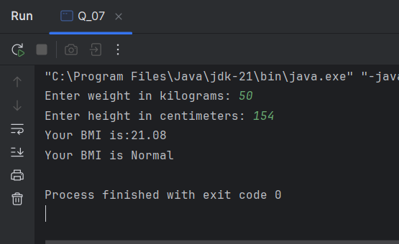

Q8.

Code:

|  |
| --- |
| ***package Q_08; import java.text.DecimalFormat; import java.util.Scanner;  public class Q_08 {  public static void main(String[] args) {  double PI = 3.14;  Scanner scanner = new Scanner(System.in);  System.out.print("Enter the radius of the sphere in centimeter: ");  double radius = scanner.nextDouble();   // Calculate the volume of the sphere  double volume = (4.0 / 3.0) * PI * Math.pow(radius, 3);  DecimalFormat df = new DecimalFormat("0.00");  System.out.println("Given Radius: " + df.format(radius));  System.out.println("The volume of the sphere: " + df.format(volume));   } }*** |

Output:

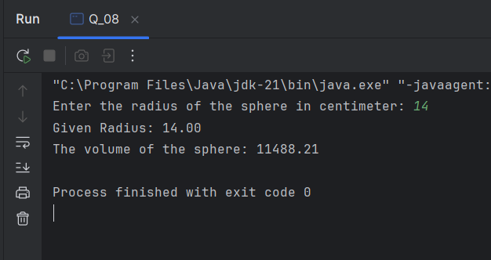

Q9.

Code:

|  |
| --- |
| ***package Q_09; import java.text.DecimalFormat; import java.util.Scanner;  public class Q_09 {  public static void main(String[] args) {  Scanner scanner = new Scanner(System.in);  // user inputs  System.out.print("Enter the principal amount in dollars: ");  double P = scanner.nextDouble();  System.out.print("Enter the interest rate in percentage: ");  double R = scanner.nextDouble();  System.out.print("Enter the number of years: ");  int N= scanner.nextInt();   double amount = P*Math.pow((1+(R/100)),N);  double moneyEarned = amount-P;  DecimalFormat df = new DecimalFormat("0.00");  System.out.println("The money earned after "+N+" years is: "+df.format(moneyEarned)+" dollers" );   } }*** |

Output:

Q10.

Code:

|  |
| --- |
| ***package Q_10; import java.text.DecimalFormat; import java.util.Scanner;  public class Q_10 {  public static void main(String[] args) {  int MONTHS_IN_YEAR = 12;  Scanner scanner = new Scanner(System.in);   System.out.print("Enter the loan amount: ");  double loanAmount = scanner.nextDouble();   System.out.print("Enter the annual interest rate (in percentage): ");  double Rate = scanner.nextDouble();   System.out.print("Enter the loan period (in years): ");  int loanPeriod = scanner.nextInt();   double monthlyInterestRate = Rate / 100.0 / MONTHS_IN_YEAR;  int numberOfPayments = loanPeriod * MONTHS_IN_YEAR;  double monthlyPayment = (loanAmount * monthlyInterestRate) /  (1 - Math.pow(1 / (1 + monthlyInterestRate), numberOfPayments));  double totalPayment = monthlyPayment * numberOfPayments;   DecimalFormat df = new DecimalFormat("0.00");  System.out.println("Monthly Payment:" +df.format(monthlyPayment));  System.out.println("Total Payment:" +df.format(totalPayment));   }  }*** |

Output:

