**Lab worksheet 4: Selection Statements**

Q1.

Code:

|  |
| --- |
| ***package Q_01;  import java.util.Scanner;  public class Q_01 {  public static void main(String[] args) {   Scanner scanner = new Scanner(System.in);   //get user input  System.out.print("Enter the first integer: ");  int num1 = scanner.nextInt();   System.out.print("Enter the second integer: ");  int num2 = scanner.nextInt();   System.out.print("Enter the third integer: ");  int num3 = scanner.nextInt();   // Initialize smallest with the first number  int smallest = num1;   if (num2 < smallest) {  smallest = num2;  }   if (num3 < smallest) {  smallest = num3;  }   System.out.println("The smallest number is: " + smallest);  scanner.close();  }   }*** |

Output:

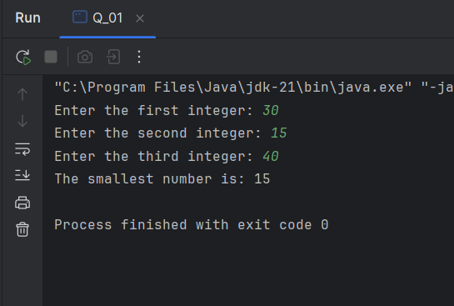

Q2.

Code:

|  |
| --- |
| ***package Q_02;  import java.util.Scanner;  public class Q_02 {  public static void main(String[] args) {  Scanner scanner = new Scanner(System.in);   System.out.println("0. Magenta");  System.out.println("1. Cyan");  System.out.println("2. Red");  System.out.println("3. Blue");  System.out.println("4. Green");  System.out.println("Select one color from the above list:");   int selection = scanner.nextInt();  switch (selection) {  case 0:  System.out.println("You selected Magenta");  break;  case 1:  System.out.println("You selected Cyan");  break;  case 2:  System.out.println("You selected Red");  break;  case 3:  System.out.println("You selected Blue");  break;  case 4:  System.out.println("You selected Green");  break;  default:  System.out.println("Invalid selection");  break;  }   scanner.close();  }  }*** |

Output:

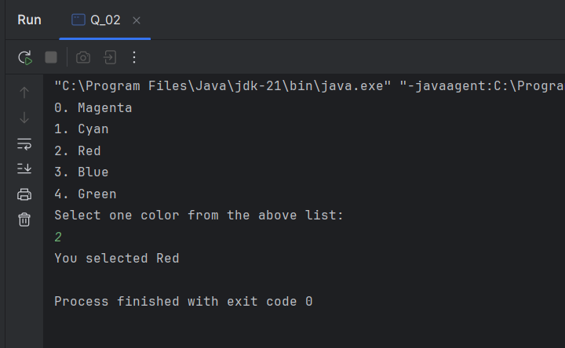

Q3.

Code:

|  |
| --- |
| ***package Q_03;  import java.util.Scanner;  public class Q_03 {  public static void main(String[] args) {  Scanner scanner = new Scanner(System.in);   System.out.print("Enter a power of 10 (Example powers:- 6, 9, 12, 15, 18, 21, 30, 100): ");  int power = scanner.nextInt();   String numberName;  switch (power) {  case 6:  numberName = "Million";  break;  case 9:  numberName = "Billion";  break;  case 12:  numberName = "Trillion";  break;  case 15:  numberName = "Quadrillion";  break;  case 18:  numberName = "Quintillion";  break;  case 21:  numberName = "Sextillion";  break;  case 30:  numberName = "Nonillion";  break;  case 100:  numberName = "Googol";  break;  default:  numberName= null;  break;  }  if (numberName != null) {  System.out.println("The number is a " + numberName + ".");  } else {  System.out.println("No corresponding word for 10 to the power of " + power + ".");  }   scanner.close();  }  }*** |

0utput:

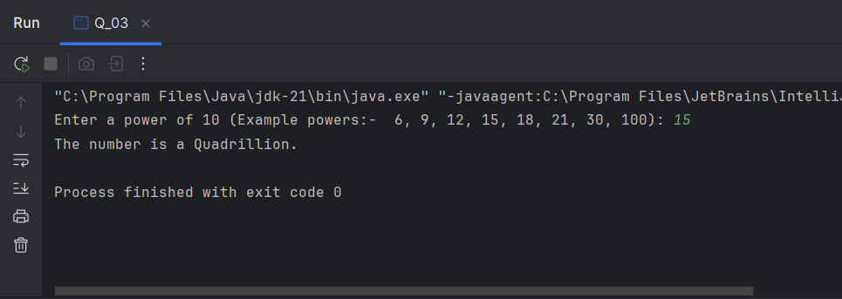

Q4.

Code:

|  |
| --- |
| ***package Q_04;  import java.util.Scanner;  public class Q_04 {  public static void main(String[] args) {  Scanner scanner = new Scanner(System.in);   System.out.print("Enter a year: ");  int year = scanner.nextInt();   // Check if the year is a leap year  if (isLeapYear(year)) {  System.out.println(year + " is a Leap Year.");  } else {  System.out.println(year + " is Not a Leap Year.");  }   scanner.close();  }   // Method to determine if a year is a leap year  public static boolean isLeapYear(int year) {  if (year % 4 == 0) {  if (year % 100 == 0) {  return year % 400 == 0;  } else {  return true;  }  }  return false;  }  }*** |

Outputs:

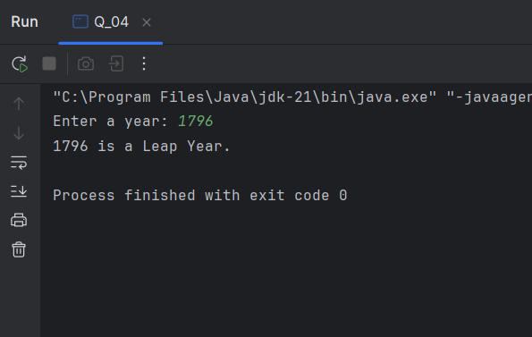

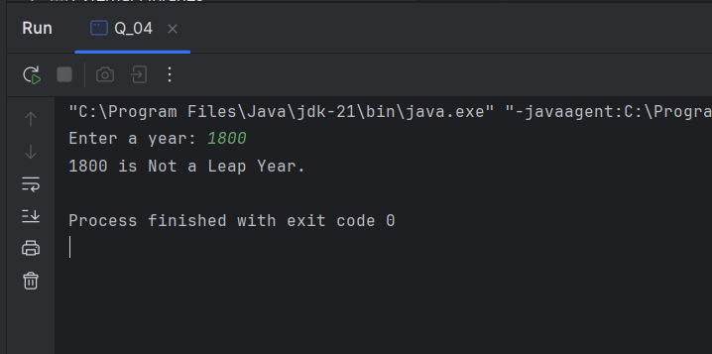

Q5.

Code:

|  |
| --- |
| ***package Q_05;  import java.util.Scanner;  public class Q_05 {  public static void main(String[] args) {  Scanner scanner = new Scanner(System.in);   System.out.println("\nEntree\t\t\tSide Dish\t\t\tDrink");  System.out.println("1. Tofu Burger\t\t$3.49\t5. Rice Cracker\t\t$0.79\t9. Cafe Mocha\t\t$1.99");  System.out.println("2. Cajun Chicken\t$4.59\t6. No-Salt Fries\t$0.69\t10. Cafe Latte\t\t$1.90");  System.out.println("3. Buffalo Wings\t$3.99\t7. Zucchini\t\t\t$1.09\t11. Espresso\t\t$2.49");  System.out.println("4. Rainbow Fillet\t$2.99\t8. Brown Rice\t\t$0.59\t12. Oolong Tea\t\t$0.99");   System.out.print("\nPlease enter the item number you want: ");  int item = scanner.nextInt();   switch (item) {  case 1:  System.out.println("Tofu Burger is $3.49");  break;  case 2:  System.out.println("Cajun Chicken is $4.59");  break;  case 3:  System.out.println("Buffalo Wings is $3.99");  break;  case 4:  System.out.println("Rainbow Fillet is $2.99");  break;  case 5:  System.out.println("Rice Cracker is $0.79");  break;  case 6:  System.out.println("No-Salt Fries is $0.69");  break;  case 7:  System.out.println("Zucchini is $1.09");  break;  case 8:  System.out.println("Brown Rice is $0.59");  break;  case 9:  System.out.println("Cafe Mocha is $1.99");  break;  case 10:  System.out.println("Cafe Latte is $1.90");  break;  case 11:  System.out.println("Espresso is $2.49");  break;  case 12:  System.out.println("Oolong Tea is $0.99");  break;  default:  System.out.println("Invalid entry");  break;  }   scanner.close();  } }*** |

Output:

