MSU AI-Training

Admin Dashboard Data

STATUS  Approved |  | OWNER  Not assigned |  | LAST UPDATED  October 28, 2026

Authors | Not assigned
Reviewers | Not assigned
Related docs | CONTEXT.md; prisma/schema.prisma; src/app/api/admin/stats/route.ts
Scope | Add role-scoped metrics, category course enrollment counts, an all-course ranking toggle, and per-video Podcast views; exclude recent quiz attempts and HeroSlide data.

1. Abstract
The overview shows learner, course, lesson, and enrollment totals with category, faculty, course, and certificate analytics. This design adds per-course enrollment counts within each category, an expandable ranking for all scoped courses, and YouTube view counts for each Podcast video. Recent quiz-attempt rows and HeroSlide data are excluded.
The design extends the existing stats route and dashboard component. It caps recent lists at five entries, lets each category expand to show course counts, keeps full record browsing in the current management tabs, and returns only fields needed by the overview. Reads remain request-time and read-only; no database migration is required.

2. Goals and Non-Goals
Goals | Non-goals
Show scoped counts, category course enrollment counts, and an expandable ranking for all courses. | Show HeroSlide data in the dashboard overview.
Preserve ADMIN and ORG_ADMIN access boundaries for every count, chart, and recent item. | Display every database row or sensitive field on one page.
Show Podcast views per video and recent course/enrollment activity. | Show recent quiz-attempt rows or add exports, date filters, live polling, or a schema change.
Keep the existing admin layout and navigation model. | Change enrollment, progress, quiz, or certificate behavior.

3. Background and Problem Statement
The admin overview currently requests GET /api/admin/stats once when the page mounts. The response covers four main totals and several learning analytics, but it does not summarize every in-scope model. New recent lists remain bounded; all scoped course summaries are included for the requested ranking toggle.
The browser keeps the current admin shell and AdminStats component. The route authenticates the session, derives system or organization scope, reads summary data from MySQL through Prisma, and returns a compact JSON response. ADMIN sees system-wide summaries. ORG_ADMIN sees only learners and learning records tied to the assigned organization. Existing management tabs remain the place to browse and edit full records.

4. Architecture

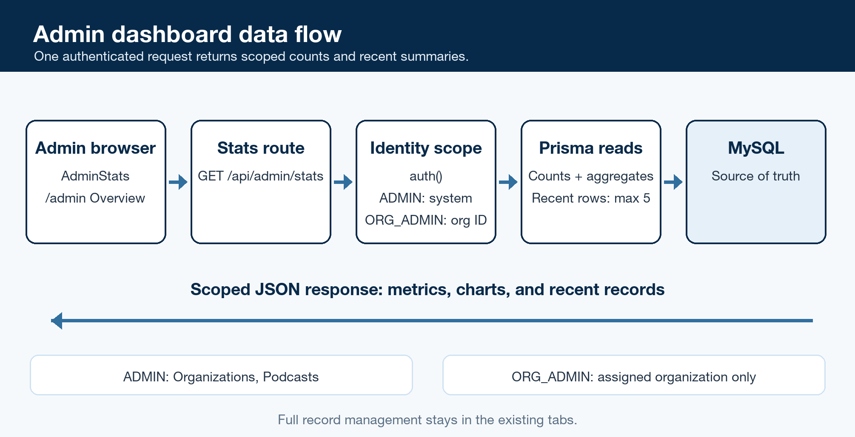
Figure 1. Admin dashboard data flow and access scope.

Core components

Component | Responsibility | Primary storage | Failure behavior
Admin overview | AdminStats requests and renders counts, charts, and recent activity. | None | Retain loading and error states; do not substitute missing values with fabricated zeros.
GET /api/admin/stats | Authenticate, calculate scoped metrics, and return compact JSON. | None | 403 for unauthorized roles; 400 for ORG_ADMIN without an organization; 500 for a database failure.
Session scope checks | Permit ADMIN and ORG_ADMIN; derive organization scope from the session. | Auth session | Reject unauthorized requests before querying data.
Prisma reads | Count and summarize records using model and relation filters. | MySQL | A required read failure returns 500 through the route.
Existing management tabs | Provide full record browsing and editing for supported domains. | Existing APIs and MySQL | Keep current tab behavior independent of summary loading.

5. Request Lifecycle
- An administrator opens /admin and selects Overview. AdminStats requests GET /api/admin/stats.
- The route calls auth() and permits only ADMIN or ORG_ADMIN. Role and organization ID come from the session, not query parameters.
- The route builds scope from the session. ADMIN reads system-wide records. ORG_ADMIN reads learners in the assigned organization and courses owned by that organization; related lessons, enrollments, progress, and quiz attempts follow the course relationship.
- The route reads scoped counts and aggregates, returns per-course enrollment counts grouped by category and all scoped courses for the ranking, and retrieves at most five recent courses and enrollments. ADMIN also receives YouTube view counts per Podcast video. Recent quiz-attempt rows and HeroSlide data are omitted.
- The request is read-only. It writes no dashboard state and changes no source record.
- The route returns JSON. Unauthorized roles receive 403, ORG_ADMIN without an organization ID receives 400, and a required database read failure returns 500.
- AdminStats renders the response with the existing loading and error states. Empty lists show empty states, while full record browsing remains in the existing tabs.

6. API and Data Contracts

Primary data contract

Field | Type | Required | Description
scope | Object | Yes | System for ADMIN; organization ID from the session for ORG_ADMIN. Never accept client-selected scope.
generatedAt | ISO timestamp | Yes | Time the response was assembled.
counts | Object | Yes | Scoped learner, organization, course, assessment, enrollment, progress, quiz attempt, and Podcast counts. HeroSlide fields are excluded; ADMIN-only fields are omitted for ORG_ADMIN.
enrollment status | Counts | Yes | Total, in-progress, and completed enrollments inside the request scope.
learning activity | Counts | Yes | Lesson progress total/completed and quiz attempts total/passed; filters follow the scoped course relationship.
analytics and recent | Arrays and objects | Yes | Category summaries include every scoped course and its enrollment count, including zero-enrollment courses; the ranking includes all scoped courses; recent lists include the newest five courses/enrollments. ADMIN also receives per-video YouTube Podcast views. Recent quiz attempts and HeroSlide records are excluded.
display fields | Strings, statuses, dates | Yes | Titles, status, and dates only. Exclude credentials, learner identifiers, question text, and answer correctness.

Contract guarantees

- The route is read-only. MySQL remains the source of truth for every displayed count.
- The request scope is derived from the authenticated session. The client cannot choose a different organization.
- Recent course and enrollment lists are newest first and capped at five entries. Each category shows its courses and enrollment counts; the course ranking starts with five rows and expands to all scoped courses. Podcast view counts are shown per video for ADMIN.
- Counts are request-time summaries. Concurrent writes may cause small differences between related counts; the overview does not promise a point-in-time transaction snapshot.
The route response is the data contract for this feature.
Document GET /api/admin/stats here and update this contract whenever the response fields change.

7. Consistency, Idempotency, and Replay

Repeated GET requests do not change system state. Each page load requests current database values. Independent reads may observe writes at slightly different instants, which is acceptable for an operational overview. If a required query fails, the route returns 500 and the dashboard shows its error state rather than presenting partial counts as complete.
Scenario | Expected behavior | Reasoning
Administrator reloads the page | Return a fresh summary for the session scope. | The route is read-only and request-time.
A record changes during the read | Related totals may reflect slightly different instants. | The overview does not require a transactional snapshot.
A database read fails | Return 500 and show the dashboard error state. | Do not present partial or fabricated counts as complete.
ORG_ADMIN changes a client parameter | Continue using the organization ID from the session. | Client input cannot expand the data boundary.

8. Security and Privacy Considerations

- Allow only ADMIN and ORG_ADMIN. Keep authorization in the route even though the admin page also checks the session.
- Apply the organization filter to every direct and relation-based query for ORG_ADMIN, including lesson progress and quiz attempts.
- Return counts and display fields only. Exclude password hashes, email addresses, student IDs, question text, answer options, and correctness flags from the overview response.
- Return organizations and Podcasts only to ADMIN; omit HeroSlide data for every role. Do not accept client-selected organization filters.
- Preserve current database retention and deletion behavior. The overview creates no stored copy, cache, or export.

9. Operational Readiness
Signal | SLO or alert | Owner | Launch gate
Summary completeness | No numeric SLO exists. Compare each metric with its model and scope. | Not assigned | Required
Route availability | GET_STATS_ERROR is logged; no alert threshold is defined. | Not assigned | Recommended
Role and organization scope | 403 for unauthorized roles; ORG_ADMIN is scoped by session organization ID. | Not assigned | Required
Query duration | No latency target exists. Measure against representative data before release. | Not assigned | Recommended
Empty and error states | Empty lists show empty states; failed requests show the existing error state. | Not assigned | Required
Rollout constraint: no database migration is needed. Release and rollback use application code. Assign a latency target and operational owner after measuring representative data.

10. Alternatives Considered

Alternative | Why it was considered | Why it was not selected
Extend the existing stats route | It already serves the overview and preserves current charts and role filters. | Recommended; keep the response bounded and scoped as it grows.
Create a separate dashboard API | It separates the overview from the current stats route. | Adds another route and contract without a demonstrated need.
Render every database row | It would put full records on one page. | Duplicates management tabs, grows with database size, and exposes more personal or assessment data.
Fetch all data in the page server component | It may avoid a client request for the first render. | The admin shell is client-rendered with local tab state; changing that boundary expands the work.

11. Open Questions
- Assign an operational owner and a latency target after measuring the route with representative data.
- Confirm owner and reviewer names for the design record; none are specified in the repository context.

12. Decision and Next Steps
Approved: add scoped metrics, per-course enrollment counts within categories, an all-course toggle, and per-video Podcast views for ADMIN. Keep recent course/enrollment lists; omit recent quizzes and HeroSlides.
Milestone | Deliverable | Exit criteria
M1 | Approve the scope and response contract. | Confirm summary view, role scope, recent lists, and ADMIN-only panels.
M2 | Implement the scoped dashboard and release. | Each category shows enrollment counts per course; all courses expand; ADMIN sees Podcast views per video. Recent quiz rows and HeroSlides are absent; no migration is needed.

Use footnotes for definitions, assumptions, or terms that need precision without interrupting the main narrative.

