PhytoSense++
Connection Diagrams & Build Reference
Dedicated wiring, plumbing, and software-architecture reference for the physical build.

1. Before You Wire Anything: Verification Tools
Recommended order: simulate the logic first, then wire on a breadboard against these diagrams, then move to the dot PCB.

1.1 Wokwi (wokwi.com) — firmware + logic simulation
- Free, browser-based ESP32 simulator. Natively supports ESP32-S3, BME280, SSD1306 OLED, and generic I2C devices.
- AD8232, ADS1115, and the capacitive soil sensor aren't in its built-in library — stub them with a potentiometer or slider-controlled analog input so you can test your ADC-reading and threshold logic before real hardware exists.
- Use this to validate: I2C bus addressing (no conflicts between BME280/BH1750/ADS1115/OLED), the relay-trigger logic, and your data-logging code path.

1.2 Fritzing — realistic breadboard + physical wiring diagrams
- Best tool for exactly what these diagrams show: electrical wiring AND physical elements like the pump tube, drawn together.
- Use it to produce your final “build reference” image for the GitHub README once the design is locked.

1.3 KiCad — schematic + PCB layout
- Once the breadboard version is verified end-to-end, move the circuit here for the schematic and the final dot-PCB layout.
Suggested order: Wokwi (logic) → breadboard against these diagrams (electrical) → Fritzing (clean documentation) → KiCad (final PCB).

2. Master Pin-Connection Table
Every connection in the system, in one place — use this as the firmware reference and the wiring checklist.
ESP32-S3 pin | Connects to | Bus / type
3V3 | AD8232, ADS1115 (VDD), BME280, BH1750, soil sensor | Power
5V (VIN) | Relay module VCC, OLED (if 5V variant), buzzer | Power
GND | Common ground — all modules share this rail | Ground
GPIO8 | SDA — shared I2C bus: ADS1115, BME280, BH1750, OLED | I2C
GPIO9 | SCL — shared I2C bus: ADS1115, BME280, BH1750, OLED | I2C
GPIO4 | AD8232 LO+ (leads-off / contact detect) | Digital in
GPIO5 | AD8232 LO- (leads-off / contact detect) | Digital in
GPIO6 | Relay IN — switches the pump's 6V line | Digital out
GPIO7 | Buzzer + | Digital out
ADS1115 A0 | AD8232 OUTPUT (bioelectric signal) | Analog
ADS1115 A1 | Soil moisture sensor AOUT | Analog
Note: confirm GPIO4/5/6/7/8/9 against your specific ESP32-S3 dev board's silkscreen before wiring — some breakout boards remap a few GPIOs, and GPIO8/9 can be reserved for onboard flash on certain S3 variants.

3. Master Hardware Connection Diagram
Every component in one view — sensing chain on the left, outputs/actuation/power on the right, ESP32-S3 as the hub.
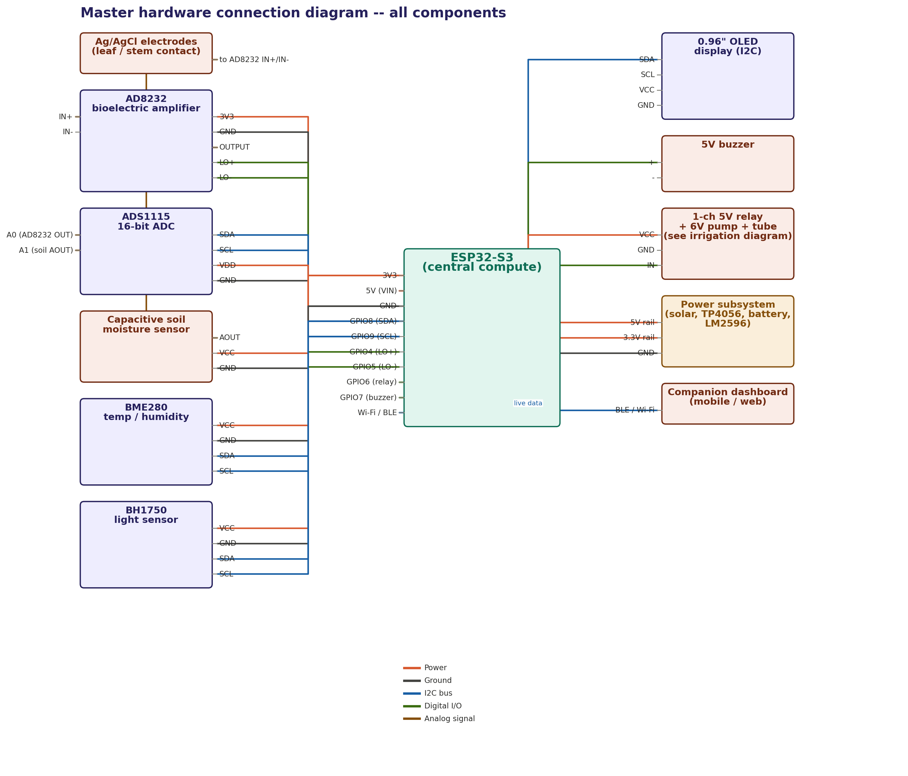
Figure 1: Full system, all components. Color key: orange = power, dark gray = ground, blue = I2C bus, green = digital I/O, brown = analog signal.

4. Phase-by-Phase Wiring

4.1 Phase 1 / 5 — Power subsystem
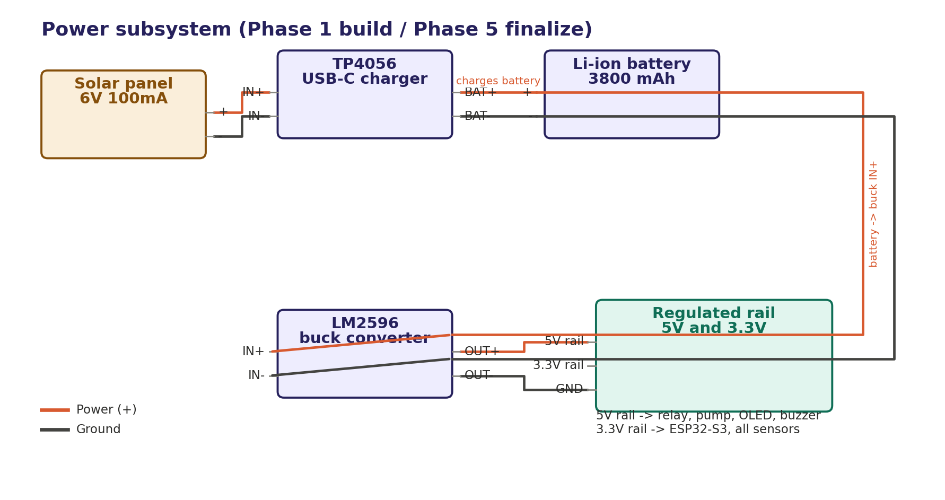
Figure 2: Solar -> TP4056 -> battery -> LM2596 -> regulated 5V/3.3V rail.

4.2 Phase 2 — Analog front-end (bioelectric sensing)
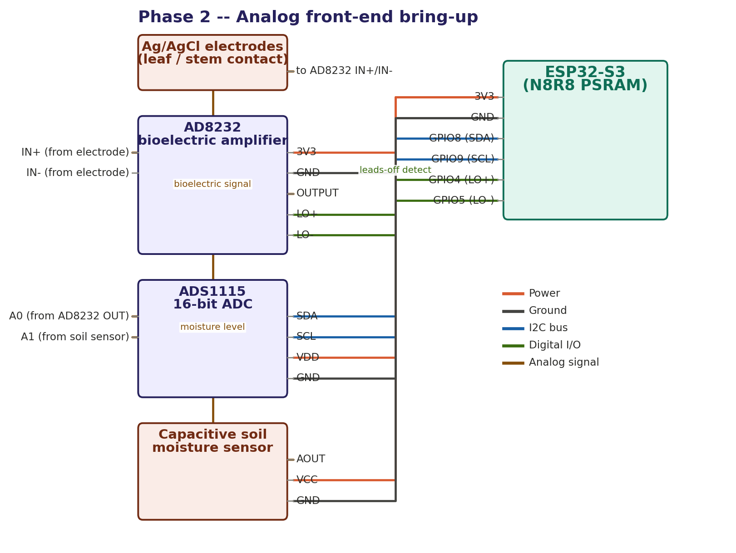
Figure 3: Electrodes -> AD8232 -> ADS1115 (A0) + ESP32-S3 leads-off GPIOs; soil sensor shares ADS1115 channel A1.

4.3 Phase 3 — Environmental sensors + irrigation (electrical AND plumbing)
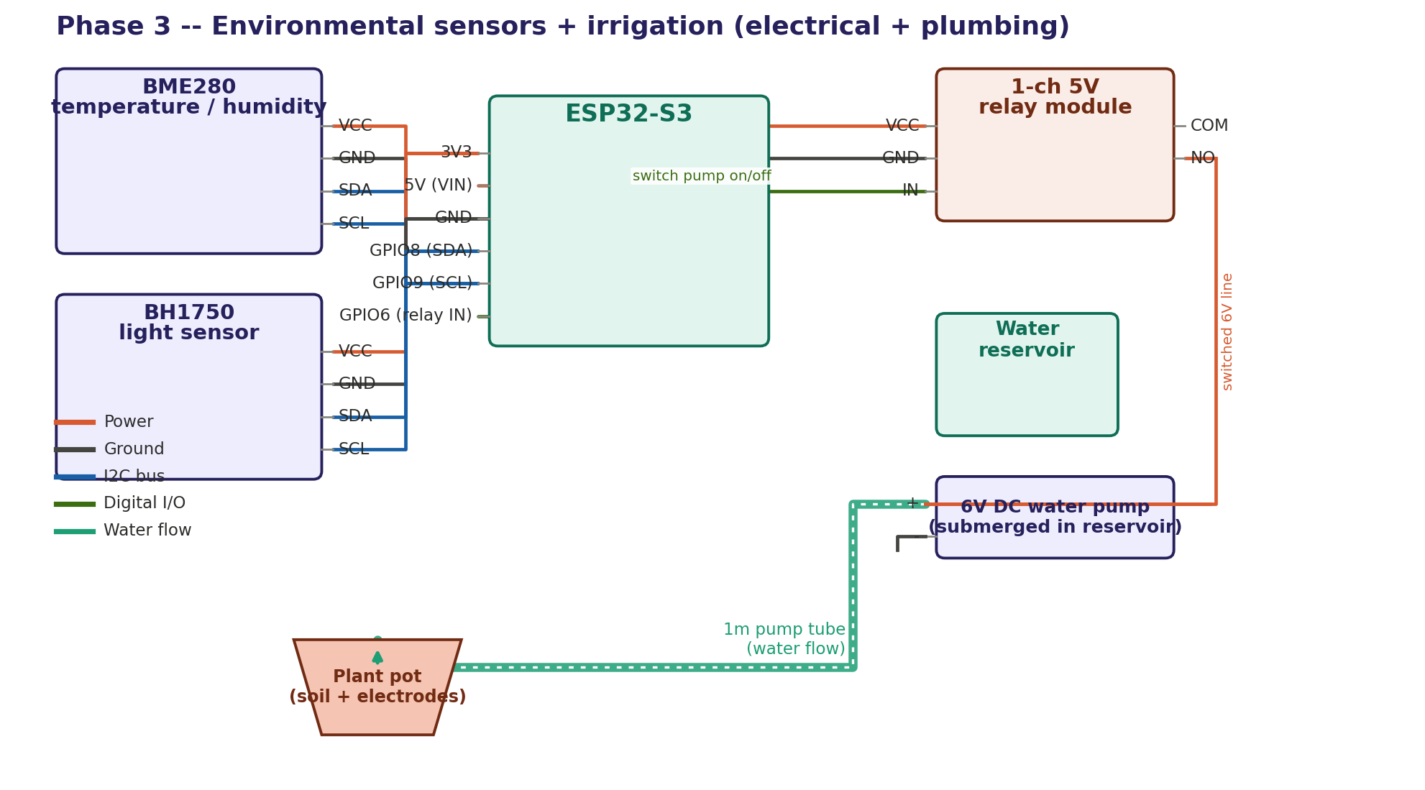
Figure 4: BME280/BH1750 on the shared I2C bus. Physical water path shown separately from the electrical path: relay switches pump power (orange) while the pump draws from the reservoir and delivers through the 1m tube (green, dashed) to the plant pot.

4.4 Phase 5 — Full system integration
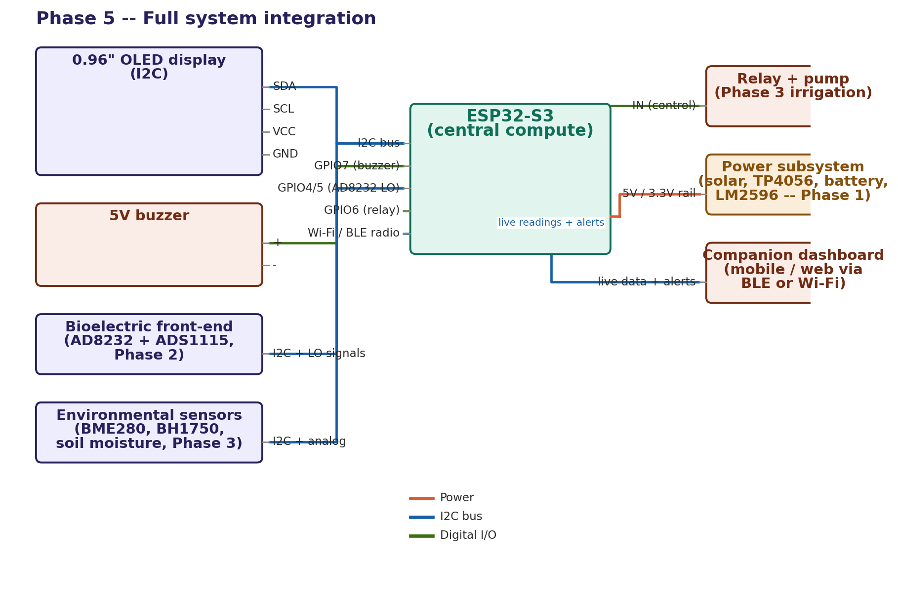
Figure 5: All subsystems converging on the ESP32-S3, including the Wi-Fi/BLE link to the companion dashboard.

5. Software Architecture (Data Flow)
How a reading turns into a decision, on-device:
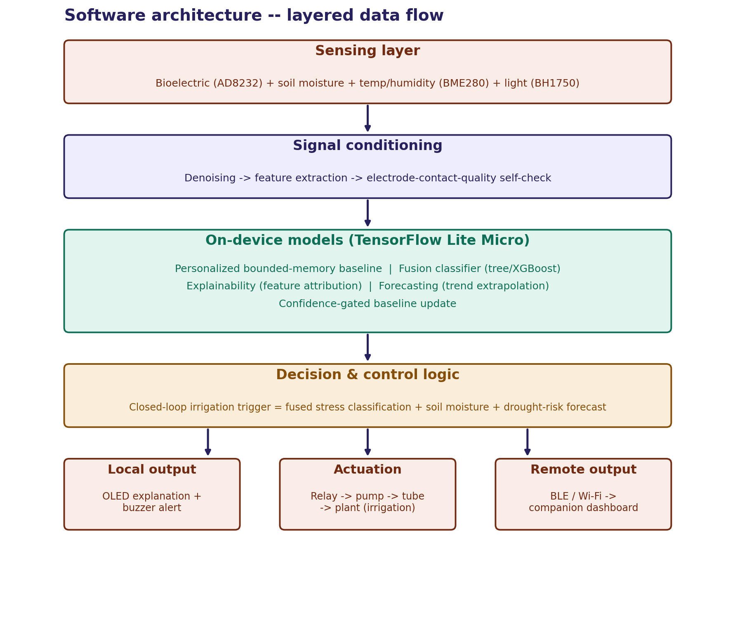
Figure 6: Sensing -> signal conditioning -> on-device models -> decision & control -> three parallel outputs (local display/alert, physical irrigation actuation, remote dashboard).

6. Build Checklist
- Simulate I2C bus + relay logic in Wokwi before touching hardware.
- Breadboard the power subsystem first (Section 4.1) — verify 5V/3.3V rail with a multimeter before connecting any sensor.
- Bring up the bioelectric front-end alone (Section 4.2); confirm a clean signal trace before adding other sensors.
- Add environmental sensors + irrigation (Section 4.3) — test the relay-pump-tube path with plain water into a test container before routing to a live plant.
- Full integration test (Section 4.4): predict -> explain -> irrigate -> forecast, end to end.
- Cross-check every GPIO against your board's actual silkscreen before final soldering.

