Thivanka Samaranayake

June 08, 2020

Foundations of Programming (Python)

Assignment08

https://github.com/THIVASAM/IntroToProg-Python-Mod08.git

**Working With Classes in Python**

# Introduction

This assignment delves into creation of custom classes to create a program. Advanced features of a class such as Fields, Constructor, Attributes, Properties, and Methods are explored. These techniques were used to create custom functions with try-except blocks to create a more advanced program. Additionally GitHub Desktop is used to manage folders on the local hard drive and improve GitHub webpage to make the presentation of look more professional.

# Difference between Classes and Objects

Classes are used to group data and functions. Fields are the data defined in the class using variables and constants. And methods are the functions in a class. Classes can be used directly or indirectly in the memory of a computer. When classes are used directly, the fields within the functions are defined explicitly by linking the class to the field with a dot notation. However classes can be used indirectly by first creating an object instance of the class. Then that object is used as the link to the class instead of directly calling out the class. This is done by using the object’s variable with a dot notation.

# Class Constructor

Constructors are special methods that automatically run when an object is created from a class. These special methods are used to initialize values in the field of data. The __init__() is a constructor that is always created when an object is created. The **“self” keyword** is used in the constructor method to refer to data or functions found in the object but not directly in the class. Since there can be multiple instances of a class, the word self is a way to refer to self’s memory location. The word self is used in each method where multiple object instances are created. When creating a static method however, the word self is not needed. **Static methods** are called directly from the class as opposed to making an object instance to call them. In general, when classes are used to process data, static method is used. And when classes are used for storing data, instance methods are used.

# Field Attributes and Property Functions

Properties are a function within the class that is used to control field or attribute data. Two types of properties are created for each field or attribute data called getters and setters. A setter is used to pass in a parameter to the property and assign it to the field or attribute. This can be used in error handling and validation. A getter is used to format a field or attribute’s data.

# Methods and Properties

Properties are functions that manage the fields or attributes of data within a class. However, methods re the “workhorse” functions with in a class that does the data processing. The __str__() method is a famous method that returns some or all of the class’s data in a string. Python contains many built in methods that can be used for various functions.

# Docstrings in Classes

Docstrings in classes are helpful notes to the developer about the class. They are placed in a class using the triple quote “””. IDEs like PyCharm allows the programmer to display data and tooltips contained within the docstrings. Python also allows programmers to view docstring using the built in __doc_property.

# Git, GitHub and GitHub Desktop

GitHub is code management software that allows you to build repositories of various projects. GitHub can be used on the web as a web browser or called on a developer’s local computer using an application. Additionally, programmers can also use the command prompt to input or extract data from GitHub. For both the desktop application and command prompt, the communication is facilitated by a program called Git. This program uses the storage and file backup capabilities of GitHub. And like GitHub it allows the programmer to manage versions of files. GitHub Desktop is a free application that can be used interact with GitHub on a local computer in a more user friendly visual style. GitHub Desktop is used by developers instead of the command line.

# Assignment08

The code shown in the following figures demonstrates the use of classes. It shows the program adding a product and price and saving it to a text file. Then the program is able to display the data added back to the user.

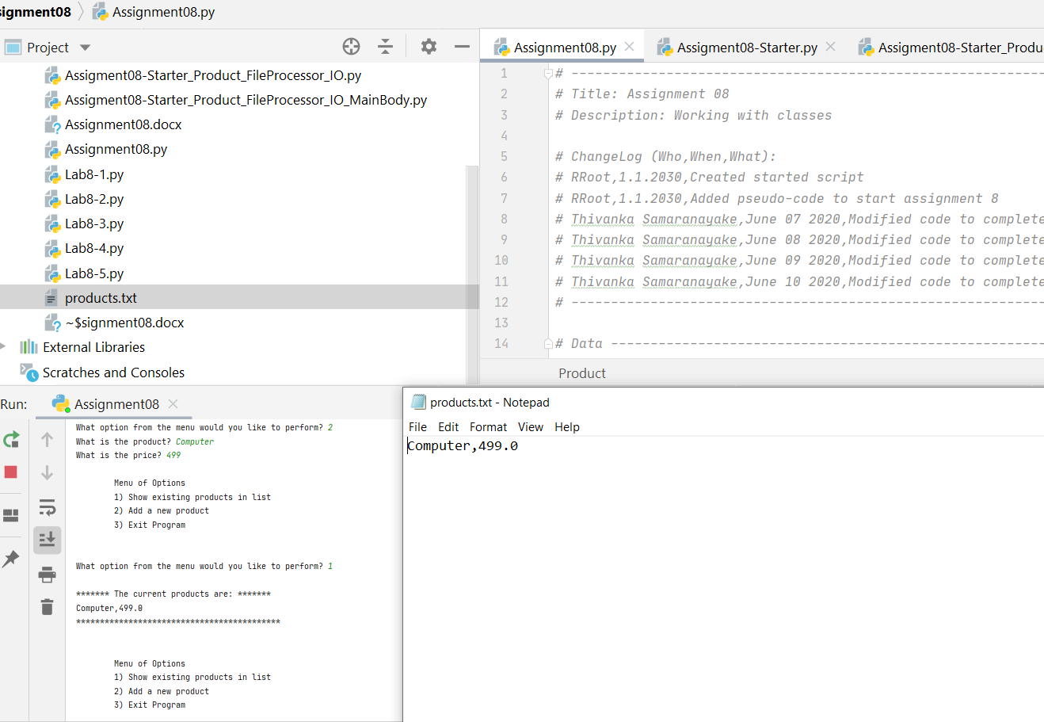

**Figure 1**—Program Running in PyCharm

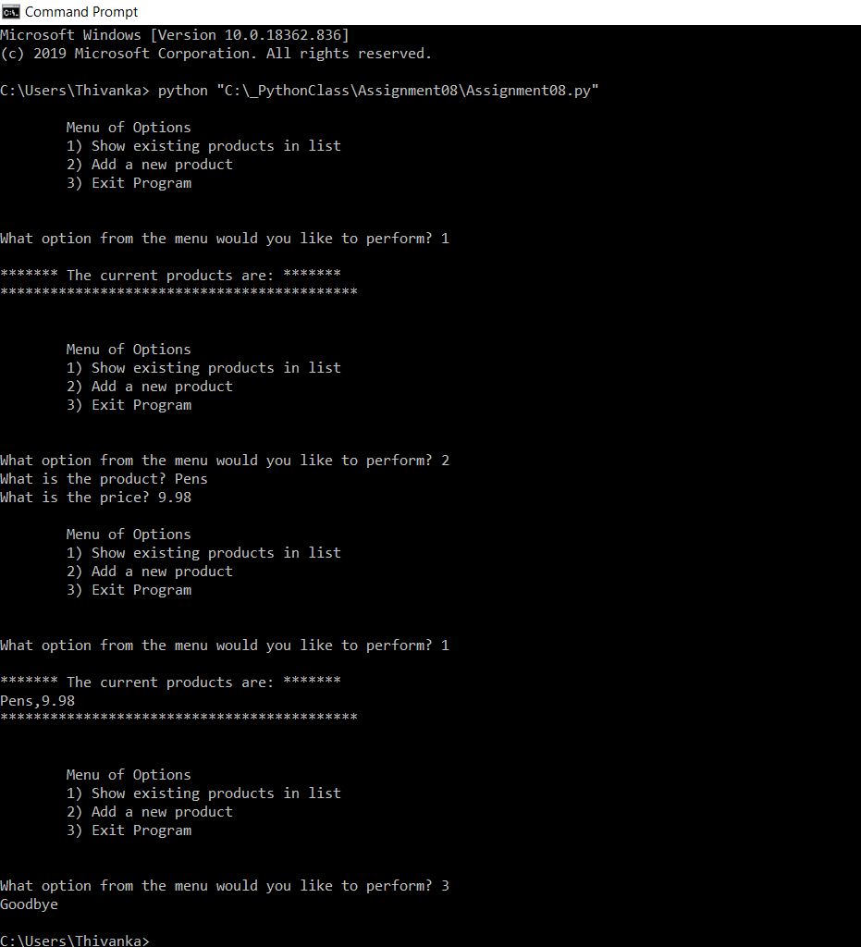

**Figure 2**—Program Running in Command Shell

# Conclusion

This module dealt with the use of classes. The use of classes was explored by adding fields, constrcutors, attributes, properties and methods. All of these techniques were used to create a simple program that was similar to Module 06 where data is taken from the user and entered into a text file. However, unlike module 06, this program uses classes in place of dictionaries. Overall this assignment was difficult and time consuming given the complexity of classes. However, it was also equally satisfying to complete once certain things about classes were understood.