Case Study Report



**Tech Saksham**

Data Analytics with Power BI

**“ Analysis of commercial electricity consumption in Indian states”**

**“A.P.C.Mahalaxmi college for women”**

|  |  |
| --- | --- |
| **NM ID** | **NAME** |
| 8263B2F2284CC4A902F447DF9E08F30B | S.THIVIKA |

Trainer Name: R.UMAMAHESWARI

Master Trainer: R.UMAMAHESWARI

|  |  |
| --- | --- |
|  |  |
|  |  |
|  |  |

**ABSTRACT**

This present study entitled “Consumption Pattern of Electricity in Rural and Urban Areas: a Case Study of Rourkela” had been conducted in and around Rourkela city. This study will give a clear understanding and insights of the primary factors that are responsible for utilization of electricity in rural and urban areas. The determinants of household expenditures on electricity consumption of both the rural and urban areas are identified and analysed. This study will discuss how in rural area people are not able to get electric connection legally using meter. This have lead to illegal way of getting electricity as the rural people’s income are too low and they are not in a position of getting registration in Electrical Department. On the contrary, in urban areas people are paying subsidised electrical bill per month. Through this study, it was found that both in rural and urban areas that the meter readings are not checked on a regular basis.

**INDEX**

|  |  |  |
| --- | --- | --- |
| **Sr. No.** | **Table of Contents** | **Page No.** |
| 1 | Chapter 1: Introduction | 4 |
| 2 | Chapter 2: Services and Tools Required | 6 |
| 3 | Chapter 3: Project Architecture | 7 |
| 4 | Chapter 4: Modeling and Result | 9 |
| 5 | Conclusion | 18 |
| 6 | Future Scope | 19 |
| 7 | References | 20 |
| 8 | Links | 21 |

**CHAPTER 1**

**INTRODUCTION**

* 1. **Problem Statement**

Electricity was introduced in Greek. William Gibert, an English physician, physicist and natural philosopher was the first to coin the term “electricity” derived from the Greek word for amber. The combinations of qualities and quantities act of community or human group’s use of resources for survival, needs, comfort and enjoyment is called consumption pattern. Consumption pattern is divided into three terms, broader terms include social process, narrow terms include energy demand, energy demand, energy utilization pattern , water conservation, water demand, water saving, related terms include consumer behaviour. When income raises agriculture sector and industrial sector get mechanized which lead to increase in population and consumption of electrification increases in both rural and urban areas. The main reason behind consumption of electricity increases is Indian economy is growing very fast it is due to globaliation, modernization and liberalization

* 1. **Proposed Solution**

Generate about 50% cumulative electric power installed from non-fossil fuel resources by 2030. Reduce carbon emissions by 1 billion tonnes from now till 2030. Reduce emissions intensity of its gross domestic product (GDP) by 45% by 2030. Achieve net zero by 2070.

* 1. **Feature**
* **Sectoral Breakdown**: Divide consumption into sectors (Retail, Hospitality, offices) to understand contributions from each other.
* **Time -Series Analysis**: Study consumption patterns over time (monthly, quarterly, anually)
* **Tariff Analysis**: Evaluate commercial electricity tariffs in each state.
* **Predictive Analy**: Create load profiles for different commercial segments.
  1. **Advantages**
* **Demand Forecasting**: Predicts future demand for capacity planning and load management.
* **Sector -Specific Strategies**: Tailors strategies for different commercial sectors.
* **Climate Goals**: Contributions to achieving national and global climate goals.
  1. **Scope**

**This study will provide clear understanding regarding the difference between the consumption of electricity in rural and urban areas. Also, this study will provide immense knowledge about the hardships faced by the rural people and the lacunae on the part of the Government Officials chiefly the electric department. The findings of the present study may be useful to the electric department in solving the problems face by the rural people in providing their needs and in framing stringent measures and laws to use electricity more judiciously and legally.**

**CHAPTER 2**

**SERVICES AND TOOLS REQUIRED**

**2.1 Services Used**

* **Data Analysis software**: Platforms like python with libraries such as pandas, Numpy provides robust capabilities for data manipulation ,visualization and statistical analysis.
* **Consulting services**: Energy consulting firms specialized in data analysis and energy management can provide expert guidance and support for analysing electricity consumption data and deriving actionable insights.
* **Machine Learning Services**: Machine learning frameworks like tensorflow enable the development of predictive model to forecast future electricity consumption trends based on historical data.

**2.2 Tools and Software used**

**Tools**:

* **PowerBI**: The main tool for this project is PowerBI, which will be used to create interactive dashboards for real-time data visualization.
* **Power Query**: This is a data connection technology that enables you to discover, connect, combine, and refine data across a wide variety of sources.

**Software Requirements**:

* **PowerBI Desktop**: This is a Windows application that you can use to create reports and publish them to PowerBI.
* **PowerBI Service**: This is an online SaaS (Software as a Service) service that you use to publish reports, create new dashboards, and share insights.
* **PowerBI Mobile**: This is a mobile application that you can use to access your reports and dashboards on the go.

**CHAPTER 3**

**PROJECT ARCHITECTURE**

**3.1 Architecture**

**USER FRONTEND BACKEND**

|  |  |  |
| --- | --- | --- |
|  | **HTML 5** | **NODEJS 14.0**  **Database** |

Here’s a high-level architecture for the project:

**1.Data Collection**: Data should include electricity consumption data for commercial establishments, demographic information, economic indicators, and any other relevant factors.

**2.Data Storage**: Store the processed data in a centralized data warehouse or data lake for easy access and analysis.

**3.Data Processing**: Cleanse and preprocess the collected data to handle missing values, outliers, and inconsistencies.

**4.Machine Learning**: Apply statistical methods, machine learning algorithms, and time series analysis to uncover insights and correlations.

**5.Data Visualization**: The processed data and the results from the predictive models are visualized in real-time using PowerBI. PowerBI allows you to create interactive dashboards that can provide valuable insights into the data.

**6.Data Access**: The dashboards created in PowerBI can be accessed through PowerBI Desktop, PowerBI Service (online), and PowerBI Mobile.

This architecture provides a comprehensive solution for real-time analysis of electricity consumption. By following this architecture, you can effectively analyze commercial electricity consumption in Indian states and derive actionable insights for decision-making and policy formulation.

**CHAPTER 4**

**MODELING AND RESULT**

**Manage relationship**

The dataset is used to understand the variations in electricity rates across different states. To manage the relationship for analysis, consider focusing on specific states or regions.

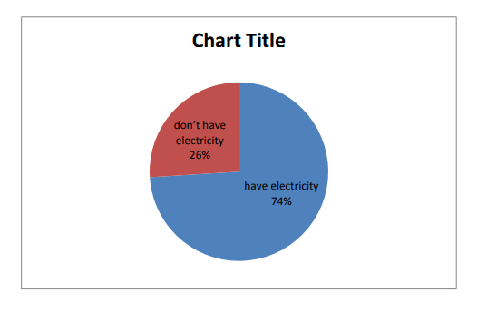

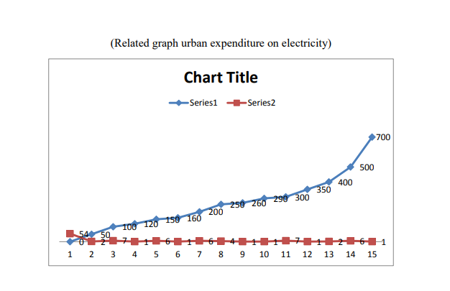

**Establish Relationships**

Define the relationship between different entities in the data, such as states, years and electricity consumption metrics. This may involve creating primary and foreign keys to link tables together.

.

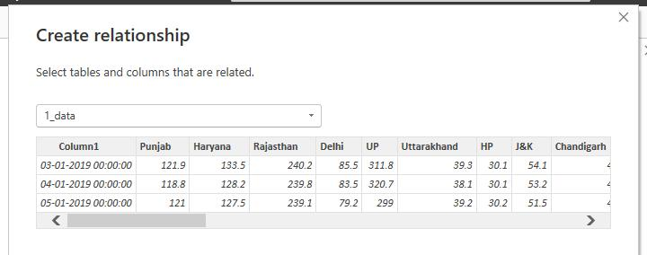

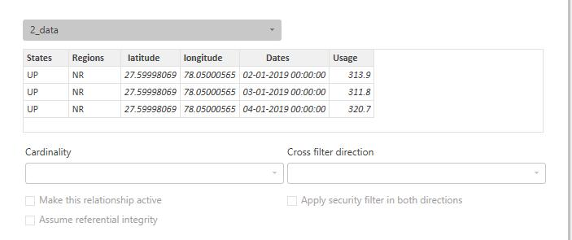

Create visualizations such as charts, graphs and maps to communicate the findings of the analysis effectively. This could help identify patterns,trends and outliers in the data.

**Dashboard**

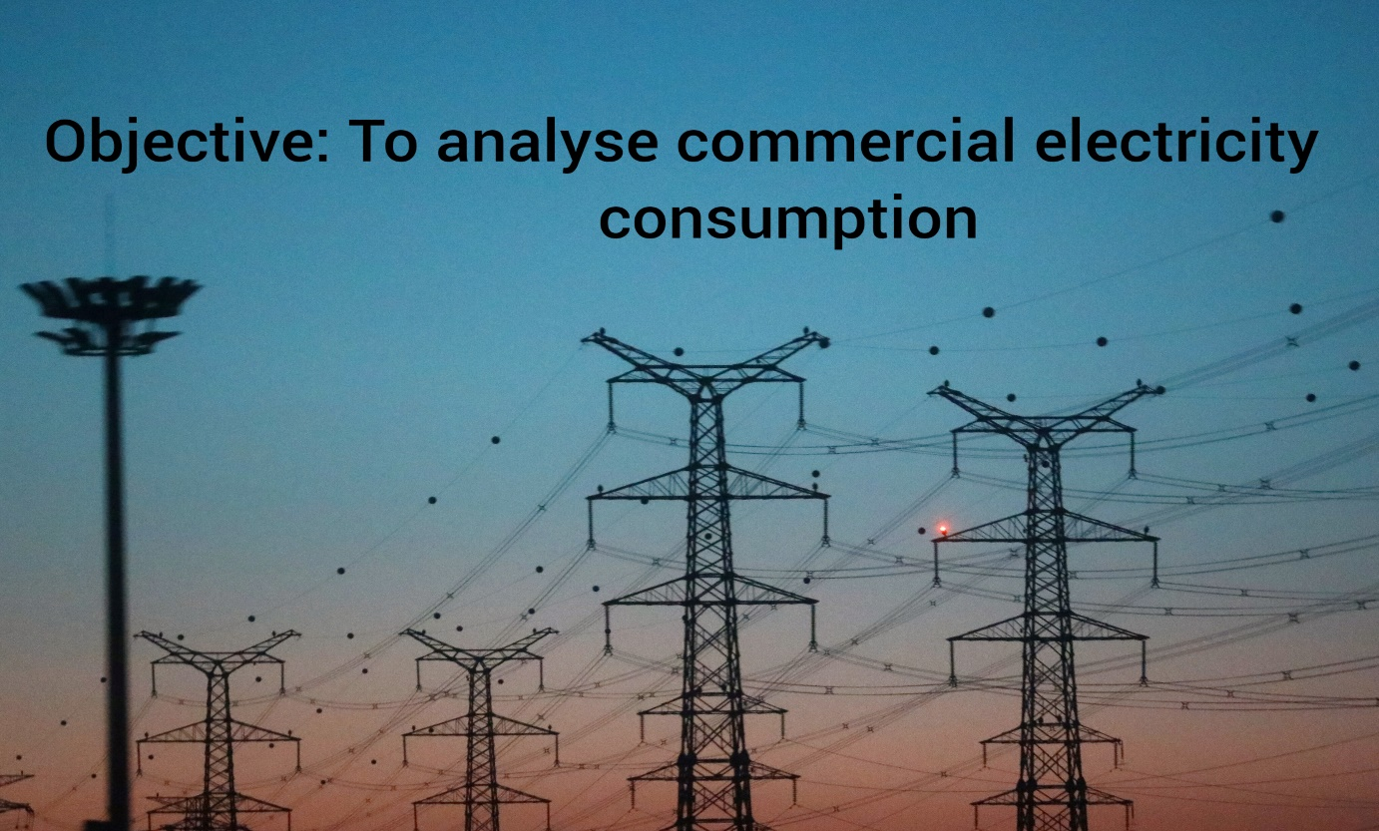

.

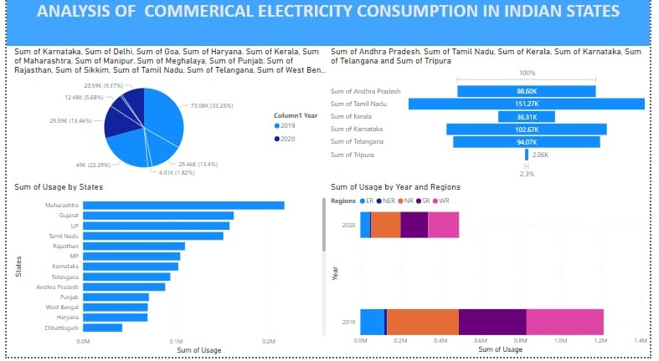

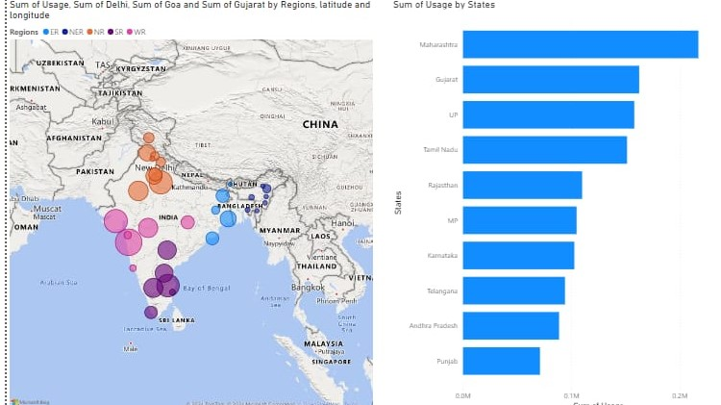

**CONCLUSION**

In conclusion, analyzing commercial electricity consumption in Indian states requires a collaborative approach involving stakeholders from government agencies, DISCOMs, research organizations, and commercial establishments. By fostering strong relationships, ensuring data access and quality, providing capacity building, and maintaining communication channels, meaningful insights can be derived to inform policy decisions, optimize resource allocation, and drive sustainable energy practices in the commercial sector across Indian .The project has also highlighted the importance of data visualization in making complex data more understandable and accessible. The use of PowerBI has made it possible to present data in a visually appealing and easy-to-understand format, thereby aiding in better decision-making.

**FUTURE SCOPE**

The future scope of this project is vast. With the advent of advanced analytics and machine learning, PowerBI can be leveraged to predict future trends based on historical data. Integrating these predictive analytics into the project could enable the bank to anticipate customer needs and proactively offer solutions. Furthermore, PowerBI’s capability to integrate with various data sources opens up the possibility of incorporating more diverse datasets for a more holistic view of customers. As data privacy and security become increasingly important, future iterations of this project should focus on implementing robust data governance strategies. This would ensure the secure handling of sensitive customer data while complying with data protection regulations. Additionally, the project could explore the integration of real-time data streams to provide even more timely and relevant insights. This could potentially transform the way banks interact with their customers, leading to improved customer satisfaction and loyalty.

**REFERENCE**

## https://ideas.repec.org/a/ebl/ecbull/eb-17-00173.html

|  |  |  |  |  |
| --- | --- | --- | --- | --- |
| |  | | --- | |  | |  |  |  |
| |  | | --- | |  | | | |

|  |  |
| --- | --- |
|  |  |

**LINK**

<https://github.com/githubtraining/hellogitworld.git>