PROJECT PLAN
Department: | EC | Semester: | 6th | Academic Year: |  | 2026– 27
A. Proposed Title of the Project:
Anviksha 8-Bit CPU
B. Name(s) of guide(s): Prof. / Dr. / Mr. / Ms.
C. Name of Team Members (Strictly not more than four students in a batch):
USN | Name
4VP23EC050 | Mr. THIYANAND M | Team Leader
4VP23EC005 | Ms. CHAITHANYA | Team Member
4VP23EC010 | Ms. FATHIMATH ANEESHA | Team Member
4VP23EC029 | Ms. PREETHA S M | Team Member

D. Date of commencement of project:
E. Probable date of completion of the project:
F. If this project is an improvement / extension of an earlier project, please give the title of earlier project and the year in which it was carried out. Specify the improvements / modifications clearly:
Not Applicable
G. Objectives of the project highlighting its importance (not more than half a page):
- To design and implement a functional 8-bit CPU using basic digital electronics components.
- To understand the instruction, fetch, decode, and execute cycle in a processor.
- To integrate core CPU blocks such as ALU, registers, program counter, control unit, and memory.
- To analyze data flow, control signals, and clock timing within the CPU.
- To bridge theoretical computer architecture concepts with practical hardware implementation
H. Block diagram and Methodology (Not more than a page):
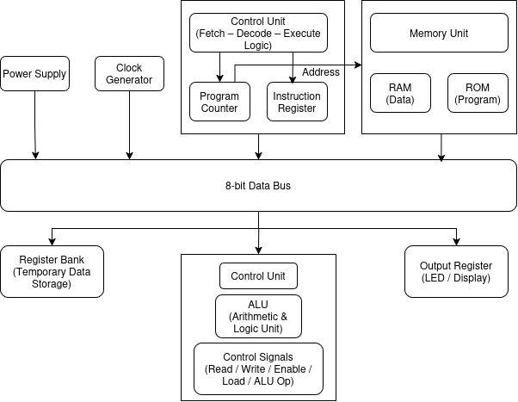
The device operates in the following sequence:
- Power Supply Setup
A regulated 5V power supply is designed and tested to ensure stable operation of all ICs used in the CPU.
- Clock Generation
A clock circuit is implemented to provide synchronized timing pulses required for instruction execution and data transfer.
- Data Bus Design
An 8-bit data bus is created to allow controlled communication between registers, ALU, memory, and output units.
- Register Implementation
Registers are designed to temporarily store data and operands needed during processing.
- ALU Design
The Arithmetic Logic Unit is developed to perform basic arithmetic and logical operations on 8-bit data.
- Instruction Control
The Program Counter and Instruction Register are implemented to manage instruction sequencing and hold current instructions.
- Control Unit Design
A control unit is designed to generate required control signals for fetch, decode, and execute cycles.
- Memory Integration
ROM and RAM are interfaced to store programs and data required for CPU operation.
- Output and Testing
An output register is added to display results, and the complete CPU is tested for correct functionality.

I. Expected Outcome of the project
- Successful design and implementation of a fully functional 8-bit Central Processing Unit.
- Correct execution of instruction fetches, decode, and execute cycles.
- Reliable performance of core CPU components such as ALU, registers, program counter, control unit, and memory.
- Accurate execution of basic arithmetic, logical, and data transfer instructions.
- Proper synchronization of operations using the clock signal.
- Clear visualization of outputs through the output register and LEDs.
- Improved practical understanding of computer architecture and digital processor design.

J. Application of the project:
- Used as an educational model to understand basic CPU architecture and internal working.
- Helps in learning instruction execution, data flow, and control logic of processors.
- Can be applied in simple embedded systems with low computational requirements.
- Serves as a foundation for designing microcontrollers and advanced CPUs.
- Useful for digital electronics and computer organization laboratory demonstrations.
K. Does the project proposed is relevant to any of the Industry or Institution in and around your area (Yes / No): |  |  |  |  | No
L. If yes, please provide details of the industry / institution and contact details:
M. Budget:
Materials Cost:8500/-  Labour Charges:  Any other cost: |  |  |  |  | Source of Funds:  Self / Industry / Others
N. Expected Completion Time:
Expected Time for Major Activities |  |  |  |  | Schedule
Synopsis (Project Plan) submission to the Department
Presentation of synopsis
Last date for re-submission (if applicable) & review
Submission of Reports
Internal Viva and/or Project Exhibition
O. Authors:
Student(s) / Author(s) |  |  |  |  | Signature with date
1.Thiyanand M
2.Chaithanya
3.Fathimath Aneesha
4.Chaithanya
Checked By: |  |  |  |  | Signature with date:
P. Guidance:
Guide (s) allotted: |  |  |  |  | Signature (s) with date
1. Guide: Prof. / Dr. / Mr. / Ms.
2. Co-Guide (if any): Prof. / Dr. / Mr. / Ms.

