PROJECT PLAN
Department: | EC | Semester: | 6th | Academic Year: |  | 2026 – 27
A. Proposed Title of the Project:
Design and Implementation of a Basic RISC-V Processor
B. Name(s) of guide(s): Prof. / Dr. / Mr. / Ms.
C. Name of Team Members (Strictly not more than four students in a batch):
USN | Name
4VP23EC050 | Mr. THIYANAND M | Team Leader
4VP23EC005 | Ms. CHAITHANYA | Team Member
4VP23EC010 | Ms. FATHIMATH ANEESHA | Team Member
4VP23EC029 | Ms. PREETHA S M | Team Member

D. Date of commencement of project:
E. Probable date of completion of the project:
F. If this project is an improvement / extension of an earlier project, please give the title of earlier project and the year in which it was carried out. Specify the improvements / modifications clearly:
Not Applicable
G. Objectives of the project highlighting its importance (not more than half a page):
- To design and implement a basic RISC-V processor architecture using hardware schematic.
- To understand the working of a processor datapath and control unit.
- To implement a simple RISC-V instruction set (RV32I subset).
- To design and integrate core components such as register file, ALU, memory, and control logic.
- To verify the execution of instructions through simulation and testing.
- To gain practical knowledge of computer architecture and digital system design.
H. Block diagram and Methodology (Not more than a page):
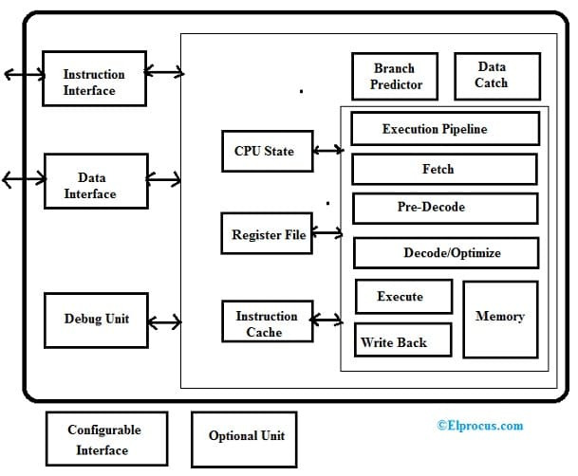
- Study of RISC-V Architecture
The basics of RISC-V instruction set architecture and processor components were studied to understand instruction flow and operation.
- Selection of Instruction Set
A simple subset of the RISC-V instruction set (RV32I) was selected for implementation to reduce complexity.
- Design of Processor Blocks
Core blocks such as Program Counter, Instruction Memory, Register File, ALU, Control Unit, and Data Memory were designed individually.
- Datapath Integration
All the designed blocks were interconnected to form a complete RISC-V processor datapath using hardware schematic.
- Control Signal Implementation
Required control signals were generated based on instruction decoding to control data flow and operations.
- 6. Simulation and Testing
Sample RISC-V instructions were executed and outputs were verified by observing register and memory values.
- Result Analysis
The processor behavior was analyzed to confirm correct instruction execution and system operation.

I. Expected Outcome of the project:
- A working basic RISC-V processor architecture will be successfully designed using hardware schematic.
- The processor will be able to execute basic RISC-V instructions correctly.
- Arithmetic and logical operations will produce accurate results through the ALU.
- Load and store operations will access memory properly.
- The project will demonstrate the complete instruction execution cycle (fetch, decode, execute, write-back).
- Simulation results will validate the correct functioning of the designed processor.
J. Application of the project:
- Learning and Education: This project helps students understand how a processor works inside, like how instructions are fetched, decoded, and executed.
- Embedded Systems: The design can be used as a basic processor for small electronic devices that need simple control and processing.
- IoT Devices: It is useful for low-power devices such as sensors and smart gadgets where simple processors are required.
- VLSI and Chip Design Practice: The project helps in learning how processors are designed at the hardware level, which is useful for VLSI studies.
- Research and Custom Design: Since RISC-V is open-source, the processor can be modified to add new features for specific applications.
K. Does the project proposed is relevant to any of the Industry or Institution in and around your area (Yes / No): |  |  |  |  | No
L. If yes, please provide details of the industry / institution and contact details:
M. Budget:
Materials Cost: 8500/-  Labour Charges:  Any other cost: |  |  |  |  | Source of Funds:  Self / Industry / Others
N. Expected Completion Time:
Expected Time for Major Activities |  |  |  |  | Schedule
Synopsis (Project Plan) submission to the Department
Presentation of synopsis
Last date for re-submission (if applicable) & review
Submission of Reports
Internal Viva and/or Project Exhibition
O. Authors:
Student(s) / Author(s) |  |  |  |  | Signature with date
1. THIYANAND M
2. CHAITHANYA
3. FATHIMATH ANEESHA
4. PREETHA S M
Checked By: |  |  |  |  | Signature with date:
P. Guidance:
Guide (s) allotted: |  |  |  |  | Signature (s) with date
1. Guide: Prof. / Dr. / Mr. / Ms.
2. Co-Guide (if any): Prof. / Dr. / Mr. / Ms.

