S.Thiyanesh 22ISR055

TASK:3

CREATING A MINIKUBE SERVICE TO HANDLE CINTAINERS

1. creating a deployment

II.exposing the deployment

III.checking for pod

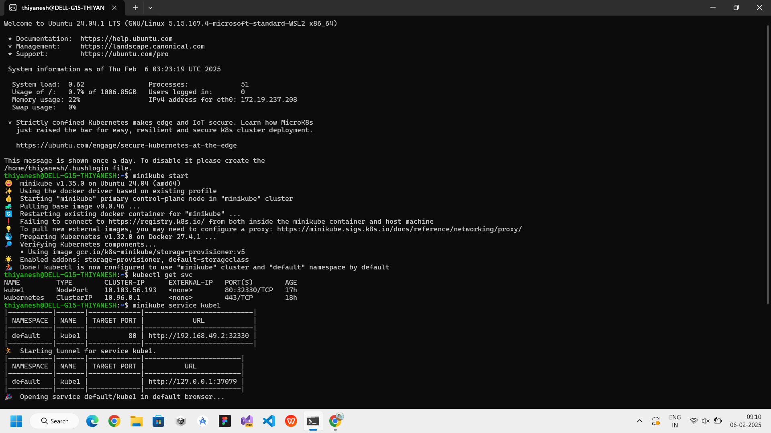

IV.opening the minikube service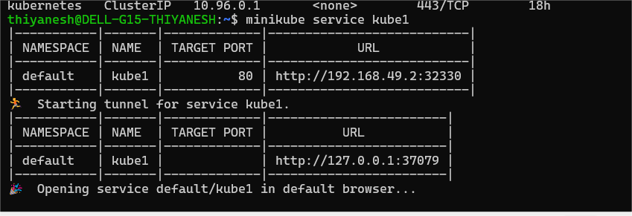

VI.output

