431 Class 06

https://thomaselove.github.io/431-2024/

2024-09-12

## Today’s Agenda

* Assumptions of our uncertainty intervals
  + for one sample / paired differences
  + for two independent samples
* Transforming an Outcome (see [Chapter 7 of our book](https://thomaselove.github.io/431-book/))
  + Why transform?
  + The importance of the logarithm and other power transformations
  + Tukey’s ladder and the Box-Cox plot
  + Back-transforming predictions, not coefficients

## Load packages and set theme

library(janitor)  
  
library(car) ## new today  
library(infer) ## new today  
library(MKinfer)  
  
library(patchwork)  
library(rstanarm)  
library(easystats)  
library(tidyverse)  
  
theme_set(theme_bw())  
knitr::opts_chunk$set(comment = NA)  
  
source("c06/data/Love-431.R") # for the lovedist() function

## Returning to the DM-464 data

dm6 <- read_csv("c06/data/dm464_class06.csv", show_col_types = FALSE) |>  
 janitor::clean_names() |>  
 mutate(across(where(is.character), as_factor)) |>  
 mutate(statin_f = as_factor(statin),  
 statin_f = fct_recode(statin_f,   
 "Statin" = "1", "No Statin" = "0")) |>  
 mutate(id_code = as.character(id_code))  
  
dim(dm6)

[1] 464 9

## Uncertainty Interval Assumptions

### One Sample (perhaps of Paired Differences)

* All approaches assume our sample is a **random** sample (or at least a representative one) from the population of interest.
* Ordinary Least Squares model / Paired T test also assumes that the population of interest follows a Normal distribution, so that our sample data should look as though it were drawn from a Normal distribution.
* Our Bayesian approach assumes a (weakly informative) prior distribution on the coefficient in our model.
* The bootstrap approach does not assume a Normal distribution for the population.

Main check in data: Normal distribution?

## Difference in A1c (end - baseline)

dm6 <- dm6 |> mutate(a1c_diff = a1c_end - a1c_base)  
  
p1 <- ggplot(dm6, aes(sample = a1c_diff)) +  
 geom_qq() + geom_qq_line(col = "red") +  
 labs(y = "A1c difference (%)", x = "Standard Normal Distribution",  
 title = "Normal Q-Q plot")  
  
bw = 1 # specify width of bins in histogram  
  
p2 <- ggplot(dm6, aes(x = a1c_diff)) +  
 geom_histogram(binwidth = bw, fill = "black", col = "yellow") +  
 stat_function(fun = function(x)   
 dnorm(x, mean = mean(dm6$a1c_diff, na.rm = TRUE),   
 sd = sd(dm6$a1c_diff, na.rm = TRUE)) *   
 length(dm6$a1c_diff) * bw,  
 geom = "area", alpha = 0.5,   
 fill = "lightblue", col = "blue") +  
 labs(x = "A1c difference (%)", y = "Count",  
 title = "Histogram & Normal Curve")  
  
p1 + p2 +   
 plot_annotation("Are differences in Hemoglobin A1c Normally distributed?")

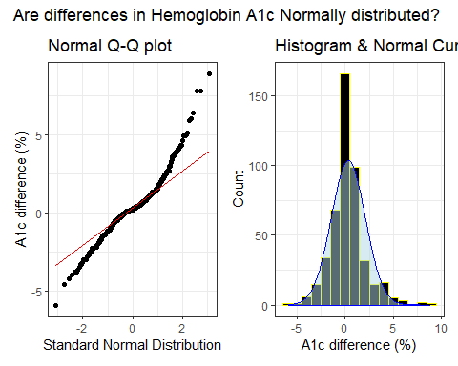

## Boxplot for Difference in A1c

ggplot(dm6, aes(x = a1c_diff, y = "")) +  
 geom_violin(fill = "cornsilk") +  
 geom_boxplot(width = 0.2) +  
 stat_summary(fun = mean, geom = "point", shape = 16, col = "red") +  
 labs(y = "", x = "A1c difference (%)", title = "Boxplot with Violin")

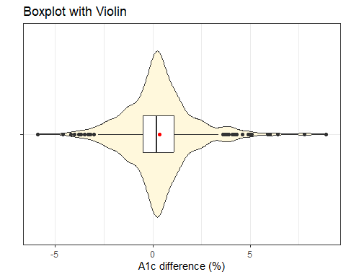

## Does a Normal model fit well?

Do we have …

1. A histogram that is symmetric and bell-shaped.
2. A boxplot where the box is symmetric around the median, as are the whiskers, without severe outliers.
3. A normal Q-Q plot that essentially falls on a straight line.
4. If in doubt, maybe compare mean and sd to median and MAD, and consider Empirical Rule to help make tough calls.

* **Don’t** rely on hypothesis tests of whether data follow a Normal distribution.

## What to do about outliers?

The paired differences here appear to be symmetric, but with outliers.

* This should push us towards a method which doesn’t require the assumption of Normality.
  + Specifically, the bootstrap would likely be a better choice than a t test, although it didn’t make a meaningful difference when we ran it last time.
  + 90% uncertainty interval with OLS/t test was (0.20, 0.47) and the bootstrap 90% uncertainty interval was also (0.20, 0.47).
* Could we transform these data in a non-linear way to better match assumptions?
  + Not really, no. Most of the transformations we use regularly are designed to address skew in the data, rather than tail behavior.
* Should we build our interval around the median instead of the mean?
  + sample median = 0.2, sample mean = 0.33
  + Maybe, but does that actually address the issue in this case?

## Bootstrap 90% interval for Median

This is from the infer package…

set.seed(431)  
  
x_med <- dm6 |>  
 observe(response = a1c_diff, stat = "median")  
  
res1 <- dm6 |>  
 specify(response = a1c_diff) |>  
 generate(reps = 2000, type = "bootstrap") |>  
 calculate(stat = "median") |>  
 get_confidence_interval(level = 0.90, type = "percentile")  
  
res1 <- res1 |>  
 mutate(pt_est = x_med$stat) |>  
 relocate(pt_est)  
  
res1

# A tibble: 1 × 3  
 pt_est lower_ci upper_ci  
 <dbl> <dbl> <dbl>  
1 0.200 0.200 0.300

## Uncertainty Interval Assumptions

### Two Independent Samples

* All methods assume each of the two samples is a random sample (or at least a representative one) from its population of interest.
* Ordinary Least Squares model / Pooled T test additionally assumes that:
  + **each** of the two populations of interest follows a Normal distribution, **and**
  + **either** the variance of those two populations is equal, so it makes sense to create a pooled estimate of the standard deviation, **or** the sample sizes are equal in the two groups (a balanced design)
* The Welch t test assumes Normality, but not equal variances.
* Our Bayesian approach assumes a (weakly informative) prior distribution on each of the coefficients (intercept and slope) of our model.
* The bootstrap approach does not assume a Normal distribution for the population, but can take advantage of an assumption of equal variances if it exists.

## From last class…

Estimating the mean difference in LDL levels at baseline for the “Statin” group minus the “No Statin” group…

| Approach | Estimate & 90% Interval |
| --- | --- |
| Ordinary least squares / Pooled t | 7.17 (0.02, 14.32) |
| Bayesian fit with stan_glm() | 7.22 (-0.06, 14.56) |
| Welch t without pooling sd | 7.17 (0.86, 13.48) |
| Bootstrap with pooled sd | 7.21 (0.34, 14.29) |
| Bootstrap with unpooled sd | 7.23 (0.88, 13.66) |

* Is there a big impact here of using the Bootstrap rather than OLS?

## LDL by Statin prescription status

ggplot(dm6, aes(x = ldl_base, y = statin_f)) +  
 geom_violin() +  
 geom_boxplot(aes(fill = statin_f), width = 0.3) +  
 stat_summary(fun = mean, geom = "point",   
 shape = 18, size = 3, col = "yellow") +  
 guides(fill = "none") +  
 labs(y = "Statin prescription", x = "LDL Cholesterol (mg/dl)",  
 title = "LDL by Statin prescription",  
 subtitle = "Each group is a bit skewed to the right")

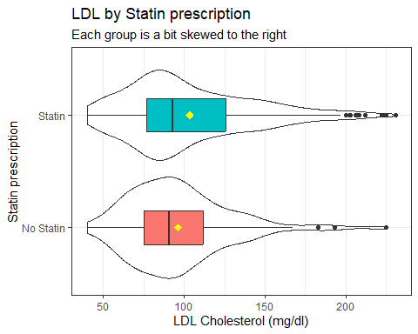

## Can we do something about the skew?

* Could we build a confidence interval for medians instead of means?
  + Yes, with the bootstrap, for example.
* Could we transform the data in a non-linear way to better match assumptions?
  + Yes, with the help of Tukey’s ladder of power transformations.

## Tukey’s Ladder

| Power ($λ$) | -2 | -1 | -0.5 | 0 | 0.5 | 1 | 2 | 3 |
| --- | --- | --- | --- | --- | --- | --- | --- | --- |
| Transformation | $\frac{1}{y^{2}}$ | $\frac{1}{y}$ | $\frac{1}{\sqrt{y}}$ | log $y$ | $\sqrt{y}$ | $y$ | $y^{2}$ | $y^{3}$ |

* Works to address skew, mainly, rather than symmetry with problems in the tails
* Some of these transformations require all values to be positive. If they aren’t, we can add a small amount to each observation until they are.
* Start at no transformation ($λ=1$)
* Try moving in one direction or the other, searching for a result which better matches what we might expect from a Normal distribution
  + If a step (like taking the square root) helps, move in that same direction.
  + If it doesn’t help, try moving in the other direction.

## A1c values (end of study)

ggplot(dm6, aes(x = a1c_end)) +   
 geom_histogram(binwidth = 0.4, fill = "slateblue", col = "white") +   
 stat_function(fun = function(x)   
 dnorm(x, mean = mean(dm6$a1c_end, na.rm = TRUE),   
 sd = sd(dm6$a1c_end, na.rm = TRUE)) *   
 length(dm6$a1c_end) * 0.4,  
 geom = "area", alpha = 0.5,   
 fill = "lightblue", col = "blue") +  
 labs(title = "A1c (untransformed)", x = "Hemoglobin A1c, %", y = "Count")

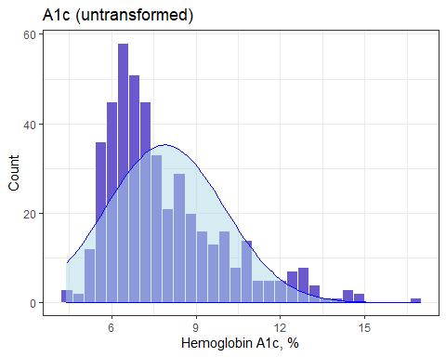

## Six Power Transformations

p1 <- ggplot(dm6, aes(x = a1c_end^3)) +   
 geom_histogram(bins = 25, fill = "firebrick", col = "white") +   
 labs(title = "A1c^3 (cubed)", x = "A1c^3", y = "Count")  
  
p2 <- ggplot(dm6, aes(x = a1c_end^2)) +   
 geom_histogram(bins = 25, fill = "magenta", col = "white") +   
 labs(title = "A1c^2 (squared)", x = "A1c^2", y = "Count")  
  
p3 <- ggplot(dm6, aes(x = a1c_end)) +   
 geom_histogram(bins = 25, fill = "slateblue", col = "white") +   
 labs(title = "A1c (untransformed)", x = "Hemoglobin A1c, %", y = "Count")  
  
p4 <- ggplot(dm6, aes(x = sqrt(a1c_end))) +   
 geom_histogram(bins = 25, fill = "skyblue", col = "white") +   
 labs(title = "sqrt(A1c) (square root)", x = "sqrt(A1c)", y = "Count")  
  
p5 <- ggplot(dm6, aes(x = log(a1c_end))) +   
 geom_histogram(bins = 25, fill = "navy", col = "white") +   
 labs(title = "log A1c (logarithm)", x = "log A1c", y = "Count")  
  
p6 <- ggplot(dm6, aes(x = 1/a1c_end)) +   
 geom_histogram(bins = 25, fill = "thistle", col = "white") +   
 labs(title = "1/A1c (inverse)", x = "1/A1c", y = "Count")  
  
(p1 + p2 + p3) / (p4 + p5 + p6)

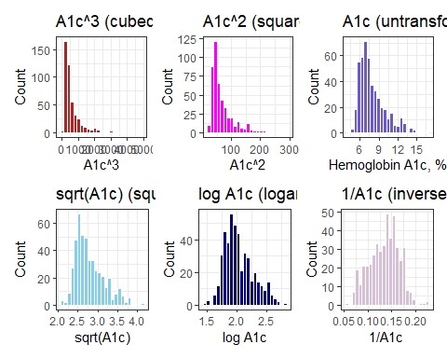

## Which Transformation to Choose?

Box-Cox approach: can we get a suggested “power” to use when transforming our outcome?

* Specify the model then apply boxCox from car package.
* Here, all values of our outcome (A1c) are strictly positive.
  + If not, we’d have to add a constant so that they were.

fit1 <- lm(a1c_end ~ 1, data = dm6)  
boxCox(fit1)

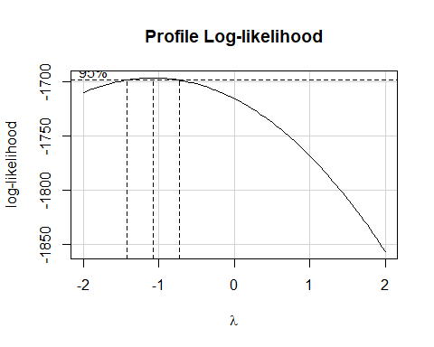

## Back to LDL by Statin prescription

ggplot(dm6, aes(x = ldl_base, y = statin_f)) +  
 geom_violin() +  
 geom_boxplot(aes(fill = statin_f), width = 0.3) +  
 stat_summary(fun = mean, geom = "point",   
 shape = 18, size = 3, col = "yellow") +  
 guides(fill = "none") +  
 labs(y = "Statin prescription", x = "LDL Cholesterol (mg/dl)",  
 title = "LDL by Statin prescription",  
 subtitle = "Each group is a bit skewed to the right")



## What transformation should we try?

fit2 <- lm(ldl_base ~ statin, data = dm6)  
boxCox(fit2)

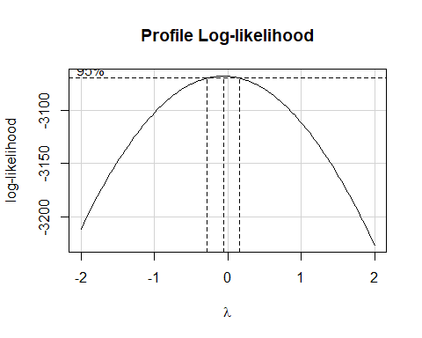

## log(LDL) by Statin?

ggplot(dm6, aes(x = log(ldl_base), y = statin_f)) +  
 geom_violin() + geom_boxplot(aes(fill = statin_f), width = 0.3) +  
 labs(y = "Statin prescription", x = "log(LDL)",  
 title = "log(LDL) by Statin prescription") +  
 guides(fill = "none")

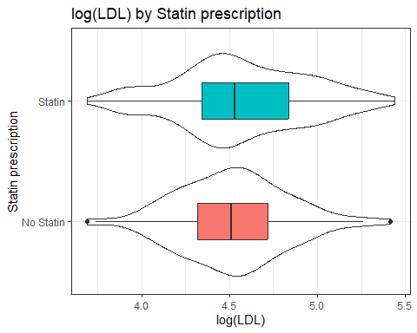

## Estimate log(LDL) by Statin

Let’s use a 90% uncertainty interval…

fit3 <- lm(log(ldl_base) ~ statin_f, data = dm6)  
  
model_parameters(fit3, ci = 0.90)

Parameter | Coefficient | SE | 90% CI | t(462) | p  
------------------------------------------------------------------------  
(Intercept) | 4.52 | 0.04 | [ 4.46, 4.58] | 122.75 | < .001  
statin f [Statin] | 0.05 | 0.04 | [-0.02, 0.12] | 1.23 | 0.220

Uncertainty intervals (equal-tailed) and p-values (two-tailed) computed  
 using a Wald t-distribution approximation.

The model has a log-transformed response variable. Consider using  
 `exponentiate = TRUE` to interpret coefficients as ratios.

## Expectations from our model

* The coefficients of this model exist in the transformed world, but we can make predictions back on our original scale.

estimate_expectation(fit3, data = "grid", ci = 0.90)

Model-based Expectation  
  
statin_f | Predicted | SE | 90% CI  
-------------------------------------------  
No Statin | 4.52 | 0.04 | [4.46, 4.58]  
Statin | 4.57 | 0.02 | [4.54, 4.60]  
  
Variable predicted: ldl_base  
Predictors modulated: statin_f

* and we exponentiate to get back to our original scale…

## Exponentiation of Expectations

* We back out of the logged predictions by exponentiating them.

| Group | Predicted LDL | 90% uncertainty interval |
| --- | --- | --- |
| No Statin | exp(4.52) = 91.8 | (exp(4.46), exp(4.58)) = (86.5, 97.5) |
| Statin | exp(4.57) = 96.5 | (exp(4.54), exp(4.60)) = (93.7, 99.5) |

* These intervals describe uncertainty about the **average predicted LDL across all subjects** in each statin group.

## Fitting Individual Predictions

* We use estimate_prediction() to make predictions for an individual subject in each group.

estimate_prediction(fit3, data = "grid", ci = 0.90)

Model-based Prediction  
  
statin_f | Predicted | SE | 90% CI  
-------------------------------------------  
No Statin | 4.52 | 0.36 | [3.92, 5.12]  
Statin | 4.57 | 0.36 | [3.97, 5.17]  
  
Variable predicted: ldl_base  
Predictors modulated: statin_f

* and again we exponentiate to get back to our original scale…

## Fitting Individual Predictions

* We back out of the logged predictions by exponentiating them.

| Group | Predicted LDL | 90% uncertainty interval |
| --- | --- | --- |
| No Statin | exp(4.52) = 91.8 | (exp(3.92), exp(5.12)) = (50.4, 167.3) |
| Statin | exp(4.57) = 96.5 | (exp(3.97), exp(5.17)) = (53, 175.9) |

* These intervals describe uncertainty about an **individual predicted LDL for a single subject** within each statin group.

## Using the log transformation

* The log transformation in R (log in R is the natural log - the base 10 log is log10()) generates coefficients which describe a multiplicative effect.

If we fit a model to predict $y$ using $x$ of the form:

$$logy=β_{0}+β_{1}x$$

where $logy$ is the natural logarithm, then if we exponentiate the slope coefficient, we get the multiplicative factor for each one-unit increase in the predictor.

## The Math

$$
\log(y) = \beta_0 + \beta_1 x \\
\exp(\log(y)) = \exp(\beta_0 + \beta_1 x) \\
y = \exp(\beta_0 + \beta_1 x) \\
y = \exp(\beta_0) \times \exp(\beta_1 x)
$$

This implies that our predictor ($x$) has a multiplicative relationship with our outcome ($y$) instead of the usual additive relationship. Hence, we can express the effect of a one-unit change in $x$ on $y$ as a percentage change.

## Example 1

Suppose we build a regression model with equation $logy=6+0.23x$.

Note that $exp\left(0.23\right)=1.26$.

* If Harry’s value of $x$ is 1 point larger than Sally’s, the predicted $y$ value for Harry will be increased by 26% relative to Sally’s. (Increased by 26% = multiplied by 1.26.)

## Example 2

fit3 <- lm(log(ldl_base) ~ statin_f, data = dm6)  
  
model_parameters(fit3, ci = 0.90)

Parameter | Coefficient | SE | 90% CI | t(462) | p  
------------------------------------------------------------------------  
(Intercept) | 4.52 | 0.04 | [ 4.46, 4.58] | 122.75 | < .001  
statin f [Statin] | 0.05 | 0.04 | [-0.02, 0.12] | 1.23 | 0.220

Uncertainty intervals (equal-tailed) and p-values (two-tailed) computed  
 using a Wald t-distribution approximation.

* We can exponentiate these coefficients…

model_parameters(fit3, exponentiate = TRUE, ci = 0.90)

Parameter | Coefficient | SE | 90% CI | t(462) | p  
-------------------------------------------------------------------------  
(Intercept) | 91.67 | 3.37 | [86.27, 97.40] | 122.75 | < .001  
statin f [Statin] | 1.05 | 0.04 | [ 0.98, 1.13] | 1.23 | 0.220

Uncertainty intervals (equal-tailed) and p-values (two-tailed) computed  
 using a Wald t-distribution approximation.

Subjects *with* a statin prescription have 5% higher LDL, on average, than do subjects *without*. The ratio has point estimate 1.05 and 90% interval estimate (0.98, 1.13).

## Difference in A1c by Sex

ggplot(dm6, aes(x = a1c_diff, y = sex)) +  
 geom_violin() + geom_boxplot(aes(fill = sex), width = 0.3) +  
 labs(x = "Change in A1c", y = "Sex",  
 title = "Difference in A1c (end - base) by Sex") +  
 guides(fill = "none")

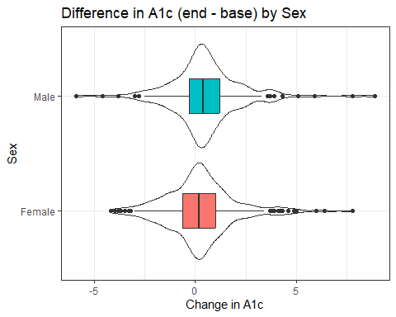

## Numerical Summary

dm6 |> group_by(sex) |>   
 reframe(lovedist(a1c_diff)) |>   
 print_md(digits = 3)

| sex | n | miss | mean | sd | med | mad | min | q25 | q75 | max |
| --- | --- | --- | --- | --- | --- | --- | --- | --- | --- | --- |
| Female | 288 | 0 | 0.227 | 1.747 | 0.200 | 1.186 | -4.200 | -0.625 | 1.000 | 7.800 |
| Male | 176 | 0 | 0.503 | 1.838 | 0.400 | 1.186 | -5.900 | -0.300 | 1.200 | 8.900 |

* Observed difference in sample means is 0.503 - 0.227 = 0.276
* Do we have a balanced design?
* Do we feel comfortable pooling these standard deviations?
* Do we feel comfortable assuming Normality for each sex?

## Might a transformation help here?

Some of the changes in A1c are negative (minimum was -5.9)

dm6 <- dm6 |> mutate(a1c_diff_p6 = a1c_diff + 6)  
fit4 <- lm(a1c_diff_p6 ~ sex, data = dm6)  
boxCox(fit4)

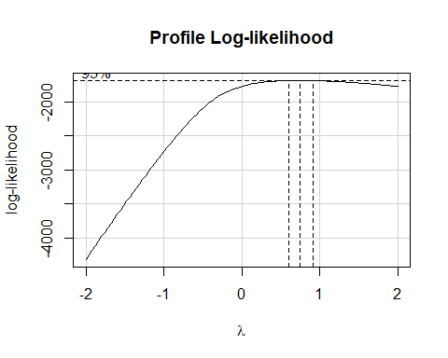

## Does using a square root help us here?

p1 <- ggplot(dm6, aes(x = a1c_diff_p6, y = sex)) +  
 geom_violin() + geom_boxplot(aes(fill = sex), width = 0.3) +  
 labs(x = "Change in A1c + 6", y = "Sex",  
 title = "A1c difference (+ 6) by Sex") +  
 guides(fill = "none")  
  
p2 <- ggplot(dm6, aes(x = sqrt(a1c_diff_p6), y = sex)) +  
 geom_violin() + geom_boxplot(aes(fill = sex), width = 0.3) +  
 labs(x = "Square Root of (Change in A1c + 6)", y = "Sex",  
 title = "Square Root of (A1c difference + 6) by Sex") +  
 guides(fill = "none")  
  
p1 / p2

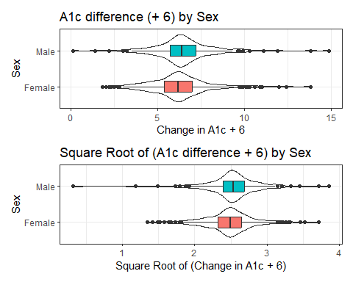

## Addressing outliers?

### OLS model

fit5 <- lm(a1c_diff ~ sex, data = dm6)  
  
model_parameters(fit5, ci = 0.90)

Parameter | Coefficient | SE | 90% CI | t(462) | p  
-----------------------------------------------------------------  
(Intercept) | 0.23 | 0.11 | [ 0.05, 0.40] | 2.16 | 0.031  
sex [Male] | 0.28 | 0.17 | [ 0.00, 0.56] | 1.62 | 0.105

Uncertainty intervals (equal-tailed) and p-values (two-tailed) computed  
 using a Wald t-distribution approximation.

* Male subjects had A1c changes that were 0.28 larger than females, on average, with 90% uncertainty interval (0, 0.56) according to our OLS model (pooled t test.)

## Addressing outliers?

### Bayesian model

set.seed(20240912)  
fit6 <- stan_glm(a1c_diff ~ sex, data = dm6, refresh = 0)  
  
model_parameters(fit6, ci = 0.90)

Parameter | Median | 90% CI | pd | Rhat | ESS | Prior  
---------------------------------------------------------------------------------------  
(Intercept) | 0.22 | [ 0.05, 0.39] | 98.42% | 1.000 | 3666.00 | Normal (0.33 +- 4.46)  
sexMale | 0.28 | [ 0.00, 0.57] | 94.80% | 1.000 | 3649.00 | Normal (0.00 +- 9.19)

Uncertainty intervals (equal-tailed) and p-values (two-tailed) computed  
 using a MCMC distribution approximation.

* Male subjects had A1c changes that were 0.28 larger than females, on average, with 90% uncertainty interval (0, 0.57) according to our Bayesian model.

## Addressing outliers?

### Bootstrap with boot.t.test

set.seed(20240912)  
boot.t.test(a1c_diff ~ sex, data = dm6, conf.level = 0.90)

Bootstrap Welch Two Sample t-test  
  
data: a1c_diff by sex  
number of bootstrap samples: 9999  
bootstrap p-value = 0.1096   
bootstrap difference of means (SE) = -0.2787276 (0.1715815)   
90 percent bootstrap percentile confidence interval:  
 -0.566107955 0.002070707  
  
Results without bootstrap:  
t = -1.6028, df = 355.56, p-value = 0.1099  
alternative hypothesis: true difference in means is not equal to 0  
90 percent confidence interval:  
 -0.561349458 0.008003498  
sample estimates:  
mean in group Female mean in group Male   
 0.2267361 0.5034091

## Session Information

xfun::session_info()

R version 4.4.1 (2024-06-14 ucrt)  
Platform: x86_64-w64-mingw32/x64  
Running under: Windows 11 x64 (build 22631)  
  
Locale:  
 LC_COLLATE=English_United States.utf8   
 LC_CTYPE=English_United States.utf8   
 LC_MONETARY=English_United States.utf8  
 LC_NUMERIC=C   
 LC_TIME=English_United States.utf8   
  
Package version:  
 abind_1.4-5 arrangements_1.1.9 askpass_1.2.0   
 backports_1.5.0 base64enc_0.1-3 bayesplot_1.11.1   
 bayestestR_0.14.0 BH_1.84.0.0 bit_4.0.5   
 bit64_4.0.5 blob_1.2.4 boot_1.3-31   
 broom_1.0.6 bslib_0.8.0 cachem_1.1.0   
 callr_3.7.6 car_3.1-2 carData_3.0-5   
 cellranger_1.1.0 checkmate_2.3.2 cli_3.6.3   
 clipr_0.8.0 coda_0.19-4.1 codetools_0.2-20   
 colorspace_2.1-1 colourpicker_1.3.0 commonmark_1.9.1   
 compiler_4.4.1 conflicted_1.2.0 correlation_0.8.5   
 cowplot_1.1.3 cpp11_0.5.0 crayon_1.5.3   
 crosstalk_1.2.1 curl_5.2.2 data.table_1.16.0   
 datasets_4.4.1 datawizard_0.12.3 DBI_1.2.3   
 dbplyr_2.5.0 Deriv_4.1.3 desc_1.4.3   
 digest_0.6.37 distributional_0.4.0 doBy_4.6.22   
 dplyr_1.1.4 DT_0.33 dtplyr_1.3.1   
 dygraphs_1.1.1.6 easystats_0.7.3 effectsize_0.8.9   
 emmeans_1.10.4 estimability_1.5.1 evaluate_0.24.0   
 exactRankTests_0.8-35 fansi_1.0.6 farver_2.1.2   
 fastmap_1.2.0 fontawesome_0.5.2 forcats_1.0.0   
 foreach_1.5.2 fs_1.6.4 gargle_1.5.2   
 generics_0.1.3 ggplot2_3.5.1 ggridges_0.5.6   
 glmnet_4.1-8 glue_1.7.0 gmp_0.7-5   
 googledrive_2.1.1 googlesheets4_1.1.1 graphics_4.4.1   
 grDevices_4.4.1 grid_4.4.1 gridExtra_2.3   
 gtable_0.3.5 gtools_3.9.5 haven_2.5.4   
 highr_0.11 hms_1.1.3 htmltools_0.5.8.1   
 htmlwidgets_1.6.4 httpuv_1.6.15 httr_1.4.7   
 ids_1.0.1 igraph_2.0.3 infer_1.0.7   
 inline_0.3.19 insight_0.20.4 isoband_0.2.7   
 iterators_1.0.14 janitor_2.2.0 jomo_2.7-6   
 jquerylib_0.1.4 jsonlite_1.8.8 knitr_1.48   
 labeling_0.4.3 later_1.3.2 lattice_0.22-6   
 lazyeval_0.2.2 lifecycle_1.0.4 lme4_1.1-35.5   
 loo_2.8.0 lubridate_1.9.3 magrittr_2.0.3   
 markdown_1.13 MASS_7.3-61 Matrix_1.7-0   
 MatrixModels_0.5.3 matrixStats_1.4.0 memoise_2.0.1   
 methods_4.4.1 mgcv_1.9.1 mice_3.16.0   
 miceadds_3.17-44 microbenchmark_1.5.0 mime_0.12   
 miniUI_0.1.1.1 minqa_1.2.8 mitml_0.4-5   
 mitools_2.4 MKdescr_0.8 MKinfer_1.2   
 modelbased_0.8.8 modelr_0.1.11 multcomp_1.4-26   
 munsell_0.5.1 mvtnorm_1.3-1 nlme_3.1-164   
 nloptr_2.1.1 nnet_7.3-19 numDeriv_2016.8.1.1   
 openssl_2.2.1 ordinal_2023.12.4.1 pan_1.9   
 parallel_4.4.1 parameters_0.22.2 patchwork_1.2.0   
 pbkrtest_0.5.3 performance_0.12.3 pillar_1.9.0   
 pkgbuild_1.4.4 pkgconfig_2.0.3 plyr_1.8.9   
 posterior_1.6.0 prettyunits_1.2.0 processx_3.8.4   
 progress_1.2.3 promises_1.3.0 ps_1.7.7   
 purrr_1.0.2 quantreg_5.98 QuickJSR_1.3.1   
 R6_2.5.1 ragg_1.3.2 rappdirs_0.3.3   
 RColorBrewer_1.1.3 Rcpp_1.0.13 RcppArmadillo_14.0.0.1  
 RcppEigen_0.3.4.0.2 RcppParallel_5.1.9 readr_2.1.5   
 readxl_1.4.3 rematch_2.0.0 rematch2_2.1.2   
 report_0.5.9 reprex_2.1.1 reshape2_1.4.4   
 rlang_1.1.4 rmarkdown_2.28 rpart_4.1.23   
 rstan_2.32.6 rstanarm_2.32.1 rstantools_2.4.0   
 rstudioapi_0.16.0 rvest_1.0.4 sandwich_3.1-0   
 sass_0.4.9 scales_1.3.0 see_0.9.0   
 selectr_0.4.2 shape_1.4.6.1 shiny_1.9.1   
 shinyjs_2.1.0 shinystan_2.6.0 shinythemes_1.2.0   
 snakecase_0.11.1 sourcetools_0.1.7.1 SparseM_1.84.2   
 splines_4.4.1 StanHeaders_2.32.10 stats_4.4.1   
 stats4_4.4.1 stringi_1.8.4 stringr_1.5.1   
 survival_3.7-0 sys_3.4.2 systemfonts_1.1.0   
 tensorA_0.36.2.1 textshaping_0.4.0 TH.data_1.1-2   
 threejs_0.3.3 tibble_3.2.1 tidyr_1.3.1   
 tidyselect_1.2.1 tidyverse_2.0.0 timechange_0.3.0   
 tinytex_0.52 tools_4.4.1 tzdb_0.4.0   
 ucminf_1.2.2 utf8_1.2.4 utils_4.4.1   
 uuid_1.2.1 V8_5.0.0 vctrs_0.6.5   
 viridisLite_0.4.2 vroom_1.6.5 withr_3.0.1   
 xfun_0.47 xml2_1.3.6 xtable_1.8-4   
 xts_0.14.0 yaml_2.3.10 zoo_1.8-12