431 Class 11

https://thomaselove.github.io/431-2024/

2024-10-01

## Today’s Agenda

* Confidence Intervals for a Population Proportion
  + Many Possibilities
  + Two We Most Often Use in Practice
* Comparing Two Proportions using Independent Samples
  + Standard Epidemiological Format
  + Working with 2x2 Tables

Today’s material is discussed in Chapter 13 of our Course Book.

## Today’s Packages

library(Epi) # for twoby2() function  
library(readxl) # to import an Excel file  
library(janitor)  
library(easystats)  
library(tidyverse)  
  
source("c11/data/Love-431.R") # for twobytwo() function  
  
theme_set(theme_bw())

# Confidence Intervals for a Population Proportion

## Moving on from Means to Proportions

We’ve focused on creating statistical inferences about a population mean when we have a quantitative outcome. Now, we’ll tackle a **categorical** outcome.

We’ll estimate a confidence interval around an unknown population proportion, or rate, symbolized with $π$, on the basis of a random sample of *n* observations from the population of interest.

The sample proportion is called $\hat{p}$, which is sometimes, unfortunately, symbolized as $p$.

* $\hat{p}$ is the sample proportion - not a *p* value.

## An Example from *JAMA Pediatrics*

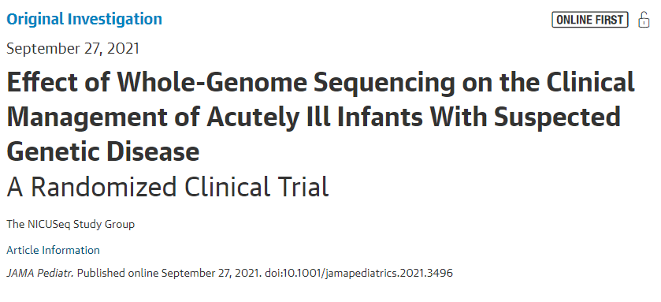

## Outcome: Change of Management (COM)

The study involved infants ages 0-120 days admitted to an intensive care unit with a suspected genetic disease.

* For our first example, we focus on a sample of 326 subjects who received whole-genome sequencing testing at some point in the first 60 days after they were enrolled in the study.
* The outcome of interest is whether or not the subject received a change of management (COM) 60 days after their enrollment.

What can we conclude about the true proportion in the population of infants who meet our study criteria who would have a COM?

## Loading the Data

nicu <- read_excel("c11/data/nicu_seq.xls") |>  
 janitor::clean_names()  
  
nicu

# A tibble: 326 × 3  
 subject interv outcome  
 <dbl> <chr> <chr>   
 1 1 Early (15) No_COM   
 2 2 Early (15) COM   
 3 3 Delayed (60) COM   
 4 4 Delayed (60) No_COM   
 5 5 Early (15) COM   
 6 6 Early (15) No_COM   
 7 7 Delayed (60) No_COM   
 8 8 Delayed (60) No_COM   
 9 9 Delayed (60) No_COM   
10 10 Early (15) No_COM   
# ℹ 316 more rows

## Our outcome data

nicu |> tabyl(outcome) |> adorn_totals() |> adorn_pct_formatting()

outcome n percent  
 COM 51 15.6%  
 No_COM 275 84.4%  
 Total 326 100.0%

Our first inferential goal will be to produce a **confidence interval for the true (population) proportion** receiving a COM, across all infants who meet study criteria, based on this sample of 326 infants.

## A Confidence Interval for a Proportion

A 100(1- $α$)% confidence interval for the population proportion $π$ can be created by using:

* the standard normal distribution,
* the sample proportion, $\hat{p}$, and
* the standard error of a sample proportion, which is defined as the square root of $\hat{p}$ multiplied by $\left(1−\hat{p}\right)$ divided by the sample size, $n$.

## A Confidence Interval for a Proportion

Specifically, that confidence interval estimate is $\hat{p}±Z_{α/2}\sqrt{\frac{\hat{p}\left(1−\hat{p}\right)}{n}}$

where $Z_{α/2}$ = the value from a standard Normal distribution cutting off the top $α/2$ of the distribution, obtained in R by substituting the desired $α/2$ value into: qnorm(alpha/2, lower.tail=FALSE).

* *Note*: This interval is reasonably accurate so long as $n\hat{p}$ and $n\left(1−\hat{p}\right)$ are each at least 5.

## Estimating $π$ in the NICU data

* We’ll build a 95% confidence interval for the true population proportion, so $α$ = 0.05
* We have n = 326 subjects
* Sample proportion is $\hat{p}$ = .156, since 51/326 = 0.156.

The standard error of that sample proportion will be

$$\text{SE}\left(\hat{p}\right)=\sqrt{\frac{\hat{p}\left(1−\hat{p}\right)}{n}}=\sqrt{\frac{0.156\left(1−0.156\right)}{326}}=0.020$$

## Confidence Interval for $π$ = Pr(COM)

Our 95% confidence interval for the true population proportion, $π$, of infants who have a COM within 60 days is:

$$\hat{p}±Z_{.025}\sqrt{\frac{\hat{p}\left(1−\hat{p}\right)}{n}}=0.156±1.96\left(0.020\right)=0.156±0.039$$

or (0.117, 0.195).

To verify that $Z_{0.025}=1.96$…

qnorm(0.025, lower.tail=FALSE)

[1] 1.959964

## Likely Accuracy of this CI?

Since $n\hat{p}=\left(326\right)\left(0.156\right)=51$ and $n\left(1−\hat{p}\right)=\left(326\right)\left(1−0.156\right)=275$ are substantially greater than 5, the CI should be reasonably accurate.

What can we conclude from this analysis?

* Point estimate of the proportion with COM is 0.156
* 95% CI for population proportion is (0.117, 0.195)

## What is the “margin of error” in this confidence interval?

95% CI for population proportion is (0.117, 0.195)

* The entire confidence interval has width 0.078 (or 7.8 percentage points.)
* The margin of error (or half-width) is 0.039, or 3.9 percentage points.

Happily, that’s our last “by hand” calculation.

## Using prop.test() to estimate a CI

Here’s one way to use R to estimate a slightly different interval.

prop.test(x = 51, n = 326, conf.level = 0.95,  
 correct = TRUE)

1-sample proportions test with continuity correction  
  
data: 51 out of 326, null probability 0.5  
X-squared = 152.54, df = 1, p-value < 2.2e-16  
alternative hypothesis: true p is not equal to 0.5  
95 percent confidence interval:  
 0.1196740 0.2015196  
sample estimates:  
 p   
0.1564417

## Using binom.test() from base R

Here’s another way to use R to estimate a slightly different interval.

binom.test(x = 51, n = 326, conf.level = 0.95)

Exact binomial test  
  
data: 51 and 326  
number of successes = 51, number of trials = 326, p-value < 2.2e-16  
alternative hypothesis: true probability of success is not equal to 0.5  
95 percent confidence interval:  
 0.1187533 0.2005092  
sample estimates:  
probability of success   
 0.1564417

## Many Different Confidence Intervals

One could use the binom.test() function from within the mosaic package to generate at least 5 other types of CI for a proportion.

For a 95% CI, we would use:

mosaic::binom.test(x = 51, n = 326, p = 0.5, conf.level = 0.95, # defaults  
 ci.method = "XXX")

where the appropriate ci.method is obtained from the next slide’s table.

## Choosing a ci.method

| Approach | ci.method to be used |
| --- | --- |
| Wald | "Wald" |
| Clopper-Pearson | "Clopper-Pearson" or "binom.test" |
| Score | "Score" or "prop.test" |
| Agresti-Coull | "agresti-coull" |
| Plus4 | "plus4" |

## Approaches 1-2 in binom.test()

Each of these five approaches involves an approximation.

1. **Wald** is the “basic biostatistics” method we just calculated, where we estimate the standard error using the sample proportion and then use the Normal distribution to set the endpoints. The Wald interval is always symmetric, and can dip below 0 or above 1.
2. **Clopper-Pearson** is used by stats::binom.test() in R as well. It guarantees coverage at least as large as the nominal coverage rate, but may produce wider intervals than the other methods.

## Approaches 3-5 in binom.test()

1. **Score** is used by stats::prop.test() and creates CIs by inverting p-values from score tests. It can be applied with a continuity correction (use ci.method = "prop.test") or without.
2. **Agresti-Coull** is the Wald method after adding Z successes and Z failures to the data, where Z is the appropriate quantile for a standard Normal distribution (1.96 for a 95% CI)
3. **Plus4** is the Wald method after adding 2 successes and 2 failures (so 4 observations) to the data.

## Plotting Some 95% CI Estimates

res <- tibble(  
 approach = c("prop.test", "Wald", "Clopper-Pearson",   
 "Score", "Agresti-Coull", "Plus4", "SAIFS"),  
 estimate = c(.15644, .15644, .15644, .15644, .15644, .15644, .15644),  
 conf.low = c(.11967, .11701, .11875, .12104, .12084, .12099, .11643 ),  
 conf.high = c(.20152, .19588, .20051, .19985, .20005, .20022, .19887)  
)  
  
ggplot(res, aes(x = approach, y = estimate)) +  
 geom_point() +   
 geom_errorbar(aes(ymin = conf.low, ymax = conf.high)) +   
 labs(title = "Some 95% CIs for x = 51, n = 326") +  
 ylim(0.1, 0.25) +  
 coord_flip()

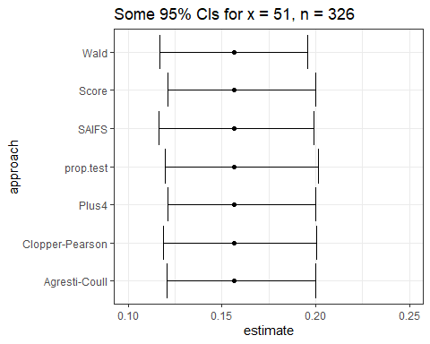

## Estimating Rates More Accurately

Suppose you have some data involving n independent tries, with x successes. The most natural estimate of the “success rate” in the data is x / n. But, strangely enough, it turns out this isn’t an entirely satisfying estimator.

Alan Agresti provides substantial motivation for $\frac{x+1}{n+2}$ and $\frac{x+2}{n+4}$ as alternatives. See <http://andrewgelman.com/2007/05/15>, for instance. We’ll call this a *Bayesian augmentation*.

## Using the Love-431.R script’s saifs_ci() function

Let’s obtain a 90% CI using this augmentation.

saifs_ci(x = 51, n = 326, conf.level = 0.90)

# A tibble: 1 × 6  
 sample_x sample_n sample_p lower upper conf_level  
 <dbl> <dbl> <dbl> <dbl> <dbl> <dbl>  
1 51 326 0.156 0.123 0.192 0.9

SAIFS refers to a confidence interval built for the proportion after single augmentation with one failure and one success.

* Reed JF (2007) “[Better Binomial Confidence Intervals](https://digitalcommons.wayne.edu/cgi/viewcontent.cgi?article=1132&context=jmasm)” *J Modern Applied Stat Methods* 6:1.

## When does this matter?

Estimates with and without the augmentation will be generally comparable, so long as…

1. the sample size is more than, say, 30 subjects, and/or
2. the sample probability of the outcome is between 0.1 and 0.9

## What if x = 0 or x = n?

The **Rule of Three** approach is often used.

* An approximate 95% CI for the proportion in a setting where x = 0 in n trials is $\left(0,\frac{3}{n}\right)$
* An approximate 95% CI for the proportion where x = n in n trials is $\left(1−\frac{3}{n},1\right)$

# Comparing Population Proportions

## Comparing Population Proportions

Suppose we compare population proportions $π_{1}$ and $π_{2}$, based on samples of sizes $n_{1}$ and $n_{2}$.

1. The individual observations in exposure group 1 are not linked/matched to individual observations in exposure group 2. (Independent Samples)
2. Each individual observation in exposure group 1 is linked or matched to a specific observation in exposure group 2. (Paired Samples)

## Paired/Matched vs. Unmatched/Independent Samples

The determination as to whether the study design creates paired or independent samples can be determined without summarizing the data. It’s a function of the sampling design, not the responses.

## A Polling Example (1/2)

* 200 adult Ohio residents agreed to participate in a poll both two months ago and again today. Each of the 200 people met the polling organization’s standards for a “likely voter in the next election”. 100 of those polled were under the age of 50 and the rest were 50 or older.
* In between the two polls, a major news event occurred which was relevant to Candidate X.

We asked them the same question at both times: “Are you considering voting for Candidate X?”

## A Polling Example (2/2)

We are interested in understanding what the data tell us about:

1. Were people under age 50 more likely to be considering Candidate X than people ages 50 and higher?
2. Were people more likely to be considering Candidate X after the news event than before?

Which of these uses *independent* samples, and which *paired* samples?

# Comparing Proportions using Independent Samples

## Visual Abstract: NICU Sequencing Paper

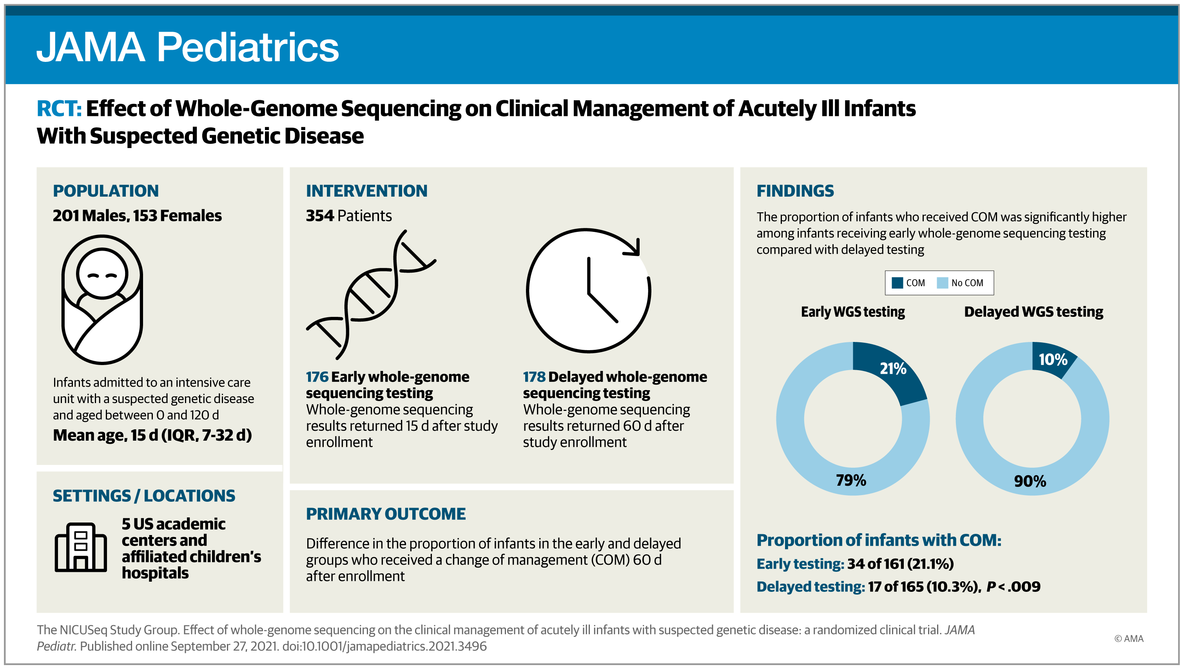

## NICU Sequencing Example

Let’s compare the proportion who have a COM between:

* Group 1: infants tested early (15 d after enrollment)
* Group 2: infants tested later (60 d after enrollment)

nicu |> count(interv, outcome)

# A tibble: 4 × 3  
 interv outcome n  
 <chr> <chr> <int>  
1 Delayed (60) COM 17  
2 Delayed (60) No_COM 148  
3 Early (15) COM 34  
4 Early (15) No_COM 127

* How might we rearrange this information? Exposure? Outcome?

## The Table We’d Like To Get To

Let’s compare the proportion who have a COM between:

* Group 1: infants tested early (at 15 d)
* Group 2: infants tested later (delayed to 60 d)

### Standard Epidemiological Format

* rows are the exposure
* columns are the outcome

What do we want in our setting?

## Our Goal: Standard Epidemiological Format

* exposure is *intervention* (15 or 60 days)
* columns are *outcome* category (COM, No COM)

COM No COM  
 Early (15 d) a b  
 Delayed (60 d) c d

## Our 2 x 2 Table

nicu |> tabyl(interv, outcome)

interv COM No_COM  
 Delayed (60) 17 148  
 Early (15) 34 127

* Is this in standard epidemiological format, with the rows indicating the exposure, and the columns indicating the outcome, and the correct count in the top left cell?

## Switching the Rows

We want Early (15) to come first, before Delayed (60):

nicu <- nicu |> mutate(interv = fct_relevel(interv, "Early (15)"))  
  
nicu |> tabyl(interv, outcome)

interv COM No_COM  
 Early (15) 34 127  
 Delayed (60) 17 148

## Adding Totals

nicu |> tabyl(interv, outcome) |>   
 adorn_totals(where = c("row", "col"))

interv COM No_COM Total  
 Early (15) 34 127 161  
 Delayed (60) 17 148 165  
 Total 51 275 326

* How many subjects do we have in each exposure group?
* How many subjects fall into each outcome group?

## Augmenting the Table

Can we augment the table to help us understand:

* What is the probability of achieving each of the two possible outcomes?
* How do the outcome probabilities differ by exposure group?

nicu |> tabyl(interv, outcome) |>   
 adorn_totals(where = c("row", "col")) |>  
 adorn_percentages(denom = "row") |>  
 adorn_pct_formatting(digits = 1) |>  
 adorn_ns(position = "front")

interv COM No_COM Total  
 Early (15) 34 (21.1%) 127 (78.9%) 161 (100.0%)  
 Delayed (60) 17 (10.3%) 148 (89.7%) 165 (100.0%)  
 Total 51 (15.6%) 275 (84.4%) 326 (100.0%)

## Why am I using denom = "row" here?

Among these subjects, compare the proportion of early (15 d) tested infants with COM to the proportion of late (60 d) tested infants with COM.

* What are the sample estimates for the two rates I am comparing?

## 2 x 2 Table: Comparing Probabilities

| – | COM | No COM | *Total* |
| --- | --- | --- | --- |
| Early (15) | 34 | 127 | *161* |
| Delayed (60) | 17 | 148 | *165* |
| *Total* | *51* | *275* | *326* |

* Pr(COM | Early) = 34/161 = 0.211
* Pr(COM | Delayed) = 17/165 = 0.103
* The ratio of those two probabilities (risks) is 0.211/0.103 = 2.05.

## CI for the Relative Risk?

Can we build a confidence interval for the relative risk of COM now in the early tested infants as compared to the delayed tested infants?

* The difference in those risks is 0.211 - 0.103 = 0.108.

How about a confidence interval for the risk difference, too?

## 2 x 2 NICU Table: Odds Ratio

| – | COM | No COM | *Total* |
| --- | --- | --- | --- |
| Early (15) | 34 | 127 | *161* |
| Delayed (60) | 17 | 148 | *165* |
| *Total* | *51* | *275* | *326* |

* Odds = Probability / (1 - Probability)
* Sample Odds of COM if Early = $\frac{34/161}{1−\left(34/161\right)}$ = 0.268
* Sample Odds of COM if Delayed = $\frac{17/165}{1−\left(17/165\right)}$ = 0.115
* Ratio of these two Odds are 2.331.

## In a 2x2 table, odds ratio = cross-product ratio.

* Here, the cross-product estimate = $\frac{34*148}{17*127}$ = 2.331.

Can we build a confidence interval for the population odds ratio for COM given “early” as compared to “delayed” testing?

## Using twoby2 from the Epi package

Once we have set up the factors for interv and outcome so that the table we produce is in standard epidemiological format, we can plug it into the twoby2 function from the Epi package.

## Using twoby2 from the Epi package

twoby2(table(nicu$interv, nicu$outcome))

2 by 2 table analysis:   
------------------------------------------------------   
Outcome : COM   
Comparing : Early (15) vs. Delayed (60)   
  
 COM No_COM P(COM) 95% conf. interval  
Early (15) 34 127 0.2112 0.155 0.2810  
Delayed (60) 17 148 0.1030 0.065 0.1595  
  
 95% conf. interval  
 Relative Risk: 2.0497 1.1942 3.5180  
 Sample Odds Ratio: 2.3307 1.2430 4.3701  
Conditional MLE Odds Ratio: 2.3247 1.1972 4.6617  
 Probability difference: 0.1081 0.0292 0.1871  
  
 Exact P-value: 0.0092   
 Asymptotic P-value: 0.0083   
------------------------------------------------------

## Interpreting the Output (1/3)

Outcome : COM   
Comparing : Early (15) vs. Delayed (60)   
  
 COM No_COM P(COM) 95% conf. interval  
Early (15) 34 127 0.2112 0.155 0.2810  
Delayed (60) 17 148 0.1030 0.065 0.1595

* Which exposure group showed the larger sample probability of receiving a change of management (COM) 60 days after enrollment?
* Is there a meaningful difference in the probabilities across the two exposure groups (early testing vs. delayed testing?)

## Interpreting the Output (2/3)

Outcome : COM   
Comparing : Early (15) vs. Delayed (60)   
  
 95% conf. interval  
 Relative Risk: 2.0497 1.1942 3.5180  
 Sample Odds Ratio: 2.3307 1.2430 4.3701  
Conditional MLE Odds Ratio: 2.3247 1.1972 4.6617  
 Probability difference: 0.1081 0.0292 0.1871

* What does a relative risk of 1 mean? How does our RR compare?
* What does an odds ratio of 1 mean? How does our sample Odds Ratio compare?
* What does a probability difference of 0 mean? How does our risk difference compare?

## What about the p values?

The hypotheses being compared can be thought of in several ways…

* $H_{0}$: $π_{1}=π_{2}$, vs. $H_{A}$ : $π_{1}≠π_{2}$.
* $H_{0}$: Pr(COM | Early) = Pr(COM | Delayed) vs. $H_{A}$ : Pr(COM | Early) $≠$ Pr(COM | Delayed).
* $H_{0}$: rows and columns of the table are *independent*, in that the probability of COM in each row is the same vs. $H_{A}$ : the rows and columns of the table are *associated*.

## Interpreting the Output (3/3)

Outcome : COM   
Comparing : Early (15) vs. Delayed (60)   
  
 Exact P-value: 0.0092   
 Asymptotic P-value: 0.0083

* The Exact P-value comes from Fisher’s exact test, and is technically exact only if we treat the row and column totals as being fixed.
* The Asymptotic P-value comes from a Pearson $χ^{2}$ test.
* Neither approach is helpful if we don’t have sufficient data to justify inference in the first place.

## Using twobytwo from the Love-431.R script

| – | COM | No COM | *Total* |
| --- | --- | --- | --- |
| Early (15) | 34 | 127 | *161* |
| Delayed (60) | 17 | 148 | *165* |
| *Total* | *51* | *275* | *326* |

Code we need is:

twobytwo(34, 127, 17, 148, # note order of counts  
 "Early", "Delayed", # names of the rows  
 "COM", "NoCOM", # names of the columns  
 conf.level = 0.99) # default is 95% confidence

2 by 2 table analysis:   
------------------------------------------------------   
Outcome : COM   
Comparing : Early vs. Delayed   
  
 COM NoCOM P(COM) 99% conf. interval  
Early 34 127 0.2112 0.1400 0.3057  
Delayed 17 148 0.1030 0.0561 0.1818  
  
 99% conf. interval  
 Relative Risk: 2.0497 1.0078 4.1688  
 Sample Odds Ratio: 2.3307 1.0202 5.3245  
Conditional MLE Odds Ratio: 2.3247 0.9919 5.7786  
 Probability difference: 0.1081 0.0037 0.2125  
  
 Exact P-value: 0.0092   
 Asymptotic P-value: 0.0083   
------------------------------------------------------

## Another Way to Create The Table

Suppose we didn’t have the data, just the visual abstract.

t1 <- matrix(c(34, 127, 17, 148), byrow = TRUE, nrow = 2)  
rownames(t1) <- c("Early", "Delayed")  
colnames(t1) <- c("COM", "No_COM")  
addmargins(t1)

COM No_COM Sum  
Early 34 127 161  
Delayed 17 148 165  
Sum 51 275 326

## Bayesian Augmentation in a 2x2 Table?

Original command:

twobytwo(34, 127, 17, 148, "Early", "Delayed", "COM", "NoCOM",   
 conf.level = 0.99)

Bayesian augmentation approach: Add two successes and add two failures in each row…

twobytwo(34+2, 127+2, 17+2, 148+2, "Early", "Delayed", "COM", "NoCOM",   
 conf.level = 0.99)

2 by 2 table analysis:   
------------------------------------------------------   
Outcome : COM   
Comparing : Early vs. Delayed   
  
 COM NoCOM P(COM) 99% conf. interval  
Early 36 129 0.2182 0.1466 0.3120  
Delayed 19 150 0.1124 0.0634 0.1917  
  
 99% conf. interval  
 Relative Risk: 1.9407 0.9893 3.8071  
 Sample Odds Ratio: 2.2032 0.9967 4.8701  
Conditional MLE Odds Ratio: 2.1980 0.9691 5.2348  
 Probability difference: 0.1058 0.0004 0.2105  
  
 Exact P-value: 0.0118   
 Asymptotic P-value: 0.0103   
------------------------------------------------------

## Session Information

xfun::session_info()

R version 4.4.1 (2024-06-14 ucrt)  
Platform: x86_64-w64-mingw32/x64  
Running under: Windows 11 x64 (build 22631)  
  
Locale:  
 LC_COLLATE=English_United States.utf8   
 LC_CTYPE=English_United States.utf8   
 LC_MONETARY=English_United States.utf8  
 LC_NUMERIC=C   
 LC_TIME=English_United States.utf8   
  
Package version:  
 askpass_1.2.0 backports_1.5.0 base64enc_0.1.3   
 bayestestR_0.14.0 bit_4.0.5 bit64_4.0.5   
 blob_1.2.4 broom_1.0.6 bslib_0.8.0   
 cachem_1.1.0 callr_3.7.6 cellranger_1.1.0   
 cli_3.6.3 clipr_0.8.0 cmprsk_2.2-12   
 coda_0.19-4.1 codetools_0.2-20 colorspace_2.1-1   
 compiler_4.4.1 conflicted_1.2.0 correlation_0.8.5   
 cpp11_0.5.0 crayon_1.5.3 curl_5.2.2   
 data.table_1.16.0 datasets_4.4.1 datawizard_0.12.3   
 DBI_1.2.3 dbplyr_2.5.0 digest_0.6.37   
 dplyr_1.1.4 dtplyr_1.3.1 easystats_0.7.3   
 effectsize_0.8.9 emmeans_1.10.4 Epi_2.55   
 estimability_1.5.1 etm_1.1.1 evaluate_1.0.0   
 fansi_1.0.6 farver_2.1.2 fastmap_1.2.0   
 fontawesome_0.5.2 forcats_1.0.0 fs_1.6.4   
 gargle_1.5.2 generics_0.1.3 ggplot2_3.5.1   
 glue_1.7.0 googledrive_2.1.1 googlesheets4_1.1.1   
 graphics_4.4.1 grDevices_4.4.1 grid_4.4.1   
 gtable_0.3.5 haven_2.5.4 highr_0.11   
 hms_1.1.3 htmltools_0.5.8.1 httr_1.4.7   
 ids_1.0.1 insight_0.20.4 isoband_0.2.7   
 janitor_2.2.0 jquerylib_0.1.4 jsonlite_1.8.9   
 knitr_1.48 labeling_0.4.3 lattice_0.22-6   
 lifecycle_1.0.4 lubridate_1.9.3 magrittr_2.0.3   
 MASS_7.3-61 Matrix_1.7-0 memoise_2.0.1   
 methods_4.4.1 mgcv_1.9-1 mime_0.12   
 modelbased_0.8.8 modelr_0.1.11 multcomp_1.4-26   
 munsell_0.5.1 mvtnorm_1.3-1 nlme_3.1-164   
 numDeriv_2016.8-1.1 openssl_2.2.1 parallel_4.4.1   
 parameters_0.22.2 performance_0.12.3 pillar_1.9.0   
 pkgconfig_2.0.3 plyr_1.8.9 prettyunits_1.2.0   
 processx_3.8.4 progress_1.2.3 ps_1.8.0   
 purrr_1.0.2 R6_2.5.1 ragg_1.3.2   
 rappdirs_0.3.3 RColorBrewer_1.1.3 Rcpp_1.0.13   
 RcppArmadillo_14.0.2.1 readr_2.1.5 readxl_1.4.3   
 rematch_2.0.0 rematch2_2.1.2 report_0.5.9   
 reprex_2.1.1 rlang_1.1.4 rmarkdown_2.28   
 rstudioapi_0.16.0 rvest_1.0.4 sandwich_3.1-1   
 sass_0.4.9 scales_1.3.0 see_0.9.0   
 selectr_0.4.2 snakecase_0.11.1 splines_4.4.1   
 stats_4.4.1 stringi_1.8.4 stringr_1.5.1   
 survival_3.7-0 sys_3.4.2 systemfonts_1.1.0   
 textshaping_0.4.0 TH.data_1.1-2 tibble_3.2.1   
 tidyr_1.3.1 tidyselect_1.2.1 tidyverse_2.0.0   
 timechange_0.3.0 tinytex_0.53 tools_4.4.1   
 tzdb_0.4.0 utf8_1.2.4 utils_4.4.1   
 uuid_1.2.1 vctrs_0.6.5 viridisLite_0.4.2   
 vroom_1.6.5 withr_3.0.1 xfun_0.47   
 xml2_1.3.6 xtable_1.8-4 yaml_2.3.10   
 zoo_1.8-12