431 Class 24
Thomas E. Love, Ph.D.
2025-12-02

R packages
knitr::opts_chunk$set(comment = NA)
library(here); library(janitor)
library(broom); library(car)
library(gt); library(GGally)
library(mosaic) ## for df_stats() function
library(conflicted) ## introduced today
library(MASS) ## fitting robust linear models
library(quantreg) ## fitting quantile regressions
library(easystats)
library(tidyverse)
theme_set(theme_bw())
conflicts_prefer(dplyr::select, base::max, base::mean)

Today’s Agenda
- The conflicted package
- It’s Just a Linear Model
- Fitting Robust Linear Models
  - with Huber weights
  - with the biweight
  - Quantile regression

The conflicted package
https://conflicted.r-lib.org/
- The goal of conflicted is to provide an alternative conflict resolution strategy. R’s default conflict resolution system gives precedence to the most recently loaded package. This can make it hard to detect conflicts, particularly when introduced by an update to an existing package. conflicted takes a different approach, making every conflict an error and forcing you to choose which function to use.

Conflict Resolution here
In the package setup today, I used the following code to resolve errors that came up in these slides:
conflicts_prefer(dplyr::select, base::max, base::mean)
- That was the complete set of conflicts I had to resolve to get the slides to run.
- As it turns out, though, there are lots of other conflicts that didn’t crop up in building these slides, because the relevant conflict never emerged…

What else does conflicted do?
The complete list of 35 conflicts is posted to our README.
conflict_scout()
35 conflicts
• `chisq.test()`: janitor and stats
• `clean_names()`: insight and janitor
• `cor()`: mosaic and stats
• `cor_test()`: correlation and mosaic
• `count()`: mosaic and dplyr
• `cov()`: mosaic and stats
• `cross()`: purrr and mosaic
• `deltaMethod()`: mosaic and car
• `do()`: mosaic and dplyr
• `expand()`: tidyr and Matrix
• `filter()`: dplyr and stats
• `fisher.test()`: janitor and stats
• `IQR()`: mosaic and stats
• `lag()`: dplyr and stats
• `latex()`: quantreg and gt
• `logit()`: mosaic and car
• `max()`: base
• `mean()`: base
• `min()`: mosaic and base
• `pack()`: tidyr and Matrix
• `prod()`: mosaic and base
• `prop.test()`: mosaic and stats
• `range()`: mosaic and base
• `recode()`: dplyr and car
• `remove_empty()`: datawizard and janitor
• `remove_empty_rows()`: datawizard and janitor
• `rescale()`: datawizard and mosaic
• `sample()`: mosaic and base
• `select()`: dplyr
• `some()`: purrr and car
• `stat()`: mosaic and ggplot2
• `sum()`: mosaic and base
• `tally()`: mosaic and dplyr
• `unpack()`: tidyr and Matrix
• `var()`: mosaic and stats

It’s Just a Linear Model

Common Statistical Tests are Linear Models
Jonas Kristoffer Lindelov has built up a terrific resources to explain this at
https://lindeloev.github.io/tests-as-linear/
What’s the point?

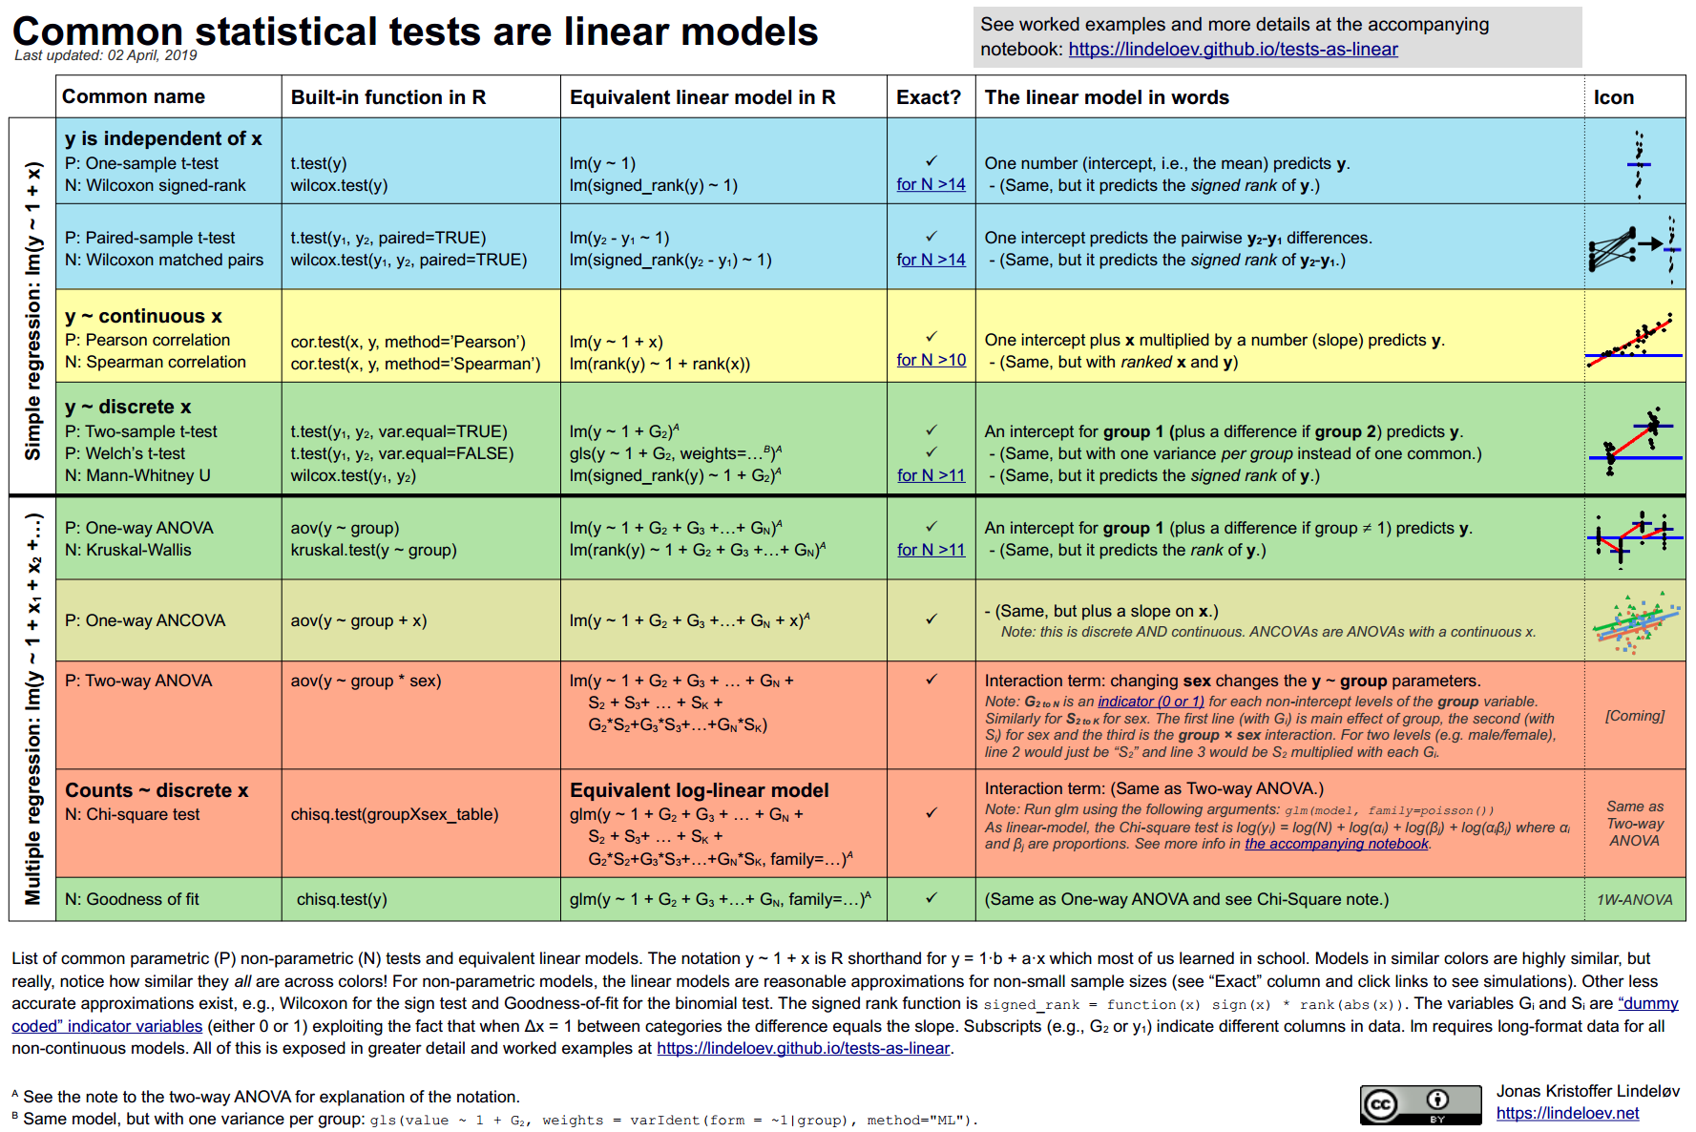

Consider Study 1 from Project B.
- Analysis A. Compare two means/medians using paired samples
  - This is a linear model. See Section 4.2 of Lindelov
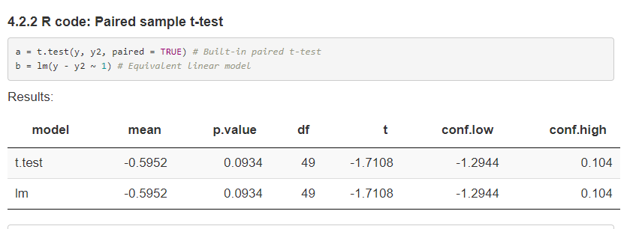

Project B Study 1?
- Analysis B. Compare two means/medians using independent samples
  - This is a linear model, and not just for the t test. See Section 5 of Lindelov
- Analysis C. Compare 3-6 means/medians using independent samples
  - ANOVA is obviously a linear model, but actually we can generate (essentially) the Kruskal-Wallis this way, too. See Section 6.1 of Lindelov

Project B Study 1?
- Analysis D. Create and analyze a 2x2 table
  - Yes, the chi-square test of independence can emerge from a linear model. See Section 7.2 of Lindelov
- Analysis E. Create and analyze a JxK table, where $2≤J≤5$ and $3≤K≤5$
  - Linear model, as in the 2x2 case. See Section 7.2 of Lindelov
Analyses D-E are more commonly thought about in the context of generalized linear models, as we’ll see in 432.

Robust Linear Models: A Brief Introduction

The crimestat data
For each of 51 states (including the District of Columbia), we have the state’s ID number, postal abbreviation and full name, as well as:
- crime - the violent crime rate per 100,000 people
- poverty - the official poverty rate (% of people living in poverty in the state/district) in 2014
- single - the percentage of households in the state/district led by a female householder with no spouse present and with her own children under 18 years living in the household in 2016

The crimestat data set
crimestat <-
read_csv(here("c24/data/crimestat.csv"), show_col_types = FALSE) |>
janitor::clean_names()
crimestat
# A tibble: 51 × 6
sid state crime poverty single state_full
<dbl> <chr> <dbl> <dbl> <dbl> <chr>
1 1 AL 427. 19.2 9.02 Alabama
2 2 AK 636. 11.4 7.63 Alaska
3 3 AZ 400. 18.2 8.31 Arizona
4 4 AR 480. 18.7 9.41 Arkansas
5 5 CA 396. 16.4 7.25 California
6 6 CO 309. 12.1 6.75 Colorado
7 7 CT 237. 10.8 8.04 Connecticut
8 8 DE 489. 13 6.52 Delaware
9 9 DC 1244. 18.4 8.41 District of Columbia
10 10 FL 540. 16.6 8.29 Florida
# ℹ 41 more rows

Our objective
Our main goal will be to build a linear regression model to predict crime using centered versions of both poverty and single.
crimestat <- crimestat |>
mutate(pov_c = poverty - mean(poverty),
single_c = single - mean(single))
We’re centering so that the intercept term is more interpretable.

Numerical Summaries
df_stats(~ crime + poverty + pov_c + single + single_c, data = crimestat) |>
gt() |> fmt_number(columns = min:sd, decimals = 2) |>
tab_options(table.font.size = 24)
response | min | Q1 | median | Q3 | max | mean | sd | n | missing
crime | 99.30 | 260.20 | 326.50 | 427.35 | 1,244.40 | 364.41 | 179.05 | 51 | 0
poverty | 9.20 | 12.15 | 14.80 | 17.20 | 21.90 | 14.87 | 3.08 | 51 | 0
pov_c | -5.67 | -2.72 | -0.07 | 2.33 | 7.03 | 0.00 | 3.08 | 51 | 0
single | 4.48 | 6.75 | 7.63 | 8.50 | 11.59 | 7.69 | 1.61 | 51 | 0
single_c | -3.21 | -0.94 | -0.06 | 0.82 | 3.90 | 0.00 | 1.61 | 51 | 0

Transform Outcome?
boxCox(lm(crime ~ pov_c + single_c, data = crimestat))
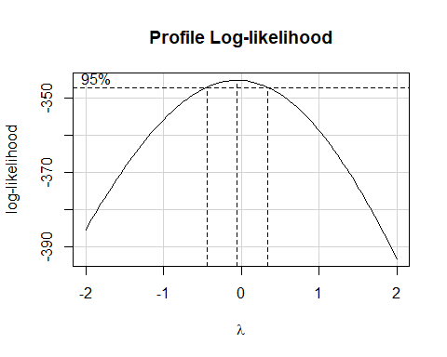

Scatterplot Matrix
temp <- crimestat |>
mutate(logcrime = log(crime)) |>
select(pov_c, single_c, logcrime)
ggpairs(temp,
title = "Scatterplot Matrix for crimestat",
lower = list(combo = wrap("facethist"), bins = 7))
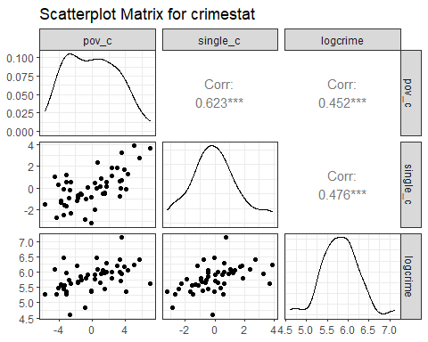

OLS linear model
crimestat <- crimestat |> mutate(logcrime = log(crime))
fit_ols <- lm(logcrime ~ pov_c + single_c, data = crimestat)
Note what happens when we put the model in parentheses…
(fit_ols <- lm(logcrime ~ pov_c + single_c, data = crimestat))
Call:
lm(formula = logcrime ~ pov_c + single_c, data = crimestat)
Coefficients:
(Intercept) pov_c single_c
5.80363 0.03581 0.08543

Coefficients of fit_ols
model_parameters(fit_ols, ci = 0.95,
pretty_names = FALSE, include_info = TRUE)
Parameter | Coefficient | SE | 95% CI | t(48) | p
------------------------------------------------------------------
(Intercept) | 5.80 | 0.05 | [ 5.70, 5.91] | 109.28 | < .001
pov_c | 0.04 | 0.02 | [-0.01, 0.08] | 1.61 | 0.114
single_c | 0.09 | 0.04 | [ 0.00, 0.17] | 2.01 | 0.050
Model: logcrime ~ pov_c + single_c (51 Observations)
Sigma: 0.379 (df = 48)
RMSE : 0.368
R2: 0.266; adjusted R2: 0.235
Uncertainty intervals (equal-tailed) and p-values (two-tailed) computed
using a Wald t-distribution approximation.
What do the 95% confidence interval estimates suggest about pov_c and single_c?

Exponentiated Coefficients
model_parameters(fit_ols, exponentiate = TRUE, ci = 0.95,
pretty_names = FALSE, include_info = TRUE)
Parameter | Coefficient | SE | 95% CI | t(48) | p
----------------------------------------------------------------------
(Intercept) | 331.50 | 17.61 | [297.93, 368.86] | 109.28 | < .001
pov_c | 1.04 | 0.02 | [ 0.99, 1.08] | 1.61 | 0.114
single_c | 1.09 | 0.05 | [ 1.00, 1.19] | 2.01 | 0.050
Model: logcrime ~ pov_c + single_c (51 Observations)
Sigma: 0.379 (df = 48)
RMSE : 0.368
R2: 0.266; adjusted R2: 0.235
Uncertainty intervals (equal-tailed) and p-values (two-tailed) computed
using a Wald t-distribution approximation.

Performance of fit_ols
model_performance(fit_ols)
# Indices of model performance
AIC | AICc | BIC | R2 | R2 (adj.) | RMSE | Sigma
------------------------------------------------------
50.8 | 51.6 | 58.5 | 0.266 | 0.235 | 0.368 | 0.379

OLS Checking (1/3)
check_model(fit_ols, check = c("linearity", "homogeneity"))
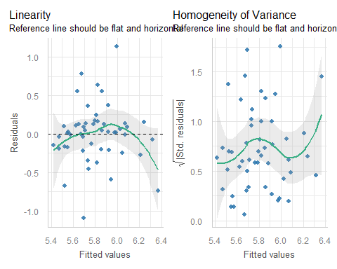

OLS Checking (2/3)
check_model(fit_ols, check = c("pp_check", "outliers"))
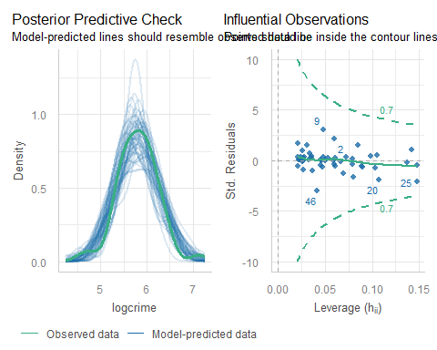

OLS Checking (3/3)
check_model(fit_ols, detrend = FALSE, check = c("normality", "qq"))
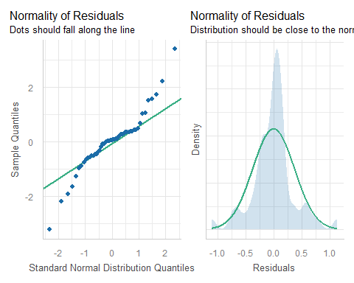

Which points are of special interest?
Largest residuals in absolute value?
aug_ols <- augment(fit_ols)
aug_ols <- aug_ols |> mutate(state = crimestat$state, sid = crimestat$sid,
abs_res = abs(.resid))
aug_ols |> select(sid, state, logcrime, pov_c, single_c, .resid, abs_res,
everything()) |>
arrange(desc(abs_res)) |> head()
# A tibble: 6 × 12
sid state logcrime pov_c single_c .resid abs_res .fitted .hat .sigma
<dbl> <chr> <dbl> <dbl> <dbl> <dbl> <dbl> <dbl> <dbl> <dbl>
1 9 DC 7.13 3.53 0.721 1.13 1.13 5.99 0.0482 0.344
2 46 VT 4.60 -2.67 -0.139 -1.10 1.10 5.70 0.0414 0.347
3 2 AK 6.45 -3.47 -0.0588 0.781 0.781 5.67 0.0595 0.365
4 25 MS 5.63 7.03 3.67 -0.739 0.739 6.37 0.148 0.365
5 20 ME 4.85 -0.873 -2.90 -0.674 0.674 5.52 0.107 0.369
6 29 NV 6.45 0.527 -0.0288 0.635 0.635 5.82 0.0207 0.372
# ℹ 2 more variables: .cooksd <dbl>, .std.resid <dbl>

Collinearity in fit_ols?
check_collinearity(fit_ols)
# Check for Multicollinearity
Low Correlation
Term VIF VIF 95% CI adj. VIF Tolerance Tolerance 95% CI
pov_c 1.63 [1.26, 2.53] 1.28 0.61 [0.40, 0.79]
single_c 1.63 [1.26, 2.53] 1.28 0.61 [0.40, 0.79]

Prediction for new data
- Declare outcome transformation in model.
fit_ols2 <- lm(log(crime) ~ pov_c + single_c, data = crimestat)
- “New” states: pov_c = 1, single_c = 2.
- What does fit_ols predict for log(crime)?
estimate_expectation(fit_ols2, ci = 0.95,
data = tibble(pov_c = 1, single_c = 2))
Model-based Predictions
pov_c | single_c | Predicted | SE | 95% CI
--------------------------------------------------
1 | 2 | 6.01 | 0.09 | [5.83, 6.19]
Variable predicted: crime
Predictions are on the log-scale (consider `transform=TRUE`).

Prediction for new data
Again, we assume we have multiple new states with pov_c = 1 and single_c = 2.
- What does fit_ols predict for average crime?
estimate_expectation(fit_ols2, ci = 0.95, transform = TRUE,
data = tibble(pov_c = 1, single_c = 2))
Model-based Predictions
pov_c | single_c | Predicted | 95% CI
-----------------------------------------------
1 | 2 | 407.60 | [339.74, 489.03]
Variable predicted: crime

Robust Linear Model with Huber weights

Robust Linear Models
There are several ways to do robust linear regression using M-estimation, including weighting using Huber and bisquare strategies.
- Robust linear regression here will make use of a method called iteratively re-weighted least squares (IRLS) to estimate models.
- M-estimation defines a weight function which is applied during estimation.

Using Huber weights
- The weights depend on the residuals and the residuals depend on the weights, so an iterative process is required.
We’ll fit the model, using the default weighting choice: what are called Huber weights, where observations with small residuals get a weight of 1, and the larger the residual, the smaller the weight.

New model (using MASS::rlm)
rob_huber <- rlm(logcrime ~ pov_c + single_c, data = crimestat)
model_parameters(rob_huber, ci = 0.95, pretty_names = F, include_info = T)
Parameter | Coefficient | SE | 95% CI | t(48) | p
------------------------------------------------------------------
(Intercept) | 5.80 | 0.04 | [ 5.72, 5.88] | 147.26 | < .001
pov_c | 0.03 | 0.02 | [ 0.00, 0.07] | 1.99 | 0.052
single_c | 0.09 | 0.03 | [ 0.03, 0.15] | 2.89 | 0.006
Model: logcrime ~ pov_c + single_c (51 Observations)
Sigma: 0.379 (df = 48)
RMSE : 0.368
Uncertainty intervals (equal-tailed) and p-values (two-tailed) computed
using a Wald t-distribution approximation.
Is this a very different result than ordinary least squares gave us?

Glance: rob_huber and OLS
glance(rob_huber) |> gt() |> fmt_number(decimals = 2) |>
tab_options(table.font.size = 24)
sigma | converged | logLik | AIC | BIC | deviance | nobs
0.22 | TRUE | -21.39 | 50.78 | 58.51 | 6.91 | 51.00
glance(fit_ols) |>
select(sigma, logLik, AIC, BIC, deviance, nobs,
r.squared, adj.r.squared) |>
gt() |> fmt_number(decimals = 2) |>
tab_options(table.font.size = 24)
sigma | logLik | AIC | BIC | deviance | nobs | r.squared | adj.r.squared
0.38 | -21.38 | 50.75 | 58.48 | 6.90 | 51.00 | 0.27 | 0.24

Understanding the Huber weights
Let’s augment the data with results from this model, including the weights.
crime_with_huber <- augment(rob_huber, crimestat) |>
mutate(w = rob_huber$w) |> arrange(w)
crime_with_huber |>
select(sid, state, w, logcrime, crime, pov_c, single_c,
.fitted, .resid, everything()) |>
head(4)
# A tibble: 4 × 16
sid state w logcrime crime pov_c single_c .fitted .resid poverty single
<dbl> <chr> <dbl> <dbl> <dbl> <dbl> <dbl> <dbl> <dbl> <dbl> <dbl>
1 9 DC 0.257 7.13 1244. 3.53 0.721 5.98 1.14 18.4 8.41
2 46 VT 0.267 4.60 99.3 -2.67 -0.139 5.70 -1.10 12.2 7.55
3 2 AK 0.379 6.45 636. -3.47 -0.0588 5.68 0.775 11.4 7.63
4 25 MS 0.399 5.63 278. 7.03 3.67 6.37 -0.737 21.9 11.4
# ℹ 5 more variables: state_full <chr>, .hat <dbl>, .sigma <dbl>,
# .cooksd <dbl>, .std.resid <dbl>

Huber Weights
crime_with_huber |> select(state, w, .resid) |>
arrange(desc(abs(.resid))) |> head(4)
# A tibble: 4 × 3
state w .resid
<chr> <dbl> <dbl>
1 DC 0.257 1.14
2 VT 0.267 -1.10
3 AK 0.379 0.775
4 MS 0.399 -0.737
crime_with_huber |> select(state, w, .resid) |>
arrange(desc(abs(.resid))) |> slice(14,15,50,51)
# A tibble: 4 × 3
state w .resid
<chr> <dbl> <dbl>
1 RI 0.877 -0.335
2 GA 1 -0.283
3 AL 1 -0.00622
4 WI 1 0.00530

What is the pattern?
ggplot(crime_with_huber, aes(x = abs(.resid), y = w)) +
geom_label(aes(label = state))
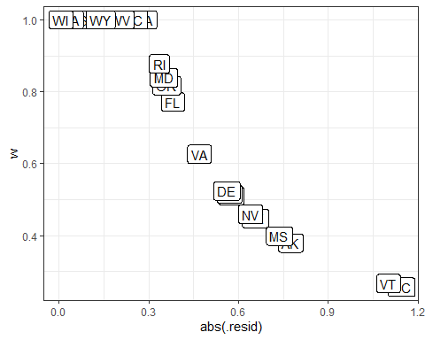

Conclusions: Weights Plot
- District of Columbia will be down-weighted the most, followed by Vermont, then Alaska and and Mississippi.
- But many of the observations will have a weight of 1.
- In ordinary least squares, all observations would have weight 1.
- So the more cases in the robust regression that have a weight close to one, the closer the results of the OLS and robust procedures will be.

Robust linear model using the biweight

Using the biweight
The biweight, or bisquare or Tukey’s bisquare is another weighing approach, in which all cases with a non-zero residual get down-weighted at least a little.
(rob_bw <- rlm(logcrime ~ pov_c + single_c,
data = crimestat, psi = psi.bisquare))
Call:
rlm(formula = logcrime ~ pov_c + single_c, data = crimestat,
psi = psi.bisquare)
Converged in 18 iterations
Coefficients:
(Intercept) pov_c single_c
5.79991656 0.02651131 0.09960112
Degrees of freedom: 51 total; 48 residual
Scale estimate: 0.23

Robust Model Coefficients
Huber weights
model_parameters(rob_huber, ci = 0.95, pretty_names = F)
Parameter | Coefficient | SE | 95% CI | t(48) | p
------------------------------------------------------------------
(Intercept) | 5.80 | 0.04 | [ 5.72, 5.88] | 147.26 | < .001
pov_c | 0.03 | 0.02 | [ 0.00, 0.07] | 1.99 | 0.052
single_c | 0.09 | 0.03 | [ 0.03, 0.15] | 2.89 | 0.006
Uncertainty intervals (equal-tailed) and p-values (two-tailed) computed
using a Wald t-distribution approximation.
Bisquare weights
model_parameters(rob_bw, ci = 0.95, pretty_names = F)
Parameter | Coefficient | SE | 95% CI | t(48) | p
------------------------------------------------------------------
(Intercept) | 5.80 | 0.04 | [ 5.72, 5.88] | 139.15 | < .001
pov_c | 0.03 | 0.02 | [-0.01, 0.06] | 1.52 | 0.136
single_c | 0.10 | 0.03 | [ 0.03, 0.17] | 2.98 | 0.005
Uncertainty intervals (equal-tailed) and p-values (two-tailed) computed
using a Wald t-distribution approximation.

Robust model performance
Huber weights
model_performance(rob_huber); n_obs(rob_huber)
# Indices of model performance
AIC | AICc | BIC | RMSE | Sigma
----------------------------------
50.8 | 51.7 | 58.5 | 0.368 | 0.379
[1] 51
Bisquare weights
model_performance(rob_bw); n_obs(rob_bw)
# Indices of model performance
AIC | AICc | BIC | RMSE | Sigma
----------------------------------
51.0 | 51.8 | 58.7 | 0.369 | 0.380
[1] 51

augment() for rob_bw
crime_bw <- augment(rob_bw, newdata = crimestat) |>
mutate(w = rob_bw$w) |>
relocate(c(w, .resid), .before = crime) |>
arrange(w)
head(crime_bw, 3) |> gt() # smallest three weights
sid | state | w | .resid | crime | poverty | single | state_full | pov_c | single_c | logcrime | .fitted
9 | DC | 0.0000000 | 1.1611449 | 1244.4 | 18.4 | 8.41 | District of Columbia | 3.527451 | 0.72117647 | 7.126409 | 5.965264
46 | VT | 0.0000000 | -1.1170912 | 99.3 | 12.2 | 7.55 | Vermont | -2.672549 | -0.13882353 | 4.598146 | 5.715237
2 | AK | 0.2632385 | 0.7528882 | 635.8 | 11.4 | 7.63 | Alaska | -3.472549 | -0.05882353 | 6.454884 | 5.701996
tail(crime_bw, 3) |> gt() # largest three weights
sid | state | w | .resid | crime | poverty | single | state_full | pov_c | single_c | logcrime | .fitted
35 | ND | 0.9998727 | 0.008574042 | 265.1 | 11.1 | 6.40 | North Dakota | -3.772549 | -1.2888235 | 5.580107 | 5.571533
50 | WI | 0.9999939 | 0.001875577 | 290.3 | 13.2 | 6.82 | Wisconsin | -1.672549 | -0.8688235 | 5.670915 | 5.669039
12 | HI | 0.9999967 | 0.001358660 | 259.2 | 11.5 | 6.14 | Hawaii | -3.372549 | -1.5488235 | 5.557600 | 5.556241

rob_bw: Weights vs. Residuals
ggplot(crime_bw, aes(x = abs(.resid), y = w)) +
geom_label(aes(label = state))
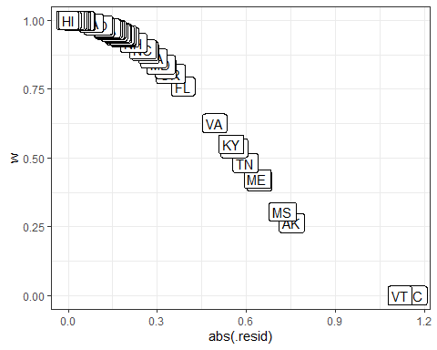

Conclusions from the biweights plot
Again, cases with large residuals (in absolute value) are down-weighted generally, but here, Vermont and Washington DC receive no weight in fitting the final model.
- We can see that the weight given to DC and Vermont is dramatically lower (in fact it is zero) using the bisquare and the parameter estimates from these two different weighting methods differ.
- The maximum weight (here, for Hawaii) for any state using the biweight is still slightly smaller than 1.

Quantile Regression

Quantile Regression on the Median
We can use the rq function in the quantreg package to model the median of our outcome (violent crime rate) on the basis of our predictors, rather than the mean, as is the case in ordinary least squares.
(fit_q50 <- rq(logcrime ~ pov_c + single_c, data = crimestat))
Call:
rq(formula = logcrime ~ pov_c + single_c, data = crimestat)
Coefficients:
(Intercept) pov_c single_c
5.81810182 0.03184378 0.10810788
Degrees of freedom: 51 total; 48 residual

Coefficients in fit_q50
model_parameters(fit_q50, ci = 0.95, pretty_names = FALSE)
# Fixed Effects
Parameter | Coefficient | SE | 95% CI | t(48) | p
------------------------------------------------------------------
(Intercept) | 5.82 | 0.05 | [ 5.73, 5.91] | 126.04 | < .001
pov_c | 0.03 | 0.02 | [-0.01, 0.07] | 1.69 | 0.097
single_c | 0.11 | 0.04 | [ 0.04, 0.18] | 2.99 | 0.004
Uncertainty intervals (equal-tailed) and p-values (two-tailed) computed
using a Wald t-distribution approximation.
glance(fit_q50) |> gt() |> tab_options(table.font.size = 24)
tau | logLik | AIC | BIC | df.residual
0.5 | -15.48026 | 36.96052 | 42.75599 | 48

Estimating a different quantile
Estimate any quantile by specifying the tau ($τ$) parameter.
- Default is tau = 0.5, which estimates the median.
- What about estimating, say, the 70th percentile?
(fit_quan70 <- rq(logcrime ~ pov_c + single_c, tau = 0.70,
data = crimestat))
Call:
rq(formula = logcrime ~ pov_c + single_c, tau = 0.7, data = crimestat)
Coefficients:
(Intercept) pov_c single_c
5.92425331 0.03722661 0.09306954
Degrees of freedom: 51 total; 48 residual

Comparing our 4 models

Comparing coefficients
compare_models(fit_ols, rob_huber, rob_bw, fit_q50,
ci = 0.95)
Parameter | fit_ols | rob_huber | rob_bw | fit_q50
-----------------------------------------------------------------------------------------------
(Intercept) | 5.80 ( 5.70, 5.91) | 5.80 (5.72, 5.88) | 5.80 ( 5.72, 5.88) | 5.82 ( 5.73, 5.91)
pov c | 0.04 (-0.01, 0.08) | 0.03 (0.00, 0.07) | 0.03 (-0.01, 0.06) | 0.03 (-0.01, 0.07)
single c | 0.09 ( 0.00, 0.17) | 0.09 (0.03, 0.15) | 0.10 ( 0.03, 0.17) | 0.11 ( 0.04, 0.18)
-----------------------------------------------------------------------------------------------
Observations | 51 | 51 | 51 | 51
Can we plot these results?

Comparing coefficients
plot(compare_models(fit_ols, rob_huber, rob_bw, fit_q50,
ci = 0.95))
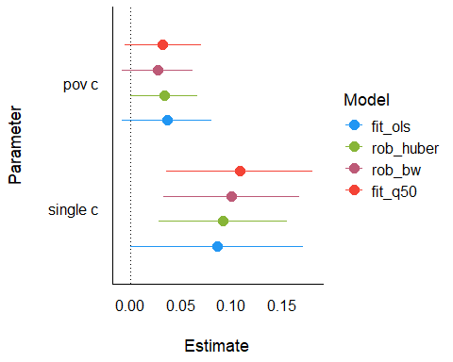

Exponentiated coefficients
plot(compare_models(fit_ols, rob_huber, rob_bw, fit_q50,
ci = 0.95, exponentiate = TRUE)) +
xlim(0.90, 1.25) + geom_vline(xintercept = 1, lty = "dashed")
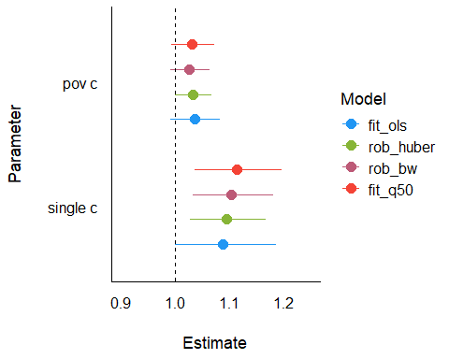

Comparing performance
compare_performance(fit_ols, rob_huber, rob_bw, fit_q50)
# Comparison of Model Performance Indices
Name | Model | AIC (weights) | BIC (weights) | RMSE | Sigma | R2
-------------------------------------------------------------------------
fit_ols | lm | 50.8 (0.001) | 58.5 (<.001) | 0.368 | 0.379 | 0.266
rob_huber | rlm | 50.8 (<.001) | 58.5 (<.001) | 0.368 | 0.379 |
rob_bw | rlm | 51.0 (<.001) | 58.7 (<.001) | 0.369 | 0.380 |
fit_q50 | rq | 37.0 (0.997) | 42.8 (0.999) | 0.369 | 0.381 | 0.260
Name | AICc (weights) | R2 (adj.)
--------------------------------------
fit_ols | 51.6 (>.999) | 0.235
rob_huber | 51.7 (>.999) |
rob_bw | 51.8 (>.999) |
fit_q50 | (>.999) |

Comparing performance
plot(compare_performance(fit_ols, rob_huber, rob_bw, fit_q50))
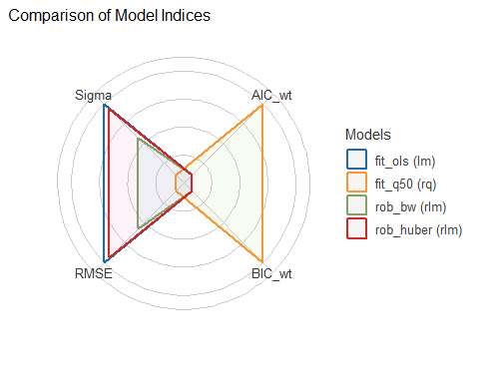

Prediction in new data
- Declare outcome transformation in each model.
rob_huber2 <- rlm(log(crime) ~ pov_c + single_c, data = crimestat)
rob_bw2 <- rlm(log(crime) ~ pov_c + single_c,
data = crimestat, psi = psi.bisquare)
fit_q50 <- rq(log(crime) ~ pov_c + single_c, data = crimestat)
- “New” states: all have pov_c = 1 and single_c = 2.
new_dat <- tibble(pov_c = 1, single_c = 2)

Predictions: Huber weights
estimate_expectation(rob_huber2, ci = 0.95, data = new_dat)
Model-based Predictions
pov_c | single_c | Predicted | SE | 95% CI
--------------------------------------------------
1 | 2 | 6.02 | 0.07 | [5.88, 6.15]
Variable predicted: crime
Predictions are on the log-scale (consider `transform=TRUE`).
estimate_expectation(rob_huber2, ci = 0.95, transform = TRUE, data = new_dat)
Model-based Predictions
pov_c | single_c | Predicted | 95% CI
-----------------------------------------------
1 | 2 | 409.68 | [357.92, 468.92]
Variable predicted: crime

Predictions: Bisquare weights
estimate_expectation(rob_bw2, ci = 0.95, data = new_dat)
Model-based Predictions
pov_c | single_c | Predicted | SE | 95% CI
--------------------------------------------------
1 | 2 | 6.03 | 0.07 | [5.88, 6.17]
Variable predicted: crime
Predictions are on the log-scale (consider `transform=TRUE`).
estimate_expectation(rob_bw2, ci = 0.95, transform = TRUE, data = new_dat)
Model-based Predictions
pov_c | single_c | Predicted | 95% CI
-----------------------------------------------
1 | 2 | 413.90 | [358.78, 477.50]
Variable predicted: crime

Quantile (median) regression
estimate_expectation(fit_q50, ci = 0.95, data = new_dat)
Model-based Predictions
pov_c | single_c | Predicted | SE | 95% CI
--------------------------------------------------
1 | 2 | 6.07 | 0.08 | [5.90, 6.24]
Variable predicted: crime
Predictions are on the log-scale (consider `transform=TRUE`).
estimate_expectation(fit_q50, ci = 0.95, transform = TRUE, data = new_dat)
Model-based Predictions
pov_c | single_c | Predicted | 95% CI
-----------------------------------------------
1 | 2 | 431.02 | [364.02, 510.35]
Variable predicted: crime

Wrapping Up
- When comparing the results of a regular OLS regression and a robust regression for a data set which displays outliers, if the results are very different, you will most likely want to use the results from the robust regression.
  - Large differences suggest that the model parameters are being highly influenced by outliers.

Wrapping Up
- Different weighting functions have advantages and drawbacks.
  - Huber weights can have difficulties with really severe outliers.
  - Bisquare weights can have difficulties converging or may yield multiple solutions.
  - Quantile regression approaches have some nice properties, but describe medians (or other quantiles) rather than means.

Session Information
xfun::session_info()
R version 4.5.2 (2025-10-31 ucrt)
Platform: x86_64-w64-mingw32/x64
Running under: Windows 11 x64 (build 26200)
Locale:
LC_COLLATE=English_United States.utf8
LC_CTYPE=English_United States.utf8
LC_MONETARY=English_United States.utf8
LC_NUMERIC=C
LC_TIME=English_United States.utf8
Package version:
abind_1.4-8 askpass_1.2.1 backports_1.5.0
base64enc_0.1.3 bayestestR_0.17.0 bigD_0.3.1
bit_4.6.0 bit64_4.6.0-1 bitops_1.0.9
blob_1.2.4 boot_1.3.32 broom_1.0.10
bslib_0.9.0 cachem_1.1.0 callr_3.7.6
car_3.1-3 carData_3.0-5 cellranger_1.1.0
cli_3.6.5 clipr_0.8.0 coda_0.19-4.1
codetools_0.2-20 commonmark_2.0.0 compiler_4.5.2
conflicted_1.2.0 correlation_0.8.8 cowplot_1.2.0
cpp11_0.5.2 crayon_1.5.3 curl_7.0.0
data.table_1.17.8 datasets_4.5.2 datawizard_1.3.0
DBI_1.2.3 dbplyr_2.5.1 Deriv_4.2.0
digest_0.6.38 doBy_4.7.0 dplyr_1.1.4
dtplyr_1.3.2 easystats_0.7.5 effectsize_1.0.1
emmeans_2.0.0 estimability_1.5.1 evaluate_1.0.5
farver_2.1.2 fastmap_1.2.0 fontawesome_0.5.3
fontBitstreamVera_0.1.1 fontLiberation_0.1.0 fontquiver_0.2.1
forcats_1.0.1 Formula_1.2-5 fs_1.6.6
gargle_1.6.0 gdtools_0.4.4 generics_0.1.4
GGally_2.4.0 ggformula_1.0.0 ggiraph_0.9.2
ggplot2_4.0.1 ggrepel_0.9.6 ggridges_0.5.7
ggstats_0.11.0 glue_1.8.0 googledrive_2.1.2
googlesheets4_1.1.2 graphics_4.5.2 grDevices_4.5.2
grid_4.5.2 gt_1.1.0 gtable_0.3.6
haven_2.5.5 here_1.0.2 highr_0.11
hms_1.1.4 htmltools_0.5.8.1 htmlwidgets_1.6.4
httr_1.4.7 ids_1.0.1 insight_1.4.2
isoband_0.2.7 janitor_2.2.1 jquerylib_0.1.4
jsonlite_2.0.0 juicyjuice_0.1.0 knitr_1.50
labeling_0.4.3 labelled_2.16.0 lattice_0.22-7
lifecycle_1.0.4 litedown_0.8 lme4_1.1.37
lubridate_1.9.4 magrittr_2.0.4 markdown_2.0
MASS_7.3-65 Matrix_1.7-4 MatrixModels_0.5-4
memoise_2.0.1 methods_4.5.2 mgcv_1.9-4
microbenchmark_1.5.0 mime_0.13 minqa_1.2.8
modelbased_0.13.0 modelr_0.1.11 mosaic_1.9.2
mosaicCore_0.9.5 mosaicData_0.20.4 multcomp_1.4-29
mvtnorm_1.3-3 nlme_3.1-168 nloptr_2.2.1
nnet_7.3.20 numDeriv_2016.8.1.1 openssl_2.3.4
parallel_4.5.2 parameters_0.28.2 patchwork_1.3.2
pbkrtest_0.5.5 performance_0.15.2 pillar_1.11.1
pkgconfig_2.0.3 prettyunits_1.2.0 processx_3.8.6
progress_1.2.3 ps_1.9.1 purrr_1.2.0
quantreg_6.1 R6_2.6.1 ragg_1.5.0
rappdirs_0.3.3 rbibutils_2.4 RColorBrewer_1.1-3
Rcpp_1.1.0 RcppEigen_0.3.4.0.2 Rdpack_2.6.4
reactable_0.4.4 reactR_0.6.1 readr_2.1.6
readxl_1.4.5 reformulas_0.4.2 rematch_2.0.0
rematch2_2.1.2 report_0.6.2 reprex_2.1.1
rlang_1.1.6 rmarkdown_2.30 rprojroot_2.1.1
rstudioapi_0.17.1 rvest_1.0.5 S7_0.2.1
sandwich_3.1-1 sass_0.4.10 scales_1.4.0
see_0.12.0 selectr_0.4.2 snakecase_0.11.1
SparseM_1.84-2 splines_4.5.2 stats_4.5.2
stringi_1.8.7 stringr_1.6.0 survival_3.8-3
sys_3.4.3 systemfonts_1.3.1 textshaping_1.0.4
TH.data_1.1-5 tibble_3.3.0 tidyr_1.3.1
tidyselect_1.2.1 tidyverse_2.0.0 timechange_0.3.0
tinytex_0.57 tools_4.5.2 tzdb_0.5.0
utf8_1.2.6 utils_4.5.2 uuid_1.2.1
V8_8.0.1 vctrs_0.6.5 viridisLite_0.4.2
vroom_1.6.6 withr_3.0.2 xfun_0.54
xml2_1.4.1 xtable_1.8-4 yaml_2.3.10
zoo_1.8-14

