431 Class 23
Thomas E. Love, Ph.D.
2025-11-20

Today’s Agenda
- Multiple Imputation in the dm500 data
  - Comparing $R^{2}$ to adjusted $R^{2}$
- Considering Bayesian alternative fits in the dm500 data
  - Key steps in evaluating a Bayesian fit
  - Reasons to “go Bayesian”
- ChatGPT and Large Language Models
- ASA Statement on the Role of Statistics ion Data Science and AI (2023)

R packages
knitr::opts_chunk$set(comment = NA)
library(janitor)
library(naniar)
library(mice)
library(gt)
library(broom)
library(rstanarm)
library(easystats)
library(tidyverse)
source("c23/data/Love-431.R")
theme_set(theme_lucid())

Same dm500.Rds Data
Outcome: a1c and we’ll use three models …
- Model 1: Use a1c_old alone to predict a1c
- Model 2: Use a1c_old and age together to predict a1c
- Model 3: Use a1c_old, age, and income together to predict a1c
Today, we’ll use 90% confidence, rather than 95%.

dm500 management and 10 imputations
dm500 <- readRDS("c20/data/dm500.Rds") |>
mutate(transa1c = 100/a1c)
imp2_fit <- dm500 |>
mice(m = 10, seed = 431, print = FALSE) |>
with(lm(transa1c ~ a1c_old + age)) |>
pool()

$R^{2}$ vs. adjusted $R^{2}$?
glance(imp2_fit)
nimp nobs r.squared adj.r.squared
1 10 500 0.3842468 0.3817684
pool.r.squared(imp2_fit)
est lo 95 hi 95 fmi
R^2 0.3842468 0.3143945 0.4525868 0.06619506
pool.r.squared(imp2_fit, adjusted = TRUE)
est lo 95 hi 95 fmi
adj R^2 0.3817684 0.3118849 0.4502088 0.06660368
- $R^{2}$ will increase even with useless predictors, while adjusted $R^{2}$ penalizes the addition of such variables, causing it to decrease and show a large gap with the original $R^{2}$ value.

What is fmi?
- fmi refers to the fraction of missing information in multiple imputation
pool.r.squared(imp2_fit)
est lo 95 hi 95 fmi
R^2 0.3842468 0.3143945 0.4525868 0.06619506
- Some people suggest using an initial estimate of fmi, based on, say, 20 imputations, to help determine how many imputations are needed overall to get accurate standard errors.
- We’ll follow up on that idea in 432.

Bayesian model fits for dm500 data (from Class 20)

Refit with Bayesian models?
What must we change to use Bayesian (stan_glm) fits?
- Must create transformed outcome in data prior to fitting with rstanarm().
- Results are a bit different for model_parameters()
- Results are a bit different for model_performance()
- No real change for check_model()
- No augment() function for rstanarm() fits.

Single Imputation & Partition
dm500_i_set <- mice(dm500, m = 1, seed = 20251111, printFlag = FALSE)
dm500_i <- complete(dm500_i_set)
set.seed(2025431)
dm500_i_train <- dm500_i |>
slice_sample(prop = 0.7, replace = FALSE) |>
mutate(transa1c = 100/a1c)
dm500_i_test <-
anti_join(dm500_i, dm500_i_train, by = "subject") |>
mutate(transa1c = 100/a1c)

Refit with Bayesian models?
- Single imputation, default weakly informative priors
set.seed(20251111)
fit1B <- stan_glm(transa1c ~ a1c_old,
data = dm500_i_train, refresh = 0)
fit2B <- stan_glm(transa1c ~ a1c_old + age,
data = dm500_i_train, refresh = 0)
fit3B <- stan_glm(transa1c ~ a1c_old + age + income,
data = dm500_i_train, refresh = 0)
- By default, stan_glm() performs 4000 simulations from the joint distribution of parameters.

Estimating fit1B Coefficients?
model_parameters(fit1B, ci = 0.90, pretty_names = FALSE, include_info = TRUE)
Parameter | Median | 90% CI | pd | Rhat | ESS | Prior
------------------------------------------------------------------------------------
(Intercept) | 21.69 | [20.72, 22.63] | 100% | 1.000 | 3565 | Normal (13.50 +- 7.43)
a1c_old | -1.07 | [-1.19, -0.95] | 100% | 1.000 | 3553 | Normal (0.00 +- 4.31)
Model: transa1c ~ a1c_old (350 Observations)
RMSE : 2.327
: 0.384
Uncertainty intervals (equal-tailed) computed using a MCMC distribution
approximation.
- : 0.384 indicates “Bayesian” $R^{2}$ value
- pd = probability of direction, an index of effect existence, representing the certainty with which an effect goes in a particular direction.
- We want Rhat < 1.05 and ESS > 100.

fit2B Coefficients?
model_parameters(fit2B, ci = 0.90, pretty_names = FALSE) |>
gt()
Parameter | Median | CI | CI_low | CI_high | pd | Rhat | ESS | Prior_Distribution | Prior_Location | Prior_Scale
(Intercept) | 20.7772481 | 0.9 | 18.987930823 | 22.55339276 | 1.00000 | 0.9998776 | 4164.834 | normal | 13.49535 | 7.4304560
a1c_old | -1.0540001 | 0.9 | -1.176713293 | -0.93425064 | 1.00000 | 1.0000342 | 4302.987 | normal | 0.00000 | 4.3099128
age | 0.0145867 | 0.9 | -0.009324963 | 0.03808705 | 0.84225 | 0.9997111 | 4877.563 | normal | 0.00000 | 0.8267916
- Rhat and ESS are diagnostic metrics.
  - If Rhat < 1.05, model convergence is probably OK.
  - If ESS > 100, then estimates are usually reliable.

fit3B Coefficients?
model_parameters(fit3B, ci = 0.90,
pretty_names = FALSE) |>
gt()
Parameter | Median | CI | CI_low | CI_high | pd | Rhat | ESS | Prior_Distribution | Prior_Location | Prior_Scale
(Intercept) | 20.88228807 | 0.9 | 18.98998280 | 22.69798122 | 1.00000 | 0.9994983 | 3729.306 | normal | 13.49535 | 7.4304560
a1c_old | -1.05231205 | 0.9 | -1.17799456 | -0.92654091 | 1.00000 | 0.9995605 | 4207.747 | normal | 0.00000 | 4.3099128
age | 0.01228744 | 0.9 | -0.01144949 | 0.03616903 | 0.81100 | 0.9995219 | 4361.226 | normal | 0.00000 | 0.8267916
incomeBetween_30-50K | 0.20099841 | 0.9 | -0.33751688 | 0.72217515 | 0.73975 | 1.0015396 | 2967.856 | normal | 0.00000 | 15.3090059
incomeBelow_30K | -0.20474625 | 0.9 | -0.76306515 | 0.33079524 | 0.73725 | 1.0005779 | 2971.260 | normal | 0.00000 | 15.4314917

Model Performance with fit1B?
model_performance(fit1B)
# Indices of model performance
ELPD | ELPD_SE | LOOIC | LOOIC_SE | WAIC | R2 | R2 (adj.) | RMSE | Sigma
-----------------------------------------------------------------------------------
-795.508 | 14.923 | 1591.0 | 29.845 | 1591.0 | 0.384 | 0.379 | 2.327 | 2.337
- R2 = “unadjusted” Bayesian $R^{2}$ (see r2_bayes for details)
- R2_adjusted = leave-one-out cross-validation (LOO) adjusted $R^{2}$, which is conceptually closer to our OLS adjusted $R^{2}$ than some other options.
- RMSE = root mean squared error, so lower values mean better fit.

Bayesian Model Performance
model_performance(fit2B)
# Indices of model performance
ELPD | ELPD_SE | LOOIC | LOOIC_SE | WAIC | R2 | R2 (adj.) | RMSE | Sigma
-----------------------------------------------------------------------------------
-796.038 | 15.012 | 1592.1 | 30.025 | 1592.1 | 0.385 | 0.378 | 2.324 | 2.338
- Sigma = residual standard deviation (95% of in-sample predictions should be within $±2σ$)
- WAIC = Widely Applicable Information Criterion. Lower WAIC values mean better fit.

Bayesian Model Performance
model_performance(fit3B)
# Indices of model performance
ELPD | ELPD_SE | LOOIC | LOOIC_SE | WAIC | R2 | R2 (adj.) | RMSE | Sigma
-----------------------------------------------------------------------------------
-797.253 | 15.042 | 1594.5 | 30.085 | 1594.5 | 0.389 | 0.375 | 2.317 | 2.337
- ELPD = expected log predictive density. Larger ELPD means better fit.
- LOOIC = leave-one-out cross-validation (LOO) information criterion. Lower LOOIC means better fit.
- LOOIC_SE = standard error of LOOIC
Performance of Bayesian Models describes more options.

Performance in Training Sample?
compare_performance(fit1B, fit2B, fit3B, rank = TRUE) |>
gt() |> fmt_number(decimals = 3) |>
tab_options(table.font.size = 20)
Name | Model | R2 | R2_adjusted | RMSE | Sigma | WAIC_wt | LOOIC_wt | Performance_Score
fit1B | stanreg | 0.384 | 0.379 | 2.327 | 2.337 | 0.566 | 0.998 | 0.637
fit3B | stanreg | 0.389 | 0.375 | 2.317 | 2.337 | 0.099 | 0.000 | 0.500
fit2B | stanreg | 0.385 | 0.378 | 2.324 | 2.338 | 0.334 | 0.002 | 0.290

Bayes Performance Indicators?
plot(compare_performance(fit1B, fit2B, fit3B,
metrics = c("WAIC", "R2", "RMSE")))
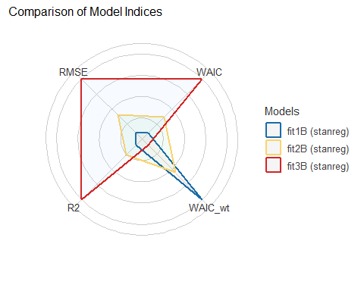

Why not all the indicators?
plot(compare_performance(fit1B, fit2B, fit3B))
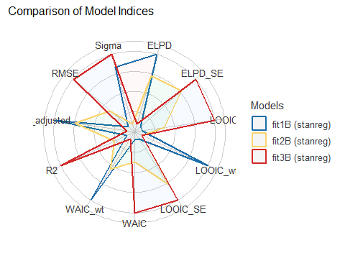

Checking Bayesian fit1B
check_model(fit1B, detrend = FALSE)
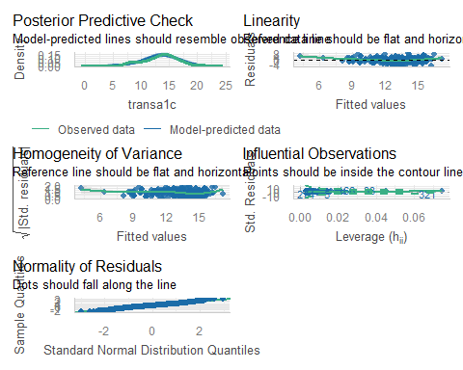

Checking Bayesian fit2B
check_model(fit2B, detrend = FALSE)
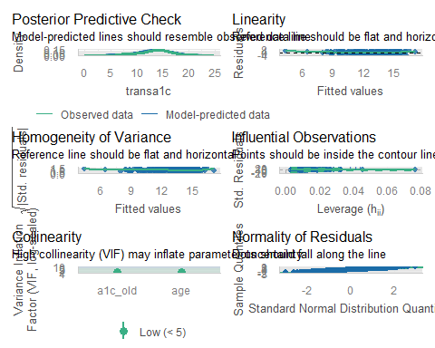

Checking Bayesian fit3B
check_model(fit3B, detrend = FALSE)
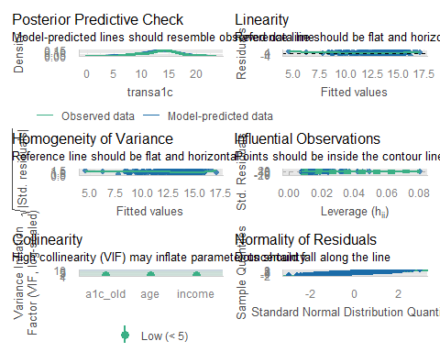

No augment from Bayes fits
The augment() function from broom doesn’t work with Bayesian fits using rstanarm().
We still want to get our predicted (fitted) values and residuals for each observation in our training sample.
aug_1B <- dm500_i_train |>
mutate(.fitted = predict(fit1B),
.resid = transa1c - predict(fit1B))
aug_2B <- dm500_i_train |>
mutate(.fitted = predict(fit2B),
.resid = transa1c - predict(fit2B))
aug_3B <- dm500_i_train |>
mutate(.fitted = predict(fit3B),
.resid = transa1c - predict(fit3B))

Bayes fit to test sample?
Everything is the same as OLS, except that we don’t have augment() for our test data, but predict() can handle this.
test_1B <- dm500_i_test |>
mutate(a1c_pred = predict(fit1B, newdata = dm500_i_test),
a1c_error = transa1c - a1c_pred,
mod = "fit1B")
test_1B |> head(4) |> gt()
a1c | a1c_old | age | income | subject | transa1c | a1c_pred | a1c_error | mod
6.3 | 11.4 | 62 | Higher_than_50K | S-001 | 15.873016 | 9.497866 | 6.37514981 | fit1B
6.5 | 5.8 | 53 | Below_30K | S-004 | 15.384615 | 15.488919 | -0.10430316 | fit1B
5.8 | 6.5 | 48 | Below_30K | S-006 | 17.241379 | 14.740037 | 2.50134233 | fit1B
16.7 | 14.6 | 54 | Below_30K | S-011 | 5.988024 | 6.074408 | -0.08638355 | fit1B

Bayes fit to test sample?
test_2B <- dm500_i_test |>
mutate(a1c_pred = predict(fit2B, newdata = dm500_i_test),
a1c_error = transa1c - a1c_pred,
mod = "fit2B")
test_3B <- dm500_i_test |>
mutate(a1c_pred = predict(fit3B, newdata = dm500_i_test),
a1c_error = transa1c - a1c_pred,
mod = "fit3B")

Combine test sample results
- For our Bayesian models…
temp12B <- bind_rows(test_1B, test_2B)
test_resB <- bind_rows(temp12B, test_3B) |>
relocate(subject, mod, a1c, everything()) |>
arrange(subject, mod)
testB_summary <- test_resB |>
group_by(mod) |>
summarize(MAPE = mean(abs(a1c_error)),
Max_APE = max(abs(a1c_error)),
RMSE = sqrt(mean(a1c_error^2)),
R2_val = cor(a1c, a1c_pred)^2)

Test-Sample Predictions
- From our Bayes models
testB_summary |> gt() |> fmt_number(decimals = 4) |>
tab_options(table.font.size = 24)
mod | MAPE | Max_APE | RMSE | R2_val
fit1B | 1.6504 | 8.2386 | 2.1832 | 0.4521
fit2B | 1.6398 | 8.1221 | 2.1659 | 0.4583
fit3B | 1.6471 | 8.3270 | 2.1791 | 0.4606
- Are any of these models dominated by another?

ChatGPT and Large Language Models: Taking Stock

ChatGPT

https://chat.openai.com/

ChatGPT response March 2023


ChatGPT 3.5 response November 2023


ChatGPT “conversation” 2025-11-16


ChatGPT “conversation” 2025-11-16


ChatGPT “conversation” 2025-11-16


ChatGPT “conversation” 2025-11-16


ChatGPT “conversation” 2025-11-16

ChatGPT “conversation” 2025-11-16


ChatGPT “conversation” 2025-11-16


ChatGPT “conversation” 2025-11-16


ChatGPT “conversation” 2025-11-16


ChatGPT “conversation” 2025-11-16
- Generates a list of 5 publications, all of which I am proud of, though only 1, 2 and 5 would be in my top 5…
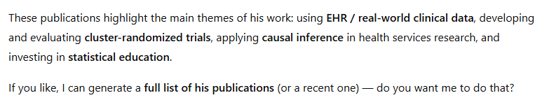

ASA Statement (2023-08-04)

 Reference
https://www.amstat.org/docs/default-source/amstat-documents/the-role-of-statistics-in-data-science-and-artificial-intelligence.pdf

ASA Statement Excerpt 1
The Role of Statistics in Data Science and Artificial Intelligence (pdf): 2023-08-04
Statistics plays a central role in data science and AI, especially in the areas of ML and deep learning. Framing questions statistically allows leveraging data resources to extract knowledge and obtain better answers. The central dogma of statistical inference, that there is a component of randomness in data, enables researchers to formulate questions in terms of underlying processes, quantify uncertainty in their answers, and separate signal from noise. A statistical framework allows researchers to distinguish between causation and correlation, and thus to identify interventions that will cause changes in outcomes.

ASA Statement Excerpt 2
The Role of Statistics in Data Science and Artificial Intelligence (pdf): 2023-08-04
The future of data science and AI is uncertain, but one thing is clear: the field will undoubtedly continue to evolve rapidly and have a profound impact on society. As a result, the role of statisticians will also be subject to change and expansion, as they must adapt to new technologies and tools while continuing to provide expertise in traditional areas of statistics such as uncertainty quantification, sampling design, and causal inference. The need for interdisciplinary collaboration and a diverse range of skills will become increasingly important for statisticians to remain relevant in this dynamic and ever-changing field.

Statistics and AI
“Statistics and AI: A Fireside Conversation”
- 3-hour webinar held on 2024-03-17, including:
  - Statistical challenges and opportunities (Panel I)
  - The evolving publication process in the AI era (Panel II)
  - Advancing next-generation statistical pipelines and resources (Panel III)
Full recording is on the Stats Up AI YouTube channel.

Session Information
xfun::session_info()
R version 4.5.2 (2025-10-31 ucrt)
Platform: x86_64-w64-mingw32/x64
Running under: Windows 11 x64 (build 26200)
Locale:
LC_COLLATE=English_United States.utf8
LC_CTYPE=English_United States.utf8
LC_MONETARY=English_United States.utf8
LC_NUMERIC=C
LC_TIME=English_United States.utf8
Package version:
abind_1.4-8 askpass_1.2.1 backports_1.5.0
base64enc_0.1-3 bayesplot_1.14.0 bayestestR_0.17.0
BH_1.87.0.1 bigD_0.3.1 bit_4.6.0
bit64_4.6.0.1 bitops_1.0.9 blob_1.2.4
boot_1.3-32 broom_1.0.10 bslib_0.9.0
cachem_1.1.0 callr_3.7.6 cellranger_1.1.0
checkmate_2.3.3 cli_3.6.5 clipr_0.8.0
coda_0.19-4.1 codetools_0.2-20 colourpicker_1.3.0
commonmark_2.0.0 compiler_4.5.2 conflicted_1.2.0
correlation_0.8.8 cpp11_0.5.2 crayon_1.5.3
crosstalk_1.2.2 curl_7.0.0 data.table_1.17.8
datasets_4.5.2 datawizard_1.3.0 DBI_1.2.3
dbplyr_2.5.1 desc_1.4.3 digest_0.6.37
distributional_0.5.0 dplyr_1.1.4 DT_0.34.0
dtplyr_1.3.2 dygraphs_1.1.1.6 easystats_0.7.5
effectsize_1.0.1 emmeans_2.0.0 estimability_1.5.1
evaluate_1.0.5 farver_2.1.2 fastmap_1.2.0
fontawesome_0.5.3 forcats_1.0.1 foreach_1.5.2
fs_1.6.6 gargle_1.6.0 generics_0.1.4
ggplot2_4.0.0 ggrepel_0.9.6 ggridges_0.5.7
glmnet_4.1-10 glue_1.8.0 googledrive_2.1.2
googlesheets4_1.1.2 graphics_4.5.2 grDevices_4.5.2
grid_4.5.2 gridExtra_2.3 gt_1.1.0
gtable_0.3.6 gtools_3.9.5 haven_2.5.5
highr_0.11 hms_1.1.4 htmltools_0.5.8.1
htmlwidgets_1.6.4 httpuv_1.6.16 httr_1.4.7
ids_1.0.1 igraph_2.2.1 inline_0.3.21
insight_1.4.2 isoband_0.2.7 iterators_1.0.14
janitor_2.2.1 jomo_2.7-6 jquerylib_0.1.4
jsonlite_2.0.0 juicyjuice_0.1.0 knitr_1.50
labeling_0.4.3 later_1.4.4 lattice_0.22-7
lazyeval_0.2.2 lifecycle_1.0.4 litedown_0.8
lme4_1.1-37 loo_2.8.0 lubridate_1.9.4
magrittr_2.0.4 markdown_2.0 MASS_7.3-65
Matrix_1.7-4 matrixStats_1.5.0 memoise_2.0.1
methods_4.5.2 mgcv_1.9-4 mice_3.18.0
mime_0.13 miniUI_0.1.2 minqa_1.2.8
mitml_0.4-5 modelbased_0.13.0 modelr_0.1.11
multcomp_1.4-29 mvtnorm_1.3-3 naniar_1.1.0
nlme_3.1-168 nloptr_2.2.1 nnet_7.3-20
norm_1.0.11.1 numDeriv_2016.8.1.1 openssl_2.3.4
ordinal_2023.12.4.1 otel_0.2.0 pan_1.9
parallel_4.5.2 parameters_0.28.2 patchwork_1.3.2
performance_0.15.2 pillar_1.11.1 pkgbuild_1.4.8
pkgconfig_2.0.3 plyr_1.8.9 posterior_1.6.1
prettyunits_1.2.0 processx_3.8.6 progress_1.2.3
promises_1.5.0 ps_1.9.1 purrr_1.2.0
QuickJSR_1.8.1 R6_2.6.1 ragg_1.5.0
rappdirs_0.3.3 rbibutils_2.4 RColorBrewer_1.1-3
Rcpp_1.1.0 RcppEigen_0.3.4.0.2 RcppParallel_5.1.11-1
Rdpack_2.6.4 reactable_0.4.4 reactR_0.6.1
readr_2.1.5 readxl_1.4.5 reformulas_0.4.2
rematch_2.0.0 rematch2_2.1.2 report_0.6.2
reprex_2.1.1 reshape2_1.4.4 rlang_1.1.6
rmarkdown_2.30 rpart_4.1.24 rstan_2.32.7
rstanarm_2.32.2 rstantools_2.5.0 rstudioapi_0.17.1
rvest_1.0.5 S7_0.2.0 sandwich_3.1-1
sass_0.4.10 scales_1.4.0 see_0.12.0
selectr_0.4.2 shape_1.4.6.1 shiny_1.11.1
shinyjs_2.1.0 shinystan_2.6.0 shinythemes_1.2.0
snakecase_0.11.1 sourcetools_0.1.7.1 splines_4.5.2
StanHeaders_2.32.10 stats_4.5.2 stats4_4.5.2
stringi_1.8.7 stringr_1.6.0 survival_3.8-3
sys_3.4.3 systemfonts_1.3.1 tensorA_0.36.2.1
textshaping_1.0.4 TH.data_1.1-4 threejs_0.3.4
tibble_3.3.0 tidyr_1.3.1 tidyselect_1.2.1
tidyverse_2.0.0 timechange_0.3.0 tinytex_0.57
tools_4.5.2 tzdb_0.5.0 ucminf_1.2.2
UpSetR_1.4.0 utf8_1.2.6 utils_4.5.2
uuid_1.2.1 V8_8.0.1 vctrs_0.6.5
viridis_0.6.5 viridisLite_0.4.2 visdat_0.6.0
vroom_1.6.6 withr_3.0.2 xfun_0.54
xml2_1.4.1 xtable_1.8-4 xts_0.14.1
yaml_2.3.10 zoo_1.8-14

