431 Class 25
Thomas E. Love, Ph.D.
2025-12-04

Today’s Agenda
- Graphical and Numerical Summaries of Data
- 432 preview: A tidymodels example with interaction
- Takeaways from 431

Today’s Packages
library(datasauRus)
library(janitor)
library(mosaic)
library(patchwork)
library(broom)
library(tidyverse)
theme_set(theme_bw())
and a couple of secrets, hidden for now.

Visualizing Data

New Data Set 1
df <- datasaurus_dozen
df <- df |>
mutate(set = as.numeric(factor(dataset)))
temp <- df |> filter(set == 1)
df_stats(~ y + x, data = temp) |>
select(response, n, missing, mean, sd)
response n missing mean sd
1 y 142 0 47.83472 26.93974
2 x 142 0 54.26610 16.76982
temp <- df |> filter(set == 1)
ggplot(temp, aes(x = x, y = y)) +
geom_point() +
labs(title = "Data Set 1",
subtitle = "Pearson correlation = -0.06") +
theme(aspect.ratio = 1)
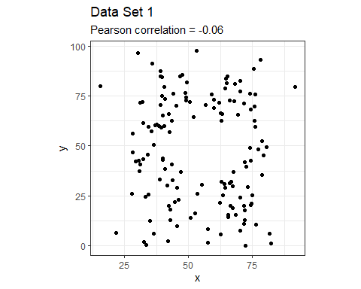

13 Data Sets in the df tibble:
df |> group_by(set) |>
summarize(n = n(), mean_x = mean(x),
sd_x = sd(x),
mean_y = mean(y),
sd_y = sd(y),
corr_xy = cor(x, y)) |>
round_half_up(digits = 2)
set n mean_x sd_x mean_y sd_y corr_xy
1 1 142 54.27 16.77 47.83 26.94 -0.06
2 2 142 54.27 16.77 47.83 26.94 -0.07
3 3 142 54.27 16.76 47.84 26.93 -0.07
4 4 142 54.26 16.77 47.83 26.94 -0.06
5 5 142 54.26 16.77 47.84 26.93 -0.06
6 6 142 54.26 16.77 47.83 26.94 -0.06
7 7 142 54.27 16.77 47.84 26.94 -0.07
8 8 142 54.27 16.77 47.84 26.94 -0.07
9 9 142 54.27 16.77 47.83 26.94 -0.07
10 10 142 54.27 16.77 47.84 26.93 -0.06
11 11 142 54.27 16.77 47.84 26.94 -0.07
12 12 142 54.27 16.77 47.83 26.94 -0.07
13 13 142 54.26 16.77 47.84 26.93 -0.07

New Data: Model for Set 1
set_1 <- lm(y ~ x, data = df |> filter(set == 1))
tidy(set_1, conf.int = T, conf.level = 0.9) |>
select(-statistic, -p.value)
# A tibble: 2 × 5
term estimate std.error conf.low conf.high
<chr> <dbl> <dbl> <dbl> <dbl>
1 (Intercept) 53.4 7.69 40.7 66.2
2 x -0.103 0.135 -0.327 0.121
glance(set_1) |>
select(r.squared, adj.r.squared, sigma, BIC, p.value)
# A tibble: 1 × 5
r.squared adj.r.squared sigma BIC p.value
<dbl> <dbl> <dbl> <dbl> <dbl>
1 0.00411 -0.00300 27.0 1352. 0.448

All 13 Models, at a glance
set_1 <- lm(y ~ x, data = df |> filter(set == 1))
set_2 <- lm(y ~ x, data = df |> filter(set == 2))
set_3 <- lm(y ~ x, data = df |> filter(set == 3))
set_4 <- lm(y ~ x, data = df |> filter(set == 4))
set_5 <- lm(y ~ x, data = df |> filter(set == 5))
set_6 <- lm(y ~ x, data = df |> filter(set == 6))
set_7 <- lm(y ~ x, data = df |> filter(set == 7))
set_8 <- lm(y ~ x, data = df |> filter(set == 8))
set_9 <- lm(y ~ x, data = df |> filter(set == 9))
set_10 <- lm(y ~ x, data = df |> filter(set == 10))
set_11 <- lm(y ~ x, data = df |> filter(set == 11))
set_12 <- lm(y ~ x, data = df |> filter(set == 12))
set_13 <- lm(y ~ x, data = df |> filter(set == 13))
a1 <- glance(set_1) |> mutate(dataset = 1)
a2 <- glance(set_2) |> mutate(dataset = 2)
a3 <- glance(set_3) |> mutate(dataset = 3)
a4 <- glance(set_4) |> mutate(dataset = 4)
a5 <- glance(set_5) |> mutate(dataset = 5)
a6 <- glance(set_6) |> mutate(dataset = 6)
a7 <- glance(set_7) |> mutate(dataset = 7)
a8 <- glance(set_8) |> mutate(dataset = 8)
a9 <- glance(set_9) |> mutate(dataset = 9)
a10 <- glance(set_10) |> mutate(dataset = 10)
a11 <- glance(set_11) |> mutate(dataset = 11)
a12 <- glance(set_12) |> mutate(dataset = 12)
a13 <- glance(set_13) |> mutate(dataset = 13)
a <- bind_rows(a1, a2, a3, a4, a5, a6, a7, a8,
a9, a10, a11, a12, a13) |>
select(dataset, r.squared, adj.r.squared, sigma,
AIC, BIC)
a
# A tibble: 13 × 6
dataset r.squared adj.r.squared sigma AIC BIC
<dbl> <dbl> <dbl> <dbl> <dbl> <dbl>
1 1 0.00411 -0.00300 27.0 1343. 1352.
2 2 0.00470 -0.00241 27.0 1343. 1352.
3 3 0.00467 -0.00244 27.0 1343. 1351.
4 4 0.00416 -0.00296 27.0 1343. 1352.
5 5 0.00364 -0.00348 27.0 1343. 1352.
6 6 0.00381 -0.00331 27.0 1343. 1352.
7 7 0.00469 -0.00242 27.0 1343. 1352.
8 8 0.00476 -0.00235 27.0 1343. 1352.
9 9 0.00471 -0.00240 27.0 1343. 1352.
10 10 0.00396 -0.00315 27.0 1343. 1352.
11 11 0.00482 -0.00229 27.0 1343. 1352.
12 12 0.00443 -0.00268 27.0 1343. 1352.
13 13 0.00430 -0.00281 27.0 1343. 1352.

Plot for Data Set 1
Does a linear model for y using x seem appropriate?
temp <- df |> filter(set == 1)
ggplot(temp, aes(x = x, y = y)) +
geom_point() +
labs(title = "Data Set 1") +
theme(aspect.ratio = 1)
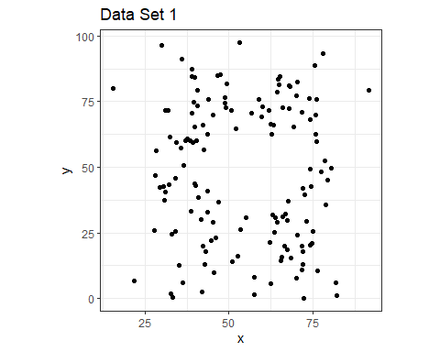

https://xkcd.com/1725/
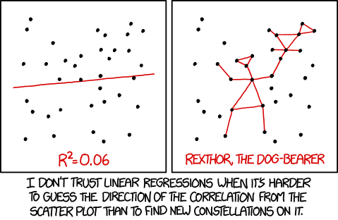

Set 1 Plot (+lm, +loess)
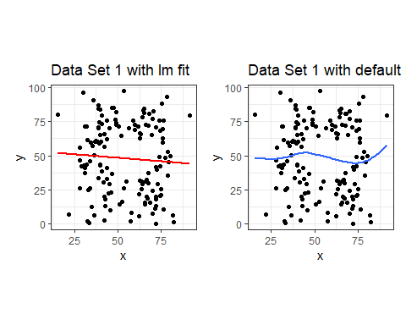

Model 1 (linear model for Set 1)
set_1
Call:
lm(formula = y ~ x, data = filter(df, set == 1))
Coefficients:
(Intercept) x
53.425 -0.103

The Other 12 Data Sets
Models 2-13 all look about the same in terms of means, medians, correlations, regression models, but what happens if we plot the data?
temp2 <- df |> filter(set != 1)
ggplot(temp2, aes(x = x, y = y, color = dataset)) +
geom_point(show.legend = FALSE) +
facet_wrap(~ set, labeller = "label_both")
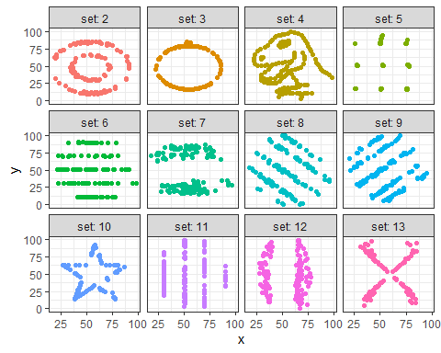

Actually, each set has a name
ggplot(temp2, aes(x = x, y = y)) +
geom_point() +
facet_wrap(~ dataset, labeller = "label_both")
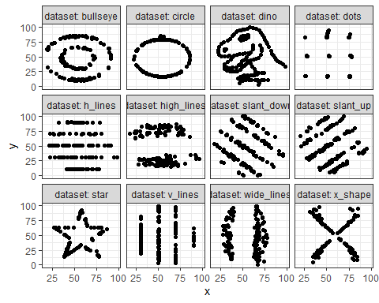

Same linear fit, each time
ggplot(temp2, aes(x = x, y = y)) +
geom_point() +
geom_smooth(method = "lm", col = "red", formula = y ~ x) +
facet_wrap(~ dataset, labeller = "label_both")
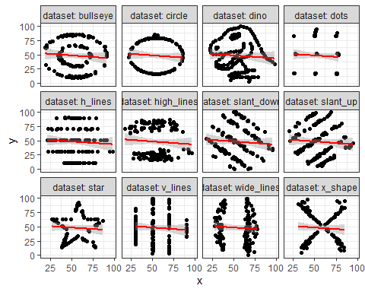

loess smooths?
ggplot(temp2, aes(x = x, y = y)) +
geom_point() +
geom_smooth(method = "loess", col = "blue", se = FALSE, formula = y ~ x) +
facet_wrap(~ dataset, labeller = "label_both",
scales = "free_y")
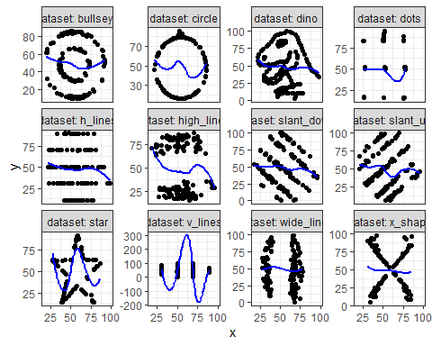

And the data come from
These are, of course, the datasauRus dozen data sets described in Spiegelhalter, available in the datasauRus package, which you can install from CRAN, thanks to the work of Steph Locke.
library(datasauRus)
df <- datasaurus_dozen
- These were created by Alberto Cairo, who has some great books like How Charts Lie
The moral of the story: Never trust summary statistics alone, always visualize your data

Two Cool Things, available online…
- We’ll visit Tomas Westlake’s work at https://r-mageddon.netlify.app/post/reanimating-the-datasaurus/
library(datasauRus)
library(ggplot2)
library(gganimate)
ggplot(datasaurus_dozen, aes(x=x, y=y))+
geom_point()+
theme_minimal() +
transition_states(dataset, 3, 1)

Two Cool Things, available online…
- Next, we’ll visit https://www.autodesk.com/research/publications/same-stats-different-graphs
This is Same Stats, Different Graphs: Generating Datasets with Varied Appearance and Identical Statistics through Simulated Annealing by Justin Matejka and George Fitzmaurice.
We’ll look at a couple of the animated plots they generate there.

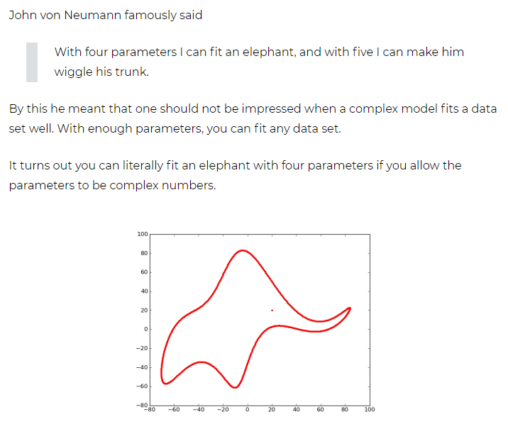

A Taste of 432: Sea Urchins and Tidy Modeling

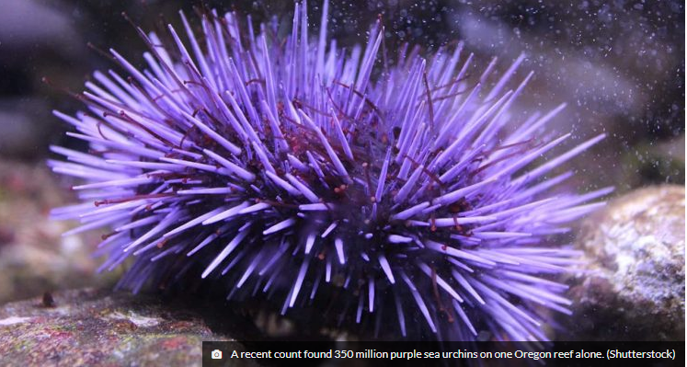

Sea Urchins and Tidy Modeling
Constable (1993) compared the inter-radial suture widths of urchins maintained on one of three food regimes
- Initial: no additional food supplied above what was in the initial sample
- Low: food supplied periodically
- High: food supplied ad libitum (as often as desired)
In an attempt to control for substantial variability in urchin sizes, the initial body volume of each urchin was measured as a covariate.
- This example comes from https://www.tidymodels.org/start/models/
- Another key source is https://www.flutterbys.com.au/stats/tut/tut7.5a.html
- Data from Constable, A.J. The role of sutures in shrinking of the test in Heliocidaris erythrogramma (Echinoidea: Echinometridae). Marine Biology 117, 423-430 (1993). https://doi.org/10.1007/BF00349318

Package Load / Data ingest (Sea Urchins)
library(tidymodels)
library(broom.mixed)
urchins <-
# Data were assembled for a tutorial
# at https://www.flutterbys.com.au/stats/tut/tut7.5a.html
read_csv("https://tidymodels.org/start/models/urchins.csv") |>
# Change the names to be a little more verbose
setNames(c("food_regime", "initial_volume", "width")) |>
mutate(food_regime =
factor(food_regime,
levels = c("Initial", "Low", "High")))

The urchins data
For each of 72 sea urchins, we know their
- experimental feeding regime group (food_regime: either Initial, Low, or High),
- size in milliliters at the start of the experiment (initial_volume), and
- suture width at the end of the experiment (width).
glimpse(urchins)
Rows: 72
Columns: 3
$ food_regime <fct> Initial, Initial, Initial, Initial, Initial, Initial, I…
$ initial_volume <dbl> 3.5, 5.0, 8.0, 10.0, 13.0, 13.0, 15.0, 15.0, 16.0, 17.0…
$ width <dbl> 0.010, 0.020, 0.061, 0.051, 0.041, 0.061, 0.041, 0.071,…

Plot the Data
ggplot(urchins,
aes(x = initial_volume, y = width,
group = food_regime, col = food_regime)) +
geom_point() + geom_smooth(method = lm, formula = y ~ x, se = FALSE) +
scale_color_viridis_d(option = "plasma", end = .7)
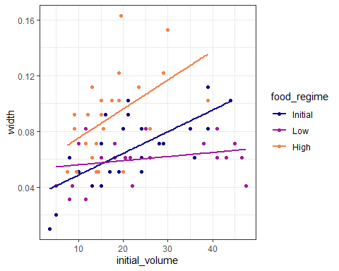

How should we model the data?
Slopes appear to be different for at least two of the feeding regimes, so we’ll use a linear model with interaction to allow each food regime to have a different slope and intercept for the effect of initial volume.
lm(width ~ initial_volume * food_regime, data = urchins) |> tidy() |>
select(term, estimate)
# A tibble: 6 × 2
term estimate
<chr> <dbl>
1 (Intercept) 0.0331
2 initial_volume 0.00155
3 food_regimeLow 0.0198
4 food_regimeHigh 0.0214
5 initial_volume:food_regimeLow -0.00126
6 initial_volume:food_regimeHigh 0.000525

Setting up a linear regression with tidymodels
lm_mod <-
linear_reg() |>
set_engine("lm")
lm_mod
Linear Regression Model Specification (regression)
Computational engine: lm
It turns out that we’ll have several options for engines here.

We can estimate or train the model with fit()
lm_fit <-
lm_mod |>
fit(width ~ initial_volume * food_regime, data = urchins)
We’ll look at the results on the next slide.

What’s in lm_fit?
tidy(lm_fit, conf.int = TRUE) |> select(term, estimate, conf.low, conf.high)
# A tibble: 6 × 4
term estimate conf.low conf.high
<chr> <dbl> <dbl> <dbl>
1 (Intercept) 0.0331 0.0139 0.0523
2 initial_volume 0.00155 0.000760 0.00235
3 food_regimeLow 0.0198 -0.00615 0.0457
4 food_regimeHigh 0.0214 -0.00760 0.0504
5 initial_volume:food_regimeLow -0.00126 -0.00228 -0.000241
6 initial_volume:food_regimeHigh 0.000525 -0.000876 0.00193

Make Predictions
Suppose that, for a publication, it would be particularly interesting to make a plot of the mean body size for urchins that started the experiment with an initial volume of 20ml. To create such a graph, we start with some new example data that we will make predictions for.
new_points <- expand.grid(initial_volume = 20,
food_regime = c("Initial", "Low", "High"))
new_points
initial_volume food_regime
1 20 Initial
2 20 Low
3 20 High

Obtain Predicted Results for these new_points
We’ll develop mean predictions and uncertainty intervals.
mean_pred <- predict(lm_fit, new_data = new_points)
conf_int_pred <- predict(lm_fit,
new_data = new_points,
type = "conf_int")
plot_data <-
new_points |>
bind_cols(mean_pred) |>
bind_cols(conf_int_pred)

Plot the plot_data results
ggplot(plot_data, aes(x = food_regime, y = .pred)) +
geom_point() +
geom_errorbar(aes(ymin = .pred_lower,
ymax = .pred_upper),
width = .2) +
labs(y = "urchin size",
title = "Linear model fit using `lm`")
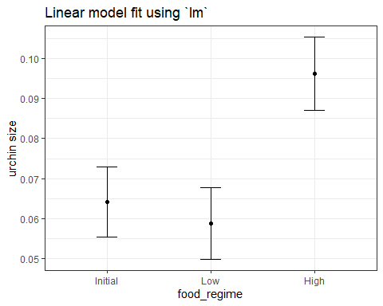

Could we use Bayesian methods?
Would the results be different if we used a Bayesian approach?
- Need to select a prior.
- Let’s use bell-shaped priors on the intercepts and slopes, using a Cauchy distribution (works out to be the same as a t distribution with one degree of freedom)
- The stan_glm() function can be used, and this is available as an engine in tidymodels, where we need to specify prior and prior_intercept to fit a linear model.

Setting up a Bayesian Model
prior_dist <- rstanarm::student_t(df = 1)
set.seed(123)
bayes_mod <-
linear_reg() |>
set_engine("stan",
prior_intercept = prior_dist,
prior = prior_dist)

Training the Bayes Model
bayes_fit <- bayes_mod |>
fit(width ~ initial_volume * food_regime, data = urchins)
tidy(bayes_fit, conf.int = TRUE) |>
select(term, estimate, conf.low, conf.high)
# A tibble: 6 × 4
term estimate conf.low conf.high
<chr> <dbl> <dbl> <dbl>
1 (Intercept) 0.0329 0.0173 0.0487
2 initial_volume 0.00156 0.000903 0.00222
3 food_regimeLow 0.0198 -0.00171 0.0411
4 food_regimeHigh 0.0215 -0.00253 0.0441
5 initial_volume:food_regimeLow -0.00126 -0.00209 -0.000423
6 initial_volume:food_regimeHigh 0.000522 -0.000606 0.00165

Building the plot for the Bayes model
bayes_plot_data <-
new_points |>
bind_cols(predict(bayes_fit, new_data = new_points)) |>
bind_cols(predict(bayes_fit, new_data = new_points,
type = "conf_int"))
ggplot(bayes_plot_data, aes(x = food_regime, y = .pred)) +
geom_point() +
geom_errorbar(aes(ymin = .pred_lower, ymax = .pred_upper),
width = .2) +
labs(y = "urchin size",
title = "Bayesian model with t(1) prior distribution")
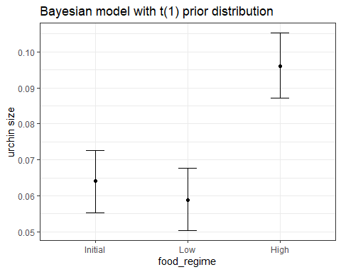

Comparing the Models
p1 <- ggplot(plot_data, aes(x = food_regime, y = .pred)) +
geom_point() +
geom_errorbar(aes(ymin = .pred_lower,
ymax = .pred_upper),
width = .2) +
geom_label(aes(label = round_half_up(.pred,3)), fill = "white") +
labs(y = "urchin size",
title = "Linear model fit using `lm`")
p2 <- ggplot(bayes_plot_data, aes(x = food_regime, y = .pred)) +
geom_point() +
geom_errorbar(aes(ymin = .pred_lower, ymax = .pred_upper), width = .2) +
geom_label(aes(label = round_half_up(.pred,3)), fill = "white") +
labs(y = "urchin size",
title = "Bayesian model with t(1) prior")
p1 + p2 +
plot_annotation(title = "Comparing linear models for urchins data")
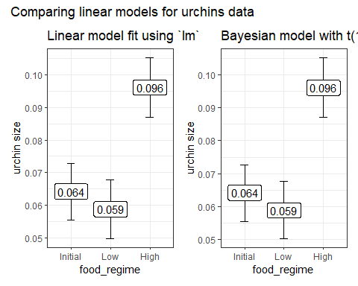

The models aren’t actually the same
p1 <- ggplot(plot_data, aes(x = food_regime, y = .pred)) +
geom_point() +
geom_errorbar(aes(ymin = .pred_lower,
ymax = .pred_upper),
width = .2) +
geom_label(aes(label = round_half_up(.pred,5)), fill = "white") +
labs(y = "urchin size",
title = "Linear model fit using `lm`")
p2 <- ggplot(bayes_plot_data, aes(x = food_regime, y = .pred)) +
geom_point() +
geom_errorbar(aes(ymin = .pred_lower, ymax = .pred_upper), width = .2) +
geom_label(aes(label = round_half_up(.pred,5)), fill = "white") +
labs(y = "urchin size",
title = "Bayesian model with t(1) prior")
p1 + p2 +
plot_annotation(title = "Comparing linear models for urchins data")
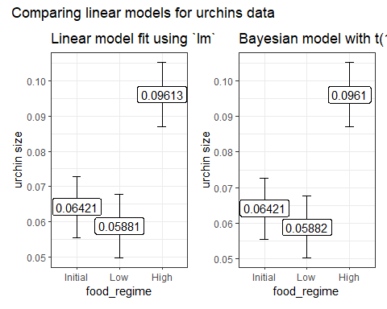

What are we plotting, actually?
plot_data
initial_volume food_regime .pred .pred_lower .pred_upper
1 20 Initial 0.06421443 0.05549934 0.07292952
2 20 Low 0.05880940 0.04986251 0.06775629
3 20 High 0.09613343 0.08696233 0.10530453
bayes_plot_data
initial_volume food_regime .pred .pred_lower .pred_upper
1 20 Initial 0.06420994 0.05533727 0.07267092
2 20 Low 0.05882441 0.05033710 0.06767421
3 20 High 0.09610333 0.08719659 0.10526191

What do we take away from 431 at the end of the day?

Ten Simple Rules for Effective Statistical Practice
From PLoS Computational Biology
- Statistical Methods Should Enable Data to Answer Scientific Questions
- Signals Always Come with Noise
- Plan Ahead, Really Ahead
- Worry About Data Quality
- Statistical Analysis Is More Than a Set of Computations

Ten Simple Rules for Effective Statistical Practice
From PLoS Computational Biology
- Keep it Simple
- Provide Assessments of Variability
- Check Your Assumptions
- When Possible, Replicate!
- Make Your Analysis Reproducible

The Impact of Study Design (Gelman)
Applied statistics is hard.
- Doing a statistical analysis is like playing basketball, or knitting a sweater. You can get better with practice.
- Incompetent statistics does not necessarily doom a research paper: some findings are solid enough that they show up even when there are mistakes in the data collection and data analyses. But we’ve also seen many examples where incompetent statistics led to conclusions that made no sense but still received publication and publicity.
- We should be thinking not just about data analysis, but also data quality.
To consult the statistician after an experiment is finished is often merely to ask him to conduct a post mortem examination. He can perhaps say what the experiment died of. (R. A. Fisher)

Build Tidy Data Sets
- Each variable should be in one column.
- Each observation should be in a different row.
- There should be one table for each “kind” of variable.
- If you have multiple tables, they should include a column in the table that allows them to be linked.
- Include real column names. Age_at_Diagnosis is much better than ADx.
- Build useful codebooks.
Jeff Leek: “How to share data with a statistician”

A Tip from David Robinson
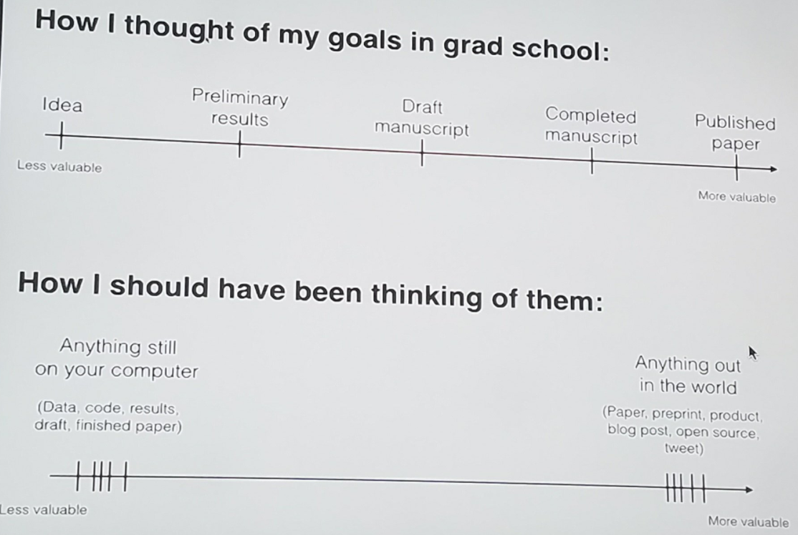

Ten of the Most Important 431 Ideas
- You have to visualize and count data to understand it.
- 90% of statistical work could be described as data management.
- Quarto and the tidyverse make it easier to do the right thing.
- Statistical significance is not a helpful concept.
- Point estimates and confidence intervals are useful ideas.

Ten of the Most Important 431 Ideas
- Most statistical procedures are in fact regression models.
- All statistical methods involve assumptions worth checking.
- The bootstrap is a very useful, and somewhat underused tool.
- Prediction models need to predict well in new situations.
- Statistical thinking is far too important to be left to statisticians.



Session Information
xfun::session_info()
R version 4.5.2 (2025-10-31 ucrt)
Platform: x86_64-w64-mingw32/x64
Running under: Windows 11 x64 (build 26200)
Locale:
LC_COLLATE=English_United States.utf8
LC_CTYPE=English_United States.utf8
LC_MONETARY=English_United States.utf8
LC_NUMERIC=C
LC_TIME=English_United States.utf8
Package version:
abind_1.4-8 askpass_1.2.1 backports_1.5.0
base64enc_0.1-3 bayesplot_1.14.0 BH_1.87.0.1
bit_4.6.0 bit64_4.6.0-1 blob_1.2.4
boot_1.3-32 broom_1.0.10 broom.mixed_0.2.9.6
bslib_0.9.0 cachem_1.1.0 callr_3.7.6
cellranger_1.1.0 checkmate_2.3.3 class_7.3-23
cli_3.6.5 clipr_0.8.0 clock_0.7.3
coda_0.19.4.1 codetools_0.2-20 colourpicker_1.3.0
commonmark_2.0.0 compiler_4.5.2 conflicted_1.2.0
cpp11_0.5.2 crayon_1.5.3 crosstalk_1.2.2
curl_7.0.0 data.table_1.17.8 datasauRus_0.1.9
DBI_1.2.3 dbplyr_2.5.1 desc_1.4.3
diagram_1.6.5 dials_1.4.2 DiceDesign_1.10
digest_0.6.38 distributional_0.5.0 dplyr_1.1.4
DT_0.34.0 dtplyr_1.3.2 dygraphs_1.1.1.6
evaluate_1.0.5 farver_2.1.2 fastmap_1.2.0
fontawesome_0.5.3 fontBitstreamVera_0.1.1 fontLiberation_0.1.0
fontquiver_0.2.1 forcats_1.0.1 fs_1.6.6
furrr_0.3.1 future_1.68.0 future.apply_1.20.0
gargle_1.6.0 gdtools_0.4.4 generics_0.1.4
ggformula_1.0.0 ggiraph_0.9.2 ggplot2_4.0.1
ggridges_0.5.7 globals_0.18.0 glue_1.8.0
googledrive_2.1.2 googlesheets4_1.1.2 gower_1.0.2
GPfit_1.0-9 graphics_4.5.2 grDevices_4.5.2
grid_4.5.2 gridExtra_2.3 gtable_0.3.6
gtools_3.9.5 hardhat_1.4.2 haven_2.5.5
highr_0.11 hms_1.1.4 htmltools_0.5.8.1
htmlwidgets_1.6.4 httpuv_1.6.16 httr_1.4.7
ids_1.0.1 igraph_2.2.1 infer_1.0.9
inline_0.3.21 ipred_0.9-15 isoband_0.2.7
janitor_2.2.1 jquerylib_0.1.4 jsonlite_2.0.0
KernSmooth_2.23.26 knitr_1.50 labeling_0.4.3
labelled_2.16.0 later_1.4.4 lattice_0.22-7
lava_1.8.2 lazyeval_0.2.2 lhs_1.2.0
lifecycle_1.0.4 listenv_0.10.0 litedown_0.8
lme4_1.1-37 loo_2.8.0 lubridate_1.9.4
magrittr_2.0.4 markdown_2.0 MASS_7.3-65
Matrix_1.7-4 matrixStats_1.5.0 memoise_2.0.1
methods_4.5.2 mgcv_1.9-4 mime_0.13
miniUI_0.1.2 minqa_1.2.8 modeldata_1.5.1
modelenv_0.2.0 modelr_0.1.11 mosaic_1.9.2
mosaicCore_0.9.5 mosaicData_0.20.4 nlme_3.1-168
nloptr_2.2.1 nnet_7.3-20 numDeriv_2016.8.1.1
openssl_2.3.4 otel_0.2.0 parallel_4.5.2
parallelly_1.45.1 parsnip_1.3.3 patchwork_1.3.2
pillar_1.11.1 pkgbuild_1.4.8 pkgconfig_2.0.3
plyr_1.8.9 posterior_1.6.1 prettyunits_1.2.0
processx_3.8.6 prodlim_2025.04.28 progress_1.2.3
progressr_0.18.0 promises_1.5.0 ps_1.9.1
purrr_1.2.0 QuickJSR_1.8.1 R6_2.6.1
ragg_1.5.0 rappdirs_0.3.3 rbibutils_2.4
RColorBrewer_1.1-3 Rcpp_1.1.0 RcppEigen_0.3.4.0.2
RcppParallel_5.1.11-1 Rdpack_2.6.4 readr_2.1.6
readxl_1.4.5 recipes_1.3.1 reformulas_0.4.2
rematch_2.0.0 rematch2_2.1.2 reprex_2.1.1
reshape2_1.4.5 rlang_1.1.6 rmarkdown_2.30
rpart_4.1.24 rsample_1.3.1 rstan_2.32.7
rstanarm_2.32.2 rstantools_2.5.0 rstudioapi_0.17.1
rvest_1.0.5 S7_0.2.1 sass_0.4.10
scales_1.4.0 selectr_0.4.2 sfd_0.1.0
shape_1.4.6.1 shiny_1.11.1 shinyjs_2.1.0
shinystan_2.6.0 shinythemes_1.2.0 slider_0.3.3
snakecase_0.11.1 sourcetools_0.1.7.1 sparsevctrs_0.3.4
splines_4.5.2 SQUAREM_2021.1 StanHeaders_2.32.10
stats_4.5.2 stats4_4.5.2 stringi_1.8.7
stringr_1.6.0 survival_3.8-3 sys_3.4.3
systemfonts_1.3.1 tailor_0.1.0 tensorA_0.36.2.1
textshaping_1.0.4 threejs_0.3.4 tibble_3.3.0
tidymodels_1.4.1 tidyr_1.3.1 tidyselect_1.2.1
tidyverse_2.0.0 timechange_0.3.0 timeDate_4051.111
tinytex_0.58 tools_4.5.2 tune_2.0.1
tzdb_0.5.0 utf8_1.2.6 utils_4.5.2
uuid_1.2.1 V8_8.0.1 vctrs_0.6.5
viridisLite_0.4.2 vroom_1.6.6 warp_0.2.2
withr_3.0.2 workflows_1.3.0 workflowsets_1.1.1
xfun_0.54 xml2_1.4.1 xtable_1.8-4
xts_0.14.1 yaml_2.3.10 yardstick_1.3.2
zoo_1.8-14

