431 Class 15
Thomas E. Love, Ph.D.
2025-10-23

Today’s Agenda
- Quiz 1
- Project A Portfolio

Quiz 1

From the Quiz 1 Sketch
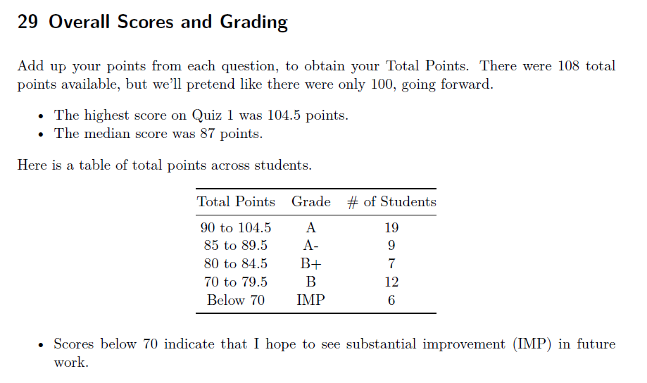

From the Quiz 1 Sketch
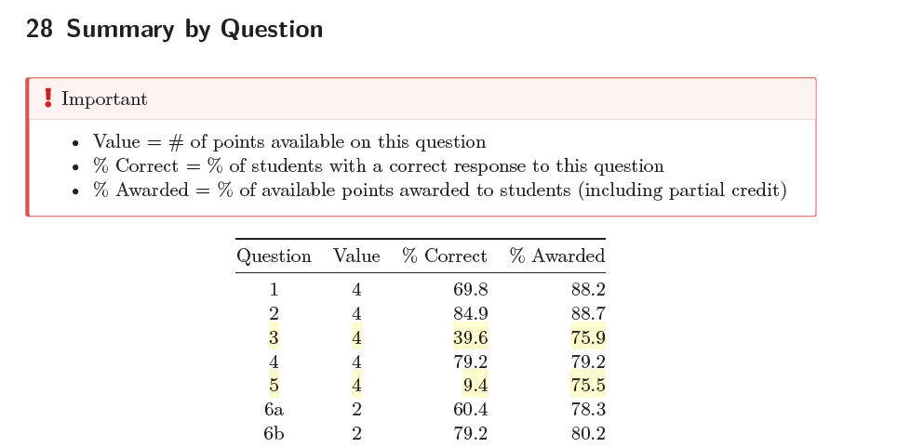

Question 3
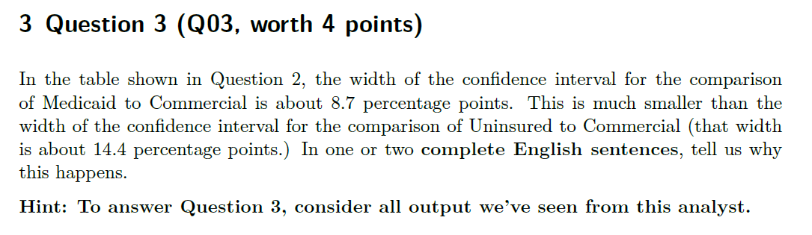

Table referred to in Q03
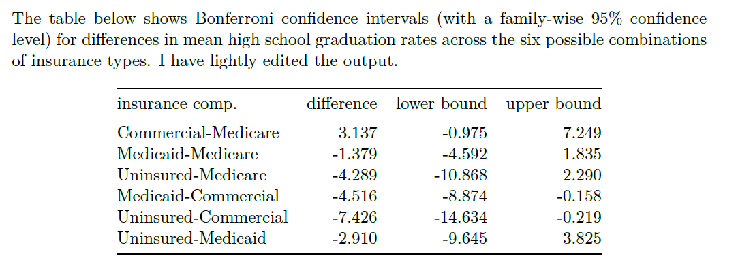

Key output for Q03
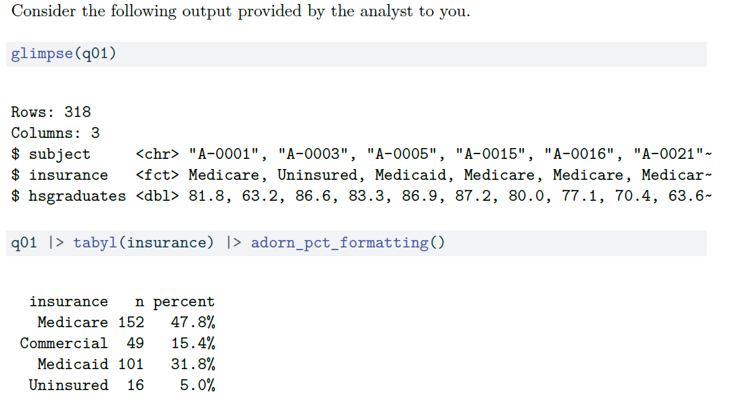

My answer
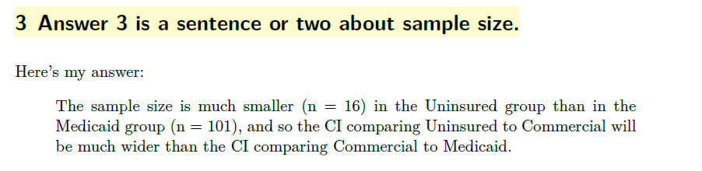

Student Responses
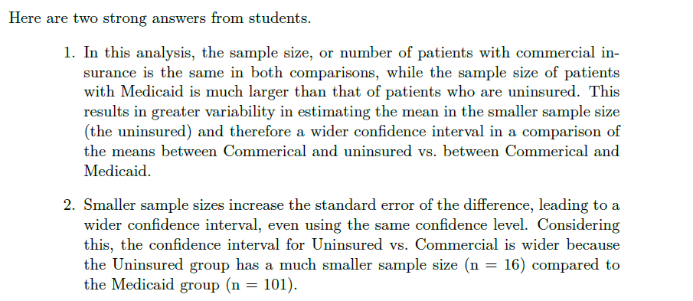

Grading Rubric (1/2)
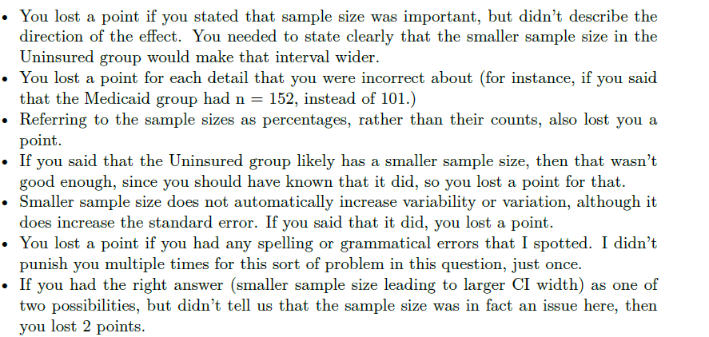

Grading Rubric and Results
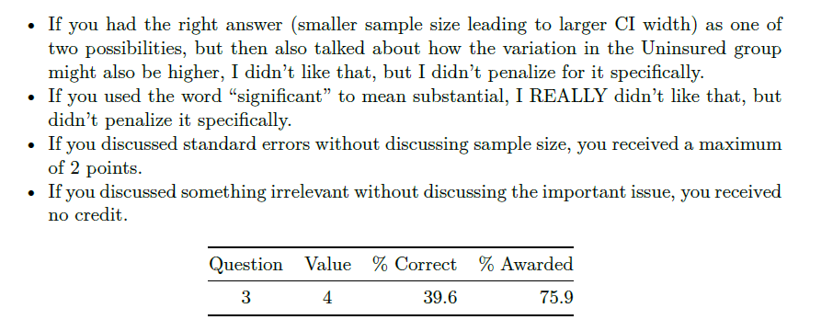

Question 5
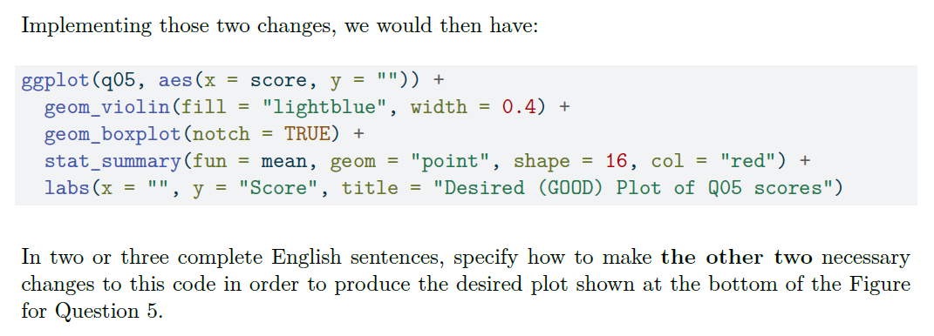

Figure for Question 5
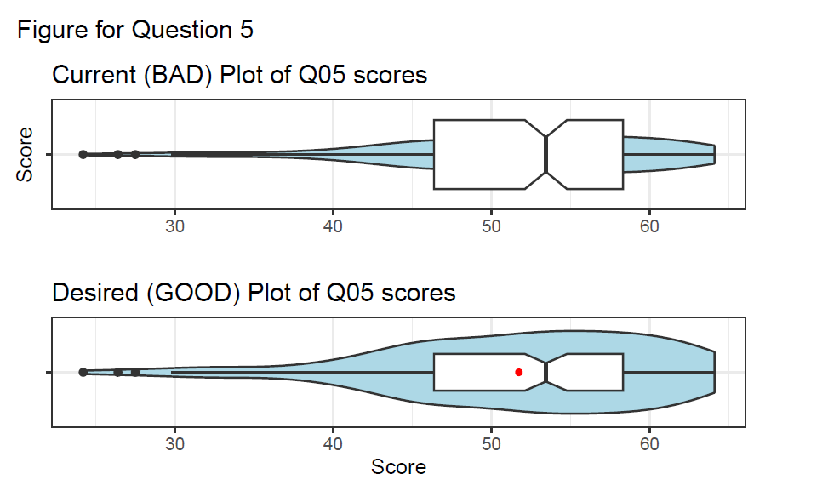

My Response
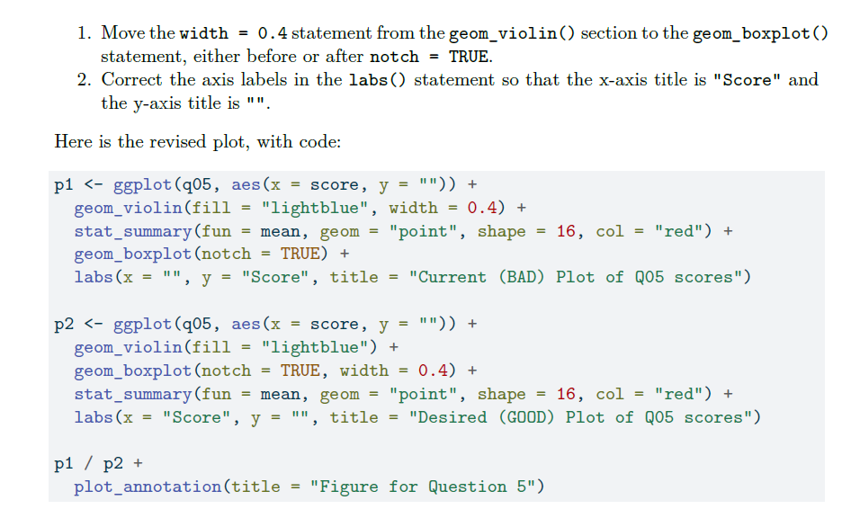

Responses and Grading
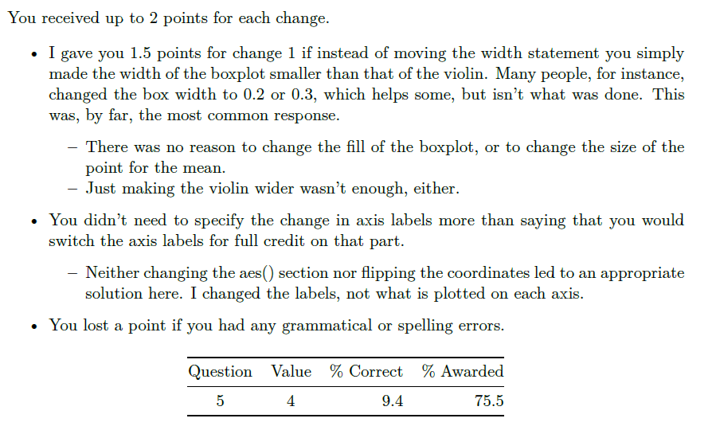

Questions 13-15
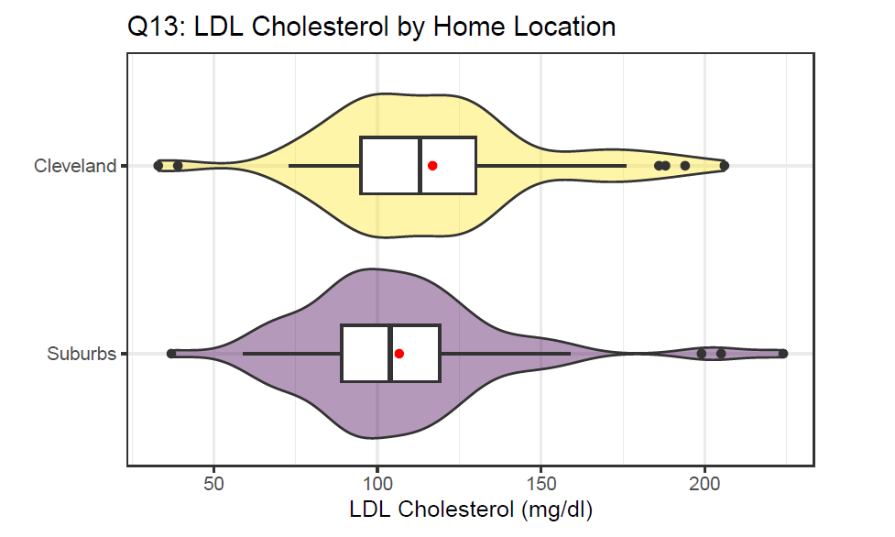

Question 13
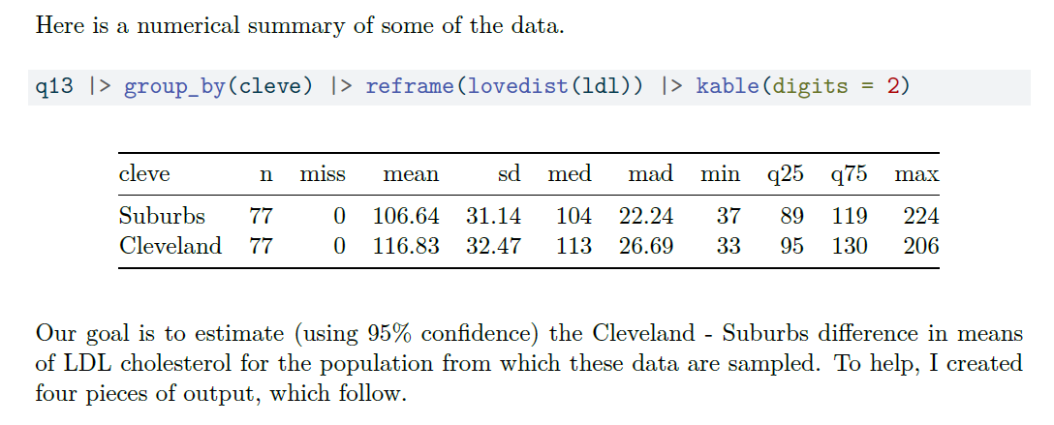

Question 13
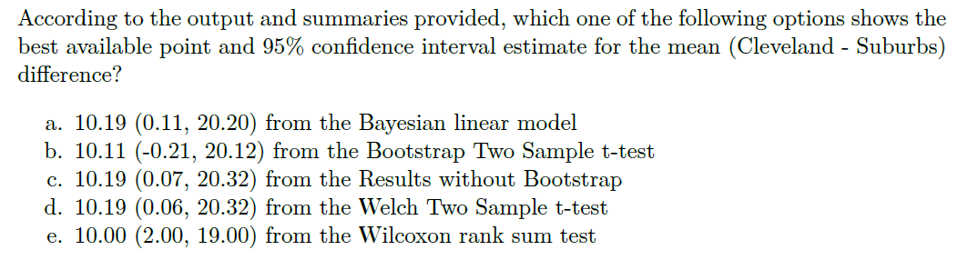

My Answer
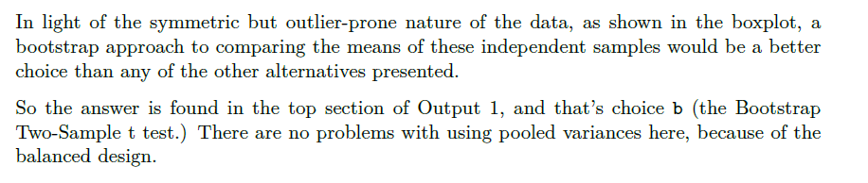

The Other Answers
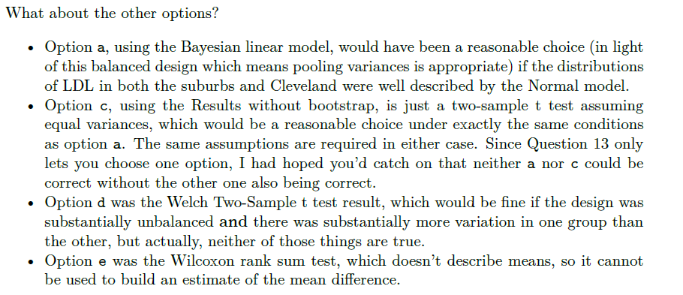

Questions 14-15
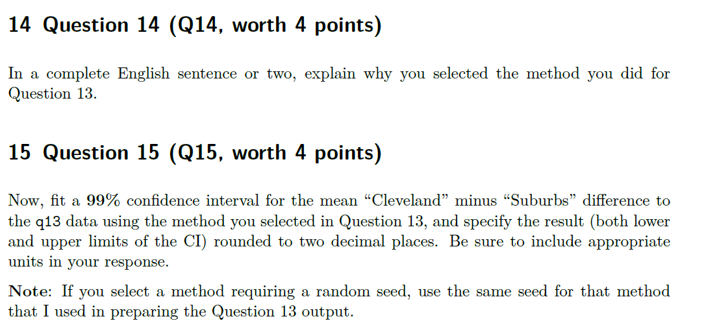

Question 14 Responses (1/3)
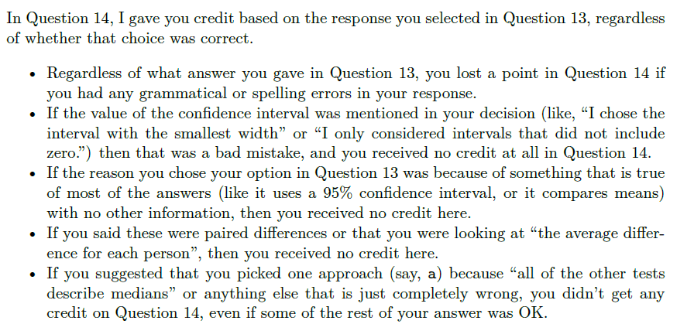

Question 14 Responses (2/3)
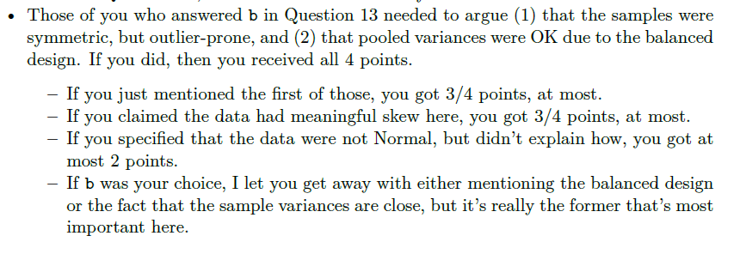

Question 14 Responses (3/3)
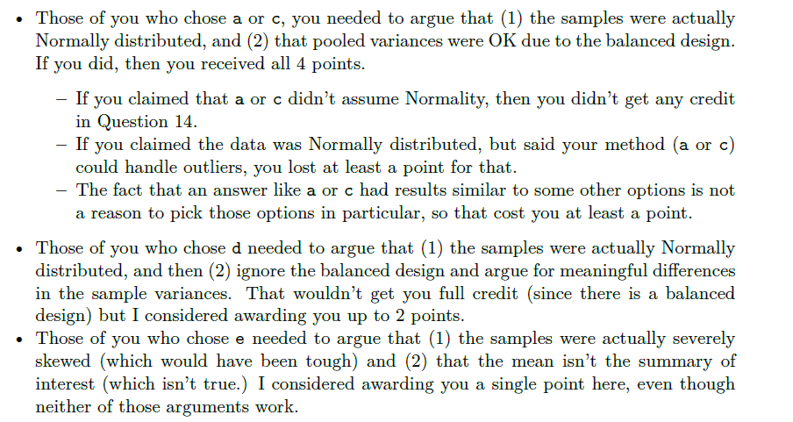

Question 15 Responses
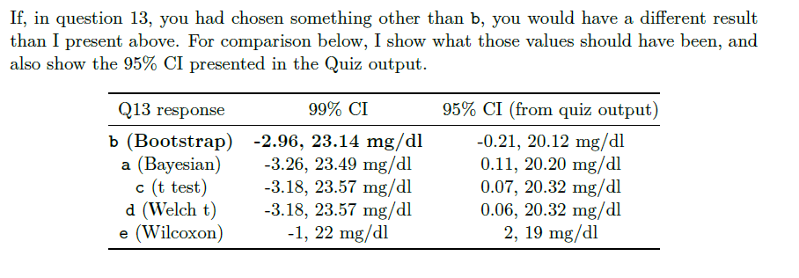

Question 19
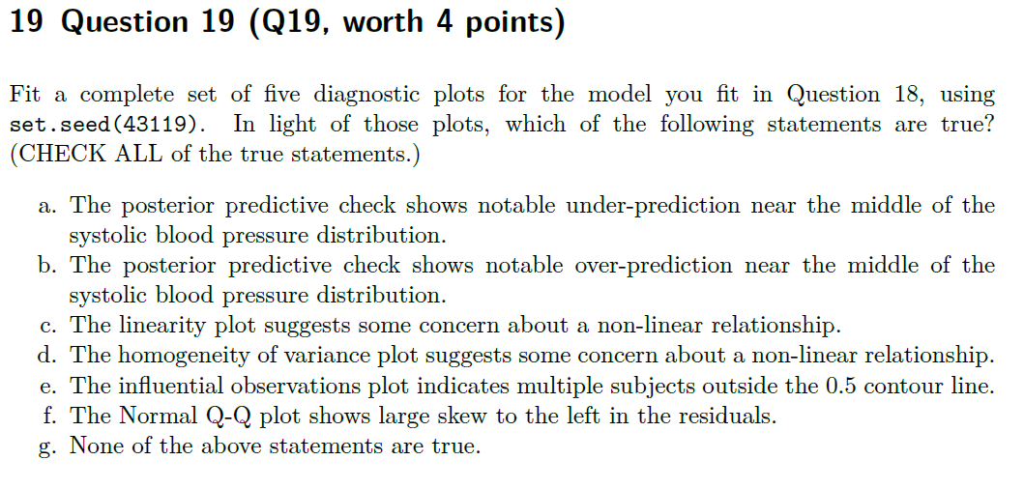

Diagnostic Plots (1st 4)
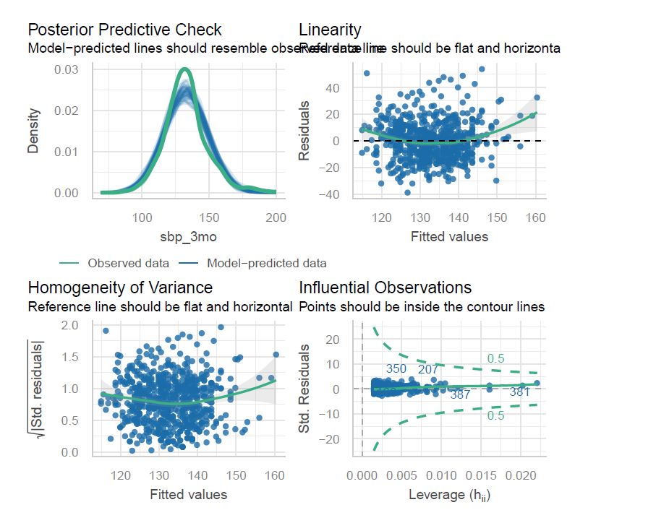

Fifth Diagnostic Plot
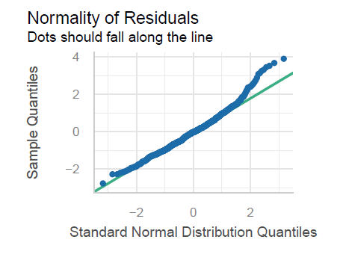

Question 19 Answer
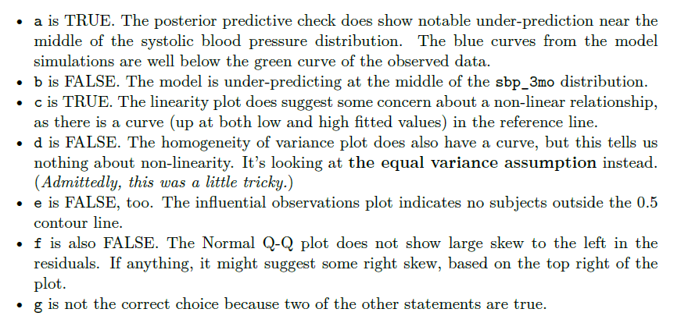

Question 20
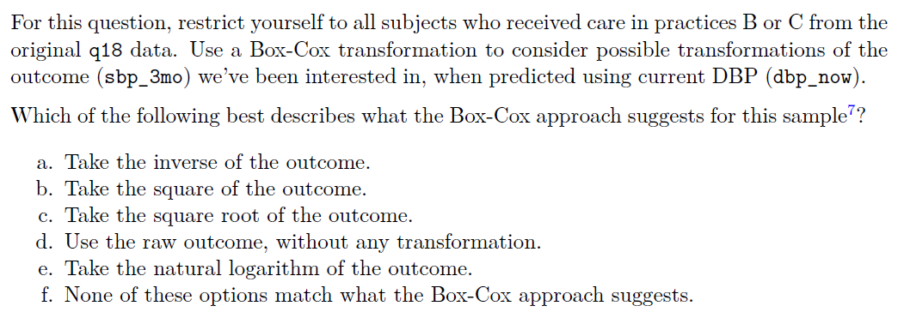

Box-Cox plot
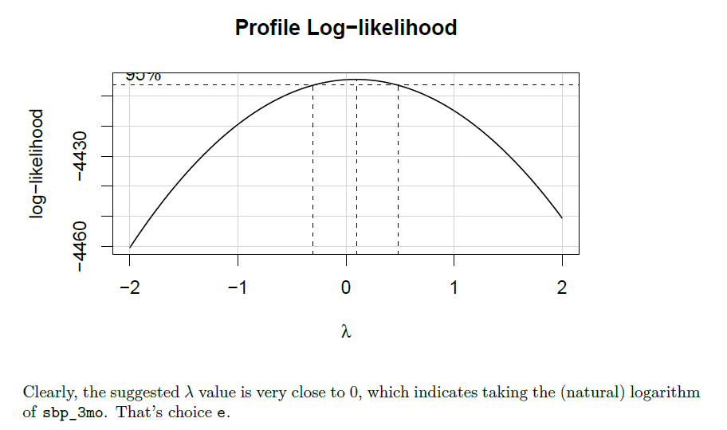

Question 21
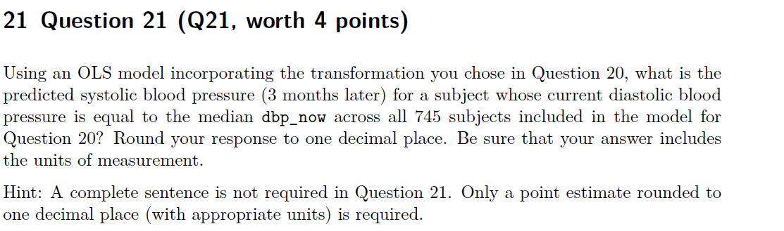

Median was 75.
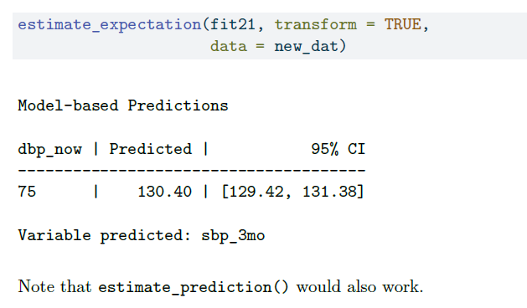

Surprising Results
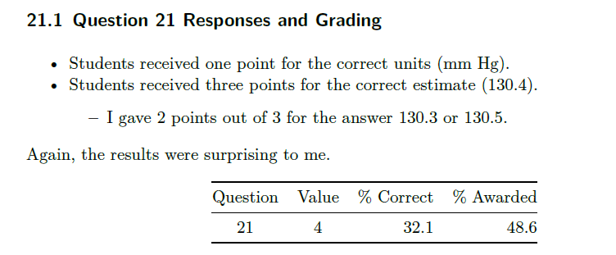

Question 25
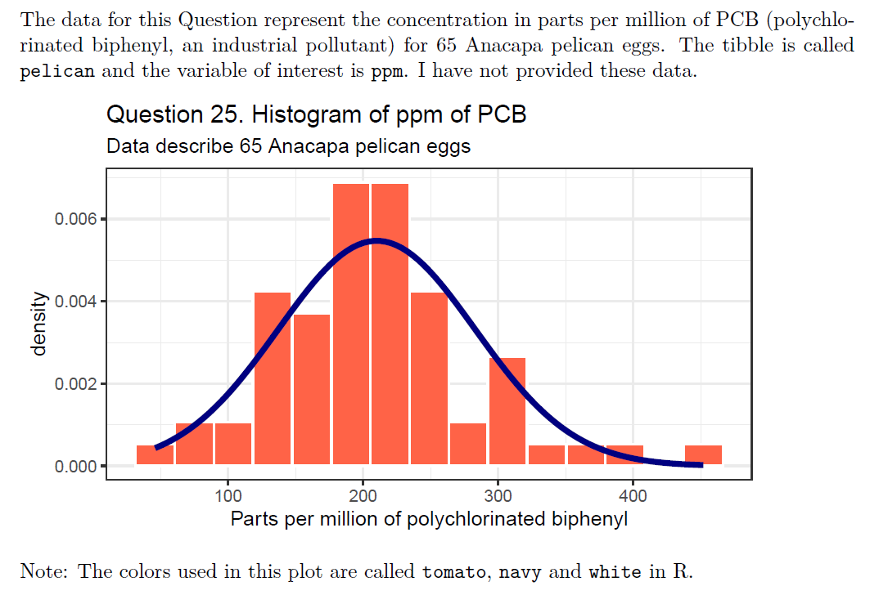

Lines 3, 5, and 7 should go.
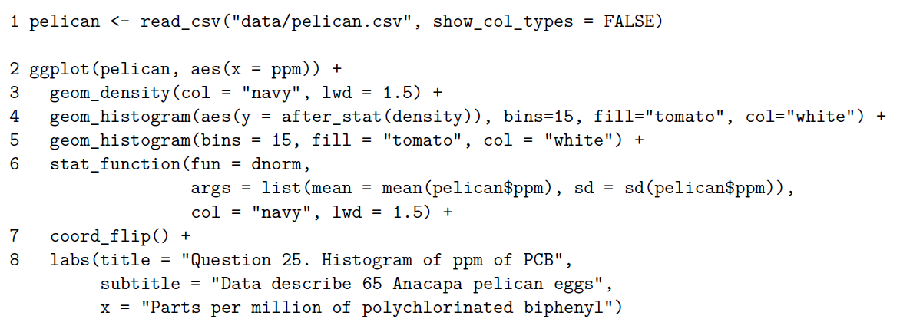

Question 27
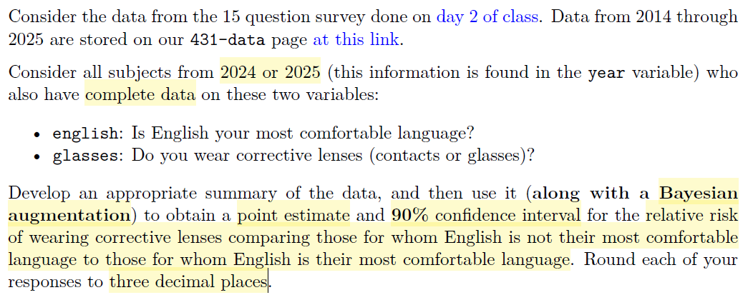

Correct 2x2 table
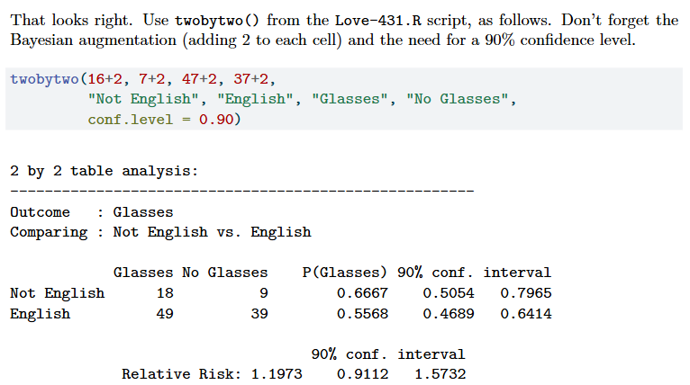

Some problems (1/2)
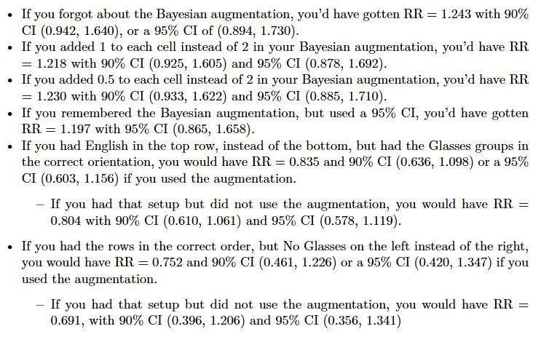

Some problems (2/2)
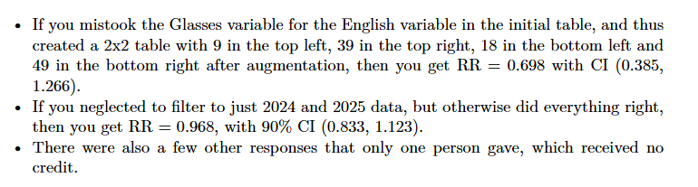

Project A

Project A Deliverables
All due next Wednesday at noon.
- The Report (18 sections, exactly) with Quarto, HTML and Rds (11 variables)
  - Portfolio Report outline is here.
  - Template for Portfolio Report is here.
  - Everything except “Reflections” section from Plan re-appears.
  - New “Reflections” section described here.
  - Report Checklist before submission is here

Project A Deliverables
- The Highlight Video (maximum 3 minutes)
  - You will produce a video in mp4 format of no more than 3 minutes in length regardless of whether you are working alone or in a team.
  - Producing a video often takes a full day of work after the portfolio report is finished. Do not leave yourself without the opportunity to do good work on this.
  - In this video, you will describe what you believe to be one of the most important findings for your Analysis 1, and for either your Analysis 2 or your Analysis 3.

Project A Deliverables
Again, this is all due next Wednesday at noon.
- The Self-Evaluation (form will open tomorrow)
  - People who complete each question on the self-evaluation thoughtfully and on time will receive either 9 or 10 points. Those who do not will receive fewer points.

Project A Advice
- Use the template for the portfolio report on the Examples page.
Note that the “Reflections” section from the Plan does not re-appear here, but everything else from the Plan does. Remember that we provided detailed feedback on your plan, and a sample Plan.
- Change your title (describe a result) and include a subtitle. No more than 80 and 150 characters, respectively. Waste no words in your title and subtitle.

Project A Advice
- The most important parts of the Report are accurate (and effectively presented) data development, accurate (and effectively presented) analyses, and the appropriateness of your research questions and your responses to them in light of your analyses. The reflection in section 16 is also important.

Project A Advice
- All videos should include a clear statement of the research questions for each of the two analyses presented, and justify the responses to those questions with results from the analyses. Many of the comments Professor Love builds in response to your Project A will relate to the Video. Do not treat it lightly. It is a vital part of the work, despite its short length.
Detailed instructions for the Video are found here. Follow them closely.

Improving Your Grade
- Perform the elements of the data science cycle (ingestion, tidying, transforming, visualizing, modeling and communicating) effectively.
  - Presenting irrelevant work that does not address the issues in question will hurt your grade.
  - Also, rehearse your video and make sure you present clearly and understandably throughout.
  - Make clear choices about what to include - that’s key.
  - Do not just show us everything you did.

Project A Advice
- A stronger grade will be associated with doing the tasks we’ve discussed more effectively.
  - Adding a lot of additional and unnecessary analyses/work without editing down to the important issues will not improve your grade, but rather have the opposite effect.
  - We want to see polished, accurate, clear work.
  - Making things clearer is the hardest thing to do, and so it’s the thing that impresses us most.

Questions? (Thanks for coming.)

