431 Class 09
Thomas E. Love, Ph.D.
2025-09-30

Today’s Agenda
- New Data, with Missing Values
  - Using naniar to help identify missingness
- More on One-Factor Analysis of Variance (ANOVA)
  - Pairwise comparisons of means
    - Getting actual simultaneous confidence intervals
    - Bonferroni and Tukey HSD procedures
  - Considering an Outcome Transformation
- Favorite Movies: Session 2

Load packages and set theme
library(janitor)
library(DescTools) ## NEW - for Bonferroni and Tukey HSD CIs
library(naniar) ## dealing with missing data
library(car) ## for the Box-Cox plot
library(patchwork)
library(rstanarm)
library(easystats)
library(tidyverse)
theme_set(theme_lucid()) ## new theme for ggplots!
knitr::opts_chunk$set(comment = NA)
source("c09/data/Love-431.R") # for the lovedist() function
- See Class 09 README for alternative ggplot themes.

Get the data
EUROFAMCARE project: a survey on the situation of family carers of older people in Europe.
ecare_orig <- read_csv("c09/data/eurocare.csv", show_col_types = FALSE) |>
janitor::clean_names() |>
mutate(across(where(is.character), as_factor)) |>
mutate(subject = as.character(subject))
dim(ecare_orig)
[1] 902 14
names(ecare_orig)
[1] "subject" "hours" "relation" "e_sex" "e_age"
[6] "dependency" "barthel" "c_age" "c_sex" "c_education"
[11] "c_employed" "neg_impact" "pos_impact" "qof_life"

Missingness?
miss_var_summary(ecare_orig)
# A tibble: 14 × 3
variable n_miss pct_miss
<chr> <int> <num>
1 c_education 60 6.65
2 pos_impact 21 2.33
3 barthel 19 2.11
4 e_age 11 1.22
5 neg_impact 10 1.11
6 qof_life 5 0.554
7 relation 1 0.111
8 e_sex 1 0.111
9 dependency 1 0.111
10 c_age 1 0.111
11 c_sex 1 0.111
12 subject 0 0
13 hours 0 0
14 c_employed 0 0

Today’s Variables
ecare_new <- ecare_orig |>
dplyr::select(subject, hours, c_education, pos_impact, dependency)
data_codebook(ecare_new |> select(!subject))
select(ecare_new, !subject) (902 rows and 4 variables, 4 shown)
ID | Name | Type | Missings | Values | N
---+-------------+-------------+-----------+-------------+------------
1 | hours | numeric | 0 (0.0%) | [4, 168] | 902
---+-------------+-------------+-----------+-------------+------------
2 | c_education | categorical | 60 (6.7%) | Middle | 506 (60.1%)
| | | | Low | 180 (21.4%)
| | | | High | 156 (18.5%)
---+-------------+-------------+-----------+-------------+------------
3 | pos_impact | numeric | 21 (2.3%) | [5, 16] | 881
---+-------------+-------------+-----------+-------------+------------
4 | dependency | categorical | 1 (0.1%) | moderate | 306 (34.0%)
| | | | severe | 304 (33.7%)
| | | | independent | 66 ( 7.3%)
| | | | slight | 225 (25.0%)
----------------------------------------------------------------------

Put factors in sensible orders?
ecare_new <- ecare_new |>
mutate(c_education = fct_relevel(c_education, "High",
"Middle", "Low"),
dependency = fct_relevel(dependency, "independent", "slight",
"moderate", "severe"))
ecare_new |> tabyl(c_education, dependency)
c_education independent slight moderate severe NA_
High 5 39 62 50 0
Middle 45 135 163 163 0
Low 12 42 61 65 0
<NA> 4 9 20 26 1

Do mean hours vary by c_education?
ggplot(ecare_new, aes(y = hours, x = c_education)) +
geom_violin(aes(fill = c_education)) +
geom_boxplot(width = 0.2) +
stat_summary(fun = mean, geom = "point",
shape = 16, size = 3, col = "red") +
scale_fill_viridis_d(alpha = 0.3) +
guides(fill = "none")
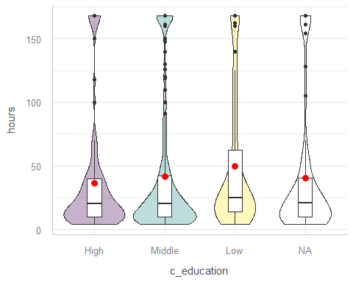

Try again with complete cases?
ecare_1 <- ecare_new |>
filter(complete.cases(hours, c_education))
dim(ecare_1)
[1] 842 5
ggplot(ecare_1, aes(y = hours, x = c_education)) +
geom_violin(aes(fill = c_education)) +
geom_boxplot(width = 0.2) +
stat_summary(fun = mean, geom = "point",
shape = 16, size = 3, col = "red") +
scale_fill_viridis_d(alpha = 0.3) +
guides(fill = "none")
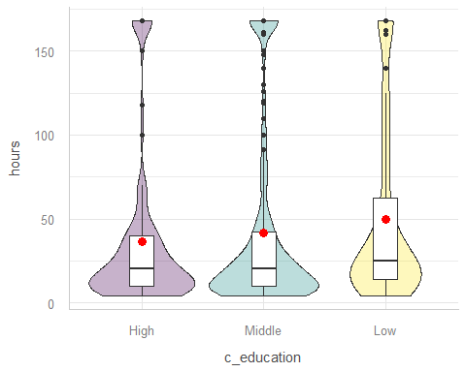

Do hours vary by c_education? (1/2)
ecare_1 |> group_by(c_education) |> reframe(lovedist(hours))
# A tibble: 3 × 11
c_education n miss mean sd med mad min q25 q75 max
<fct> <int> <int> <dbl> <dbl> <dbl> <dbl> <dbl> <dbl> <dbl> <dbl>
1 High 156 0 36.6 46.4 20 17.8 4 10 40 168
2 Middle 506 0 41.8 51.4 20 19.3 4 10 42 168
3 Low 180 0 49.8 52.2 25 22.2 4 14 62.5 168
- Sample mean hours are somewhat smaller for carers with higher levels of education.
  - Does these mean differences seem meaningful?
  - Does each group’s data follow a Normal distribution?

Do hours vary by c_education? (2/2)
ecare_1 |> group_by(c_education) |> reframe(lovedist(hours))
# A tibble: 3 × 11
c_education n miss mean sd med mad min q25 q75 max
<fct> <int> <int> <dbl> <dbl> <dbl> <dbl> <dbl> <dbl> <dbl> <dbl>
1 High 156 0 36.6 46.4 20 17.8 4 10 40 168
2 Middle 506 0 41.8 51.4 20 19.3 4 10 42 168
3 Low 180 0 49.8 52.2 25 22.2 4 14 62.5 168
- What else might we consider here?
  - Do we have a balanced design?
  - Are sample variances very different from each other?

ANOVA model for this comparison
m1 <- lm(hours ~ c_education, data = ecare_1)
anova(m1)
Analysis of Variance Table
Response: hours
Df Sum Sq Mean Sq F value Pr(>F)
c_education 2 15301 7650.4 2.9758 0.05155 .
Residuals 839 2156977 2570.9
---
Signif. codes: 0 '***' 0.001 '**' 0.01 '*' 0.05 '.' 0.1 ' ' 1
model_parameters(m1, ci = 0.95)
Parameter | Coefficient | SE | 95% CI | t(839) | p
----------------------------------------------------------------------------
(Intercept) | 36.62 | 4.06 | [28.65, 44.58] | 9.02 | < .001
c education [Middle] | 5.14 | 4.64 | [-3.97, 14.26] | 1.11 | 0.268
c education [Low] | 13.20 | 5.55 | [ 2.31, 24.08] | 2.38 | 0.018
Uncertainty intervals (equal-tailed) and p-values (two-tailed) computed
using a Wald t-distribution approximation.

Holm 95% pairwise comparisons??
estimate_contrasts(m1, ci = 0.95, p_adjust = "holm")
We selected `contrast=c("c_education")`.
Marginal Contrasts Analysis
Level1 | Level2 | Difference | SE | 95% CI | t(839) | p
---------------------------------------------------------------------
Middle | High | 5.14 | 4.64 | [-3.97, 14.26] | 1.11 | 0.268
Low | High | 13.20 | 5.55 | [ 2.31, 24.08] | 2.38 | 0.053
Low | Middle | 8.05 | 4.40 | [-0.58, 16.69] | 1.83 | 0.135
Variable predicted: hours
Predictors contrasted: c_education
p-value adjustment method: Holm (1979)
- NEW: CIs aren’t actually changed from model_parameters(), just the p values!
- Holm procedure stops once it finds a small p value.

Bonferroni approach?
estimate_contrasts(m1, ci = 0.95, p_adjust = "bonferroni")
We selected `contrast=c("c_education")`.
Marginal Contrasts Analysis
Level1 | Level2 | Difference | SE | 95% CI | t(839) | p
---------------------------------------------------------------------
Middle | High | 5.14 | 4.64 | [-3.97, 14.26] | 1.11 | 0.805
Low | High | 13.20 | 5.55 | [ 2.31, 24.08] | 2.38 | 0.053
Low | Middle | 8.05 | 4.40 | [-0.58, 16.69] | 1.83 | 0.203
Variable predicted: hours
Predictors contrasted: c_education
p-value adjustment method: Bonferroni
- Again, only the p values change here… what to do?

Actual Bonferroni 95% CIs?
## this requires library(DescTools)
PostHocTest(aov(m1), method = "bonferroni",
conf.level = 0.95, ordered = FALSE)
Posthoc multiple comparisons of means : Bonferroni
95% family-wise confidence level
$c_education
diff lwr.ci upr.ci pval
Middle-High 5.143509 -5.9949619 16.28198 0.8049
Low-High 13.195726 -0.1089773 26.50043 0.0527 .
Low-Middle 8.052218 -2.5034246 18.60786 0.2029
---
Signif. codes: 0 '***' 0.001 '**' 0.01 '*' 0.05 '.' 0.1 ' ' 1

Plot means with Bonferroni CIs
par(mar=c(3,10,3,3), las = 1)
plot(PostHocTest(aov(m1), method = "bonferroni", conf.level = 0.95))
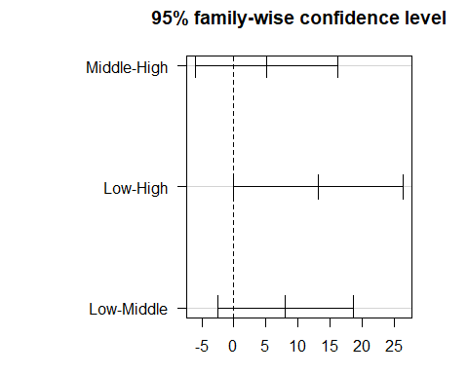

What about Tukey HSD intervals?
Tukey’s HSD approach is a better choice than Holm for pre-planned comparisons with a balanced (or nearly balanced) design. Which should we use here?
PostHocTest(aov(m1), method = "hsd", conf.level = 0.95, ordered = TRUE)
Posthoc multiple comparisons of means : Tukey HSD
95% family-wise confidence level
factor levels have been ordered
$c_education
diff lwr.ci upr.ci pval
Middle-High 5.143509 -5.7585415 16.04556 0.5096
Low-High 13.195726 0.1734226 26.21803 0.0462 *
Low-Middle 8.052218 -2.2793751 18.38381 0.1605
---
Signif. codes: 0 '***' 0.001 '**' 0.01 '*' 0.05 '.' 0.1 ' ' 1

Plot means with Tukey CIs
par(mar=c(3,10,3,3), las = 1)
plot(PostHocTest(aov(m1), method = "hsd", conf.level = 0.95))
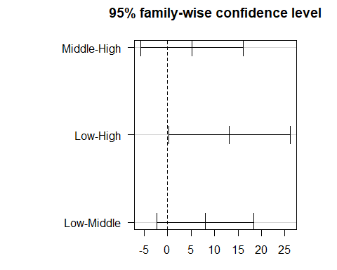

Does model m1 work well?
plot(m1, which = 2)
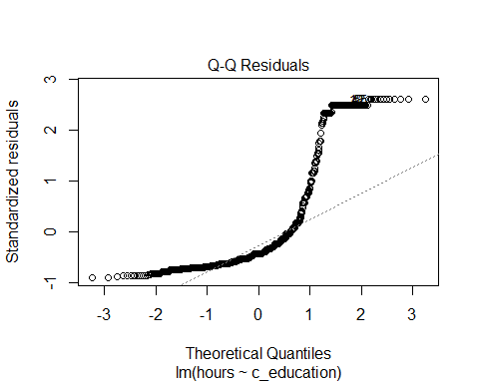

Could we transform the outcome?
boxCox(m1)
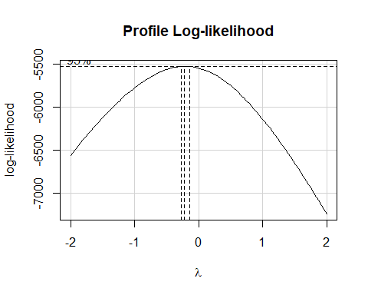

Impact of log transformation
ecare_1 |> group_by(c_education) |> reframe(lovedist(log(hours)))
# A tibble: 3 × 11
c_education n miss mean sd med mad min q25 q75 max
<fct> <int> <int> <dbl> <dbl> <dbl> <dbl> <dbl> <dbl> <dbl> <dbl>
1 High 156 0 3.04 1.01 3.00 1.03 1.39 2.30 3.69 5.12
2 Middle 506 0 3.10 1.09 3.00 1.03 1.39 2.30 3.74 5.12
3 Low 180 0 3.38 1.04 3.22 1.09 1.39 2.64 4.13 5.12
ggplot(ecare_1, aes(y = log(hours), x = c_education)) +
geom_violin(aes(fill = c_education)) +
geom_boxplot(width = 0.2) +
stat_summary(fun = mean, geom = "point",
shape = 16, size = 3, col = "red") +
scale_fill_viridis_d(alpha = 0.3) +
guides(fill = "none")
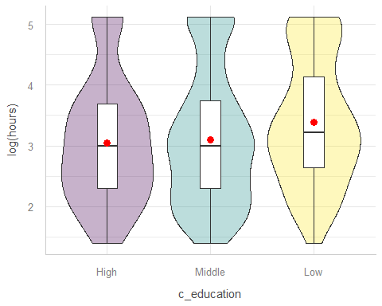

ANOVA after Transforming hours
m2 <- lm(log(hours) ~ c_education, data = ecare_1)
anova(m2)
Analysis of Variance Table
Response: log(hours)
Df Sum Sq Mean Sq F value Pr(>F)
c_education 2 12.71 6.3566 5.5824 0.003905 **
Residuals 839 955.36 1.1387
---
Signif. codes: 0 '***' 0.001 '**' 0.01 '*' 0.05 '.' 0.1 ' ' 1
- What’s the conclusion here?

Bonferroni 95% CIs for log(hours)
PostHocTest(aov(m2), method = "bonferroni",
conf.level = 0.95, ordered = TRUE)
Posthoc multiple comparisons of means : Bonferroni
95% family-wise confidence level
factor levels have been ordered
$c_education
diff lwr.ci upr.ci pval
Middle-High 0.06143952 -0.17297617 0.2958552 1.0000
Low-High 0.34132988 0.06132453 0.6213352 0.0106 *
Low-Middle 0.27989036 0.05774063 0.5020401 0.0078 **
---
Signif. codes: 0 '***' 0.001 '**' 0.01 '*' 0.05 '.' 0.1 ' ' 1
- Variable predicted is actually log(hours)

Bonferroni 95% CIs for log(hours)
par(mar=c(3,10,3,3), las = 1)
plot(PostHocTest(aov(m2), method = "bonferroni",
conf.level = 0.95, ordered = TRUE))
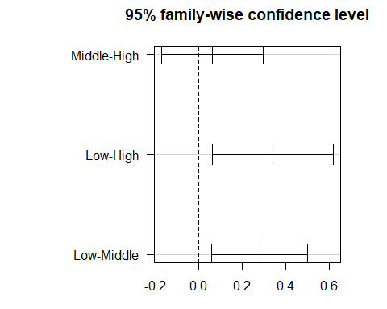

Normality still a problem?
plot(m2, which = 2)
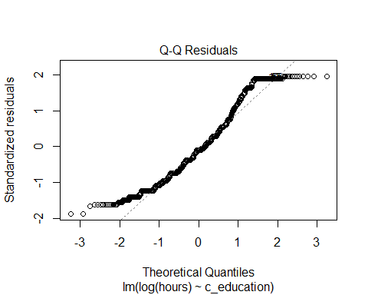

Kruskal-Wallis ANOVA
If the data were severely skewed, you might try:
kruskal.test(hours ~ c_education, data = ecare_1)
Kruskal-Wallis rank sum test
data: hours by c_education
Kruskal-Wallis chi-squared = 11.216, df = 2, p-value = 0.003669
- $H_{0}$: The four education groups have the same center to their hours distributions.
- $H_{A}$: At least one group has a shifted distribution, with a different center to its hours.

K Samples: Comparing Means I
- What is the outcome under study?
- What are the ($K≥2$) treatment/exposure groups?
- Were the data in fact collected using independent samples?
- Are the data random samples from the population(s) of interest? Or is there at least a reasonable argument for generalizing from the samples to the population(s)?
- What confidence level do we require?

K Samples: Comparing Means II
- Are we doing one-sided or two-sided testing? (usually 2-sided)
- What does the distribution of each individual sample tell us about which inferential procedure to use?
- Are there meaningful differences between population means?
- Can we identify pairwise comparisons of means that show meaningful differences using an appropriate procedure that protects against Type I error expansion due to multiple comparisons?

Another ANOVA Example
- Starting on the next slide, there is a second one-factor ANOVA example (using the same EUROFAMCARE data) for self-study.
- I have edited Section 9.9 of the Course Book to reflect correct simultaneous CIs for the Bonferroni and Tukey methods as presented today.
OK, let’s return to discussing the favorite movies data.

A Second One-Factor ANOVA Example for Self-Study

Same data, new question
Do pos_impact means differ by dependency level?
ecare_2 <- ecare_new |> filter(complete.cases(pos_impact, dependency))
ecare_2 |> group_by(dependency) |> reframe(lovedist(pos_impact))
# A tibble: 4 × 11
dependency n miss mean sd med mad min q25 q75 max
<fct> <int> <int> <dbl> <dbl> <dbl> <dbl> <dbl> <dbl> <dbl> <dbl>
1 independent 65 0 13.2 2.21 13 2.97 8 12 15 16
2 slight 224 0 12.8 2.15 13 2.97 6 12 15 16
3 moderate 303 0 12.3 2.17 12 2.97 6 11 14 16
4 severe 289 0 12.2 2.34 12 2.97 5 11 14 16
- Balanced design?
- Reasonable to pool standard deviations?

Draw comparison boxplots
- Do we see serious problems with Normality?
ggplot(ecare_2, aes(y = pos_impact, x = dependency)) +
geom_violin(aes(fill = dependency)) +
geom_boxplot(width = 0.2) +
stat_summary(fun = mean, geom = "point",
shape = 16, size = 3, col = "red") +
scale_fill_viridis_d(alpha = 0.3) +
guides(fill = "none") +
coord_flip()
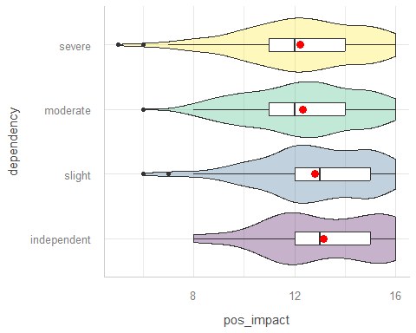

Fit an ANOVA model
m3 <- lm(pos_impact ~ dependency, data = ecare_2)
anova(m3)
Analysis of Variance Table
Response: pos_impact
Df Sum Sq Mean Sq F value Pr(>F)
dependency 3 76.3 25.4313 5.1255 0.001614 **
Residuals 877 4351.5 4.9618
---
Signif. codes: 0 '***' 0.001 '**' 0.01 '*' 0.05 '.' 0.1 ' ' 1
model_parameters(m3, ci = 0.95)
Parameter | Coefficient | SE | 95% CI | t(877) | p
-----------------------------------------------------------------------------
(Intercept) | 13.15 | 0.28 | [12.61, 13.70] | 47.61 | < .001
dependency [slight] | -0.36 | 0.31 | [-0.98, 0.26] | -1.14 | 0.253
dependency [moderate] | -0.82 | 0.30 | [-1.42, -0.23] | -2.71 | 0.007
dependency [severe] | -0.92 | 0.31 | [-1.52, -0.32] | -3.02 | 0.003
Uncertainty intervals (equal-tailed) and p-values (two-tailed) computed
using a Wald t-distribution approximation.

Simultaneous Bonferroni CIs?
PostHocTest(aov(m3), method = "bonferroni", conf.level = 0.95)
Posthoc multiple comparisons of means : Bonferroni
95% family-wise confidence level
$dependency
diff lwr.ci upr.ci pval
slight-independent -0.35920330 -1.1890359 0.47062934 1.0000
moderate-independent -0.82381315 -1.6289472 -0.01867910 0.0417 *
severe-independent -0.92201224 -1.7305835 -0.11344097 0.0159 *
moderate-slight -0.46460985 -0.9836277 0.05440796 0.1089
severe-slight -0.56280895 -1.0871430 -0.03847494 0.0278 *
severe-moderate -0.09819909 -0.5824973 0.38609915 1.0000
---
Signif. codes: 0 '***' 0.001 '**' 0.01 '*' 0.05 '.' 0.1 ' ' 1

Plot means with Bonferroni CIs
par(mar=c(3,10,3,3), las = 1)
plot(PostHocTest(aov(m3),
method = "bonferroni", conf.level = 0.95))
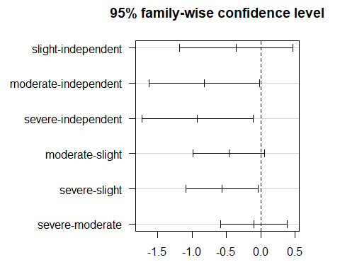

Consider transforming pos_impact?
boxCox(m3)
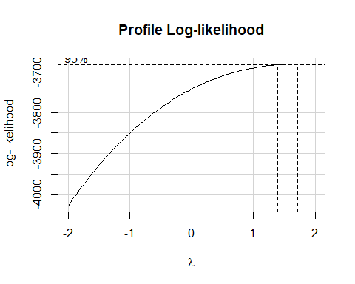

Impact of square transformation
ecare_2 |> group_by(dependency) |> reframe(lovedist((pos_impact^2)))
# A tibble: 4 × 11
dependency n miss mean sd med mad min q25 q75 max
<fct> <int> <int> <dbl> <dbl> <dbl> <dbl> <dbl> <dbl> <dbl> <dbl>
1 independent 65 0 178. 56.8 169 71.2 64 144 225 256
2 slight 224 0 168. 53.0 169 71.2 36 144 225 256
3 moderate 303 0 157. 52.9 144 65.2 36 121 196 256
4 severe 289 0 155. 55.5 144 65.2 25 121 196 256
ggplot(ecare_2, aes(y = (pos_impact^2), x = dependency)) +
geom_violin(aes(fill = dependency)) +
geom_boxplot(width = 0.2) +
stat_summary(fun = mean, geom = "point",
shape = 16, size = 3, col = "red") +
scale_fill_viridis_d(alpha = 0.3) +
guides(fill = "none") +
coord_flip()
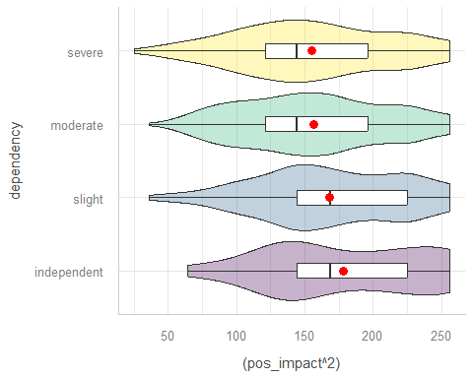

ANOVA after Transformation
m4 <- lm((pos_impact^2) ~ dependency, data = ecare_2)
anova(m4)
Analysis of Variance Table
Response: (pos_impact^2)
Df Sum Sq Mean Sq F value Pr(>F)
dependency 3 45967 15322 5.2383 0.001379 **
Residuals 877 2565252 2925
---
Signif. codes: 0 '***' 0.001 '**' 0.01 '*' 0.05 '.' 0.1 ' ' 1
model_parameters(m4, ci = 0.95)
Parameter | Coefficient | SE | 95% CI | t(877) | p
-------------------------------------------------------------------------------
(Intercept) | 177.83 | 6.71 | [164.66, 191.00] | 26.51 | < .001
dependency [slight] | -9.51 | 7.62 | [-24.46, 5.45] | -1.25 | 0.212
dependency [moderate] | -21.10 | 7.39 | [-35.61, -6.59] | -2.85 | 0.004
dependency [severe] | -22.74 | 7.42 | [-37.31, -8.17] | -3.06 | 0.002
Uncertainty intervals (equal-tailed) and p-values (two-tailed) computed
using a Wald t-distribution approximation.

Simultaneous Bonferroni CIs?
PostHocTest(aov(m4), method = "bonferroni", conf.level = 0.95)
Posthoc multiple comparisons of means : Bonferroni
95% family-wise confidence level
$dependency
diff lwr.ci upr.ci pval
slight-independent -9.509341 -29.65758 10.6388976 1.0000
moderate-independent -21.104697 -40.65326 -1.5561371 0.0265 *
severe-independent -22.740804 -42.37282 -3.1087889 0.0136 *
moderate-slight -11.595356 -24.19705 1.0063351 0.0910 .
severe-slight -13.231463 -25.96223 -0.5006954 0.0367 *
severe-moderate -1.636107 -13.39481 10.1225969 1.0000
---
Signif. codes: 0 '***' 0.001 '**' 0.01 '*' 0.05 '.' 0.1 ' ' 1

Bonferroni 95% CIs: (pos_impact^2)
par(mar=c(3,10,3,3), las = 1)
plot(PostHocTest(aov(m4), method = "bonferroni",
conf.level = 0.95, ordered = TRUE))
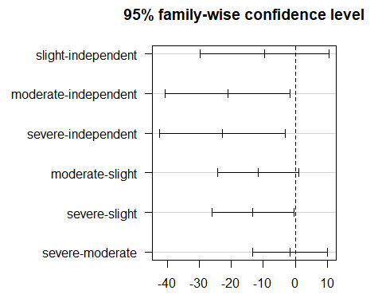

Session Information
xfun::session_info()
R version 4.5.1 (2025-06-13 ucrt)
Platform: x86_64-w64-mingw32/x64
Running under: Windows 11 x64 (build 26100)
Locale:
LC_COLLATE=English_United States.utf8
LC_CTYPE=English_United States.utf8
LC_MONETARY=English_United States.utf8
LC_NUMERIC=C
LC_TIME=English_United States.utf8
Package version:
abind_1.4-8 askpass_1.2.1 backports_1.5.0
base_4.5.1 base64enc_0.1-3 bayesplot_1.14.0
bayestestR_0.17.0 BH_1.87.0.1 bit_4.6.0
bit64_4.6.0-1 blob_1.2.4 boot_1.3-32
broom_1.0.10 bslib_0.9.0 cachem_1.1.0
callr_3.7.6 car_3.1-3 carData_3.0-5
cellranger_1.1.0 checkmate_2.3.3 class_7.3-23
cli_3.6.5 clipr_0.8.0 coda_0.19-4.1
codetools_0.2-20 colourpicker_1.3.0 commonmark_2.0.0
compiler_4.5.1 conflicted_1.2.0 correlation_0.8.8
cowplot_1.2.0 cpp11_0.5.2 crayon_1.5.3
crosstalk_1.2.2 curl_7.0.0 data.table_1.17.8
datasets_4.5.1 datawizard_1.2.0 DBI_1.2.3
dbplyr_2.5.1 Deriv_4.2.0 desc_1.4.3
DescTools_0.99.60 digest_0.6.37 distributional_0.5.0
doBy_4.7.0 dplyr_1.1.4 DT_0.34.0
dtplyr_1.3.2 dygraphs_1.1.1.6 e1071_1.7-16
easystats_0.7.5 effectsize_1.0.1 emmeans_1.11.2-8
estimability_1.5.1 evaluate_1.0.5 Exact_3.3
expm_1.0-0 farver_2.1.2 fastmap_1.2.0
fontawesome_0.5.3 forcats_1.0.0 Formula_1.2-5
fs_1.6.6 gargle_1.6.0 generics_0.1.4
ggplot2_4.0.0 ggridges_0.5.7 gld_2.6.8
glue_1.8.0 googledrive_2.1.2 googlesheets4_1.1.2
graphics_4.5.1 grDevices_4.5.1 grid_4.5.1
gridExtra_2.3 gtable_0.3.6 gtools_3.9.5
haven_2.5.5 highr_0.11 hms_1.1.3
htmltools_0.5.8.1 htmlwidgets_1.6.4 httpuv_1.6.16
httr_1.4.7 ids_1.0.1 igraph_2.1.4
inline_0.3.21 insight_1.4.2 isoband_0.2.7
janitor_2.2.1 jquerylib_0.1.4 jsonlite_2.0.0
knitr_1.50 labeling_0.4.3 later_1.4.4
lattice_0.22-7 lazyeval_0.2.2 lifecycle_1.0.4
litedown_0.7 lme4_1.1-37 lmom_3.2
loo_2.8.0 lubridate_1.9.4 magrittr_2.0.4
marginaleffects_0.30.0 markdown_2.0 MASS_7.3-65
Matrix_1.7-4 MatrixModels_0.5.4 matrixStats_1.5.0
memoise_2.0.1 methods_4.5.1 mgcv_1.9.3
microbenchmark_1.5.0 mime_0.13 miniUI_0.1.2
minqa_1.2.8 modelbased_0.13.0 modelr_0.1.11
multcomp_1.4-28 mvtnorm_1.3-3 naniar_1.1.0
nlme_3.1-168 nloptr_2.2.1 nnet_7.3.20
norm_1.0.11.1 numDeriv_2016.8.1.1 openssl_2.3.3
parallel_4.5.1 parameters_0.28.2 patchwork_1.3.2
pbkrtest_0.5.5 performance_0.15.1 pillar_1.11.1
pkgbuild_1.4.8 pkgconfig_2.0.3 plyr_1.8.9
posterior_1.6.1 prettyunits_1.2.0 processx_3.8.6
progress_1.2.3 promises_1.3.3 proxy_0.4-27
ps_1.9.1 purrr_1.1.0 quantreg_6.1
QuickJSR_1.8.1 R6_2.6.1 ragg_1.5.0
rappdirs_0.3.3 rbibutils_2.3 RColorBrewer_1.1-3
Rcpp_1.1.0 RcppEigen_0.3.4.0.2 RcppParallel_5.1.11-1
Rdpack_2.6.4 readr_2.1.5 readxl_1.4.5
reformulas_0.4.1 rematch_2.0.0 rematch2_2.1.2
report_0.6.1 reprex_2.1.1 reshape2_1.4.4
rlang_1.1.6 rmarkdown_2.29 rootSolve_1.8.2.4
rstan_2.32.7 rstanarm_2.32.1 rstantools_2.5.0
rstudioapi_0.17.1 rvest_1.0.5 S7_0.2.0
sandwich_3.1-1 sass_0.4.10 scales_1.4.0
see_0.12.0 selectr_0.4.2 shiny_1.11.1
shinyjs_2.1.0 shinystan_2.6.0 shinythemes_1.2.0
snakecase_0.11.1 sourcetools_0.1.7.1 SparseM_1.84.2
splines_4.5.1 StanHeaders_2.32.10 stats_4.5.1
stats4_4.5.1 stringi_1.8.7 stringr_1.5.2
survival_3.8-3 sys_3.4.3 systemfonts_1.2.3
tensorA_0.36.2.1 textshaping_1.0.3 TH.data_1.1-4
threejs_0.3.4 tibble_3.3.0 tidyr_1.3.1
tidyselect_1.2.1 tidyverse_2.0.0 timechange_0.3.0
tinytex_0.57 tools_4.5.1 tzdb_0.5.0
UpSetR_1.4.0 utf8_1.2.6 utils_4.5.1
uuid_1.2.1 V8_7.0.0 vctrs_0.6.5
viridis_0.6.5 viridisLite_0.4.2 visdat_0.6.0
vroom_1.6.6 withr_3.0.2 xfun_0.53
xml2_1.4.0 xtable_1.8-4 xts_0.14.1
yaml_2.3.10 zoo_1.8-14

