431 Class 14
Thomas E. Love, Ph.D.
2025-10-16

Today’s Agenda
- Ingesting / Managing some Favorite Movies Data
- Independent Samples Comparisons with ANOVA
  - Checking the Fit
  - Transformations
- Simple Linear Regression Models
  - Fitting and Predicting with an OLS model
  - Performance of an OLS model
  - What makes a “good” fit?

In addition to this…
See the movies_update1.html document (and associated movies_update1.qmd) found in our Shared Drive.

Load packages and set theme
knitr::opts_chunk$set(comment = NA)
library(janitor)
library(naniar)
library(googlesheets4) ## to read in data from shared Google Sheet
library(rstanarm) ## to fit Bayesian linear models
library(DescTools) ## for post-hoc testing in ANOVA
library(car) ## for boxCox
library(easystats)
library(tidyverse)
theme_set(theme_minimal())
source("c14/data/Love-431.R") ## for lovedist() function

Importing Data on Favorite Movies
gs4_deauth() # indicates to Google Drive that you're reading a public file
url_movies <- "https://docs.google.com/spreadsheets/d/17-L3FCXxMLP_07fChi6aP7721sqol7e4qx2sOKxzry4/edit?usp=sharing"
## this is movies_2025-10-06 from our shared drive
movies_raw <- read_sheet(url_movies, na = c("", "NA"))
✔ Reading from "movies_2025-10-06".
✔ Range 'movies_2025-10-06'.
- I am specifying that both empty cells and cells with NA indicate missing values: read_sheet() needs this.
dim(movies_raw)
[1] 260 39

A little cleanup
movies <- movies_raw |>
select(mov_id, length, imdb_stars, metascore, mpa,
imdb_genres, movie) |>
mutate(across(where(is.character), as_factor),
movie = as.character(movie),
mov_id = as.character(mov_id))

Distinct identifiers?
nrow(movies_raw)
[1] 260
n_distinct(movies_raw$mov_id)
[1] 260
n_distinct(movies_raw$movie)
[1] 260

Any missing values?
n_miss(movies)
[1] 29
miss_var_summary(movies)
# A tibble: 7 × 3
variable n_miss pct_miss
<chr> <int> <num>
1 metascore 15 5.77
2 mpa 14 5.38
3 mov_id 0 0
4 length 0 0
5 imdb_stars 0 0
6 imdb_genres 0 0
7 movie 0 0

mpa is categorical
movies |> count(mpa) |> arrange(desc(n))
# A tibble: 10 × 2
mpa n
<fct> <int>
1 PG-13 84
2 R 80
3 PG 67
4 <NA> 14
5 G 8
6 Approved 2
7 TV-G 2
8 TV-14 1
9 TV-MA 1
10 TV-PG 1

Collapse to 3 mpa categories
movies <- movies |>
mutate(mpa3 = fct_lump_n(mpa, n = 2, other_level = "Other"))
movies |> tabyl(mpa3)
mpa3 n percent valid_percent
PG-13 84 0.32307692 0.3414634
R 80 0.30769231 0.3252033
Other 82 0.31538462 0.3333333
<NA> 14 0.05384615 NA
- fct_lump_n() with n = 2 collapses all mpa values occurring less often than the top 2 mpa values, preserving missingness.

imdb_genres is tougher to deal with
I’ll make indicator variables for each of the 20 genres. A better programmer could improve this rapidly.
movies <- movies |>
mutate(action = as.numeric(str_detect(imdb_genres, fixed("Action"))),
adventure = as.numeric(str_detect(imdb_genres, fixed("Adventure"))),
animation = as.numeric(str_detect(imdb_genres, fixed("Animation"))),
biography = as.numeric(str_detect(imdb_genres, fixed("Biography"))),
comedy = as.numeric(str_detect(imdb_genres, fixed("Comedy"))),
crime = as.numeric(str_detect(imdb_genres, fixed("Crime"))),
drama = as.numeric(str_detect(imdb_genres, fixed("Drama"))),
family = as.numeric(str_detect(imdb_genres, fixed("Family"))),
fantasy = as.numeric(str_detect(imdb_genres, fixed("Fantasy"))),
history = as.numeric(str_detect(imdb_genres, fixed("History"))),
horror = as.numeric(str_detect(imdb_genres, fixed("Horror"))),
mystery = as.numeric(str_detect(imdb_genres, fixed("Mystery"))),
music = as.numeric(str_detect(imdb_genres, fixed("Music"))),
musical = as.numeric(str_detect(imdb_genres, fixed("Musical"))),
romance = as.numeric(str_detect(imdb_genres, fixed("Romance"))),
scifi = as.numeric(str_detect(imdb_genres, fixed("Sci-Fi"))),
sport = as.numeric(str_detect(imdb_genres, fixed("Sport"))),
thriller = as.numeric(str_detect(imdb_genres, fixed("Thriller"))),
war = as.numeric(str_detect(imdb_genres, fixed("War"))),
western = as.numeric(str_detect(imdb_genres, fixed("Western"))),
)

Results
movies |> select(action:war) |> colSums()
action adventure animation biography comedy crime drama family
60 87 29 17 103 34 153 44
fantasy history horror mystery music musical romance scifi
60 6 12 26 30 17 62 51
sport thriller war
6 50 11
How many movies are categorized as both comedy and drama?
movies |> tabyl(comedy, drama)
comedy 0 1
0 54 103
1 53 50

Any action and musical?
movies |> count(action, musical)
# A tibble: 4 × 3
action musical n
<dbl> <dbl> <int>
1 0 0 185
2 0 1 15
3 1 0 58
4 1 1 2

Which movies?
movies |> filter(action == 1, musical == 1) |>
select(movie, action, musical, imdb_genres, imdb_stars)
# A tibble: 2 × 5
movie action musical imdb_genres imdb_stars
<chr> <dbl> <dbl> <fct> <dbl>
1 Om Shanti Om (Peace Be With You) 1 1 Action, Comedy, Dr… 6.8
2 Weird: The Al Yankovic Story 1 1 Action, Biography,… 6.8

Question 1

Question 1
Do movies with different mpa ratings show meaningful differences in average length? We’ll use 98% confidence.
movies |> group_by(mpa3) |> reframe(lovedist(length))
# A tibble: 4 × 11
mpa3 n miss mean sd med mad min q25 q75 max
<fct> <int> <int> <dbl> <dbl> <dbl> <dbl> <dbl> <dbl> <dbl> <dbl>
1 PG-13 84 0 128. 24.6 125 24.5 90 112. 143 201
2 R 80 0 127. 23.7 120. 22.2 94 111. 140. 189
3 Other 82 0 111. 19.7 105 16.3 77 97 123. 170
4 <NA> 14 0 134 37.3 134. 35.6 70 113. 159. 207
ggplot(movies, aes(x = mpa3, y = length)) +
geom_violin(aes(fill = mpa3)) +
geom_boxplot(width = 0.4, notch = TRUE) +
stat_summary(fun = mean, geom = "point", size = 3, col = "hotpink") +
scale_fill_oi() +
guides(fill = "none") +
labs(x = "MPA rating (3 categories)", y = "Movie Length (minutes)")
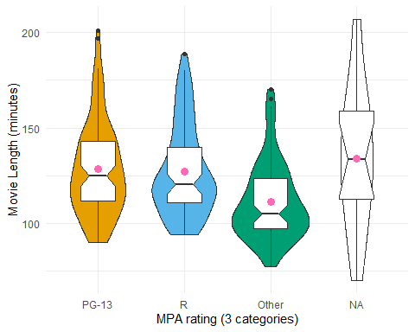

Second Attempt
Oops. Need to fix missingness.
movies1 <- movies |> filter(complete.cases(mpa3, length))
ggplot(movies1, aes(x = mpa3, y = length)) +
geom_violin(aes(fill = mpa3)) +
geom_boxplot(width = 0.4, notch = TRUE) +
stat_summary(fun = mean, geom = "point", size = 3, col = "hotpink") +
scale_fill_oi() +
guides(fill = "none") +
labs(x = "MPA rating (3 categories)", y = "Movie Length (minutes)")
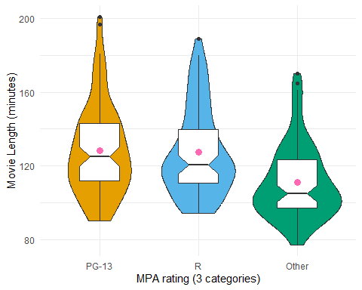
What would we like to see here?

Comparing 3 means: ANOVA
fit1 <- lm(length ~ mpa3, data = movies)
anova(fit1)
Analysis of Variance Table
Response: length
Df Sum Sq Mean Sq F value Pr(>F)
mpa3 2 15409 7704.4 14.888 7.957e-07 ***
Residuals 243 125751 517.5
---
Signif. codes: 0 '***' 0.001 '**' 0.01 '*' 0.05 '.' 0.1 ' ' 1
- The p value is 0.0000008. Do we need to say more?
- How much of the variation in length does the fit1 model account for?
  - proportion explained = 15409 / (15409 + 125751) = 0.109

Parameters of model fit1
model_parameters(fit1, ci = 0.98)
Parameter | Coefficient | SE | 98% CI | t(243) | p
----------------------------------------------------------------------
(Intercept) | 128.27 | 2.48 | [122.46, 134.09] | 51.68 | < .001
mpa3 [R] | -0.96 | 3.55 | [ -9.28, 7.36] | -0.27 | 0.787
mpa3 [Other] | -17.24 | 3.53 | [-25.51, -8.97] | -4.88 | < .001
Uncertainty intervals (equal-tailed) and p-values (two-tailed) computed
using a Wald t-distribution approximation.
- What is the regression equation here?
- length = 128.27 - 0.96 (if mpa3 = R) - 17.24 (if mpa3 = Other)
- Can we estimate the means in each mpa3 category?

Predicting for mpa3 categories?
estimate_means(fit1, ci = 0.98)
We selected `by=c("mpa3")`.
Estimated Marginal Means
mpa3 | Mean | SE | 98% CI | t(243)
-------------------------------------------------
PG-13 | 128.27 | 2.48 | [122.46, 134.09] | 51.68
R | 127.31 | 2.54 | [121.36, 133.27] | 50.06
Other | 111.04 | 2.51 | [105.15, 116.92] | 44.20
Variable predicted: length
Predictors modulated: mpa3
- How shall we compare these means and maintain overall 98% confidence?
- Remember the sample sizes: 84 movies in PG-13, 80 in R, 82 in Other.

Bonferroni comparisons?
PostHocTest(aov(fit1), method = "bonferroni", conf.level = 0.98)
Posthoc multiple comparisons of means : Bonferroni
98% family-wise confidence level
$mpa3
diff lwr.ci upr.ci pval
R-PG-13 -0.9613095 -10.68648 8.763859 1.0000
Other-PG-13 -17.2372242 -26.90146 -7.572993 5.7e-06 ***
Other-R -16.2759146 -26.05877 -6.493064 2.5e-05 ***
---
Signif. codes: 0 '***' 0.001 '**' 0.01 '*' 0.05 '.' 0.1 ' ' 1
- What conclusions can we draw?
- Would a Tukey HSD approach be appropriate here?
  - Pre-planned comparisons? (Roughly) balanced design?

Tukey HSD comparisons
PostHocTest(aov(fit1), method = "hsd", conf.level = 0.98)
Posthoc multiple comparisons of means : Tukey HSD
98% family-wise confidence level
$mpa3
diff lwr.ci upr.ci pval
R-PG-13 -0.9613095 -10.57042 8.647799 0.9605
Other-PG-13 -17.2372242 -26.78612 -7.688325 5.7e-06 ***
Other-R -16.2759146 -25.94202 -6.609812 2.5e-05 ***
---
Signif. codes: 0 '***' 0.001 '**' 0.01 '*' 0.05 '.' 0.1 ' ' 1
I like plotting these.

Plot Tukey HSD results
par(mar=c(3,6,3,3), las = 1)
plot(PostHocTest(aov(fit1), method = "hsd", conf.level = 0.98))
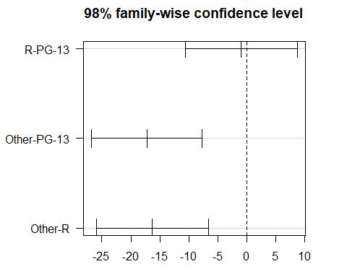

Check ANOVA diagnostics
set.seed(123)
plot(check_model(fit1, check = c("pp_check", "qq"), detrend = FALSE))
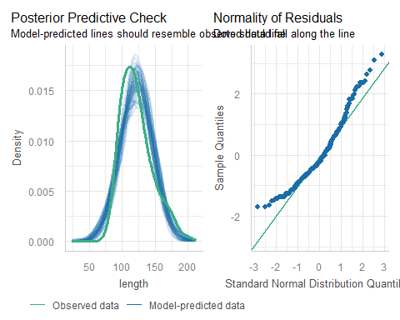

Would a transformation help?
boxCox(fit1)
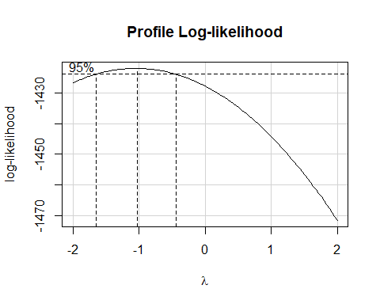

Inverse of our outcome
movies1 <- movies1 |> mutate(invlength = 1000/length)
fit1a <- lm(invlength ~ mpa3, data = movies1)
anova(fit1a)
Analysis of Variance Table
Response: invlength
Df Sum Sq Mean Sq F value Pr(>F)
mpa3 2 75.88 37.940 18.215 4.255e-08 ***
Residuals 243 506.13 2.083
---
Signif. codes: 0 '***' 0.001 '**' 0.01 '*' 0.05 '.' 0.1 ' ' 1

Why did I use 1000/length?
movies1 <- movies1 |> mutate(length_inv = 1/length)
fit1b <- lm(length_inv ~ mpa3, data = movies1)
anova(fit1b)
Analysis of Variance Table
Response: length_inv
Df Sum Sq Mean Sq F value Pr(>F)
mpa3 2 0.00007588 3.794e-05 18.215 4.255e-08 ***
Residuals 243 0.00050613 2.083e-06
---
Signif. codes: 0 '***' 0.001 '**' 0.01 '*' 0.05 '.' 0.1 ' ' 1

ANOVA diagnostics better?
set.seed(124)
plot(check_model(fit1a, check = c("pp_check", "qq"), detrend = FALSE))
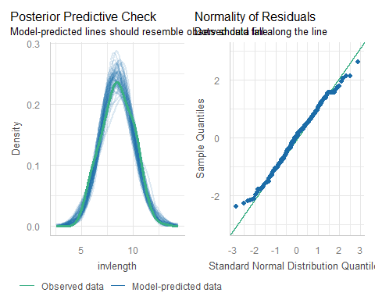

Estimate group means from fit1a
estimate_means(fit1a, ci = 0.98)
We selected `by=c("mpa3")`.
Estimated Marginal Means
mpa3 | Mean | SE | 98% CI | t(243)
-------------------------------------------
PG-13 | 8.06 | 0.16 | [7.69, 8.43] | 51.20
R | 8.11 | 0.16 | [7.73, 8.48] | 50.23
Other | 9.26 | 0.16 | [8.89, 9.63] | 58.11
Variable predicted: invlength
Predictors modulated: mpa3
- What does a predicted (1000/length) of 8.11 mean?
- Back out of transformation…
  - if 1000/length = 8.11, then length = 1000/8.11 = 123.3 minutes (compare to 127.31 in untransformed data.)

Tukey HSD for fit1a model
par(mar=c(3,6,3,3), las = 1)
plot(PostHocTest(aov(fit1a), method = "hsd", conf.level = 0.98))
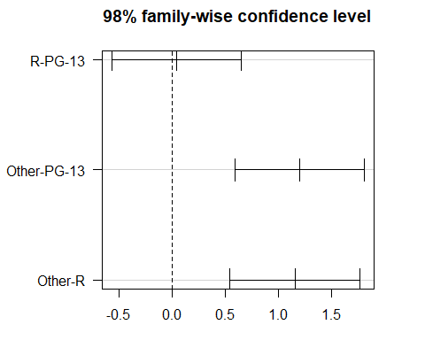

Why did the direction change?
PostHocTest(aov(fit1a), method = "hsd", conf.level = 0.98)
Posthoc multiple comparisons of means : Tukey HSD
98% family-wise confidence level
$mpa3
diff lwr.ci upr.ci pval
R-PG-13 0.04270197 -0.5669202 0.6523241 0.9804
Other-PG-13 1.19840071 0.5925984 1.8042030 6.1e-07 ***
Other-R 1.15569874 0.5424608 1.7689367 2.1e-06 ***
---
Signif. codes: 0 '***' 0.001 '**' 0.01 '*' 0.05 '.' 0.1 ' ' 1
- PG-13 and R movies still look longer than “Other”
- but a longer movie has a smaller 1000/length value.

Question 2

Question 2
How well can we predict imdb_stars (the public: 0-10 scale) using metascore (critics: 0-100 scale)?
ggplot(movies, aes(x = metascore, y = imdb_stars)) +
geom_point() +
geom_smooth(method = "lm", col = "red", formula = y ~ x, se = TRUE) +
geom_smooth(method = "loess", col = "blue", formula = y ~ x, se = FALSE) +
labs(x = "Metascore from Critics", y = "Average IMDB Star Rating")
Warning: Removed 15 rows containing non-finite outside the scale range
(`stat_smooth()`).
Removed 15 rows containing non-finite outside the scale range
(`stat_smooth()`).
Warning: Removed 15 rows containing missing values or values outside the scale range
(`geom_point()`).
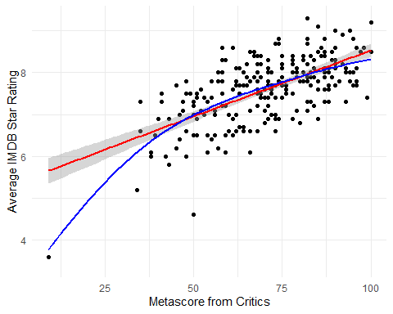

Deal with missing values
movies2 <- movies |>
select(mov_id, metascore, imdb_stars, imdb_genres, movie) |>
filter(complete.cases(metascore, imdb_stars))
ggplot(movies2, aes(x = metascore, y = imdb_stars)) +
geom_point() +
geom_smooth(method = "lm", col = "red", formula = y ~ x, se = TRUE) +
geom_smooth(method = "loess", col = "blue", formula = y ~ x, se = FALSE) +
labs(x = "Metascore from Critics", y = "Average IMDB Star Rating")
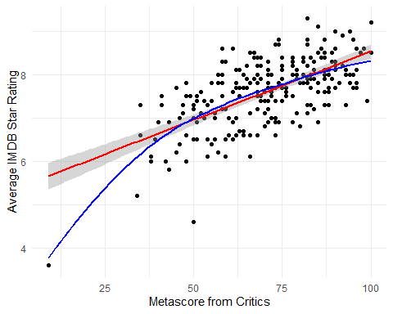

Which movies have low imdb_stars?
ggplot(movies2, aes(x = metascore, y = imdb_stars)) +
geom_point() +
geom_label(data = movies2 |> filter(imdb_stars < 5.5), aes(label = movie))
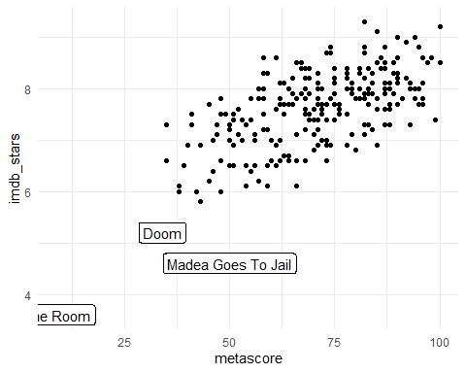

Which three movies are those?
movies2 |> filter(imdb_stars < 5.5) |>
select(mov_id, imdb_stars, metascore, movie, imdb_genres)
# A tibble: 3 × 5
mov_id imdb_stars metascore movie imdb_genres
<chr> <dbl> <dbl> <chr> <fct>
1 M-152 4.6 50 Madea Goes To Jail Comedy, Crime, Drama
2 M-058 5.2 34 Doom Action, Horror, Sci-Fi
3 M-211 3.6 9 The Room Drama
Let’s keep these movies in, for now, at least.

Anything else need attention?
data_codebook(movies2 |> select(metascore, imdb_stars))
select(movies2, metascore, imdb_stars) (245 rows and 2 variables, 2 shown)
ID | Name | Type | Missings | Values | N
---+------------+---------+----------+------------+----
1 | metascore | numeric | 0 (0.0%) | [9, 100] | 245
---+------------+---------+----------+------------+----
2 | imdb_stars | numeric | 0 (0.0%) | [3.6, 9.3] | 245
-------------------------------------------------------
movies2 |> reframe(lovedist(imdb_stars))
# A tibble: 1 × 10
n miss mean sd med mad min q25 q75 max
<int> <int> <dbl> <dbl> <dbl> <dbl> <dbl> <dbl> <dbl> <dbl>
1 245 0 7.61 0.781 7.7 0.741 3.6 7.2 8.1 9.3
movies2 |> reframe(lovedist(metascore))
# A tibble: 1 × 10
n miss mean sd med mad min q25 q75 max
<int> <int> <dbl> <dbl> <dbl> <dbl> <dbl> <dbl> <dbl> <dbl>
1 245 0 70.8 15.8 71 17.8 9 60 83 100

Linear model, fit with OLS
Predict imdb_stars using metascore using OLS.
fit2 <- lm(imdb_stars ~ metascore, data = movies2)
## We'll use 89% confidence here, just for fun.
model_parameters(fit2, digits = 3, ci = 0.89)
Parameter | Coefficient | SE | 89% CI | t(243) | p
--------------------------------------------------------------------
(Intercept) | 5.370 | 0.177 | [5.085, 5.655] | 30.266 | < .001
metascore | 0.032 | 0.002 | [0.028, 0.036] | 12.931 | < .001
Uncertainty intervals (equal-tailed) and p-values (two-tailed) computed
using a Wald t-distribution approximation.
- What is our fit2 model’s regression equation?
- imdb_stars = 5.37 + 0.032 metascore
- Does the intercept (5.37) mean anything to us here?

Interpreting the coefficients
model_parameters(fit2, digits = 3, ci = 0.89)
Parameter | Coefficient | SE | 89% CI | t(243) | p
--------------------------------------------------------------------
(Intercept) | 5.370 | 0.177 | [5.085, 5.655] | 30.266 | < .001
metascore | 0.032 | 0.002 | [0.028, 0.036] | 12.931 | < .001
Uncertainty intervals (equal-tailed) and p-values (two-tailed) computed
using a Wald t-distribution approximation.
- If we have two movies, and movie A has a metascore that is 1 point higher than movie B, then …
- our model fit2 predicts that movie A will have an imdb_stars value that is 0.032 higher than movie B.
- What if movie A’s metascore was 10 points higher than movie B’s?

Making Predictions with fit2
dat_new <- tibble(metascore = c(10, 20, 30, 40, 41))
estimate_prediction(fit2, data = dat_new, ci = 0.89)
Model-based Predictions
metascore | Predicted | SE | 89% CI
-------------------------------------------
10 | 5.69 | 0.62 | [4.69, 6.68]
20 | 6.00 | 0.62 | [5.01, 6.99]
30 | 6.32 | 0.61 | [5.34, 7.30]
40 | 6.64 | 0.61 | [5.66, 7.61]
41 | 6.67 | 0.61 | [5.69, 7.64]
Variable predicted: imdb_stars
- Could instead use estimate_expectation(): same predictions, just confidence intervals rather than prediction intervals.

Does the model perform well?
model_performance(fit2)
# Indices of model performance
AIC | AICc | BIC | R2 | R2 (adj.) | RMSE | Sigma
---------------------------------------------------------
451.0 | 451.1 | 461.5 | 0.408 | 0.405 | 0.600 | 0.603
- How can we interpret Sigma = 0.603?
  - About 95% of our predicted imdb_stars should be within $±2\left(0.603\right)$ stars. Is this good?
  - movies2 data: imdb_stars: range (3.6, 9.3), sd = 0.781.
  - IQR (middle half of movies) are between 7.2 and 8.1

Thinking about R-square
model_performance(fit2)
# Indices of model performance
AIC | AICc | BIC | R2 | R2 (adj.) | RMSE | Sigma
---------------------------------------------------------
451.0 | 451.1 | 461.5 | 0.408 | 0.405 | 0.600 | 0.603
- What proportion of the variation in imdb_stars is explained by metascore?
- R-square = 0.408. So what is the Pearson correlation?
- Same sign as slope: imdb_stars = 5.37 + 0.032 metascore
- Square root of R-square (0.408) is 0.639.

Checking OLS Model Fit
Main assumptions of any simple linear regression are:
- linearity: we assume that the outcome is linearly related to our predictor
- constant variance (homoscedasticity): we assume that the variation of our outcome is about the same regardless of the value of our predictor
- normal distribution: we assume that the errors around the regression model at any specified values of the x-variables follow an approximately Normal distribution.
To check these assumptions, consider the following plots.

Diagnostic Plots?
For an HTML report, run this, with
#| fig-height: 8 in the first line of the code chunk, then
set.seed(12345)
plot(check_model(fit2, detrend = FALSE))
but for the slides, I’ll do…
set.seed(12345)
fit2_dx <- plot(check_model(fit2, detrend = FALSE, panel = FALSE))
For confidence bands, please install `qqplotr`.
so I can show each plots in a separate slide.
- set.seed() is so we all get the same posterior predictive plot.

Posterior Predictive Check
fit2_dx[[1]]
Ignoring unknown labels:
• size : ""
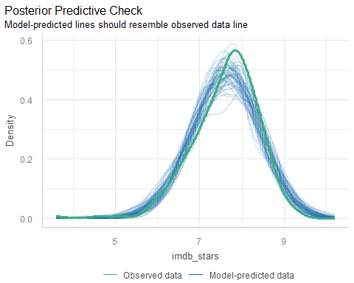

Linearity Plot
fit2_dx[[2]]
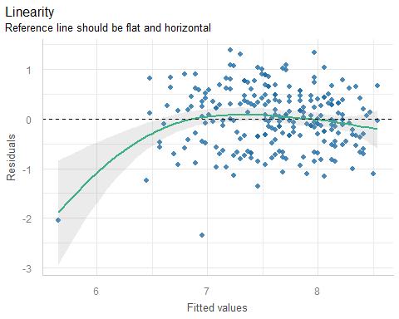

Homogeneity of Variance Plot
fit2_dx[[3]]
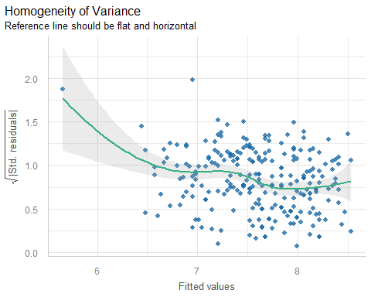

Influential Observations
fit2_dx[[4]]
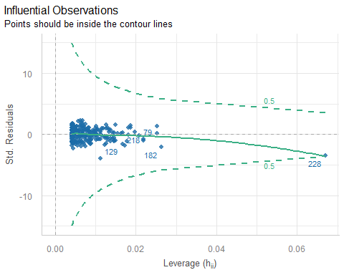

What is point 228?
movies2 |> slice(228) |>
select(mov_id, metascore, imdb_stars, movie)
# A tibble: 1 × 4
mov_id metascore imdb_stars movie
<chr> <dbl> <dbl> <chr>
1 M-211 9 3.6 The Room
- If we removed “The Room”, we would see some changes in our model.
- “The Room” is the movie with the lowest metascore, and the lowest imdb_stars of any of our movies.

Normality of Residuals
fit2_dx[[5]]
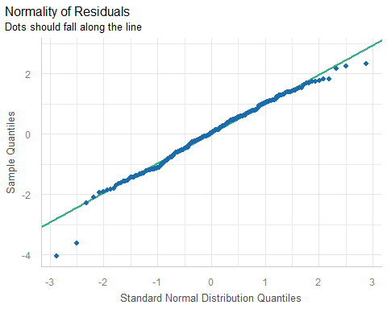

Which movies are poorly fit?
movies2 <- movies2 |> mutate(residf2 = resid(fit2), fitf2 = fitted(fit2))
ggplot(movies2, aes(x = residf2)) +
geom_histogram(bins = 25, fill = "navy", col = "white")
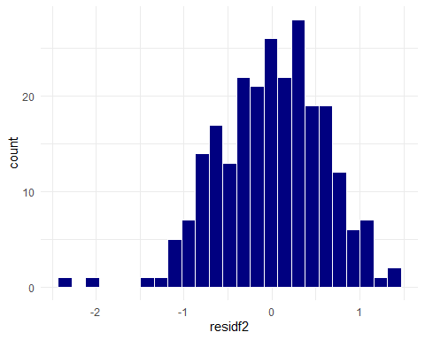

Which movies miss the mark?
Which movies are more than 1.2 stars off in their predictions?
movies2 |> filter(residf2 < -1.2 | residf2 > 1.2) |>
select(mov_id, metascore, imdb_stars, movie, residf2, fitf2) |>
arrange(residf2)
# A tibble: 7 × 6
mov_id metascore imdb_stars movie residf2 fitf2
<chr> <dbl> <dbl> <chr> <dbl> <dbl>
1 M-152 50 4.6 Madea Goes To Jail -2.35 6.95
2 M-211 9 3.6 The Room -2.05 5.65
3 M-174 66 6.1 Mystery Men -1.36 7.46
4 M-058 34 5.2 Doom -1.25 6.45
5 M-092 61 8.6 The Green Mile 1.30 7.30
6 M-219 82 9.3 The Shawshank Redemption 1.33 7.97
7 M-138 58 8.6 Life Is Beautiful 1.39 7.21

Regression Model Calibration?
ggplot(movies2, aes(x = imdb_stars, y = fitf2)) +
geom_text(aes(label = mov_id)) +
geom_abline( slope = 1, intercept = 0 , col = "sienna", lwd = 2)
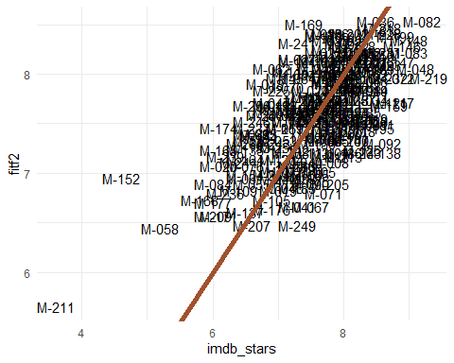

Calibration of this Model?
ggplot(movies2, aes(x = imdb_stars, y = fitf2)) +
geom_point() +
geom_label(data = movies2 |> filter(imdb_stars < 5.4), aes(label = movie)) +
geom_abline( slope = 1, intercept = 0 , col = "sienna", lwd = 2)
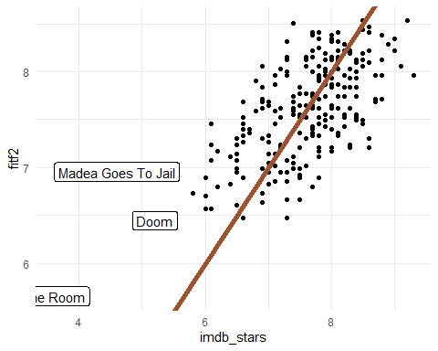

What if we dropped the three outliers?
We’d have to have a real reason to do this, of course. It couldn’t just be “our model doesn’t fit them well.”
movies2a <- movies2 |> filter(imdb_stars >= 5.5)
dim(movies2)
[1] 245 7
dim(movies2a)
[1] 242 7

Scatterplot with and without
What happens when we drop our three “outliers”?
p1 <- ggplot(movies2, aes(x = metascore, y = imdb_stars)) +
geom_point() +
geom_smooth(method = "lm", col = "red", formula = y ~ x, se = TRUE) +
geom_smooth(method = "loess", col = "blue", formula = y ~ x, se = FALSE) +
labs(x = "Metascore from Critics", y = "Average IMDB Star Rating",
title = "245 Movies")
p2 <- ggplot(movies2a, aes(x = metascore, y = imdb_stars)) +
geom_point() +
geom_smooth(method = "lm", col = "red", formula = y ~ x, se = TRUE) +
geom_smooth(method = "loess", col = "blue", formula = y ~ x, se = FALSE) +
labs(x = "Metascore from Critics", y = "Average IMDB Star Rating",
title = "242 Movies")
p1 + p2
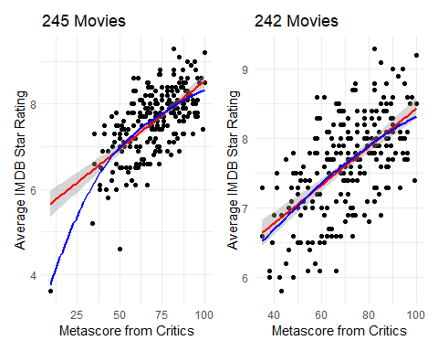

With and without 3 movies
## with Madea Goes to Jail, Doom, and The Room
model_parameters(fit2, ci = 0.89)
Parameter | Coefficient | SE | 89% CI | t(243) | p
---------------------------------------------------------------------
(Intercept) | 5.37 | 0.18 | [5.09, 5.65] | 30.27 | < .001
metascore | 0.03 | 2.45e-03 | [0.03, 0.04] | 12.93 | < .001
Uncertainty intervals (equal-tailed) and p-values (two-tailed) computed
using a Wald t-distribution approximation.
## without those movies
fit2a <- lm(imdb_stars ~ metascore, data = movies2a)
model_parameters(fit2a, ci = 0.89)
Parameter | Coefficient | SE | 89% CI | t(240) | p
---------------------------------------------------------------------
(Intercept) | 5.68 | 0.17 | [5.40, 5.96] | 32.54 | < .001
metascore | 0.03 | 2.40e-03 | [0.02, 0.03] | 11.49 | < .001
Uncertainty intervals (equal-tailed) and p-values (two-tailed) computed
using a Wald t-distribution approximation.

With and without 3 movies
Summaries aren’t directly comparable, since we’ve dropped three movies.
## with Madea Goes to Jail, Doom, and The Room
model_performance(fit2, ci = 0.89)
# Indices of model performance
AIC | AICc | BIC | R2 | R2 (adj.) | RMSE | Sigma
---------------------------------------------------------
451.0 | 451.1 | 461.5 | 0.408 | 0.405 | 0.600 | 0.603
## without those movies
model_performance(fit2a, ci = 0.89)
# Indices of model performance
AIC | AICc | BIC | R2 | R2 (adj.) | RMSE | Sigma
---------------------------------------------------------
412.0 | 412.1 | 422.5 | 0.355 | 0.352 | 0.560 | 0.562

Prediction if metascore is 60
dat_new2 <- tibble(metascore = 60)
## with Madea Goes to Jail, Doom, and The Room
estimate_expectation(fit2, ci = 0.89, data = dat_new2)
Model-based Predictions
metascore | Predicted | SE | 89% CI
-------------------------------------------
60 | 7.27 | 0.05 | [7.19, 7.34]
Variable predicted: imdb_stars
## without those movies
estimate_expectation(fit2a, ci = 0.89, data = dat_new2)
Model-based Predictions
metascore | Predicted | SE | 89% CI
-------------------------------------------
60 | 7.34 | 0.05 | [7.27, 7.41]
Variable predicted: imdb_stars

Are the diagnostic plots better?
set.seed(12121)
fit2a_dx <- plot(check_model(fit2a, detrend = FALSE, panel = FALSE))
For confidence bands, please install `qqplotr`.

“With” on left, “Without” on right
p1 <- fit2_dx[[1]]
p2 <- fit2a_dx[[1]]
p1 + p2
Ignoring unknown labels:
• size : ""
Ignoring unknown labels:
• size : ""
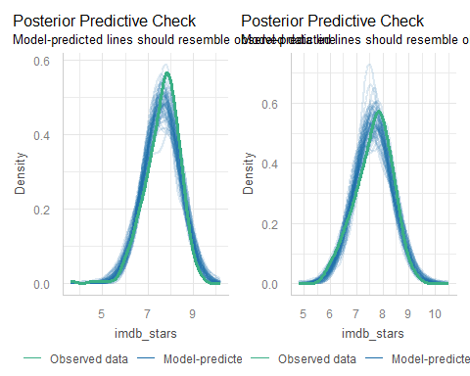

“With” on left, “Without” on right
p1 <- fit2_dx[[2]]
p2 <- fit2a_dx[[2]]
p1 + p2
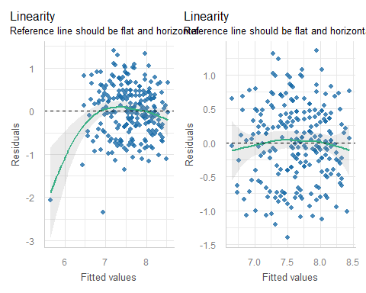

“With” on left, “Without” on right
p1 <- fit2_dx[[3]]
p2 <- fit2a_dx[[3]]
p1 + p2
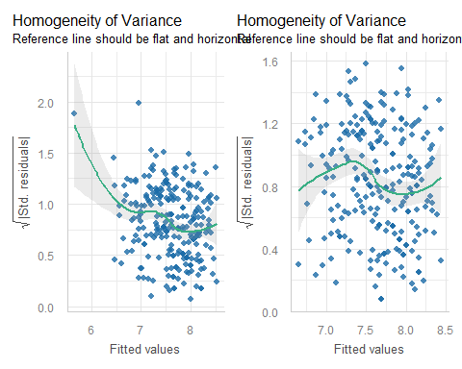

“With” on left, “Without” on right
p1 <- fit2_dx[[4]]
p2 <- fit2a_dx[[4]]
p1 + p2
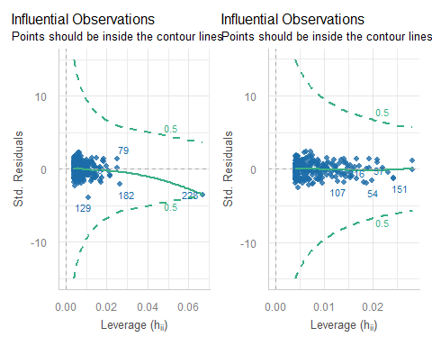

“With” on left, “Without” on right
p1 <- fit2_dx[[5]]
p2 <- fit2a_dx[[5]]
p1 + p2
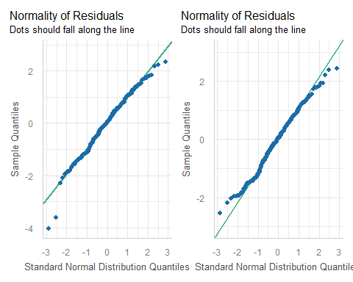

GOOD LUCK ON THE QUIZ!
xfun::session_info()
R version 4.5.1 (2025-06-13 ucrt)
Platform: x86_64-w64-mingw32/x64
Running under: Windows 11 x64 (build 26100)
Locale:
LC_COLLATE=English_United States.utf8
LC_CTYPE=English_United States.utf8
LC_MONETARY=English_United States.utf8
LC_NUMERIC=C
LC_TIME=English_United States.utf8
Package version:
abind_1.4-8 askpass_1.2.1 backports_1.5.0
base_4.5.1 base64enc_0.1-3 bayesplot_1.14.0
bayestestR_0.17.0 BH_1.87.0.1 bit_4.6.0
bit64_4.6.0.1 blob_1.2.4 boot_1.3-32
broom_1.0.10 bslib_0.9.0 cachem_1.1.0
callr_3.7.6 car_3.1-3 carData_3.0-5
cellranger_1.1.0 checkmate_2.3.3 class_7.3-23
cli_3.6.5 clipr_0.8.0 coda_0.19-4.1
codetools_0.2-20 colourpicker_1.3.0 commonmark_2.0.0
compiler_4.5.1 conflicted_1.2.0 correlation_0.8.8
cowplot_1.2.0 cpp11_0.5.2 crayon_1.5.3
crosstalk_1.2.2 curl_7.0.0 data.table_1.17.8
datasets_4.5.1 datawizard_1.3.0 DBI_1.2.3
dbplyr_2.5.1 Deriv_4.2.0 desc_1.4.3
DescTools_0.99.60 digest_0.6.37 distributional_0.5.0
doBy_4.7.0 dplyr_1.1.4 DT_0.34.0
dtplyr_1.3.2 dygraphs_1.1.1.6 e1071_1.7-16
easystats_0.7.5 effectsize_1.0.1 emmeans_1.11.2-8
estimability_1.5.1 evaluate_1.0.5 Exact_3.3
expm_1.0-0 farver_2.1.2 fastmap_1.2.0
fontawesome_0.5.3 forcats_1.0.1 Formula_1.2-5
fs_1.6.6 gargle_1.6.0 generics_0.1.4
ggplot2_4.0.0 ggrepel_0.9.6 ggridges_0.5.7
gld_2.6.8 glue_1.8.0 googledrive_2.1.2
googlesheets4_1.1.2 graphics_4.5.1 grDevices_4.5.1
grid_4.5.1 gridExtra_2.3 gtable_0.3.6
gtools_3.9.5 haven_2.5.5 highr_0.11
hms_1.1.3 htmltools_0.5.8.1 htmlwidgets_1.6.4
httpuv_1.6.16 httr_1.4.7 ids_1.0.1
igraph_2.1.4 inline_0.3.21 insight_1.4.2
isoband_0.2.7 janitor_2.2.1 jquerylib_0.1.4
jsonlite_2.0.0 knitr_1.50 labeling_0.4.3
later_1.4.4 lattice_0.22-7 lazyeval_0.2.2
lifecycle_1.0.4 litedown_0.7 lme4_1.1-37
lmom_3.2 loo_2.8.0 lubridate_1.9.4
magrittr_2.0.4 marginaleffects_0.30.0 markdown_2.0
MASS_7.3-65 Matrix_1.7-4 MatrixModels_0.5.4
matrixStats_1.5.0 memoise_2.0.1 methods_4.5.1
mgcv_1.9-3 microbenchmark_1.5.0 mime_0.13
miniUI_0.1.2 minqa_1.2.8 modelbased_0.13.0
modelr_0.1.11 multcomp_1.4-28 mvtnorm_1.3-3
naniar_1.1.0 nlme_3.1-168 nloptr_2.2.1
nnet_7.3.20 norm_1.0.11.1 numDeriv_2016.8.1.1
openssl_2.3.4 parallel_4.5.1 parameters_0.28.2
patchwork_1.3.2 pbkrtest_0.5.5 performance_0.15.2
pillar_1.11.1 pkgbuild_1.4.8 pkgconfig_2.0.3
plyr_1.8.9 posterior_1.6.1 prettyunits_1.2.0
processx_3.8.6 progress_1.2.3 promises_1.3.3
proxy_0.4-27 ps_1.9.1 purrr_1.1.0
quantreg_6.1 QuickJSR_1.8.1 R6_2.6.1
ragg_1.5.0 rappdirs_0.3.3 rbibutils_2.3
RColorBrewer_1.1-3 Rcpp_1.1.0 RcppEigen_0.3.4.0.2
RcppParallel_5.1.11-1 Rdpack_2.6.4 readr_2.1.5
readxl_1.4.5 reformulas_0.4.1 rematch_2.0.0
rematch2_2.1.2 report_0.6.1 reprex_2.1.1
reshape2_1.4.4 rlang_1.1.6 rmarkdown_2.30
rootSolve_1.8.2.4 rstan_2.32.7 rstanarm_2.32.2
rstantools_2.5.0 rstudioapi_0.17.1 rvest_1.0.5
S7_0.2.0 sandwich_3.1-1 sass_0.4.10
scales_1.4.0 see_0.12.0 selectr_0.4.2
shiny_1.11.1 shinyjs_2.1.0 shinystan_2.6.0
shinythemes_1.2.0 snakecase_0.11.1 sourcetools_0.1.7.1
SparseM_1.84.2 splines_4.5.1 StanHeaders_2.32.10
stats_4.5.1 stats4_4.5.1 stringi_1.8.7
stringr_1.5.2 survival_3.8-3 sys_3.4.3
systemfonts_1.3.1 tensorA_0.36.2.1 textshaping_1.0.3
TH.data_1.1-4 threejs_0.3.4 tibble_3.3.0
tidyr_1.3.1 tidyselect_1.2.1 tidyverse_2.0.0
timechange_0.3.0 tinytex_0.57 tools_4.5.1
tzdb_0.5.0 UpSetR_1.4.0 utf8_1.2.6
utils_4.5.1 uuid_1.2.1 V8_8.0.0
vctrs_0.6.5 viridis_0.6.5 viridisLite_0.4.2
visdat_0.6.0 vroom_1.6.6 withr_3.0.2
xfun_0.53 xml2_1.4.0 xtable_1.8-4
xts_0.14.1 yaml_2.3.10 zoo_1.8-14

