431 Class 02
Thomas E. Love, Ph.D.
2025-09-04

Instructions for the Quick Survey
Please read these instructions before writing.
- Introduce yourself to someone that you don’t know.
- Record the survey answers for that other person, while they record your responses.
- Be sure to complete all 15 questions (both sides.)
- When you are finished, thank your partner and raise your hand. Someone will come to collect your survey.
Regarding Question 4, Professor Love is the large fellow standing in the front of the room.

Today’s Agenda
- Data Structures and Variables
  - Evaluating some of the Quick Survey variables
- Looking at some of the data collected in Class 01
  - Group Guessing of Ages from 10 Photographs
  - Guessing Dr. Love’s Age (twice)
- Welcome to 431 Survey Report
- What to work on this weekend

The R Packages I’ll Load Today
library(janitor)
library(rstanarm)
library(easystats)
library(tidyverse)
source("c02/data/Love-431.R")
knitr::opts_chunk$set(comment = NA)
- If you actually run this in R, you will get some messages which we will suppress and ignore today.

Chatfield’s Six Rules for Data Analysis
- Do not attempt to analyze the data until you understand what is being measured and why.
- Find out how the data were collected.
- Look at the structure of the data.
- Carefully examine the data in an exploratory way, before attempting a more sophisticated analysis.
- Use your common sense at all times.
- Report the results in a clear, self-explanatory way.
Chatfield, Chris (1996) Problem Solving: A Statistician’s Guide, 2nd ed.

Our Quick Survey
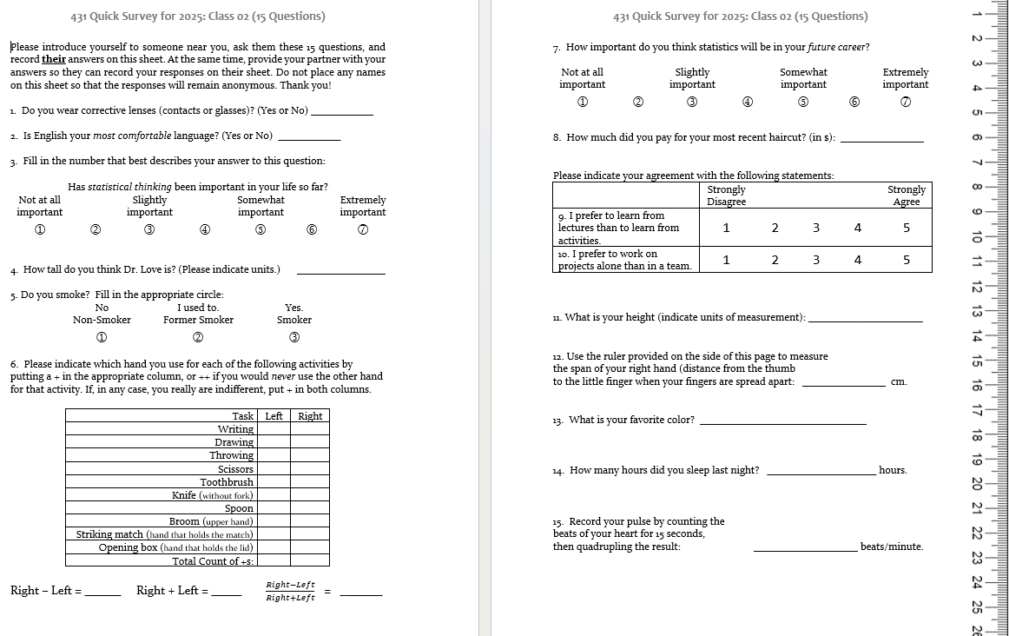

Types of Data
The key distinction we’ll make is between
- quantitative (numerical) and
- categorical (qualitative) information.
Information that is quantitative describes a quantity.
- All quantitative variables have units of measurement.
- Quantitative variables are recorded in numbers, and we use them as numbers (for instance, taking a mean of the variable makes some sense.)

Continuous vs. Discrete Quantities
Continuous variables (can take any value in a range) vs. Discrete variables (limited set of potential values)
- Is Height a continuous or a discrete variable?
- Height is certainly continuous as a concept, but how precise is our ruler?
- Piano vs. Violin

Quantitative Variable Subtypes
We can also distinguish interval (equal distance between values, but zero point is arbitrary) from ratio variables (meaningful zero point.)
- Is Weight an interval or ratio variable?
- How about IQ?

Qualitative (Categorical) Data
Qualitative variables consist of names of categories.
- Each possible value is a code for a category (could use numerical or non-numerical codes.)
  - Binary categorical variables (two categories, often labeled 1 or 0)
  - Multi-categorical variables (three or more categories)
- Can distinguish nominal (no underlying order) vs. ordinal (categories are ordered.)

Some Categorical Variables
- How is your overall health? (Excellent, Very Good, Good, Fair, Poor)
- Which candidate would you vote for if the election were held today?
- Did this patient receive this procedure?
- If you needed to analyze a small data set right away, which of the following software tools would you be comfortable using to accomplish that task?

Are these quantitative or categorical?
- Do you smoke? (1 = Non-, 2 = Former, 3 = Smoker)
- How much did you pay for your most recent haircut? (in $)
- What is your favorite color?
- How many hours did you sleep last night?
- Statistical thinking in your future career? (1 = Not at all important to 7 = Extremely important)
- If quantitative, are they discrete or continuous? Do they have a meaningful zero point?
- If categorical, how many categories? Nominal or ordinal?

Importing and Tidying Data
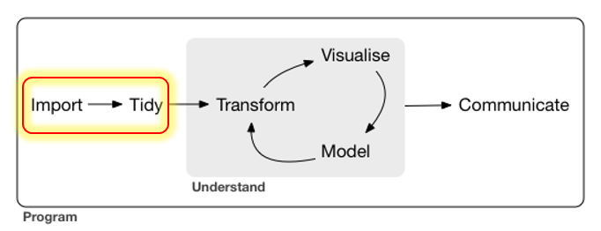

Ingesting the Quick Surveys
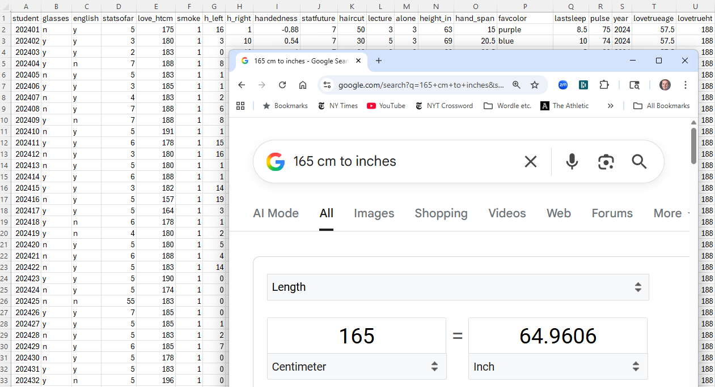

The Quick Survey
Over 10 years, 547 people took (essentially) the same survey in the same way.
Fall | 2024 | 2022 | 2021 | 2020 | 2019
n | 53 | 54 | 58 | 67 | 61

Fall | 2018 | 2017 | 2016 | 2015 | 2014 | Total
n | 51 | 48 | 64 | 49 | 42 | 547

Question
About how many of those 547 surveys caused no problems in recording responses?

The 15 Survey Items
# | Topic | # | Topic
Q1 | glasses | Q9 | lectures_vs_activities
Q2 | english | Q10 | projects_alone
Q3 | stats_so_far | Q11 | height
Q4 | guess_TL_ht | Q12 | hand_span
Q5 | smoke | Q13 | color
Q6 | handedness | Q14 | sleep
Q7 | stats_future | Q15 | pulse_rate
Q8 | haircut | - | -
- At one time, I asked about sex rather than glasses.
- In prior years, people guessed my age, rather than height here.
- Sometimes, I’ve asked for a 30-second pulse check, then doubled.

Response to the Question I asked
About how many of those 547 surveys caused no problems in recording responses?
- Guesses?
- 196/547 (36%) caused no problems.

Guess My Age
What should we do in these cases?

English best language?
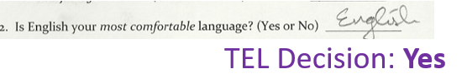
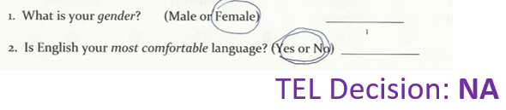
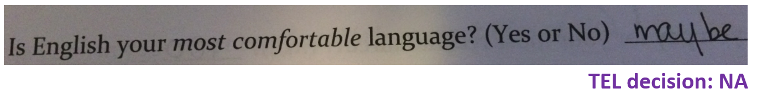

Height
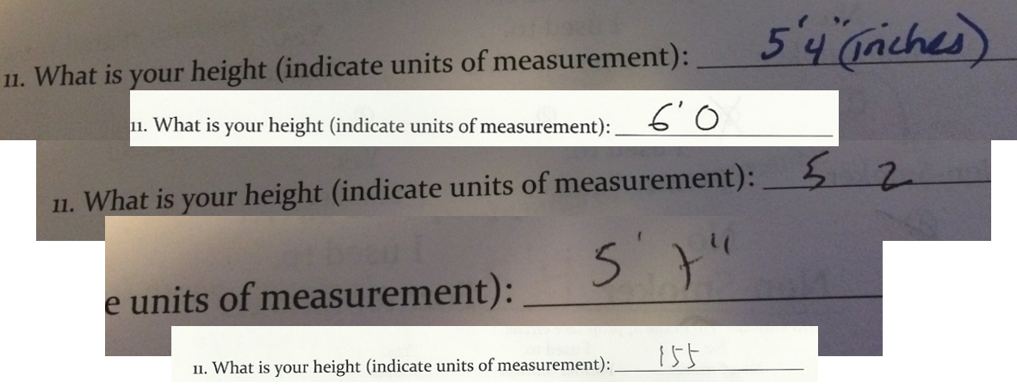

Handedness Scale (2016-21 version)
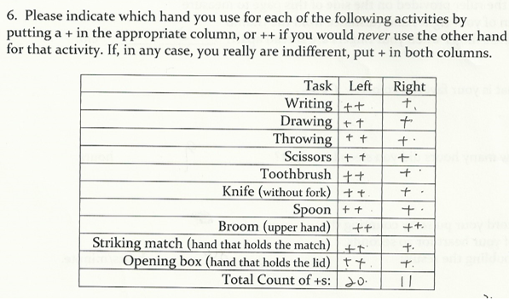

Favorite color
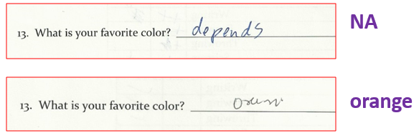
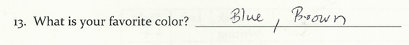
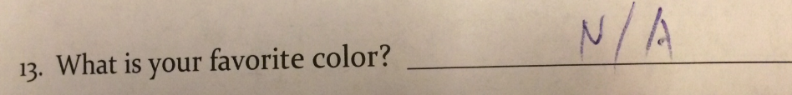

Following the Rules? (2019 version)
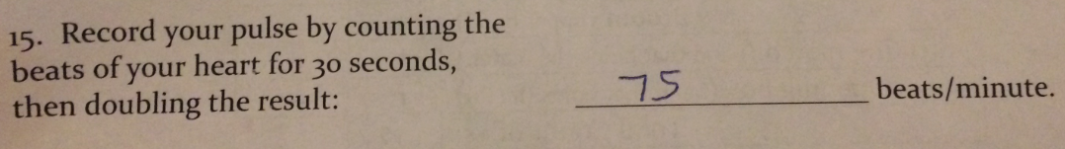

2019 pulse responses, sorted (n = 61, 1 NA)
33 46 48 56 60 60 3 | 3
62 63 65 65 66 66 4 | 68
68 68 68 69 70 70 5 | 6
70 70 70 70 70 70 6 | 002355668889
71 72 72 74 74 74 7 | 00000000122444445666888
74 74 75 76 76 76 8 | 000012445668
78 78 78 80 80 80 9 | 000046
80 81 82 84 84 85 10 | 44
86 86 88 90 90 90 11 | 0
90 94 96 104 104 110

Stem and Leaf: Pulse Rates 2014-2024
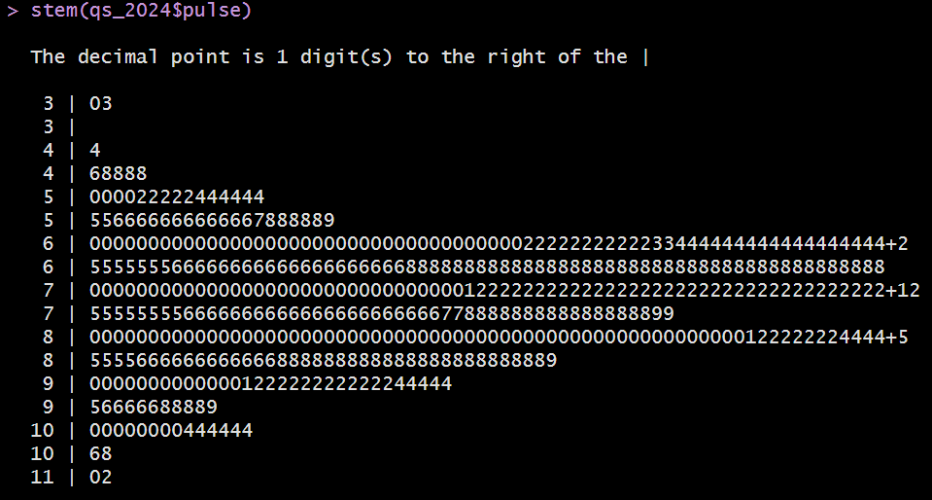
(Thanks, John Tukey)

Garbage in, garbage out …
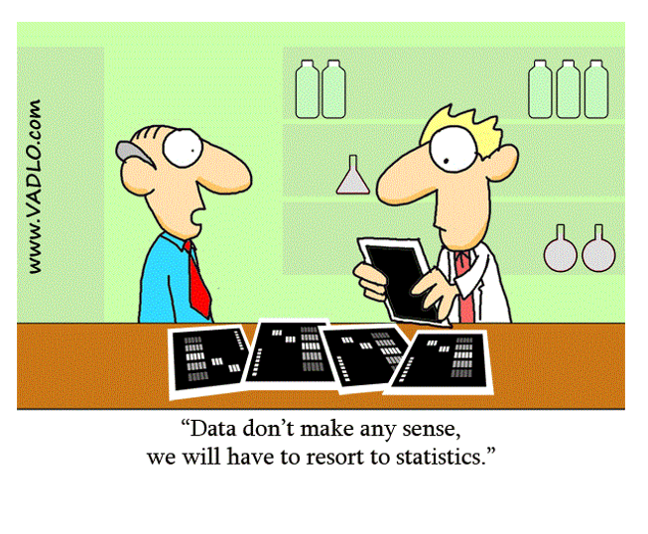

Group Age Guessing from Photos (11 groups in 2025, 10 Photos)

Photos 1-5
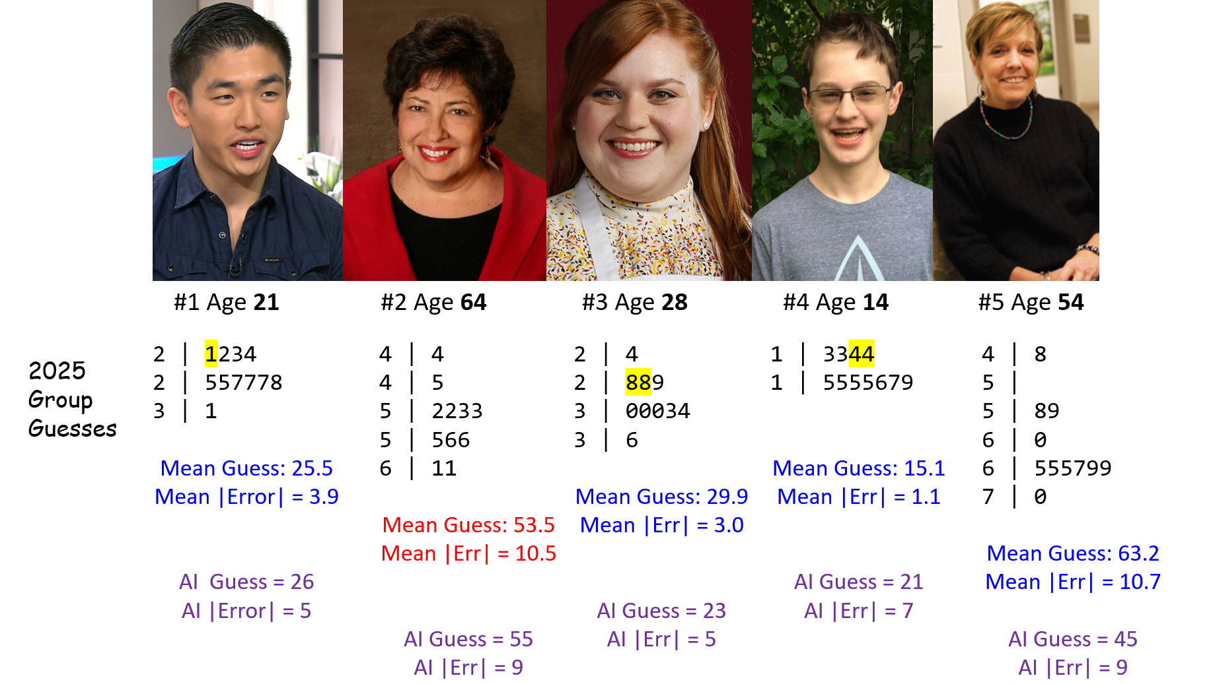

Photos 6-10
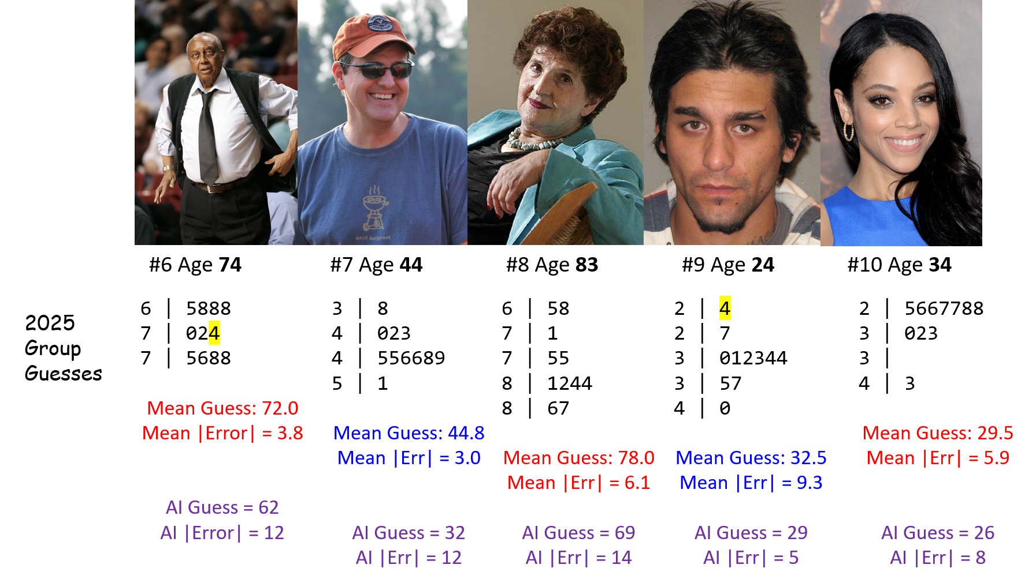

2025 Groups 1-6: Guessing Ten Photos
Group | Within 2 | Within 5 | Too Low | Correct | Too High | Beat AI
Less than 0.05 | 4 | 5 | 4 | 2 | 4 | 6
Big Data | 2 | 4 | 4 | 1 | 5 | 7
Bio-Baddies | 3 | 4 | 4 | 1 | 5 | 6
Bonferroni | 4 | 4 | 6 | 1 | 3 | 7
Multicultural Thunder | 4 | 7 | 7 | 1 | 2 | 7
TukeySEASE | 4 | 6 | 6 | 1 | 3 | 6
These groups each guessed at least one age correctly. The other groups (and AI results) follow on the next slide.

2025 Groups 7-11 and AI: Ten Photos
Group | Within 2 | Within 5 | Too Low | Correct | Too High | Beat AI
CAAH | 2 | 5 | 8 | 0 | 2 | 5
Chipmunk | 3 | 6 | 7 | 0 | 3 | 7
Mangos | 4 | 6 | 3 | 0 | 7 | 7
Mean Squad | 3 | 6 | 5 | 0 | 5 | 8
Pillars of Freedom | 3 | 4 | 6 | 0 | 4 | 7
AI (2025) | 0 | 3 | 3 | 0 | 7 | –
- AI tool is https://howolddoyoulook.com/ used on 2025-08-21.
- So … who wins?
- What other summaries might be helpful in deciding who wins?

Consider the AI (2025) results
Subject | Photo | AI guess | True Age | Error
Chong | 1 | 26 | 21 | 5
Archuleta | 2 | 55 | 64 | -9
Mayfield | 3 | 23 | 28 | 5
…
Lawson | 10 | 26 | 34 | -8
- Sum of AI errors = 5 + (-9) + (-5) + 7 + (-9) + (-12) + (-12) + (-14) + 5 + (-8) = -52
- Mean of AI errors across 10 photos is -5.2 years.
- Minimum AI error is -14 years, Maximum AI error is 7 years
- Median of the AI errors = -8.5 years.
- Standard Deviation of the AI errors = 7.9 years.

2025 Groups | Mean Error | SD (Err) | Median (Err) | (Min, Max) Err
Less than 0.05 | -2.6 | 10.3 | 0 | -20, 16
Big Data | -2.2 | 7.5 | -3 | -12, 10
Bio-Baddies | 0.2 | 7.9 | -0.5 | -12, 15
Bonferroni | 1.8 | 8.2 | 1 | -8, 16
Multicultural Thunder | 2.6 | 5.9 | 2 | -7, 15
TukeySEASE | 1.6 | 6.7 | 1 | -12, 11
CAAH | 4.9 | 4.7 | 5 | -3, 11
Chipmunk | 2.4 | 6.3 | 2 | -8, 13
Mangos | -1.7 | 7.7 | -1.5 | -19, 8
Mean Squad | -2.6 | 7.4 | 0 | -18, 6
Pillars of Freedom | -0.1 | 7.6 | 1 | -11, 11
AI | -5.2 | 7.9 | -8.5 | -14, 7

Summaries of Errors
- How helpful are the summaries on the previous slide in this setting?
- Should we be looking at |error| or maybe squared error?
AI errors are: 5, -9, -5, 7, -9, -12, -12, -14, 5, -8
- Sum of the AI errors is -52, and mean error is -5.2
- For AI, sum of the |errors| = 86, so mean absolute error is 8.6 years
- Sum of squared errors is 834, so mean squared error is 83.4, whose square root (RMSE) = 9.13

Absolute and Squared Errors
- AE = Absolute Value of Error = |guess - actual|
- RMSE = square Root of Mean Squared Error
Group | Mean AE | Range (AE) | Median AE | RMSE
Less than 0.05 | 7.4 | (0, 20) | 5 | 10.11
Big Data | 6.4 | (0, 12) | 6 | 7.43
Bio-Baddies | 6.0 | (0, 15) | 6 | 7.50
Bonferroni | 6.2 | (0, 16) | 6.5 | 8.02
Multicultural Thunder | 4.6 | (0, 15) | 3.5 | 6.18
TukeySEASE | 5.0 | (0, 12) | 4 | 6.56

Absolute and Squared Errors
- AE = Absolute Value of Error = |guess - actual|
- RMSE = square Root of Mean Squared Error
Group | Mean AE | Range (AE) | Median AE | RMSE
CAAH | 5.7 | (1, 11) | 5 | 6.64
Chipmunk | 5.2 | (1, 13) | 4 | 6.45
Mangos | 5.5 | (1, 19) | 4.5 | 7.49
Mean Squad | 5.6 | (1, 18) | 3.5 | 7.50
Pillars of Freedom | 6.1 | (1, 11) | 6 | 7.22
AI | 8.6 | (5, 14) | 8.5 | 9.13
- So … now who wins? (next slide may help…)

Group | Mean AE | Range (AE) | Median AE | RMSE | Within 2 | Within 5
Less than 0.05 | 7.4 | (0, 20) | 5 | 10.11 | 4 | 5
Big Data | 6.4 | (0, 12) | 6 | 7.43 | 2 | 4
Bio-Baddies | 6.0 | (0, 15) | 6 | 7.50 | 3 | 4
Bonferroni | 6.2 | (0, 16) | 6.5 | 8.02 | 4 | 4
Multicultural Thunder | 4.6 | (0, 15) | 3.5 | 6.18 | 4 | 7
TukeySEASE | 5.0 | (0, 12) | 4 | 6.56 | 4 | 6
CAAH | 5.7 | (1, 11) | 5 | 6.64 | 2 | 5
Chipmunk | 5.2 | (1, 13) | 4 | 6.45 | 3 | 6
Mangos | 5.5 | (1, 19) | 4.5 | 7.49 | 4 | 6
Mean Squad | 5.6 | (1, 18) | 3.5 | 7.50 | 3 | 6
Pillars of Freedom | 6.1 | (1, 11) | 6 | 7.22 | 3 | 4
AI (2025-08-21) | 8.6 | (5, 14) | 8.5 | 9.13 | 0 | 3

Importing guesses from 2014-2025
photos <-
read_csv("c02/data/ten-photo-age-history-2025.csv",
show_col_types = F)
photos <- photos |>
mutate(label = fct_reorder(label, card))
head(photos)
# A tibble: 6 × 13
order card label age sex facing year mean_guess error abs_error sq_error
<dbl> <dbl> <fct> <dbl> <chr> <chr> <chr> <dbl> <dbl> <dbl> <dbl>
1 1 1 Chong 21 M R 2025 25.5 4.5 4.5 20.2
2 2 2 Arch… 64 F L 2025 53.5 -10.5 10.5 110.
3 3 3 Mayf… 28 F L 2025 29.9 1.9 1.9 3.61
4 4 4 Love 14 M L 2025 15.1 1.1 1.1 1.21
5 5 5 McGi… 54 F R 2025 63.2 9.2 9.2 84.6
6 6 6 Chan… 74 M L 2025 72 -2 2 4
# ℹ 2 more variables: `detailed description` <chr>, jpeg <chr>

2014-2025 Errors
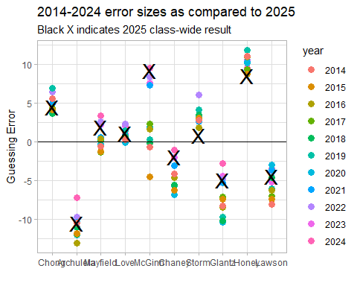

Guessing My Age (Twice) from Class 01

From our 431-Data Page: A .csv file
love-age-guesses-2022-2025.csv is on our 431-data page.
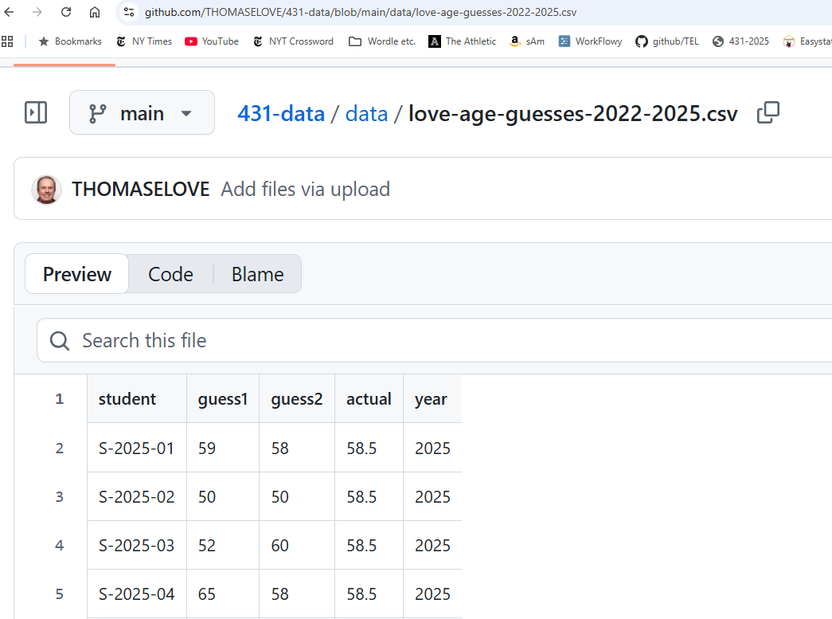

Creating the age_guess Tibble
Clicking on RAW in the 431-data presentation takes us to a (long) URL that contains the raw data in this sheet.
I’ll read in the sheet’s data to a new tibble (a special kind of R data frame) called age_guess using the read_csv() function.
url_age <-
"https://raw.githubusercontent.com/THOMASELOVE/431-data/main/data/love-age-guesses-2022-2025.csv"
age_guess <- read_csv(url_age, show_col_types = FALSE)

The age_guess tibble
What do we get?
age_guess
# A tibble: 199 × 5
student guess1 guess2 actual year
<chr> <dbl> <dbl> <dbl> <dbl>
1 S-2025-01 59 58 58.5 2025
2 S-2025-02 50 50 58.5 2025
3 S-2025-03 52 60 58.5 2025
4 S-2025-04 65 58 58.5 2025
5 S-2025-05 60 63 58.5 2025
6 S-2025-06 55 60 58.5 2025
7 S-2025-07 60 59 58.5 2025
8 S-2025-08 53 57 58.5 2025
9 S-2025-09 50 59 58.5 2025
10 S-2025-10 53 56 58.5 2025
# ℹ 189 more rows

How many guesses in each year?
age_guess |> count(year)
# A tibble: 4 × 2
year n
<dbl> <int>
1 2022 53
2 2023 39
3 2024 56
4 2025 51

How many first guesses were less than my actual age?
age_guess |> count(year, guess1 < actual)
# A tibble: 8 × 3
year `guess1 < actual` n
<dbl> <lgl> <int>
1 2022 FALSE 19
2 2022 TRUE 34
3 2023 FALSE 13
4 2023 TRUE 26
5 2024 FALSE 26
6 2024 TRUE 30
7 2025 FALSE 28
8 2025 TRUE 23

What do the guess1 values look like?
age_guess |>
select(guess1) |>
arrange(guess1)
# A tibble: 199 × 1
guess1
<dbl>
1 40
2 40
3 42
4 42
5 43
6 43
7 44
8 44
9 45
10 45
# ℹ 189 more rows

Plot the guess1 values?
ggplot(data = age_guess,
aes(x = guess1)) +
geom_dotplot(binwidth = 1)
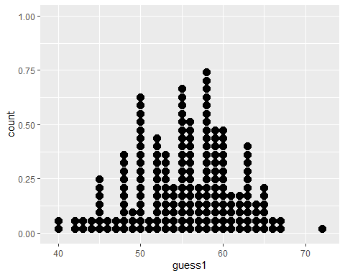

Can we make a histogram?
ggplot(age_guess,
aes(x = guess1)) +
geom_histogram()
`stat_bin()` using `bins = 30`. Pick better value with `binwidth`.
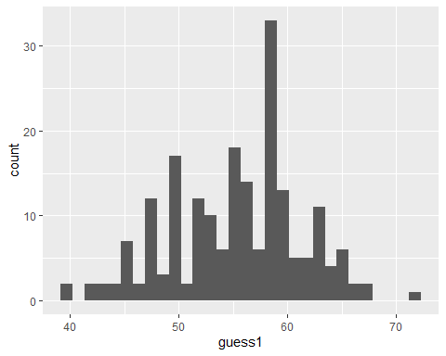

Improving the Histogram, 1
ggplot(age_guess,
aes(x = guess1)) +
geom_histogram(bins = 10)
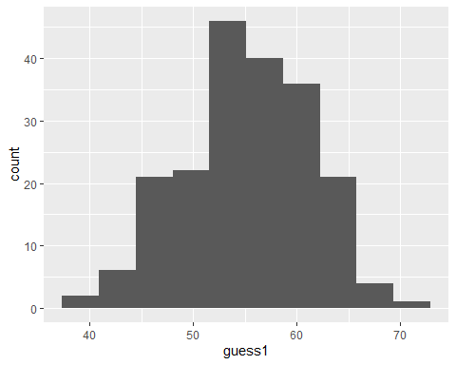

Improving the Histogram, 2
ggplot(age_guess,
aes(x = guess1)) +
geom_histogram(bins = 10,
col = "yellow")
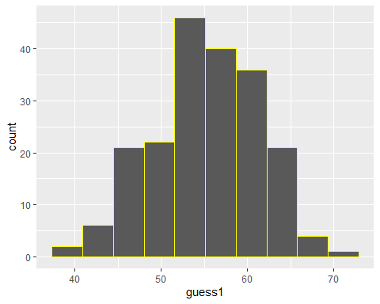

Improving the Histogram, 3
output shown now on next slide
ggplot(age_guess,
aes(x = guess1)) +
geom_histogram(bins = 10,
col = "white",
fill = "blue")
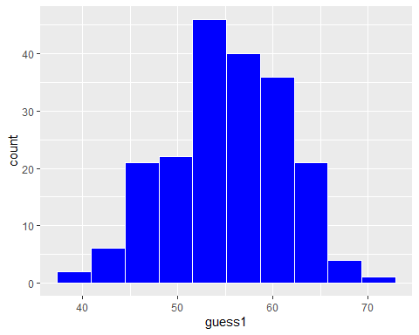

Improving the Histogram, 4
Change theme, specify bin width rather than number of bins
ggplot(age_guess,
aes(x = guess1)) +
geom_histogram(binwidth = 2,
col = "white", fill = "blue") +
theme_bw()
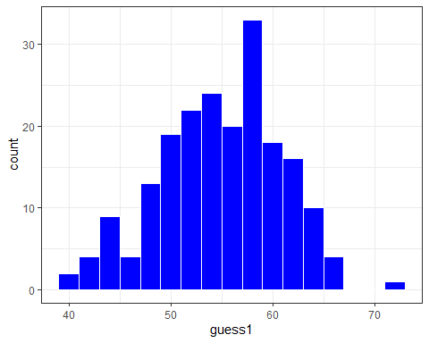

Improving the Histogram, 5
ggplot(age_guess,
aes(x = guess1)) +
geom_histogram(binwidth = 2,
col = "white", fill = "blue") +
theme_bw() +
labs(
x = "First Guess of Dr. Love's Age",
y = "Fall 2022-2025 431 students")
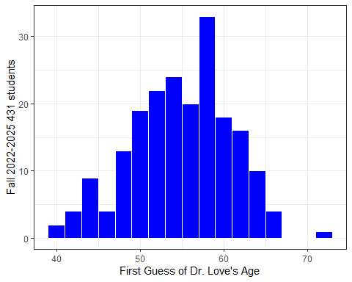

Add title and subtitle (ver. 6)
ggplot(age_guess,
aes(x = guess1)) +
geom_histogram(binwidth = 2,
col = "white", fill = "blue") +
theme_bw() +
labs(
x = "First Guess of Dr. Love's Age",
y = "Fall 2022-2025 431 students",
title = "Pretty wide range of guesses",
subtitle = "Dr. Love's Actual Age = 55.5 in 2022, 58.5 in 2025")
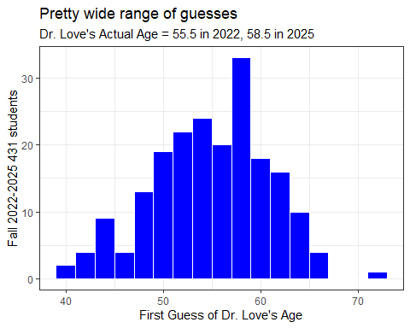

Improving the Histogram, 7
Add a vertical line at 58.5 years to show my age this year.
ggplot(age_guess,
aes(x = guess1)) +
geom_histogram(binwidth = 2,
col = "white", fill = "blue") +
geom_vline(aes(xintercept = 58.5), col = "red") +
theme_bw() +
labs(
x = "First Guess of Dr. Love's Age",
y = "Fall 2022-2025 431 students",
title = "Pretty wide range of guesses",
subtitle = "Dr. Love's Actual Age = 58.5 in 2025")
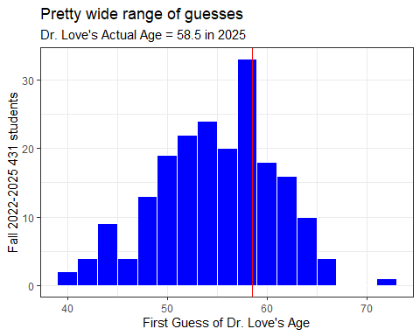

In which year did I look oldest?
Create facets separating out each year’s guesses…
ggplot(age_guess,
aes(x = guess1, fill = factor(year))) +
geom_histogram(binwidth = 2, col = "white") +
theme_bw() +
facet_grid(year ~ .) +
labs(
x = "First Guess of Dr. Love's Age",
y = "# of Students",
title = "Distribution of guesses over the past three years",
subtitle = "Dr. Love's Actual Age = 55.5 in 2022, 58.5 in 2025")
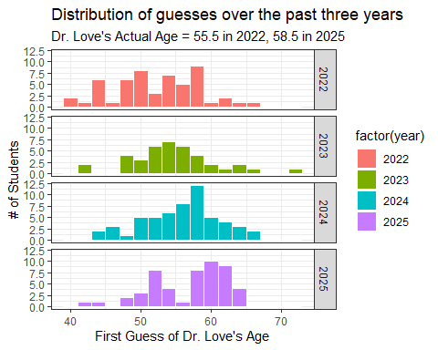

Numerical Summary
age_guess |> select(student, guess1, guess2, year) |> summary()
student guess1 guess2 year
Length:199 Min. :40.00 Min. :40.00 Min. :2022
Class :character 1st Qu.:51.00 1st Qu.:54.00 1st Qu.:2022
Mode :character Median :56.00 Median :57.00 Median :2024
Mean :55.33 Mean :56.93 Mean :2024
3rd Qu.:59.00 3rd Qu.:60.00 3rd Qu.:2025
Max. :72.00 Max. :70.00 Max. :2025
NA's :3
- Was the average guess larger on guess 1 or 2?
- What was the range of first guesses? Second guesses?
- What does the NA's : 3 mean in guess2?
- Why is student not summarized any further?

Let’s Focus on 2025 guesses
age_25 <- age_guess |>
filter(year == "2025")
age_25
# A tibble: 51 × 5
student guess1 guess2 actual year
<chr> <dbl> <dbl> <dbl> <dbl>
1 S-2025-01 59 58 58.5 2025
2 S-2025-02 50 50 58.5 2025
3 S-2025-03 52 60 58.5 2025
4 S-2025-04 65 58 58.5 2025
5 S-2025-05 60 63 58.5 2025
6 S-2025-06 55 60 58.5 2025
7 S-2025-07 60 59 58.5 2025
8 S-2025-08 53 57 58.5 2025
9 S-2025-09 50 59 58.5 2025
10 S-2025-10 53 56 58.5 2025
# ℹ 41 more rows

First Guesses in 2025
age_25 |> select(guess1) |> table()
guess1
43 45 48 50 52 53 54 55 56 58 59 60 61 62 63 64 65
1 1 2 3 5 3 2 2 1 3 5 7 3 2 7 1 3

Simple Numerical Summary
age_25 |> select(guess1) |> summary()
guess1
Min. :43.00
1st Qu.:53.00
Median :59.00
Mean :57.31
3rd Qu.:61.50
Max. :65.00

Stem-and-Leaf of 2025 Guesses
stem(age_25$guess1, scale = 0.5)
The decimal point is 1 digit(s) to the right of the |
4 | 3
4 | 588
5 | 0002222233344
5 | 55688899999
6 | 00000001112233333334
6 | 555

Summarizing 2025 Guesses
describe_distribution(age_25 |> select(guess1, guess2), ci = 0.90)
Bootstrapping confidence intervals using 100 iterations, please be
patient...
For more stable intervals, increase the number of `iterations`, but note
that this can also increase the computation time significantly.
Variable | Mean | 90% CI (Mean) | SD | IQR | Range | Skewness
--------------------------------------------------------------------------
guess1 | 57.31 | [56.31, 58.57] | 5.52 | 9 | [43.00, 65.00] | -0.65
guess2 | 59.35 | [58.30, 60.14] | 4.25 | 4 | [47.00, 69.00] | -0.40
Variable | Kurtosis | n | n_Missing
------------------------------------
guess1 | -0.37 | 51 | 0
guess2 | 1.32 | 51 | 0
- Mean = sum of values divided by number of values
- Standard Deviation = square root of variance, measure of variation
- IQR = difference between 75th and 25th percentiles
- 90% confidence interval for mean estimated via bootstrap
- Range = minimum and maximum values
- n = sample size
- n_Missing = # of missing values

Summarizing 2025 Guesses
describe_distribution(age_25 |> select(guess1, guess2),
centrality = "median", ci = 0.90,
range = FALSE, quartiles = TRUE)
Bootstrapping confidence intervals using 100 iterations, please be
patient...
For more stable intervals, increase the number of `iterations`, but note
that this can also increase the computation time significantly.
Variable | Median | 90% CI (Median) | MAD | IQR | Quartiles | Skewness
--------------------------------------------------------------------------
guess1 | 59 | [58.00, 60.00] | 5.93 | 9 | 53.00, 61.50 | -0.65
guess2 | 59 | [59.00, 60.00] | 2.97 | 4 | 58.00, 62.00 | -0.40
Variable | Kurtosis | n | n_Missing
------------------------------------
guess1 | -0.37 | 51 | 0
guess2 | 1.32 | 51 | 0
- Median = 50th percentile (middle value when data are sorted)
- 90% CI here is a bootstrap 90% confidence interval for the median
- MAD = median absolute deviation (scaled to take the same value as the standard deviation when the data follow a Normal distribution)
- Quartiles = 25th and 75th percentiles

Summarizing 2025 Guesses
- Using the lovedist() function from the Love-431.R script
age_25 |>
reframe(lovedist(guess1))
# A tibble: 1 × 10
n miss mean sd med mad min q25 q75 max
<int> <int> <dbl> <dbl> <dbl> <dbl> <dbl> <dbl> <dbl> <dbl>
1 51 0 57.3 5.52 59 5.93 43 53 61.5 65
age_25 |>
reframe(lovedist(guess2))
# A tibble: 1 × 10
n miss mean sd med mad min q25 q75 max
<int> <int> <dbl> <dbl> <dbl> <dbl> <dbl> <dbl> <dbl> <dbl>
1 51 0 59.4 4.25 59 2.97 47 58 62 69

How did guesses change in 2025?
- Did your guesses decrease / stay the same / increase?
- Calculate guess2 - guess1 and examine its sign.
age_guess |>
filter(year == "2025") |>
count(sign(guess2 - guess1))
# A tibble: 3 × 2
`sign(guess2 - guess1)` n
<dbl> <int>
1 -1 11
2 0 12
3 1 28

How much did guesses change in 2025?
Create new variable (change = guess2 - guess1)
age_guess <- age_guess |>
mutate(change = guess2 - guess1)
age_guess |> filter(year == "2025") |> select(change) |> summary()
change
Min. :-7.000
1st Qu.: 0.000
Median : 1.000
Mean : 2.039
3rd Qu.: 5.000
Max. :16.000

Histogram of Guess Changes
What will this look like?
ggplot(data = age_guess, aes(x = change)) +
geom_histogram(binwidth = 2, fill = "royalblue", col = "yellow") +
theme_bw() +
labs(x = "Change from first to second guess",
y = "Students in 431 for Fall 2022-2025",
title = "Most stayed close to their first guess.")
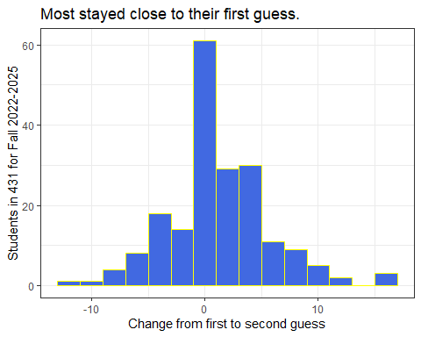

Guess 1 vs. Guess 2 Scatterplot
ggplot(data = age_guess, aes(x = guess1, y = guess2)) +
geom_point()
Warning: Removed 3 rows containing missing values or values outside the scale range
(`geom_point()`).
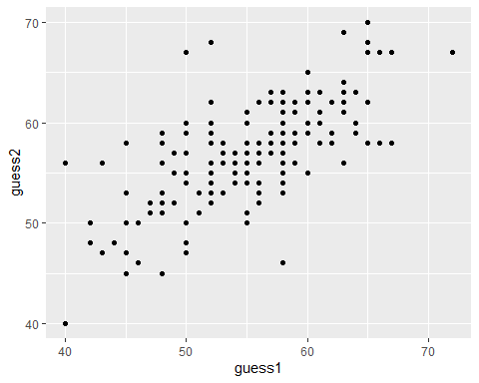

Filter to complete cases, and add regression line
temp <- age_guess |>
filter(complete.cases(guess1, guess2))
ggplot(data = temp, aes(x = guess1, y = guess2)) +
geom_point() +
geom_smooth(method = "lm", formula = y ~ x, col = "purple")
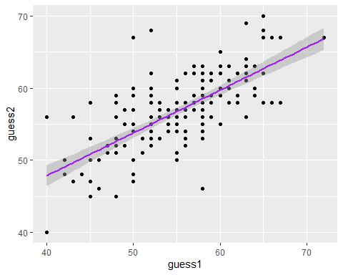

What is that regression line?
lm(guess2 ~ guess1, data = age_guess)
Call:
lm(formula = guess2 ~ guess1, data = age_guess)
Coefficients:
(Intercept) guess1
24.1295 0.5931
- Note that lm filters to complete cases by default.

Bayesian linear regression instead?
set.seed(431)
stan_glm(guess2 ~ guess1, data = age_guess, refresh = 0)
stan_glm
family: gaussian [identity]
formula: guess2 ~ guess1
observations: 196
predictors: 2
------
Median MAD_SD
(Intercept) 24.1 2.4
guess1 0.6 0.0
Auxiliary parameter(s):
Median MAD_SD
sigma 3.7 0.2
------
* For help interpreting the printed output see ?print.stanreg
* For info on the priors used see ?prior_summary.stanreg

How about a loess smooth curve?
temp <- age_guess |>
filter(complete.cases(guess1, guess2))
ggplot(data = temp, aes(x = guess1, y = guess2)) +
geom_point() +
geom_smooth(method = "loess", formula = y ~ x, col = "blue") +
theme_bw()
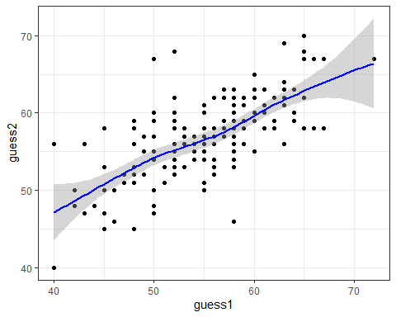

Add y = x line (no change in guess)?
temp <- age_guess |>
filter(complete.cases(guess1, guess2))
ggplot(data = temp, aes(x = guess1, y = guess2)) +
geom_point() +
geom_smooth(method = "loess", formula = y ~ x, col = "blue") +
geom_abline(intercept = 0, slope = 1, col = "red") +
theme_bw()
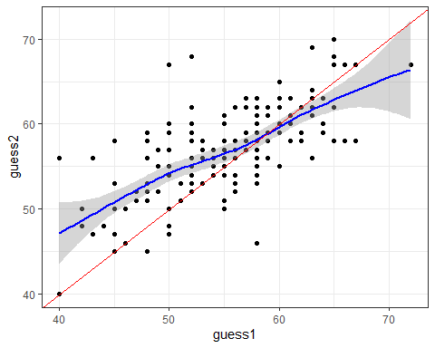

2025 Data, With Better Labels
ggplot(data = temp |> filter(year == "2025"), aes(x = guess1, y = guess2)) +
geom_point() +
geom_smooth(method = "loess", formula = y ~ x, col = "blue") +
geom_abline(intercept = 0, slope = 1, col = "red") +
geom_text(x = 47, y = 45, label = "y = x", col = "red") +
labs(x = "First Guess of Love's Age",
y = "Second Guess of Love's Age",
title = "Student Guesses of Dr. Love's Age in 2025",
subtitle = "Love's actual age = 58.5 in 2025") +
theme_bw()
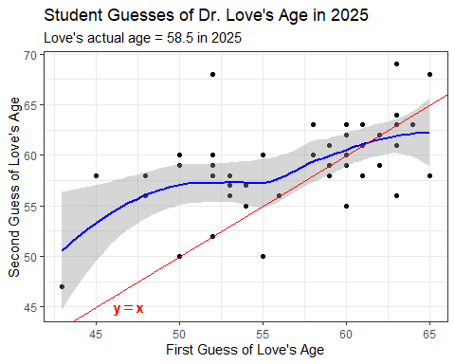

OK. That’s it for the slides. Back to the Class 02 README.

