431 Class 16
Thomas E. Love, Ph.D.
2025-10-28

Today’s Agenda
- Ingesting / Managing some Favorite Movies Data
- Comparing two groups on a transformed outcome
- Comparing two groups adjusting for a covariate
- Fitting OLS models with two predictors
- Model Parameters, Model Performance comparisons
- Using estimate_relation() for…
  - predictions and uncertainty intervals (PIs & CIs)
  - back-transformation of predictions
- Checking Model Diagnostics

Load packages and set theme
knitr::opts_chunk$set(comment = NA)
library(janitor)
library(naniar)
library(googlesheets4)
library(car)
library(easystats)
library(tidyverse)
theme_set(theme_modern()) ## I prefer this to theme_classic()
source("c16/data/Love-431.R") ## for lovedist() function

Cleveland Cavaliers Team Colors?
cavs_wine <- "#860038"
cavs_gold <- "#fdbb30"
cavs_navy <- "#041e42"
Source: https://teamcolorcodes.com/cleveland-cavaliers-color-codes/.

Data Ingest and Management

Importing Data on Favorite Movies
gs4_deauth() # indicates to Google Drive that you're reading a public file
url_movies <- "https://docs.google.com/spreadsheets/d/1bRx7aOgxhWkZemfFNUNC72DbyVEvayHTcJrZVphBjuI/edit?usp=sharing"
## this is movies_2025-10-28 from our shared drive
mov_raw <- read_sheet(url_movies, na = c("", "NA"))
✔ Reading from "movies_2025-10-28".
✔ Range 'movies_2025-10-28'.
dim(mov_raw)
[1] 260 72

Data Cleanup for Today
movies <- mov_raw |>
select(mov_id, bw_rating, imdb_stars, gen_1, gen_2, gen_3,
rt_audience, movie) |>
mutate(across(where(is.character), as_factor),
movie = as.character(movie),
mov_id = as.character(mov_id))
movies |> head()
# A tibble: 6 × 8
mov_id bw_rating imdb_stars gen_1 gen_2 gen_3 rt_audience movie
<chr> <dbl> <dbl> <fct> <fct> <fct> <dbl> <chr>
1 M-001 1 8.4 M M F 93 3 Idiots
2 M-002 3 8 M F F 92 8 1/2
3 M-003 3 7.4 M F M 69 10 Things I Hate Ab…
4 M-004 3 7.3 F F F 74 20th Century Women
5 M-005 NA 7.6 M F M 89 300
6 M-006 0 8.3 M M M 89 2001: A Space Odyss…

Missingness?
miss_var_summary(movies) |> filter(n_miss > 0)
# A tibble: 2 × 3
variable n_miss pct_miss
<chr> <int> <num>
1 bw_rating 13 5
2 rt_audience 2 0.769
miss_case_table(movies)
# A tibble: 3 × 3
n_miss_in_case n_cases pct_cases
<int> <int> <dbl>
1 0 247 95
2 1 11 4.23
3 2 2 0.769

Which movies have missing data?
movies |> filter(!complete.cases(bw_rating, rt_audience)) |>
select(mov_id, bw_rating, rt_audience, movie)
# A tibble: 13 × 4
mov_id bw_rating rt_audience movie
<chr> <dbl> <dbl> <chr>
1 M-005 NA 89 300
2 M-015 NA NA B for Busy (Al qing shen hua)
3 M-039 NA NA Chinese Doctors (Zhong guo yi sheng)
4 M-078 NA 85 Gifted Hands: The Ben Carson Story
5 M-079 NA 28 The Gingerdead Man
6 M-108 NA 65 House Party 2
7 M-123 NA 90 Jab We Met (When We Met)
8 M-136 NA 91 The Legend of 1900 (La leggenda del pianista su…
9 M-139 NA 96 Like Stars on Earth (Taare Zameen Par)
10 M-149 NA 56 Loving Adults
11 M-181 NA 77 Om Shanti Om (Peace Be With You)
12 M-235 NA 90 Still Walking (Aruitemo aruitemo)
13 M-251 NA 88 Waterloo Bridge

How to deal with missing data?
- Solution today: complete case analysis
- Solution starting Thursday: (single or multiple) imputation
movies_cc <- movies |> drop_na()
dim(movies_cc)
[1] 247 8

Bechdel-Wallace Rating
Bechdel-Wallace scores range from 0 to 3, and are a count of how many of these standards are met by the movie:
- It has to have at least two named women in it.
- Who talk to each other
- About something besides a man.
A passing score is 3, anything less doesn’t pass the test.
- We’ll create bw_test to show Pass or Fail.

Star Genders
gen_1, gen_2 and gen_3 represent the genders (M or F) played in the movie by each of the first three listed stars on IMDB.
- We’ll create a variable called females to count the number of female stars (0-3).

Code to create new variables
movies_cc <- movies_cc |>
mutate(bw_test = factor(bw_rating == 3),
bw_test = fct_recode(bw_test, "Pass" = "TRUE", "Fail" = "FALSE")) |>
mutate(females = as.numeric(gen_1 == "F") +
as.numeric(gen_2 == "F") + as.numeric(gen_3 == "F"))

Checking our cleaning
movies_cc |> select(mov_id, bw_test, bw_rating, females, gen_1, gen_2, gen_3) |>
head()
# A tibble: 6 × 7
mov_id bw_test bw_rating females gen_1 gen_2 gen_3
<chr> <fct> <dbl> <dbl> <fct> <fct> <fct>
1 M-001 Fail 1 1 M M F
2 M-002 Pass 3 2 M F F
3 M-003 Pass 3 1 M F M
4 M-004 Pass 3 3 F F F
5 M-006 Fail 0 0 M M M
6 M-007 Pass 3 2 F M F

Tabulating the New Variables
movies_cc |> tabyl(bw_test, females) |>
adorn_totals(where = c("row", "col")) |>
adorn_title()
females
bw_test 0 1 2 3 Total
Fail 39 64 5 0 108
Pass 16 68 42 13 139
Total 55 132 47 13 247
Let’s put Pass before Fail in the bw_test variable when we fit models:
movies_cc <- movies_cc |> mutate(bw_test = fct_relevel(bw_test, "Pass"))

Today’s Outcome: imdb_stars
- 1 star = worst possible, 10 stars = best possible
ggplot(movies_cc, aes(x = imdb_stars)) +
geom_histogram(binwidth = 0.25, fill = cavs_wine, col = cavs_gold)
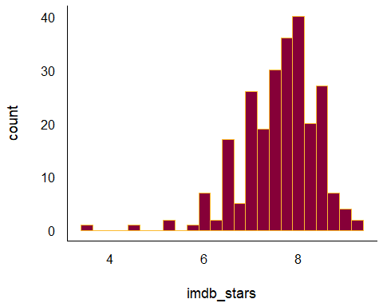

A Covariate: rt_audience
- This is the Popcornmeter, audience scores on 0-100 scale
ggplot(movies_cc, aes(x = rt_audience)) +
geom_histogram(binwidth = 2, fill = cavs_wine, col = cavs_gold)
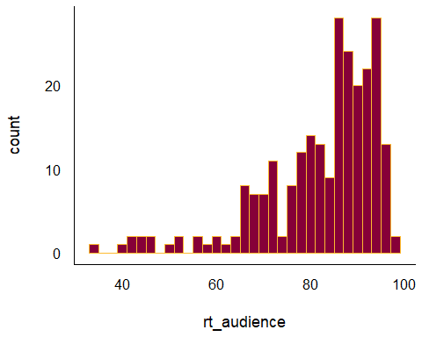

Audience Reaction Measures
- imdb_stars (1 = worst possible, 10 = best possible)
movies_cc |> reframe(lovedist(imdb_stars))
# A tibble: 1 × 10
n miss mean sd med mad min q25 q75 max
<int> <int> <dbl> <dbl> <dbl> <dbl> <dbl> <dbl> <dbl> <dbl>
1 247 0 7.60 0.794 7.7 0.741 3.6 7.15 8.1 9.3
- rt_audience (0 to 100 scale: the “Popcornmeter”)
movies_cc |> reframe(lovedist(rt_audience))
# A tibble: 1 × 10
n miss mean sd med mad min q25 q75 max
<int> <int> <dbl> <dbl> <dbl> <dbl> <dbl> <dbl> <dbl> <dbl>
1 247 0 82.7 12.3 86 10.4 34 77.5 92 98

Today’s Analyses
movies1 <- movies_cc |> select(mov_id, bw_test, imdb_stars,
females, rt_audience, movie)
dim(movies1)
[1] 247 6
- Do movies which pass the bw_test have more (or fewer) imdb_stars than movies which do not pass it?
- Would adjusting for the number of female characters among the first three stars (females) change our thinking about the association in analysis 1?
- Would adjusting for the Rotten Tomatoes Popcornmeter (rt_audience) change our thinking about analysis 1?

Analysis 1

IMDB Stars by bw_test (pass/fail)
ggplot(movies1, aes(x = imdb_stars, y = bw_test)) +
geom_violin(col = cavs_wine) +
geom_boxplot(width = 0.3, col = cavs_wine, fill = cavs_gold, outlier.size = 3) +
stat_summary(geom = "point", fun = mean, shape = 16, size = 3, col = cavs_navy)
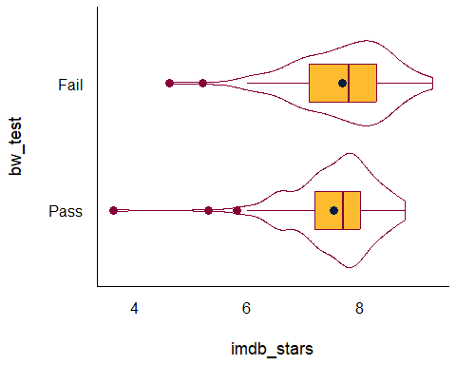

Analysis 1: Numerical Summary
- Do movies which pass the bw_test have more (or fewer) imdb_stars than movies which do not pass it?
movies1 |>
reframe(lovedist(imdb_stars), .by = bw_test)
# A tibble: 2 × 11
bw_test n miss mean sd med mad min q25 q75 max
<fct> <int> <int> <dbl> <dbl> <dbl> <dbl> <dbl> <dbl> <dbl> <dbl>
1 Fail 108 0 7.68 0.846 7.8 0.890 4.6 7.1 8.3 9.3
2 Pass 139 0 7.54 0.748 7.7 0.593 3.6 7.2 8 8.8
- What should we do to compare these means?
  - t test / OLS model, Bayes t test / model, Bootstrap, Wilcoxon rank sum test?

Box-Cox?
fit0 <- lm(imdb_stars ~ bw_test, data = movies1)
boxCox(fit0, lambda = seq(-2, 5, 1/10))
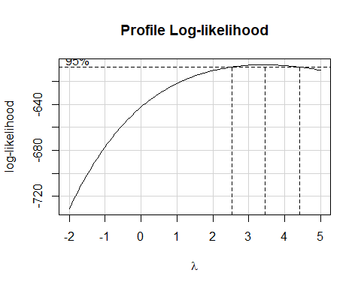

Squaring the outcome?
ggplot(movies1, aes(x = imdb_stars^2, y = bw_test)) +
geom_violin(col = cavs_wine) +
geom_boxplot(width = 0.3, col = cavs_wine, fill = cavs_gold, outlier.size = 3) +
stat_summary(geom = "point", fun = mean, shape = 16, size = 3, col = cavs_navy)
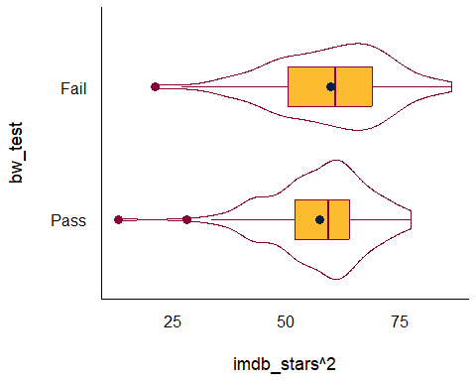

Cubing the outcome?
ggplot(movies1, aes(x = imdb_stars^3, y = bw_test)) +
geom_violin(col = cavs_wine) +
geom_boxplot(width = 0.3, col = cavs_wine, fill = cavs_gold, outlier.size = 3) +
stat_summary(geom = "point", fun = mean, shape = 16, size = 3, col = cavs_navy)
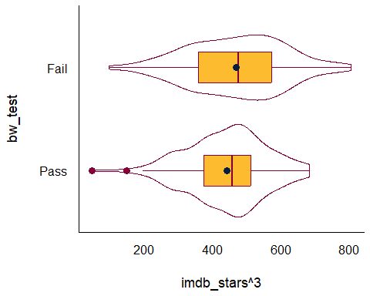

Tesseracting? (outcome^4)
ggplot(movies1, aes(x = imdb_stars^4, y = bw_test)) +
geom_violin(col = cavs_wine) +
geom_boxplot(width = 0.3, col = cavs_wine, fill = cavs_gold, outlier.size = 3) +
stat_summary(geom = "point", fun = mean, shape = 16, size = 3, col = cavs_navy)
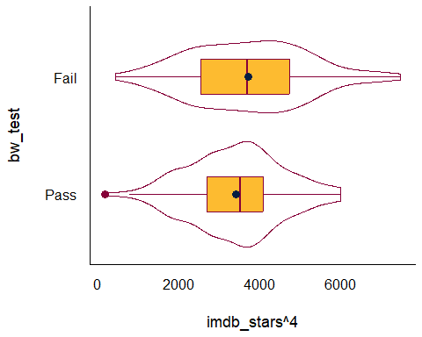

Which shall we choose?
- If our main goal is to create an interpretable model, then we have a different answer than if our main goal is to transform until the data appear as close to a Normal distribution as possible.
- Most of the time, I stick with simpler transformations, that I can back out of easily, like squares, logs, square roots and inverses.
So here, I’ll go with imdb_stars squared…
movies1 <- movies1 |>
mutate(stars_sq = imdb_stars^2)

OLS Linear Model (t test)
fit1 <- lm(stars_sq ~ bw_test, data = movies1)
model_parameters(fit1, ci = 0.9)
Parameter | Coefficient | SE | 90% CI | t(245) | p
----------------------------------------------------------------------
(Intercept) | 57.42 | 0.97 | [55.82, 59.02] | 59.18 | < .001
bw test [Fail] | 2.31 | 1.47 | [-0.12, 4.73] | 1.57 | 0.117
Uncertainty intervals (equal-tailed) and p-values (two-tailed) computed
using a Wald t-distribution approximation.
- What does the intercept in fit1 mean?
- What does the slope of bw_test mean in fit1?

OLS Linear Model (t test)
fit1 <- lm(stars_sq ~ bw_test, data = movies1)
model_parameters(fit1, ci = 0.9)
Parameter | Coefficient | SE | 90% CI | t(245) | p
----------------------------------------------------------------------
(Intercept) | 57.42 | 0.97 | [55.82, 59.02] | 59.18 | < .001
bw test [Fail] | 2.31 | 1.47 | [-0.12, 4.73] | 1.57 | 0.117
Uncertainty intervals (equal-tailed) and p-values (two-tailed) computed
using a Wald t-distribution approximation.
Interpretation?
- Movies which failed the Bechdel-Wallace test had a higher average (squared number of IMDB stars) by 2.31 than did movies which passed the B-W test.

OLS Linear Model (t test)
fit1 <- lm(stars_sq ~ bw_test, data = movies1)
model_parameters(fit1, ci = 0.9, pretty_names = FALSE)
Parameter | Coefficient | SE | 90% CI | t(245) | p
-------------------------------------------------------------------
(Intercept) | 57.42 | 0.97 | [55.82, 59.02] | 59.18 | < .001
bw_testFail | 2.31 | 1.47 | [-0.12, 4.73] | 1.57 | 0.117
Uncertainty intervals (equal-tailed) and p-values (two-tailed) computed
using a Wald t-distribution approximation.
Interpretation?
- The data are consistent at the 90% confidence level with (-0.12, 4.73) more (squared IMDB stars) on average when bw_test is Fail, assuming a random sample of movies, and that our model fit1 is correct.

Estimating the Effect with fit1
estimate_contrasts(fit1, contrast = "bw_test", ci = 0.90)
Marginal Contrasts Analysis
Level1 | Level2 | Difference | SE | 90% CI | t(245) | p
--------------------------------------------------------------------
Fail | Pass | 2.31 | 1.47 | [-0.12, 4.73] | 1.57 | 0.117
Variable predicted: stars_sq
Predictors contrasted: bw_test
p-values are uncorrected.
- Same results as previous slide.
- More useful if we have more than 2 levels of our predictor, naturally.

Is fit1 correct?
set.seed(43101)
plot(check_model(fit1, check = c("pp_check", "qq")))
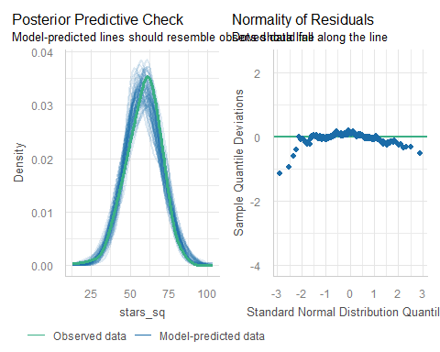

Let’s keep in the trend…
set.seed(43102)
plot(check_model(fit1, check = c("pp_check", "qq"), detrend = FALSE))
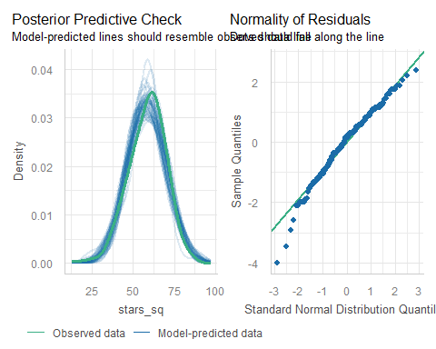

Which plots are useful?
If we have at least one quantitative predictor, then we consider all five diagnostic plots carefully.
- The 5 Plots include: linearity, homogeneity, influential points, as well as posterior predictive check and Normal Q-Q plot of residuals.
- If we have only a categorical predictor (or predictors), then we will focus on 2 plots: the posterior predictive check and the Normal Q-Q plot of residuals.

Useful here?
plot(check_model(fit1, check = c("linearity", "homogeneity")))
Warning in simpleLoess(y, x, w, span, degree = degree, parametric = parametric,
: pseudoinverse used at 57.41
Warning in simpleLoess(y, x, w, span, degree = degree, parametric = parametric,
: neighborhood radius 2.3187
Warning in simpleLoess(y, x, w, span, degree = degree, parametric = parametric,
: reciprocal condition number 1.6521e-15
Warning in simpleLoess(y, x, w, span, degree = degree, parametric = parametric,
: There are other near singularities as well. 5.3766
Warning in predLoess(object$y, object$x, newx = if (is.null(newdata)) object$x
else if (is.data.frame(newdata))
as.matrix(model.frame(delete.response(terms(object)), : pseudoinverse used at
57.41
Warning in predLoess(object$y, object$x, newx = if (is.null(newdata)) object$x
else if (is.data.frame(newdata))
as.matrix(model.frame(delete.response(terms(object)), : neighborhood radius
2.3187
Warning in predLoess(object$y, object$x, newx = if (is.null(newdata)) object$x
else if (is.data.frame(newdata))
as.matrix(model.frame(delete.response(terms(object)), : reciprocal condition
number 1.6521e-15
Warning in predLoess(object$y, object$x, newx = if (is.null(newdata)) object$x
else if (is.data.frame(newdata))
as.matrix(model.frame(delete.response(terms(object)), : There are other near
singularities as well. 5.3766
Warning in simpleLoess(y, x, w, span, degree = degree, parametric = parametric,
: pseudoinverse used at 57.41
Warning in simpleLoess(y, x, w, span, degree = degree, parametric = parametric,
: neighborhood radius 2.3187
Warning in simpleLoess(y, x, w, span, degree = degree, parametric = parametric,
: reciprocal condition number 1.6521e-15
Warning in simpleLoess(y, x, w, span, degree = degree, parametric = parametric,
: There are other near singularities as well. 5.3766
Warning in predLoess(object$y, object$x, newx = if (is.null(newdata)) object$x
else if (is.data.frame(newdata))
as.matrix(model.frame(delete.response(terms(object)), : pseudoinverse used at
57.41
Warning in predLoess(object$y, object$x, newx = if (is.null(newdata)) object$x
else if (is.data.frame(newdata))
as.matrix(model.frame(delete.response(terms(object)), : neighborhood radius
2.3187
Warning in predLoess(object$y, object$x, newx = if (is.null(newdata)) object$x
else if (is.data.frame(newdata))
as.matrix(model.frame(delete.response(terms(object)), : reciprocal condition
number 1.6521e-15
Warning in predLoess(object$y, object$x, newx = if (is.null(newdata)) object$x
else if (is.data.frame(newdata))
as.matrix(model.frame(delete.response(terms(object)), : There are other near
singularities as well. 5.3766
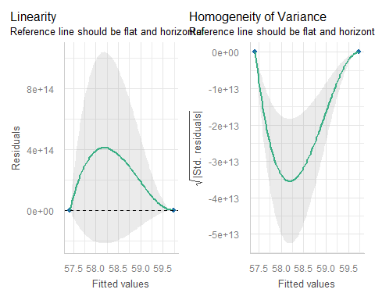

Useful here?
plot(check_model(fit1, check = "outliers"))
Warning in simpleLoess(y, x, w, span, degree = degree, parametric = parametric,
: pseudoinverse used at 0.0071839
Warning in simpleLoess(y, x, w, span, degree = degree, parametric = parametric,
: neighborhood radius 0.0020753
Warning in simpleLoess(y, x, w, span, degree = degree, parametric = parametric,
: reciprocal condition number 0
Warning in simpleLoess(y, x, w, span, degree = degree, parametric = parametric,
: There are other near singularities as well. 4.307e-06
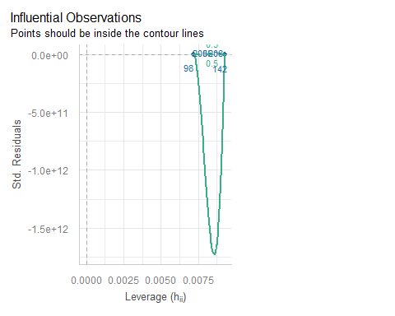

Performance of the model
model_performance(fit1)
# Indices of model performance
AIC | AICc | BIC | R2 | R2 (adj.) | RMSE | Sigma
--------------------------------------------------------------
1908.9 | 1909.0 | 1919.4 | 0.010 | 0.006 | 11.393 | 11.440
- Can we provide some context for the Sigma value?
movies1 |> reframe(lovedist(imdb_stars^2), .by = bw_test)
# A tibble: 2 × 11
bw_test n miss mean sd med mad min q25 q75 max
<fct> <int> <int> <dbl> <dbl> <dbl> <dbl> <dbl> <dbl> <dbl> <dbl>
1 Fail 108 0 59.7 12.5 60.8 13.3 21.2 50.4 68.9 86.5
2 Pass 139 0 57.4 10.6 59.3 8.90 13.0 51.8 64 77.4

Uncertainty Intervals
When making predictions, we can build confidence or prediction intervals using our linear regression model.
- We can do so using estimate_relation()…
  - confidence intervals: describe the mean across a population of subjects with this predictor value
  - prediction intervals: describe the best estimate for a single new subject with this predictor value.
- We can also transform the predictions and intervals back to our original outcome (imdb_stars).

Estimate Relation with fit1
estimate_relation(fit1, ci = 0.90)
Model-based Predictions
bw_test | Predicted | SE | 90% CI
-------------------------------------------
Pass | 57.42 | 0.97 | [55.82, 59.02]
Fail | 59.73 | 1.10 | [57.91, 61.55]
Variable predicted: stars_sq
Predictors modulated: bw_test
- From fit1: Predicted stars_sq when bw_test is “Pass” = 57.42, with 90% confidence interval (38.47, 76.38).
- Predicted stars_sq when bw_test is “Fail” = 59.73, with 90% CI (40.75, 78.70).

Transform and predict imdb_stars
- Refit fit1 to clarify the outcome transformation to R.
fit1a <- lm((imdb_stars)^2 ~ bw_test, data = movies1)
- Back-transform predictions, with 90% confidence intervals.
estimate_relation(fit1a, ci = 0.90, transform = TRUE) ## back-transform
Model-based Predictions
bw_test | Predicted | 90% CI
----------------------------------
Pass | 7.58 | [7.47, 7.68]
Fail | 7.73 | [7.61, 7.85]
Variable predicted: imdb_stars
Predictors modulated: bw_test

Prediction Plot with CIs
plot(estimate_relation(fit1a, ci = 0.90, transform = TRUE)) +
labs(title = "Predictions from `fit1a` with 90% Confidence Intervals")
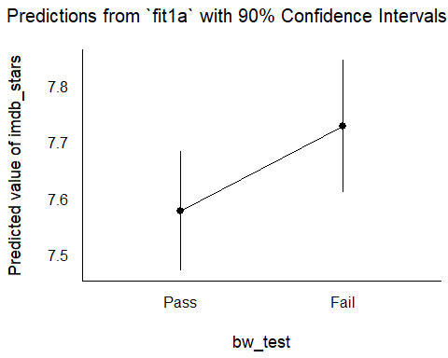

Prediction Intervals
estimate_relation(fit1a, ci = 0.90, transform = TRUE,
predict = "prediction")
Model-based Predictions
bw_test | Predicted | 90% CI
----------------------------------
Pass | 7.58 | [6.20, 8.74]
Fail | 7.73 | [6.38, 8.87]
Variable predicted: imdb_stars
Predictors modulated: bw_test
- What is the difference between these prediction intervals and the 90% confidence intervals we saw 2 slides ago?

Prediction Plot with PIs
plot(estimate_relation(fit1a, ci = 0.90,
predict = "prediction", transform = TRUE)) +
labs(title = "Predictions from `fit1a` with 90% Prediction Intervals")
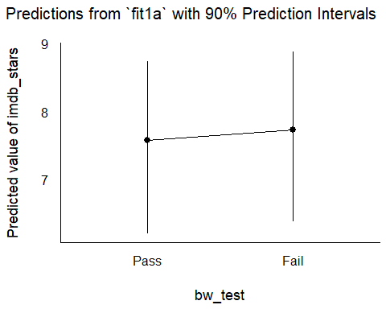

Uncertainty Intervals
We can build uncertainty intervals using our linear model for new predictor values, but if the outcome is transformed, we must back-transform manually.
- For confidence intervals for the mean across a population of subjects with (new) specified values of the predictors, use estimate_expectation().
- For prediction intervals for a single new subject with (new) specified values of the predictors, use estimate_prediction().

estimate_expectation(fit1, contrast = "bw_test", ci = 0.90,
data = tibble(bw_test = c("Pass", "Fail")))
Model-based Predictions
bw_test | Predicted | SE | 90% CI
-------------------------------------------
Pass | 57.42 | 0.97 | [55.82, 59.02]
Fail | 59.73 | 1.10 | [57.91, 61.55]
Variable predicted: stars_sq
fit1 predictions (and 90% confidence intervals) for average imdb_stars across many movies…
bw_test | Predicted imdb_stars | 90% CI for imdb_stars
Pass | $\sqrt{57.42}$ = 7.58 | (7.47, 7.68)
Fail | $\sqrt{59.73}$ = 7.73 | (7.61, 7.85)

estimate_prediction(fit1, ci = 0.90,
data = tibble(bw_test = c("Pass", "Fail")))
Model-based Predictions
bw_test | Predicted | SE | 90% CI
--------------------------------------------
Pass | 57.42 | 11.48 | [38.47, 76.38]
Fail | 59.73 | 11.49 | [40.75, 78.70]
Variable predicted: stars_sq
fit1 predictions (and 90% prediction intervals) for imdb_stars for a single new movie…
bw_test | Predicted imdb_stars | 90% CI for imdb_stars
Pass | $\sqrt{57.42}$ = 7.58 | (6.2, 8.74)
Fail | $\sqrt{59.73}$ = 7.73 | (6.38, 8.87)

Analysis 2

Adjusting for a Covariate
- Would adjusting for the number of female characters among the first three stars (females) change our thinking about the association in analysis 1?
Analysis 1 conclusion:
- Movies that failed had 2.31 more (90% CI: -0.12, 4.73) “imdb_stars squared” than did movies that passed the Bechdel-Wallace test, assuming our sample is randomly drawn from all movies of interest, and that our regression model for stars_sq is correct.

Fit model fit2
Let’s include both the key predictor (bw_test) and the covariate (females) in the model for stars_sq…
fit2 <- lm(stars_sq ~ bw_test + females, data = movies1)
model_parameters(fit2, ci = 0.90, pretty_names = FALSE)
Parameter | Coefficient | SE | 90% CI | t(244) | p
-------------------------------------------------------------------
(Intercept) | 61.19 | 1.69 | [58.40, 63.98] | 36.16 | < .001
bw_testFail | 0.42 | 1.61 | [-2.24, 3.07] | 0.26 | 0.795
females | -2.74 | 1.02 | [-4.42, -1.07] | -2.70 | 0.007
Uncertainty intervals (equal-tailed) and p-values (two-tailed) computed
using a Wald t-distribution approximation.
- What does this intercept (61.19) mean?

Interpreting fit2 intercept
model_parameters(fit2, ci = 0.90, pretty_names = FALSE)
Parameter | Coefficient | SE | 90% CI | t(244) | p
-------------------------------------------------------------------
(Intercept) | 61.19 | 1.69 | [58.40, 63.98] | 36.16 | < .001
bw_testFail | 0.42 | 1.61 | [-2.24, 3.07] | 0.26 | 0.795
females | -2.74 | 1.02 | [-4.42, -1.07] | -2.70 | 0.007
Uncertainty intervals (equal-tailed) and p-values (two-tailed) computed
using a Wald t-distribution approximation.
Intercept = 61.19 specifies the predicted stars_sq according to the fit2 model if both bw_testFail = 0 and females = 0.
- bw_testFail = 1 if bw_test = Fail, and
- bw_testFail = 0 if bw_test = Pass, so…

fit2 Intercept
model_parameters(fit2, ci = 0.90, pretty_names = FALSE)
Parameter | Coefficient | SE | 90% CI | t(244) | p
-------------------------------------------------------------------
(Intercept) | 61.19 | 1.69 | [58.40, 63.98] | 36.16 | < .001
bw_testFail | 0.42 | 1.61 | [-2.24, 3.07] | 0.26 | 0.795
females | -2.74 | 1.02 | [-4.42, -1.07] | -2.70 | 0.007
Uncertainty intervals (equal-tailed) and p-values (two-tailed) computed
using a Wald t-distribution approximation.
- Model fit2 predicts that for a movie with 0 females among the three main stars, and a passing bw_test result, the stars_sq will be 61.19 (so the predicted imdb_stars = $\sqrt{61.19}$ = 7.82 stars.)

Interpret bw_test slope
model_parameters(fit2, ci = 0.90, pretty_names = FALSE)
Parameter | Coefficient | SE | 90% CI | t(244) | p
-------------------------------------------------------------------
(Intercept) | 61.19 | 1.69 | [58.40, 63.98] | 36.16 | < .001
bw_testFail | 0.42 | 1.61 | [-2.24, 3.07] | 0.26 | 0.795
females | -2.74 | 1.02 | [-4.42, -1.07] | -2.70 | 0.007
Uncertainty intervals (equal-tailed) and p-values (two-tailed) computed
using a Wald t-distribution approximation.
- What does the slope of bw_test mean here?

Interpret slope of bw_test
model_parameters(fit2, ci = 0.90, pretty_names = FALSE)
Parameter | Coefficient | SE | 90% CI | t(244) | p
-------------------------------------------------------------------
(Intercept) | 61.19 | 1.69 | [58.40, 63.98] | 36.16 | < .001
bw_testFail | 0.42 | 1.61 | [-2.24, 3.07] | 0.26 | 0.795
females | -2.74 | 1.02 | [-4.42, -1.07] | -2.70 | 0.007
Uncertainty intervals (equal-tailed) and p-values (two-tailed) computed
using a Wald t-distribution approximation.
Suppose we have two movies, each with the same number of females in its first three stars, but one movie passed and the other failed the B-W test.
The model fit2 predicts that the movie which failed will have 0.42 more “imdb_stars squared” than the movie which passed, with 90% CI (-2.24, 3.07).

Interpret females slope
model_parameters(fit2, ci = 0.90, pretty_names = FALSE)
Parameter | Coefficient | SE | 90% CI | t(244) | p
-------------------------------------------------------------------
(Intercept) | 61.19 | 1.69 | [58.40, 63.98] | 36.16 | < .001
bw_testFail | 0.42 | 1.61 | [-2.24, 3.07] | 0.26 | 0.795
females | -2.74 | 1.02 | [-4.42, -1.07] | -2.70 | 0.007
Uncertainty intervals (equal-tailed) and p-values (two-tailed) computed
using a Wald t-distribution approximation.
- What does the slope of females mean?

Interpret slope of females
model_parameters(fit2, ci = 0.90, pretty_names = FALSE)
Parameter | Coefficient | SE | 90% CI | t(244) | p
-------------------------------------------------------------------
(Intercept) | 61.19 | 1.69 | [58.40, 63.98] | 36.16 | < .001
bw_testFail | 0.42 | 1.61 | [-2.24, 3.07] | 0.26 | 0.795
females | -2.74 | 1.02 | [-4.42, -1.07] | -2.70 | 0.007
Uncertainty intervals (equal-tailed) and p-values (two-tailed) computed
using a Wald t-distribution approximation.
Suppose we have two movies, each with the same B-W test result, but movie A has one more female in its first three stars than movie B.
- The model fit2 predicts that movie A will have 2.74 fewer “imdb_stars squared” than movie B, with 90% CI (1.07, 4.42) fewer “imdb_stars squared”.

fit1 and fit2 parameters
What do we learn from this comparison?
model_parameters(fit1, ci = 0.90, pretty_names = FALSE)
Parameter | Coefficient | SE | 90% CI | t(245) | p
-------------------------------------------------------------------
(Intercept) | 57.42 | 0.97 | [55.82, 59.02] | 59.18 | < .001
bw_testFail | 2.31 | 1.47 | [-0.12, 4.73] | 1.57 | 0.117
Uncertainty intervals (equal-tailed) and p-values (two-tailed) computed
using a Wald t-distribution approximation.
model_parameters(fit2, ci = 0.90, pretty_names = FALSE)
Parameter | Coefficient | SE | 90% CI | t(244) | p
-------------------------------------------------------------------
(Intercept) | 61.19 | 1.69 | [58.40, 63.98] | 36.16 | < .001
bw_testFail | 0.42 | 1.61 | [-2.24, 3.07] | 0.26 | 0.795
females | -2.74 | 1.02 | [-4.42, -1.07] | -2.70 | 0.007
Uncertainty intervals (equal-tailed) and p-values (two-tailed) computed
using a Wald t-distribution approximation.
- Do the differences in slope for bw_testFail make sense?

Model Performance?
model_performance(fit1)
# Indices of model performance
AIC | AICc | BIC | R2 | R2 (adj.) | RMSE | Sigma
--------------------------------------------------------------
1908.9 | 1909.0 | 1919.4 | 0.010 | 0.006 | 11.393 | 11.440
model_performance(fit2)
# Indices of model performance
AIC | AICc | BIC | R2 | R2 (adj.) | RMSE | Sigma
--------------------------------------------------------------
1903.6 | 1903.8 | 1917.6 | 0.039 | 0.031 | 11.227 | 11.296
- fit2 has better (smaller) AIC, AICc, BIC, RMSE and Sigma
- fit2 also has better (larger) R-squared and adjusted R-squared

Performance Comparison Plot
plot(compare_performance(fit1, fit2))
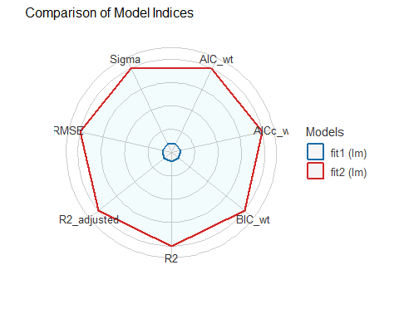

Diagnostics for fit2?
set.seed(43103)
plot(check_model(fit2, check = c("pp_check", "qq"), detrend = FALSE))
For confidence bands, please install `qqplotr`.
Ignoring unknown labels:
• size : ""
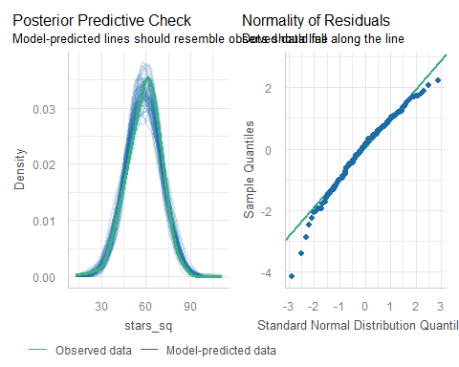

Predictions with fit2?
fit2a <- lm((imdb_stars^2) ~ bw_test + females, data = movies1)
estimate_relation(fit2, ci = 0.9)
Model-based Predictions
bw_test | females | Predicted | SE | 90% CI
-----------------------------------------------------
Pass | 0 | 61.19 | 1.69 | [58.40, 63.98]
Fail | 0 | 61.61 | 1.29 | [59.48, 63.74]
Pass | 1 | 58.45 | 1.03 | [56.75, 60.15]
Fail | 1 | 58.87 | 1.13 | [56.99, 60.74]
Pass | 2 | 55.70 | 1.15 | [53.81, 57.60]
Fail | 2 | 56.12 | 1.72 | [53.28, 58.96]
Pass | 3 | 52.96 | 1.91 | [49.81, 56.11]
Variable predicted: stars_sq
Predictors modulated: bw_test, females

No prediction at Fail, 3 females?
Recall the original data…
movies1 |> tabyl(bw_test, females)
bw_test 0 1 2 3
Pass 16 68 42 13
Fail 39 64 5 0
- With no observations in the (Fail, 3) cell to work with, R won’t make a prediction.

Back-transform predictions?
fit2a <- lm((imdb_stars^2) ~ bw_test + females, data = movies1)
estimate_relation(fit2a, ci = 0.9, transform = TRUE)
Model-based Predictions
bw_test | females | Predicted | 90% CI
--------------------------------------------
Pass | 0 | 7.82 | [7.64, 8.00]
Fail | 0 | 7.85 | [7.71, 7.98]
Pass | 1 | 7.65 | [7.53, 7.76]
Fail | 1 | 7.67 | [7.55, 7.79]
Pass | 2 | 7.46 | [7.34, 7.59]
Fail | 2 | 7.49 | [7.30, 7.68]
Pass | 3 | 7.28 | [7.06, 7.49]
Variable predicted: imdb_stars
Predictors modulated: bw_test, females

fit2 predictions with CIs
plot(estimate_relation(fit2a, ci = 0.9, transform = TRUE)) +
labs(title = "Predicted imdb_stars with 90% CIs")
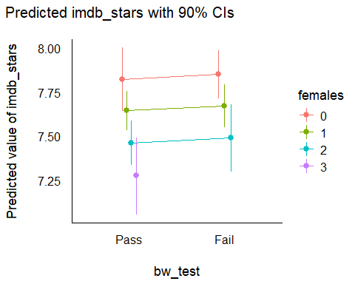

fit2 predictions with PIs
plot(estimate_relation(fit2a, ci = 0.9, transform = TRUE,
predict = "prediction")) +
labs(title = "Predicted imdb_stars with 90% PIs")
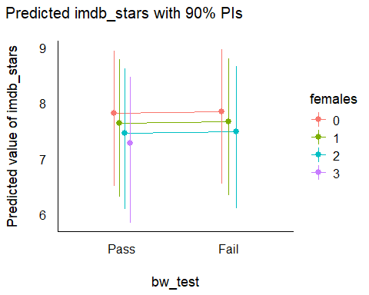

Other fit2 Diagnostics?
plot(check_model(fit2, check = c("linearity", "homogeneity")))
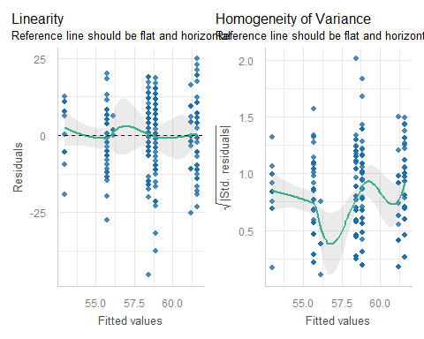

Other fit2 Diagnostics?
plot(check_model(fit2, check = c("outliers")))
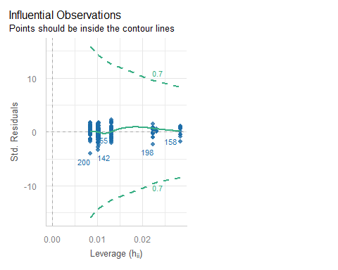

Analysis 3

Adjusting for a Covariate
- Would adjusting for the Rotten Tomatoes Popcornmeter (rt_audience) change our thinking about analysis 1?
Analysis 1 conclusion:
- Movies that failed had 2.31 more (90% CI: -0.12, 4.73) “imdb_stars squared” than did movies that passed the Bechdel-Wallace test, assuming our sample is randomly drawn from all movies of interest, and that our regression model for stars_sq is correct.

Fit a model (1st try)
Let’s include both the key predictor (bw_test) and the covariate (rt_audience) in the model for stars_sq…
fit3x <- lm(stars_sq ~ bw_test + rt_audience,
data = movies1)
model_parameters(fit3x, ci = 0.90, pretty_names = FALSE)
Parameter | Coefficient | SE | 90% CI | t(244) | p
------------------------------------------------------------------
(Intercept) | -0.57 | 3.20 | [-5.86, 4.73] | -0.18 | 0.860
bw_testFail | 1.00 | 0.95 | [-0.57, 2.58] | 1.05 | 0.293
rt_audience | 0.71 | 0.04 | [ 0.64, 0.77] | 18.45 | < .001
Uncertainty intervals (equal-tailed) and p-values (two-tailed) computed
using a Wald t-distribution approximation.
- What does this intercept (-0.57) mean?
- rt_audience had minimum 34 and maximum 98, in our data, on the 0-100 scale.

Centering the Covariate
In the movies1 data, the variable rt_audience has mean 82.6963563.
- We’ll center our covariate (rt_audience) by subtracting its mean.
- This will help our intercept term in the model to mean something, since centered(rt_audience) = 0 means the mean value of rt_audience.

Centering rt_audience
movies1 <- movies1 |>
mutate(rt_aud_c = center(rt_audience),
rt_aud_c2 = rt_audience - mean(rt_audience))
movies1 |>
select(mov_id, rt_audience, rt_aud_c, rt_aud_c2, movie) |>
head(4)
# A tibble: 4 × 5
mov_id rt_audience rt_aud_c rt_aud_c2 movie
<chr> <dbl> <dw_trnsf> <dbl> <chr>
1 M-001 93 10.303644 10.3 3 Idiots
2 M-002 92 9.303644 9.30 8 1/2
3 M-003 69 -13.696356 -13.7 10 Things I Hate About You
4 M-004 74 -8.696356 -8.70 20th Century Women

Interpreting fit3 intercept
fit3 <- lm(stars_sq ~ bw_test + rt_aud_c, data = movies1)
model_parameters(fit3, ci = 0.90, pretty_names = FALSE)
Parameter | Coefficient | SE | 90% CI | t(244) | p
-------------------------------------------------------------------
(Intercept) | 57.99 | 0.63 | [56.95, 59.03] | 92.20 | < .001
bw_testFail | 1.00 | 0.95 | [-0.57, 2.58] | 1.05 | 0.293
rt_aud_c | 0.71 | 0.04 | [ 0.64, 0.77] | 18.45 | < .001
Uncertainty intervals (equal-tailed) and p-values (two-tailed) computed
using a Wald t-distribution approximation.
Intercept = 57.99 specifies the predicted stars_sq according to the fit3 model if both bw_test = “Pass” and rt_audience is at its mean.

Interpret bw_test slope
model_parameters(fit3, ci = 0.90, pretty_names = FALSE)
Parameter | Coefficient | SE | 90% CI | t(244) | p
-------------------------------------------------------------------
(Intercept) | 57.99 | 0.63 | [56.95, 59.03] | 92.20 | < .001
bw_testFail | 1.00 | 0.95 | [-0.57, 2.58] | 1.05 | 0.293
rt_aud_c | 0.71 | 0.04 | [ 0.64, 0.77] | 18.45 | < .001
Uncertainty intervals (equal-tailed) and p-values (two-tailed) computed
using a Wald t-distribution approximation.
Suppose we have two movies, each with the same Rotten Tomatoes audience rating, but one movie passed and the other failed the B-W test.
The model fit3 predicts that the movie which failed will have 1.00 more “imdb_stars squared” than the movie which passed, with 90% CI (-0.57, 2.58).

Interpret rt_aud_c slope
model_parameters(fit3, ci = 0.90, pretty_names = FALSE)
Parameter | Coefficient | SE | 90% CI | t(244) | p
-------------------------------------------------------------------
(Intercept) | 57.99 | 0.63 | [56.95, 59.03] | 92.20 | < .001
bw_testFail | 1.00 | 0.95 | [-0.57, 2.58] | 1.05 | 0.293
rt_aud_c | 0.71 | 0.04 | [ 0.64, 0.77] | 18.45 | < .001
Uncertainty intervals (equal-tailed) and p-values (two-tailed) computed
using a Wald t-distribution approximation.
Suppose we have two movies, each with the same B-W test result, but movie A has a Rotten Tomatoes Audience Score 1 point higher than movie B.
- The model fit3 predicts that movie A will have 0.71 more “imdb_stars squared” than movie B, with 90% CI (0.64, 0.77).

fit1 and fit3 parameters
model_parameters(fit1, ci = 0.90, pretty_names = FALSE)
Parameter | Coefficient | SE | 90% CI | t(245) | p
-------------------------------------------------------------------
(Intercept) | 57.42 | 0.97 | [55.82, 59.02] | 59.18 | < .001
bw_testFail | 2.31 | 1.47 | [-0.12, 4.73] | 1.57 | 0.117
Uncertainty intervals (equal-tailed) and p-values (two-tailed) computed
using a Wald t-distribution approximation.
model_parameters(fit3, ci = 0.90, pretty_names = FALSE)
Parameter | Coefficient | SE | 90% CI | t(244) | p
-------------------------------------------------------------------
(Intercept) | 57.99 | 0.63 | [56.95, 59.03] | 92.20 | < .001
bw_testFail | 1.00 | 0.95 | [-0.57, 2.58] | 1.05 | 0.293
rt_aud_c | 0.71 | 0.04 | [ 0.64, 0.77] | 18.45 | < .001
Uncertainty intervals (equal-tailed) and p-values (two-tailed) computed
using a Wald t-distribution approximation.

Model Performance?
model_performance(fit1)
# Indices of model performance
AIC | AICc | BIC | R2 | R2 (adj.) | RMSE | Sigma
--------------------------------------------------------------
1908.9 | 1909.0 | 1919.4 | 0.010 | 0.006 | 11.393 | 11.440
model_performance(fit3)
# Indices of model performance
AIC | AICc | BIC | R2 | R2 (adj.) | RMSE | Sigma
------------------------------------------------------------
1695.1 | 1695.3 | 1709.1 | 0.587 | 0.583 | 7.361 | 7.406
- fit3 has better (smaller) AIC, AICc, BIC, RMSE and Sigma
- fit3 also has better (larger) R-squared and adjusted R-squared

Performance Comparison Plot
plot(compare_performance(fit1, fit3))
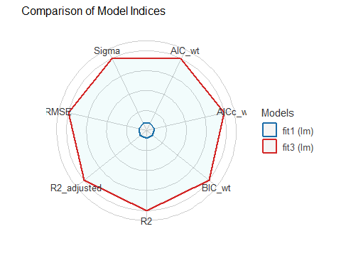

fit3 vs. fit2?
plot(compare_performance(fit2, fit3))
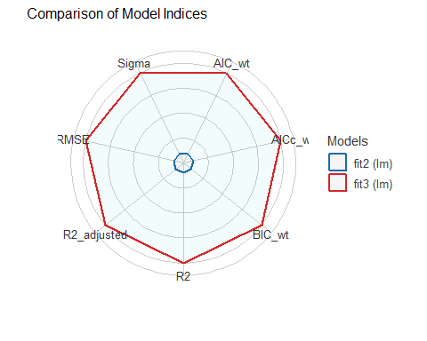

Predictions with fit3?
fit3a <- lm((imdb_stars^2) ~ bw_test + center(rt_audience),
data = movies1)
estimate_relation(fit3a, ci = 0.9)
Model-based Predictions
bw_test | rt_audience | Predicted | SE | 90% CI
---------------------------------------------------------
Fail | 34.00 | 24.51 | 2.04 | [21.15, 27.88]
Pass | 41.11 | 28.54 | 1.69 | [25.76, 31.33]
Fail | 41.11 | 29.55 | 1.78 | [26.60, 32.49]
Pass | 48.22 | 33.58 | 1.44 | [31.21, 35.95]
Fail | 48.22 | 34.58 | 1.54 | [32.05, 37.12]
Pass | 55.33 | 38.62 | 1.20 | [36.64, 40.59]
Fail | 55.33 | 39.62 | 1.30 | [37.47, 41.77]
Pass | 62.44 | 43.65 | 0.98 | [42.04, 45.26]
Fail | 62.44 | 44.66 | 1.08 | [42.87, 46.45]
Pass | 69.56 | 48.69 | 0.79 | [47.39, 49.99]
Fail | 69.56 | 49.69 | 0.90 | [48.21, 51.17]
Pass | 76.67 | 53.72 | 0.66 | [52.63, 54.81]
Fail | 76.67 | 54.73 | 0.76 | [53.47, 55.99]
Pass | 83.78 | 58.76 | 0.63 | [57.71, 59.80]
Fail | 83.78 | 59.76 | 0.71 | [58.59, 60.94]
Pass | 90.89 | 63.79 | 0.72 | [62.61, 64.98]
Fail | 90.89 | 64.80 | 0.76 | [63.54, 66.06]
Fail | 98.00 | 69.83 | 0.90 | [68.35, 71.32]
Variable predicted: imdb_stars
Predictors modulated: bw_test, rt_audience
Predictions are on the power-scale (consider `transform=TRUE`).

Back-transform predictions?
fit3b <- lm((imdb_stars^2) ~ center(rt_audience) + bw_test,
data = movies1)
estimate_relation(fit3b, ci = 0.9, transform = TRUE)
Model-based Predictions
rt_audience | bw_test | Predicted | 90% CI
------------------------------------------------
41.11 | Pass | 5.34 | [5.08, 5.60]
48.22 | Pass | 5.79 | [5.59, 6.00]
55.33 | Pass | 6.21 | [6.05, 6.37]
62.44 | Pass | 6.61 | [6.48, 6.73]
69.56 | Pass | 6.98 | [6.88, 7.07]
76.67 | Pass | 7.33 | [7.25, 7.40]
83.78 | Pass | 7.67 | [7.60, 7.73]
90.89 | Pass | 7.99 | [7.91, 8.06]
34.00 | Fail | 4.95 | [4.60, 5.28]
41.11 | Fail | 5.44 | [5.16, 5.70]
48.22 | Fail | 5.88 | [5.66, 6.09]
55.33 | Fail | 6.29 | [6.12, 6.46]
62.44 | Fail | 6.68 | [6.55, 6.82]
69.56 | Fail | 7.05 | [6.94, 7.15]
76.67 | Fail | 7.40 | [7.31, 7.48]
83.78 | Fail | 7.73 | [7.65, 7.81]
90.89 | Fail | 8.05 | [7.97, 8.13]
98.00 | Fail | 8.36 | [8.27, 8.44]
Variable predicted: imdb_stars
Predictors modulated: rt_audience, bw_test

fit3 predictions with CIs
plot(estimate_relation(fit3b, ci = 0.9, transform = TRUE)) +
scale_fill_viridis_d() +
labs(title = "fit3b Predicted imdb_stars with 90% CIs")
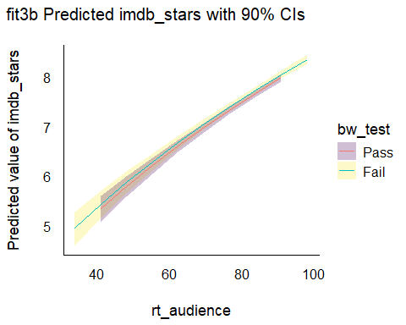

fit3b predictions with PIs
plot(estimate_relation(fit3b, ci = 0.9, transform = TRUE,
predict = "prediction")) +
scale_fill_oi() +
labs(title = "fit3b Predicted imdb_stars with 90% PIs")
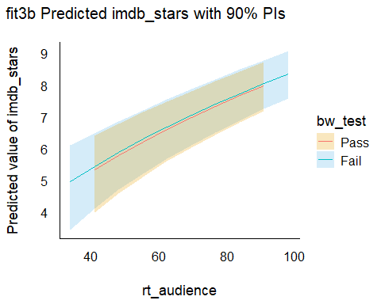

Diagnostics for fit3?
set.seed(43104)
plot(check_model(fit3, check = c("pp_check", "qq"), detrend = FALSE))
For confidence bands, please install `qqplotr`.
Ignoring unknown labels:
• size : ""
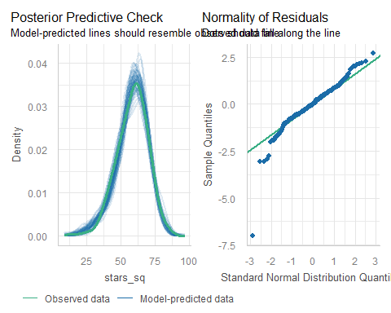

Other fit3 Diagnostics?
plot(check_model(fit3, check = c("linearity", "homogeneity")))
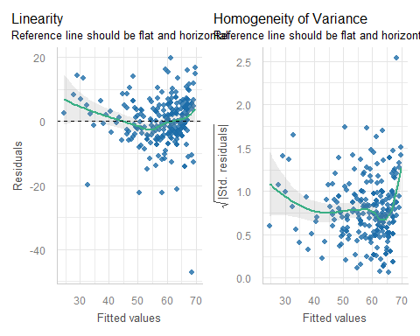

What movie is the big outlier?
movies1 <- movies1 |>
mutate(pred3 = fit3$fitted.values, res3 = fit3$resid)
temp <- movies1 |>
select(mov_id, rt_aud = rt_audience, bw_test, stars_sq,
pred3, res3, movie) |> arrange(res3)
temp |> head(3) ## three most negative residuals
# A tibble: 3 × 7
mov_id rt_aud bw_test stars_sq pred3 res3 movie
<chr> <dbl> <fct> <dbl> <dbl> <dbl> <chr>
1 M-152 96 Fail 21.2 68.4 -47.3 Madea Goes To Jail
2 M-103 72 Pass 28.1 50.4 -22.3 High School Musical 2
3 M-084 83 Pass 36 58.2 -22.2 Godzilla, King of the Monsters
temp |> tail(3) ## three most positive residuals
# A tibble: 3 × 7
mov_id rt_aud bw_test stars_sq pred3 res3 movie
<chr> <dbl> <fct> <dbl> <dbl> <dbl> <chr>
1 M-159 85 Pass 75.7 59.6 16.1 The Matrix
2 M-219 98 Fail 86.5 69.8 16.7 The Shawshank Redemption
3 M-148 86 Fail 81 61.3 19.7 Lord of the Rings: The Return of t…

Could we make other decisions?

What if we cubed imdb_stars?
movies1 <- movies1 |>
mutate(stars_cubed = imdb_stars^3)
fit4a <- lm(stars_cubed ~ bw_test + rt_aud_c,
data = movies1)
set.seed(43105)
plot(check_model(fit4a,
check = c("pp_check", "qq"),
detrend = FALSE),
colors = c(cavs_gold, cavs_wine, cavs_navy))
For confidence bands, please install `qqplotr`.
Ignoring unknown labels:
• size : ""
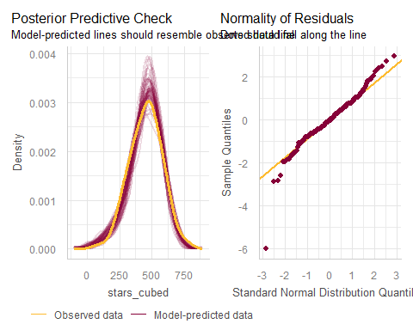

imdb_stars to the 4th power?
movies1 <- movies1 |>
mutate(stars_4 = imdb_stars^4)
fit5 <- lm(stars_4 ~ bw_test + rt_aud_c,
data = movies1)
set.seed(43106)
plot(check_model(
fit5, check = c("pp_check", "qq"), detrend = FALSE,
colors = c(cavs_wine, cavs_navy, cavs_gold)))
For confidence bands, please install `qqplotr`.
Ignoring unknown labels:
• size : ""
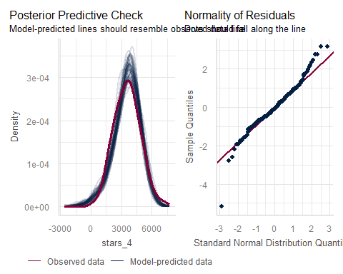

That’s all, folks!
Is there more we could do? Sure. There always is.
xfun::session_info()
R version 4.5.1 (2025-06-13 ucrt)
Platform: x86_64-w64-mingw32/x64
Running under: Windows 11 x64 (build 26200)
Locale:
LC_COLLATE=English_United States.utf8
LC_CTYPE=English_United States.utf8
LC_MONETARY=English_United States.utf8
LC_NUMERIC=C
LC_TIME=English_United States.utf8
Package version:
abind_1.4-8 askpass_1.2.1 backports_1.5.0
base64enc_0.1.3 bayestestR_0.17.0 bit_4.6.0
bit64_4.6.0.1 blob_1.2.4 boot_1.3.32
broom_1.0.10 bslib_0.9.0 cachem_1.1.0
callr_3.7.6 car_3.1-3 carData_3.0-5
cellranger_1.1.0 checkmate_2.3.3 cli_3.6.5
clipr_0.8.0 coda_0.19-4.1 codetools_0.2-20
compiler_4.5.1 conflicted_1.2.0 correlation_0.8.8
cowplot_1.2.0 cpp11_0.5.2 crayon_1.5.3
curl_7.0.0 data.table_1.17.8 datasets_4.5.1
datawizard_1.3.0 DBI_1.2.3 dbplyr_2.5.1
Deriv_4.2.0 digest_0.6.37 doBy_4.7.0
dplyr_1.1.4 dtplyr_1.3.2 easystats_0.7.5
effectsize_1.0.1 emmeans_1.11.2-8 estimability_1.5.1
evaluate_1.0.5 farver_2.1.2 fastmap_1.2.0
fontawesome_0.5.3 forcats_1.0.1 Formula_1.2-5
fs_1.6.6 gargle_1.6.0 generics_0.1.4
ggplot2_4.0.0 ggrepel_0.9.6 glue_1.8.0
googledrive_2.1.2 googlesheets4_1.1.2 graphics_4.5.1
grDevices_4.5.1 grid_4.5.1 gridExtra_2.3
gtable_0.3.6 haven_2.5.5 highr_0.11
hms_1.1.3 htmltools_0.5.8.1 httr_1.4.7
ids_1.0.1 insight_1.4.2 isoband_0.2.7
janitor_2.2.1 jquerylib_0.1.4 jsonlite_2.0.0
knitr_1.50 labeling_0.4.3 lattice_0.22-7
lifecycle_1.0.4 lme4_1.1.37 lubridate_1.9.4
magrittr_2.0.4 marginaleffects_0.30.0 MASS_7.3-65
Matrix_1.7-4 MatrixModels_0.5.4 memoise_2.0.1
methods_4.5.1 mgcv_1.9-3 microbenchmark_1.5.0
mime_0.13 minqa_1.2.8 modelbased_0.13.0
modelr_0.1.11 multcomp_1.4-28 mvtnorm_1.3-3
naniar_1.1.0 nlme_3.1-168 nloptr_2.2.1
nnet_7.3.20 norm_1.0.11.1 numDeriv_2016.8.1.1
openssl_2.3.4 parallel_4.5.1 parameters_0.28.2
patchwork_1.3.2 pbkrtest_0.5.5 performance_0.15.2
pillar_1.11.1 pkgconfig_2.0.3 plyr_1.8.9
prettyunits_1.2.0 processx_3.8.6 progress_1.2.3
ps_1.9.1 purrr_1.1.0 quantreg_6.1
R6_2.6.1 ragg_1.5.0 rappdirs_0.3.3
rbibutils_2.3 RColorBrewer_1.1-3 Rcpp_1.1.0
RcppEigen_0.3.4.0.2 Rdpack_2.6.4 readr_2.1.5
readxl_1.4.5 reformulas_0.4.1 rematch_2.0.0
rematch2_2.1.2 report_0.6.1 reprex_2.1.1
rlang_1.1.6 rmarkdown_2.30 rstudioapi_0.17.1
rvest_1.0.5 S7_0.2.0 sandwich_3.1-1
sass_0.4.10 scales_1.4.0 see_0.12.0
selectr_0.4.2 snakecase_0.11.1 SparseM_1.84.2
splines_4.5.1 stats_4.5.1 stringi_1.8.7
stringr_1.5.2 survival_3.8-3 sys_3.4.3
systemfonts_1.3.1 textshaping_1.0.3 TH.data_1.1-4
tibble_3.3.0 tidyr_1.3.1 tidyselect_1.2.1
tidyverse_2.0.0 timechange_0.3.0 tinytex_0.57
tools_4.5.1 tzdb_0.5.0 UpSetR_1.4.0
utf8_1.2.6 utils_4.5.1 uuid_1.2.1
vctrs_0.6.5 viridis_0.6.5 viridisLite_0.4.2
visdat_0.6.0 vroom_1.6.6 withr_3.0.2
xfun_0.53 xml2_1.4.0 xtable_1.8-4
yaml_2.3.10 zoo_1.8-14

Here is a video explaining the Bechdel-Wallace test.

