431 Class 07
Thomas E. Love, Ph.D.
2025-09-23

Today’s Agenda
- New Data: Ohio’s 88 Counties
- Comparing Two Samples
  - How should we interpret an uncertainty interval?
- Comparing More than Two Independent Samples
  - Analysis of Variance (ANOVA)
  - Using Regression to Develop an ANOVA model

Load packages and set theme
library(janitor)
library(patchwork)
library(readxl)
library(knitr)
library(kableExtra)
library(MKinfer)
library(rstanarm)
library(car)
library(ggdist)
library(easystats)
library(tidyverse)
theme_set(theme_bw())
knitr::opts_chunk$set(comment = NA)
source("c07/data/Love-431.R") # for the lovedist() function

ohio_2019.xlsx codebook
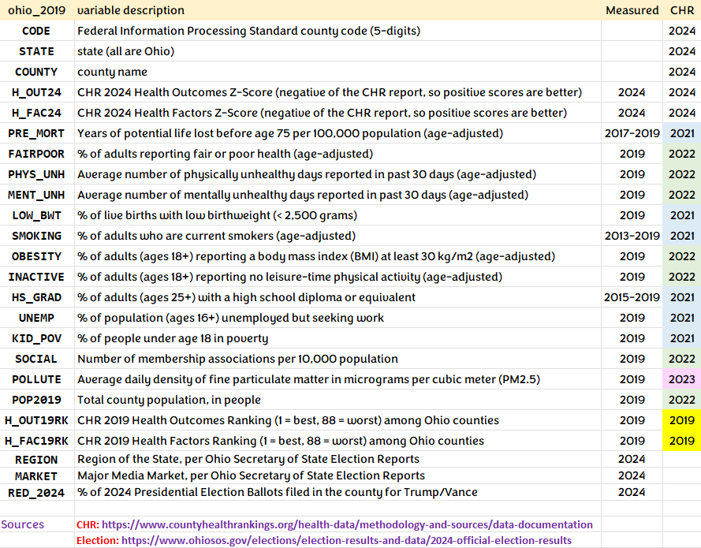

The ohio_2019.xlsx file
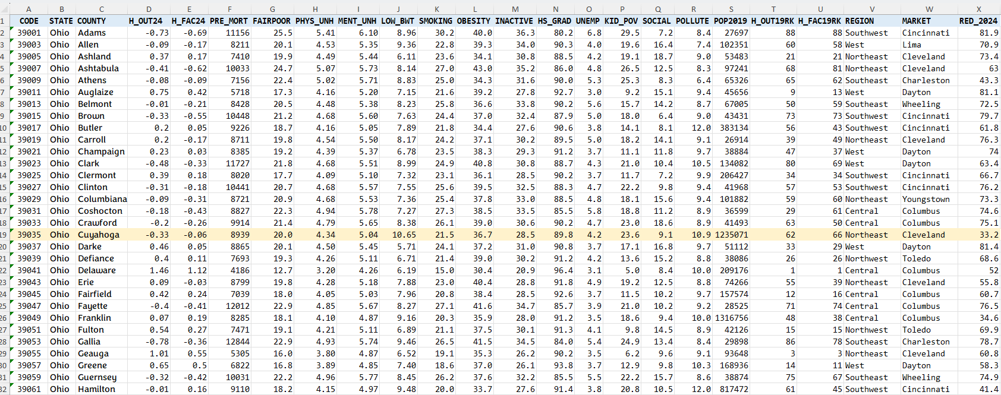

Data Ingest
oh19 <- read_xlsx("c07/data/ohio_2019.xlsx") |>
janitor::clean_names()
oh19
# A tibble: 88 × 24
code state county h_out24 h_fac24 pre_mort fairpoor phys_unh ment_unh
<chr> <chr> <chr> <dbl> <dbl> <dbl> <dbl> <dbl> <dbl>
1 39001 Ohio Adams -0.73 -0.69 11156 25.5 5.41 6.1
2 39003 Ohio Allen -0.09 -0.17 8211 20.1 4.53 5.35
3 39005 Ohio Ashland 0.37 0.17 7410 19.9 4.49 5.44
4 39007 Ohio Ashtabula -0.41 -0.62 10033 24.7 5.07 5.73
5 39009 Ohio Athens -0.08 -0.09 7156 22.4 5.02 5.71
6 39011 Ohio Auglaize 0.75 0.42 5718 17.3 4.16 5.2
7 39013 Ohio Belmont -0.01 -0.21 8428 20.5 4.48 5.38
8 39015 Ohio Brown -0.33 -0.55 10448 21.2 4.68 5.6
9 39017 Ohio Butler 0.2 0.05 9226 18.7 4.16 5.05
10 39019 Ohio Carroll 0.2 -0.17 8711 19.8 4.54 5.5
# ℹ 78 more rows
# ℹ 15 more variables: low_bwt <dbl>, smoking <dbl>, obesity <dbl>,
# inactive <dbl>, hs_grad <dbl>, unemp <dbl>, kid_pov <dbl>, social <dbl>,
# pollute <dbl>, pop2019 <dbl>, h_out19rk <dbl>, h_fac19rk <dbl>,
# region <chr>, market <chr>, red_2024 <dbl>

Selecting Variables for Today’s Class
ohio_7 <- oh19 |>
select(county, h_out24, red_2024, inactive,
h_fac19rk, h_out19rk, social)
ohio_7
# A tibble: 88 × 7
county h_out24 red_2024 inactive h_fac19rk h_out19rk social
<chr> <dbl> <dbl> <dbl> <dbl> <dbl> <dbl>
1 Adams -0.73 81.9 36.3 88 88 7.2
2 Allen -0.09 70.9 34 58 60 16.4
3 Ashland 0.37 73.4 30.8 21 21 18.7
4 Ashtabula -0.41 63 35.2 81 68 12.5
5 Athens -0.08 43.3 31.6 62 65 8.3
6 Auglaize 0.75 81.1 27.8 13 9 15.1
7 Belmont -0.01 72.5 33.8 59 50 14.2
8 Brown -0.33 79.7 32.4 73 73 6.4
9 Butler 0.2 61.8 27.6 43 56 8.1
10 Carroll 0.2 76.3 30.2 49 39 14.1
# ℹ 78 more rows

Variables Selected: ohio_7
Variable | Description
county | County name
h_out24 | CHR 2024 Health Outcomes Score
red_2024 | % of 2024 Election Ballots for Trump/Vance
inactive | 2019: % 18+ without leisure physical activity
h_fac19rk | CHR 2019 Health Factors Rank
h_out19rk | CHR 2019 Health Outcomes Rank
social | 2019: Membership associations / 100K pop.

data_codebook() result
data_codebook(ohio_7)
ohio_7 (88 rows and 7 variables, 7 shown)
ID | Name | Type | Missings | Values | N
---+-----------+-----------+----------+---------------+---------
1 | county | character | 0 (0.0%) | Adams | 1 (1.1%)
| | | | Allen | 1 (1.1%)
| | | | Ashland | 1 (1.1%)
| | | | Ashtabula | 1 (1.1%)
| | | | Athens | 1 (1.1%)
| | | | Auglaize | 1 (1.1%)
| | | | Belmont | 1 (1.1%)
| | | | Brown | 1 (1.1%)
| | | | Butler | 1 (1.1%)
| | | | Carroll | 1 (1.1%)
| | | | (...) |
---+-----------+-----------+----------+---------------+---------
2 | h_out24 | numeric | 0 (0.0%) | [-1.21, 1.46] | 88
---+-----------+-----------+----------+---------------+---------
3 | red_2024 | numeric | 0 (0.0%) | [33.2, 83] | 88
---+-----------+-----------+----------+---------------+---------
4 | inactive | numeric | 0 (0.0%) | [20.9, 39.1] | 88
---+-----------+-----------+----------+---------------+---------
5 | h_fac19rk | numeric | 0 (0.0%) | [1, 88] | 88
---+-----------+-----------+----------+---------------+---------
6 | h_out19rk | numeric | 0 (0.0%) | [1, 88] | 88
---+-----------+-----------+----------+---------------+---------
7 | social | numeric | 0 (0.0%) | [3.8, 19.3] | 88
----------------------------------------------------------------

Data Management for ohio_7
- Store ranks (1 = best, 88 = worst) of counties based on h_out24 in h_out24rk.
ohio_7 <- ohio_7 |>
mutate(h_out24rk = 89-row_number(h_out24))
ohio_7 |> select(county, h_out24, h_out24rk) |>
filter(county %in% c("Cuyahoga", "Delaware", "Geauga", "Scioto"))
# A tibble: 4 × 3
county h_out24 h_out24rk
<chr> <dbl> <dbl>
1 Cuyahoga -0.33 70
2 Delaware 1.46 1
3 Geauga 1.01 6
4 Scioto -1.21 88

Data Management for ohio_7
- Create two groups in sedentary to reflect top third and bottom third of counties by inactive
ohio_7 <- ohio_7 |>
mutate(sedentary = case_when(
inactive >= quantile(inactive, 0.67) ~ "More",
inactive < quantile(inactive, 0.33) ~ "Less"))
ohio_7 |> tabyl(sedentary) |> adorn_pct_formatting()
sedentary n percent valid_percent
Less 29 33.0% 50.0%
More 29 33.0% 50.0%
<NA> 30 34.1% -

Data Management for ohio_7
- Place into hfactor four groups of equal size derived from the h_fac19rk data.
ohio_7 <- ohio_7 |>
mutate(hfactor = case_when(
h_fac19rk <= 22 ~ "Best",
h_fac19rk > 22 & h_fac19rk <= 44 ~ "High",
h_fac19rk > 44 & h_fac19rk <= 66 ~ "Low",
h_fac19rk > 66 ~ "Worst"))
ohio_7 |> group_by(hfactor) |> reframe(lovedist(h_fac19rk))
# A tibble: 4 × 11
hfactor n miss mean sd med mad min q25 q75 max
<chr> <int> <int> <dbl> <dbl> <dbl> <dbl> <dbl> <dbl> <dbl> <dbl>
1 Best 22 0 11.5 6.49 11.5 8.15 1 6.25 16.8 22
2 High 22 0 33.5 6.49 33.5 8.15 23 28.2 38.8 44
3 Low 22 0 55.5 6.49 55.5 8.15 45 50.2 60.8 66
4 Worst 22 0 77.5 6.49 77.5 8.15 67 72.2 82.8 88

Data Management for ohio_7
- Place into soc_grp three groups of (approximately) equal size derived from the social data.
ohio_7 <- ohio_7 |>
mutate(soc_gp = cut_number(social, n = 3))
ohio_7 |> tabyl(soc_gp) |> adorn_pct_formatting()
soc_gp n percent
[3.8,10.2] 30 34.1%
(10.2,12.9] 29 33.0%
(12.9,19.3] 29 33.0%
ohio_7 <- ohio_7 |>
mutate(soc_gp = fct_recode(factor(soc_gp),
"Small" = "[3.8,10.2]",
"Medium" = "(10.2,12.9]",
"Large" = "(12.9,19.3]"))

One of Today’s Outcomes
- red_2024 = % of 2024 Presidential Election Ballots for Trump/Vance
ohio_7 |> reframe(lovedist(red_2024))
# A tibble: 1 × 10
n miss mean sd med mad min q25 q75 max
<int> <int> <dbl> <dbl> <dbl> <dbl> <dbl> <dbl> <dbl> <dbl>
1 88 0 68.3 11.2 71 9.41 33.2 62.7 76.2 83
ohio_7 |> select(county, red_2024) |>
filter(county %in% c("Cuyahoga", "Putnam"))
# A tibble: 2 × 2
county red_2024
<chr> <dbl>
1 Cuyahoga 33.2
2 Putnam 83

Another of Today’s Outcomes
- h_out24 (outcomes) = quantity that describes the county’s premature death and quality of life results, weighted equally and standardized (z scores), in 2024.
  - Higher (more positive) values indicate better outcomes in this county.
ohio_7 |> reframe(lovedist(h_out24))
# A tibble: 1 × 10
n miss mean sd med mad min q25 q75 max
<int> <int> <dbl> <dbl> <dbl> <dbl> <dbl> <dbl> <dbl> <dbl>
1 88 0 0.0915 0.533 0.16 0.482 -1.21 -0.31 0.425 1.46

Create Factors, Drop Unused Levels
ohio_7 <- ohio_7 |>
mutate(across(where(is.character), as_factor)) |>
mutate(county = as.character(county)) |>
droplevels()
glimpse(ohio_7)
Rows: 88
Columns: 11
$ county <chr> "Adams", "Allen", "Ashland", "Ashtabula", "Athens", "Auglaiz…
$ h_out24 <dbl> -0.73, -0.09, 0.37, -0.41, -0.08, 0.75, -0.01, -0.33, 0.20, …
$ red_2024 <dbl> 81.9, 70.9, 73.4, 63.0, 43.3, 81.1, 72.5, 79.7, 61.8, 76.3, …
$ inactive <dbl> 36.3, 34.0, 30.8, 35.2, 31.6, 27.8, 33.8, 32.4, 27.6, 30.2, …
$ h_fac19rk <dbl> 88, 58, 21, 81, 62, 13, 59, 73, 43, 49, 37, 69, 34, 53, 60, …
$ h_out19rk <dbl> 88, 60, 21, 68, 65, 9, 50, 73, 56, 39, 47, 80, 34, 57, 59, 2…
$ social <dbl> 7.2, 16.4, 18.7, 12.5, 8.3, 15.1, 14.2, 6.4, 8.1, 14.1, 11.8…
$ h_out24rk <dbl> 82, 57, 30, 74, 55, 8, 53, 71, 41, 40, 38, 78, 28, 67, 56, 6…
$ sedentary <fct> More, More, NA, More, NA, Less, More, More, Less, NA, Less, …
$ hfactor <fct> Worst, Low, Best, Worst, Low, Best, Low, Worst, High, Low, H…
$ soc_gp <fct> Small, Large, Large, Medium, Small, Large, Large, Small, Sma…

Research Question 1

Question 1
What is the difference in the average % of Republican presidential election ballots in 2024 between the most sedentary and least sedentary thirds of Ohio counties (as measured in 2019)?
Key variables:
- red_2024 (numeric)
- sedentary (factor with 2 levels)
Comparing Two Means: Paired or Independent Samples?

DTDP. What’s wrong here?
ggplot(ohio_7, aes(x = sedentary, y = red_2024)) +
geom_boxplot()
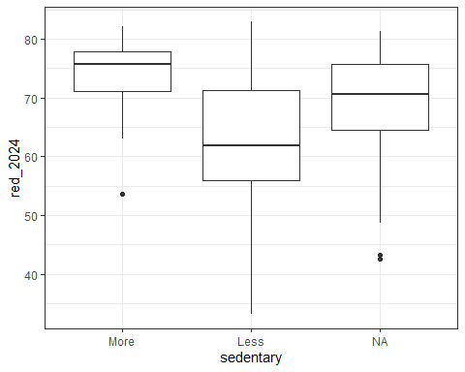

% Republican by Sedentary
ques1 <- ohio_7 |> filter(complete.cases(sedentary))
ggplot(ques1, aes(x = sedentary, y = red_2024)) +
geom_violin(aes(fill = sedentary)) +
geom_boxplot(width = 0.2, fill = "white", notch = TRUE) +
stat_summary(fun = mean, geom = "point",
size = 2, col = "red") +
scale_fill_viridis_d(option = "plasma", alpha = 0.4) +
guides(fill = "none") +
labs(x = "% of votes for Republicans in 2024",
title = "Two Sample Comparison") +
coord_flip()
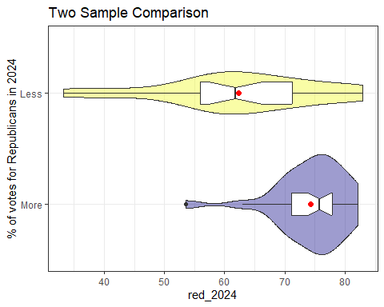

Summarizing the Sample
Numerical Summary with lovedist() from Love-431.R.
ques1 |> group_by(sedentary) |>
reframe(lovedist(red_2024))
# A tibble: 2 × 11
sedentary n miss mean sd med mad min q25 q75 max
<fct> <int> <int> <dbl> <dbl> <dbl> <dbl> <dbl> <dbl> <dbl> <dbl>
1 More 29 0 74.3 5.95 75.7 4.45 53.6 71.1 77.9 82.2
2 Less 29 0 62.3 13.0 61.8 11.7 33.2 56 71.3 83
- Which group has the larger sample mean red_2024?
- Can we reasonably pool standard deviations?
- What can we say about skew in each group?

Q1: Comparison with t-test/OLS
What conclusions can we draw from this pooled t approach?
m1a <- t.test(red_2024 ~ sedentary, conf.level = 0.95,
var.equal = TRUE, data = ques1)
model_parameters(m1a)
Two Sample t-test
Parameter | Group | sedentary = More | sedentary = Less | Difference
------------------------------------------------------------------------
red_2024 | sedentary | 74.30 | 62.31 | 11.99
Parameter | 95% CI | t(56) | p
------------------------------------------
red_2024 | [6.65, 17.32] | 4.50 | < .001
Alternative hypothesis: true difference in means between group More and group Less is not equal to 0

Q1: Comparison with t-test/OLS
Are these the same results?
m1b <- lm(red_2024 ~ sedentary, data = ques1)
model_parameters(m1b, conf.level = 0.95)
Parameter | Coefficient | SE | 95% CI | t(56) | p
------------------------------------------------------------------------
(Intercept) | 74.30 | 1.88 | [ 70.53, 78.07] | 39.48 | < .001
sedentary [Less] | -11.99 | 2.66 | [-17.32, -6.65] | -4.50 | < .001
Uncertainty intervals (equal-tailed) and p-values (two-tailed) computed
using a Wald t-distribution approximation.

Q1: Comparison with Welch’s t
m1c <- t.test(red_2024 ~ sedentary, conf.level = 0.95,
var.equal = FALSE, data = ques1)
model_parameters(m1c)
Welch Two Sample t-test
Parameter | Group | sedentary = More | sedentary = Less | Difference
------------------------------------------------------------------------
red_2024 | sedentary | 74.30 | 62.31 | 11.99
Parameter | 95% CI | t(39.17) | p
---------------------------------------------
red_2024 | [6.60, 17.37] | 4.50 | < .001
Alternative hypothesis: true difference in means between group More and group Less is not equal to 0

Q1: Comparison with bootstrap
set.seed(43107)
boot.t.test(red_2024 ~ sedentary, data = ques1, R = 2000,
var.equal = FALSE, conf.level = 0.95)
Bootstrap Welch Two Sample t-test
data: red_2024 by sedentary
number of bootstrap samples: 2000
bootstrap p-value < 5e-04
bootstrap difference of means (SE) = 12.04928 (2.606542)
95 percent bootstrap percentile confidence interval:
6.694914 17.120948
Results without bootstrap:
t = 4.5035, df = 39.173, p-value = 5.87e-05
alternative hypothesis: true difference in means is not equal to 0
95 percent confidence interval:
6.603544 17.368870
sample estimates:
mean in group More mean in group Less
74.29655 62.31034

Q1 estimates
Approach | Estimate | 95% confidence interval
Pooled t | 11.99 | (6.65, 17.32)
Welch t | 11.99 | (6.60, 17.37)
Bootstrap | 12.05 | (6.69, 17.12)
- Which of these should we choose?
  - Or does it not matter much?
- Once we’ve made a choice, how can we describe the result properly?

Selecting the OLS/pooled t (1/2)
- Point Estimate: 11.99
- 95% pooled t Confidence Interval: (6.65, 17.32)
Our best point estimate for the true difference (More Sedentary - Less Sedentary) is 11.99 percentage points in the % of Republican voters in 2024.
The confidence interval reflects imprecision in the population estimate, based only on assuming that the counties in our sample are selected at random from the population of interest.

Selecting the OLS/pooled t (2/2)
- Point Estimate: 11.99 (more - less sedentary)
- Are these counties in fact selected at random?
When we generalize beyond these counties to the population they were selected at random from, then our data are compatible (at the 95% confidence level) with differences in the population means (more sedentary - less sedentary) between 6.65 and 17.32 percentage points, depending on the assumptions of our pooled t procedure (or linear model) being correct.

Selecting the Bootstrap (1/2)
- Point Estimate: 12.05
- 95% bootstrap Confidence Interval: (6.69, 17.12)
The confidence interval reflects imprecision in the population estimate, based only on assuming that the counties are selected at random from the population of interest.
- So what population of counties were these “selected at random from”?

Selecting the Bootstrap (2/2)
- Point Estimate: 12.05 (more - less sedentary)
When we generalize beyond these counties to the population they were selected at random from, then our data are compatible (at the 95% confidence level) with differences in the population means (more sedentary - less sedentary) between 6.69 and 17.12 percentage points, depending on the assumptions of our bootstrap procedure being correct.

Research Question 2

Question 2
What can we say about the difference between the rank in Health Outcomes Z-score for CHR 2024, and the rank in Health Outcomes Z-score for CHR 2019, on average, across Ohio’s 88 counties?
Key variables:
- h_out24rk (numeric: 1 = best, 88 = worst)
- h_out19rk (numeric: 1 = best, 88 = worst)
Comparing Two Means: Paired or Independent Samples?

Calculating Paired Differences
- Let’s use rank in 2024 - rank in 2019, as above, which makes negative numbers improvements from 2019 to 2024.
ques2 <- ohio_7 |>
mutate(out_d = h_out24rk - h_out19rk)
ques2 |> select(county, h_out24rk, h_out19rk, out_d) |>
filter(county %in% c("Adams", "Cuyahoga"))
# A tibble: 2 × 4
county h_out24rk h_out19rk out_d
<chr> <dbl> <dbl> <dbl>
1 Adams 82 88 -6
2 Cuyahoga 70 62 8

DTDP for Paired Differences
bw <- 2 # specify width of bins in histogram
p1 <- ggplot(ques2, aes(out_d)) +
geom_histogram(binwidth = bw, fill = "black", col = "yellow" ) +
stat_function(fun = function(x) {
dnorm(x, mean = mean(ques2$out_d, na.rm = TRUE),
sd = sd(ques2$out_d, na.rm = TRUE) ) *
length(ques2$out_d) * bw},
geom = "area", alpha = 0.5, fill = "lightblue", col = "blue") +
labs(x = "2024 - 2019 Rank", y = "", title = "Histogram")
p2 <- ggplot(ques2, aes(sample = out_d)) +
geom_qq() +
geom_qq_line(col = "red") +
labs(y = "2024 - 2019 Rank", x = "Standard Normal Distribution",
title = "Normal Q-Q plot")
p3 <- ggplot(ques2, aes(x = out_d, y = "")) +
geom_violin(fill = "cornsilk") +
geom_boxplot(width = 0.2) +
stat_summary(fun = mean, geom = "point", shape = 16, col = "red") +
labs(y = "", x = "2024 - 2019 Rank", title = "Boxplot with Violin")
p1 + (p2 / p3 + plot_layout(heights = c(2, 1))) +
plot_annotation(title = "2024 - 2019 Difference in CHR Health Outcome Rank",
subtitle = "Negative Differences indicate improvements from 2019 to 2024")
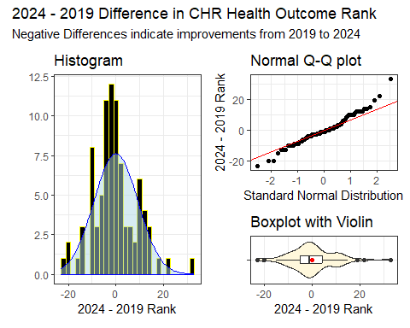

Numerical Summary of Data
ques2 |>
reframe(lovedist(out_d))
# A tibble: 1 × 10
n miss mean sd med mad min q25 q75 max
<int> <int> <dbl> <dbl> <dbl> <dbl> <dbl> <dbl> <dbl> <dbl>
1 88 0 0 9.21 -1 7.41 -23 -5 4.25 33
What can we say about the distribution of paired differences in our sample?
- Do we see meaningful skew?
- Do we see meaningfully heavy or light tails?
- Which comparison approach should we use?

OLS/t-based approach
m2a <- lm(out_d ~ 1, data = ques2)
model_parameters(m2a, conf.level = 0.95)
Parameter | Coefficient | SE | 95% CI | t(87) | p
---------------------------------------------------------------------
(Intercept) | -4.73e-16 | 0.98 | [-1.95, 1.95] | -4.82e-16 | > .999
Uncertainty intervals (equal-tailed) and p-values (two-tailed) computed
using a Wald t-distribution approximation.
m2b <- t.test(ques2$out_d, conf.level = 0.95)
model_parameters(m2b)
One Sample t-test
Parameter | Mean | mu | Difference | 95% CI | t(87) | p
-------------------------------------------------------------------
out_d | 0 | 0 | 0 | [-1.95, 1.95] | 0 | > .999
Alternative hypothesis: true mean is not equal to 0

Bootstrap approach
set.seed(432071)
boot.t.test(ques2$out_d, R = 2000, conf.level = 0.95)
Bootstrap One Sample t-test
data: ques2$out_d
number of bootstrap samples: 2000
bootstrap p-value = 0.951
bootstrap mean of x (SE) = -0.02305682 (0.9745855)
95 percent bootstrap percentile confidence interval:
-1.875284 1.898011
Results without bootstrap:
t = 0, df = 87, p-value = 1
alternative hypothesis: true mean is not equal to 0
95 percent confidence interval:
-1.952246 1.952246
sample estimates:
mean of x
0

Q2 estimates
Approach | Estimate | 95% confidence interval
OLS / t | 0 | (-1.95, 1.95)
Bootstrap | -0.02 | (-1.88, 1.90)
- Which of these should we choose?
  - Or does it not matter much?
- Once we’ve made a choice, how can we describe the result properly?

Choosing OLS for Paired t
- Point Estimate for mean difference = 0
- 95% confidence interval (-1.95, 1.95)
When we generalize beyond these counties to the population they were selected at random from, then our data are compatible (at the 95% confidence level) with population mean differences in rank between -1.95 and 1.95, depending on the assumptions of our linear model (paired t test) being correct.

Research Question 3

Question 3
How large is the mean difference in 2024 Health Outcomes scores across the four groups of Ohio counties defined by their 2019 Health Factors rankings?
Key variables:
- h_out24 (numeric)
- hfactor (factor with 4 levels)
Comparing Four Means with Independent Samples

DTDP for Question 3
What’s wrong here?
ggplot(ohio_7, aes(x = hfactor, y = h_out24)) +
geom_boxplot()
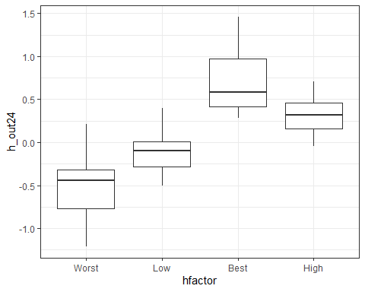

Re-order hfactor levels
ohio_7 |> tabyl(hfactor)
hfactor n percent
Worst 22 0.25
Low 22 0.25
Best 22 0.25
High 22 0.25
ohio_7 <- ohio_7 |>
mutate(hfactor = fct_relevel(hfactor,
"Worst", "Low", "High", "Best"))
ohio_7 |> tabyl(hfactor)
hfactor n percent
Worst 22 0.25
Low 22 0.25
High 22 0.25
Best 22 0.25

DTDP for Question 3
ggplot(ohio_7, aes(x = hfactor, y = h_out24)) +
geom_violin(aes(fill = hfactor)) +
geom_boxplot(width = 0.2, fill = "white") +
stat_summary(fun = mean, geom = "point",
size = 2, col = "red") +
scale_fill_viridis_d(option = "plasma", alpha = 0.4) +
guides(fill = "none") +
labs(x = "CHR 2019 Health Factors Group",
y = "CHR 2024 Health Outcomes Score",
title = "Four Sample Comparison")
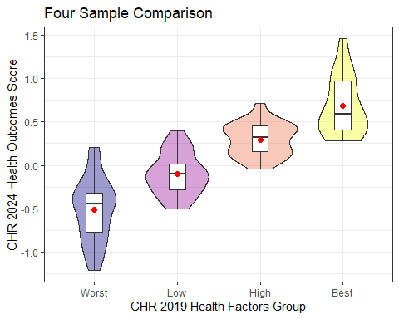

Numerical Summary: Four Samples
ohio_7 |> group_by(hfactor) |> reframe(lovedist(h_out24))
# A tibble: 4 × 11
hfactor n miss mean sd med mad min q25 q75 max
<fct> <int> <int> <dbl> <dbl> <dbl> <dbl> <dbl> <dbl> <dbl> <dbl>
1 Worst 22 0 -0.513 0.376 -0.445 0.393 -1.21 -0.768 -0.32 0.21
2 Low 22 0 -0.1 0.242 -0.095 0.259 -0.5 -0.28 0.0125 0.4
3 High 22 0 0.296 0.189 0.32 0.215 -0.04 0.16 0.458 0.71
4 Best 22 0 0.683 0.334 0.585 0.289 0.28 0.412 0.975 1.46
- How will we analyze these data?

ANOVA model (Comparing 4 samples)
- Our analysis will use a linear model, accompanied by an analysis of variance (ANOVA) table.
- We could also run an ANOVA table with or without pooling standard deviations.
- We’ll worry about this model only if the sample data are very severely non-Normal.

ANOVA for Question 3
m3 <- lm(h_out24 ~ hfactor, data = ohio_7)
anova(m3)
Analysis of Variance Table
Response: h_out24
Df Sum Sq Mean Sq F value Pr(>F)
hfactor 3 17.464 5.8214 67.115 < 2.2e-16 ***
Residuals 84 7.286 0.0867
---
Signif. codes: 0 '***' 0.001 '**' 0.01 '*' 0.05 '.' 0.1 ' ' 1
- What can we conclude here?

Model Parameters
model_parameters(m3)
Parameter | Coefficient | SE | 95% CI | t(84) | p
---------------------------------------------------------------------
(Intercept) | -0.51 | 0.06 | [-0.64, -0.39] | -8.17 | < .001
hfactor [Low] | 0.41 | 0.09 | [ 0.24, 0.59] | 4.65 | < .001
hfactor [High] | 0.81 | 0.09 | [ 0.63, 0.99] | 9.12 | < .001
hfactor [Best] | 1.20 | 0.09 | [ 1.02, 1.37] | 13.47 | < .001
Uncertainty intervals (equal-tailed) and p-values (two-tailed) computed
using a Wald t-distribution approximation.
- What does this suggest?

Meaning of indicator variables?
h_out24 = -0.51 + 0.41 hfactor(Low)
+ 0.81 hfactor(High) + 1.20 hfactor(Best)
group | hfactorLow | hfactorHigh | hfactorBest
Worst | 0 | 0 | 0
Low | 1 | 0 | 0
High | 0 | 1 | 0
Best | 0 | 0 | 1
- So what is the predicted h_out24 score for a county in each behavior group, according to this model?

Calculating Estimates
h_out24 = -0.51 + 0.41 hfactor(Low)
+ 0.81 hfactor(High) + 1.20 hfactor(Best)
Category | Predicted h_out24
Worst | -0.51
Low | -0.51 + 0.41 = -0.10
High | -0.51 + 0.81 = 0.30
Best | -0.51 + 1.20 = 0.69

Recall Observed Group Means
ohio_7 |> group_by(hfactor) |>
summarise(n = n(), mean = mean(h_out24))
# A tibble: 4 × 3
hfactor n mean
<fct> <int> <dbl>
1 Worst 22 -0.513
2 Low 22 -0.1
3 High 22 0.296
4 Best 22 0.683
Forgive the small rounding error. This matches the model, exactly.
Next time, we’ll do more.

Research Question 4

Question 4
How large is the mean difference in 2024 Health Outcomes scores across the three groups of Ohio counties defined by their 2019 social associations?
Key variables:
- h_out24 (numeric)
- soc_gp (factor with 3 levels)
Comparing Three Means with Independent Samples

DTDP for Question 4
ggplot(ohio_7, aes(x = soc_gp, y = h_out24)) +
geom_violin(aes(fill = soc_gp)) +
geom_boxplot(width = 0.2, fill = "white") +
stat_summary(fun = mean, geom = "point",
size = 2, col = "red") +
scale_fill_viridis_d(option = "plasma", alpha = 0.4) +
guides(fill = "none") +
labs(x = "CHR 2019 Social Associations Group",
y = "CHR 2024 Health Outcomes Score",
title = "Three Sample Comparison")
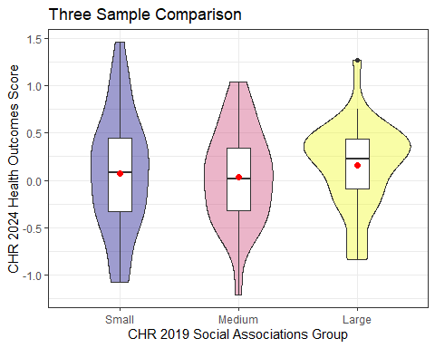

Numerical Summary: Three Samples
ohio_7 |> group_by(soc_gp) |> reframe(lovedist(h_out24))
# A tibble: 3 × 11
soc_gp n miss mean sd med mad min q25 q75 max
<fct> <int> <int> <dbl> <dbl> <dbl> <dbl> <dbl> <dbl> <dbl> <dbl>
1 Small 30 0 0.077 0.628 0.08 0.593 -1.08 -0.33 0.442 1.46
2 Medium 29 0 0.0390 0.509 0.02 0.504 -1.21 -0.32 0.34 1.04
3 Large 29 0 0.159 0.457 0.23 0.356 -0.84 -0.09 0.44 1.27

ANOVA for Question 4
m4 <- lm(h_out24 ~ soc_gp, data = ohio_7)
anova(m4)
Analysis of Variance Table
Response: h_out24
Df Sum Sq Mean Sq F value Pr(>F)
soc_gp 2 0.2183 0.10917 0.3783 0.6862
Residuals 85 24.5320 0.28861
- What can we conclude here?

Model Parameters
model_parameters(m4)
Parameter | Coefficient | SE | 95% CI | t(85) | p
--------------------------------------------------------------------
(Intercept) | 0.08 | 0.10 | [-0.12, 0.27] | 0.79 | 0.435
soc gp [Medium] | -0.04 | 0.14 | [-0.32, 0.24] | -0.27 | 0.786
soc gp [Large] | 0.08 | 0.14 | [-0.20, 0.36] | 0.59 | 0.560
Uncertainty intervals (equal-tailed) and p-values (two-tailed) computed
using a Wald t-distribution approximation.
More to come.

Session Information
xfun::session_info()
R version 4.5.1 (2025-06-13 ucrt)
Platform: x86_64-w64-mingw32/x64
Running under: Windows 11 x64 (build 26100)
Locale:
LC_COLLATE=English_United States.utf8
LC_CTYPE=English_United States.utf8
LC_MONETARY=English_United States.utf8
LC_NUMERIC=C
LC_TIME=English_United States.utf8
Package version:
abind_1.4-8 arrangements_1.1.9 askpass_1.2.1
backports_1.5.0 base64enc_0.1-3 bayesplot_1.14.0
bayestestR_0.17.0 BH_1.87.0.1 bit_4.6.0
bit64_4.6.0.1 blob_1.2.4 boot_1.3-32
broom_1.0.10 bslib_0.9.0 cachem_1.1.0
callr_3.7.6 car_3.1-3 carData_3.0-5
cellranger_1.1.0 checkmate_2.3.3 cli_3.6.5
clipr_0.8.0 coda_0.19-4.1 codetools_0.2-20
colourpicker_1.3.0 commonmark_2.0.0 compiler_4.5.1
conflicted_1.2.0 correlation_0.8.8 cowplot_1.2.0
cpp11_0.5.2 crayon_1.5.3 crosstalk_1.2.2
curl_7.0.0 data.table_1.17.8 datasets_4.5.1
datawizard_1.2.0 DBI_1.2.3 dbplyr_2.5.1
Deriv_4.2.0 desc_1.4.3 digest_0.6.37
distributional_0.5.0 doBy_4.7.0 dplyr_1.1.4
DT_0.34.0 dtplyr_1.3.2 dygraphs_1.1.1.6
easystats_0.7.5 effectsize_1.0.1 emmeans_1.11.2-8
estimability_1.5.1 evaluate_1.0.5 exactRankTests_0.8-35
farver_2.1.2 fastmap_1.2.0 fontawesome_0.5.3
forcats_1.0.0 foreach_1.5.2 Formula_1.2-5
fs_1.6.6 gargle_1.6.0 generics_0.1.4
ggdist_3.3.3 ggplot2_4.0.0 ggridges_0.5.7
glmnet_4.1-10 glue_1.8.0 gmp_0.7-5
googledrive_2.1.2 googlesheets4_1.1.2 graphics_4.5.1
grDevices_4.5.1 grid_4.5.1 gridExtra_2.3
gtable_0.3.6 gtools_3.9.5 haven_2.5.5
highr_0.11 hms_1.1.3 htmltools_0.5.8.1
htmlwidgets_1.6.4 httpuv_1.6.16 httr_1.4.7
ids_1.0.1 igraph_2.1.4 inline_0.3.21
insight_1.4.2 isoband_0.2.7 iterators_1.0.14
janitor_2.2.1 jomo_2.7-6 jquerylib_0.1.4
jsonlite_2.0.0 kableExtra_1.4.0 knitr_1.50
labeling_0.4.3 later_1.4.4 lattice_0.22-7
lazyeval_0.2.2 lifecycle_1.0.4 litedown_0.7
lme4_1.1-37 loo_2.8.0 lubridate_1.9.4
magrittr_2.0.3 markdown_2.0 MASS_7.3-65
Matrix_1.7-4 MatrixModels_0.5.4 matrixStats_1.5.0
memoise_2.0.1 methods_4.5.1 mgcv_1.9.3
mice_3.18.0 miceadds_3.17-44 microbenchmark_1.5.0
mime_0.13 miniUI_0.1.2 minqa_1.2.8
mitml_0.4-5 mitools_2.4 MKdescr_0.9
MKinfer_1.2 modelbased_0.13.0 modelr_0.1.11
multcomp_1.4-28 mvtnorm_1.3-3 nlme_3.1-168
nloptr_2.2.1 nnet_7.3-20 numDeriv_2016.8.1.1
openssl_2.3.3 ordinal_2023.12.4.1 pan_1.9
parallel_4.5.1 parameters_0.28.2 patchwork_1.3.2
pbkrtest_0.5.5 performance_0.15.1 pillar_1.11.1
pkgbuild_1.4.8 pkgconfig_2.0.3 plyr_1.8.9
posterior_1.6.1 prettyunits_1.2.0 processx_3.8.6
progress_1.2.3 promises_1.3.3 ps_1.9.1
purrr_1.1.0 quadprog_1.5.8 quantreg_6.1
QuickJSR_1.8.0 R6_2.6.1 ragg_1.5.0
rappdirs_0.3.3 rbibutils_2.3 RColorBrewer_1.1-3
Rcpp_1.1.0 RcppArmadillo_15.0.2.1 RcppEigen_0.3.4.0.2
RcppParallel_5.1.11-1 Rdpack_2.6.4 readr_2.1.5
readxl_1.4.5 reformulas_0.4.1 rematch_2.0.0
rematch2_2.1.2 report_0.6.1 reprex_2.1.1
reshape2_1.4.4 rlang_1.1.6 rmarkdown_2.29
rpart_4.1.24 rstan_2.32.7 rstanarm_2.32.1
rstantools_2.5.0 rstudioapi_0.17.1 rvest_1.0.5
S7_0.2.0 sandwich_3.1-1 sass_0.4.10
scales_1.4.0 see_0.12.0 selectr_0.4.2
shape_1.4.6.1 shiny_1.11.1 shinyjs_2.1.0
shinystan_2.6.0 shinythemes_1.2.0 snakecase_0.11.1
sourcetools_0.1.7.1 SparseM_1.84.2 splines_4.5.1
StanHeaders_2.32.10 stats_4.5.1 stats4_4.5.1
stringi_1.8.7 stringr_1.5.2 survival_3.8-3
svglite_2.2.1 sys_3.4.3 systemfonts_1.2.3
tensorA_0.36.2.1 textshaping_1.0.3 TH.data_1.1-4
threejs_0.3.4 tibble_3.3.0 tidyr_1.3.1
tidyselect_1.2.1 tidyverse_2.0.0 timechange_0.3.0
tinytex_0.57 tools_4.5.1 tzdb_0.5.0
ucminf_1.2.2 utf8_1.2.6 utils_4.5.1
uuid_1.2.1 V8_7.0.0 vctrs_0.6.5
viridisLite_0.4.2 vroom_1.6.5 withr_3.0.2
xfun_0.53 xml2_1.4.0 xtable_1.8-4
xts_0.14.1 yaml_2.3.10 zoo_1.8-14

