431 Class 03
Thomas E. Love, Ph.D.
2025-09-09

Today’s Agenda
- Work in R with a data set (15 question Class 02 survey)
- Open RStudio, load in data and a template to write code
  - We’ll type only a little into the template today.
    - We’ll then look at the completed Quarto document.
    - We’ll also inspect and knit the Quarto file after all of the code is included.
  - Then we’ll start over again with the slides.
These slides walk through everything in the Quarto document.

Today’s Files
From our 431-data page, or our Class 03 README (data folder), you should find:
- 431-first-r-template.qmd
- survey15_2014_to_2025.csv
and
- 431-class03-all-code.qmd
in addition to the usual slide materials.

Today’s Plan
We’re using Quarto to gather together into a single document:
- the R code we build,
- text commenting on and reacting to that R code, and
- the output of the analyses we build.
Everything in these slides is also going into our Quarto file.

Load packages and set theme
library(janitor)
library(patchwork)
library(easystats)
library(tidyverse)
theme_set(theme_bw())
knitr::opts_chunk$set(comment = NA)
Loading packages in R is like opening up apps on your phone. We need to tell R that, in addition to the base functions available in the software, we also have other functions we want to use.
- Why are we loading these packages, in particular?

On the tidyverse meta-package
- We will use the series of packages called the tidyverse in every Quarto file we create.
  - The tidyverse was developed (in part) by Hadley Wickham, Chief Scientist at Posit (makers of RStudio).
  - dplyr for data wrangling, cleaning and transformation
  - ggplot2 is our main visualization package
  - other tidyverse packages help import data, work with factors and other common activities.

More on today’s packages
- The janitor package has some tools for examining, cleaning and tabulating data (including tabyl() and clean_names()) that we’ll use regularly.
- The patchwork package will help us show multiple ggplots together.
- The easystats meta-package contains several other packages that will help us (especially) with building models and presenting our results.
- It’s helpful to load the tidyverse package last.

Today’s Data
Our data come from the Quick 15-item Survey we did in Class 02 (pdf in Class 02 README), which we’ve done (in various forms) since 2014.
- A copy of these data (in .csv format) is on our 431-data page, and also linked on our Class 03 README.
So first, let’s ingest the data into R.

Ingesting the data into R

Our 431-data page
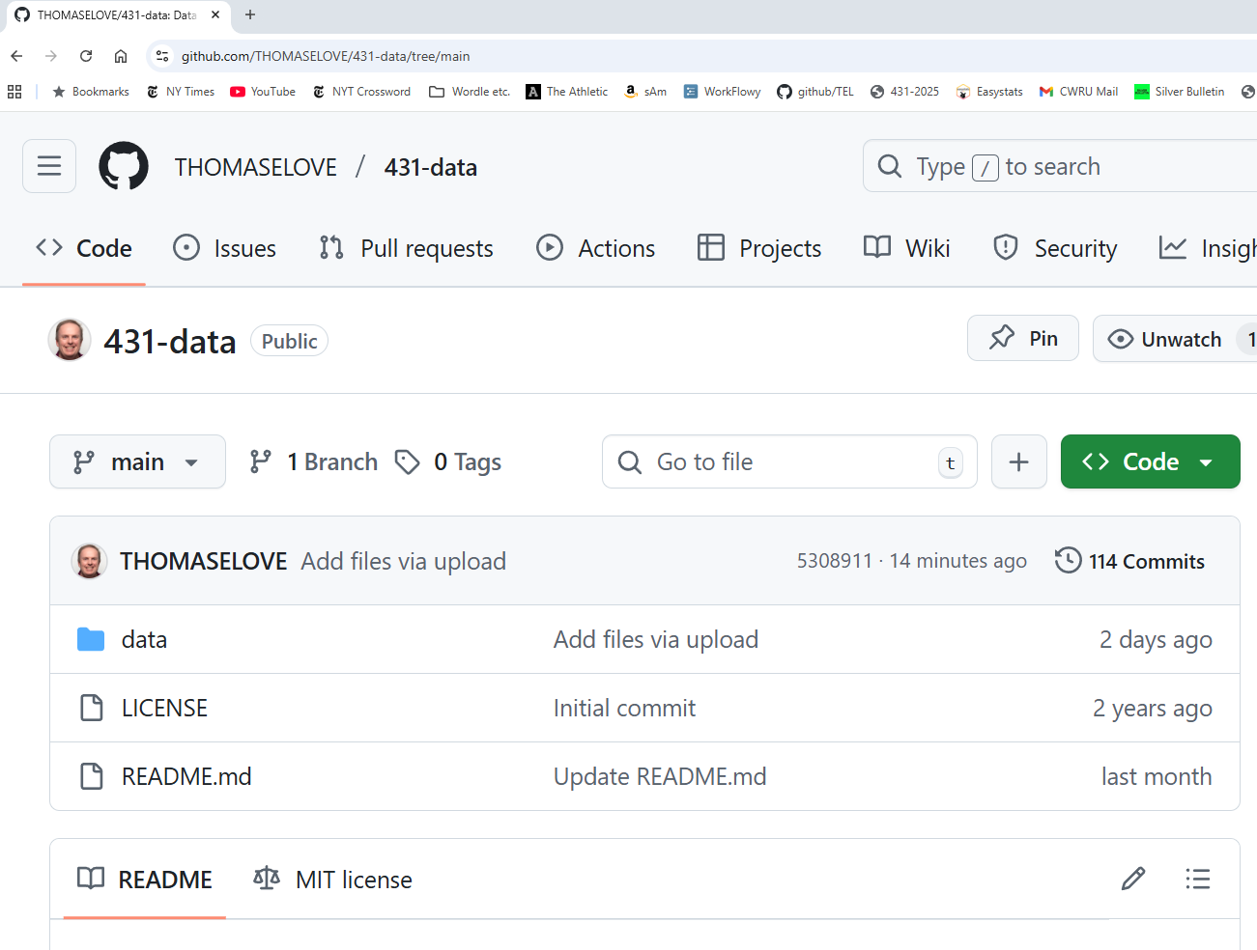

We want survey15_2014_to_2025.csv
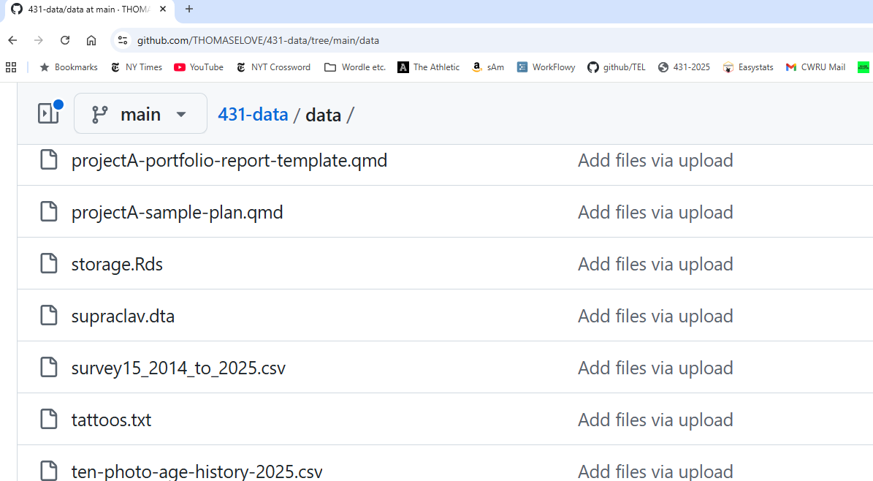

Get the Raw version
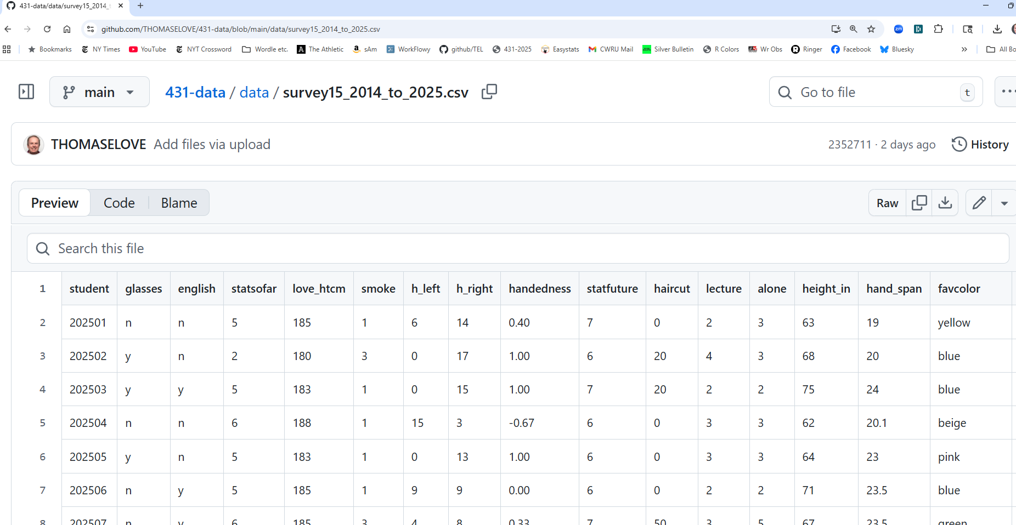

Raw .csv file suitable for saving
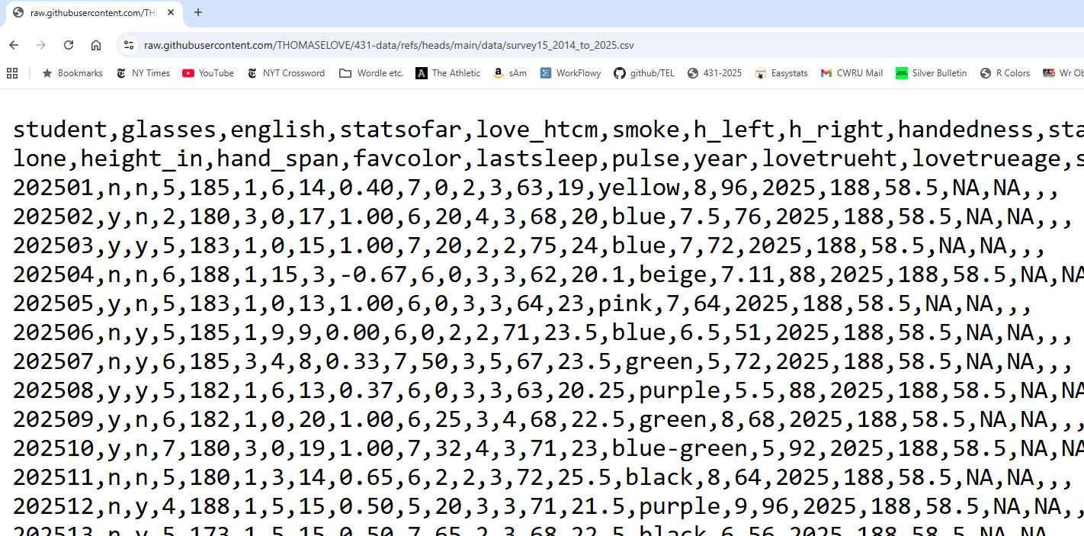
- So https://raw.githubusercontent.com/THOMASELOVE/431-data/refs/heads/main/data/survey15_2014_to_2025.csv is the URL we want.

Tell R what URL you want to use
url_raw <-
"https://raw.githubusercontent.com/THOMASELOVE/431-data/refs/heads/main/data/survey15_2014_to_2025.csv"
- We assign the URL to url_raw with <-.
- This way, we have a shorter name to type.
- We’re going to ingest these data into a file called surv15_raw.

Read in data from our .csv file
surv15_raw <-
read_csv(url_raw, show_col_types = FALSE) |>
janitor::clean_names()
- The <- assignment arrow creates surv15_raw
- We use read_csv to read in the survey15_2014_to_2025.csv file from our 431-data page.
- We use show_col_types = FALSE to suppress some unnecessary output describing the column types
- We use clean_names() from the janitor package
- We use the pipe |> to direct the information flow

What is the result?
surv15_raw
# A tibble: 656 × 23
student glasses english statsofar love_htcm smoke h_left h_right handedness
<dbl> <chr> <chr> <dbl> <dbl> <dbl> <dbl> <dbl> <dbl>
1 202501 n n 5 185 1 6 14 0.4
2 202502 y n 2 180 3 0 17 1
3 202503 y y 5 183 1 0 15 1
4 202504 n n 6 188 1 15 3 -0.67
5 202505 y n 5 183 1 0 13 1
6 202506 n y 5 185 1 9 9 0
7 202507 n y 6 185 3 4 8 0.33
8 202508 y y 5 182 1 6 13 0.37
9 202509 y n 6 182 1 0 20 1
10 202510 y n 7 180 3 0 19 1
# ℹ 646 more rows
# ℹ 14 more variables: statfuture <dbl>, haircut <dbl>, lecture <dbl>,
# alone <dbl>, height_in <dbl>, hand_span <dbl>, favcolor <chr>,
# lastsleep <dbl>, pulse <dbl>, year <dbl>, lovetrueht <dbl>,
# lovetrueage <dbl>, sex <chr>, ageguess <dbl>

A more detailed look?
glimpse(surv15_raw)
Rows: 656
Columns: 23
$ student <dbl> 202501, 202502, 202503, 202504, 202505, 202506, 202507, 20…
$ glasses <chr> "n", "y", "y", "n", "y", "n", "n", "y", "y", "y", "n", "n"…
$ english <chr> "n", "n", "y", "n", "n", "y", "y", "y", "n", "n", "n", "y"…
$ statsofar <dbl> 5, 2, 5, 6, 5, 5, 6, 5, 6, 7, 5, 4, 5, 3, 6, 5, 6, 4, 5, 5…
$ love_htcm <dbl> 185, 180, 183, 188, 183, 185, 185, 182, 182, 180, 180, 188…
$ smoke <dbl> 1, 3, 1, 1, 1, 1, 3, 1, 1, 3, 1, 1, 1, 1, 1, 1, 1, 1, 1, 1…
$ h_left <dbl> 6, 0, 0, 15, 0, 9, 4, 6, 0, 0, 3, 5, 5, 1, 0, 16, 7, 0, 0,…
$ h_right <dbl> 14, 17, 15, 3, 13, 9, 8, 13, 20, 19, 14, 15, 15, 9, 10, 2,…
$ handedness <dbl> 0.40, 1.00, 1.00, -0.67, 1.00, 0.00, 0.33, 0.37, 1.00, 1.0…
$ statfuture <dbl> 7, 6, 7, 6, 6, 6, 7, 6, 6, 7, 6, 5, 7, 5, 7, 6, 7, 7, 7, 6…
$ haircut <dbl> 0, 20, 20, 0, 0, 0, 50, 0, 25, 32, 2, 20, 65, 30, 10, 300,…
$ lecture <dbl> 2, 4, 2, 3, 3, 2, 3, 3, 3, 4, 2, 3, 2, 3, 3, 3, 3, 3, 5, 2…
$ alone <dbl> 3, 3, 2, 3, 3, 2, 5, 3, 4, 3, 3, 3, 3, 3, 1, 2, 3, 3, 4, 4…
$ height_in <dbl> 63.00, 68.00, 75.00, 62.00, 64.00, 71.00, 67.00, 63.00, 68…
$ hand_span <dbl> 19.00, 20.00, 24.00, 20.10, 23.00, 23.50, 23.50, 20.25, 22…
$ favcolor <chr> "yellow", "blue", "blue", "beige", "pink", "blue", "green"…
$ lastsleep <dbl> 8.00, 7.50, 7.00, 7.11, 7.00, 6.50, 5.00, 5.50, 8.00, 5.00…
$ pulse <dbl> 96, 76, 72, 88, 64, 51, 72, 88, 68, 92, 64, 96, 56, 20, 72…
$ year <dbl> 2025, 2025, 2025, 2025, 2025, 2025, 2025, 2025, 2025, 2025…
$ lovetrueht <dbl> 188, 188, 188, 188, 188, 188, 188, 188, 188, 188, 188, 188…
$ lovetrueage <dbl> 58.5, 58.5, 58.5, 58.5, 58.5, 58.5, 58.5, 58.5, 58.5, 58.5…
$ sex <chr> NA, NA, NA, NA, NA, NA, NA, NA, NA, NA, NA, NA, NA, NA, NA…
$ ageguess <dbl> NA, NA, NA, NA, NA, NA, NA, NA, NA, NA, NA, NA, NA, NA, NA…

Counting the glasses variable
surv15_raw |> count(glasses)
# A tibble: 3 × 2
glasses n
<chr> <int>
1 n 144
2 y 256
3 <NA> 256

Counting glasses and english
surv15_raw |> count(glasses, english)
# A tibble: 9 × 3
glasses english n
<chr> <chr> <int>
1 n n 34
2 n y 109
3 n <NA> 1
4 y n 57
5 y y 197
6 y <NA> 2
7 <NA> n 47
8 <NA> y 205
9 <NA> <NA> 4

Favorite Color in 2025?
surv15_raw |>
filter(year == "2025") |>
tabyl(favcolor) |>
adorn_pct_formatting()
favcolor n percent
beige 1 1.9%
black 4 7.5%
blue 13 24.5%
blue-green 1 1.9%
green 11 20.8%
light yellow 1 1.9%
orange 1 1.9%
pink 4 7.5%
purple 9 17.0%
red 3 5.7%
sage green 1 1.9%
sky blue 1 1.9%
white 1 1.9%
yellow 2 3.8%

Using summary() on Quantities
surv15_raw |>
select(love_htcm, haircut, height_in, lastsleep) |>
summary()
love_htcm haircut height_in lastsleep
Min. :152.0 Min. : 0.00 Min. :57.0 Min. : 2.000
1st Qu.:178.0 1st Qu.: 12.00 1st Qu.:64.0 1st Qu.: 6.000
Median :183.0 Median : 25.00 Median :67.0 Median : 7.000
Mean :182.3 Mean : 32.04 Mean :67.1 Mean : 6.911
3rd Qu.:187.5 3rd Qu.: 40.00 3rd Qu.:70.0 3rd Qu.: 8.000
Max. :196.0 Max. :300.00 Max. :77.5 Max. :12.000
NA's :385 NA's :12 NA's :9 NA's :8
- Numerical summaries (five quantiles, plus the mean) for:
  - your guess of my height (in cm), last haircut price ($), your height (in inches), and last night’s hours of sleep
- How many observations are available?

More Descriptive Summaries
surv15_raw |>
select(love_htcm, haircut, height_in, lastsleep) |>
describe_distribution()
Variable | Mean | SD | IQR | Range | Skewness | Kurtosis | n | n_Missing
-------------------------------------------------------------------------------------------
love_htcm | 182.26 | 6.39 | 10 | [152.00, 196.00] | -1.14 | 3.61 | 271 | 385
haircut | 32.04 | 35.23 | 28 | [0.00, 300.00] | 3.03 | 13.81 | 644 | 12
height_in | 67.10 | 3.82 | 6 | [57.00, 77.50] | 0.21 | -0.54 | 647 | 9
lastsleep | 6.91 | 1.36 | 2 | [2.00, 12.00] | -0.35 | 0.75 | 648 | 8

Even More Descriptive Summaries
surv15_raw |>
select(love_htcm, haircut, height_in, lastsleep) |>
describe_distribution(centrality = "median")
Variable | Median | MAD | IQR | Range | Skewness | Kurtosis | n | n_Missing
-------------------------------------------------------------------------------------------
love_htcm | 183 | 7.41 | 10 | [152.00, 196.00] | -1.14 | 3.61 | 271 | 385
haircut | 25 | 22.24 | 28 | [0.00, 300.00] | 3.03 | 13.81 | 644 | 12
height_in | 67 | 4.45 | 6 | [57.00, 77.50] | 0.21 | -0.54 | 647 | 9
lastsleep | 7 | 1.48 | 2 | [2.00, 12.00] | -0.35 | 0.75 | 648 | 8

Manage the data into an analytic tibble called surv15

Variables we’ll look at closely today
We’ll place these seven variables into our analytic data frame (tibble.)
- student: student identification (numerical code)
- year: indicates year when survey was taken (August)
- english: y = prefers to speak English, else n
- smoke: 1 = never smoker, 2 = quit, 3 = current
- pulse: pulse rate (beats per minute)
- height_in: student’s height (in inches)
- haircut: price of student’s last haircut (in $)

Select our variables
surv15 <- surv15_raw |>
select(student, year, english, smoke,
pulse, height_in, haircut)
- The select() function chooses the variables (columns) we want to keep in our new tibble called surv15.
- What should the result of this code look like?

What do we have now?
dim(surv15)
[1] 656 7
surv15
# A tibble: 656 × 7
student year english smoke pulse height_in haircut
<dbl> <dbl> <chr> <dbl> <dbl> <dbl> <dbl>
1 202501 2025 n 1 96 63 0
2 202502 2025 n 3 76 68 20
3 202503 2025 y 1 72 75 20
4 202504 2025 n 1 88 62 0
5 202505 2025 n 1 64 64 0
6 202506 2025 y 1 51 71 0
7 202507 2025 y 3 72 67 50
8 202508 2025 y 1 88 63 0
9 202509 2025 n 1 68 68 25
10 202510 2025 n 3 92 71 32
# ℹ 646 more rows

Initial Numeric Summaries
- Is everything the “type” of variable it should be?
- Are we getting the summaries we want?
summary(surv15)
student year english smoke
Min. :201401 Min. :2014 Length:656 Min. :1.000
1st Qu.:201710 1st Qu.:2017 Class :character 1st Qu.:1.000
Median :202014 Median :2020 Mode :character Median :1.000
Mean :201991 Mean :2020 Mean :1.095
3rd Qu.:202252 3rd Qu.:2022 3rd Qu.:1.000
Max. :202553 Max. :2025 Max. :3.000
NA's :2
pulse height_in haircut
Min. : 20.00 Min. :57.0 Min. : 0.00
1st Qu.: 65.00 1st Qu.:64.0 1st Qu.: 12.00
Median : 72.00 Median :67.0 Median : 25.00
Mean : 74.02 Mean :67.1 Mean : 32.04
3rd Qu.: 80.00 3rd Qu.:70.0 3rd Qu.: 40.00
Max. :124.00 Max. :77.5 Max. :300.00
NA's :79 NA's :9 NA's :12

What should we be seeing?
- Categorical variables should list the categories, with associated counts.
  - To accomplish this, the variable needs to be represented in R with a factor, rather than as a character or numeric variable.
- Quantitative variables should show the minimum, median, mean, maximum, etc.
names(surv15)
[1] "student" "year" "english" "smoke" "pulse" "height_in"
[7] "haircut"

Categorical variables as factors
We want the year and smoke information treated as categorical, rather than as quantitative, and the english information as a factor, too. Also, do we want to summarize the student ID codes?
- We use the mutate() function to help with this.
surv15 <- surv15 |>
mutate(year = as_factor(year),
smoke = as_factor(smoke),
english = as_factor(english),
student = as.character(student))
- Note that it’s as_factor() but as.character(). Sigh.

Next step: Recheck the summaries and do range checks
- Do these summaries make sense?
- Are the minimum and maximum values appropriate?
- How much missingness are we to deal with?

Now, how’s our summary?
summary(surv15)
student year english smoke pulse
Length:656 2020 : 67 n :138 1 :605 Min. : 20.00
Class :character 2016 : 64 y :511 2 : 36 1st Qu.: 65.00
Mode :character 2019 : 61 NA's: 7 3 : 13 Median : 72.00
2021 : 58 NA's: 2 Mean : 74.02
2024 : 56 3rd Qu.: 80.00
2022 : 54 Max. :124.00
(Other):296 NA's :79
height_in haircut
Min. :57.0 Min. : 0.00
1st Qu.:64.0 1st Qu.: 12.00
Median :67.0 Median : 25.00
Mean :67.1 Mean : 32.04
3rd Qu.:70.0 3rd Qu.: 40.00
Max. :77.5 Max. :300.00
NA's :9 NA's :12
- Some things to look for appear on the next slide.

What to look for…
- Are we getting counts for all variables that are categorical?
  - Do the category levels make sense?
- Are we getting means and medians for all variables that are quantities?
  - Do the minimum and maximum values make sense for each of these quantities?
- Which variables have missing data, as indicated by NA's?

The summary for year is an issue
- Just to fill in the gap left by the summary() result, how many students responded each year?
surv15 |> tabyl(year) |> adorn_totals() |> adorn_pct_formatting()
year n percent
2014 42 6.4%
2015 49 7.5%
2016 64 9.8%
2017 48 7.3%
2018 51 7.8%
2019 61 9.3%
2020 67 10.2%
2021 58 8.8%
2022 54 8.2%
2023 53 8.1%
2024 56 8.5%
2025 53 8.1%
Total 656 100.0%

Three Exploratory Questions

Three Exploratory Questions
- What is the distribution of pulse rates among students in 431 since 2014?
- Does the distribution of student heights change materially over time?
- Is the Normal distribution a good model for student heights? How about for student haircut prices?

Question 1

Question 1
What is the distribution of pulse rates among students in 431 since 2014?
surv15 |> tabyl(pulse) |> adorn_pct_formatting()
pulse n percent valid_percent
20 1 0.2% 0.2%
30 1 0.2% 0.2%
33 1 0.2% 0.2%
44 1 0.2% 0.2%
46 1 0.2% 0.2%
48 4 0.6% 0.7%
50 4 0.6% 0.7%
51 1 0.2% 0.2%
52 6 0.9% 1.0%
54 6 0.9% 1.0%
55 2 0.3% 0.3%
56 13 2.0% 2.3%
57 1 0.2% 0.2%
58 5 0.8% 0.9%
59 1 0.2% 0.2%
60 41 6.2% 7.1%
62 11 1.7% 1.9%
63 2 0.3% 0.3%
64 35 5.3% 6.1%
65 8 1.2% 1.4%
66 20 3.0% 3.5%
67 1 0.2% 0.2%
68 47 7.2% 8.1%
69 2 0.3% 0.3%
70 33 5.0% 5.7%
71 1 0.2% 0.2%
72 43 6.6% 7.5%
74 21 3.2% 3.6%
75 8 1.2% 1.4%
76 30 4.6% 5.2%
77 2 0.3% 0.3%
78 16 2.4% 2.8%
79 3 0.5% 0.5%
80 62 9.5% 10.7%
81 1 0.2% 0.2%
82 8 1.2% 1.4%
84 23 3.5% 4.0%
85 4 0.6% 0.7%
86 12 1.8% 2.1%
88 28 4.3% 4.9%
89 1 0.2% 0.2%
90 13 2.0% 2.3%
91 1 0.2% 0.2%
92 13 2.0% 2.3%
94 5 0.8% 0.9%
95 1 0.2% 0.2%
96 9 1.4% 1.6%
98 4 0.6% 0.7%
99 1 0.2% 0.2%
100 8 1.2% 1.4%
104 6 0.9% 1.0%
106 1 0.2% 0.2%
108 1 0.2% 0.2%
110 1 0.2% 0.2%
112 1 0.2% 0.2%
124 1 0.2% 0.2%
NA 79 12.0% -

Histogram, first try
- What is the distribution of student pulse rates?
ggplot(data = surv15, aes(x = pulse)) +
geom_histogram(bins = 15, fill = "royalblue", col = "seagreen1")
Warning: Removed 79 rows containing non-finite outside the scale range
(`stat_bin()`).
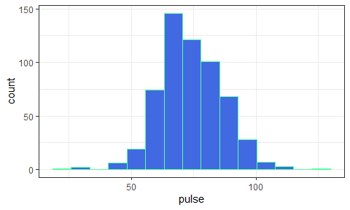

Describing the Pulse Rates
How might we describe this distribution?
- What is the center?
- How much of a range around that center do we see? How spread out are the data?
- What is the shape of this distribution?
  - Is it symmetric, or is it skewed to the left or to the right?
(Histogram is replotted on the next slide)

Histogram (with warning suppressed)
ggplot(data = surv15, aes(x = pulse)) +
geom_histogram(bins = 15, fill = "royalblue", col = "seagreen1")
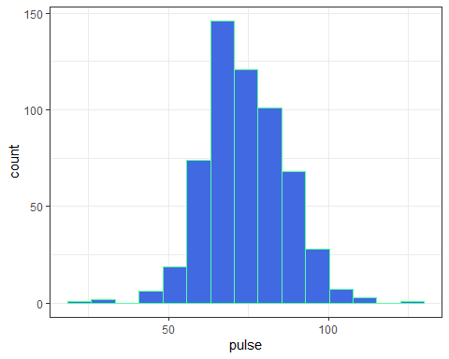

Some Key Numerical Summaries
surv15 |> select(pulse) |> summary()
pulse
Min. : 20.00
1st Qu.: 65.00
Median : 72.00
Mean : 74.02
3rd Qu.: 80.00
Max. :124.00
NA's :79
length(surv15$pulse)
[1] 656
sd(surv15$pulse, na.rm = TRUE)
[1] 12.69663
mad(surv15$pulse, na.rm = TRUE)
[1] 11.8608
- Do these summaries help us describe the data?

Histogram, version 2
dat1 <- surv15 |>
filter(complete.cases(pulse))
ggplot(data = dat1, aes(x = pulse)) +
geom_histogram(fill = "seagreen", col = "white", bins = 20) +
labs(title = "Pulse Rates of Dr. Love's students",
subtitle = "2014 - 2025",
y = "Number of Students",
x = "Pulse Rate (beats per minute)")
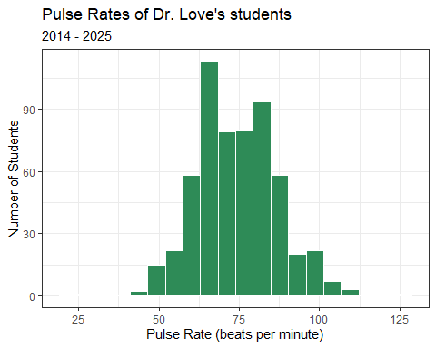
- How did we deal with missing data?
- How did we add axis labels and titles to the plot?
- What is the distinction between fill and col?
- How many bins should we use?

Question 2

Question 2
Does the distribution of student heights change over time?
(Plot shown on next slide)
ggplot(surv15, aes(x = year, y = height_in)) +
geom_point(alpha = 0.7, color = "forestgreen")
Warning: Removed 9 rows containing missing values or values outside the scale range
(`geom_point()`).
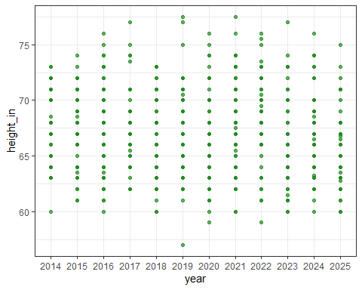

Yearly Five-Number Summaries
surv15 |>
filter(complete.cases(height_in)) |>
group_by(year) |>
summarize(n = n(), min = min(height_in), q25 = quantile(height_in, 0.25),
median = median(height_in), q75 = quantile(height_in, 0.75),
max = max(height_in))
- What should this produce? (Results on next slide)

Yearly Five-Number Summaries
surv15 |>
filter(complete.cases(height_in)) |>
group_by(year) |>
summarize(n = n(), min = min(height_in), q25 = quantile(height_in, 0.25),
median = median(height_in), q75 = quantile(height_in, 0.75),
max = max(height_in))
# A tibble: 12 × 7
year n min q25 median q75 max
<fct> <int> <dbl> <dbl> <dbl> <dbl> <dbl>
1 2014 40 60 64.8 68 71 73
2 2015 49 61 65 68 70 74
3 2016 64 60 64 67 70 76
4 2017 48 62 65 67 69 77
5 2018 51 60 63 66 70 73
6 2019 60 57 65 68 70 77.5
7 2020 66 59 63 66 69.8 76
8 2021 55 60 64.5 67.5 71 77.5
9 2022 54 59 66 68.5 70.4 76
10 2023 53 60 64 65 69 77
11 2024 54 60 64 67 69.8 76
12 2025 53 60 63 66 68 75
- Do these summaries change materially over time?
- What are these summaries, specifically?

Five-Number Summary
- Key summaries based on percentiles / quantiles
  - minimum = 0th, maximum = 100th, median = 50th
  - quartiles (25th, 50th and 75th percentiles)
  - Range is maximum - minimum
  - IQR (inter-quartile range) is 75th - 25th percentile
- These summaries are generally more resistant to outliers than mean, standard deviation
- Form the elements of a boxplot (box-and-whisker plot)

Boxplot of Heights by Year
dat1 <- surv15 |>
filter(complete.cases(height_in))
ggplot(data = dat1, aes(x = year, y = height_in)) +
geom_boxplot() +
labs(title = "Heights of Dr. Love's students, by year",
subtitle = "2014 - 2025", x = "Year", y = "Height (in inches)")
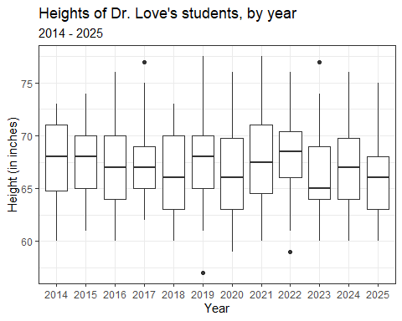
- How did we deal with missing data here?

Thinking about the Boxplot
- Box covers the middle half of the data (25th and 75th percentiles), and the solid line indicates the median
- Whiskers extend from the quartiles to the most extreme values that are not judged by Tukey’s “fences” method to be candidate outliers
  - Fences are drawn at 25th percentile - 1.5 IQR and 75th percentile + 1.5 IQR
- Are any values candidate outliers by this method?
- Was it important to change year to a factor earlier?

Adding a Violin to the Boxplot
- When we’d like to better understand the shape of a distribution, we can amplify the boxplot.
dat1 <- surv15 |>
filter(complete.cases(height_in))
ggplot(data = dat1, aes(x = year, y = height_in)) +
geom_violin() +
geom_boxplot(aes(fill = year), width = 0.3) +
guides(fill = "none") +
scale_fill_viridis_d(alpha = 0.3) +
labs(title = "Heights of Dr. Love's students, by year",
subtitle = "2014 - 2025", x = "Year", y = "Height (in inches)")
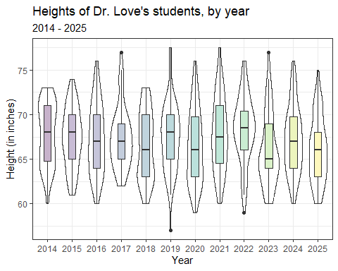

Boxplot with Violin
- How did we change the boxplot when we added the violin?
- What would happen if we added the boxplot first and the violin second?
- What does guides(fill = "none") do?
- What does scale_fill_viridis_d(alpha = 0.3) do?

Key Numerical Summaries
surv15 |>
filter(complete.cases(height_in)) |>
group_by(year) |>
summarize(n = n(), mean = mean(height_in), sd = sd(height_in),
median = median(height_in), mad = mad(height_in))
# A tibble: 12 × 6
year n mean sd median mad
<fct> <int> <dbl> <dbl> <dbl> <dbl>
1 2014 40 67.8 3.46 68 4.45
2 2015 49 67.3 3.32 68 2.97
3 2016 64 67.2 3.86 67 4.45
4 2017 48 67.4 3.46 67 2.97
5 2018 51 66.5 3.81 66 4.45
6 2019 60 67.4 3.83 68 4.45
7 2020 66 66.4 4.09 66 4.45
8 2021 55 67.8 4.13 67.5 5.19
9 2022 54 68.4 3.74 68.5 3.71
10 2023 53 66.0 4.00 65 2.97
11 2024 54 67.2 3.70 67 4.45
12 2025 53 66.0 3.65 66 3.71

Question 3

Question 3
Are the data on student heights in 2025 well described by a Normal distribution?
- Can we use a mean and standard deviation to describe the center and spread of the data effectively?

A Normal distribution
This is a Normal (or Gaussian) distribution with mean 150 and standard deviation 30.
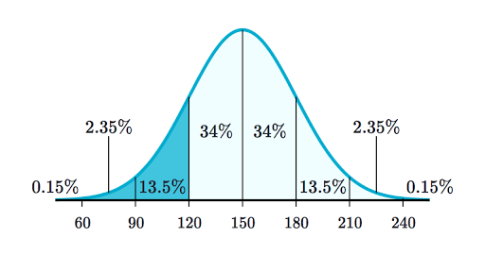
- A Normal distribution is completely specified by its mean and standard deviation. The “bell shape” doesn’t change.

Summarizing Quantitative Data
If the data followed a Normal model,
- we would be justified in using the sample mean to describe the center, and
- in using the sample standard deviation to describe the spread (variation.)
But it is often the case that these measures aren’t robust enough, because the data show meaningful skew (asymmetry), or the data have lighter or heavier tails than a Normal model would predict.

The Empirical Rule for Approximately Normal Distributions
If the data followed a Normal distribution,
- approximately 68% of the data would be within 1 SD of the mean,
- approximately 95% of the data would be within 2 SD of the mean, while
- essentially all (99.7%) of the data would be within 3 SD of the mean.

Empirical Rule & 2025 Student Heights
dat2 <- surv15 |>
filter(complete.cases(height_in),
year == "2025")
describe_distribution(dat2$height_in)
Mean | SD | IQR | Range | Skewness | Kurtosis | n | n_Missing
--------------------------------------------------------------------------
66.05 | 3.65 | 5 | [60.00, 75.00] | 0.34 | -0.55 | 53 | 0
In 2025, we had 53 students whose height_in was available, with mean 66.05 inches (167.8 cm) and standard deviation 3.65 inches (9.3 cm).
Consider a picture of the data…

Histogram of 2025 Student Heights
dat2 <- surv15 |>
filter(complete.cases(height_in)) |>
filter(year == "2025")
ggplot(data = dat2, aes(x = height_in)) +
geom_histogram(fill = "salmon", col = "white", binwidth = 1) +
labs(title = "Heights of Dr. Love's students",
subtitle = "2025 (n = 53 students with height data)",
y = "Number of Students", x = "Height (inches)")
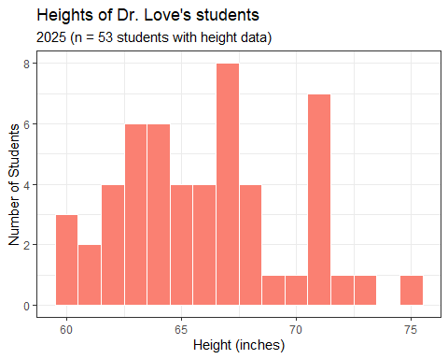
- How did we use the two filter() statements?
- Why might I have changed from specifying bins to binwidth here?

Checking the 1-SD Empirical Rule
- Of the 53 students in 2025 with heights, how many were within 1 SD of the mean?
  - Mean = 66.05, SD = 3.65.
  - 66.05 - 3.65 = 62.4; 66.05 + 3.65 = 69.7 inches
surv15 |> filter(complete.cases(height_in)) |>
filter(year == "2025") |>
count(height_in >= 62.4 & height_in <= 69.7)
# A tibble: 2 × 2
`height_in >= 62.4 & height_in <= 69.7` n
<lgl> <int>
1 FALSE 20
2 TRUE 33
33/(33+20)
[1] 0.6226415

2-SD Empirical Rule
- How many of the 53 height_in values gathered in 2025 were between 66.05 - 2(3.65) = 58.75 and 66.05 + 2(3.65) = 73.35 inches?
surv15 |> filter(complete.cases(height_in)) |>
filter(year == "2025") |>
count(height_in >= 58.75 & height_in <= 73.35)
# A tibble: 2 × 2
`height_in >= 58.75 & height_in <= 73.35` n
<lgl> <int>
1 FALSE 1
2 TRUE 52
52/(52+1)
[1] 0.9811321

3-SD Empirical Rule
- How many of the 53 height_in values gathered in 2025 were between 66.05 - 3(3.65) = 55.1 and 66.05 + 3(3.65) = 77.0 inches?
surv15 |> filter(complete.cases(height_in)) |>
filter(year == "2025") |>
count(height_in >= 55.1 & height_in <= 77.0)
# A tibble: 1 × 2
`height_in >= 55.1 & height_in <= 77` n
<lgl> <int>
1 TRUE 53
53/(53+0)
[1] 1

Empirical Rule Table for 2025 data
- $\overset{‾}{x}$ = sample mean, $s$ = sample SD
- For height_in: $n$ = 53 with data, $\overset{‾}{x}=66.05,s=3.45$
- For haircut: $n$ = 53 with data, $\overset{‾}{x}=38.4,s=52.6$
Range | “Normal” | height_in | haircut
$\overset{‾}{x}±s$ | ~68% | $\frac{33}{53}$ = 62.3% | $\frac{48}{53}$ = 90.6%
$\overset{‾}{x}±2×s$ | ~95% | $\frac{52}{53}$ = 98.1% | $\frac{51}{53}$ = 96.2%
$\overset{‾}{x}±3×s$ | ~99.7% | $\frac{53}{53}$ = 100% | $\frac{51}{53}$ = 96.2%

Boxplots: Height & Haircut Price
dat2 <- surv15 |> filter(complete.cases(height_in), year == "2025")
p2 <- ggplot(data = dat2, aes(x = "height (inches)", y = height_in)) +
geom_violin() + geom_boxplot(width = 0.3, fill = "tomato") +
labs(title = "Boxplot of 2025 Student Heights", x = "")
dat3 <- surv15 |> filter(complete.cases(haircut), year == "2025")
p3 <- ggplot(data = dat3, aes(x = "haircut ($)", y = haircut)) +
geom_violin() + geom_boxplot(width = 0.3, fill = "dodgerblue") +
labs(title = "Boxplot of 2025 Haircut Prices", x = "")
p2 + p3 +
plot_annotation(title = "2025 15-Question Survey Data")
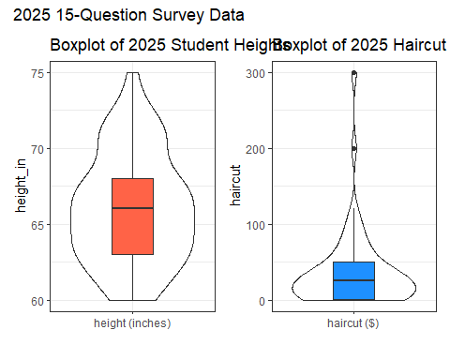
- What is width = 0.3 doing? How about the x options?
- What am I doing with p2 + p3 + plot_annotation?
- What should this look like?

Mean/SD vs. Median/MAD
If the data are approximately Normally distributed (like height_in and pulse) we can safely use the sample mean and standard deviation as summaries. If not, then …
- The median is a more robust summary of the center.
- For spread, try the median absolute deviation.
Measure | Median | Mean | MAD | Std. Dev.
height_in | 67 | 67.2 | 4.5 | 3.7
haircut | 30 | 37.9 | 22.2 | 38.2

Thoughts So Far

Question 1 Thoughts
- What is the distribution of pulse rates among students in 431 since 2014?
  - Fairly “normal” (bell-shaped) with mean 74 beats per minute and SD = 12.9 bpm.


Question 2 Thoughts
- Does the distribution of student heights change over time?
  - Somewhat. More recent classes display smaller median heights.


Question 3 Thoughts
- Are the data on student heights in 2025 well described by a Normal distribution?
  - To some extent, yes. Mean was 66.05 inches, SD = 3.65 inches, with median = 66 inches, MAD = 3.7 inches.
- What about haircut prices?
  - Not well described by a Normal distribution. Some very large outliers, and many results gathered close to 0, which describes right skew, where the mean (38.36 USD) substantially exceeds the median (25.00 USD.)

Next Time
- Two More Exploratory Questions

Session Information
xfun::session_info()
R version 4.5.1 (2025-06-13 ucrt)
Platform: x86_64-w64-mingw32/x64
Running under: Windows 11 x64 (build 26100)
Locale:
LC_COLLATE=English_United States.utf8
LC_CTYPE=English_United States.utf8
LC_MONETARY=English_United States.utf8
LC_NUMERIC=C
LC_TIME=English_United States.utf8
Package version:
askpass_1.2.1 backports_1.5.0 base64enc_0.1.3
bayestestR_0.17.0 bit_4.6.0 bit64_4.6.0-1
blob_1.2.4 broom_1.0.9 bslib_0.9.0
cachem_1.1.0 callr_3.7.6 cellranger_1.1.0
cli_3.6.5 clipr_0.8.0 coda_0.19-4.1
codetools_0.2-20 compiler_4.5.1 conflicted_1.2.0
correlation_0.8.8 cpp11_0.5.2 crayon_1.5.3
curl_7.0.0 data.table_1.17.8 datasets_4.5.1
datawizard_1.2.0 DBI_1.2.3 dbplyr_2.5.0
digest_0.6.37 dplyr_1.1.4 dtplyr_1.3.1
easystats_0.7.5 effectsize_1.0.1 emmeans_1.11.2-8
estimability_1.5.1 evaluate_1.0.5 farver_2.1.2
fastmap_1.2.0 fontawesome_0.5.3 forcats_1.0.0
fs_1.6.6 gargle_1.6.0 generics_0.1.4
ggplot2_3.5.2 glue_1.8.0 googledrive_2.1.1
googlesheets4_1.1.2 graphics_4.5.1 grDevices_4.5.1
grid_4.5.1 gtable_0.3.6 haven_2.5.5
highr_0.11 hms_1.1.3 htmltools_0.5.8.1
httr_1.4.7 ids_1.0.1 insight_1.4.2
isoband_0.2.7 janitor_2.2.1 jquerylib_0.1.4
jsonlite_2.0.0 knitr_1.50 labeling_0.4.3
lattice_0.22-7 lifecycle_1.0.4 lubridate_1.9.4
magrittr_2.0.3 MASS_7.3-65 Matrix_1.7-3
memoise_2.0.1 methods_4.5.1 mgcv_1.9.3
mime_0.13 modelbased_0.13.0 modelr_0.1.11
multcomp_1.4-28 mvtnorm_1.3-3 nlme_3.1.168
numDeriv_2016.8.1.1 openssl_2.3.3 parallel_4.5.1
parameters_0.28.1 patchwork_1.3.2 performance_0.15.1
pillar_1.11.0 pkgconfig_2.0.3 prettyunits_1.2.0
processx_3.8.6 progress_1.2.3 ps_1.9.1
purrr_1.1.0 R6_2.6.1 ragg_1.5.0
rappdirs_0.3.3 RColorBrewer_1.1-3 readr_2.1.5
readxl_1.4.5 rematch_2.0.0 rematch2_2.1.2
report_0.6.1 reprex_2.1.1 rlang_1.1.6
rmarkdown_2.29 rstudioapi_0.17.1 rvest_1.0.5
sandwich_3.1-1 sass_0.4.10 scales_1.4.0
see_0.11.0 selectr_0.4.2 snakecase_0.11.1
splines_4.5.1 stats_4.5.1 stringi_1.8.7
stringr_1.5.1 survival_3.8-3 sys_3.4.3
systemfonts_1.2.3 textshaping_1.0.3 TH.data_1.1-4
tibble_3.3.0 tidyr_1.3.1 tidyselect_1.2.1
tidyverse_2.0.0 timechange_0.3.0 tinytex_0.57
tools_4.5.1 tzdb_0.5.0 utf8_1.2.6
utils_4.5.1 uuid_1.2.1 vctrs_0.6.5
viridisLite_0.4.2 vroom_1.6.5 withr_3.0.2
xfun_0.52 xml2_1.4.0 xtable_1.8-4
yaml_2.3.10 zoo_1.8-14

MAD scaled here to equal the standard deviation when data follow the Normal.

