431 Class 04
Thomas E. Love, Ph.D.
2025-09-11

Today’s Agenda
- Analyzing some data from the 15-item Quick Survey.
- Addressing five exploratory questions.
- Demonstrate techniques and code that might be helpful for Lab 1, due next Wednesday 2025-09-16 at noon.

Load packages and set theme
library(janitor)
library(patchwork)
library(rstanarm) ## new today
library(easystats)
library(tidyverse)
theme_set(theme_bw())
knitr::opts_chunk$set(comment = NA)
source("c04/data/Love-431.R") ## new today
We’re sourcing in the Love-431.R R script, which contains a function we’ll use.

Ingest, manage data
Read in data from .csv (comma-separated version) file.
surv15_raw <-
read_csv("c04/data/survey15_2014_to_2025.csv",
show_col_types = FALSE) |>
janitor::clean_names()
Select variables, make categories into factors
surv15 <- surv15_raw |>
select(student, year, english, smoke, pulse, height_in, haircut) |>
mutate(year = as_factor(year),
smoke = as_factor(smoke),
english = as_factor(english),
student = as.character(student))

Resulting tibble
surv15
# A tibble: 656 × 7
student year english smoke pulse height_in haircut
<chr> <fct> <fct> <fct> <dbl> <dbl> <dbl>
1 202501 2025 n 1 96 63 0
2 202502 2025 n 3 76 68 20
3 202503 2025 y 1 72 75 20
4 202504 2025 n 1 88 62 0
5 202505 2025 n 1 64 64 0
6 202506 2025 y 1 51 71 0
7 202507 2025 y 3 72 67 50
8 202508 2025 y 1 88 63 0
9 202509 2025 n 1 68 68 25
10 202510 2025 n 3 92 71 32
# ℹ 646 more rows

Five Exploratory Questions
- What is the distribution of pulse rates among students in 431 since 2014?
- Does the distribution of student heights change materially over time?
- Is the Normal distribution a good model for student pulse rates from 2014-2025? How about haircut prices?
- Do taller people appear to have paid less for their most recent haircut?
- Do students have a more substantial tobacco history if their best language is English or something else?

Question 1

Question 1
What is the distribution of pulse rates among students in 431 since 2014?
surv15 |> tabyl(pulse) |> adorn_pct_formatting()
pulse n percent valid_percent
20 1 0.2% 0.2%
30 1 0.2% 0.2%
33 1 0.2% 0.2%
44 1 0.2% 0.2%
46 1 0.2% 0.2%
48 4 0.6% 0.7%
50 4 0.6% 0.7%
51 1 0.2% 0.2%
52 6 0.9% 1.0%
54 6 0.9% 1.0%
55 2 0.3% 0.3%
56 13 2.0% 2.3%
57 1 0.2% 0.2%
58 5 0.8% 0.9%
59 1 0.2% 0.2%
60 41 6.2% 7.1%
62 11 1.7% 1.9%
63 2 0.3% 0.3%
64 35 5.3% 6.1%
65 8 1.2% 1.4%
66 20 3.0% 3.5%
67 1 0.2% 0.2%
68 47 7.2% 8.1%
69 2 0.3% 0.3%
70 33 5.0% 5.7%
71 1 0.2% 0.2%
72 43 6.6% 7.5%
74 21 3.2% 3.6%
75 8 1.2% 1.4%
76 30 4.6% 5.2%
77 2 0.3% 0.3%
78 16 2.4% 2.8%
79 3 0.5% 0.5%
80 62 9.5% 10.7%
81 1 0.2% 0.2%
82 8 1.2% 1.4%
84 23 3.5% 4.0%
85 4 0.6% 0.7%
86 12 1.8% 2.1%
88 28 4.3% 4.9%
89 1 0.2% 0.2%
90 13 2.0% 2.3%
91 1 0.2% 0.2%
92 13 2.0% 2.3%
94 5 0.8% 0.9%
95 1 0.2% 0.2%
96 9 1.4% 1.6%
98 4 0.6% 0.7%
99 1 0.2% 0.2%
100 8 1.2% 1.4%
104 6 0.9% 1.0%
106 1 0.2% 0.2%
108 1 0.2% 0.2%
110 1 0.2% 0.2%
112 1 0.2% 0.2%
124 1 0.2% 0.2%
NA 79 12.0% -

Histogram, first try
- What is the distribution of student pulse rates?
ggplot(data = surv15, aes(x = pulse)) +
geom_histogram()
`stat_bin()` using `bins = 30`. Pick better value with `binwidth`.
Warning: Removed 79 rows containing non-finite outside the scale range
(`stat_bin()`).
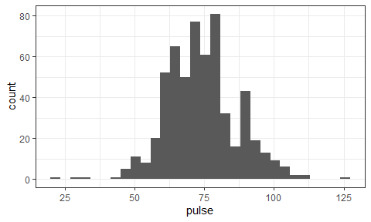

Describing the Pulse Rates
How might we describe this distribution?
- What is the center?
- How much of a range around that center do we see? How spread out are the data?
- What is the shape of this distribution?
  - Is it symmetric, or is it skewed to the left or to the right?
(Histogram is re plotted on the next slide)

Histogram (with warning suppressed)
ggplot(data = surv15, aes(x = pulse)) +
geom_histogram()
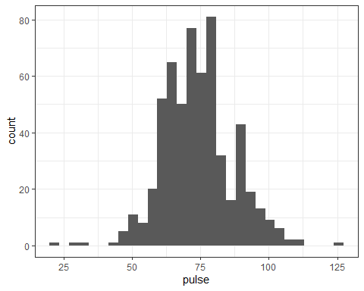

Some Key Numerical Summaries
surv15 |> select(pulse) |> summary()
pulse
Min. : 20.00
1st Qu.: 65.00
Median : 72.00
Mean : 74.02
3rd Qu.: 80.00
Max. :124.00
NA's :79
length(surv15$pulse)
[1] 656
sd(surv15$pulse, na.rm = TRUE)
[1] 12.69663
mad(surv15$pulse, na.rm = TRUE)
[1] 11.8608
- Do these summaries help us describe the data?

Histogram, version 2
dat1 <- surv15 |>
filter(complete.cases(pulse))
ggplot(data = dat1, aes(x = pulse)) +
geom_histogram(fill = "seagreen", col = "white", bins = 20) +
labs(title = "Pulse Rates of Dr. Love's students",
subtitle = "2014 - 2025",
y = "Number of Students",
x = "Pulse Rate (beats per minute)")
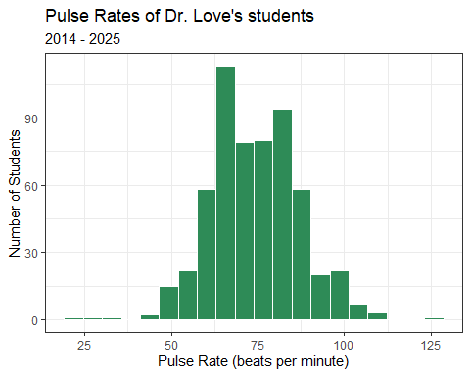
- How did we deal with missing data?
- How did we add axis labels and titles to the plot?
- What is the distinction between fill and col?
- How many bins should we use?

Question 2

Question 2
Does the distribution of student heights change over time?
ggplot(surv15, aes(x = year, y = height_in)) +
geom_point()
Warning: Removed 9 rows containing missing values or values outside the scale range
(`geom_point()`).
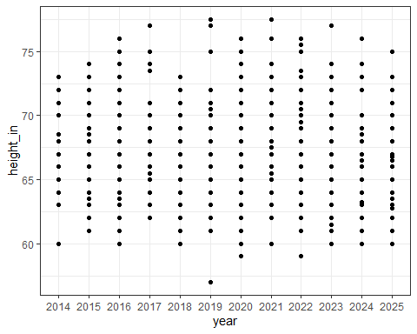

Yearly Five-Number Summaries
surv15 |>
filter(complete.cases(height_in)) |>
group_by(year) |>
summarize(n = n(), min = min(height_in), q25 = quantile(height_in, 0.25),
median = median(height_in), q75 = quantile(height_in, 0.75),
max = max(height_in))
- What should this produce? (Results on next slide)

Yearly Five-Number Summaries
surv15 |>
filter(complete.cases(height_in)) |>
group_by(year) |>
summarize(n = n(), min = min(height_in), q25 = quantile(height_in, 0.25),
median = median(height_in), q75 = quantile(height_in, 0.75),
max = max(height_in))
# A tibble: 12 × 7
year n min q25 median q75 max
<fct> <int> <dbl> <dbl> <dbl> <dbl> <dbl>
1 2014 40 60 64.8 68 71 73
2 2015 49 61 65 68 70 74
3 2016 64 60 64 67 70 76
4 2017 48 62 65 67 69 77
5 2018 51 60 63 66 70 73
6 2019 60 57 65 68 70 77.5
7 2020 66 59 63 66 69.8 76
8 2021 55 60 64.5 67.5 71 77.5
9 2022 54 59 66 68.5 70.4 76
10 2023 53 60 64 65 69 77
11 2024 54 60 64 67 69.8 76
12 2025 53 60 63 66 68 75
- Do these summaries change materially over time?
- What are these summaries, specifically?

Five-Number Summary
- Key summaries based on percentiles / quantiles
  - minimum = 0th, maximum = 100th, median = 50th
  - quartiles (25th, 50th and 75th percentiles)
  - Range is maximum - minimum
  - IQR (inter-quartile range) is 75th - 25th percentile
- These summaries are generally more resistant to outliers than mean, standard deviation
- Form the elements of a boxplot (box-and-whisker plot)

Boxplot of Heights by Year
dat1 <- surv15 |>
filter(complete.cases(height_in))
ggplot(data = dat1, aes(x = year, y = height_in)) +
geom_boxplot() +
labs(title = "Heights of Dr. Love's students, by year",
subtitle = "2014 - 2025", x = "Year", y = "Height (in inches)")
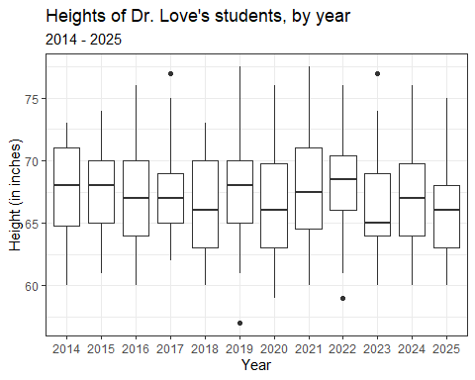
- How did we deal with missing data here?

Thinking about the Boxplot
- Box covers the middle half of the data (25th and 75th percentiles), and the solid line indicates the median
- Whiskers extend from the quartiles to the most extreme values that are not judged by Tukey’s “fences” method to be candidate outliers
  - Fences are drawn at 25th percentile - 1.5 IQR and 75th percentile + 1.5 IQR
- Are any values candidate outliers by this method?
- Was it important to change year to a factor earlier?

Adding a Violin to the Boxplot
- When we’d like to better understand the shape of a distribution, we can amplify the boxplot.
dat1 <- surv15 |>
filter(complete.cases(height_in))
ggplot(data = dat1, aes(x = year, y = height_in)) +
geom_violin() +
geom_boxplot(aes(fill = year), width = 0.3) +
guides(fill = "none") +
scale_fill_viridis_d(alpha = 0.3) +
labs(title = "Heights of Dr. Love's students, by year",
subtitle = "2014 - 2025", x = "Year", y = "Height (in inches)")
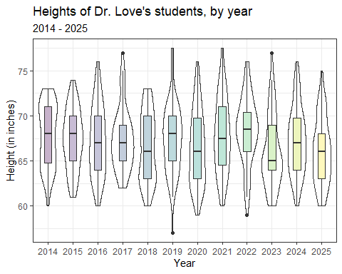

Boxplot with Violin
- How did we change the boxplot when we added the violin?
- What would happen if we added the boxplot first and the violin second?
- What does guides(fill = "none") do?
- What does scale_fill_viridis_d(alpha = 0.3) do?

Key Numerical Summaries
surv15 |>
filter(complete.cases(height_in)) |>
group_by(year) |>
summarize(n = n(), mean = mean(height_in), sd = sd(height_in),
median = median(height_in), mad = mad(height_in))
# A tibble: 12 × 6
year n mean sd median mad
<fct> <int> <dbl> <dbl> <dbl> <dbl>
1 2014 40 67.8 3.46 68 4.45
2 2015 49 67.3 3.32 68 2.97
3 2016 64 67.2 3.86 67 4.45
4 2017 48 67.4 3.46 67 2.97
5 2018 51 66.5 3.81 66 4.45
6 2019 60 67.4 3.83 68 4.45
7 2020 66 66.4 4.09 66 4.45
8 2021 55 67.8 4.13 67.5 5.19
9 2022 54 68.4 3.74 68.5 3.71
10 2023 53 66.0 4.00 65 2.97
11 2024 54 67.2 3.70 67 4.45
12 2025 53 66.0 3.65 66 3.71

Summary Statistics for Student Height, 2014-2025
surv15 |> describe_distribution(height_in)
Variable | Mean | SD | IQR | Range | Skewness | Kurtosis | n | n_Missing
---------------------------------------------------------------------------------------
height_in | 67.10 | 3.82 | 6 | [57.00, 77.50] | 0.21 | -0.54 | 647 | 9
surv15 |> describe_distribution(height_in, centrality = "median")
Variable | Median | MAD | IQR | Range | Skewness | Kurtosis | n | n_Missing
----------------------------------------------------------------------------------------
height_in | 67 | 4.45 | 6 | [57.00, 77.50] | 0.21 | -0.54 | 647 | 9

Use my lovedist() function from the Love-431.R script…
surv15 |> reframe(lovedist(height_in)) |> print_md(digits = 2)
n | miss | mean | sd | med | mad | min | q25 | q75 | max
656 | 9 | 67.10 | 3.82 | 67 | 4.45 | 57 | 64 | 70 | 77.50
- n = sample size, miss = missing values
- mean = arithmetic average (sum of values / number of values)
- sd = standard deviation (measures dispersion)
- med = median (50th percentile)
- mad = median absolute deviation (scaled measure of dispersion)
- min, q25, q75, max = 0th, 25th, 75th and 100th percentile

lovedist() results by year
surv15 |> group_by(year) |> reframe(lovedist(height_in))
# A tibble: 12 × 11
year n miss mean sd med mad min q25 q75 max
<fct> <int> <int> <dbl> <dbl> <dbl> <dbl> <dbl> <dbl> <dbl> <dbl>
1 2014 42 2 67.8 3.46 68 4.45 60 64.8 71 73
2 2015 49 0 67.3 3.32 68 2.97 61 65 70 74
3 2016 64 0 67.2 3.86 67 4.45 60 64 70 76
4 2017 48 0 67.4 3.46 67 2.97 62 65 69 77
5 2018 51 0 66.5 3.81 66 4.45 60 63 70 73
6 2019 61 1 67.4 3.83 68 4.45 57 65 70 77.5
7 2020 67 1 66.4 4.09 66 4.45 59 63 69.8 76
8 2021 58 3 67.8 4.13 67.5 5.19 60 64.5 71 77.5
9 2022 54 0 68.4 3.74 68.5 3.71 59 66 70.4 76
10 2023 53 0 66.0 4.00 65 2.97 60 64 69 77
11 2024 56 2 67.2 3.70 67 4.45 60 64 69.8 76
12 2025 53 0 66.0 3.65 66 3.71 60 63 68 75

Question 3

Question 3
Are the data on student pulse rates from 2014-2025 well described by a Normal distribution? How about haircut prices?
- Can we use a mean and standard deviation to describe the center and spread of the data effectively?
- Can we estimate a population mean accurately using our sample of data?

A Normal distribution
This is a Normal (or Gaussian) distribution with mean 150 and standard deviation 30.
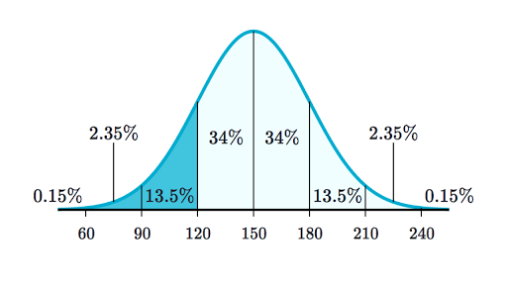
- A Normal distribution is completely specified by its mean and standard deviation. The “bell shape” doesn’t change.

Summarizing Quantitative Data
If the data followed a Normal model,
- we would be justified in using the sample mean to describe the center, and
- in using the sample standard deviation to describe the spread (variation.)
But it is often the case that these measures aren’t robust enough, because the data show meaningful skew (asymmetry), or the data have lighter or heavier tails than a Normal model would predict.

The Empirical Rule for Approximately Normal Distributions
If the data followed a Normal distribution,
- approximately 68% of the data would be within 1 SD of the mean,
- approximately 95% of the data would be within 2 SD of the mean, while
- essentially all (99.7%) of the data would be within 3 SD of the mean.

Empirical Rule & Pulse Rates
dat2 <- surv15 |> filter(complete.cases(pulse))
dat2 |> select(pulse) |> describe_distribution()
Variable | Mean | SD | IQR | Range | Skewness | Kurtosis | n | n_Missing
----------------------------------------------------------------------------------------
pulse | 74.02 | 12.70 | 15 | [20.00, 124.00] | 0.14 | 0.80 | 577 | 0
Since 2014, we’ve had pulse rates on 577 students, with mean 74 beats per minute and standard deviation 12.7 bpm.
Consider a picture of the data…

Histogram of 2014-2025 Pulse Rates
dat2 <- surv15 |> filter(complete.cases(pulse))
ggplot(data = dat2, aes(x = pulse)) +
geom_histogram(fill = "tomato", col = "white", binwidth = 5) +
labs(title = "Pulse Rates of Dr. Love's students",
subtitle = "2014-2025 (n = 577 students)",
y = "Number of Students", x = "Pulse Rate (bpm)")
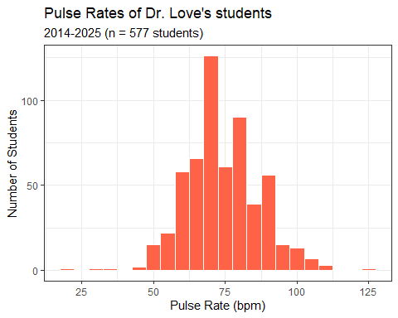
- Why might I have changed from specifying bins to binwidth here?
- Does the resulting plot look like a (bell-shaped) Normal distribution?

Checking the 1-SD Empirical Rule
- Of the 577 pulse rates, how many were within 1 SD of the mean?
  - Mean = 74, SD = 12.7.
  - 74 - 12.7 = 61.3 bpm; 74 + 12.7 = 86.7 bpm
surv15 |>
filter(complete.cases(pulse)) |>
count(pulse >= 61.3 & pulse <= 86.7)
# A tibble: 2 × 2
`pulse >= 61.3 & pulse <= 86.7` n
<lgl> <int>
1 FALSE 184
2 TRUE 393
393/(393+184)
[1] 0.6811092

2-SD Empirical Rule
- How many of the 577 pulse values were between 74 - 2(12.7) = 48.6 and 74 + 2(12.7) = 99.4 bpm?
surv15 |> filter(complete.cases(pulse)) |>
count(pulse >= 48.6 & pulse <= 99.4)
# A tibble: 2 × 2
`pulse >= 48.6 & pulse <= 99.4` n
<lgl> <int>
1 FALSE 28
2 TRUE 549
549/(549+28)
[1] 0.9514731

3-SD Empirical Rule
- How many of the 577 pulse values were between 74 - 3(12.7) = 35.9 and 74 + 3(12.7) = 112.1 bpm?
surv15 |> filter(complete.cases(pulse)) |>
count(pulse >= 35.9 & pulse <= 112.1)
# A tibble: 2 × 2
`pulse >= 35.9 & pulse <= 112.1` n
<lgl> <int>
1 FALSE 4
2 TRUE 573
573/(573+4)
[1] 0.9930676

Histogram of 2014-2025 Haircut Prices
dat3 <- surv15 |> filter(complete.cases(haircut))
ggplot(data = dat3, aes(x = haircut)) +
geom_histogram(fill = "forestgreen", col = "white", bins = 20) +
labs(title = "Haircut Prices of Dr. Love's students",
subtitle = "2014-2025 (n = 644 students)",
y = "Number of Students", x = "Haircut Price (USD)")
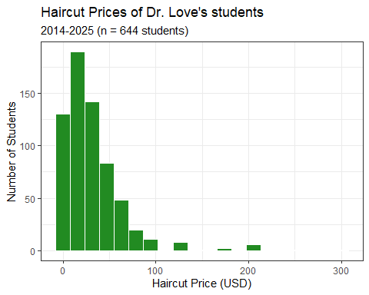

Empirical Rule Table for 2014-2025 data
- $\overset{‾}{x}$ = sample mean, $s$ = sample SD
- For pulse: $n$ = 577 with data, $\overset{‾}{x}=74,s=12.7$
- For haircut: $n$ = 644 with data, $\overset{‾}{x}=32.0,s=35.2$
Range | “Normal” | pulse | haircut
$\overset{‾}{x}±s$ | ~68% | $\frac{393}{577}$ = 68.1% | $\frac{581}{644}$ = 90.2%
$\overset{‾}{x}±2×s$ | ~95% | $\frac{549}{577}$ = 95.1% | $\frac{623}{644}$ = 96.7%
$\overset{‾}{x}±3×s$ | ~99.7% | $\frac{573}{577}$ = 99.3% | $\frac{632}{644}$ = 98.1%

Boxplots: Pulse Rate & Haircut Price
dat2 <- surv15 |> filter(complete.cases(pulse))
p2 <- ggplot(data = dat2, aes(x = "pulse (bpm)", y = pulse)) +
geom_violin() + geom_boxplot(width = 0.3, fill = "tomato") +
labs(title = "Boxplot of Student Pulse Rates", x = "")
dat3 <- surv15 |> filter(complete.cases(haircut))
p3 <- ggplot(data = dat3, aes(x = "haircut ($)", y = haircut)) +
geom_violin() + geom_boxplot(width = 0.3, fill = "forestgreen") +
labs(title = "Boxplot of Student Haircut Prices", x = "")
p2 + p3 +
plot_annotation(title = "15-Question Survey Data",
subtitle = "2014-2025 Students in 431")
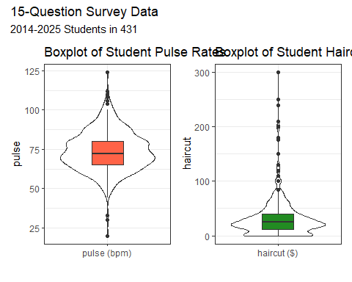
- What is width = 0.3 doing? How about the x options?
- What am I doing with p2 + p3 + plot_annotation?

Summarizing these data
- Normal distribution may be a reasonable model for pulse but not haircut according to our plots.
surv15 |> reframe(lovedist(pulse))
# A tibble: 1 × 10
n miss mean sd med mad min q25 q75 max
<int> <int> <dbl> <dbl> <dbl> <dbl> <dbl> <dbl> <dbl> <dbl>
1 656 79 74.0 12.7 72 11.9 20 65 80 124
surv15 |> reframe(lovedist(haircut))
# A tibble: 1 × 10
n miss mean sd med mad min q25 q75 max
<int> <int> <dbl> <dbl> <dbl> <dbl> <dbl> <dbl> <dbl> <dbl>
1 656 12 32.0 35.2 25 22.2 0 12 40 300
- What does these results imply about how we should summarize the data?

Mean/SD vs. Median/MAD
If the data are approximately Normally distributed (like pulse) we can safely use the sample mean and standard deviation as summaries. If not (see haircut), then …
- The median is a more robust summary of the center.
- For spread, try the median absolute deviation.
Measure | observed | NA | Mean | SD | Median | MAD
pulse | 577 | 79 | 74 | 12.7 | 72 | 11.9
haircut | 644 | 12 | 32 | 35.2 | 25 | 22.2

Making Estimates from our Sample
One estimate of the average pulse rate of all students who study at CWRU could come from our sample.
dat2 <- surv15 |> filter(complete.cases(pulse))
dat2 |> reframe(lovedist(pulse))
# A tibble: 1 × 10
n miss mean sd med mad min q25 q75 max
<int> <int> <dbl> <dbl> <dbl> <dbl> <dbl> <dbl> <dbl> <dbl>
1 577 0 74.0 12.7 72 11.9 20 65 80 124
Our point estimate for the mean pulse rate of the population of all CWRU students is the mean from our sample of 577 students with known pulse rates: 74 bpm.
- How much uncertainty is there in that estimate?

Uncertainty Interval for a Mean
A linear model (using only an intercept term) yields a 90% uncertainty (confidence) interval for the population mean.
mod_pulse <- lm(pulse ~ 1, data = dat2)
model_parameters(mod_pulse, ci = 0.90)
Parameter | Coefficient | SE | 90% CI | t(576) | p
-------------------------------------------------------------------
(Intercept) | 74.02 | 0.53 | [73.15, 74.89] | 140.04 | < .001
Uncertainty intervals (equal-tailed) and p-values (two-tailed) computed
using a Wald t-distribution approximation.
Our 90% uncertainty interval (confidence interval) is (73.15, 74.89) beats per minute for the mean pulse rate across the entire population of CWRU students.

A Bayesian estimate
Bayesian linear model (using only an intercept term) to obtain a 90% uncertainty (credible) interval for the population mean using a weakly informative prior.
set.seed(4312025)
mod_pulse <- stan_glm(pulse ~ 1, data = dat2, refresh = 0)
model_parameters(mod_pulse, ci = 0.90)
Parameter | Median | 90% CI | pd | Rhat | ESS | Prior
-------------------------------------------------------------------------------------
(Intercept) | 74.02 | [73.12, 74.89] | 100% | 1.000 | 2797 | Normal (74.02 +- 31.74)
Uncertainty intervals (equal-tailed) computed using a MCMC distribution
approximation.
Note that this 95% credible interval (73.12, 74.89) is very similar to the confidence interval (73.15, 74.89).

Haircut Prices
A problem with the haircut price data is that it doesn’t follow a Normal distribution, so it’s more difficult to describe the center of the data with a sample mean…
dat3 <- surv15 |> filter(complete.cases(haircut))
mod_haircut <- lm(haircut ~ 1, data = dat3)
model_parameters(mod_haircut, ci = 0.9)
Parameter | Coefficient | SE | 90% CI | t(643) | p
-------------------------------------------------------------------
(Intercept) | 32.04 | 1.39 | [29.75, 34.33] | 23.08 | < .001
Uncertainty intervals (equal-tailed) and p-values (two-tailed) computed
using a Wald t-distribution approximation.
- Is this a completely reasonable approach here?

Question 4

Question 4
Do tall people pay less for haircuts?
- Why might we think that they do, before we see the data?
- Convert our student heights from inches to centimeters…
surv15 <- surv15 |> mutate(height_cm = height_in * 2.54)
surv15 |> select(student, height_in, height_cm) |> head()
# A tibble: 6 × 3
student height_in height_cm
<chr> <dbl> <dbl>
1 202501 63 160.
2 202502 68 173.
3 202503 75 190.
4 202504 62 157.
5 202505 64 163.
6 202506 71 180.

A First Scatterplot
- We’ll include the straight line from a linear model, in red.
dat4 <- surv15 |> filter(complete.cases(height_cm, haircut))
ggplot(dat4, aes(x = height_cm, y = haircut)) +
geom_point(alpha = 0.3) +
geom_smooth(method = "lm", col = "red",
formula = y ~ x, se = TRUE) +
labs(x = "Height (in cm)",
y = "Price of last haircut (in $)",
title = "Do taller people pay less for haircuts?")
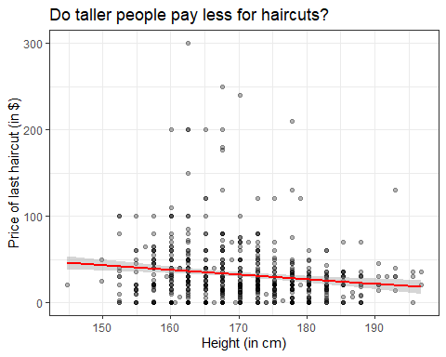

Straight line regression model?
dat4 <- surv15 |> filter(complete.cases(height_cm, haircut))
mod4 <- lm(haircut ~ height_cm, data = dat4)
mod4
Call:
lm(formula = haircut ~ height_cm, data = dat4)
Coefficients:
(Intercept) height_cm
124.5312 -0.5423

Summarizing our model
model_parameters(mod4)
Parameter | Coefficient | SE | 95% CI | t(640) | p
---------------------------------------------------------------------
(Intercept) | 124.53 | 24.36 | [76.70, 172.36] | 5.11 | < .001
height cm | -0.54 | 0.14 | [-0.82, -0.26] | -3.80 | < .001
Uncertainty intervals (equal-tailed) and p-values (two-tailed) computed
using a Wald t-distribution approximation.
Regression Equation is:
$$haircut=124.53−0.54\left(height_{cm}\right)+error$$
Our predicted haircut price for someone who is 170 cm (about 5 feet 7 inches) tall is…
$$
haircut = 124.53 - 0.54 (170) = $32.73
$$

Interpreting the Regression Equation
$$haircut=124.53−0.54\left(height_{cm}\right)+error$$
- The intercept suggests that a student who is 0 cm tall has an average haircut price of $124.53, although we don’t have any students in the data whose height is anywhere near as small as 0 cm, so this isn’t very useful.
- The slope is more important. When comparing two students who differ by 1 cm in height, we observe a haircut price that is, on average, $0.54 smaller for the student with the larger (taller) height.

lm fit vs. loess smooth curve?
dat4 <- surv15 |> filter(complete.cases(height_cm, haircut))
ggplot(dat4, aes(x = height_cm, y = haircut)) +
geom_point(alpha = 0.5) +
geom_smooth(method = "lm", col = "red",
formula = y ~ x, se = FALSE) +
geom_smooth(method = "loess", col = "blue",
formula = y ~ x, se = FALSE) +
labs(x = "Height (in cm)",
y = "Price of last haircut (in $)",
title = "Do taller people pay less for haircuts?")
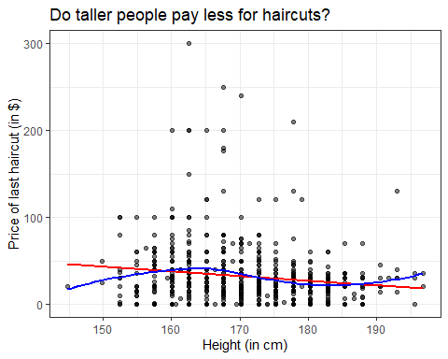
- Does a linear model appear to fit these data well?
- Do taller people pay less for their haircuts?

What is the (Pearson) correlation of height and haircut price?
dat4 <- surv15 |> filter(complete.cases(height_cm, haircut))
dat4 |>
select(height_in, height_cm, haircut) |>
cor()
height_in height_cm haircut
height_in 1.0000000 1.0000000 -0.1486261
height_cm 1.0000000 1.0000000 -0.1486261
haircut -0.1486261 -0.1486261 1.0000000

Question 5

Question 5
Do students have a more substantial tobacco history if they prefer to speak English or a language other than English?
surv15 |> count(english, smoke)
# A tibble: 9 × 3
english smoke n
<fct> <fct> <int>
1 n 1 128
2 n 2 4
3 n 3 6
4 y 1 471
5 y 2 32
6 y 3 7
7 y <NA> 1
8 <NA> 1 6
9 <NA> <NA> 1
smoke codes (tobacco use): 1 = Never, 2 = Former, 3 = Current

Restrict ourselves to 2025 data
- Do students in the 2025 class have a more substantial history of tobacco use if they prefer to speak a language other than English?
dat5 <- surv15 |>
filter(year == "2025") |>
filter(complete.cases(english, smoke)) |>
select(student, year, english, smoke)
summary(dat5)
student year english smoke
Length:53 2025 :53 n:15 1:47
Class :character 2014 : 0 y:38 2: 3
Mode :character 2015 : 0 3: 3
2016 : 0
2017 : 0
2018 : 0
(Other): 0

Tabulating the categorical variables individually
dat5 |> tabyl(english)
english n percent
n 15 0.2830189
y 38 0.7169811
dat5 |> tabyl(smoke) |> adorn_pct_formatting()
smoke n percent
1 47 88.7%
2 3 5.7%
3 3 5.7%
- What does adorn_pct_formatting() do?

Cross-Classification (2 rows $×$ 3 columns)
dat5 |> tabyl(english, smoke)
english 1 2 3
n 12 1 2
y 35 2 1

Recode the smoke levels to more meaningful names in tobacco
dat5 <- dat5 |>
mutate(tobacco = fct_recode(smoke,
"Never" = "1", "Quit" = "2", "Current" = "3"))

Check our work?
dat5 |> count(smoke, tobacco)
# A tibble: 3 × 3
smoke tobacco n
<fct> <fct> <int>
1 1 Never 47
2 2 Quit 3
3 3 Current 3
- Everyone with smoke = 1 has tobacco as Never, etc.

Restate the cross-tabulation
Now we’ll use this new variable, and this time, add row and column totals.
dat5 |> tabyl(english, tobacco) |>
adorn_totals(where = c("row", "col"))
english Never Quit Current Total
n 12 1 2 15
y 35 2 1 38
Total 47 3 3 53
- What can we conclude about this association?

How about in 2014-2025?
dat6 <- surv15 |>
filter(complete.cases(english, smoke)) |>
mutate(tobacco = fct_recode(smoke,
"Never" = "1", "Quit" = "2", "Current" = "3"))
dat6 |>
tabyl(english, tobacco) |>
adorn_totals(where = c("row", "col"))
english Never Quit Current Total
n 128 4 6 138
y 471 32 7 510
Total 599 36 13 648
- Now, what is your conclusion?

Next Time
Working with a new data set
 Note
By now, I’ve shown you everything you need to complete all Tasks for Lab 1, due next Wednesday at noon (2025-09-16.)

Session Information
xfun::session_info()
R version 4.5.1 (2025-06-13 ucrt)
Platform: x86_64-w64-mingw32/x64
Running under: Windows 11 x64 (build 26100)
Locale:
LC_COLLATE=English_United States.utf8
LC_CTYPE=English_United States.utf8
LC_MONETARY=English_United States.utf8
LC_NUMERIC=C
LC_TIME=English_United States.utf8
Package version:
abind_1.4-8 askpass_1.2.1 backports_1.5.0
base64enc_0.1-3 bayesplot_1.14.0 bayestestR_0.17.0
BH_1.87.0.1 bit_4.6.0 bit64_4.6.0-1
blob_1.2.4 boot_1.3-31 broom_1.0.9
bslib_0.9.0 cachem_1.1.0 callr_3.7.6
cellranger_1.1.0 checkmate_2.3.3 cli_3.6.5
clipr_0.8.0 coda_0.19-4.1 codetools_0.2-20
colourpicker_1.3.0 commonmark_2.0.0 compiler_4.5.1
conflicted_1.2.0 correlation_0.8.8 cpp11_0.5.2
crayon_1.5.3 crosstalk_1.2.2 curl_7.0.0
data.table_1.17.8 datasets_4.5.1 datawizard_1.2.0
DBI_1.2.3 dbplyr_2.5.0 desc_1.4.3
digest_0.6.37 distributional_0.5.0 dplyr_1.1.4
DT_0.34.0 dtplyr_1.3.1 dygraphs_1.1.1.6
easystats_0.7.5 effectsize_1.0.1 emmeans_1.11.2-8
estimability_1.5.1 evaluate_1.0.5 farver_2.1.2
fastmap_1.2.0 fontawesome_0.5.3 forcats_1.0.0
fs_1.6.6 gargle_1.6.0 generics_0.1.4
ggplot2_3.5.2 ggridges_0.5.7 glue_1.8.0
googledrive_2.1.1 googlesheets4_1.1.2 graphics_4.5.1
grDevices_4.5.1 grid_4.5.1 gridExtra_2.3
gtable_0.3.6 gtools_3.9.5 haven_2.5.5
highr_0.11 hms_1.1.3 htmltools_0.5.8.1
htmlwidgets_1.6.4 httpuv_1.6.16 httr_1.4.7
ids_1.0.1 igraph_2.1.4 inline_0.3.21
insight_1.4.2 isoband_0.2.7 janitor_2.2.1
jquerylib_0.1.4 jsonlite_2.0.0 knitr_1.50
labeling_0.4.3 later_1.4.4 lattice_0.22-7
lazyeval_0.2.2 lifecycle_1.0.4 litedown_0.7
lme4_1.1-37 loo_2.8.0 lubridate_1.9.4
magrittr_2.0.3 markdown_2.0 MASS_7.3-65
Matrix_1.7-3 matrixStats_1.5.0 memoise_2.0.1
methods_4.5.1 mgcv_1.9-3 mime_0.13
miniUI_0.1.2 minqa_1.2.8 modelbased_0.13.0
modelr_0.1.11 multcomp_1.4-28 mvtnorm_1.3-3
nlme_3.1-168 nloptr_2.2.1 numDeriv_2016.8.1.1
openssl_2.3.3 parallel_4.5.1 parameters_0.28.1
patchwork_1.3.2 performance_0.15.1 pillar_1.11.0
pkgbuild_1.4.8 pkgconfig_2.0.3 plyr_1.8.9
posterior_1.6.1 prettyunits_1.2.0 processx_3.8.6
progress_1.2.3 promises_1.3.3 ps_1.9.1
purrr_1.1.0 QuickJSR_1.8.0 R6_2.6.1
ragg_1.5.0 rappdirs_0.3.3 rbibutils_2.3
RColorBrewer_1.1-3 Rcpp_1.1.0 RcppEigen_0.3.4.0.2
RcppParallel_5.1.11-1 Rdpack_2.6.4 readr_2.1.5
readxl_1.4.5 reformulas_0.4.1 rematch_2.0.0
rematch2_2.1.2 report_0.6.1 reprex_2.1.1
reshape2_1.4.4 rlang_1.1.6 rmarkdown_2.29
rstan_2.32.7 rstanarm_2.32.1 rstantools_2.5.0
rstudioapi_0.17.1 rvest_1.0.5 sandwich_3.1-1
sass_0.4.10 scales_1.4.0 see_0.11.0
selectr_0.4.2 shiny_1.11.1 shinyjs_2.1.0
shinystan_2.6.0 shinythemes_1.2.0 snakecase_0.11.1
sourcetools_0.1.7.1 splines_4.5.1 StanHeaders_2.32.10
stats_4.5.1 stats4_4.5.1 stringi_1.8.7
stringr_1.5.1 survival_3.8-3 sys_3.4.3
systemfonts_1.2.3 tensorA_0.36.2.1 textshaping_1.0.3
TH.data_1.1-4 threejs_0.3.4 tibble_3.3.0
tidyr_1.3.1 tidyselect_1.2.1 tidyverse_2.0.0
timechange_0.3.0 tinytex_0.57 tools_4.5.1
tzdb_0.5.0 utf8_1.2.6 utils_4.5.1
uuid_1.2.1 V8_7.0.0 vctrs_0.6.5
viridisLite_0.4.2 vroom_1.6.5 withr_3.0.2
xfun_0.52 xml2_1.4.0 xtable_1.8-4
xts_0.14.1 yaml_2.3.10 zoo_1.8-14

MAD scaled here to equal the standard deviation when data follow the Normal.

