431 Class 18
Thomas E. Love, Ph.D.
2025-11-04

Today’s Agenda
Two-Factor (Two-Way) Analysis of Variance
- The importance of interaction
- Interpreting ANOVA output
- What are the key model checks for ANOVA?
- Comparing Model Performance Indices
- What if we add a covariate?

R Packages
library(janitor)
Attaching package: 'janitor'
The following objects are masked from 'package:stats':
chisq.test, fisher.test
library(readxl)
library(gt)
library(easystats)
# Attaching packages: easystats 0.7.5
✔ bayestestR 0.17.0 ✔ correlation 0.8.8
✔ datawizard 1.3.0 ✔ effectsize 1.0.1
✔ insight 1.4.2 ✔ modelbased 0.13.0
✔ performance 0.15.2 ✔ parameters 0.28.2
✔ report 0.6.1 ✔ see 0.12.0
library(tidyverse)
── Attaching core tidyverse packages ──────────────────────── tidyverse 2.0.0 ──
✔ dplyr 1.1.4 ✔ readr 2.1.5
✔ forcats 1.0.1 ✔ stringr 1.5.2
✔ ggplot2 4.0.0 ✔ tibble 3.3.0
✔ lubridate 1.9.4 ✔ tidyr 1.3.1
✔ purrr 1.1.0
── Conflicts ────────────────────────────────────────── tidyverse_conflicts() ──
✖ dplyr::filter() masks stats::filter()
✖ dplyr::lag() masks stats::lag()
ℹ Use the conflicted package (<http://conflicted.r-lib.org/>) to force all conflicts to become errors
source("c18/data/Love-431.R")
knitr::opts_chunk$set(comment = NA)
theme_set(theme_bw())

The dm464 data, in full
We’ve discussed subsets of these data in previous classes.
dm464 <- read_xlsx("c18/data/dm464.xlsx") |>
janitor::clean_names() |>
mutate(across(where(is.character), as_factor)) |>
mutate(id_code = as.character(id_code),
smoke_start = fct_relevel(smoke_start, "Current", "Former"),
smoke_end = fct_relevel(smoke_end, "Current", "Former"),
insur_start = fct_relevel(insur_start, "Medicare",
"Commercial", "Medicaid"),
insur_end = fct_relevel(insur_end, "Medicare",
"Commercial", "Medicaid"))
dim(dm464)
[1] 464 42

Descriptions for Today’s Variables
- Cohort of 464 English-speaking adults with diabetes measured at the start and end of a two-year period.
Variable | Description
id_code | DM-xxxx code to identify subjects (not consecutive)
bmi_end | Body Mass Index in $\left(kg/m^{2}\right)$ at the end of the period
dep_start | Depression diagnosis at the start of the period (1 = yes, 0 = no)
ed_start | High = more than 78% of adult residents of subject’s home neighborhood graduated high school, vs. Low = no more than 78%.
insur_start | Subject’s insurance status at the start (3 levels)
- 78% was close to the median value of the quantitative measure of high school graduation rate among enrolled subjects at the start of the period.
- All subjects have either Medicare, Commercial or Medicaid insurance.

Today’s Variables
dm18 <- dm464 |>
mutate(ed_start = factor(ifelse(nedlev_start > 78, "High", "Low")),
dep_start = factor(depdiag_start)) |>
select(id_code, bmi_end, dep_start, ed_start, insur_start)
dm18 |> gt_preview()
 | id_code | bmi_end | dep_start | ed_start | insur_start
1 | DM-1007 | 47.2 | 0 | Low | Medicare
2 | DM-1017 | 34.7 | 0 | High | Commercial
3 | DM-1039 | 50.0 | 1 | High | Medicare
4 | DM-1049 | 57.2 | 1 | Low | Medicaid
5 | DM-1064 | 45.2 | 1 | Low | Medicaid
6..463
464 | DM-9938 | 43.6 | 1 | High | Medicare

data_codebook() results
data_codebook(dm18 |> select (-id_code))
select(dm18, -id_code) (464 rows and 4 variables, 4 shown)
ID | Name | Type | Missings | Values | N
---+-------------+-------------+----------+------------+------------
1 | bmi_end | numeric | 0 (0.0%) | [16, 78.3] | 464
---+-------------+-------------+----------+------------+------------
2 | dep_start | categorical | 0 (0.0%) | 0 | 295 (63.6%)
| | | | 1 | 169 (36.4%)
---+-------------+-------------+----------+------------+------------
3 | ed_start | categorical | 0 (0.0%) | High | 228 (49.1%)
| | | | Low | 236 (50.9%)
---+-------------+-------------+----------+------------+------------
4 | insur_start | categorical | 0 (0.0%) | Medicare | 193 (41.6%)
| | | | Commercial | 61 (13.1%)
| | | | Medicaid | 210 (45.3%)
--------------------------------------------------------------------

Two-Factor Analysis of Variance: Example 1

Example 1
Suppose we want to simultaneously understand the impacts of two factors on BMI at the end of the period, specifically:
- dep_start (1 or 0), and
- ed_start (Low or High)
and it is possible that the impact of depression diagnosis on BMI may depend on the home neighborhood’s educational attainment, and vice versa (i.e. depression and education may interact.)

An interaction plot is a plot of means.
Calculate and store the group means.
ex1_means <- dm18 |>
group_by(dep_start, ed_start) |>
summarize(mean_bmi = mean(bmi_end))
`summarise()` has grouped output by 'dep_start'. You can override using the
`.groups` argument.
ex1_means
# A tibble: 4 × 3
# Groups: dep_start [2]
dep_start ed_start mean_bmi
<fct> <fct> <dbl>
1 0 High 33.4
2 0 Low 34.1
3 1 High 35.7
4 1 Low 38.7

How strong is the interaction?
Now, we’ll plot these means, and look for a substantial interaction (non-parallel lines.)
ggplot(ex1_means, aes(x = dep_start, y = mean_bmi)) +
geom_line(aes(group = ed_start, color = ed_start)) +
geom_point(aes(color = ed_start)) +
scale_color_material() +
labs(title = "Example 1 Interaction Plot",
subtitle = "Do we see substantially non-parallel lines?",
y = "Mean BMI at end of period",
x = "Depression Diagnosis (1 = yes, 0 = no)",
color = "HS Graduation Rate")
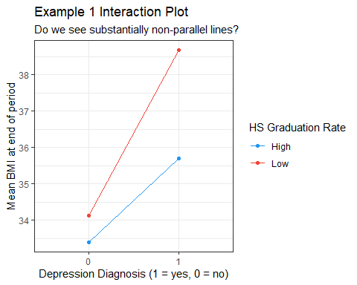

Two-Way ANOVA without interaction
This model predicts our outcome (bmi_end) using the two factors as main effects only (with no interaction.)
mainfx <- lm(bmi_end ~ dep_start + ed_start, data = dm18)
mainfx
Call:
lm(formula = bmi_end ~ dep_start + ed_start, data = dm18)
Coefficients:
(Intercept) dep_start1 ed_startLow
32.981 3.452 1.555
$$bmi_{end}=32.98+3.452\left(dep_{start}=1\right)+1.555\left(ed_{start}=Low\right)$$

Interpret the estimate: 3.45?
model_parameters(mainfx, ci = 0.90, pretty_names = FALSE)
Parameter | Coefficient | SE | 90% CI | t(461) | p
-------------------------------------------------------------------
(Intercept) | 32.98 | 0.65 | [31.91, 34.05] | 50.68 | < .001
dep_start1 | 3.45 | 0.84 | [ 2.06, 4.84] | 4.10 | < .001
ed_startLow | 1.56 | 0.81 | [ 0.22, 2.89] | 1.92 | 0.056
Uncertainty intervals (equal-tailed) and p-values (two-tailed) computed
using a Wald t-distribution approximation.
If we have two subjects who live in neighborhoods with the same ed_start value, but only one has a depression diagnosis at the start of the period, then on average the subject with a depression diagnosis will have a BMI that is 3.45 $kg/m^{2}$ higher than the subject without such a diagnosis, according to our mainfx model.

Interpret the estimate: 1.56?
model_parameters(mainfx, ci = 0.90, pretty_names = FALSE)
Parameter | Coefficient | SE | 90% CI | t(461) | p
-------------------------------------------------------------------
(Intercept) | 32.98 | 0.65 | [31.91, 34.05] | 50.68 | < .001
dep_start1 | 3.45 | 0.84 | [ 2.06, 4.84] | 4.10 | < .001
ed_startLow | 1.56 | 0.81 | [ 0.22, 2.89] | 1.92 | 0.056
Uncertainty intervals (equal-tailed) and p-values (two-tailed) computed
using a Wald t-distribution approximation.
Our mainfx model estimates that if we have two subjects who have the same depression diagnosis status at the start of the period, but live in neighborhoods with different ed_start values (one High and one Low), then on average the subject living in the Low education neighborhood will have a BMI that is 1.56 $kg/m^{2}$ higher than the other subject.

Interpret the intercept term?
model_parameters(mainfx, ci = 0.90, pretty_names = FALSE)
Parameter | Coefficient | SE | 90% CI | t(461) | p
-------------------------------------------------------------------
(Intercept) | 32.98 | 0.65 | [31.91, 34.05] | 50.68 | < .001
dep_start1 | 3.45 | 0.84 | [ 2.06, 4.84] | 4.10 | < .001
ed_startLow | 1.56 | 0.81 | [ 0.22, 2.89] | 1.92 | 0.056
Uncertainty intervals (equal-tailed) and p-values (two-tailed) computed
using a Wald t-distribution approximation.
32.98 is the intercept. It’s the mainfx model’s estimate of the mean of bmi_end across all subjects where both dep_start is 0 and ed_start = High.

ANOVA table for main effects model
anova(mainfx)
Analysis of Variance Table
Response: bmi_end
Df Sum Sq Mean Sq F value Pr(>F)
dep_start 1 1303 1302.59 17.1020 4.21e-05 ***
ed_start 1 280 280.48 3.6824 0.05561 .
Residuals 461 35113 76.17
---
Signif. codes: 0 '***' 0.001 '**' 0.01 '*' 0.05 '.' 0.1 ' ' 1

% of Total SS explained by the two factors?
- Total SS = 1303 + 280 + 35113 = 36696
- So % explained = (1303 + 280) / 36696 = 0.043, or 4.3%

Model mainfx and its assumptions
- mainfx is a “main effects only” model. It assumes there is zero interaction between dep_start and ed_start in predicting our outcome, bmi_end.
- Like any ANOVA model, mainfx makes the usual linear model assumptions (linearity, constant variance, Normality)
  - Focus: posterior predictive check, and Normal Q-Q plot of residuals.

Checking model mainfx
set.seed(20251104)
check_model(mainfx, check = c("pp_check", "qq"), detrend = FALSE)
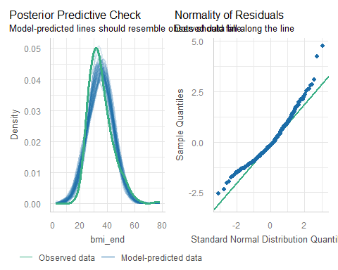

Interaction Plot, again


Two-Way ANOVA with Interaction
Fit the linear model, including an interaction (*) between our factors.
withint <- lm(bmi_end ~ dep_start * ed_start, data = dm18)
withint
Call:
lm(formula = bmi_end ~ dep_start * ed_start, data = dm18)
Coefficients:
(Intercept) dep_start1 ed_startLow
33.3878 2.3073 0.7447
dep_start1:ed_startLow
2.2284

withint model equation?
$$
bmi_{end} = 33.4 + 2.3 (dep_{start} = 1) \\
+ 0.7 (ed_{start} = Low) \\ + 2.2 (dep_{start} = 1) \times (ed_{start} = Low)
$$
dep_start | ed_start | Estimated bmi_end
0 | High | 33.4
0 | Low | 33.4 + 0.7 = 34.1
1 | High | 33.4 + 2.3 = 35.7
1 | Low | 33.4 + 2.3 + 0.7 + 2.2 = 38.6

Effect of High vs. Low ed_start?
Est. bmi_end | ed_start = High | ed_start = Low
dep_start = 0 | 33.4 | 34.1
dep_start = 1 | 35.7 | 38.6
- If dep_start = 0, High ed_start yields 33.4; Low yields 34.1, so High - Low difference in estimates is -0.7.
- If dep_start = 1, High ed_start yields 35.7; Low yields 38.6, so High - Low difference in estimates is -2.9.
- Estimated effect of ed_start depends on dep_start.

Effect of dep_start = 1 vs. 0?
Est. bmi_end | ed_start = High | ed_start = Low
dep_start = 1 | 35.7 | 38.6
dep_start = 0 | 33.4 | 34.1
- If ed_start is High, then dep_start = 1 yields 35.7, and 0 yields 33.4, so the difference in estimated bmi_end is 2.3.
- If ed_start is Low, then dep_start = 1 yields 38.6, and 0 yields 34.1, so the difference in estimated bmi_end is 4.5.
- Estimated effect of dep_start depends on ed_start.

ANOVA table for withint model
anova(withint)
Analysis of Variance Table
Response: bmi_end
Df Sum Sq Mean Sq F value Pr(>F)
dep_start 1 1303 1302.59 17.1299 4.152e-05 ***
ed_start 1 280 280.48 3.6884 0.05541 .
dep_start:ed_start 1 133 133.25 1.7523 0.18625
Residuals 460 34979 76.04
---
Signif. codes: 0 '***' 0.001 '**' 0.01 '*' 0.05 '.' 0.1 ' ' 1
- Total SS = 1303 + 280 + 133 + 34979 = 36695
- % explained = (1303 + 280 + 133) / 36695 = 0.047, or 4.7%
- Is this a big improvement over the mainfx model?

Checking model withint
set.seed(202410291)
check_model(withint, check = c("pp_check", "qq"), detrend = FALSE)
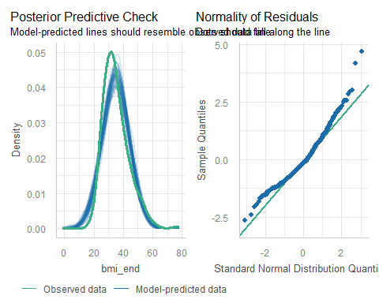

Compare performance of our two models?
compare_performance(mainfx, withint, rank = TRUE)
# Comparison of Model Performance Indices
Name | Model | R2 | R2 (adj.) | RMSE | Sigma | AIC weights
-----------------------------------------------------------------
withint | lm | 0.047 | 0.041 | 8.683 | 8.720 | 0.471
mainfx | lm | 0.043 | 0.039 | 8.699 | 8.727 | 0.529
Name | AICc weights | BIC weights | Performance-Score
--------------------------------------------------------
withint | 0.465 | 0.101 | 57.14%
mainfx | 0.535 | 0.899 | 42.86%

Plot to compare performance indicators
plot(compare_performance(mainfx, withint))
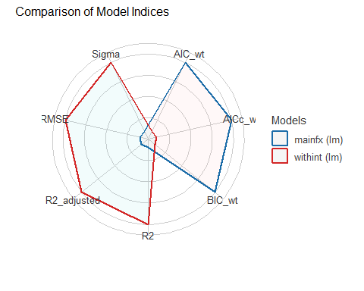

Do we have a substantial interaction?
- Interaction plot shows slightly non-parallel lines.
- % of variation explained by the interaction term is about 0.4% of the variation in bmi_end, overall.
- p value for the interaction term is pretty large ($p$ = 0.19)
- Is there a substantial improvement in the fit with the interaction?
  - In-sample performance indices are split.
What do you think?

Two-Factor Analysis of Variance: Example 2

Example 2
Suppose that we now want to understand the impact on BMI at the end of the period, of:
- insur_start (Medicare, Commercial or Medicaid), and
- ed_start (Low or High)
and it’s possible that the impact of insurance on BMI may depend on the home neighborhood’s educational attainment, and vice versa (i.e. insurance and education may interact.)

Build an interaction plot
Calculate and store group means.
ex2_means <- dm18 |>
group_by(insur_start, ed_start) |>
summarize(mean_bmi = mean(bmi_end))
`summarise()` has grouped output by 'insur_start'. You can override using the
`.groups` argument.
ex2_means
# A tibble: 6 × 3
# Groups: insur_start [3]
insur_start ed_start mean_bmi
<fct> <fct> <dbl>
1 Medicare High 33.6
2 Medicare Low 34.1
3 Commercial High 35.9
4 Commercial Low 34.4
5 Medicaid High 34.2
6 Medicaid Low 38.2

How strong is the interaction?
Now, we’ll plot these means, and look for a substantial interaction (non-parallel lines.)
ggplot(ex2_means, aes(x = insur_start, y = mean_bmi)) +
geom_line(aes(group = ed_start, color = ed_start)) +
geom_point(aes(color = ed_start)) +
scale_color_material() +
labs(title = "Example 2 Interaction Plot",
subtitle = "Do we see substantially non-parallel lines?",
y = "Mean BMI at end of period",
x = "Insurance at start of period",
color = "HS Graduation Rate")
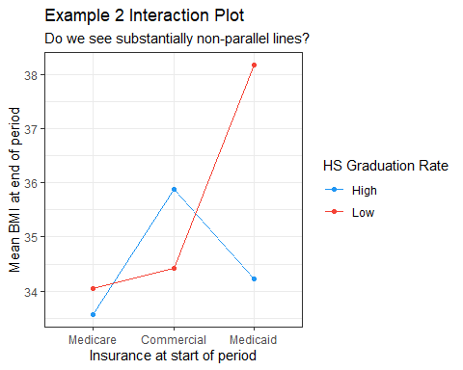

Example 2: Two-Way ANOVA models
mainfx2 <- lm(bmi_end ~ insur_start + ed_start, data = dm18)
withint2 <- lm(bmi_end ~ insur_start * ed_start, data = dm18)
compare_performance(mainfx2, withint2, rank = TRUE)
# Comparison of Model Performance Indices
Name | Model | R2 | R2 (adj.) | RMSE | Sigma | AIC weights
------------------------------------------------------------------
withint2 | lm | 0.037 | 0.027 | 8.727 | 8.784 | 0.758
mainfx2 | lm | 0.024 | 0.018 | 8.786 | 8.824 | 0.242
Name | AICc weights | BIC weights | Performance-Score
---------------------------------------------------------
withint2 | 0.747 | 0.048 | 85.71%
mainfx2 | 0.253 | 0.952 | 14.29%

Plotting Performance Indices
plot(compare_performance(mainfx2, withint2))
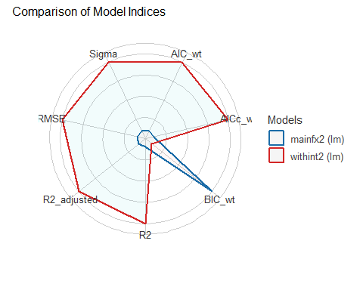

Interpret mainfx2 estimates?
model_parameters(mainfx2, ci = 0.90, pretty_names = FALSE)
Parameter | Coefficient | SE | 90% CI | t(460) | p
-----------------------------------------------------------------------------
(Intercept) | 32.85 | 0.78 | [31.56, 34.13] | 42.02 | < .001
insur_startCommercial | 1.44 | 1.30 | [-0.70, 3.57] | 1.11 | 0.269
insur_startMedicaid | 2.40 | 0.88 | [ 0.94, 3.85] | 2.72 | 0.007
ed_startLow | 1.79 | 0.82 | [ 0.44, 3.15] | 2.18 | 0.030
Uncertainty intervals (equal-tailed) and p-values (two-tailed) computed
using a Wald t-distribution approximation.
$$bmi_{end}=32.9+1.4\left(Comm.\right)+2.4\left(Medicaid\right)+1.8\left(LowEd.\right)$$
Est. bmi_end | Medicare | Commercial | Medicaid
ed_start High | 32.9 | 34.3 | 35.3
ed_start Low | 34.7 | 36.1 | 37.1

Specify withint2 equation?
model_parameters(withint2, ci = 0.90, pretty_names = FALSE)
Parameter | Coefficient | SE | 90% CI
-----------------------------------------------------------------------
(Intercept) | 33.57 | 0.95 | [32.01, 35.13]
insur_startCommercial | 2.31 | 1.84 | [-0.72, 5.34]
insur_startMedicaid | 0.66 | 1.26 | [-1.42, 2.74]
ed_startLow | 0.48 | 1.27 | [-1.61, 2.58]
insur_startCommercial:ed_startLow | -1.94 | 2.58 | [-6.20, 2.32]
insur_startMedicaid:ed_startLow | 3.44 | 1.76 | [ 0.55, 6.34]
Parameter | t(458) | p
---------------------------------------------------
(Intercept) | 35.44 | < .001
insur_startCommercial | 1.26 | 0.210
insur_startMedicaid | 0.53 | 0.599
ed_startLow | 0.38 | 0.704
insur_startCommercial:ed_startLow | -0.75 | 0.452
insur_startMedicaid:ed_startLow | 1.96 | 0.051
Uncertainty intervals (equal-tailed) and p-values (two-tailed) computed
using a Wald t-distribution approximation.

withint2 model equation
$$
bmi_{end} = 33.6 + 2.3 Commercial + 0.7 Medicaid + 0.5 (ed_{start} = Low) \\ - 1.9 Commercial \times (ed_{start} = Low) + 3.4 Medicaid \times (ed_{start} = Low)
$$
insur_start | ed_start | Estimated bmi_end
Medicare | High | 33.6
Commercial | High | 33.6 + 2.3 = 35.9
Medicaid | High | 33.6 + 0.7 = 34.3
Medicare | Low | 33.6 + 0.5 = 34.1
Commercial | Low | 33.6 + 2.3 + 0.5 - 1.9 = 34.5
Medicaid | Low | 33.6 + 0.7 + 0.5 + 3.4 = 38.2

ANOVA table for main effects model
anova(mainfx2)
Analysis of Variance Table
Response: bmi_end
Df Sum Sq Mean Sq F value Pr(>F)
insur_start 2 510 254.82 3.2727 0.03879 *
ed_start 1 369 369.45 4.7450 0.02989 *
Residuals 460 35817 77.86
---
Signif. codes: 0 '***' 0.001 '**' 0.01 '*' 0.05 '.' 0.1 ' ' 1

% of Total SS explained by the two factors?
- Total SS = 510 + 369 + 35817 = 36696
- So % explained = (510 + 369) / 36696 = 0.024, or 2.4%

ANOVA table for interaction model
anova(withint2)
Analysis of Variance Table
Response: bmi_end
Df Sum Sq Mean Sq F value Pr(>F)
insur_start 2 510 254.82 3.3029 0.03765 *
ed_start 1 369 369.45 4.7888 0.02915 *
insur_start:ed_start 2 482 240.88 3.1223 0.04500 *
Residuals 458 35335 77.15
---
Signif. codes: 0 '***' 0.001 '**' 0.01 '*' 0.05 '.' 0.1 ' ' 1

% of Total SS explained by the model?
- Total SS = 510 + 369 + 482 + 35335 = 36696
- So % explained = (510 + 369 + 482) / 36696 = 0.037, or 3.7%

Checking model mainfx2
set.seed(202410292)
check_model(mainfx2, check = c("pp_check", "qq"), detrend = FALSE)
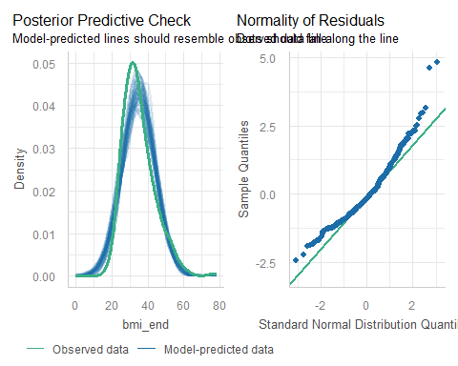

Checking model withint2
set.seed(202410293)
check_model(withint2, check = c("pp_check", "qq"), detrend = FALSE)
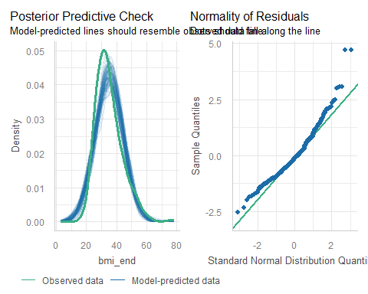

Substantial interaction here?
- Interaction plot shows substantially non-parallel lines.
- Interaction term explains about 1.3% of the variation in bmi_end, overall.
- p value for the interaction term is fairly small ($p$ = 0.045)
- Substantial improvement in the fit with interaction?
  - 6/7 in-sample performance indices prefer interaction
What do you think?

Add a covariate?

What if we added a covariate?
dm18a <- dm464 |>
mutate(ed_start = factor(ifelse(nedlev_start > 78, "High", "Low")),
dep_start = factor(depdiag_start)) |>
mutate(bmi_c = center(bmi_start)) |>
select(id_code, bmi_end, dep_start, ed_start, insur_start,
bmi_c, bmi_start)
dm18a |> reframe(lovedist(bmi_start))
# A tibble: 1 × 10
n miss mean sd med mad min q25 q75 max
<int> <int> <dbl> <dbl> <dbl> <dbl> <dbl> <dbl> <dbl> <dbl>
1 464 0 35.2 8.82 33.4 8.01 17.3 28.9 40.4 75.1
dm18a |> reframe(lovedist(bmi_c))
# A tibble: 1 × 10
n miss mean sd med mad min q25 q75 max
<int> <int> <dbl> <dbl> <dbl> <dbl> <dbl> <dbl> <dbl> <dbl>
1 464 0 2.30e-15 8.82 -1.84 8.01 -17.9 -6.34 5.21 39.9

Analysis of Covariance Model
fit3 <- lm(bmi_end ~ bmi_c + dep_start * insur_start, data = dm18a)
anova(fit3)
Analysis of Variance Table
Response: bmi_end
Df Sum Sq Mean Sq F value Pr(>F)
bmi_c 1 34213 34213 6413.8007 < 2e-16 ***
dep_start 1 8 8 1.4107 0.23556
insur_start 2 29 14 2.7165 0.06718 .
dep_start:insur_start 2 9 4 0.8135 0.44394
Residuals 457 2438 5
---
Signif. codes: 0 '***' 0.001 '**' 0.01 '*' 0.05 '.' 0.1 ' ' 1

Proportion of Variation Explained
eta_squared(fit3)
# Effect Size for ANOVA (Type I)
Parameter | Eta2 (partial) | 95% CI
-----------------------------------------------------
bmi_c | 0.93 | [0.93, 1.00]
dep_start | 3.08e-03 | [0.00, 1.00]
insur_start | 0.01 | [0.00, 1.00]
dep_start:insur_start | 3.55e-03 | [0.00, 1.00]
- One-sided CIs: upper bound fixed at [1.00].

Drop Interaction?
fit4 <- lm(bmi_end ~ bmi_c + dep_start + insur_start, data = dm18a)
anova(fit4)
Analysis of Variance Table
Response: bmi_end
Df Sum Sq Mean Sq F value Pr(>F)
bmi_c 1 34213 34213 6419.0169 < 2e-16 ***
dep_start 1 8 8 1.4119 0.23536
insur_start 2 29 14 2.7187 0.06702 .
Residuals 459 2446 5
---
Signif. codes: 0 '***' 0.001 '**' 0.01 '*' 0.05 '.' 0.1 ' ' 1

Drop Depression?
fit5 <- lm(bmi_end ~ bmi_c + insur_start, data = dm18a)
anova(fit5)
Analysis of Variance Table
Response: bmi_end
Df Sum Sq Mean Sq F value Pr(>F)
bmi_c 1 34213 34213 6414.4440 < 2e-16 ***
insur_start 2 29 15 2.7587 0.06442 .
Residuals 460 2453 5
---
Signif. codes: 0 '***' 0.001 '**' 0.01 '*' 0.05 '.' 0.1 ' ' 1

Compare fit3, fit4, fit5
compare_performance(fit3, fit4, fit5, rank = TRUE)
# Comparison of Model Performance Indices
Name | Model | R2 | R2 (adj.) | RMSE | Sigma | AIC weights | AICc weights
-----------------------------------------------------------------------------
fit4 | lm | 0.933 | 0.933 | 2.296 | 2.309 | 0.370 | 0.368
fit5 | lm | 0.933 | 0.933 | 2.300 | 2.309 | 0.515 | 0.526
fit3 | lm | 0.934 | 0.933 | 2.292 | 2.310 | 0.114 | 0.106
Name | BIC weights | Performance-Score
--------------------------------------
fit4 | 0.083 | 60.74%
fit5 | 0.916 | 46.38%
fit3 | 4.09e-04 | 28.57%

Compare fit3, fit4, fit5
plot(compare_performance(fit3, fit4, fit5))
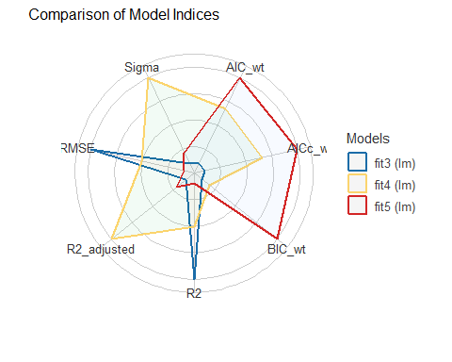

Check Model fit4 (1/3)
check_model(fit4, check = c("pp_check", "qq"), detrend = FALSE)
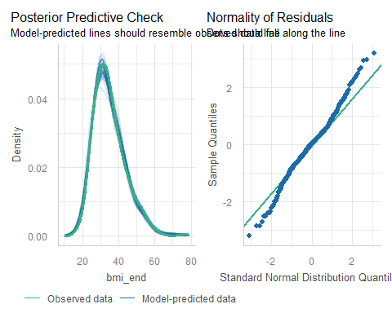

Check Model fit4 (2/3)
check_model(fit4, check = c("linearity", "homogeneity"))
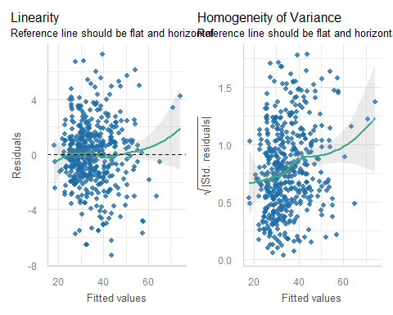

Check Model fit4 (3/3)
check_model(fit4, check = c("outliers", "vif"))
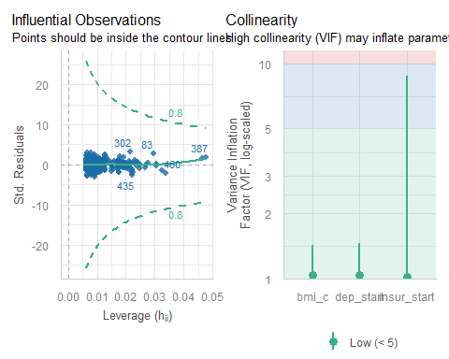

Session Information
xfun::session_info()
R version 4.5.1 (2025-06-13 ucrt)
Platform: x86_64-w64-mingw32/x64
Running under: Windows 11 x64 (build 26200)
Locale:
LC_COLLATE=English_United States.utf8
LC_CTYPE=English_United States.utf8
LC_MONETARY=English_United States.utf8
LC_NUMERIC=C
LC_TIME=English_United States.utf8
Package version:
askpass_1.2.1 backports_1.5.0 base64enc_0.1.3
bayestestR_0.17.0 bigD_0.3.1 bit_4.6.0
bit64_4.6.0.1 bitops_1.0.9 blob_1.2.4
broom_1.0.10 bslib_0.9.0 cachem_1.1.0
callr_3.7.6 cellranger_1.1.0 cli_3.6.5
clipr_0.8.0 coda_0.19-4.1 codetools_0.2-20
commonmark_2.0.0 compiler_4.5.1 conflicted_1.2.0
correlation_0.8.8 cpp11_0.5.2 crayon_1.5.3
curl_7.0.0 data.table_1.17.8 datasets_4.5.1
datawizard_1.3.0 DBI_1.2.3 dbplyr_2.5.1
digest_0.6.37 dplyr_1.1.4 dtplyr_1.3.2
easystats_0.7.5 effectsize_1.0.1 emmeans_1.11.2-8
estimability_1.5.1 evaluate_1.0.5 farver_2.1.2
fastmap_1.2.0 fontawesome_0.5.3 forcats_1.0.1
fs_1.6.6 gargle_1.6.0 generics_0.1.4
ggplot2_4.0.0 ggrepel_0.9.6 glue_1.8.0
googledrive_2.1.2 googlesheets4_1.1.2 graphics_4.5.1
grDevices_4.5.1 grid_4.5.1 gt_1.1.0
gtable_0.3.6 haven_2.5.5 highr_0.11
hms_1.1.4 htmltools_0.5.8.1 htmlwidgets_1.6.4
httr_1.4.7 ids_1.0.1 insight_1.4.2
isoband_0.2.7 janitor_2.2.1 jquerylib_0.1.4
jsonlite_2.0.0 juicyjuice_0.1.0 knitr_1.50
labeling_0.4.3 lattice_0.22-7 lifecycle_1.0.4
litedown_0.7 lubridate_1.9.4 magrittr_2.0.4
markdown_2.0 MASS_7.3-65 Matrix_1.7-4
memoise_2.0.1 methods_4.5.1 mgcv_1.9-3
mime_0.13 modelbased_0.13.0 modelr_0.1.11
multcomp_1.4-29 mvtnorm_1.3-3 nlme_3.1-168
numDeriv_2016.8.1.1 openssl_2.3.4 parameters_0.28.2
patchwork_1.3.2 performance_0.15.2 pillar_1.11.1
pkgconfig_2.0.3 prettyunits_1.2.0 processx_3.8.6
progress_1.2.3 ps_1.9.1 purrr_1.1.0
R6_2.6.1 ragg_1.5.0 rappdirs_0.3.3
RColorBrewer_1.1-3 Rcpp_1.1.0 reactable_0.4.4
reactR_0.6.1 readr_2.1.5 readxl_1.4.5
rematch_2.0.0 rematch2_2.1.2 report_0.6.1
reprex_2.1.1 rlang_1.1.6 rmarkdown_2.30
rstudioapi_0.17.1 rvest_1.0.5 S7_0.2.0
sandwich_3.1-1 sass_0.4.10 scales_1.4.0
see_0.12.0 selectr_0.4.2 snakecase_0.11.1
splines_4.5.1 stats_4.5.1 stringi_1.8.7
stringr_1.5.2 survival_3.8-3 sys_3.4.3
systemfonts_1.3.1 textshaping_1.0.4 TH.data_1.1-4
tibble_3.3.0 tidyr_1.3.1 tidyselect_1.2.1
tidyverse_2.0.0 timechange_0.3.0 tinytex_0.57
tools_4.5.1 tzdb_0.5.0 utf8_1.2.6
utils_4.5.1 uuid_1.2.1 V8_8.0.1
vctrs_0.6.5 viridisLite_0.4.2 vroom_1.6.6
withr_3.0.2 xfun_0.53 xml2_1.4.0
xtable_1.8-4 yaml_2.3.10 zoo_1.8-14

The assessment of linearity and non-constant variance used by check_model() are best used when we have at least one quantitative predictor in our model.

