431 Class 12
Thomas E. Love, Ph.D.
2025-10-09

Today’s Agenda
Contingency Tables (Sections 13-14 in Course Book)
- Some Reminders about 2 x 2 tables
- Building a J x K Table
- Chi-Square Tests of Independence
  - Cochran Conditions and Checking Assumptions

Today’s Packages
library(janitor)
library(patchwork)
library(easystats)
library(tidyverse)
theme_set(theme_bw())
source("c12/data/Love-431.R")

TB Prevalence in IV Drug Users
Suppose now that we are investigating factors affecting tuberculosis prevalence among intravenous drug users.
- Among 97 individuals who admit to sharing needles,
  - 24 (24.7%) had a positive tuberculin skin test result.
- Among 161 drug users who deny sharing needles,
  - 28 (17.4%) had a positive test result.
What does the 2x2 table look like?

TB Prevalence In IV Drug Users
The 2x2 Table is…
TB+ TB-
share 24 73
don't 28 133
- Standard Epidemiological Format
  - rows describe needle sharing
  - columns describe TB test result
- people who share needles: 24 TB+, and 97-24 = 73 TB-
- people who don’t share: 28 TB+ and 161-28 = 133 TB-

twobytwo (with Bayesian Augmentation)
To start, we’ll test the null hypothesis that the population proportions of intravenous drug users who have a positive tuberculin skin test result are identical for those who share needles and those who do not.
$$
H_0: \pi_{share} = \pi_{donotshare} \\
H_A: \pi_{share} \neq \pi_{donotshare}
$$
We’ll use the Bayesian augmentation.

twobytwo results (95% CI)
twobytwo(24+2, 73+2, 28+2, 133+2,
"Sharing", "Not Sharing",
"TB test+", "TB test-", conf.level = 0.95)
2 by 2 table analysis:
------------------------------------------------------
Outcome : TB test+
Comparing : Sharing vs. Not Sharing
TB test+ TB test- P(TB test+) 95% conf. interval
Sharing 26 75 0.2574 0.1816 0.3513
Not Sharing 30 135 0.1818 0.1301 0.2482
95% conf. interval
Relative Risk: 1.4158 0.8910 2.2498
Sample Odds Ratio: 1.5600 0.8594 2.8318
Conditional MLE Odds Ratio: 1.5572 0.8189 2.9511
Probability difference: 0.0756 -0.0244 0.1819
Exact P-value: 0.1638
Asymptotic P-value: 0.1438
------------------------------------------------------

Change to 90% confidence?
- What if we use a 90% confidence level instead?
2 by 2 table analysis:
------------------------------------------------------
Outcome : TB test+
Comparing : Sharing vs. Not Sharing
TB test+ TB test- P(TB test+) 90% conf. interval
Sharing 26 75 0.2574 0.1925 0.3351
Not Sharing 30 135 0.1818 0.1375 0.2365
90% conf. interval
Relative Risk: 1.4158 0.9599 2.0884
Sample Odds Ratio: 1.5600 0.9458 2.5729
Conditional MLE Odds Ratio: 1.5572 0.9023 2.6818
Probability difference: 0.0756 -0.0088 0.1646
Exact P-value: 0.1638
Asymptotic P-value: 0.1438
------------------------------------------------------

Larger Contingency Tables

A $2×3$ contingency table
This table displays the count of patients who show complete, partial, or no response after treatment with either active medication or a placebo in a study of 100 patients…
Group | None | Partial | Complete
Active | 8 | 24 | 20
Placebo | 12 | 26 | 10
Is there a meaningful association here?

The Pearson Chi-Square Test
- $H_{0}$: Response Distribution is the same, regardless of Treatment.
- $H_{A}$: There is an association between Treatment and Response.
The Pearson $χ^{2}$ test assumes the null hypothesis is true (rows and columns are independent.) That is a model for our data. How does it work?

Calculating Chi-Square
Here’s the table, with marginal totals added.
– | None | Partial | Complete | TOTAL
Active | 8 | 24 | 20 | 52
Placebo | 12 | 26 | 10 | 48
TOTAL | 20 | 50 | 30 | 100
The test needs to estimate the expected frequency in each of the six cells under the assumption of independence. If the rows and columns were independent, what is the expected count in the Active/None cell?

The Independence Model
– | None | Partial | Complete | TOTAL
Active | – | – | – | 52
Placebo | – | – | – | 48
TOTAL | 20 | 50 | 30 | 100
If the rows and columns were independent, then:
- 20/100 of subjects would have response = “None”
  - That’s 20% of the 52 Active, and 20% of the 48 Placebo
- 50% would have a “Partial” and 30% would have a “Complete” response in each group.

Observed (Expected) Cell Counts
So, can we fill in the expected frequencies under our independence model?
– | None | Partial | Complete | TOTAL
Active | 8 (10.4) | 24 (26.0) | 20 (15.6) | 52
Placebo | 12 (9.6) | 26 (24.0) | 10 (14.4) | 48
TOTAL | 20 | 50 | 30 | 100

General Formula for Expected Frequencies under Independence
$$\text{Expected Frequency}=\frac{\text{Row total}×\text{Column total}}{\text{Grand Total}}$$
This assumes that the independence model holds: the probability of being in a particular column is exactly the same in each row, and vice versa.

Chi-Square Assumptions
- Expected Frequencies: We assume that the expected frequency, under the null hypothesized model of independence, will be at least 5 (and ideally at least 10) in each cell. If that is not the case, then the $χ^{2}$ test is likely to give unreliable results.
- The Cochran conditions require us to have no cells with zero counts and at least 80% of the cells in our table with expected counts of 5 or higher. That’s what R uses to warn you of trouble.
- Miss the standards? Consider collapsing categories.

Observed (Expected) Cell Counts (again)
– | None | Partial | Complete | TOTAL
Active | 8 (10.4) | 24 (26.0) | 20 (15.6) | 52
Placebo | 12 (9.6) | 26 (24.0) | 10 (14.4) | 48
TOTAL | 20 | 50 | 30 | 100
- Do we meet the Cochran conditions in this case?

Getting the Table into R
We’ll put the table into a matrix in R. Here’s one approach…
T1 <- matrix(c(8, 24, 20, 12, 26, 10),
ncol=3, nrow=2, byrow=TRUE)
rownames(T1) <- c("Active", "Placebo")
colnames(T1) <- c("None", "Partial", "Complete")
T1
None Partial Complete
Active 8 24 20
Placebo 12 26 10
chisq.test(T1)
Pearson's Chi-squared test
data: T1
X-squared = 4.0598, df = 2, p-value = 0.1313

Chi-Square Test Results in R
- $H_{0}$: Response Distribution is the same, regardless of Treatment.
  - Rows and Columns of the table are independent
- $H_{A}$: There is an association between Treatment and Response.
  - Rows and Columns of the table are associated.
- For our T1: $χ^{2}$ = 4.0598, df = 2, p = 0.1313
What is the conclusion?

Does Sample Size Affect $χ^{2}$?
- T1 results were: $χ^{2}$ = 4.0598, df = 2, p = 0.1313
- Suppose we had same pattern, but twice the data?
T1_doubled <- T1*2
T1_doubled
None Partial Complete
Active 16 48 40
Placebo 24 52 20
chisq.test(T1_doubled)
Pearson's Chi-squared test
data: T1_doubled
X-squared = 8.1197, df = 2, p-value = 0.01725

Fisher’s exact test instead?
Yes, but … if the Pearson assumptions don’t hold, then the Fisher’s test is not generally an improvement.
fisher.test(T1)
Fisher's Exact Test for Count Data
data: T1
p-value = 0.1358
alternative hypothesis: two.sided
- Intended for small-ish square tables, with the same number of rows as columns.

Returning to the DM464 data
- We discussed these data (other variables) in Classes 5-6.
dm12 <- read_csv("c12/data/dm464_class12.csv", show_col_types = FALSE) |>
janitor::clean_names() |>
mutate(tobacco = fct_relevel(tobacco, "Current", "Former"),
insurance = fct_relevel(insurance, "Medicare",
"Commercial", "Medicaid"))
dm12 |> tabyl(tobacco, insurance) |>
adorn_totals(where = c("row", "col"))
tobacco Medicare Commercial Medicaid Total
Current 33 8 76 117
Former 92 23 71 186
Never 68 30 63 161
Total 193 61 210 464

dm12: Bar Plots with Counts
p1 <- ggplot(dm12, aes(x = insurance)) +
geom_bar(aes(fill = insurance)) +
geom_text(aes(label = ..count..), stat = "count",
vjust = 1.5, col = "black") +
scale_fill_oi() + ## from see package
guides(fill = "none")
p2 <- ggplot(dm12, aes(x = tobacco)) +
geom_bar(aes(fill = tobacco)) +
geom_text(aes(label = ..count..), stat = "count",
vjust = 1.5, col = "white") +
scale_fill_metro() + ## from see package
guides(fill = "none")
p1 + p2
Warning: The dot-dot notation (`..count..`) was deprecated in ggplot2 3.4.0.
ℹ Please use `after_stat(count)` instead.
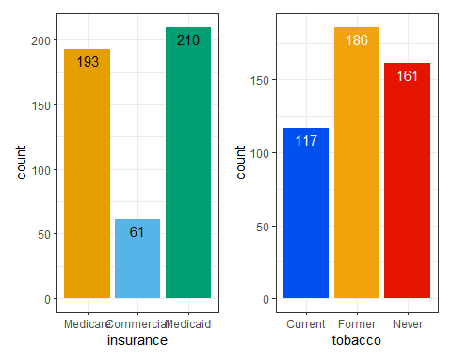

A $3×3$ table with the dm12 data
dm12 |>
tabyl(insurance, tobacco) |>
adorn_totals(where = c("row", "col"))
insurance Current Former Never Total
Medicare 33 92 68 193
Commercial 8 23 30 61
Medicaid 76 71 63 210
Total 117 186 161 464

Plotting a Cross-Tabulation?
ggplot(dm12, aes(x = insurance, y = tobacco)) +
geom_count()
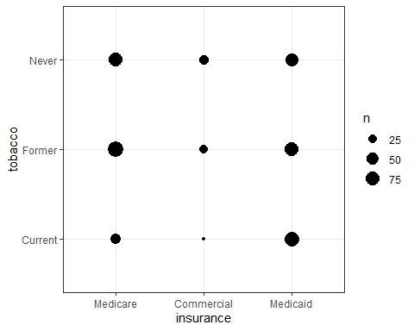

Tobacco Bar Chart faceted by Insurance
ggplot(dm12, aes(x = tobacco, fill = tobacco)) +
geom_bar() +
facet_wrap(~ insurance) +
scale_fill_pizza() + ## also from see package
guides(fill = "none") +
geom_text(aes(label = ..count..), stat = "count",
vjust = -0.5, col = "navy")
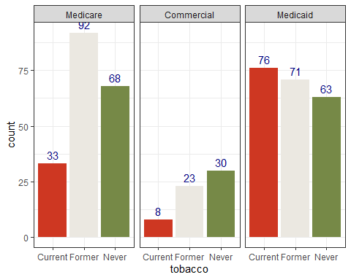

dm12 Tobacco and Insurance
- $H_{0}$: Insurance type and Tobacco status are independent
- $H_{A}$: Insurance type and Tobacco status are associated
dm12 |> tabyl(insurance, tobacco) |> chisq.test()
Pearson's Chi-squared test
data: tabyl(dm12, insurance, tobacco)
X-squared = 28.574, df = 4, p-value = 9.542e-06
Can we check our expected frequencies?

Checking Expected Frequencies
res <- dm12 |> tabyl(insurance, tobacco) |> chisq.test()
res$observed
insurance Current Former Never
Medicare 33 92 68
Commercial 8 23 30
Medicaid 76 71 63
res$expected
insurance Current Former Never
Medicare 48.66595 77.36638 66.96767
Commercial 15.38147 24.45259 21.16595
Medicaid 52.95259 84.18103 72.86638
Any problems with Cochran conditions?

Mosaic Plot for Cross-Tabulation
Each rectangle’s area is proportional to the number of cases in that cell.
plot(dm12$insurance, dm12$tobacco, ylab = "", xlab = "")
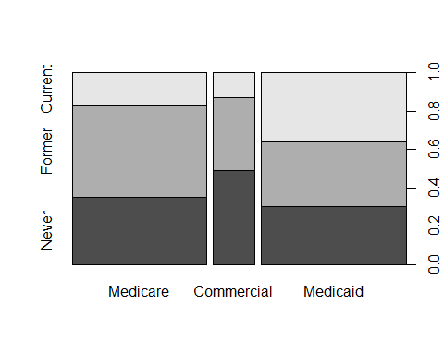

Session Information
xfun::session_info()
R version 4.5.1 (2025-06-13 ucrt)
Platform: x86_64-w64-mingw32/x64
Running under: Windows 11 x64 (build 26100)
Locale:
LC_COLLATE=English_United States.utf8
LC_CTYPE=English_United States.utf8
LC_MONETARY=English_United States.utf8
LC_NUMERIC=C
LC_TIME=English_United States.utf8
Package version:
askpass_1.2.1 backports_1.5.0 base64enc_0.1.3
bayestestR_0.17.0 bit_4.6.0 bit64_4.6.0-1
blob_1.2.4 broom_1.0.10 bslib_0.9.0
cachem_1.1.0 callr_3.7.6 cellranger_1.1.0
cli_3.6.5 clipr_0.8.0 cmprsk_2.2-12
coda_0.19-4.1 codetools_0.2-20 compiler_4.5.1
conflicted_1.2.0 correlation_0.8.8 cpp11_0.5.2
crayon_1.5.3 curl_7.0.0 data.table_1.17.8
datasets_4.5.1 datawizard_1.2.0 DBI_1.2.3
dbplyr_2.5.1 digest_0.6.37 dplyr_1.1.4
dtplyr_1.3.2 easystats_0.7.5 effectsize_1.0.1
emmeans_1.11.2-8 Epi_2.60 estimability_1.5.1
etm_1.1.2 evaluate_1.0.5 farver_2.1.2
fastmap_1.2.0 fontawesome_0.5.3 forcats_1.0.0
fs_1.6.6 gargle_1.6.0 generics_0.1.4
ggplot2_4.0.0 glue_1.8.0 googledrive_2.1.2
googlesheets4_1.1.2 graphics_4.5.1 grDevices_4.5.1
grid_4.5.1 gtable_0.3.6 haven_2.5.5
highr_0.11 hms_1.1.3 htmltools_0.5.8.1
httr_1.4.7 ids_1.0.1 insight_1.4.2
isoband_0.2.7 janitor_2.2.1 jquerylib_0.1.4
jsonlite_2.0.0 knitr_1.50 labeling_0.4.3
lattice_0.22-7 lifecycle_1.0.4 lubridate_1.9.4
magrittr_2.0.4 MASS_7.3-65 Matrix_1.7-4
memoise_2.0.1 methods_4.5.1 mgcv_1.9-3
mime_0.13 modelbased_0.13.0 modelr_0.1.11
multcomp_1.4-28 mvtnorm_1.3-3 nlme_3.1-168
numDeriv_2016.8-1.1 openssl_2.3.3 parallel_4.5.1
parameters_0.28.2 patchwork_1.3.2 performance_0.15.1
pillar_1.11.1 pkgconfig_2.0.3 plyr_1.8.9
prettyunits_1.2.0 processx_3.8.6 progress_1.2.3
ps_1.9.1 purrr_1.1.0 R6_2.6.1
ragg_1.5.0 rappdirs_0.3.3 RColorBrewer_1.1-3
Rcpp_1.1.0 RcppArmadillo_15.0.2.2 readr_2.1.5
readxl_1.4.5 rematch_2.0.0 rematch2_2.1.2
report_0.6.1 reprex_2.1.1 rlang_1.1.6
rmarkdown_2.29 rstudioapi_0.17.1 rvest_1.0.5
S7_0.2.0 sandwich_3.1-1 sass_0.4.10
scales_1.4.0 see_0.12.0 selectr_0.4.2
snakecase_0.11.1 splines_4.5.1 stats_4.5.1
stringi_1.8.7 stringr_1.5.2 survival_3.8-3
sys_3.4.3 systemfonts_1.2.3 textshaping_1.0.3
TH.data_1.1-4 tibble_3.3.0 tidyr_1.3.1
tidyselect_1.2.1 tidyverse_2.0.0 timechange_0.3.0
tinytex_0.57 tools_4.5.1 tzdb_0.5.0
utf8_1.2.6 utils_4.5.1 uuid_1.2.1
vctrs_0.6.5 viridisLite_0.4.2 vroom_1.6.6
withr_3.0.2 xfun_0.53 xml2_1.4.0
xtable_1.8-4 yaml_2.3.10 zoo_1.8-14

