431 Class 21
Thomas E. Love, Ph.D.
2025-11-13

Today’s Agenda
- The here package and the gtExtras package are new.
- df_stats(): numerical summaries for a tibble.
- Example: msleep data from ggplot2 in the tidyverse
  - Fitting and comparing linear models
  - Incorporating both single and multiple imputation
 Note
Today’s (arbitrary) confidence level = 89%.

Today’s Packages
library(here) ## new today
library(janitor)
library(naniar)
library(patchwork)
library(car)
library(mice)
library(gt)
library(gtExtras) ## new: some fancy gt themes
library(GGally)
library(mosaic) ## df_stats() for summaries
library(broom)
library(easystats)
library(tidyverse)
source(here("c21/data/Love-431.R"))
theme_set(theme_azurelight())

The here package


The here package
https://here.r-lib.org/
The here package creates paths relative to the top-level directory. The package displays the top-level of the current project on load or any time you call here():
here()
[1] "D:/Teaching/431/2025-431/431-slides-2025"
The goal of the here package is to enable easy file referencing in project-oriented workflows. In contrast to using setwd(), which is fragile and dependent on the way you organize your files, here uses the top-level directory of a project to easily build paths to files.

Jenny Bryan’s Ode to the here package
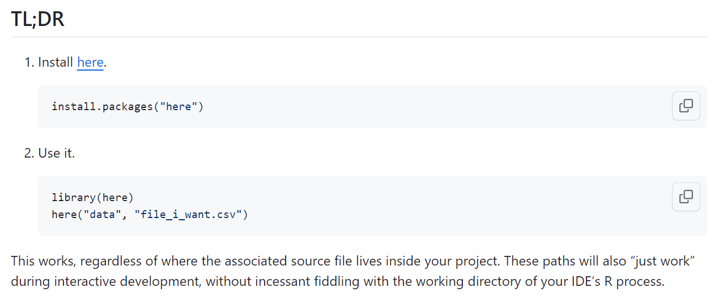

Jenny Bryan on Project-oriented workflow
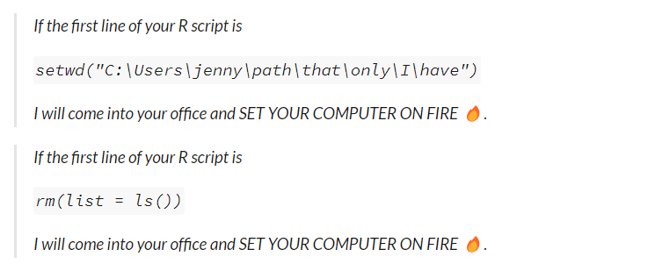

R projects and here()
- Organize each project into a folder on your computer.
- Make sure the top-level folder advertises itself as such. If you use RStudio and/or Git, those both leave characteristic files that do that.
- Use the here() function to build the path when you read or write a file, relative to the top-level directory.
- Whenever you work on this project, launch RStudio from the project’s top-level directory.

Mammals and How They Sleep

Mammals sleep data (msleep)
gt_preview(msleep) |> tab_options(table.font.size = 18)
 | name | genus | vore | order | conservation | sleep_total | sleep_rem | sleep_cycle | awake | brainwt | bodywt
1 | Cheetah | Acinonyx | carni | Carnivora | lc | 12.1 | NA | NA | 11.9 | NA | 50.000
2 | Owl monkey | Aotus | omni | Primates | NA | 17.0 | 1.8 | NA | 7.0 | 0.01550 | 0.480
3 | Mountain beaver | Aplodontia | herbi | Rodentia | nt | 14.4 | 2.4 | NA | 9.6 | NA | 1.350
4 | Greater short-tailed shrew | Blarina | omni | Soricomorpha | lc | 14.9 | 2.3 | 0.1333333 | 9.1 | 0.00029 | 0.019
5 | Cow | Bos | herbi | Artiodactyla | domesticated | 4.0 | 0.7 | 0.6666667 | 20.0 | 0.42300 | 600.000
6..82
83 | Red fox | Vulpes | carni | Carnivora | NA | 9.8 | 2.4 | 0.3500000 | 14.2 | 0.05040 | 4.230
- https://ggplot2.tidyverse.org/reference/msleep.html has details.

msleep Variables of Interest
Variable | Description
name | Common name of mammal
vore | Carni-, insecti-, herbi- or omnivore
brainwt | brain weight in kilograms
bodywt | body weight in kilograms
sleep_rem | REM sleep, in hours
sleep_total | total amount of sleep, in hours
awake | (outcome) time spent awake, in hours

Modeling Plan
 Note
Note that awake = 24 - sleep_total.
Goal: Model awake with 4 pieces of information:
- the type of food the mammal consumes (vore)
- the weight of the mammal’s brain (brainwt)
- the weight of the mammal’s body (bodywt), and
- the proportion of total time asleep spent in REM sleep (sleep_rem / sleep_total)

Create ms431 data
ms431 <- msleep |>
mutate(rem_prop = sleep_rem / sleep_total) |>
select(name, awake, vore, brainwt, bodywt, rem_prop) |>
mutate(vore = fct_infreq(vore))
gt_preview(ms431, top_n = 5, bottom_n = 2) |>
tab_options(table.font.size = 18) |>
fmt_number(col = brainwt:rem_prop, n_sigfig = 3) |>
gt_theme_guardian()
 | name | awake | vore | brainwt | bodywt | rem_prop
1 | Cheetah | 11.9 | carni | NA | 50.0 | NA
2 | Owl monkey | 7.0 | omni | 0.0155 | 0.480 | 0.106
3 | Mountain beaver | 9.6 | herbi | NA | 1.35 | 0.167
4 | Greater short-tailed shrew | 9.1 | omni | 0.000290 | 0.0190 | 0.154
5 | Cow | 20.0 | herbi | 0.423 | 600 | 0.175
6..81
82 | Arctic fox | 11.5 | carni | 0.0445 | 3.38 | NA
83 | Red fox | 14.2 | carni | 0.0504 | 4.23 | 0.245

Change vore to use 3 levels
ms431 |> tabyl(vore) |> adorn_pct_formatting()
vore n percent valid_percent
herbi 32 38.6% 42.1%
omni 20 24.1% 26.3%
carni 19 22.9% 25.0%
insecti 5 6.0% 6.6%
<NA> 7 8.4% -
ms431 <- ms431 |> mutate(vore3 = fct_lump_n(vore, n = 2))
ms431 |> tabyl(vore, vore3) |> adorn_title(placement = "combined")
vore/vore3 herbi omni Other NA_
herbi 32 0 0 0
omni 0 20 0 0
carni 0 0 19 0
insecti 0 0 5 0
<NA> 0 0 0 7

Scatterplot Matrix (Problem?)
ggpairs(ms431 |> select(vore3, brainwt, bodywt, rem_prop, awake),
title = "Are body weight and brain weight too highly correlated?",
lower = list(combo = wrap("facethist", bins = 10)))
Warning: Removed 7 rows containing missing values or values outside the scale range
(`stat_boxplot()`).
Warning: Removed 25 rows containing non-finite outside the scale range
(`stat_boxplot()`).
Warning: Removed 7 rows containing missing values or values outside the scale range
(`stat_boxplot()`).
Removed 7 rows containing missing values or values outside the scale range
(`stat_boxplot()`).
Warning: Removed 20 rows containing non-finite outside the scale range
(`stat_boxplot()`).
Warning: Removed 7 rows containing missing values or values outside the scale range
(`stat_boxplot()`).
Warning: Removed 27 rows containing non-finite outside the scale range
(`stat_bin()`).
Warning: Removed 27 rows containing non-finite outside the scale range
(`stat_density()`).
Warning: Removed 27 rows containing missing values
Warning: Removed 35 rows containing missing values
Warning: Removed 27 rows containing missing values
Warning: Removed 27 rows containing missing values or values outside the scale range
(`geom_point()`).
Warning: Removed 22 rows containing missing values
Warning: Removed 22 rows containing non-finite outside the scale range
(`stat_bin()`).
Warning: Removed 35 rows containing missing values or values outside the scale range
(`geom_point()`).
Warning: Removed 22 rows containing missing values or values outside the scale range
(`geom_point()`).
Warning: Removed 22 rows containing non-finite outside the scale range
(`stat_density()`).
Warning: Removed 22 rows containing missing values
Warning: Removed 27 rows containing missing values or values outside the scale range
(`geom_point()`).
Warning: Removed 22 rows containing missing values or values outside the scale range
(`geom_point()`).
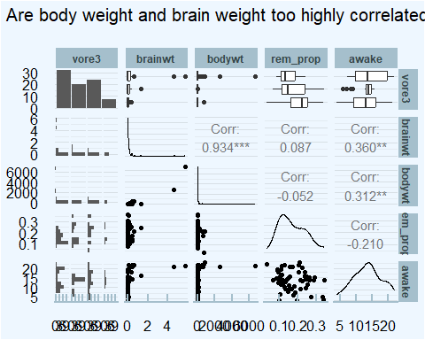

Correlation (bodywt, brainwt)
ms431 |> select(bodywt, brainwt) |> correlation(ci = 0.89)
# Correlation Matrix (pearson-method)
Parameter1 | Parameter2 | r | 89% CI | t(54) | p
-----------------------------------------------------------------
bodywt | brainwt | 0.93 | [0.90, 0.96] | 19.18 | < .001***
p-value adjustment method: Holm (1979)
Observations: 56
- Potentially huge collinearity problem
- Both bodywt and brainwt are extremely right-skewed

Add in brain_prop = brainwt/bodywt
- If we switch to brain_prop and bodywt as our predictors, do we still have a collinearity problem?
ms431 <- ms431 |> mutate(brain_prop = brainwt / bodywt)
ms431 |> select(bodywt, brainwt, brain_prop) |> correlation(ci = 0.89)
# Correlation Matrix (pearson-method)
Parameter1 | Parameter2 | r | 89% CI | t(54) | p
-------------------------------------------------------------------
bodywt | brainwt | 0.93 | [ 0.90, 0.96] | 19.18 | < .001***
bodywt | brain_prop | -0.21 | [-0.41, 0.00] | -1.59 | 0.234
brainwt | brain_prop | -0.20 | [-0.40, 0.01] | -1.52 | 0.234
p-value adjustment method: Holm (1979)
Observations: 56

Modeling Plan, Revised
Model awake using these four variables:
- vore3 (omni-, herbi-, Other)
- bodywt (in kg)
- brain_prop = (brainwt / bodywt)
- rem_prop = (sleep_rem / sleep_total)
ms431 <- ms431 |>
select(awake, vore3, bodywt, brain_prop, rem_prop, name)

Missing Data?

Are there missing data?
miss_var_summary(ms431) |> filter(n_miss > 0) |> gt() |>
tab_options(table.font.size = 18) |> gt_theme_dark()
variable | n_miss | pct_miss
brain_prop | 27 | 32.5
rem_prop | 22 | 26.5
vore3 | 7 | 8.43
miss_case_table(ms431) |> gt() |> tab_options(table.font.size = 18) |>
fmt_number(columns = pct_cases, decimals = 2) |> gt_theme_dark()
n_miss_in_case | n_cases | pct_cases
0 | 43 | 51.81
1 | 26 | 31.33
2 | 12 | 14.46
3 | 2 | 2.41

Missing Data Mechanisms
- Missing completely at random There are no systematic differences between the missing values and the observed values.
  - For example, blood pressure measurements may be missing because of breakdown of an automatic sphygmomanometer.
- Missing at random Any systematic difference between the missing and observed values can be explained by other observed data.
  - For example, missing BP measurements may be lower than measured BPs but only because younger people more often have a missing BP.
- Missing not at random Even after the observed data are accounted, systematic differences remain between missing and observed values.
  - For example, people with high BP may be more likely to have headaches that cause them to miss clinic appointments.
“Missing at random” is an assumption that justifies the analysis, rather than a property of the data.

What assumption should we use?
Little’s test, with $H_{0}$: data are MCAR
mcar_test(ms431) ## naniar provides this function
# A tibble: 1 × 4
statistic df p.value missing.patterns
<dbl> <dbl> <dbl> <int>
1 24.3 22 0.329 6
If we had a small $p$ value for the $χ^{2}$ test statistic, we would conclude that the ms431 data are not MCAR.
 Reference
Little, Roderick J. A. 1988. “A Test of Missing Completely at Random for Multivariate Data with Missing Values.” Journal of the American Statistical Association 83 (404): 1198–1202. doi:10.1080/01621459.1988.10478722.

If not MCAR, then what?
Suppose we assume that the data are MAR. This suggests the need for imputation of missing values.
 Note
If we were willing to assume MCAR, we could also do a complete case analysis, but imputation might help a bit with power.
Here, we have complete data on our outcome (awake) and bodywt so we won’t need to impute them.
- We will need to impute vore3 (7), brain_prop (27) and rem_prop (22) from our sample of 83 mammals.
- vore3 is a factor, the others are quantities.

Single Imputation
We’ll use a singly imputed data set to select predictors.
set.seed(12345)
ms431_imp1 <- mice(ms431, m = 1, printFlag = FALSE)
Warning: Number of logged events: 9
ms431_imp <- complete(ms431_imp1)
prop_complete(ms431)
[1] 0.8875502
prop_complete(ms431_imp)
[1] 1
 Note
After we’ve settled on a final prediction model using ms431_imp, we’ll implement multiple imputation.

Consider Transformations?

Scatterplot Matrix: ms431_imp
ggpairs(ms431_imp |> select(vore3, brain_prop, bodywt, rem_prop, awake),
title = "bodywt is enormously right-skewed",
lower = list(combo = wrap("facethist", bins = 10)))
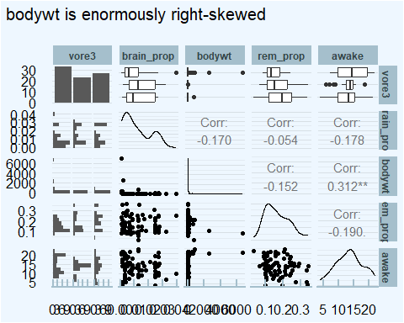

Compare bodywt to log(bodywt)?
p1 <- ggplot(ms431_imp, aes(sample = bodywt)) +
geom_qq() +
geom_qq_line(col = "purple") +
labs(title = "Untransformed bodywt",
x = "Standard Normal Distribution",
y = "Body Weight (kg)")
p2 <- ggplot(ms431_imp, aes(sample = log(bodywt))) +
geom_qq() +
geom_qq_line(col = "purple") +
labs(title = "Log of bodywt",
x = "Standard Normal Distribution",
y = "log(Body Weight)")
p1 + p2
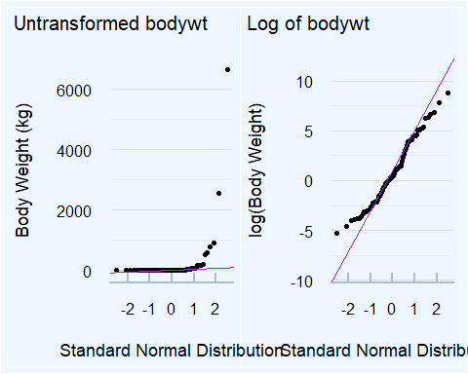

New Scatterplot Matrix: ms431_imp
ms431_imp <- ms431_imp |> mutate(log_body = log(bodywt))
ggpairs(ms431_imp |> select(vore3, brain_prop, log_body, rem_prop, awake),
title = "Any signs of big problems now?",
lower = list(combo = wrap("facethist", bins = 10)))
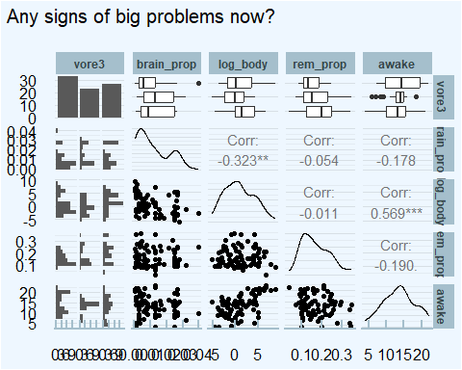

Outcome Transformation?
temp_fit <- lm(awake ~ log_body + brain_prop + rem_prop + vore3,
data = ms431_imp)
boxCox(temp_fit)
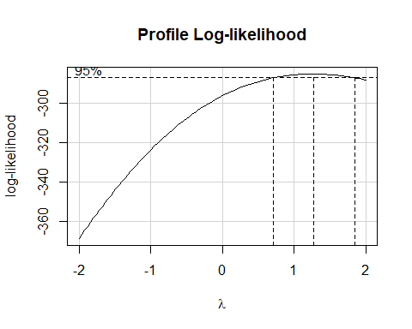

Range check of quantities
df_stats(~ awake + log_body + brain_prop + rem_prop,
data = ms431_imp) |>
gt() |> fmt_number(columns = min:sd, decimals = 3) |>
tab_options(table.font.size = 24) |> gt_theme_guardian()
response | min | Q1 | median | Q3 | max | mean | sd | n | missing
awake | 4.100 | 10.250 | 13.900 | 16.150 | 22.100 | 13.567 | 4.452 | 83 | 0
log_body | -5.298 | -1.760 | 0.513 | 3.712 | 8.803 | 0.843 | 3.256 | 83 | 0
brain_prop | 0.001 | 0.003 | 0.008 | 0.020 | 0.040 | 0.012 | 0.010 | 83 | 0
rem_prop | 0.037 | 0.112 | 0.156 | 0.215 | 0.347 | 0.170 | 0.070 | 83 | 0

Exploring our factor in ms431_imp
ms431_imp |> tabyl(vore3) |> adorn_pct_formatting()
vore3 n percent
herbi 33 39.8%
omni 23 27.7%
Other 27 32.5%
- Original data…
msleep |> tabyl(vore) |> adorn_pct_formatting()
vore n percent valid_percent
carni 19 22.9% 25.0%
herbi 32 38.6% 42.1%
insecti 5 6.0% 6.6%
omni 20 24.1% 26.3%
<NA> 7 8.4% -

Should we rescale any predictors?
Fit the model with all four predictors, and look at coefficients:
fit_all <- lm(awake ~ log_body + brain_prop + rem_prop + vore3,
data = ms431_imp)
model_parameters(fit_all, pretty_names = FALSE, ci = 0.89)
Parameter | Coefficient | SE | 89% CI | t(77) | p
--------------------------------------------------------------------
(Intercept) | 14.86 | 1.22 | [ 12.89, 16.83] | 12.20 | < .001
log_body | 0.83 | 0.13 | [ 0.62, 1.04] | 6.34 | < .001
brain_prop | 12.40 | 43.66 | [-58.20, 83.00] | 0.28 | 0.777
rem_prop | -7.98 | 5.94 | [-17.58, 1.63] | -1.34 | 0.183
vore3omni | -0.32 | 1.00 | [ -1.94, 1.31] | -0.32 | 0.752
vore3Other | -2.13 | 0.99 | [ -3.73, -0.53] | -2.15 | 0.034
Uncertainty intervals (equal-tailed) and p-values (two-tailed) computed
using a Wald t-distribution approximation.

Partition into test and training samples

Distinct names for ms431_imp?
- Do we have a unique name to identify each mammal?
n_distinct(ms431_imp$name) == nrow(ms431_imp) # compare numbers
[1] TRUE
near(n_distinct(ms431_imp$name), nrow(ms431_imp)) # tidyverse approach
[1] TRUE
- Does this look right?
- Did we need both of these approaches?

Partitioning the sample
- Partition 70% into training, the others to test, while maintaining a similar distribution of vore3 groups.
set.seed(20251113)
ms431_train <- slice_sample(ms431_imp, prop = 0.7, by = "vore3")
ms431_test <- anti_join(ms431_imp, ms431_train, by = "name")
ms431_train |> tabyl(vore3) |> adorn_pct_formatting() |> adorn_totals()
vore3 n percent
herbi 23 40.4%
omni 16 28.1%
Other 18 31.6%
Total 57 -
ms431_test |> tabyl(vore3) |> adorn_pct_formatting() |> adorn_totals()
vore3 n percent
herbi 10 38.5%
omni 7 26.9%
Other 9 34.6%
Total 26 -

Four Models to Consider

Four Models We’ll Fit
Predicting awake with…
- Model fit1: A simple regression on log_body
- Model fit2: A model with log_body and brain_prop
- Model fit3: log_body, brain_prop and rem_prop
- Model fit4: All four predictors (including vore3)
using the ms431_train data (imputed)

Model fit1
fit1 <- lm(awake ~ log_body,
data = ms431_train)
model_parameters(fit1, ci = 0.89, pretty_names = FALSE,
include_info = TRUE)
Parameter | Coefficient | SE | 89% CI | t(55) | p
------------------------------------------------------------------
(Intercept) | 13.00 | 0.51 | [12.16, 13.83] | 25.29 | < .001
log_body | 0.78 | 0.15 | [ 0.53, 1.02] | 5.21 | < .001
Model: awake ~ log_body (57 Observations)
Sigma: 3.780 (df = 55)
RMSE : 3.713
R2: 0.331; adjusted R2: 0.319
Uncertainty intervals (equal-tailed) and p-values (two-tailed) computed
using a Wald t-distribution approximation.

Using tidy() from broom
tidy(fit1, conf.level = 0.89, conf.int = TRUE) |>
gt() |> fmt_number(decimals = 2) |> gt_theme_guardian()
term | estimate | std.error | statistic | p.value | conf.low | conf.high
(Intercept) | 13.00 | 0.51 | 25.29 | 0.00 | 12.16 | 13.83
log_body | 0.78 | 0.15 | 5.21 | 0.00 | 0.53 | 1.02
model_parameters(fit1, ci = 0.89, pretty_names = FALSE) |>
gt() |> fmt_number(decimals = 2) |> gt_theme_guardian()
Parameter | Coefficient | SE | CI | CI_low | CI_high | t | df_error | p
(Intercept) | 13.00 | 0.51 | 0.89 | 12.16 | 13.83 | 25.29 | 55.00 | 0.00
log_body | 0.78 | 0.15 | 0.89 | 0.53 | 1.02 | 5.21 | 55.00 | 0.00

Model fit2
fit2 <- lm(awake ~ log_body + brain_prop,
data = ms431_train)
model_parameters(fit2, ci = 0.89, pretty_names = FALSE,
include_info = TRUE)
Parameter | Coefficient | SE | 89% CI | t(54) | p
--------------------------------------------------------------------
(Intercept) | 13.08 | 0.82 | [ 11.74, 14.42] | 15.87 | < .001
log_body | 0.77 | 0.16 | [ 0.51, 1.02] | 4.90 | < .001
brain_prop | -6.90 | 52.67 | [-92.49, 78.69] | -0.13 | 0.896
Model: awake ~ log_body + brain_prop (57 Observations)
Sigma: 3.814 (df = 54)
RMSE : 3.712
R2: 0.331; adjusted R2: 0.306
Uncertainty intervals (equal-tailed) and p-values (two-tailed) computed
using a Wald t-distribution approximation.

Model fit3
fit3 <- lm(awake ~ log_body + brain_prop + rem_prop,
data = ms431_train)
model_parameters(fit3, ci = 0.89, pretty_names = FALSE,
include_info = TRUE)
Parameter | Coefficient | SE | 89% CI | t(53) | p
--------------------------------------------------------------------
(Intercept) | 15.12 | 1.45 | [ 12.76, 17.47] | 10.44 | < .001
log_body | 0.76 | 0.15 | [ 0.51, 1.01] | 4.95 | < .001
brain_prop | -8.63 | 51.79 | [-92.81, 75.56] | -0.17 | 0.868
rem_prop | -11.46 | 6.75 | [-22.43, -0.48] | -1.70 | 0.096
Model: awake ~ log_body + brain_prop + rem_prop (57 Observations)
Sigma: 3.749 (df = 53)
RMSE : 3.616
R2: 0.365; adjusted R2: 0.329
Uncertainty intervals (equal-tailed) and p-values (two-tailed) computed
using a Wald t-distribution approximation.

Model fit4
fit4 <- lm(awake ~ log_body + brain_prop + vore3 + rem_prop,
data = ms431_train)
model_parameters(fit4, ci = 0.89, pretty_names = FALSE,
include_info = TRUE)
Parameter | Coefficient | SE | 89% CI | t(51) | p
--------------------------------------------------------------------
(Intercept) | 14.91 | 1.46 | [ 12.55, 17.28] | 10.25 | < .001
log_body | 0.82 | 0.16 | [ 0.56, 1.07] | 5.25 | < .001
brain_prop | -9.88 | 51.90 | [-94.30, 74.54] | -0.19 | 0.850
vore3omni | 0.74 | 1.25 | [ -1.29, 2.77] | 0.59 | 0.557
vore3Other | -1.52 | 1.24 | [ -3.55, 0.50] | -1.23 | 0.226
rem_prop | -8.88 | 7.06 | [-20.36, 2.60] | -1.26 | 0.214
Model: awake ~ log_body + brain_prop + vore3 + rem_prop (57 Observations)
Sigma: 3.712 (df = 51)
RMSE : 3.511
R2: 0.401; adjusted R2: 0.343
Uncertainty intervals (equal-tailed) and p-values (two-tailed) computed
using a Wald t-distribution approximation.

Model Performance?
model_performance(fit1)
# Indices of model performance
AIC | AICc | BIC | R2 | R2 (adj.) | RMSE | Sigma
---------------------------------------------------------
317.3 | 317.8 | 323.4 | 0.331 | 0.319 | 3.713 | 3.780
- glance() function from broom package
glance(fit1) |> gt()
r.squared | adj.r.squared | sigma | statistic | p.value | df | logLik | AIC | BIC | deviance | df.residual | nobs
0.330692 | 0.3185228 | 3.779859 | 27.17442 | 2.887391e-06 | 1 | -155.6537 | 317.3073 | 323.4365 | 785.8034 | 55 | 57

Combining glance() results
bind_rows(glance(fit1) |> mutate(name = "fit1"),
glance(fit2) |> mutate(name = "fit2"),
glance(fit3) |> mutate(name = "fit3"),
glance(fit4) |> mutate(name = "fit4")) |>
select(name, r.squared, adj.r.squared, sigma, AIC, BIC, nobs, df) |>
gt() |> fmt_number(decimals = 5, columns = 2) |>
fmt_number(decimals = 4, columns = c(3:4)) |>
fmt_number(decimals = 0, columns = c(5:6))
name | r.squared | adj.r.squared | sigma | AIC | BIC | nobs | df
fit1 | 0.33069 | 0.3185 | 3.7799 | 317 | 323 | 57 | 1
fit2 | 0.33090 | 0.3061 | 3.8141 | 319 | 327 | 57 | 2
fit3 | 0.36536 | 0.3294 | 3.7495 | 318 | 328 | 57 | 3
fit4 | 0.40139 | 0.3427 | 3.7122 | 319 | 333 | 57 | 5

Compare Models
compare_performance(fit1, fit2, fit3, fit4, rank = TRUE)
# Comparison of Model Performance Indices
Name | Model | R2 | R2 (adj.) | RMSE | Sigma | AIC weights | AICc weights
-----------------------------------------------------------------------------
fit4 | lm | 0.401 | 0.343 | 3.511 | 3.712 | 0.182 | 0.092
fit1 | lm | 0.331 | 0.319 | 3.713 | 3.780 | 0.412 | 0.520
fit3 | lm | 0.365 | 0.329 | 3.616 | 3.749 | 0.254 | 0.223
fit2 | lm | 0.331 | 0.306 | 3.712 | 3.814 | 0.153 | 0.165
Name | BIC weights | Performance-Score
--------------------------------------
fit4 | 0.006 | 58.73%
fit1 | 0.819 | 52.50%
fit3 | 0.065 | 43.07%
fit2 | 0.109 | 4.34%

Compare Models (in training sample)
plot(compare_performance(fit1, fit2, fit3, fit4))
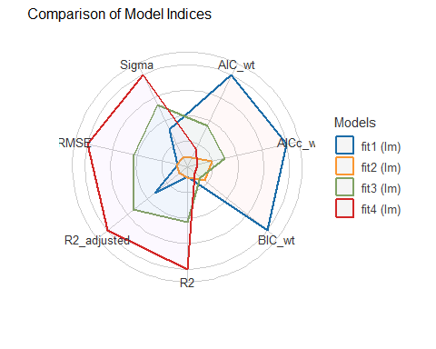

Checking Assumptions

Check Assumptions? (fit1)
- These plots would be too short in the slides, but fine in HTML with #|: fig-height: 9, so I don’t run them here.
set.seed(43101); check_model(fit1, detrend = FALSE)
set.seed(43102); check_model(fit2, detrend = FALSE)
set.seed(43103); check_model(fit3, detrend = FALSE)
- We’ll look at fit4’s check_model() plots in detail…

First Two Plots for fit4
set.seed(43104)
check_model(fit4, detrend = FALSE, check = c("pp_check", "linearity"))
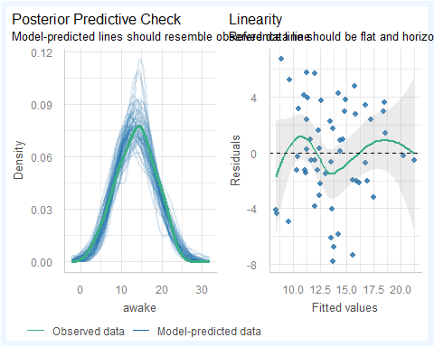

Next Two Plots for fit4
set.seed(43104)
check_model(fit4, detrend = FALSE, check = c("homogeneity", "outliers"))
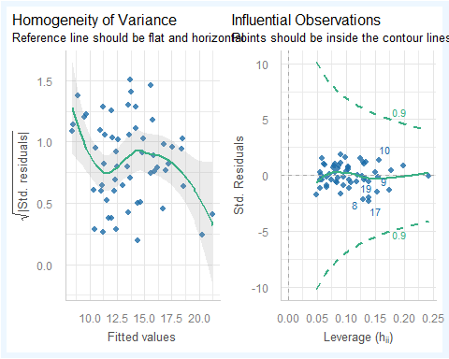

Next Two Plots for fit4
set.seed(43104)
check_model(fit4, detrend = FALSE, check = c("vif", "qq"))
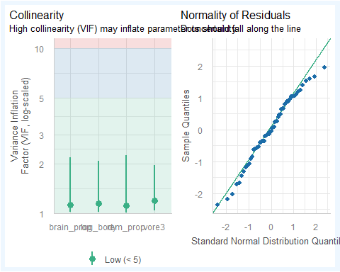

augment for the 4 models
- We’ll add fitted values (predicted values) and residuals to the data when predicting into the ms431_test data.
test_fit1 <- augment(fit1, newdata = ms431_test) |> mutate(mod = "fit1")
test_fit2 <- augment(fit2, newdata = ms431_test) |> mutate(mod = "fit2")
test_fit3 <- augment(fit3, newdata = ms431_test) |> mutate(mod = "fit3")
test_fit4 <- augment(fit4, newdata = ms431_test) |> mutate(mod = "fit4")
test_comp <- bind_rows(test_fit1, test_fit2, test_fit3, test_fit4) |>
arrange(name, mod)

Comparing Models: Test Sample
test_comp |> group_by(mod) |>
summarize(n = n(), MAPE = mean(abs(.resid)),
RMSPE = sqrt(mean(.resid^2)),
max_error = max(abs(.resid)),
valid_R2 = cor(awake, .fitted)^2) |>
gt() |> fmt_number(decimals = 3, columns = -"n") |>
tab_options(table.font.size = 20)
mod | n | MAPE | RMSPE | max_error | valid_R2
fit1 | 26 | 2.736 | 3.477 | 7.410 | 0.307
fit2 | 26 | 2.748 | 3.481 | 7.465 | 0.305
fit3 | 26 | 2.728 | 3.407 | 7.407 | 0.343
fit4 | 26 | 2.724 | 3.356 | 7.630 | 0.358
- What should we pick here?

Model 4 (training sample)
model_parameters(fit4, ci = 0.89, pretty_names = FALSE) |>
gt() |> tab_options(table.font.size = 20) |>
fmt_number(decimals = 3, columns = c(-CI, -df_error)) |>
gt_theme_espn()
Parameter | Coefficient | SE | CI | CI_low | CI_high | t | df_error | p
(Intercept) | 14.912 | 1.455 | 0.89 | 12.546 | 17.279 | 10.248 | 51 | 0.000
log_body | 0.817 | 0.156 | 0.89 | 0.564 | 1.071 | 5.246 | 51 | 0.000
brain_prop | -9.883 | 51.901 | 0.89 | -94.300 | 74.535 | -0.190 | 51 | 0.850
vore3omni | 0.737 | 1.249 | 0.89 | -1.294 | 2.768 | 0.590 | 51 | 0.557
vore3Other | -1.525 | 1.243 | 0.89 | -3.546 | 0.497 | -1.227 | 51 | 0.226
rem_prop | -8.879 | 7.056 | 0.89 | -20.356 | 2.597 | -1.259 | 51 | 0.214
model_performance(fit4) |> gt() |> fmt_number(decimals = 3) |>
tab_options(table.font.size = 20) |> gt_theme_guardian()
AIC | AICc | BIC | R2 | R2_adjusted | RMSE | Sigma
318.944 | 321.230 | 333.245 | 0.401 | 0.343 | 3.511 | 3.712

Create Multiple Imputations
How many subjects have missing data that affect this model?
ms431_sub <- ms431 |>
mutate(log_body = log(bodywt)) |>
select(name, awake, log_body, brain_prop, rem_prop, vore3)
pct_miss_case(ms431_sub)
[1] 48.19277

We’ll build 50 imputed data sets.
set.seed(4312345)
ms431_mice <- mice(ms431_sub, m = 50, printFlag = FALSE)
Warning: Number of logged events: 414
summary(ms431_mice)
Class: mids
Number of multiple imputations: 50
Imputation methods:
name awake log_body brain_prop rem_prop vore3
"" "" "" "pmm" "pmm" "polyreg"
PredictorMatrix:
name awake log_body brain_prop rem_prop vore3
name 0 1 1 1 1 1
awake 0 0 1 1 1 1
log_body 0 1 0 1 1 1
brain_prop 0 1 1 0 1 1
rem_prop 0 1 1 1 0 1
vore3 0 1 1 1 1 0
Number of logged events: 414
it im dep meth out
1 0 0 constant name
2 1 1 rem_prop pmm brain_prop
3 1 1 vore3 polyreg brain_prop
4 1 2 rem_prop pmm brain_prop
5 1 2 vore3 polyreg brain_prop
6 1 3 rem_prop pmm brain_prop

Run Model 4 on each imputation
fit4_mods <- with(ms431_mice, lm(awake ~ log_body + brain_prop + rem_prop + vore3))
summary(fit4_mods)
# A tibble: 300 × 7
term estimate std.error statistic p.value nobs df.residual
<chr> <dbl> <dbl> <dbl> <dbl> <int> <dbl>
1 (Intercept) 15.2 1.16 13.1 2.84e-21 83 77
2 log_body 0.843 0.137 6.14 3.37e- 8 83 77
3 brain_prop 12.8 57.3 0.223 8.24e- 1 83 77
4 rem_prop -11.1 5.82 -1.90 6.12e- 2 83 77
5 vore3omni -0.152 0.999 -0.152 8.79e- 1 83 77
6 vore3Other -2.11 0.997 -2.11 3.79e- 2 83 77
7 (Intercept) 15.6 1.24 12.6 2.08e-20 83 77
8 log_body 0.802 0.141 5.69 2.20e- 7 83 77
9 brain_prop -4.33 44.9 -0.0964 9.23e- 1 83 77
10 rem_prop -12.8 6.03 -2.13 3.67e- 2 83 77
# ℹ 290 more rows

Pool Results across imputations
fit4_pool <- pool(fit4_mods)
model_parameters(fit4_pool, ci = 0.89, pretty_names = FALSE) |>
gt() |> tab_options(table.font.size = 20) |>
fmt_number(decimals = 3, columns = c(-CI, -df_error)) |>
gt_theme_espn()
Parameter | Coefficient | SE | CI | CI_low | CI_high | t | df_error | p
(Intercept) | 15.007 | 1.428 | 0.89 | 12.682 | 17.331 | 10.511 | 48.30575 | 0.000
log_body | 0.855 | 0.137 | 0.89 | 0.633 | 1.077 | 6.225 | 71.95546 | 0.000
brain_prop | 15.033 | 56.440 | 0.89 | -76.500 | 106.566 | 0.266 | 61.13288 | 0.791
rem_prop | -9.063 | 7.233 | 0.89 | -20.869 | 2.744 | -1.253 | 42.55456 | 0.217
vore3omni | -0.370 | 1.099 | 0.89 | -2.151 | 1.411 | -0.337 | 63.49196 | 0.737
vore3Other | -2.021 | 1.088 | 0.89 | -3.785 | -0.257 | -1.858 | 61.45541 | 0.068

Estimate R-square and Adjusted R-square
pool.r.squared(fit4_mods)
est lo 95 hi 95 fmi
R^2 0.4094328 0.2387964 0.5681481 0.03997778
pool.r.squared(fit4_mods, adjusted = TRUE)
est lo 95 hi 95 fmi
adj R^2 0.371052 0.2016042 0.5348944 0.04391358

More Details on MI modeling
fit4_pool
Class: mipo m = 50
term m estimate ubar b t dfcom
1 (Intercept) 50 15.0065792 1.435231e+00 5.911009e-01 2.038154e+00 77
2 log_body 50 0.8548381 1.811614e-02 7.278312e-04 1.885853e-02 77
3 brain_prop 50 15.0331607 2.678559e+03 4.970033e+02 3.185503e+03 77
4 rem_prop 50 -9.0625286 3.343594e+01 1.850984e+01 5.231598e+01 77
5 vore3omni 50 -0.3703406 1.045378e+00 1.587314e-01 1.207284e+00 77
6 vore3Other 50 -2.0211265 9.993758e-01 1.807292e-01 1.183720e+00 77
df riv lambda fmi
1 48.30575 0.42008761 0.29581809 0.32326850
2 71.95546 0.04097935 0.03936615 0.06499827
3 61.13288 0.18925974 0.15914080 0.18536320
4 42.55456 0.56466289 0.36088470 0.38894403
5 63.49196 0.15487791 0.13410760 0.16015263
6 61.45541 0.18445896 0.15573267 0.18192961

What if we picked model fit1?
fit1_mods <- with(ms431_mice, lm(awake ~ log_body))
fit1_pool <- pool(fit1_mods)
model_parameters(fit1_pool, ci = 0.89, pretty_names = FALSE) |>
gt() |> tab_options(table.font.size = 20) |>
fmt_number(decimals = 3, columns = c(-CI, -df_error)) |>
gt_theme_espn()
Parameter | Coefficient | SE | CI | CI_low | CI_high | t | df_error | p
(Intercept) | 12.912 | 0.418 | 0.89 | 12.236 | 13.587 | 30.896 | 79.06352 | 0.000
log_body | 0.778 | 0.125 | 0.89 | 0.576 | 0.980 | 6.224 | 79.06352 | 0.000
pool.r.squared(fit1_mods)
est lo 95 hi 95 fmi
R^2 0.323527 0.1619897 0.4882656 4.081633e-10

What if we picked model fit2?
fit2_mods <- with(ms431_mice, lm(awake ~ log_body + brain_prop))
fit2_pool <- pool(fit2_mods)
model_parameters(fit2_pool, ci = 0.89, pretty_names = FALSE) |>
gt() |> tab_options(table.font.size = 20) |>
fmt_number(decimals = 3, columns = c(-CI, -df_error)) |>
gt_theme_espn()
Parameter | Coefficient | SE | CI | CI_low | CI_high | t | df_error | p
(Intercept) | 12.787 | 0.748 | 0.89 | 11.576 | 13.998 | 17.095 | 70.04680 | 0.000
log_body | 0.790 | 0.140 | 0.89 | 0.564 | 1.016 | 5.648 | 76.43286 | 0.000
brain_prop | 11.495 | 54.789 | 0.89 | -77.237 | 100.226 | 0.210 | 67.52202 | 0.834
pool.r.squared(fit2_mods)
est lo 95 hi 95 fmi
R^2 0.3252385 0.1634207 0.4899301 0.0009612085

What if we picked model fit3?
fit3_mods <- with(ms431_mice, lm(awake ~ log_body + brain_prop + rem_prop))
fit3_pool <- pool(fit3_mods)
model_parameters(fit3_pool, ci = 0.89, pretty_names = FALSE) |>
gt() |> tab_options(table.font.size = 20) |>
fmt_number(decimals = 3, columns = c(-CI, -df_error)) |>
gt_theme_espn()
Parameter | Coefficient | SE | CI | CI_low | CI_high | t | df_error | p
(Intercept) | 15.100 | 1.420 | 0.89 | 12.790 | 17.410 | 10.633 | 51.37881 | 0.000
log_body | 0.806 | 0.138 | 0.89 | 0.582 | 1.030 | 5.825 | 72.70706 | 0.000
brain_prop | 5.738 | 53.878 | 0.89 | -81.559 | 93.035 | 0.106 | 65.20770 | 0.916
rem_prop | -12.849 | 6.530 | 0.89 | -23.475 | -2.223 | -1.968 | 49.65098 | 0.055
pool.r.squared(fit3_mods)
est lo 95 hi 95 fmi
R^2 0.3731144 0.2010679 0.5390561 0.07273496

Guidelines for reporting, I (Sterne)
How should we report on analyses potentially affected by missing data?
- Report the number of missing values for each variable of interest, or the number of cases with complete data for each important component of the analysis. Give reasons for missing values if possible, and indicate how many individuals were excluded because of missing data when reporting the flow of participants through the study. If possible, describe reasons for missing data in terms of other variables (rather than just reporting a universal reason such as treatment failure.)
- Clarify whether there are important differences between individuals with complete and incomplete data, for example, by providing a table comparing the distributions of key exposure and outcome variables in these different groups
- Describe the type of analysis used to account for missing data (e.g., multiple imputation), and the assumptions that were made (e.g., missing at random)

Guidelines for reporting, II (Sterne)
How should we report on analyses that involve multiple imputation?
- Provide details of the imputation modeling (software used, key settings, number of imputed datasets, variables included in imputation procedure, etc.)
- If a large fraction of the data is imputed, compare observed and imputed values.
- Where possible, provide results from analyses restricted to complete cases, for comparison with results based on multiple imputation. If there are important differences between the results, suggest explanations.
- It is also desirable to investigate the robustness of key inferences to possible departures from the missing at random assumption, by assuming a range of missing not at random mechanisms in sensitivity analyses.

Session Information
xfun::session_info()
R version 4.5.2 (2025-10-31 ucrt)
Platform: x86_64-w64-mingw32/x64
Running under: Windows 11 x64 (build 26200)
Locale:
LC_COLLATE=English_United States.utf8
LC_CTYPE=English_United States.utf8
LC_MONETARY=English_United States.utf8
LC_NUMERIC=C
LC_TIME=English_United States.utf8
Package version:
abind_1.4-8 askpass_1.2.1 backports_1.5.0
base64enc_0.1.3 bayestestR_0.17.0 bigD_0.3.1
bit_4.6.0 bit64_4.6.0.1 bitops_1.0.9
blob_1.2.4 boot_1.3-32 broom_1.0.10
bslib_0.9.0 cachem_1.1.0 callr_3.7.6
car_3.1-3 carData_3.0-5 cellranger_1.1.0
cli_3.6.5 clipr_0.8.0 coda_0.19-4.1
codetools_0.2-20 commonmark_2.0.0 compiler_4.5.2
conflicted_1.2.0 correlation_0.8.8 cowplot_1.2.0
cpp11_0.5.2 crayon_1.5.3 curl_7.0.0
data.table_1.17.8 datasets_4.5.2 datawizard_1.3.0
DBI_1.2.3 dbplyr_2.5.1 Deriv_4.2.0
digest_0.6.37 doBy_4.7.0 dplyr_1.1.4
dtplyr_1.3.2 easystats_0.7.5 effectsize_1.0.1
emmeans_2.0.0 estimability_1.5.1 evaluate_1.0.5
farver_2.1.2 fastmap_1.2.0 fontawesome_0.5.3
fontBitstreamVera_0.1.1 fontLiberation_0.1.0 fontquiver_0.2.1
forcats_1.0.1 foreach_1.5.2 Formula_1.2-5
fs_1.6.6 gargle_1.6.0 gdtools_0.4.4
generics_0.1.4 GGally_2.4.0 ggformula_1.0.0
ggiraph_0.9.2 ggplot2_4.0.0 ggrepel_0.9.6
ggridges_0.5.7 ggstats_0.11.0 glmnet_4.1-10
glue_1.8.0 googledrive_2.1.2 googlesheets4_1.1.2
graphics_4.5.2 grDevices_4.5.2 grid_4.5.2
gridExtra_2.3 gt_1.1.0 gtable_0.3.6
gtExtras_0.6.1 haven_2.5.5 here_1.0.2
highr_0.11 hms_1.1.4 htmltools_0.5.8.1
htmlwidgets_1.6.4 httr_1.4.7 ids_1.0.1
insight_1.4.2 isoband_0.2.7 iterators_1.0.14
janitor_2.2.1 jomo_2.7-6 jquerylib_0.1.4
jsonlite_2.0.0 juicyjuice_0.1.0 knitr_1.50
labeling_0.4.3 labelled_2.16.0 lattice_0.22-7
lifecycle_1.0.4 litedown_0.8 lme4_1.1-37
lubridate_1.9.4 magrittr_2.0.4 markdown_2.0
MASS_7.3-65 Matrix_1.7-4 MatrixModels_0.5.4
memoise_2.0.1 methods_4.5.2 mgcv_1.9-4
mice_3.18.0 microbenchmark_1.5.0 mime_0.13
minqa_1.2.8 mitml_0.4-5 modelbased_0.13.0
modelr_0.1.11 mosaic_1.9.2 mosaicCore_0.9.5
mosaicData_0.20.4 multcomp_1.4-29 mvtnorm_1.3-3
naniar_1.1.0 nlme_3.1-168 nloptr_2.2.1
nnet_7.3-20 norm_1.0-11.1 numDeriv_2016.8.1.1
openssl_2.3.4 ordinal_2023.12.4.1 paletteer_1.6.0
pan_1.9 parallel_4.5.2 parameters_0.28.2
patchwork_1.3.2 pbkrtest_0.5.5 performance_0.15.2
pillar_1.11.1 pkgconfig_2.0.3 plyr_1.8.9
prettyunits_1.2.0 prismatic_1.1.2 processx_3.8.6
progress_1.2.3 ps_1.9.1 purrr_1.2.0
quantreg_6.1 R6_2.6.1 ragg_1.5.0
rappdirs_0.3.3 rbibutils_2.4 RColorBrewer_1.1-3
Rcpp_1.1.0 RcppEigen_0.3.4.0.2 Rdpack_2.6.4
reactable_0.4.4 reactR_0.6.1 readr_2.1.5
readxl_1.4.5 reformulas_0.4.2 rematch_2.0.0
rematch2_2.1.2 report_0.6.2 reprex_2.1.1
rlang_1.1.6 rmarkdown_2.30 rpart_4.1.24
rprojroot_2.1.1 rstudioapi_0.17.1 rvest_1.0.5
S7_0.2.0 sandwich_3.1-1 sass_0.4.10
scales_1.4.0 see_0.12.0 selectr_0.4.2
shape_1.4.6.1 snakecase_0.11.1 SparseM_1.84.2
splines_4.5.2 stats_4.5.2 stringi_1.8.7
stringr_1.6.0 survival_3.8-3 sys_3.4.3
systemfonts_1.3.1 textshaping_1.0.4 TH.data_1.1-4
tibble_3.3.0 tidyr_1.3.1 tidyselect_1.2.1
tidyverse_2.0.0 timechange_0.3.0 tinytex_0.57
tools_4.5.2 tzdb_0.5.0 ucminf_1.2.2
UpSetR_1.4.0 utf8_1.2.6 utils_4.5.2
uuid_1.2.1 V8_8.0.1 vctrs_0.6.5
viridis_0.6.5 viridisLite_0.4.2 visdat_0.6.0
vroom_1.6.6 withr_3.0.2 xfun_0.54
xml2_1.4.1 xtable_1.8-4 yaml_2.3.10
zoo_1.8-14

