431 Class 05
Thomas E. Love, Ph.D.
2026-09-08
 An IMPORTANT Note to Word users
The kable() and kable_styling() stuff used in the HTML slides doesn’t work in Word. Hence, those bits of code are not included in this Word version.

Today’s Agenda
- The dm464 study
  - Data stored in an Excel spreadsheet, rather than a .csv file
  - Data on 464 adults with diabetes between the ages of 18 and 73
- Estimating the Difference between Two Population Means
  - when our samples are paired
  - when our samples are independent
- Comparisons and estimates built using
  - ordinary least squares linear models (and their t-based equivalents),
  - the bootstrap, and
  - Bayesian linear models
- Chapters 5-6 of Dr. Love’s book have more.

Load packages and set theme
knitr::opts_chunk$set(comment = NA)
source("c05/data/Love-431.R") # for the lovedist() function
library(janitor)
library(patchwork)
library(rstanarm)
library(readxl) ## new today
library(knitr) ## new (sort of) today
library(kableExtra) ## new today
library(ggdist) ## new today
library(MKinfer) ## new today
library(easystats)
library(tidyverse)
theme_set(theme_bw())

Managing the dm464 Data

Today’s data (dm464.xlsx)
The data describe a cohort of 464 adults measured in a one-year baseline window, and then again in a similar window two years after baseline.
- The data in dm464 are simulated, but mirror real data gathered by Better Health Partnership.
- The dm464 data are restricted to people ages 18-73 at baseline, with a diabetes diagnosis who spoke English as their primary language, who lived in Cuyahoga County, and for whom multiple primary care visits were observed in the baseline and follow-up periods.

Data are in an Excel Sheet
- Stored in an Excel worksheet called dm464.xlsx, rather than in a .csv file.
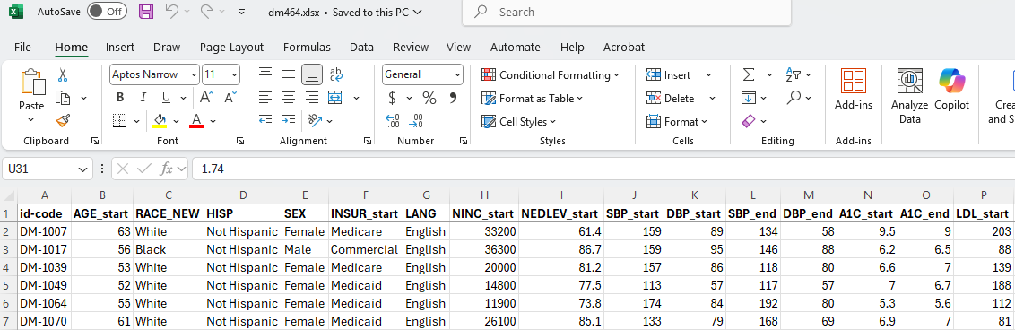

Pulling in the dm464 data
Ingest the data with read_xlsx() from readxl package.
dm464_raw <- read_xlsx("c05/data/dm464.xlsx")
dim(dm464_raw)
[1] 464 42
names(dm464_raw)
[1] "id-code" "AGE_start" "RACE_NEW" "HISP"
[5] "SEX" "INSUR_start" "LANG" "NINC_start"
[9] "NEDLEV_start" "SBP_start" "DBP_start" "SBP_end"
[13] "DBP_end" "A1C_start" "A1C_end" "LDL_start"
[17] "LDL_end" "HEIGHT_start" "WEIGHT_start" "BMI_start"
[21] "HEIGHT_end" "WEIGHT_end" "BMI_end" "SMOKE_start"
[25] "SMOKE_end" "STATIN_start" "STATIN_end" "ACEARB_start"
[29] "ACEARB_end" "BETAB_start" "BETAB_end" "EYEEX_start"
[33] "EYEEX_end" "PNEUMO_start" "PNEUMO_end" "DEPDIAG_start"
[37] "DEPDIAG_end" "HOME_start" "HOME_end" "INSUR_end"
[41] "NINC_end" "NEDLEV_end"

Auto-cleaning variable names
dm464 <- dm464_raw |> janitor::clean_names()
names(dm464)
[1] "id_code" "age_start" "race_new" "hisp"
[5] "sex" "insur_start" "lang" "ninc_start"
[9] "nedlev_start" "sbp_start" "dbp_start" "sbp_end"
[13] "dbp_end" "a1c_start" "a1c_end" "ldl_start"
[17] "ldl_end" "height_start" "weight_start" "bmi_start"
[21] "height_end" "weight_end" "bmi_end" "smoke_start"
[25] "smoke_end" "statin_start" "statin_end" "acearb_start"
[29] "acearb_end" "betab_start" "betab_end" "eyeex_start"
[33] "eyeex_end" "pneumo_start" "pneumo_end" "depdiag_start"
[37] "depdiag_end" "home_start" "home_end" "insur_end"
[41] "ninc_end" "nedlev_end"
- Here’s a nice overview of janitor functions. By default, names are parsed to snake_case but other options exist.

Today’s Seven Variables
Variable | Definition
id_code | Subject Code (unique for each row)
age_start | baseline age, in years
sex | Female or Male
a1c_start | baseline Hemoglobin A1c, %
a1c_end | Hemoglobin A1c at study end, %
ldl_start | baseline LDL cholesterol, mg/dl
statin_start | baseline: Statin prescribed? (1 or 0)

Select (and Rename) Variables
Let’s select our variables, and simplify some names.
class05 <- dm464 |>
select(id_code, age = age_start, sex, a1c_base = a1c_start,
a1c_end, ldl = ldl_start, statin = statin_start)
str(class05)
tibble [464 × 7] (S3: tbl_df/tbl/data.frame)
$ id_code : chr [1:464] "DM-1007" "DM-1017" "DM-1039" "DM-1049" ...
$ age : num [1:464] 63 56 53 52 55 61 68 56 67 64 ...
$ sex : chr [1:464] "Female" "Male" "Female" "Female" ...
$ a1c_base: num [1:464] 9.5 6.2 6.6 7 5.3 6.9 11.1 8.3 10.5 5.7 ...
$ a1c_end : num [1:464] 9 6.5 7 6.7 5.6 7 9.8 8.8 13.1 5.4 ...
$ ldl : num [1:464] 203 88 139 188 112 81 167 89 135 68 ...
$ statin : num [1:464] 1 1 1 1 0 1 0 1 1 0 ...

Change characters to factors
- The sex variable is listed as character, but we’d like it instead to be represented as a factor.
  - The id_code should remain as a character variable.
- We’ll also add a factor version of the statin variable (stat_f is binary: with 1 = statin, and 0 = no)
class05 <- class05 |>
mutate(sex = as_factor(sex)) |>
mutate(stat_f = fct_recode(as_factor(statin), "statin" = "1", "no" = "0"))

Checking our work
- Do the stat_f and statin variables agree?
class05 |> count(statin, stat_f)
# A tibble: 2 × 3
statin stat_f n
<dbl> <fct> <int>
1 0 no 97
2 1 statin 367
- Do we have a different id_code in each row?
nrow(class05)
[1] 464
class05 |> select(id_code) |> n_distinct()
[1] 464

Missingness? Range checks? Types?
summary(class05)
id_code age sex a1c_base a1c_end
Length :464 Min. :21.00 Female:288 Min. : 4.200 Min. : 4.400
N.unique :464 1st Qu.:51.00 Male :176 1st Qu.: 6.200 1st Qu.: 6.400
N.blank : 0 Median :58.00 Median : 7.000 Median : 7.300
Min.nchar: 7 Mean :57.57 Mean : 7.564 Mean : 7.895
Max.nchar: 7 3rd Qu.:65.00 3rd Qu.: 8.325 3rd Qu.: 9.000
Max. :73.00 Max. :14.900 Max. :17.000
ldl statin stat_f
Min. : 40.0 Min. :0.0000 no : 97
1st Qu.: 76.0 1st Qu.:1.0000 statin:367
Median : 92.0 Median :1.0000
Mean :101.9 Mean :0.7909
3rd Qu.:122.2 3rd Qu.:1.0000
Max. :231.0 Max. :1.0000
- Revised “codebook” on next slide

Variable | Definition (class05 tibble)
id_code | subject code
age | baseline age, in years
sex | Female or Male
a1c_base | baseline Hemoglobin A1c, %
a1c_end | Hemoglobin A1c at study end, %
ldl | baseline LDL cholesterol, mg/dl
statin | baseline: Statin prescribed? (1 or 0)
stat_f | statin as factor (1 = statin, 0 = no)

Our class05 analytic tibble
class05
# A tibble: 464 × 8
id_code age sex a1c_base a1c_end ldl statin stat_f
<chr> <dbl> <fct> <dbl> <dbl> <dbl> <dbl> <fct>
1 DM-1007 63 Female 9.5 9 203 1 statin
2 DM-1017 56 Male 6.2 6.5 88 1 statin
3 DM-1039 53 Female 6.6 7 139 1 statin
4 DM-1049 52 Female 7 6.7 188 1 statin
5 DM-1064 55 Female 5.3 5.6 112 0 no
6 DM-1070 61 Female 6.9 7 81 1 statin
7 DM-1076 68 Female 11.1 9.8 167 0 no
8 DM-1095 56 Female 8.3 8.8 89 1 statin
9 DM-1110 67 Male 10.5 13.1 135 1 statin
10 DM-1143 64 Female 5.7 5.4 68 0 no
# ℹ 454 more rows

Saving and Loading a tibble
We can save the class05 tibble to a file, for instance …
write_rds(class05, "c05/data/class05.Rds")
which we can then reload whenever we like with …
class05_read <- read_rds("c05/data/class05.Rds")
identical(class05, class05_read)
[1] TRUE

Six Key “Verbs” for Data Management

6 key data management “verbs”
- filter() chooses rows
- select() chooses columns
- arrange() sorts rows by values
- mutate() creates new columns
- group_by() manipulates groups of data
- summarize() provides numerical summaries
All of these are in the dplyr package; part of the tidyverse. See the Data Transformation chapter of R4DS.

filter()
We use the filter() function to change which rows are present in the data, without changing the order.
class05 |> filter(sex == "Female", age < 30)
# A tibble: 4 × 8
id_code age sex a1c_base a1c_end ldl statin stat_f
<chr> <dbl> <fct> <dbl> <dbl> <dbl> <dbl> <fct>
1 DM-1617 21 Female 7.8 5.6 114 0 no
2 DM-1681 23 Female 7.2 10.9 128 1 statin
3 DM-4953 29 Female 8.5 6.6 146 1 statin
4 DM-5252 27 Female 9.6 9.2 128 1 statin

select()
We use the select() function to change which columns are present…
class05 |> select(id_code, a1c_base, a1c_end)
# A tibble: 464 × 3
id_code a1c_base a1c_end
<chr> <dbl> <dbl>
1 DM-1007 9.5 9
2 DM-1017 6.2 6.5
3 DM-1039 6.6 7
4 DM-1049 7 6.7
5 DM-1064 5.3 5.6
6 DM-1070 6.9 7
7 DM-1076 11.1 9.8
8 DM-1095 8.3 8.8
9 DM-1110 10.5 13.1
10 DM-1143 5.7 5.4
# ℹ 454 more rows

arrange()
We use arrange() to change the order of the rows based on their values.
class05 |> arrange(a1c_base) |>
select(id_code, a1c_base, a1c_end)
# A tibble: 464 × 3
id_code a1c_base a1c_end
<chr> <dbl> <dbl>
1 DM-3822 4.2 4.4
2 DM-9713 5 5.3
3 DM-9795 5.1 4.5
4 DM-9899 5.1 7.6
5 DM-1064 5.3 5.6
6 DM-1713 5.3 6.3
7 DM-4269 5.3 6
8 DM-6656 5.3 4.6
9 DM-8526 5.3 5.5
10 DM-8827 5.3 5.8
# ℹ 454 more rows

mutate()
We use mutate() to add new columns calculated from the existing columns.
class05 |> select(id_code, a1c_base, a1c_end) |>
mutate(a1c_change = a1c_end - a1c_base)
# A tibble: 464 × 4
id_code a1c_base a1c_end a1c_change
<chr> <dbl> <dbl> <dbl>
1 DM-1007 9.5 9 -0.5
2 DM-1017 6.2 6.5 0.300
3 DM-1039 6.6 7 0.400
4 DM-1049 7 6.7 -0.300
5 DM-1064 5.3 5.6 0.300
6 DM-1070 6.9 7 0.1000
7 DM-1076 11.1 9.8 -1.30
8 DM-1095 8.3 8.8 0.5
9 DM-1110 10.5 13.1 2.6
10 DM-1143 5.7 5.4 -0.300
# ℹ 454 more rows

group_by() and summarize()
We use group_by() to divide the data in groups of interest then use summarize() to obtain summaries.
class05 |> select(id_code, sex, a1c_base, a1c_end) |>
mutate(a1c_change = a1c_end - a1c_base) |>
group_by(sex) |> summarize(n = n(), median = median(a1c_change))
# A tibble: 2 × 3
sex n median
<fct> <int> <dbl>
1 Female 288 0.200
2 Male 176 0.400
We’ve used this group_by() approach, with lovedist(), too.

Today’s Analytic Questions
We’ll use the class05 tibble to address these two questions…
- How large is the difference in the mean Hemoglobin A1c level at baseline as compared to the A1c level in the follow-up period?
- How large is the difference in the mean LDL cholesterol level at baseline for people who have a statin prescription at baseline, as compared to those who don’t?

Comparing Means

Paired Samples Comparisons
Suppose we want to compare the weights of mice:
- before they are switched to a new diet, vs.
- after they have been on the new diet for 2 weeks
In our sample of (say) 100 mice, each mouse provides a pair of measurements, and we can calculate the change in weight for each mouse:
mouse | before | after | change
A-001 | 14 | 16 | 2
A-002 | 18 | 17 | -1

Paired Samples and our Mice
We want to make estimates using data on those 100 changes in weight to describe what might happen in a larger population of mice who switched diets.
- Each mouse’s “before” and “after” data, then, describes two paired samples.
We compare means (or other summaries) using paired samples whenever data are gathered so that the responses from the two groups being compared (here, before and after) are paired (or matched.)

Independent Samples
Suppose we want to compare the weights of mice who are on diet A, vs. mice who are on diet B.
We sample 50 mice on diet A and 50 different mice on diet B. Each mouse provides a weight after their selected diet, and there is no pre-planned pairing of individual diet A mice to diet B mice.
mouse | diet | weight
A-101 | A | 18
B-102 | B | 15

Independent Samples & Mice
We then make estimates using the weights of all 100 sampled mice to describe what might happen in a larger population comparing diet A to B.
- Each mouse provides an “A” or “B” weight, and the samples are not paired, but rather independent.
We compare means (or other summaries) using independent samples whenever we have data gathered so that the responses from the two groups being compared (here, A and B) are not paired (or matched.)

Question 1

Comparing a1c_base to a1c_end
- How large is the difference in the mean Hemoglobin A1c level at baseline as compared to the A1c level in the follow-up period?
We are comparing each subject’s a1c_base to their a1c_end, to learn what our sample might tell us about the mean of those differences.
- Does this planned analysis make use of paired samples or independent samples?
  - What do you think?

Paired or Independent Samples?
Does this planned analysis make use of paired samples or independent samples?
- Each subject provides an a1c_base as well as an a1c_end.
- Calculating the difference (a1c_end - a1c_base) makes sense for each individual subject.
- This will leave us with $n=464$ paired differences to study.

Paired A1c samples…
- How are the samples paired?
class05 |> select(id_code, a1c_base, a1c_end)
# A tibble: 464 × 3
id_code a1c_base a1c_end
<chr> <dbl> <dbl>
1 DM-1007 9.5 9
2 DM-1017 6.2 6.5
3 DM-1039 6.6 7
4 DM-1049 7 6.7
5 DM-1064 5.3 5.6
6 DM-1070 6.9 7
7 DM-1076 11.1 9.8
8 DM-1095 8.3 8.8
9 DM-1110 10.5 13.1
10 DM-1143 5.7 5.4
# ℹ 454 more rows

Build the paired A1c differences
class05 <- class05 |>
mutate(a1c_diff = a1c_end - a1c_base)
class05 |> reframe(lovedist(a1c_diff))
# A tibble: 1 × 10
n miss mean sd med mad min q25 q75 max
<int> <int> <dbl> <dbl> <dbl> <dbl> <dbl> <dbl> <dbl> <dbl>
1 464 0 0.332 1.79 0.200 1.19 -5.9 -0.5 1.1 8.9
Could also use summary(), fivenum(), describe_distribution(), mean_sd, median_mad, summarize(), etc. to obtain various numerical summaries in this case.

Make a prettier table?
Using the knitr package…
class05 |> reframe(lovedist(a1c_diff)) |>
kable(digits = 2)
n | miss | mean | sd | med | mad | min | q25 | q75 | max
464 | 0 | 0.33 | 1.79 | 0.2 | 1.19 | -5.9 | -0.5 | 1.1 | 8.9

Standard Deviation (sd in R)
- Find the mean of the $n$ observations in your data, $\overset{‾}{x}$.
- Find the squared difference between each data point $x_{i}$ and the mean $\overset{‾}{x}$.
- Sum these squared differences.
- Divide the sum by $n−1$.
- This gives the variance.
- The square root of the variance is the standard deviation.
$$s=\sqrt{\frac{\sum_{i=1}^{n}{(x_{i}−\overset{‾}{x})^{2}}}{n−1}}$$
- The standard deviation is more often used to measure variation than the variance because the standard deviation has the same units of measurement as the mean.

Median Absolute Deviation
The median absolute deviation (MAD) is the median of the absolute deviations from the sample median, so if $x_{med}$ is the sample median of a set of $n$ observations, the MAD is:
$$MAD=median(|x_{i}−x_{MED}|)×1.4826$$
- The purpose of multiplying by the constant is so that if data come from a Normal distribution, the MAD (with this multiplication) and the standard deviation will have the same value.
- See Appendix E of Dr. Love’s Course Book for detailed descriptions of key summaries.

DTDP: Paired A1c differences
ggplot(data = class05, aes(x = a1c_diff)) +
geom_histogram(bins = 20, fill = "#002D72", col = "#FF5910") +
labs(title = "Paired difference in A1c (end - baseline)",
subtitle = "n = 464 subjects",
x = "Difference in A1c (end - baseline)", y = "Subjects")
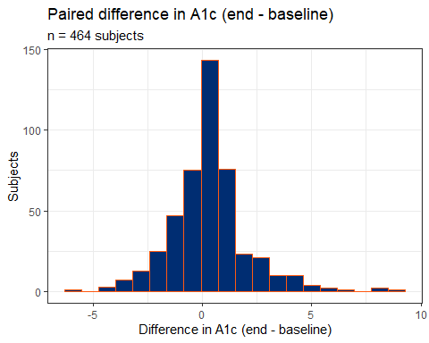

What does the distribution of A1c differences look like? (1/4)
- Plot p1 - Histogram with superimposed Normal curve
bw = 1 # specify width of bins in histogram
p1 <- ggplot(class05, aes(x = a1c_diff)) +
geom_histogram(binwidth = bw, fill = "black", col = "yellow") +
stat_function(fun = function(x)
dnorm(x, mean = mean(class05$a1c_diff, na.rm = TRUE),
sd = sd(class05$a1c_diff, na.rm = TRUE)) *
length(class05$a1c_diff) * bw,
geom = "area", alpha = 0.5,
fill = "lightblue", col = "blue") +
labs(x = "A1c difference (%)", y = "Count",
title = "Histogram & Normal Curve")

What does the distribution of A1c differences look like? (2/4)
- Plot p2 - Normal Q-Q plot
p2 <- ggplot(class05, aes(sample = a1c_diff)) +
geom_qq() + geom_qq_line(col = "red") +
labs(y = "A1c difference (%)", x = "Standard Normal Distribution",
title = "Normal Q-Q plot")

What does the distribution of A1c differences look like? (3/4)
- Plot p3 - Boxplot with violin and mean
p3 <- ggplot(class05, aes(x = a1c_diff, y = "")) +
geom_violin(fill = "cornsilk") +
geom_boxplot(width = 0.2) +
stat_summary(fun = mean, geom = "point", shape = 16, col = "red") +
labs(y = "", x = "A1c difference (%)", title = "Boxplot with Violin")

Shape of the distribution? (4/4)
- Use the patchwork package to combine plots p1, p2 and p3 into a single figure
- See section 2.4.6 in our Course Book for similar “Three Plots At Once” code.
p1 +
(p2 / p3 + plot_layout(heights = c(2, 1))) +
plot_annotation(title = "class05: Differences in A1c")
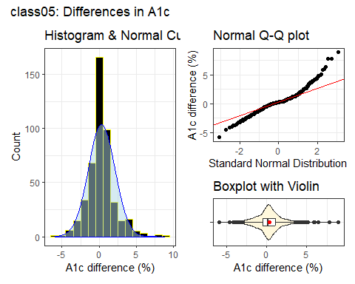

Summaries of A1c differences
OK, so the distribution of A1c differences looks symmetric, but outlier-prone relative to a Normal distribution.
- Let’s look again at our numerical summaries…
class05 |> reframe(lovedist(a1c_diff))
# A tibble: 1 × 10
n miss mean sd med mad min q25 q75 max
<int> <int> <dbl> <dbl> <dbl> <dbl> <dbl> <dbl> <dbl> <dbl>
1 464 0 0.332 1.79 0.200 1.19 -5.9 -0.5 1.1 8.9
- What does the sample mean (0.33) suggest in this context?

Standing Break

Estimating the Mean Difference
We’ll demonstrate three ways to estimate the population mean difference in A1c, and form a 90% uncertainty interval using these paired samples.
- Ordinary least squares regression model (equivalent to a paired t procedure here) fit with lm().
- Bayesian regression model with a weakly informative prior, fit with stan_glm() from rstanarm.
- Bootstrap confidence interval for the mean difference, fit with boot.t.test() from MKinfer.

Using lm() to fit an OLS model
fit1 <- lm(a1c_diff ~ 1, data = class05)
model_parameters(fit1, ci = 0.90, pretty_names = FALSE)
Parameter | Coefficient | SE | 90% CI | t(463) | p
-----------------------------------------------------------------
(Intercept) | 0.33 | 0.08 | [0.20, 0.47] | 4.00 | < .001
Uncertainty intervals (equal-tailed) and p-values (two-tailed) computed
using a Wald t-distribution approximation.
- Sample mean difference is 0.33, with 90% uncertainty interval (0.20, 0.47).
- All three of these summaries are positive numbers. What does that indicate?

Paired t approach = same as OLS
- Note that here we must include conf.level = 0.90 within the t.test() command and ci = 0.90 in the call to model_parameters() in order to get the right (90%) uncertainty interval.
fit2 <- t.test(class05$a1c_diff, conf.level = 0.90)
model_parameters(fit2, ci = 0.90, pretty_names = FALSE)
One Sample t-test
Parameter | Mean | mu | Difference | 90% CI | t(463) | p
-------------------------------------------------------------------
a1c_diff | 0.33 | 0 | 0.33 | [0.20, 0.47] | 4.00 | < .001
Alternative hypothesis: true mean is not equal to 0

Bayesian fit
Bayesian inference is an excellent choice for virtually every regression model, even when using weakly informative default priors (as we will do in 431), because it yields estimates which are stable, and because it helps present uncertainty in useful ways.
set.seed(43101)
fit3 <- stan_glm(a1c_diff ~ 1, data = class05, refresh = 0)
model_parameters(fit3, ci = 0.90, pretty_names = FALSE)
Parameter | Median | 90% CI | pd | Rhat | ESS (tail) | Prior
---------------------------------------------------------------------------------------
(Intercept) | 0.33 | [0.20, 0.47] | 100% | 1.000 | 2157 | Normal (0.33 +- 4.46)
Uncertainty intervals (equal-tailed) computed using a MCMC distribution
approximation.

The bootstrap (with MKinfer)
set.seed(43102)
boot.t.test(class05$a1c_diff, conf.level = 0.90, R = 2000)
Bootstrap One Sample t-test
data: class05$a1c_diff
number of bootstrap samples: 2000
bootstrap p-value < 5e-04
bootstrap mean of x (SE) = 0.3318219 (0.08270615)
90 percent bootstrap percentile confidence interval:
0.1974030 0.4762931
Results without bootstrap:
t = 4.0016, df = 463, p-value = 7.323e-05
alternative hypothesis: true mean is not equal to 0
90 percent confidence interval:
0.1950719 0.4682901
sample estimates:
mean of x
0.331681

90% Uncertainty Intervals
Estimating the mean of the paired differences in Hemoglobin A1c levels from baseline to study end…
Approach | Estimate & 90% Interval
Linear model / Paired t | 0.33 (0.20, 0.47)
Bayesian fit: stan_glm() | 0.33 (0.20, 0.47)
Bootstrap: boot.t.test() | 0.33 (0.197, 0.476)
- Do our conclusions change here?

Are our paired A1c values correlated?
- Here, we see a meaningful and positive correlation between the paired A1c values, suggesting that the pairing helped to reduce nuisance variation.
class05 |> select(a1c_base, a1c_end) |> correlation()
# Correlation Matrix (pearson-method)
Parameter1 | Parameter2 | r | 95% CI | t(462) | p
------------------------------------------------------------------
a1c_base | a1c_end | 0.60 | [0.53, 0.65] | 15.98 | < .001***
p-value adjustment method: Holm (1979)
Observations: 464

Question 2

Comparing ldl by statin level
We’ll build a boxplot, including violins and means.
ggplot(class05, aes(x = ldl, y = stat_f,
fill = stat_f)) +
geom_violin() +
geom_boxplot(width = 0.3, fill = "white") +
stat_summary(fun = mean, geom = "point", shape = 16, size = 3,
col = "red") +
scale_fill_viridis_d(alpha = 0.3) +
guides(fill = "none") +
labs(title = "LDL by Statin Prescription Status",
x = "Most recent LDL in the baseline period, in mg/dl",
y = "Statin Prescription at end of baseline period")
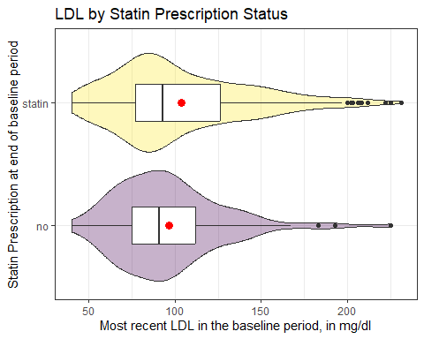

Rain Cloud Plot
This plot includes stat_slab() and stat_dotsinterval() from the ggdist package.
ggplot(class05, aes(y = stat_f, x = ldl, fill = stat_f)) +
stat_slab(aes(thickness = after_stat(pdf * n)), scale = 0.7) +
stat_dotsinterval(side = "bottom", scale = 0.7,
slab_linewidth = NA) +
scale_fill_viridis_d(alpha = 0.7, begin = 0.2) +
guides(fill = "none") +
labs(title = "LDL by Statin Prescription Status",
x = "Most recent LDL in the baseline period, in mg/dl",
y = "Statin Prescription at end of baseline period")
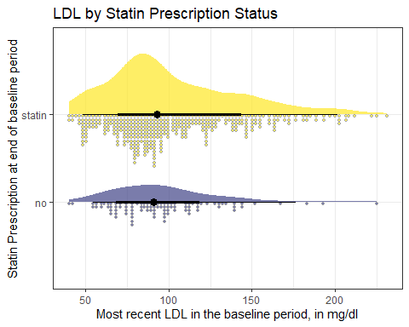

Faceted Histograms
bw = 5
ggplot(class05, aes(x = ldl)) +
geom_histogram(binwidth = bw, fill = "navy", col = "white") +
facet_wrap(~ stat_f) +
labs(x = "LDL at baseline", y = "Counts",
title = "LDL by Statin Status")
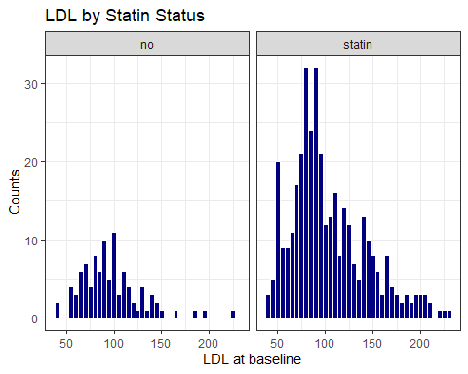

Faceted Normal Q-Q plots
ggplot(class05, aes(sample = ldl)) +
geom_qq() + geom_qq_line(col = "purple") +
facet_wrap(~ stat_f) +
labs(x = "Standard Normal distribution", y = "LDL at baseline")
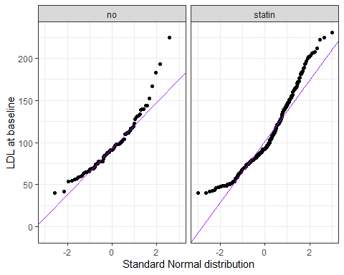

Comparing ldl by statin level
- LDL data in each statin group are skewed to the right, with the mean higher than the median.
class05 |> group_by(stat_f) |> reframe(lovedist(ldl))
# A tibble: 2 × 11
stat_f n miss mean sd med mad min q25 q75 max
<fct> <int> <int> <dbl> <dbl> <dbl> <dbl> <dbl> <dbl> <dbl> <dbl>
1 no 97 0 96.3 31.6 91 28.2 40 75 112 225
2 statin 367 0 103. 39.5 93 34.1 40 77 126 231
- Were these data collected using matched/paired samples or using independent samples?

Estimating Difference in Means
Building 90% uncertainty intervals for the difference in population means using independent samples.
- Ordinary least squares regression model (same as a pooled t procedure here) fit with lm().
- Bayesian regression model with a weakly informative prior fit with stan_glm() from rstanarm.
- Welch t method without pooling standard deviations.
- Bootstrap confidence interval approach.

Using lm() to fit an OLS model
fit4 <- lm(ldl ~ stat_f, data = class05)
model_parameters(fit4, ci = 0.90, pretty_names = FALSE)
Parameter | Coefficient | SE | 90% CI | t(462) | p
---------------------------------------------------------------------
(Intercept) | 96.26 | 3.86 | [89.90, 102.62] | 24.94 | < .001
stat_fstatin | 7.17 | 4.34 | [ 0.02, 14.32] | 1.65 | 0.099
Uncertainty intervals (equal-tailed) and p-values (two-tailed) computed
using a Wald t-distribution approximation.
- Comparing those on a statin to those that aren’t, our model suggests that the mean difference in LDL levels is 7.17 mg/dl with 90% uncertainty interval (0.02, 14.32) mg/dl.

Pooled t = same as OLS
fit5 <- t.test(ldl ~ stat_f, data = class05,
var.equal = TRUE, conf.level = 0.90)
model_parameters(fit5, ci = 0.90, pretty_names = FALSE)
Two Sample t-test
Parameter | Group | stat_f = no | stat_f = statin | Difference
---------------------------------------------------------------
ldl | stat_f | 96.26 | 103.43 | -7.17
Parameter | 90% CI | t(462) | p
--------------------------------------------
ldl | [-14.32, -0.02] | -1.65 | 0.099
Alternative hypothesis: true difference in means between group no and group statin is not equal to 0

Bayesian regression model
set.seed(43103)
fit6 <- stan_glm(ldl ~ stat_f, data = class05, refresh = 0)
model_parameters(fit6, ci = 0.90, pretty_names = FALSE)
Parameter | Median | 90% CI | pd | Rhat | ESS (tail) | Prior
------------------------------------------------------------------------------------------------
(Intercept) | 96.32 | [89.93, 102.70] | 100% | 0.999 | 2404 | Normal (101.93 +- 95.20)
stat_fstatin | 7.07 | [-0.26, 14.08] | 94.25% | 1.000 | 2168 | Normal (0.00 +- 233.87)
Uncertainty intervals (equal-tailed) computed using a MCMC distribution
approximation.

Welch t approach (no pooling)
fit7 <- t.test(ldl ~ stat_f, data = class05,
var.equal = FALSE, conf.level = 0.90)
model_parameters(fit7, ci = 0.90, pretty_names = FALSE)
Welch Two Sample t-test
Parameter | Group | stat_f = no | stat_f = statin | Difference
---------------------------------------------------------------
ldl | stat_f | 96.26 | 103.43 | -7.17
Parameter | 90% CI | t(183.36) | p
-----------------------------------------------
ldl | [-13.48, -0.86] | -1.88 | 0.062
Alternative hypothesis: true difference in means between group no and group statin is not equal to 0

Bootstrap, with MKinfer
set.seed(43104)
boot.t.test(ldl ~ stat_f, var.equal = TRUE, R = 2000,
data = class05, conf.level = 0.90)
Bootstrap Two Sample t-test
data: ldl by stat_f
number of bootstrap samples: 2000
bootstrap p-value = 0.093
bootstrap difference of means (SE) = -7.251915 (4.34287)
90 percent bootstrap percentile confidence interval:
-14.2840024 -0.1761131
Results without bootstrap:
t = -1.6523, df = 462, p-value = 0.09915
alternative hypothesis: true difference in means is not equal to 0
90 percent confidence interval:
-14.32216921 -0.01795271
sample estimates:
mean in group no mean in group statin
96.25773 103.42779

Bootstrap without pooling sd
set.seed(43105)
boot.t.test(ldl ~ stat_f, var.equal = FALSE, R = 2000,
data = class05, conf.level = 0.90)
Bootstrap Welch Two Sample t-test
data: ldl by stat_f
number of bootstrap samples: 2000
bootstrap p-value = 0.056
bootstrap difference of means (SE) = -7.0623 (3.784715)
90 percent bootstrap percentile confidence interval:
-12.9985828 -0.8738097
Results without bootstrap:
t = -1.8786, df = 183.36, p-value = 0.06188
alternative hypothesis: true difference in means is not equal to 0
90 percent confidence interval:
-13.4797701 -0.8603518
sample estimates:
mean in group no mean in group statin
96.25773 103.42779

90% Uncertainty Intervals
Mean difference in baseline LDL for “Statin” group minus “No Statin” group. Do our conclusions change?
Approach | Estimate & 90% Interval
Linear model / Pooled t | 7.17 (0.02, 14.32)
Bayesian fit: stan_glm() | 7.07 (-0.26, 14.08)
Welch t (unpooled sd) | 7.17 (0.86, 13.48)
Bootstrap, pooled sd | 7.25 (0.18, 14.28)
Bootstrap, unpooled sd | 7.06 (0.87, 13.00)

Session Information
xfun::session_info()
R version 4.6.1 (2026-06-24 ucrt)
Platform: x86_64-w64-mingw32/x64
Running under: Windows 11 x64 (build 26200)
Locale:
LC_COLLATE=English_United States.utf8
LC_CTYPE=English_United States.utf8
LC_MONETARY=English_United States.utf8
LC_NUMERIC=C
LC_TIME=English_United States.utf8
Package version:
abind_1.4-8 arrangements_1.1.10 askpass_1.2.1
backports_1.5.1 base64enc_0.1-6 bayesplot_1.16.0
bayestestR_0.18.1 BH_1.90.0.1 bit_4.6.0
bit64_4.8.4 blob_1.3.0 boot_1.3-32
broom_1.0.13 bslib_0.12.0 cachem_1.1.0
callr_3.8.0 cellranger_1.1.0 checkmate_2.3.4
cli_3.6.6 clipr_0.8.1 coda_0.19-4.1
codetools_0.2-20 colourpicker_1.3.0 commonmark_2.0.0
compiler_4.6.1 conflicted_1.2.0 correlation_0.8.8
cpp11_0.5.5 crayon_1.5.3 crosstalk_1.2.2
curl_8.0.0 data.table_1.18.6.1 datasets_4.6.1
datawizard_1.3.1 DBI_1.3.0 dbplyr_2.6.0
desc_1.4.3 digest_0.6.39 distributional_0.8.1
dplyr_1.2.1 DT_0.34.0 dtplyr_1.3.3
dygraphs_1.1.1.6 easystats_0.7.6 effectsize_1.0.3
emmeans_2.0.4 estimability_2.0.0 evaluate_1.0.5
exactRankTests_0.8-37 farver_2.1.2 fastmap_1.2.0
fontawesome_0.5.3 forcats_1.0.1 foreach_1.5.2
fs_2.1.0 gargle_1.6.1 generics_0.1.4
ggdist_3.3.3 ggplot2_4.0.3 ggridges_0.5.7
glmnet_5.0 glue_1.8.1 gmp_0.7-5.1
googledrive_2.1.2 googlesheets4_1.1.2 graphics_4.6.1
grDevices_4.6.1 grid_4.6.1 gridExtra_2.3.1
gtable_0.3.6 gtools_3.9.5 haven_2.5.5
highr_0.12 hms_1.1.4 htmltools_0.5.9
htmlwidgets_1.6.4 httpuv_1.6.17 httr_1.4.8
ids_1.0.1 igraph_2.3.3 inline_0.3.21
insight_1.5.3 isoband_0.3.0 iterators_1.0.14
janitor_2.2.1 jomo_2.7-6 jquerylib_0.1.4
jsonlite_2.0.0 kableExtra_1.4.1 knitr_1.51
labeling_0.4.3 later_1.4.8 lattice_0.23-1
lazyeval_0.2.3 lifecycle_1.0.5 litedown_0.11
lme4_2.0-6 loo_2.10.1 lubridate_1.9.5
magrittr_2.0.5 markdown_2.0 MASS_7.3-66
Matrix_1.7-6 matrixStats_1.5.0 memoise_2.0.1
methods_4.6.1 mice_3.19.0 miceadds_3.20-10
mime_0.13 miniUI_0.1.2 minqa_1.2.8
mitml_0.4-5 mitools_2.4 MKdescr_0.9
MKinfer_1.3 modelbased_0.17.0 modelr_0.1.11
multcomp_1.4-32 mvtnorm_1.4-2 nlme_3.1-170
nloptr_2.2.1 nnet_7.3-21 numDeriv_2016.8.1.1
openssl_2.4.2 ordinal_2026.7.26 otel_0.2.0
pan_2.0 parallel_4.6.1 parameters_0.29.2
patchwork_1.3.2 performance_0.18.0 pillar_1.11.1
pkgbuild_1.4.8 pkgconfig_2.0.3 plyr_1.8.9
posterior_1.7.0 prettyunits_1.2.0 processx_3.9.0
progress_1.2.3 promises_1.5.0 ps_1.9.3
purrr_1.2.2 quadprog_1.5-8 QuickJSR_1.11.0
R6_2.6.1 ragg_1.5.2 rappdirs_0.3.4
rbibutils_2.4.1 RColorBrewer_1.1-3 Rcpp_1.1.2
RcppArmadillo_15.4.2.1 RcppEigen_0.3.4.0.2 RcppParallel_6.2.0
Rdpack_2.6.6 readr_2.2.0 readxl_1.5.0
reformulas_0.4.4 rematch_2.0.0 rematch2_2.1.2
report_0.6.4 reprex_2.1.1 reshape2_1.4.5
rlang_1.3.0 rmarkdown_2.31 rpart_4.1.27
rstan_2.32.7 rstanarm_2.32.2 rstantools_2.7.1
rstudioapi_0.19.0 rvest_1.0.5 S7_0.2.2
sandwich_3.1-3 sass_0.4.10 scales_1.4.0
see_0.14.1 selectr_0.6.0 shape_1.4.6.1
shiny_1.14.0 shinyjs_2.1.1 shinystan_2.7.0
shinythemes_1.2.0 snakecase_0.11.1 sourcetools_0.1.7.2
splines_4.6.1 StanHeaders_2.32.10 stats_4.6.1
stats4_4.6.1 stringi_1.8.9 stringr_1.6.0
survival_3.8-11 svglite_2.2.2 sys_3.4.3
systemfonts_1.3.2 tensorA_0.36.2.1 textshaping_1.0.5
TH.data_1.1-5 threejs_0.3.4 tibble_3.3.1
tidyr_1.3.2 tidyselect_1.2.1 tidyverse_2.0.0
timechange_0.4.0 tinytex_0.60 tools_4.6.1
tzdb_0.5.0 ucminf_1.2.3 utf8_1.2.6
utils_4.6.1 uuid_1.2.2 V8_8.2.0
vctrs_0.7.3 viridisLite_0.4.3 vroom_1.7.1
withr_3.0.3 xfun_0.60 xml2_1.6.0
xtable_1.8-8 xts_0.14.2 yaml_2.3.12
zoo_1.9-0

Excel file downloaded to the c05/data subdirectory of my R project directory.
Maybe we started with 100 mice, and randomly assigned 50 to each diet.
Chapter 5 of Dr. Love’s book has more details and examples.
Chapter 6 has more details and examples.

