431 Class 09
Thomas E. Love, Ph.D.
2026-09-22

Today’s Agenda
- New Data on European Family Care Givers
- Comparing Working Hours by Education Level
  - One-Way Analysis of Variance
  - Considering an Outcome Transformation in ANOVA
- Correlation and Regression to study burden
  - Fitting a linear model with lm()
  - Checking its performance and fit
- Favorite Movies: Session 2

Load packages and set theme
knitr::opts_chunk$set(comment = NA)
source("c09/data/Love-431.R") # for the lovedist() function
library(janitor)
library(patchwork)
library(DescTools) ## post-hoc Bonferroni or Tukey HSD
library(naniar) ## dealing with missing data
library(car) ## for Box-Cox
library(easystats)
library(tidyverse)
theme_set(theme_lucid())

Get the data
EUROFAMCARE project: a survey on the situation of family carers of older people in Europe.
ecare_raw <- read_csv("c09/data/eurocare.csv", show_col_types = FALSE) |>
janitor::clean_names() |>
mutate(across(where(is.character), as_factor)) |>
mutate(subject = as.character(subject)) |>
select(subject, hours, c_educ = c_education, neg_impact, pos_impact)
dim(ecare_raw)
[1] 902 5
head(ecare_raw, 3)
# A tibble: 3 × 5
subject hours c_educ neg_impact pos_impact
<chr> <dbl> <fct> <dbl> <dbl>
1 S-0001 16 Middle 12 12
2 S-0002 148 Middle 20 11
3 S-0003 70 Low 11 13

Variable Descriptions
Variable | Description
subject | carer (care giver) associated with this family
hours | weekly hours carer spends caring for elder
c_educ | carer education level (High, Medium, Low)
neg_impact | COPE Index: carer’s burden: negative impact
pos_impact | COPE Index: carer’s burden: positive impact
More on these burden scores later.

Missingness Assessment
miss_var_summary(ecare_raw)
# A tibble: 5 × 3
variable n_miss pct_miss
<chr> <int> <num>
1 c_educ 60 6.65
2 pos_impact 21 2.33
3 neg_impact 10 1.11
4 subject 0 0
5 hours 0 0
miss_case_table(ecare_raw)
# A tibble: 4 × 3
n_miss_in_case n_cases pct_cases
<int> <int> <dbl>
1 0 818 90.7
2 1 78 8.65
3 2 5 0.554
4 3 1 0.111

Eliminating Missing Values
Today, we’ll filter to complete cases across the whole data set.
ecare <- ecare_raw |> drop_na()
summary(ecare)
subject hours c_educ neg_impact pos_impact
Length :818 Min. : 4.00 Middle:494 Min. : 7.00 Min. : 5.0
N.unique :818 1st Qu.: 10.00 Low :175 1st Qu.: 9.00 1st Qu.:11.0
N.blank : 0 Median : 20.00 High :149 Median :11.00 Median :13.0
Min.nchar: 6 Mean : 41.58 Mean :11.82 Mean :12.5
Max.nchar: 6 3rd Qu.: 42.00 3rd Qu.:14.00 3rd Qu.:14.0
Max. :168.00 Max. :28.00 Max. :16.0
Complete case analyses can create problems, but for today, we’ll ignore them.

c_educ is a factor
ecare |> tabyl(c_educ)
c_educ n percent
Middle 494 0.6039120
Low 175 0.2139364
High 149 0.1821516
Put this factor into a more sensible order with fct_relevel()
ecare <- ecare |>
mutate(c_educ =
fct_relevel(c_educ, "High", "Middle", "Low"))

Automated Codebook
We don’t need to see the subjects list.
data_codebook(ecare |> select(!subject))
select(ecare, !subject) (818 rows and 4 variables, 4 shown)
ID | Name | Type | Missings | Values | N
---+------------+-------------+----------+----------+------------
1 | hours | numeric | 0 (0.0%) | [4, 168] | 818
---+------------+-------------+----------+----------+------------
2 | c_educ | categorical | 0 (0.0%) | High | 149 (18.2%)
| | | | Middle | 494 (60.4%)
| | | | Low | 175 (21.4%)
---+------------+-------------+----------+----------+------------
3 | neg_impact | numeric | 0 (0.0%) | [7, 28] | 818
---+------------+-------------+----------+----------+------------
4 | pos_impact | numeric | 0 (0.0%) | [5, 16] | 818
-----------------------------------------------------------------

How do mean hours vary by c_educ?
ggplot(ecare, aes(y = hours, x = c_educ)) +
geom_violin(aes(fill = c_educ)) +
geom_boxplot(width = 0.2) +
stat_summary(fun = mean, geom = "point",
shape = 16, size = 3, col = "red") +
scale_fill_viridis_d(alpha = 0.3) +
guides(fill = "none")
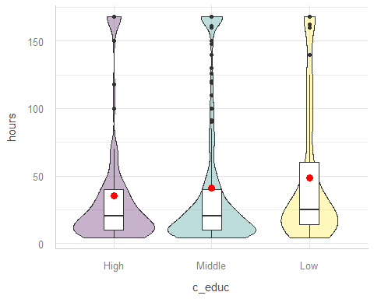

How do hours vary by c_educ? (1/2)
ecare |> group_by(c_educ) |> reframe(lovedist(hours))
# A tibble: 3 × 11
c_educ n miss mean sd med mad min q25 q75 max
<fct> <int> <int> <dbl> <dbl> <dbl> <dbl> <dbl> <dbl> <dbl> <dbl>
1 High 149 0 35.5 44.7 20 17.8 4 10 40 168
2 Middle 494 0 40.9 50.7 20 18.5 4 10 40 168
3 Low 175 0 48.6 51.2 25 22.2 4 14 60 168
- Sample mean hours are somewhat smaller for carers with higher levels of education.
  - Does these mean differences seem meaningful?
  - Does each group’s data follow a Normal distribution?

Do hours vary by c_educ? (2/2)
ecare |> group_by(c_educ) |> reframe(lovedist(hours))
# A tibble: 3 × 11
c_educ n miss mean sd med mad min q25 q75 max
<fct> <int> <int> <dbl> <dbl> <dbl> <dbl> <dbl> <dbl> <dbl> <dbl>
1 High 149 0 35.5 44.7 20 17.8 4 10 40 168
2 Middle 494 0 40.9 50.7 20 18.5 4 10 40 168
3 Low 175 0 48.6 51.2 25 22.2 4 14 60 168
- What else might we consider here?
  - Do we have a balanced design?
  - Are sample variances very different from each other?

ANOVA model for this comparison
fit1 <- lm(hours ~ c_educ, data = ecare)
anova(fit1)
Analysis of Variance Table
Response: hours
Df Sum Sq Mean Sq F value Pr(>F)
c_educ 2 14218 7109.0 2.8706 0.05724 .
Residuals 815 2018305 2476.4
---
Signif. codes: 0 '***' 0.001 '**' 0.01 '*' 0.05 '.' 0.1 ' ' 1
model_parameters(fit1, ci = 0.95)
Parameter | Coefficient | SE | 95% CI | t(815) | p
-----------------------------------------------------------------------
(Intercept) | 35.53 | 4.08 | [27.53, 43.53] | 8.72 | < .001
c educ [Middle] | 5.40 | 4.65 | [-3.73, 14.53] | 1.16 | 0.246
c educ [Low] | 13.04 | 5.55 | [ 2.15, 23.93] | 2.35 | 0.019
Uncertainty intervals (equal-tailed) and p-values (two-tailed) computed
using a Wald t-distribution approximation.

Plot means with Bonferroni 95% CIs
- Tukey is less appealing in light of unbalanced design.
par(mar=c(3,10,3,3), las = 1)
plot(PostHocTest(aov(fit1), method = "bonferroni", conf.level = 0.95))
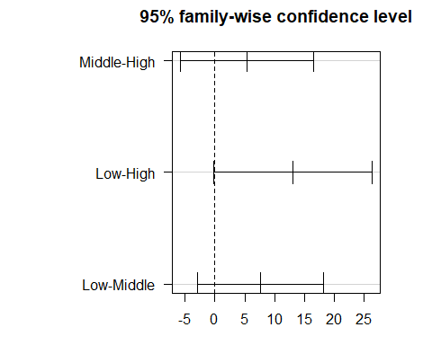

Does model fit1 work well?
plot(fit1, which = 2)
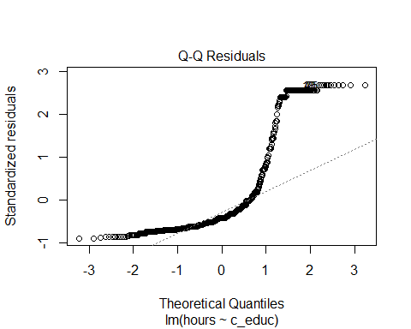

Could we transform the outcome?
boxCox(fit1)
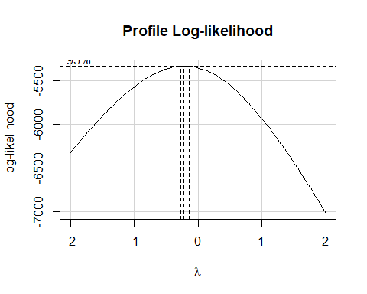

Impact of log transformation
ecare |> group_by(c_educ) |> reframe(lovedist(log(hours)))
# A tibble: 3 × 11
c_educ n miss mean sd med mad min q25 q75 max
<fct> <int> <int> <dbl> <dbl> <dbl> <dbl> <dbl> <dbl> <dbl> <dbl>
1 High 149 0 3.03 0.993 3.00 1.03 1.39 2.30 3.69 5.12
2 Middle 494 0 3.09 1.09 3.00 1.03 1.39 2.30 3.69 5.12
3 Low 175 0 3.36 1.03 3.22 1.09 1.39 2.64 4.09 5.12
ggplot(ecare, aes(y = log(hours), x = c_educ)) +
geom_violin(aes(fill = c_educ)) +
geom_boxplot(width = 0.2) +
stat_summary(fun = mean, geom = "point",
shape = 16, size = 3, col = "red") +
scale_fill_viridis_d(alpha = 0.3) +
guides(fill = "none")
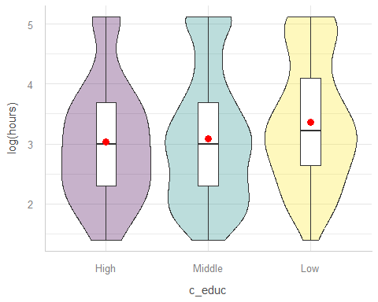

ANOVA after Transforming hours
fit2 <- lm(log(hours) ~ c_educ, data = ecare)
anova(fit2)
Analysis of Variance Table
Response: log(hours)
Df Sum Sq Mean Sq F value Pr(>F)
c_educ 2 11.81 5.9064 5.2668 0.005337 **
Residuals 815 913.98 1.1214
---
Signif. codes: 0 '***' 0.001 '**' 0.01 '*' 0.05 '.' 0.1 ' ' 1
- What’s the conclusion here?

Bonferroni 95% CIs for log(hours)
PostHocTest(aov(fit2), method = "bonferroni", conf.level = 0.95)
Posthoc multiple comparisons of means : Bonferroni
95% family-wise confidence level
$c_educ
diff lwr.ci upr.ci pval
Middle-High 0.05805003 -0.17939101 0.2954911 1.0000
Low-High 0.33281527 0.04963222 0.6159983 0.0148 *
Low-Middle 0.27476524 0.05128586 0.4982446 0.0098 **
---
Signif. codes: 0 '***' 0.001 '**' 0.01 '*' 0.05 '.' 0.1 ' ' 1
- Variable predicted is actually log(hours)

Bonferroni 95% CIs for log(hours)
par(mar=c(3,10,3,3), las = 1)
plot(PostHocTest(aov(fit2), method = "bonferroni", conf.level = 0.95))
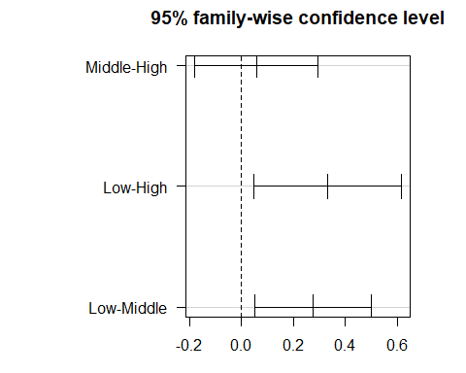

Normality still a problem?
plot(fit2, which = 2)
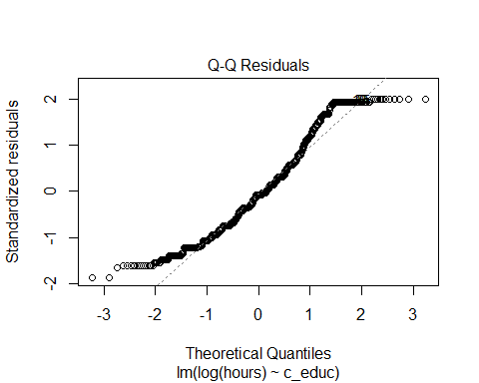

Kruskal-Wallis ANOVA
If the data were severely skewed, you might try:
kruskal.test(hours ~ c_educ, data = ecare)
Kruskal-Wallis rank sum test
data: hours by c_educ
Kruskal-Wallis chi-squared = 10.622, df = 2, p-value = 0.004938
- $H_{0}$: The four education groups have the same center to their hours distributions.
- $H_{A}$: At least one group has a shifted distribution, with a different center to its hours.

K Samples: Comparing Means (1)
- What is the outcome under study?
- What are the ($K≥2$) treatment/exposure groups?
- Were the data in fact collected using independent samples?
- Are the data random samples from the population(s) of interest? Or is there at least a reasonable argument for generalizing from the samples to the population(s)?
- What confidence level do we require?

K Samples: Comparing Means (2)
- Are we doing one-sided or two-sided testing? (usually 2-sided)
- What does the distribution of each individual sample tell us about which inferential procedure to use?
- Are there meaningful differences between population means?
- Can we identify pairwise comparisons of means that show meaningful differences using an appropriate procedure that protects against Type I error expansion due to multiple comparisons?

Standing Break, and then we’ll discuss linear regression

Association of Two Quantities
How well can we predict a carer’s negative impact score on the basis of their positive impact score?
- The two scales are described further on the next slide.
ecare |> reframe(lovedist(neg_impact))
# A tibble: 1 × 10
n miss mean sd med mad min q25 q75 max
<int> <int> <dbl> <dbl> <dbl> <dbl> <dbl> <dbl> <dbl> <dbl>
1 818 0 11.8 3.89 11 2.97 7 9 14 28
ecare |> reframe(lovedist(pos_impact))
# A tibble: 1 × 10
n miss mean sd med mad min q25 q75 max
<int> <int> <dbl> <dbl> <dbl> <dbl> <dbl> <dbl> <dbl> <dbl>
1 818 0 12.5 2.25 13 2.97 5 11 14 16

Caregiver Burden Subscales
- neg_impact is higher for carers characterized by avoiding problems, focusing on negative emotions, or engaging in unhealthy behaviors, which are linked to increased psychological distress and other adverse effects.
  - scores in our data range from 7 to 28
- pos_impact is higher for carers characterized by adaptive coping strategies focused on finding positive meaning and growth or positive outcomes in stressful situations.
  - scores in our data range from 5 to 16

Histograms of burden scales
plot1 <- ggplot(ecare, aes(x = neg_impact)) +
geom_histogram(binwidth = 1, fill = "blue", col = "white") +
labs(title = "Negative Impact")
plot2 <- ggplot(ecare, aes(x = pos_impact)) +
geom_histogram(binwidth = 1, fill = "forestgreen", col = "white") +
labs(title = "Positive Impact")
plot1 + plot2
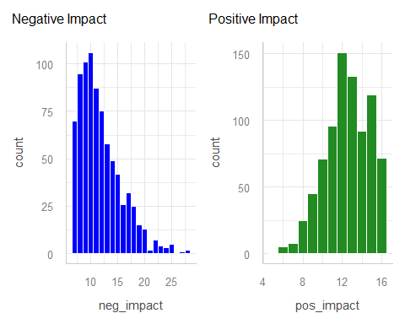

Scatterplot of 818 Carers
- We’ll plot each point with alpha = 0.3 so that if we have multiple overlapping points, the plot will look darker there.
ggplot(ecare, aes(x = pos_impact, y = neg_impact)) +
geom_point(alpha = 0.3) +
geom_smooth(method = "loess",
formula = y ~ x, se = FALSE, col = "blue") +
geom_smooth(method = "lm",
formula = y ~ x, se = TRUE, col = "red") +
labs(title = "EUROFAMCARE data for 818 subjects",
x = "Positive Impact Score",
y = "Negative Impact Score",
caption = "Linear model in red, loess smooth in blue")
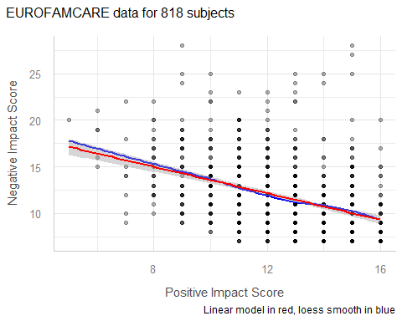

Jittered Scatterplot
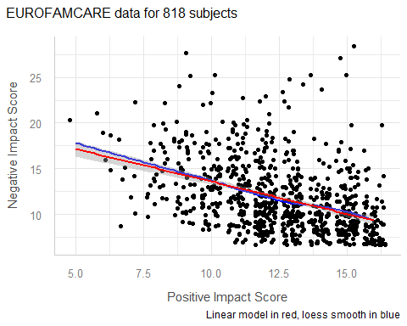

Pearson Correlation Coefficent
- Pearson r ranges from -1 (perfect inverse relationship: as x goes up, y goes down) to +1 (perfect direct relationship: as x goes up, y goes up.)
- Pearson r measures only a linear association.
ecare |> select(neg_impact, pos_impact) |> correlation()
# Correlation Matrix (pearson-method)
Parameter1 | Parameter2 | r | 95% CI | t(816) | p
---------------------------------------------------------------------
neg_impact | pos_impact | -0.41 | [-0.47, -0.35] | -12.86 | < .001***
p-value adjustment method: Holm (1979)
Observations: 818

Considering the Correlation
ecare |> select(neg_impact, pos_impact) |> correlation()
# Correlation Matrix (pearson-method)
Parameter1 | Parameter2 | r | 95% CI | t(816) | p
---------------------------------------------------------------------
neg_impact | pos_impact | -0.41 | [-0.47, -0.35] | -12.86 | < .001***
p-value adjustment method: Holm (1979)
Observations: 818
- Is the direction of this correlation surprising?
- How about its magnitude?

Fit a linear model with OLS
Ordinary Least Squares used to fit a linear model…
fit3 <- lm(neg_impact ~ pos_impact, data = ecare)
model_parameters(fit3, ci = 0.97, pretty_names = FALSE)
Parameter | Coefficient | SE | 97% CI | t(816) | p
-------------------------------------------------------------------
(Intercept) | 20.69 | 0.70 | [19.17, 22.22] | 29.52 | < .001
pos_impact | -0.71 | 0.06 | [-0.83, -0.59] | -12.86 | < .001
Uncertainty intervals (equal-tailed) and p-values (two-tailed) computed
using a Wald t-distribution approximation.
Note that we’re creating 97% confidence intervals here.

Interpreting the intercept
model_parameters(fit3, ci = 0.97, pretty_names = FALSE)
Parameter | Coefficient | SE | 97% CI | t(816) | p
-------------------------------------------------------------------
(Intercept) | 20.69 | 0.70 | [19.17, 22.22] | 29.52 | < .001
pos_impact | -0.71 | 0.06 | [-0.83, -0.59] | -12.86 | < .001
Uncertainty intervals (equal-tailed) and p-values (two-tailed) computed
using a Wald t-distribution approximation.
- Our fit3 model estimates the neg_impact value to be 20.69 if pos_impact = 0.
- All of our pos_impact values are between 5 and 16, so we don’t have any useful information about what happens when pos_impact = 0, and thus the intercept isn’t actually useful.

Interpret slope estimate
model_parameters(fit3, ci = 0.97, pretty_names = FALSE)
Parameter | Coefficient | SE | 97% CI | t(816) | p
-------------------------------------------------------------------
(Intercept) | 20.69 | 0.70 | [19.17, 22.22] | 29.52 | < .001
pos_impact | -0.71 | 0.06 | [-0.83, -0.59] | -12.86 | < .001
Uncertainty intervals (equal-tailed) and p-values (two-tailed) computed
using a Wald t-distribution approximation.
- Suppose Harry’s pos_impact is one point larger than Sally’s. Our fit3 model predicts the neg_impact for Harry to be 0.71 points less than that of Sally, on average.
- Of course, this assumes Harry and Sally are similar to the subjects in ecare and that our linear model fit3 is correct.

Interpret slope’s 97% CI
model_parameters(fit3, ci = 0.97, pretty_names = FALSE)
Parameter | Coefficient | SE | 97% CI | t(816) | p
-------------------------------------------------------------------
(Intercept) | 20.69 | 0.70 | [19.17, 22.22] | 29.52 | < .001
pos_impact | -0.71 | 0.06 | [-0.83, -0.59] | -12.86 | < .001
Uncertainty intervals (equal-tailed) and p-values (two-tailed) computed
using a Wald t-distribution approximation.
- When we generalize beyond these 818 study participants to the population they were selected at random from, then our data are compatible (at the 97% confidence level) with population slopes between -0.83 and -0.59, depending on the assumptions of our model fit3 being correct.

Performance of this model?
model_performance(fit3)
# Indices of model performance
AIC | AICc | BIC | R2 | R2 (adj.) | RMSE | Sigma
------------------------------------------------------------
4396.1 | 4396.2 | 4410.2 | 0.169 | 0.168 | 3.541 | 3.546
- $R^{2}$ tells us model fit3 accounts for 16.9% of the variation in neg_impact we see in these 818 subjects.
- $R^{2}$ = 0.169 is the square of the Pearson correlation (-0.41) of neg_impact and pos_impact.
- $η^{2}$ in ANOVA = this $R^{2}$.
Adjusted $R^{2}$ will be useful when we have multiple predictors.

Performance of this model?
model_performance(fit3)
# Indices of model performance
AIC | AICc | BIC | R2 | R2 (adj.) | RMSE | Sigma
------------------------------------------------------------
4396.1 | 4396.2 | 4410.2 | 0.169 | 0.168 | 3.541 | 3.546
The model fit3 assumes that our errors (residuals) come from a Normal distribution with mean 0 and standard deviation Sigma ($) = 3.546.
- About 68% of our predicted neg_impact values should be within $±3.546$ points of the correct value, and 95% should be within $±2(3.546)$, or $±7.092$ points.

Favorite Movies Data

Session Information
xfun::session_info()
R version 4.6.1 (2026-06-24 ucrt)
Platform: x86_64-w64-mingw32/x64
Running under: Windows 11 x64 (build 26200)
Locale:
LC_COLLATE=English_United States.utf8
LC_CTYPE=English_United States.utf8
LC_MONETARY=English_United States.utf8
LC_NUMERIC=C
LC_TIME=English_United States.utf8
Package version:
abind_1.4-8 askpass_1.2.1 backports_1.5.1
base_4.6.1 base64enc_0.1.6 bayestestR_0.19.0
bit_4.6.0 bit64_4.8.6 blob_1.3.0
boot_1.3-32 broom_1.0.13 bslib_0.12.0
cachem_1.1.0 callr_3.8.0 car_3.1-5
carData_3.0-6 cellranger_1.1.0 class_7.3-24
cli_3.6.6 clipr_0.8.1 coda_0.19-4.1
codetools_0.2-20 colorspace_2.1.3 compiler_4.6.1
conflicted_1.2.0 correlation_0.8.8 cowplot_1.2.0
cpp11_0.5.5 crayon_1.5.3 curl_8.0.0
data.table_1.18.6.1 datasets_4.6.1 datawizard_1.4.0
DBI_1.3.0 dbplyr_2.6.0 Deriv_4.3.5
DescTools_0.99.60 digest_0.6.39 doBy_4.7.2
dplyr_1.2.1 dtplyr_1.3.3 e1071_1.7-17
easystats_0.7.6 effectsize_1.0.3 emmeans_2.0.4
estimability_2.0.0 evaluate_1.0.5 Exact_3.3
expm_1.0-1 farver_2.1.2 fastmap_1.2.0
fontawesome_0.5.3 forcats_1.0.1 forecast_9.0.2
Formula_1.2-6 fracdiff_1.5.4 fs_2.1.0
gargle_1.6.1 generics_0.1.4 ggplot2_4.0.3
gld_2.6.8 glue_1.8.1 googledrive_2.1.2
googlesheets4_1.1.2 graphics_4.6.1 grDevices_4.6.1
grid_4.6.1 gridExtra_2.3.1 gtable_0.3.6
haven_2.5.5 highr_0.12 hms_1.1.4
htmltools_0.5.9 httr_1.4.9 ids_1.0.1
insight_1.5.4 isoband_0.3.0 janitor_2.2.1
jquerylib_0.1.4 jsonlite_2.0.0 knitr_1.52
labeling_0.4.3 lattice_0.23-1 lifecycle_1.0.5
lme4_2.0.6 lmom_3.3 lmtest_0.9.40
lubridate_1.9.5 magrittr_2.0.5 MASS_7.3-66
Matrix_1.7-6 MatrixModels_0.5.4 memoise_2.0.1
methods_4.6.1 mgcv_1.9-4 mime_0.13
minqa_1.2.8 modelbased_0.17.0 modelr_0.1.11
multcomp_1.4-32 mvtnorm_1.4-2 naniar_1.1.0
nlme_3.1-171 nloptr_2.2.1 nnet_7.3.21
norm_1.0.11.1 numDeriv_2016.8.1.1 openssl_2.4.2
otel_0.2.0 parallel_4.6.1 parameters_0.29.3
patchwork_1.3.2 pbkrtest_0.5.5 performance_0.18.2
pillar_1.11.1 pkgconfig_2.0.3 plyr_1.8.9
prettyunits_1.2.0 processx_3.9.0 progress_1.2.3
proxy_0.4-29 ps_1.9.3 purrr_1.2.2
quantreg_6.1 R6_2.6.1 ragg_1.5.2
rappdirs_0.3.4 rbibutils_2.4.1 RColorBrewer_1.1-3
Rcpp_1.1.2 RcppArmadillo_15.6.0.1 RcppEigen_0.3.4.0.2
Rdpack_2.6.6 readr_2.2.0 readxl_1.5.0
reformulas_0.4.4 rematch_2.0.0 rematch2_2.1.2
report_0.6.4 reprex_2.1.1 rlang_1.3.0
rmarkdown_2.32 rootSolve_1.8.2.4 rstudioapi_0.19.0
rvest_1.0.5 S7_0.2.2 sandwich_3.1-3
sass_0.4.10 scales_1.4.0 see_0.14.2
selectr_0.6.0 snakecase_0.11.1 SparseM_1.84.2
splines_4.6.1 stats_4.6.1 stringi_1.8.9
stringr_1.6.0 survival_3.8-11 sys_3.4.3
systemfonts_1.3.2 textshaping_1.0.5 TH.data_1.1-5
tibble_3.3.1 tidyr_1.3.2 tidyselect_1.2.1
tidyverse_2.0.0 timechange_0.4.0 timeDate_4052.112
tinytex_0.60 tools_4.6.1 tzdb_0.5.0
UpSetR_1.4.1 urca_1.3.4 utf8_1.2.6
utils_4.6.1 uuid_1.2.2 vctrs_0.7.3
viridis_0.6.5 viridisLite_0.4.3 visdat_0.6.0
vroom_1.7.1 withr_3.0.3 xfun_0.60
xml2_1.6.0 xtable_1.8-8 yaml_2.3.12
zoo_1.9-0

